From grasslands to genes: exploring the major microbial drivers of antibiotic-resistance in microhabitats under persistent overgrazing

Jian Li^{1,2*}, Quanhui Ma^{3,4}, Mingkang Jin¹, Lijie Huang^{1,5}, Dafeng Hui⁶, Jordi Sardans^{7,8}, Josep Peñuelas^{7,8}, Patrick O’Connor⁹, Yu Zhu^{3,10*}, Xiaoru Yang^{1,2}, Ling Wang⁴, Yong-Guan Zhu^{1,2,11}
¹Key Laboratory of Urban Environment and Health, Ningbo Observation and Research Station, Institute of Urban Environment, Chinese Academy of Sciences, Xiamen 361021, China;
²Zhejiang Key Laboratory of Urban Environmental Processes and Pollution Control, CAS Haixi Industrial Technology Innovation Center in Beilun, Ningbo 315830, China;
³ Ministry of Education Key Laboratory of Ecology and Resource Use of the Mongolian Plateau & Inner Mongolia Key Laboratory of Grassland Ecology, School of Ecology and Environment, Inner Mongolia University, Hohhot 010021 China;
⁴ Institute of Grassland Science, Key Laboratory of Vegetation Ecology, Ministry of Education/Jilin Songnen Grassland Ecosystem National Observation and Research Station, Northeast Normal University, Changchun 130024 China;
⁵School of Life Sciences, Institute of Life Sciences and Green Development, Hebei University, Baoding 071002, China;
⁶Department of Biological Sciences, Tennessee State University, Nashville, Tennessee 37209, USA;
⁷CSIC, Global Ecology Unit, CREAF-CSIC-UAB, Bellaterra, 08193 Barcelona, Catalonia, Spain
⁸CREAF, Cerdanyola del Vallès, 08193 Barcelona, Catalonia, Spain;
⁹Centre for Global Food and Resources, University of Adelaide, Adelaide, 5005, Australia;
¹⁰ State Key Laboratory of Black Soils Conservation and Utilization & Key Laboratory of Wetland Ecology and Environment, Northeast Institute of Geography and Agroecology, Chinese Academy of Sciences, Changchun 130102 China;
¹¹State Key Lab of Urban and Regional Ecology, Research Center for Eco-Environmental Sciences, Chinese Academy of Sciences, Beijing, China;
*Authors for correspondence:
Jian Li
Address: Key Laboratory of Urban Environment and Health, Ningbo Observation and Research Station, Institute of Urban Environment, Chinese Academy of Sciences, Xiamen 361021, China
E-mail: jianli@iue.ac.cn
Yu Zhu
Address: Ministry of Education Key Laboratory of Ecology and Resource Use of the Mongolian Plateau & Inner Mongolia Key Laboratory of Grassland Ecology, School of Ecology and Environment, Inner Mongolia University, Hohhot 010021 China
E-mail: zhuyu@iga.ac.cn
Supplementary materials:
10 figures and 5 tables
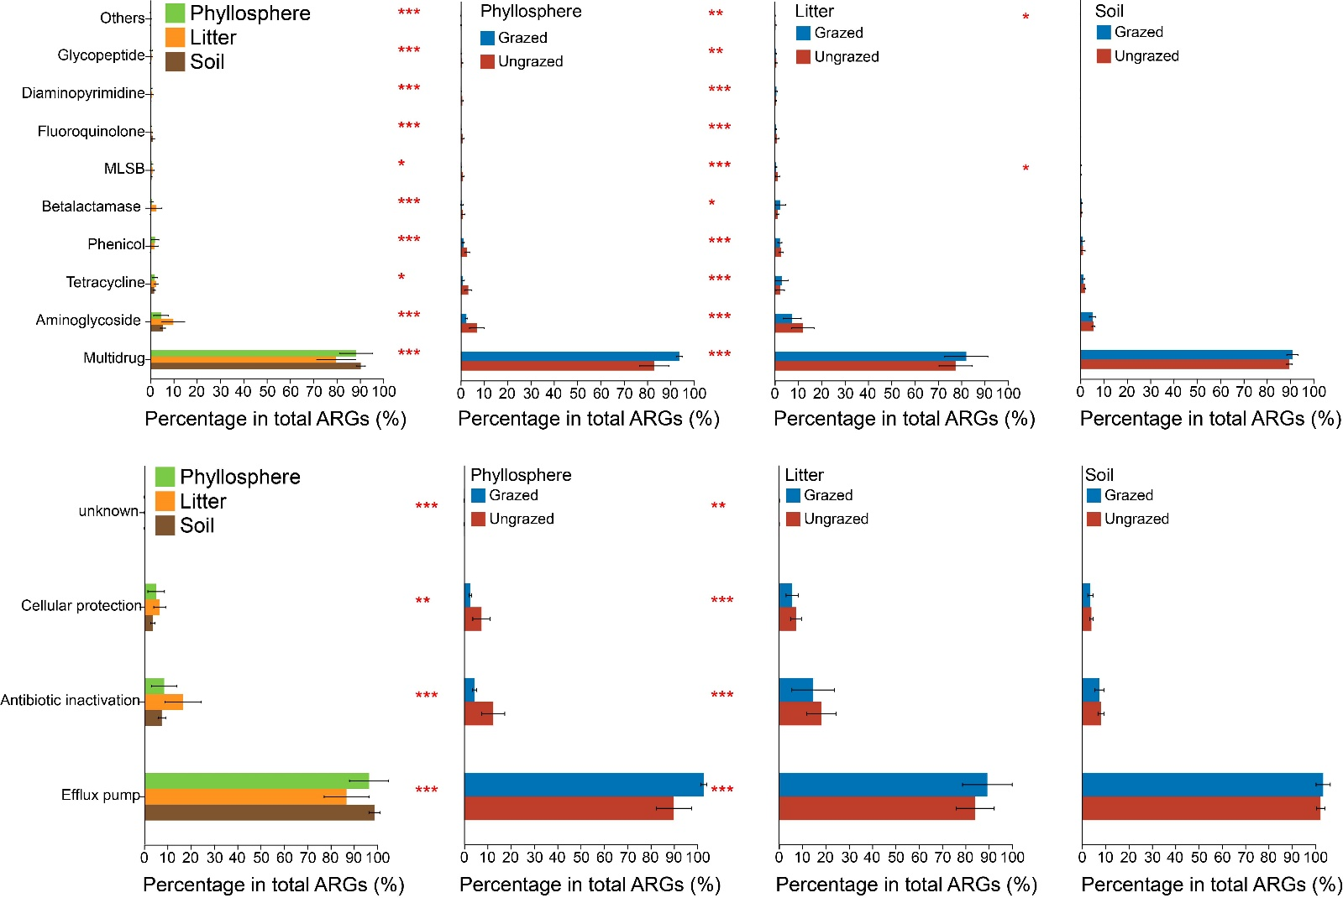
SFig.1. Bar chart of Kruskal-Wallis test results of antibiotic resistance genes (ARGs) classified based on their suggested drug class and mechanism in different microhabitats and grazing treatments. *: p < 0.05; **: p < 0.01; ***: p < 0.001.
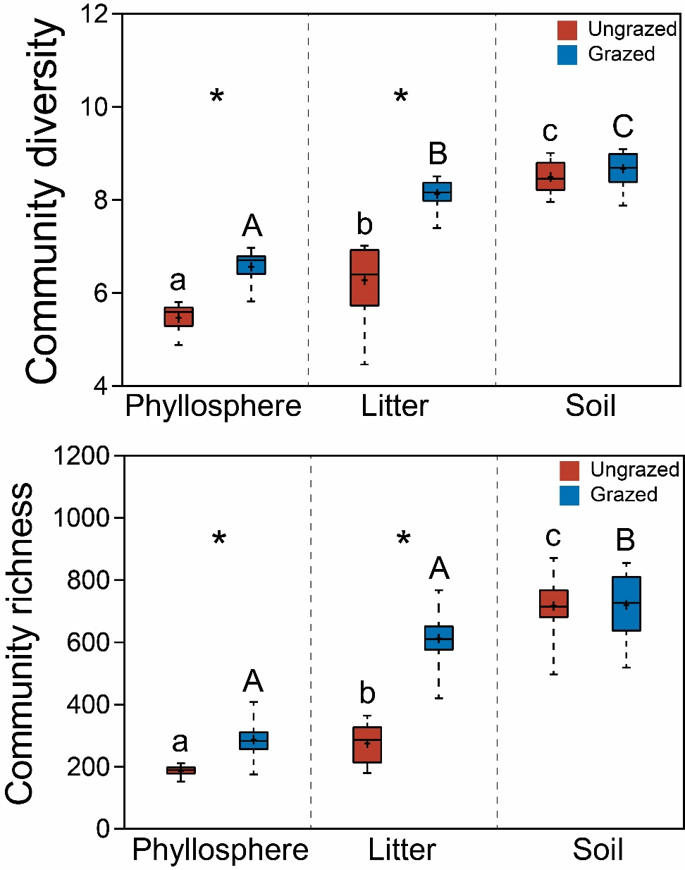
SFig.2. Diversity and richness of the whole microbial community among different microhabitats and grazing treatments. Different lower and upper case letters indicate significant differences at p < 0.05 level among different microhabitats in grazed and ungrazed treatments, respectively. * indicates significant differences at p < 0.05 level between grazed and ungrazed plots.
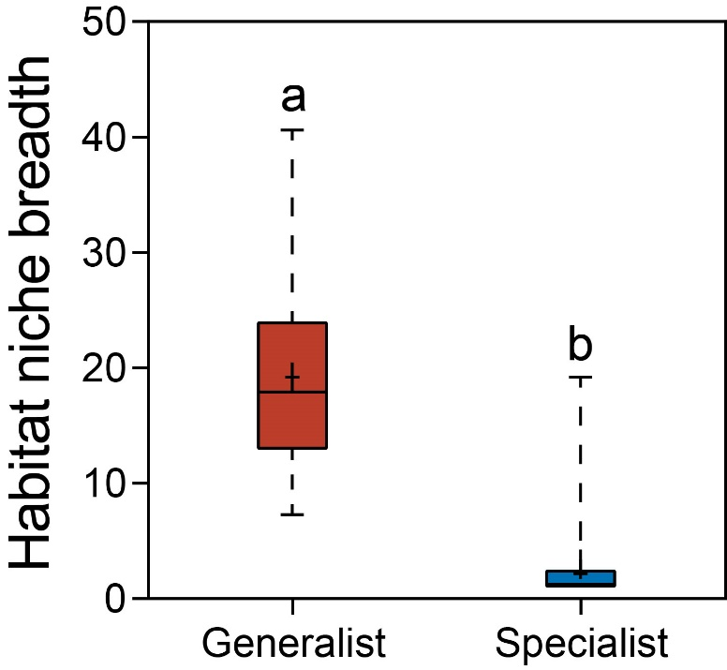
SFig.3. Habitat niche breadth of generalist and specialist communities. Different letters indicate significant differences at p < 0.05 level.
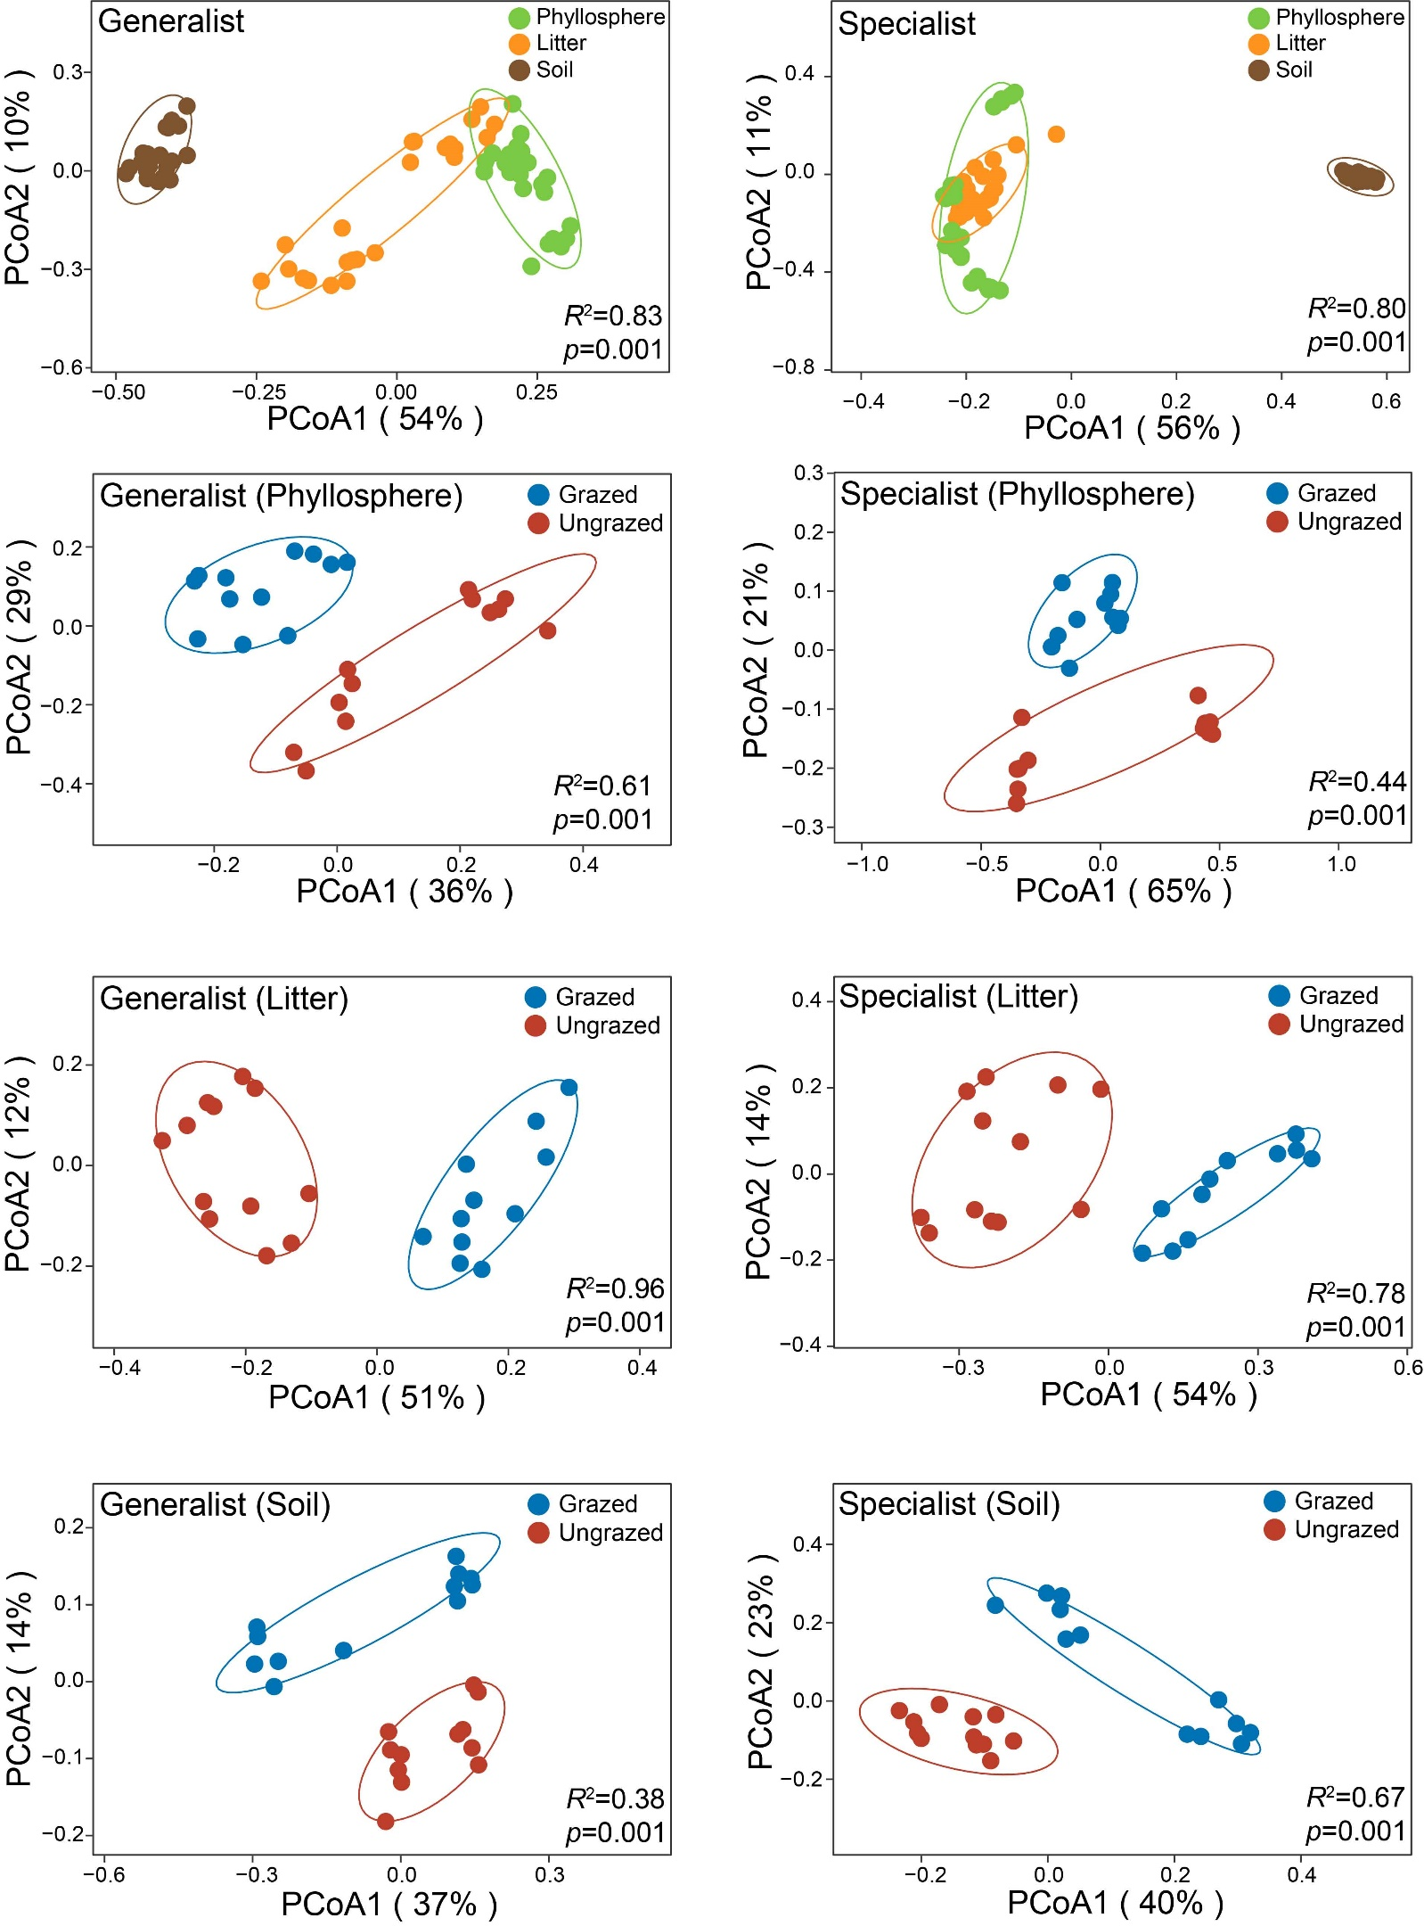
SFig.4. Principal coordinate analysis (PCoA) of generalist and specialist communities among different microhabitats and grazing treatments.
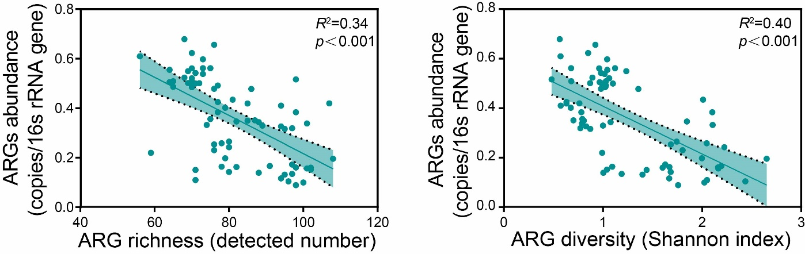
SFig.5. Spearman correlations between antibiotic resistance genes (ARGs) abundance and their diversity and richness.

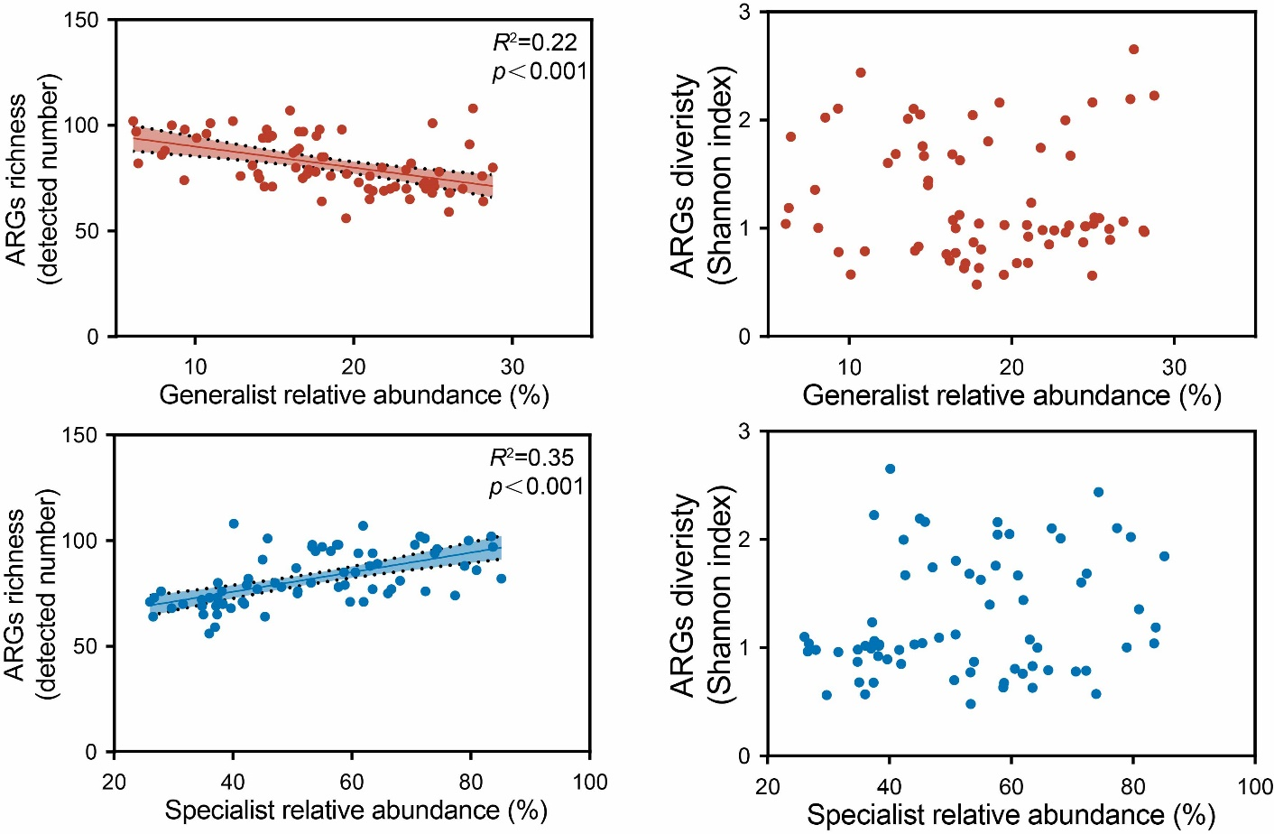
SFig.6. Spearman correlations between diversity and richness of antibiotic resistance genes (ARGs) and relative abundance of generalist and specialist communities.

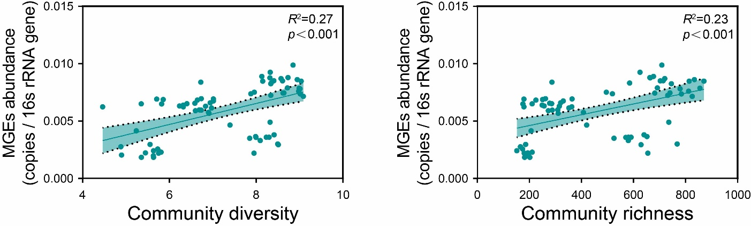
SFig.7. Spearman correlations between mobile genetic elements (MGEs) and the whole microbial community diversity and richness.
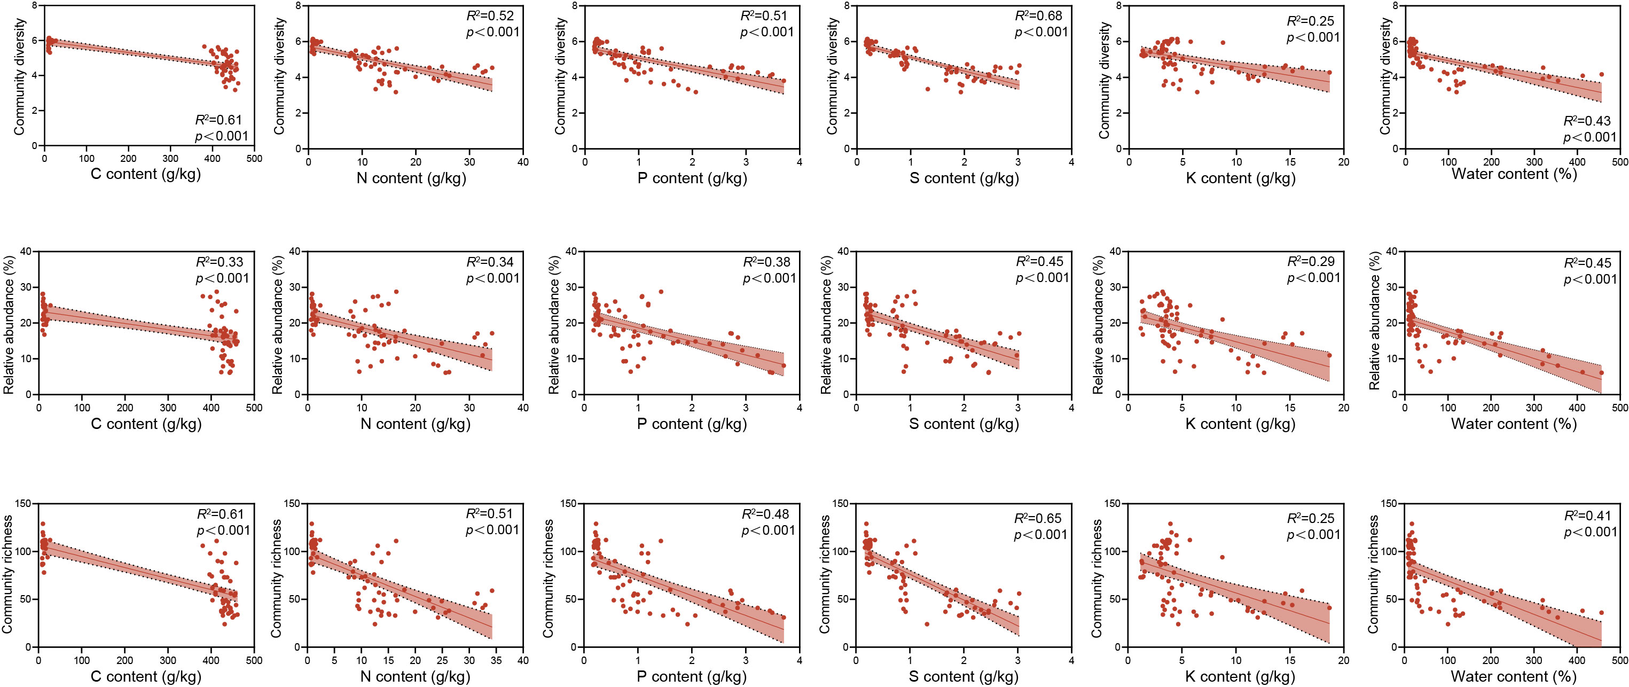
SFig.8. Spearman correlations between nutrient content and generalist community relative abundance, community diversity and richness.
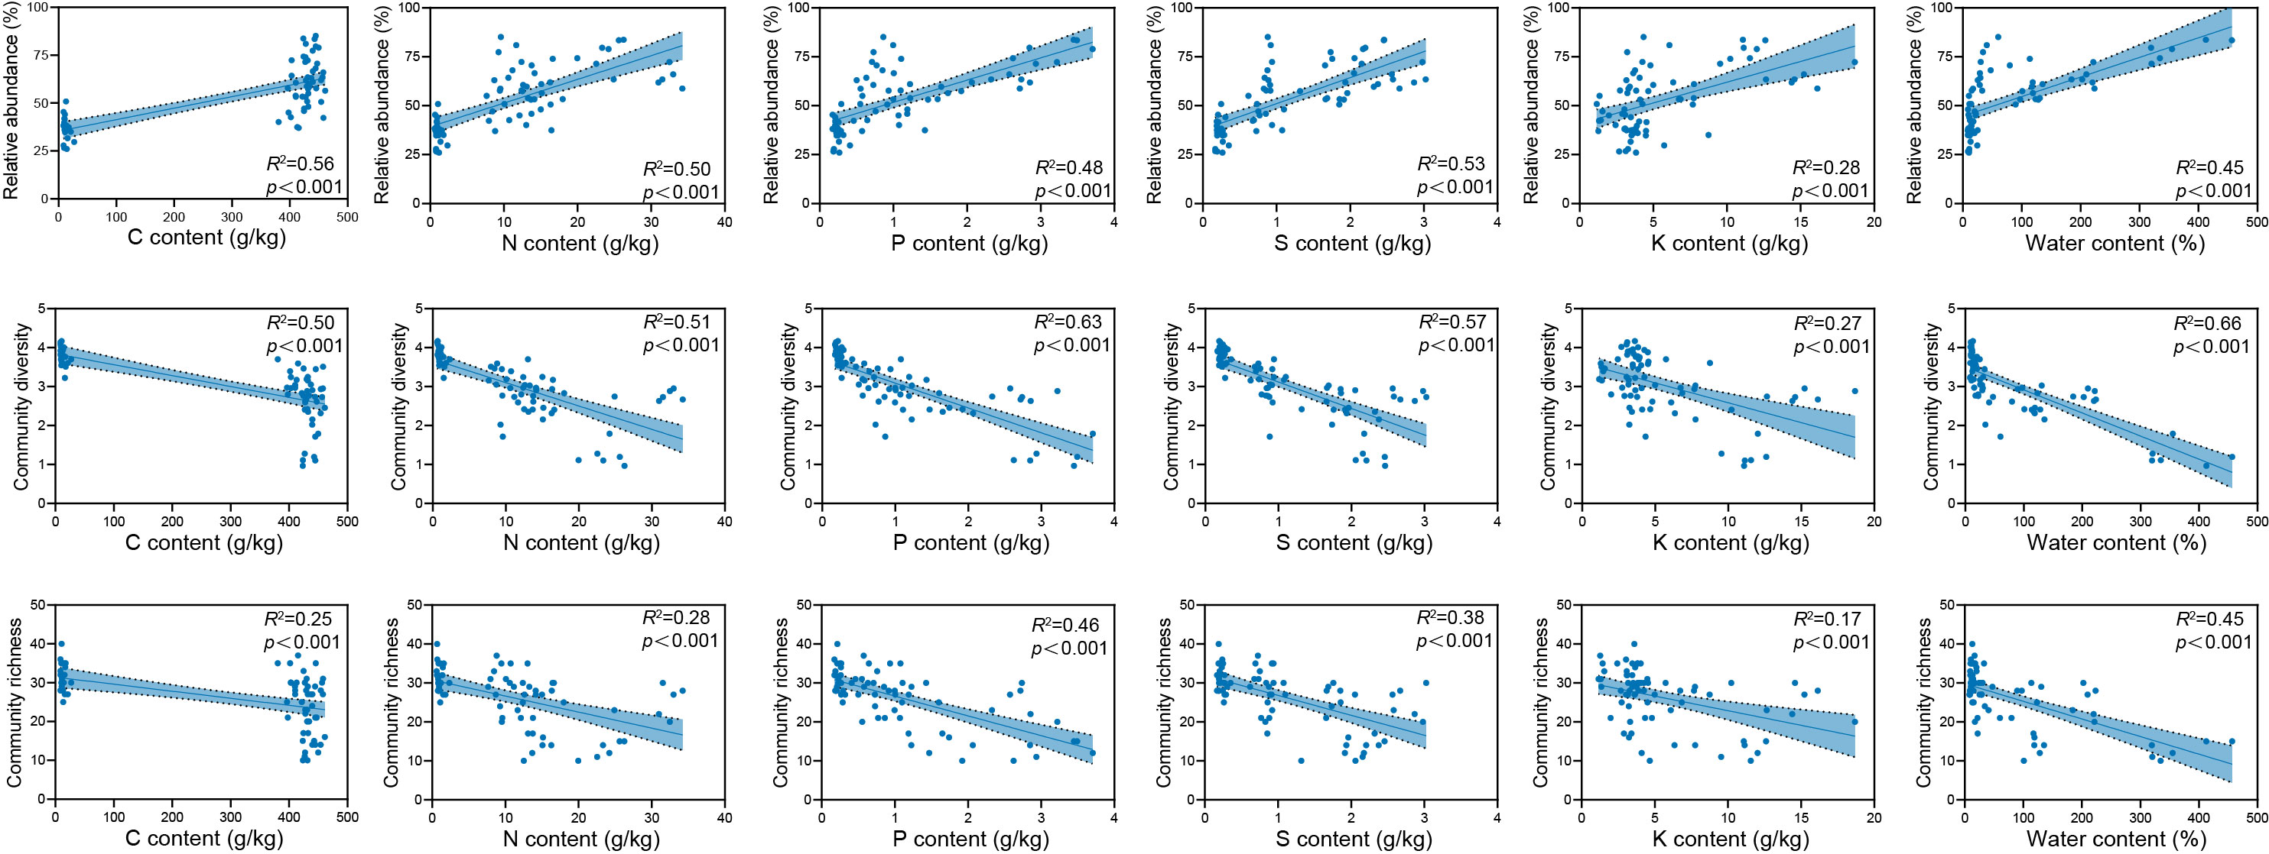
SFig.9. Spearman correlations between nutrient content and specialist community relative abundance, community diversity, and richness.

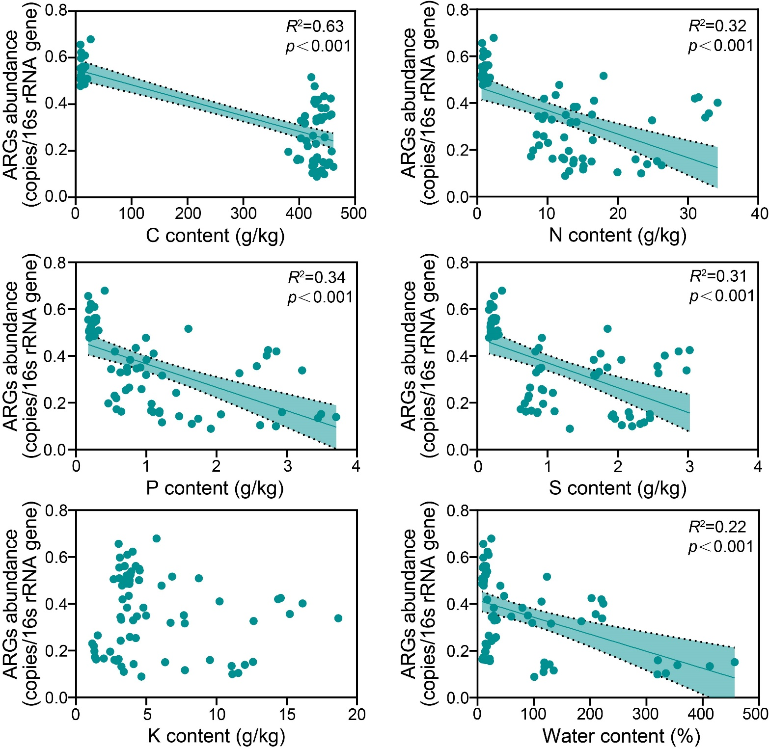
SFig.10. Spearman correlations between nutrient content and relative abundance of antibiotic resistance genes (ARGs).
Table S1. Properties of the soil in the experimental site.
 | pH | Nitrogen (g kg⁻¹) | Phosphorus (g kg⁻¹) | Organic matter (g kg⁻¹)
 | 7.5-10.5 | 0.75 | 0.35 | 6.9-8.6

Table S2. List of primer pairs of antibiotic resistance genes in the present study. Bold font indicates the primer pairs with positive results.
Gene name | Suggested drug class | Suggested mechanism | Forward primer | Reverse Primer
AAC(3)-Ia | Aminoglycoside antibiotic | Antibiotic inactivation | ACGTTCTGCCAAAGTTTGAG | ACTGCCGGATCGTCAC
AAC(3)-Ib | Aminoglycoside antibiotic | Antibiotic inactivation | CAGCGAGACGTTCATCGC | CACGCTTCAGGTGGCTAATC
AAC(3)-Id | Aminoglycoside antibiotic | Antibiotic inactivation | AGATAGTTATGCCCGCAACAAG | ACGCGCTGCGCCTATA
AAC(3)-Iic | Aminoglycoside antibiotic | Antibiotic inactivation | ACGGCATTCTCGATTGCTTT | CCGAGCTTCACGTAAGCATTT
Aac(3)-iid_iia_iie | Aminoglycoside antibiotic | Antibiotic inactivation | CGATGGTCGCGGTTGGTC | TCGGCGTAGTGCAATGCG
AAC(3)-IV | Aminoglycoside antibiotic | Antibiotic inactivation | CCAACACGACGCTGCATC | GCTGTCGCCACAATGTCG
AAC(3)-Via | Aminoglycoside antibiotic | Antibiotic inactivation | GTGTCCGTCGCCAAGGA | GGTGACGGCCTTGTCGA
AAC(3)-Xa | Aminoglycoside antibiotic | Antibiotic inactivation | GCAAGCGGTTCGTGACGTA | TCAGGTGCTCCTCGATCCAG
AAC(6')-Ib | Aminoglycoside antibiotic | Antibiotic inactivation | CGTCGCCGAGCAACTTG | CGGTACCTTGCCTCTCAAACC
aac(6')-ie-aph(2'')-ia | Aminoglycoside antibiotic | Antibiotic inactivation | CCAAGAGCAATAAGGGCATACCAA | GCCACACTATCATAACCACTACCG
AAC(6')-Ig | Aminoglycoside antibiotic | Antibiotic inactivation | GCGATGTTAGAAGCCTCAATTCG | CACACTTCGGCCTGTCGAA
AAC(6')-IIa | Aminoglycoside antibiotic | Antibiotic inactivation | CGACCCGACTCCGAACAA | GCACGAATCCTGCCTTCTCA
AAC(6')-IIc | Aminoglycoside antibiotic | Antibiotic inactivation | CAGTCTTTGGCTAATCCATCACAG | AACGAACCCGGCCTTCTC
AAC(6')-Ij | Aminoglycoside antibiotic | Antibiotic inactivation | ATGCCTGTATCTGAATCCCTGATG | GGCAATCGCTTGTTGAGTATCTG
AAC(6')-Im | Aminoglycoside antibiotic | Antibiotic inactivation | CGTGAGCATTATACAGAGCAATGG | CCATTTCCGTTCGTAGATATTGGC
AAC(6')-Ip | Aminoglycoside antibiotic | Antibiotic inactivation | GGGAATTATCGGAATAGCTCTTGG | TTGGGCTGTTCTTCCTAGCTAA
AAC(6')-Ir | Aminoglycoside antibiotic | Antibiotic inactivation | GCTATAACGATCAGCAGCAAGC | CGCGATGCATGGCATGAC
AAC(6')-Is | Aminoglycoside antibiotic | Antibiotic inactivation | AAGCTTACTCTGGCCTGATCATG | TGCCTGAACGTCGATATTCAGG
AAC(6')-Iv | Aminoglycoside antibiotic | Antibiotic inactivation | TTGGCTTATACCGACACCCA | CCCGTTGCGATACCTGAAC
AAC(6')-Iw | Aminoglycoside antibiotic | Antibiotic inactivation | TGCGTCAGTTACTTACACGAAC | CCTGATGCATTGCATGACTGA
AAC(6')-Iy | Aminoglycoside antibiotic | Antibiotic inactivation | GCCTCAATCCGCCACGATTA | ACGCGCTCTGTTTCCTCAAA
AAC(6')-Iz | Aminoglycoside antibiotic | Antibiotic inactivation | TGCGCCATGACTACGTGAAC | GACTGTCCGAAGCCAGTTCG
aacA_aphD | Aminoglycoside antibiotic | Antibiotic inactivation | AGAGCCTTGGGAAGATGAAGTTT | TTGATCCATACCATAGACTATCTCATCA
aacA43 | Aminoglycoside antibiotic | Antibiotic inactivation | CTTGGCCTACATTAGATTCAGCTC | GCTCTCAATCTTTGATAGGAGCAG
aadA | Aminoglycoside antibiotic | Antibiotic inactivation | GTTGTGCACGACGACATCATT | GGCTCGAAGATACCTGCAAGAA
aadA10 | Aminoglycoside antibiotic | Antibiotic inactivation | ACAGGCACTCAACGTCATCG | CGCGGAGAACTCTGCTTTGA
aadA16 | Aminoglycoside antibiotic | Antibiotic inactivation | ACGGTGGCCTGAAGCC | GAATTGCAGTTCCCGTCTGG
aadA17 | Aminoglycoside antibiotic | Antibiotic inactivation | TGTACGGCTCCGCAGTG | CACGGAATGATGTCGTCGTG
aadA2 | Aminoglycoside antibiotic | Antibiotic inactivation | CAATGACATTCTTGCGGGTATC | GACCTACCAAGGCAACGCTATG
aadA21 | Aminoglycoside antibiotic | Antibiotic inactivation | ACGGCTCCGCAGTGGAT | GGCCACAGTAACCAACAAATCA
aadA5 | Aminoglycoside antibiotic | Antibiotic inactivation | ATCACGATCTTGCGATTTTGCT | CTGCGGATGGGCCTAGAAG
aadA6 | Aminoglycoside antibiotic | Antibiotic inactivation | CCATCGAGCGTCATCTGGAA | CCCGTCTGGCCGGATAAC
aadA7 | Aminoglycoside antibiotic | Antibiotic inactivation | CACTCCGCGCCTTGGA | TGTGGCGGGCTCGAAG
aadA9 | Aminoglycoside antibiotic | Antibiotic inactivation | CGCGGCAAGCCTATCTTG | CAAATCAGCGACCGCAGACT
ANT(2'')-Ia | Aminoglycoside antibiotic | Antibiotic inactivation | CCTGCTTGGTGGGCAGAC | CGGCACGCAAGACCTCAA
ANT(4') | Aminoglycoside antibiotic | Antibiotic inactivation | CCGACAACATTTCTACCATCCTT | ACCGAAGCGCTCGTCGTATA
ANT(4')-Ia | Aminoglycoside antibiotic | Antibiotic inactivation | GATGGCCGCTGACACATG | TCAACATTGCGCCATAGTGG
ANT(6) | Aminoglycoside antibiotic | Antibiotic inactivation | TACCTTATTGCCCTTGGAAGAGTTA | GGAACTATGTCCCTTTTAATTCTACAATCT
ANT(6)-Ia | Aminoglycoside antibiotic | Antibiotic inactivation | TCGCCATGAGCTGCTGA | CCTATCATACTCCGGATAGGCATA
ANT(6)-Ib | Aminoglycoside antibiotic | Antibiotic inactivation | AGAACATCCGACAGCACGTTC | CCAACCTTCCATGAAATCATTCGC
APH(2'')-Iva | Aminoglycoside antibiotic | Antibiotic inactivation | TGAGCAGTATCATAAGTTGAGTGAAAAG | GACAGAACAATCAATCTCTATGGAATG
APH(3')-Ia | Aminoglycoside antibiotic | Antibiotic inactivation | TGAACAAGTCTGGAAAGAAATGCA | CCTATTAATTTCCCCTCGTCAAAAA
APH(3'')-Ia | Aminoglycoside antibiotic | Antibiotic inactivation | TAACAGCGATCGCGTATTTCG | TCCGACTCGTCCAACATCAATA
APH(3')-Ib | Aminoglycoside antibiotic | Antibiotic inactivation | AACAGGTTTGGGAGGCGATG | CGCAACAAGCCTCTCCTGAA
APH(3')-Via | Aminoglycoside antibiotic | Antibiotic inactivation | TCTCATGGCGATATCACGGATAG | TTTCCTCCGATGCATCCTCTC
APH(3')-VIIa | Aminoglycoside antibiotic | Antibiotic inactivation | CTCTCTCATGGAGATATGAGCGCTA | AATCCGGTTCAAGTCCCAACATG
APH(3')-VIIIa | Aminoglycoside antibiotic | Antibiotic inactivation | TCGGTATCCCGGTTGTGAG | ACACGAGGTACGGGAATCC
APH(4)-Ia | Aminoglycoside antibiotic | Antibiotic inactivation | CGCTCCCGATTCCGGAA | CACAGTTTGCCAGTGATACACA
APH(4)-Ib | Aminoglycoside antibiotic | Antibiotic inactivation | GGGAACACCGTGCTCACC | GTTGGTCCCGTGCAGGTC
APH(6)-Ia | Aminoglycoside antibiotic | Antibiotic inactivation | CGCTGGGAGCTGAAGAGG | AGCATCGTGCTGCTCTCC
APH(6)-Ic | Aminoglycoside antibiotic | Antibiotic inactivation | CACGACAACGTGCTCGAC | CCGTCTTCGGCGAACCA
APH(6)-Id | Aminoglycoside antibiotic | Antibiotic inactivation | GCTCGGTCGTGAGAACAATCT | CAATTTCGGTCGCCTGGTAGT
APH(9)-Ib | Aminoglycoside antibiotic | Antibiotic inactivation | GCTATGTGCTGGTGGACTGG | GGAACCACTCGACGAACTCG
APH3-III | Aminoglycoside antibiotic | Antibiotic inactivation | CAGAAGGCAATGTCATACCACTTG | GACAGCCGCTTAGCCGAA
APHA3 | Aminoglycoside antibiotic | Antibiotic inactivation | AAAAGCCCGAAGAGGAACTTG | CATCTTTCACAAAGATGTTGCTGTCT
apmA | Aminoglycoside antibiotic | Antibiotic inactivation | GGCGCACATGCATTCATCA | CTATACTCCAGTCCCACCATTTGA
armA | Aminoglycoside antibiotic | Antibiotic inactivation | TCTTCGACGAATGAAAGAGTCG | GCTAATGGATTGAAGCCACAACC
spec_aph | Aminoglycoside antibiotic | Antibiotic inactivation | GGTGCTGATATGAATGCCTTTGG | CATTGGGCGCATCAATAAATGG
str | Aminoglycoside antibiotic | Antibiotic inactivation | AATGAGTTTTGGAGTGTCTCAACGTA | AATCAAAACCCCTATTAAAGCCAAT
strA | Aminoglycoside antibiotic | Antibiotic inactivation | CCGGTGGCATTTGAGAAAAA | GTGGCTCAACCTGCGAAAAG
ACC-1 | Beta-lactamase antibiotic | Antibiotic inactivation | CACACAGCTGATGGCTTATCTAAAA | AATAAACGCGATGGGTTCCA
ACT beta-lac | Beta-lactamase antibiotic | Antibiotic inactivation | AAGCCGCTCAAGCTGGA | GCCATATCCTGCACGTTGG
ADC beta-lac | Beta-lactamase antibiotic | Antibiotic inactivation | GGTATGGCTGTGGGTGTTATTCA | AGGCAAGGTTACCACTTGTATACG
AmpC beta-lac | Beta-lactamase antibiotic | Antibiotic inactivation | CAGGATCTGATGTGGGAGAACTA | TCGGGAACCATTTGTTGGC
BEL beta-lac | Beta-lactamase antibiotic | Antibiotic inactivation | ATGTCCATGGCACAGACTGTG | CCTGTCTTGTCACCCGTTACC
bl1acc | Beta-lactamase antibiotic | Antibiotic inactivation | TGTTATCCGTGATTACCTGTCTGG | CTCAGCGAGCCAACTTCAAATA
Bla1 | Beta-lactamase antibiotic | Antibiotic inactivation | GCAAGTTGAAGCGAAAGAAAAGA | TACCAGTATCAATCGCATATACACCTAA
BlaB beta-lac | Beta-lactamase antibiotic | Antibiotic inactivation | CGTGCCGGAGGTCTTGAATA | GGGATAGTAAACCTGAAACTCGGA
blaSFO | Beta-lactamase antibiotic | Antibiotic inactivation | CCGCCGCCATCCAGTA | GGGCCGCCAAGATGCT
blaZ beta-lac | Beta-lactamase antibiotic | Antibiotic inactivation | GGAGATAAAGTAACAAATCCAGTTAGATATGA | TGCTTAATTTTCCATTTGCGATAAG
CARB beta-lac | Beta-lactamase antibiotic | Antibiotic inactivation | TGATTTGAGGGATACGACAACTCC | CTGTAATACTCCGAGCACCAA
CARB-2 | Beta-lactamase antibiotic | Antibiotic inactivation | TTGTGACCTATTCCCCTGTAATAGAA | TGCGAAGCACGCATCATC
CcrA | Beta-lactamase antibiotic | Antibiotic inactivation | GCAGCGTTGCTGGACACA | GTTCGGGATAAACGTGGTGACT
CcrA beta-lac | Beta-lactamase antibiotic | Antibiotic inactivation | CACTGGCACGGCGATTGTA | CGGCAGCCAAACCACGATA
cepA beta-lac | Beta-lactamase antibiotic | Antibiotic inactivation | AGTTGCGCAGAACAGTCCTCTT | TCGTATCTTGCCCGTCGATAAT
CfxA beta-lac | Beta-lactamase antibiotic | Antibiotic inactivation | TCATTCCTCGTTCAAGTTTTCAGA | TGCAGCACCAAGAGGAGATGT
class C beta-lac | Beta-lactamase antibiotic | Antibiotic inactivation | CTGGCGCATACCTGGATTAC | GCCAGTTCAGCATCTCCCA
CMY beta-lac | Beta-lactamase antibiotic | Antibiotic inactivation | AAAGCCTCATGGGTGCATAAA | ATAGCTTTTGTTTGCCAGCATCA
CMY_mox beta-lac | Beta-lactamase antibiotic | Antibiotic inactivation | CTATGTCAATGTGCCGAAGCA | GGCTTGTCCTCTTTCGAATAGC
CphA beta-lac | Beta-lactamase antibiotic | Antibiotic inactivation | GCGAGCTGCACAAGCTGAT | CGGCCCAGTCGCTCTTC
cphA2 | Beta-lactamase antibiotic | Antibiotic inactivation | GTAACGCCTACTGGAAGTCCA | CAGCTTCTCCTTGAGAATGCAG
CTX-M beta-lac | Beta-lactamase antibiotic | Antibiotic inactivation | GCGATAACGTGGCGATGAAT | GTCGAGACGGAACGTTTCGT
CTX-M-1_3_15 | Beta-lactamase antibiotic | Antibiotic inactivation | CGTACCGAGCCGACGTTAA | CAACCCAGGAAGCAGGCA
DHA beta-lac | Beta-lactamase antibiotic | Antibiotic inactivation | TGGCCGCAGCAGAAAGA | CCGTTTTATGCACCCAGGAA
FOX beta-lac | Beta-lactamase antibiotic | Antibiotic inactivation | CCTACGGCTATTCGAAGGAAGATAAG | CCGGATTGGCCTGGAAGC
GES beta-lac | Beta-lactamase antibiotic | Antibiotic inactivation | GCAATGTGCTCAACGTTCAAG | GTGCCTGAGTCAATTCTTTCAAAG
GOB beta-lac | Beta-lactamase antibiotic | Antibiotic inactivation | CTTGGGCTTGAATGCTCAGGTA | TGTATGGTCGTAGTGAGCCTGA
HERA beta-lac | Beta-lactamase antibiotic | Antibiotic inactivation | GGGCAACCGCATTCTGAC | GCATCTCCCACTTTATCGTCAC
IMI beta-lac | Beta-lactamase antibiotic | Antibiotic inactivation | ACATCTACACCTGCAGCAGTAG | AATCGCTTGGTACGCTAGCA
IMIR beta-lac | Beta-lactamase antibiotic | Antibiotic inactivation | AGCCGGACTAGAGCTTCATG | GGCAGAACTCATCATCTGCAAA
IMP beta-lac | Beta-lactamase antibiotic | Antibiotic inactivation | GGAATAGAGTGGCTTAATTC | GGTTTAACAAAACAACCACC
IND beta-lac | Beta-lactamase antibiotic | Antibiotic inactivation | CGCCTGTTAAACCCAACCTGTA | CGCTCTGTCATCATGAGAGTGG
KPC beta-lac | Beta-lactamase antibiotic | Antibiotic inactivation | GCCGCCAATTTGTTGCTGAA | GCCGGTCGTGTTTCCCTTT
L1 beta-lac | Beta-lactamase antibiotic | Antibiotic inactivation | CACCGGGTTACCAGCTGAAG | GCGAAGCTGCGCTTGTAGTC
LEN beta-lac | Beta-lactamase antibiotic | Antibiotic inactivation | TGTTCGCCTGTGTGTTATCTCC | GCAGCACTTTAAAGGTGCTCAC
mecA | Beta-lactamase antibiotic | Cellular protection | GGTTACGGACAAGGTGAAATACTGAT | TGTCTTTTAATAAGTGAGGTGCGTTAATA
MIR beta-lac | Beta-lactamase antibiotic | Antibiotic inactivation | CGGTCTGCCGTTACAGGTG | AAAGACCCGCGTCGTCATG
NDM beta-lac | Beta-lactamase antibiotic | Antibiotic inactivation | GGCCACACCAGTGACAATATCA | CAGGCAGCCACCAAAAGC
OCH beta-lac | Beta-lactamase antibiotic | Antibiotic inactivation | GGCGACTTGCGCCGTAT | TTTTCTGCTCGGCCATGAG
OXA-10 | Beta-lactamase antibiotic | Antibiotic inactivation | CGACCGAGTATGTACCTGCTTC | TCAAGTCCAATACGACGAGCTA
OXY-1-1 | Beta-lactamase antibiotic | Antibiotic inactivation | AAAGGTGACCGCATTCGC | CCAGCGTCAGCTTGCG
OXY-2-1 | Beta-lactamase antibiotic | Antibiotic inactivation | CGTTCAGGCGGCAGGTT | GCCGCGATATAAGATTTGAGAATT
pbp | Beta-lactamase antibiotic | Cellular protection | CCGGTGCCATTGGTTTAGA | AAAATAGCCGCCCCAAGATT
Pbp5 | Beta-lactamase antibiotic | Cellular protection | GGCGAACTTCTAATTAATCCTATCCA | CGCCGATGACATTCTTCTTATCTT
PDC beta-lac | Beta-lactamase antibiotic | Antibiotic inactivation | CGCCGTACAACCGGTGAT | GAAGTAATGCGGTTCTCCTTTCA
penA | Beta-lactamase antibiotic | Cellular protection | AGACGGTAACGTATAACTTTTTGAAAGA | GCGTGTAGCCGGCAATG
PER-1 | Beta-lactamase antibiotic | Antibiotic inactivation | GCAAATGAAGCGCAGATGC | GACCACAGTACCAGCTGGTA
ROB-1 | Beta-lactamase antibiotic | Antibiotic inactivation | GCAAAGGCATGACGATTGC | CGCGCTGTTGTCGCTAAA
SHV-11 | Beta-lactamase antibiotic | Antibiotic inactivation | TTGACCGCTGGGAAACGG | TCCGGTCTTATCGGCGATAAAC
SME beta-lac | Beta-lactamase antibiotic | Antibiotic inactivation | GAGGAAGACTTTGATGGGAGGATTG | CGCTATATTGCAATGCAGCAGAAG
TEM beta-lac | Beta-lactamase antibiotic | Antibiotic inactivation | CGCCGCATACACTATTCTCAG | GCTTCATTCAGCTCCGGTTC
TLA beta-lac | Beta-lactamase antibiotic | Antibiotic inactivation | ACACTTTGCCATTGCTGTTTATGT | TGCAAATTTCGGCAATAATCTTT
VEB beta-lac | Beta-lactamase antibiotic | Antibiotic inactivation | CCCGATGCAAAGCGTTATG | GAAAGATTCCCTTTATCTATCTCAGACAA
VIM beta-lac | Beta-lactamase antibiotic | Antibiotic inactivation | GCACTTCTCGCGGAGATTG | CGACGGTGATGCGTACGTT
mdtH | Fluoroquinolone antibiotic | Efflux pump | ATGCTGGCTGTACAAGTGATG | CACTCCAGCGGGCGATA
pmrA | Fluoroquinolone antibiotic | Efflux pump | TTTGCAGGTTTTGTTCCTAATGC | GCAGAGCCTGATTTCTCCTTTG
qacA_B | Fluoroquinolone antibiotic | Efflux pump | AAGGGCCACTGCATTAGCTG | CCAGTCCAATCATGCCTGCA
QepA_1_2 | Fluoroquinolone antibiotic | Efflux pump | GGGCATCGCGCTGTTC | GCGCATCGGTGAAGCC
QnrA | Fluoroquinolone antibiotic | Cellular protection | AGGATTTCTCACGCCAGGATT | CCGCTTTCAATGAAACTGCAA
QnrB4 | Fluoroquinolone antibiotic | Cellular protection | TCACCACCCGCACCTG | GGATATCTAAATCGCCCAGTTCC
QnrB46_47_48 | Fluoroquinolone antibiotic | Cellular protection | CGACGTTCAGTGGTTCAGATCTC | GCCAAGCCGCTCCATGAG
QnrB-bob_resign | Fluoroquinolone antibiotic | Cellular protection | GCGACGTTCAGTGGTTCAGA | GCTGCTCGCCAGTCGAA
QnrD | Fluoroquinolone antibiotic | Cellular protection | CGCTGGAATGGCACTGTGA | GCTCTCCATCCAACTTCACTCC
QnrS1_S3_S5 | Fluoroquinolone antibiotic | Cellular protection | CCACTTTGATGTCGCAGATCTTC | CCCTCTCCATATTGGCATAGGAAA
QnrS2 | Fluoroquinolone antibiotic | Cellular protection | TCCCGAGCAAACTTTGCCAA | GGTGAGTCCCTATCCAGCGA
Qnrvc1_vc3_vc6 | Fluoroquinolone antibiotic | Cellular protection | CTCACATCAGGACTTGCAAGAA | ATGAAGCATCTCGAAGATCAGC
Qnrvc4_vc5_vc7 | Fluoroquinolone antibiotic | Cellular protection | TTCCTTTAAACGGGCAAACCTC | CGATACCTGATTCATGAAGCTAGC
EreA | Macrolidelincosamide-streptogramin B(MLSB) | Antibiotic inactivation | GATAATTCTGCTGGCGCACA | GCAGGCGTGGTCACAAC
EreB | Macrolidelincosamide-streptogramin B(MLSB) | Antibiotic inactivation | TCGTATATGGCGGGCGTAGTA | GGTCCAAGATGGGTGAATGCA
Erm(34) | Macrolidelincosamide-streptogramin B(MLSB) | Cellular protection | AAAGCGGTTTACAAGCGTTTCG | GGGTGCTCTAGGGTTGTTTAGTG
Erm(35) | Macrolidelincosamide-streptogramin B(MLSB) | Cellular protection | CCTTCAGTCAGAACCGGCAA | GCTGATTTGACAGTTGGTGGTG
Erm(36) | Macrolidelincosamide-streptogramin B(MLSB) | Cellular protection | GGCGGACCGACTTGCAT | TCTGCGTTGACGACGGTTAC
Erm(42) | Macrolidelincosamide-streptogramin B(MLSB) | Cellular protection | TGTTGAGATTGGGCCTGGA | CTAAGGGTGGGTTCTCACTATCTA
Erm(K) | Macrolidelincosamide-streptogramin B(MLSB) | Cellular protection | GTTTGATATTGGCATTGTCAGAGAAA | ACCATTGCCGAGTCCACTTT
erm(O) | Macrolidelincosamide-streptogramin B(MLSB) | Cellular protection | TGATGACGGCTCAGTGG | GTGCACCAGCGCCTGA
ErmA | Macrolidelincosamide-streptogramin B(MLSB) | Cellular protection | TCGTTGAGAAGGGATTTGCGA | TTGCATGCTTCAAAGCCTGTC
ermA_ermTR | Macrolidelincosamide-streptogramin B(MLSB) | Cellular protection | ACATTTTACCAAGGAACTTGTGGAA | GTGGCATGACATAAACCTTCATCA
ErmB | Macrolidelincosamide-streptogramin B(MLSB) | Cellular protection | GAACACTAGGGTTGTTCTTGCA | CTGGAACATCTGTGGTATGGC
ErmD | Macrolidelincosamide-streptogramin B(MLSB) | Cellular protection | TTTCCGGACAGCATTTGATGC | TCCACTGCCAATACCTTACCG
ErmE | Macrolidelincosamide-streptogramin B(MLSB) | Cellular protection | GTCACGCAGCTGGAGTTCG | CGGTGAAGCACAGCTCGAC
ErmF | Macrolidelincosamide-streptogramin B(MLSB) | Cellular protection | CAGCTTTGGTTGAACATTTACGAA | AAATTCCTAAAATCACAACCGACAA
ErmG | Macrolidelincosamide-streptogramin B(MLSB) | Cellular protection | CCCTTGAATTAGTACAGAGGTG | GCAAACTCGTATTCCACGA
ErmH | Macrolidelincosamide-streptogramin B(MLSB) | Cellular protection | GGAGTGAGGCTGACCGTAGAAG | ATCGGCGAAACGCACAAA
ErmQ | Macrolidelincosamide-streptogramin B(MLSB) | Cellular protection | TGAAAGCCATGCGTCTGAC | TTCAGCTGGCAGCTTAAGC
ErmS | Macrolidelincosamide-streptogramin B(MLSB) | Cellular protection | GAGTACGCCCGCAAACG | GCGTTCGATCCGGAGGA
ErmT | Macrolidelincosamide-streptogramin B(MLSB) | Cellular protection | GTTCACTAGCACTATTTTTAATGACAGAAGT | GAAGGGTGTCTTTTTAATACAATTAACGA
ErmX | Macrolidelincosamide-streptogramin B(MLSB) | Cellular protection | GCTCAGTGGTCCCCATGGT | ATCCCCCCGTCAACGTTT
ErmY | Macrolidelincosamide-streptogramin B(MLSB) | Cellular protection | TTGTCTTTGAAAGTGAAGCAACAGT | TAACGCTAGAGAACGATTTGTATTGAG
lmrA | Macrolidelincosamide-streptogramin B(MLSB) | Cellular protection and Efflux pump | TTCAGATGCAATGGCGTTTG | ATAATCGGGAACATAATGAGCATAACTAC
lnuA | Macrolidelincosamide-streptogramin B(MLSB) | Antibiotic inactivation | TGACGCTCAACACACTCAAAAA | TTCATGCTTAAGTTCCATACGTGAA
lnuB | Macrolidelincosamide-streptogramin B(MLSB) | Antibiotic inactivation | GGATCGTTTACCAAAGGAGAAGG | AGCATAGCCTTCGTATCAGGAA
lnuC | Macrolidelincosamide-streptogramin B(MLSB) | Antibiotic inactivation | GGGTGTAGATGCTCTTCTTGGA | CTTTACCCGAAAGAGTTTCTACCG
lnuF | Macrolidelincosamide-streptogramin B(MLSB) | Antibiotic inactivation | ATACCGGTCATTTCCACTTGGC | GCATCAGGCTGATGAGGTTCAA
mef(B) | Macrolidelincosamide-streptogramin B(MLSB) | Efflux pump | CCGATAGGCTTACTTGTTGCAG | AGTCCACTTGCGGTTTCATTG
mphA | Macrolidelincosamide-streptogramin B(MLSB) | Antibiotic inactivation | TCAGCGGGATGATCGACTG | GAGGGCGTAGAGGGCGTA
mphB | Macrolidelincosamide-streptogramin B(MLSB) | Antibiotic inactivation | CGCAGCGCTTGATCTTGTAG | TTACTGCATCCATACGCTGCTT
oleC | Macrolidelincosamide-streptogramin B(MLSB) | Efflux pump | CCCGGAGTCGATGTTCGA | GCCGAAGACGTACACGAACAG
pica | Macrolidelincosamide-streptogramin B(MLSB) | Cellular protection | GCAATCGAGGCGGTGTTC | TTGCCGCAGCCAATTCA
pikR2 | Macrolidelincosamide-streptogramin B(MLSB) | Cellular protection | TCGTGGGCCAGGTGAAGA | TTCCCCTTGCCGGTGAA
vatA | Macrolidelincosamide-streptogramin B(MLSB) | Antibiotic inactivation | ATGAACGGAGCGAATCATCGG | CCATACCGATCCAAACGTCATTTC
vatB | Macrolidelincosamide-streptogramin B(MLSB) | Antibiotic inactivation | GCAATTGTTGCTGCGAATTCAG | GTGCTGACCAATCCCACCA
vatE | Macrolidelincosamide-streptogramin B(MLSB) | Antibiotic inactivation | GACCGTCCTACCAGGCGTAA | TTGGATTGCCACCGACAATT
acrA | Multidrug | Efflux pump | GGTCTATCACCCTACGCGCTATC | GCGCGCACGAACATACC
acrB | Multidrug | Efflux pump | AGTCGGTGTTCGCCGTTAAC | CAAGGAAACGAACGCAATACC
AcrF | Multidrug | Efflux pump | GCGGCCAGGCACAAAA | TACGCTCTTCCCACGGTTTC
acrR | Multidrug | Cellular protection and Efflux pump | GCGCTGGAGACACGACAAC | GCCTTGCTGCGAGAACAAA
adeA | Multidrug | Efflux pump | CAGTTCGAGCGCCTATTTCTG | CGCCCTGACCGACCAAT
adeI | Multidrug | Efflux pump | CAGTCTGGTTTGCAGTAACCA | CACTCCTACAACAACAGGCAA
arsA | Multidrug | Unknown | CAGGTCAGCCGCATCAACC | GCCTGAAACACGGCAATTTCTTC
cadC | Multidrug | Unknown | CGCTCTGTGTCAGGATGAAGAG | CTTTCTTATGTGCTAGGGCGATCA
cefa_qacelta | Multidrug | Efflux pump | TAGTTGGCGAAGTAATCGCAAC | TGCGATGCCATAACCGATTATG
ceoA | Multidrug | Efflux pump | ATCAACACGGACCAGGACAAG | GGAAAGTCCGCTCACGATGA
Cfr Group | Multidrug | Cellular protection | GCAAAATTCAGAGCAAGTTACGAA | AAAATGACTCCCAACCTGCTTTAT
cmr | Multidrug | Efflux pump | CGGCATCGTCAGTGGAATT | CGGTTCCGAAAAAGATGGAA
copA | Multidrug | Unknown | TGCACCTGACVGGSCAYAT | GVACTTCRCGGAACATRCC
czcA | Multidrug | Unknown | GCCTTGTTCATCGGCGAAC | GGCAATGTCGCCTTCGTTC
emrB_qacA | Multidrug | Efflux pump | CTTTTCTCTAACCGTACATTATCTACGATAAA | AGAACGTAGCGACTGATAAAATGCT
emrD | Multidrug | Efflux pump | CTCAGCAGTATGGTGGTAAGCATT | ACCAGGCGCCGAAGAAC
lsaC | Multidrug | Cellular protection | AAACGGCGTGAAAGTATCAGG | TTGTGGTGATGTAACGGATGC
marR | Multidrug | Cellular protection and Efflux pump | GCTGTTGATGACATTGCTCACA | CGGCGTACTGGTGAAGCTAAC
mdtA | Multidrug | Efflux pump | ACAAGCCCAGGGCCAAC | CCTTAATGGTGCCTTCGGTTTC
mdtE | Multidrug | Efflux pump | CGTCGGCGCACTCGTT | TCCAGACGTTGTACGGTAACCA
mdtG | Multidrug | Efflux pump | TTCCAGCCGGTCAGCAA | GACATCTCCCGCGAGTTCG
MdtK | Multidrug | Efflux pump | TCGGGCATCCCGTTTATGATC | GTAGGCTGCGCATAATACCCA
mel_1 | Multidrug | Cellular protection | TAATTATCGCAGCAGCTGGTTC | GTTCCCAAACGGAGTATAAGAGTG
mel_2 | Multidrug | Cellular protection | GGCAAGCTAGGTGTTGAGC | ATTGCTCAACACCTAGCTTGC
mepA | Multidrug | Efflux pump | ATCGGTCGCTCTTCGTTCAC | ATAAATAGGATCGAGCTGCTGGAT
merA-marko | Multidrug | Unknown | GTGCCGTCCAAGATCATG | GGTGGAAGTCCAGTAGGGTGA
MexA | Multidrug | Efflux pump | AGGACAACGCTATGCAACGAA | CCGGAAAGGGCCGAAAT
MexB | Multidrug | Efflux pump | CTGGAGATCGACGACGAGAAG | GAAATCGTTGACGTAGCTGGAA
MexE | Multidrug | Efflux pump | GGTCAGCACCGACAAGGTCTAC | AGCTCGACGTACTTGAGGAACAC
msrA | Multidrug | Cellular protection | CTGCTAACACAAGTACGATTCCAAAT | TCAAGTAAAGTTGTCTTACCTACACCATT
msrC | Multidrug | Cellular protection | TCAGACCGGATCGGTTGTC | CCTATTTTTTGGAGTCTTCTCTCTAATGTT
msrE | Multidrug | Cellular protection | CGGCAGATGGTCTGAGCTTAAA | CGCACTCTTCCTGCATAAAGGA
mtrD | Multidrug | Efflux pump | CGGAGTCCATCGACCATTTG | ATCGTCGGCAAGGAGAATCA
mtrE | Multidrug | Efflux pump | CGATGTGTCGTTTTGGAAGGT | CCTGCACCATGATTCCTCAATA
multidrug resistance | Multidrug | Efflux pump | AATTTTGCCGATTATTGCTGAAA | GATTGTCATCATTCGTTTATCACCAA
nimE | Multidrug | Antibiotic inactivation | TGCGCCAAGATAGGGCATA | GTCGTGAATTCGGCAGGTTTA
norA | Multidrug | Efflux pump | ATCGCCGTTTGGTGGTACG | TCCACCAATCCCTGGTCCTAAA
OprD | Multidrug | Cellular protection | ATGAAGTGGAGCGCCATTG | GGCCACGGCGAACTGA
optrA | Multidrug | Cellular protection | GGTGGATGAAGTCCGTACGG | AGGTTAGACCTCCAAGAGCCA
oqxA | Multidrug | Efflux pump | GAGTCAACCTACCTCCACTATCA | GCTGCGAGTTATCCAGCAG
pbrT | Multidrug | Unknown | GATGCGCACTGGGCTTG | TCGGAATATGCGGAAATGCG
pcoA | Multidrug | Unknown | TGGCGTATGGAGTTTCAATGC | GAATAATGCCGTGCCAGTGAA
qacF_H | Multidrug | Efflux pump | TCGCAACATCCGCATTAAAA | ATGGATTTCAGAACCAGAGAAAGAAA
qacH_351 | Multidrug | Efflux pump | GTCGGTGTTGCTTATGCAGTCT | CAACCAGGCAATGGCTGTAA
silE | Multidrug | Unknown | GGTGGAAAGTCATCAGAGGATGA | CAAAGCCCAGCAAGGATGC
sugE | Multidrug | Unknown | CTTAGTTATTGCTGGTCTGCTGGA | GCATCGGGTTAGCGGACTC
tcrB | Multidrug | Unknown | GTGCCGGAACTCAAGTAGCA | GCACCGACTGCTGGACTTAA
terW | Multidrug | Unknown | TCAAAGAGCTACGCGAGTCATA | CCTTCCCTGTGGACTCACC
tolC | Multidrug | Efflux pump | GGCCGAGAACCTGATGCA | AGACTTACGCAATTCCGGGTTA
ttgA | Multidrug | Efflux pump | ACGCCAATGCCAAACGATT | GTCACGGCGCAGCTTGA
ttgB | Multidrug | Efflux pump | TCGCCCTGGATGTACACCTT | ACCATTGCCGACATCAACAAC
vgaA | Multidrug | Cellular protection | GGAAGCTATAGAGGCGTTTGAATC | CCGAAGGTTCAATACTCAATCGAC
vgaALC | Multidrug | Cellular protection | GTGAAGATGTCTCGGGTACAATTG | GAAATACCAGGATTCCCATGCAC
vgaB | Multidrug | Cellular protection | TAAAAGAGAATAAGGCGCAAGGA | TGTTTAGTAGCATGTTGCATTTTCC
cat | Phenicol antibiotic | Antibiotic inactivation | ATCGGCCAGACTGGATATCGA | CACAGCTCCAGTTGCAACAAC
cat(pC221) | Phenicol antibiotic | Antibiotic inactivation | AATGACCGTATGCTGCAAGAAG | TTTGCCTGCTATGGCATTCTG
catB2 | Phenicol antibiotic | Antibiotic inactivation | GCTACTATTCCGGCTATTACCATG | GGGCTCCTCGTTCATGTAGA
catB3 | Phenicol antibiotic | Antibiotic inactivation | GCACTCGATGCCTTCCAAAA | AGAGCCGATCCAAACGTCAT
catB8 | Phenicol antibiotic | Antibiotic inactivation | CACTCGACGCCTTCCAAAG | CCGAGCCTATCCAGACATCATT
catB9 | Phenicol antibiotic | Antibiotic inactivation | CACCTTATGAAGTGGTCGGTTCA | GTCTGATGAACACAGAGACTGCA
catI | Phenicol antibiotic | Antibiotic inactivation | GGGTGAGTTTCACCAGTTTTGATT | CACCTTGTCGCCTTGCGTATA
catII | Phenicol antibiotic | Antibiotic inactivation | CCTGGAACCGCAGAGAACA | CGGAACTCCGGAAACTGATTAAC
catIII | Phenicol antibiotic | Antibiotic inactivation | CTGATTGCTCAGGCCGTGAA | ATGAGTATGGGCAACTCAGTGC
catP | Phenicol antibiotic | Antibiotic inactivation | CCTTTGGACTGAGTGTAAGTCTGA | TAAAGCCATCGAAGGTTGACCA
catQ | Phenicol antibiotic | Antibiotic inactivation | AGGTGCACTTACAGTATGACTGC | AACGTGGGAAGTTCTCGTCATAC
cmlA1 | Phenicol antibiotic | Efflux pump | TAGGAAGCATCGGAACGTTGAT | CAGACCGAGCACGACTGTTG
cmlA5 | Phenicol antibiotic | Efflux pump | GCGCTCTTCGAGGATTCG | CCGCCCAAGCAGAAGTAGAC
cmlv | Phenicol antibiotic | Antibiotic inactivation | GCCCTCATCACCGTCTTCG | GGACGTTGGCGATGGAGAG
cmx | Phenicol antibiotic | Efflux pump | GCGATCGCCATCCTCTGT | TCGACACGGAGCCTTGGT
fexA | Phenicol antibiotic | Efflux pump | TGGTGTGGCTGTTGCAATCTTA | CCAAGGTACAAAGCACCTTGGA
floR | Phenicol antibiotic | Efflux pump | AACCCGCCCTCTGGATCA | GCCGTCGAGAAGAAGACGAA
tet(38) | Tetracycline antibiotic | Efflux pump | AAGCGACATTAGCCGGTTTAG | CTGCTCGTACTTAAGCCAAGG
tet(39) | Tetracycline antibiotic | Efflux pump | TATAGCGGGTCCGGTAATAGGTG | CCATAACGATCCTGCCCATAGATAAC
tet(40) | Tetracycline antibiotic | Efflux pump | CTGTCCGTGCGCAATATATCC | GGATATATTGCGCACGGACAG
tet(44) | Tetracycline antibiotic | Cellular protection | CTCATGTAGATGCAGGAAAGACG | GTAACTGCTGCCTGAATTGTGA
tet32 | Tetracycline antibiotic | Cellular protection | CCATTACTTCGGACAACGGTAGA | CAATCTCTGTGAGGGCATTTAACA
tetA | Tetracycline antibiotic | Efflux pump | CTCACCAGCCTGACCTCGAT | CACGTTGTTATAGAAGCCGCATAG
tetA(P) | Tetracycline antibiotic | Efflux pump | GGAAACCTTAGTTCAGTGACTTGG | CCCATTTAACCACGCACTGAA
tetB | Tetracycline antibiotic | Efflux pump | AGTGCGCTTTGGATGCTGTA | AGCCCCAGTAGCTCCTGTGA
tetB(P) | Tetracycline antibiotic | Cellular protection | TGGGCGACAGTAGGCTTAGAA | TGACCCTACTGAAACATTAGAAATATACCT
tetC | Tetracycline antibiotic | Efflux pump | ACTGGTAAGGTAAACGCCATTGTC | ATGCATAAACCAGCCATTGAGTAAG
tetD | Tetracycline antibiotic | Efflux pump | AATTGCACTGCCTGCATTGC | GACAGATTGCCAGCAGCAGA
tetE | Tetracycline antibiotic | Efflux pump | TTGGCGCTGTATGCAATGAT | CGACGACCTATGCGATCTGA
tetG | Tetracycline antibiotic | Efflux pump | TCGCGTTCCTGCTTGCC | CCGCGAGCGACAAACCA
tetH | Tetracycline antibiotic | Efflux pump | TTTGGGTCATCTTACCAGCATTAA | TTGCGCATTATCATCGACAGA
tetJ | Tetracycline antibiotic | Efflux pump | CAGCGCCCATACGCCATTTA | CCTACTTCAGTAGTGTGCCAAGC
tetK | Tetracycline antibiotic | Efflux pump | CAGCAGTCATTGGAAAATTATCTGATTATA | CCTTGTACTAACCTACCAAAAATCAAAATA
tetL | Tetracycline antibiotic | Efflux pump | ATGGTTGTAGTTGCGCGCTATAT | ATCGCTGGACCGACTCCTT
tetM | Tetracycline antibiotic | Cellular protection | GGAGCGATTACAGAATTAGGAAGC | TCCATATGTCCTGGCGTGTC
tetO | Tetracycline antibiotic | Cellular protection | CAACATTAACGGAAAGTTTATTGTATACCA | TTGACGCTCCAAATTCATTGTATC
tetPB | Tetracycline antibiotic | Efflux pump | TGGCAAGACGAGTTTGACTGA | GATCGCTCCACTTCAGCGATAA
tetQ | Tetracycline antibiotic | Cellular protection | CGCCTCAGAAGTAAGTTCATACACTAAG | TCGTTCATGCGGATATTATCAGAAT
tetR | Tetracycline antibiotic | Cellular protection and Efflux pump | CCGTCAATGCGCTGATGAC | GCCAATCCATCGACAATCACC
tetS | Tetracycline antibiotic | Cellular protection | TTAAGGACAAACTTTCTGACGACATC | TGTCTCCCATTGTTCTGGTTCA
tetT | Tetracycline antibiotic | Cellular protection | CCATATAGAGGTTCCACCAAATCC | TGACCCTATTGGTAGTGGTTCTATTG
tetU | Tetracycline antibiotic | Efflux pump | GTGGCAAAGCAACGGATTG | TGCGGGCTTGCAAAACTATC
tetW | Tetracycline antibiotic | Cellular protection | ATGAACATTCCCACCGTTATCTTT | ATATCGGCGGAGAGCTTATCC
tetX | Tetracycline antibiotic | Antibiotic inactivation | AAATTTGTTACCGACACGGAAGTT | CATAGCTGAAAAAATCCAGGACAGTT
tet36 | Tetracycline antibiotic | Cellular protection | AGAATACTCAGCAGAGGTCAGTTCCT | TGGTAGGTCGATAACCCGAAAAT
dfrA1 | Others | Cellular protection | GGAATGGCCCTGATATTCCA | AGTCTTGCGTCCAACCAACAG
dfrA10 | Others | Cellular protection | CTTCAACTATCACAGAGCACGAAG | TCTACCGGTACATACACATCAGC
dfrA12 | Others | Cellular protection | CCTCTACCGAACCGTCACACA | GCGACAGCGTTGAAACAACTAC
dfrA14 | Others | Cellular protection | CGGATCATGTCATTGTTTCAGG | ATGTTAGAGGCGAAGTCTTGG
dfrA15 | Others | Cellular protection | AGGCCGAAAGACTTTCGAGTC | TCACCTTCTGGCTCAATGTCG
dfrA17 | Others | Cellular protection | CGGGAACGGCCCTGATATTCC | CGTGTTGCGACCGCATACTTTC
dfrA18 | Others | Cellular protection | GGAGCGAATCAAGGAGAAAGGAA | GCAATGCGTTGATCGGTATTCTC
dfrA21 | Others | Cellular protection | TTGTTTCAACGCTGTCGCA | GGTTTCGGTTGAGACAAGCTC
dfrA22 | Others | Cellular protection | CAGCCGAACACGGCAAAG | CGGAGTGCGTGTACGTGA
dfrA25 | Others | Cellular protection | TCAAACTGGACAGCGGCTA | GTCGATTGTCGACACATGCA
dfrA27 | Others | Cellular protection | GCCGCTCAGGATCGGTA | GTCGAGATATGTAGCGTGTCG
dfrA5 | Others | Cellular protection | CCATGGAGTGCCAAAGGTG | CACCTTTGGCACTCCATGG
dfrA7 | Others | Cellular protection | GTAATCGGTAGTGGTCCTGA | ATCAGGACCACTACCGATTAC
dfrA8 | Others | Cellular protection | GGTCGCACCTGCATCGTTA | AGCGCCACCAATGACGTAG
dfrB4 | Others | Cellular protection | CGGTTCGCATTCCCATCAAA | CGCAGTCATGGGATAAATCTGG
dfrBmulti | Others | Cellular protection | ACCAAGGCAGAAGTGAAGTCA | GGTGAGCCTCAGACTCGAC
dfrC | Others | Cellular protection | GTCGCTCACGATAAACAAAGAGTC | CCCTTCATGGTGAAATGAAGCTTG
dfrG | Others | Cellular protection | TCAATCGGAAGAGCCTTACCTGA | TGGGCAAATACCTCATTCCATTCC
dfrK | Others | Cellular protection | TGCTGCGATGGATAAGAACAG | CTTCCAGGTAATGCTCTTCCG
FosB | Others | Antibiotic inactivation | CTTGCAGGCCTATGGATTGC | TCTGTTCTCAAGTGTGCCAGTA
FosX | Others | Antibiotic inactivation | AGCTGGTTTGTGGATTTGCA | CCACACCGAGAGCTTTAATCCG
vanA | Others | Cellular protection | GGGCTGTGAGGTCGGTTG | TTCAGTACAATGCGGCCGTTA
vanB | Others | Cellular protection | TTGTCGGCGAAGTGGATCA | AGCCTTTTTCCGGCTCGTT
vanC | Others | Cellular protection | CCTGCCACAATCGATCGTT | CGGCTTCATTCGGCTTGATA
vanC2_vanC3 | Others | Cellular protection | TGACTGTCGGTGCTTGTGA | GATAGAGCAGCTGAGCTTGTTC
vanD | Others | Cellular protection | CAGAGGAACATAATGTTTCGATAAAATCT | GCCGGATTTTGTGATTCCAA
vanG | Others | Cellular protection | TGTTTCGCAGAACCGTGTCAA | CCCTGCACTGTTCCATCTTCTC
vanHB | Others | Cellular protection | GAGGTTTCCGAGGCGACAA | CTCTCGGCGGCAGTCGTAT
vanHD | Others | Cellular protection | GTGGCCGATTATACCGTCATG | CGCAGGTCATTCAGGCAAT
vanRA | Others | Cellular protection | CCCTTACTCCCACCGAGTTTT | TTCGTCGCCCCATATCTCAT
vanRB | Others | Cellular protection | GCCCTGTCGGATGACGAA | TTACATAGTCGTCTGCCTCTGCAT
vanRC | Others | Cellular protection | TGCGGGAAAAACTGAACGA | CCCCCCATACGGTTTTGATTA
vanRC4 | Others | Cellular protection | AGTGCTTTGGCTTATCTCGAAAA | TCCGGCAGCATCACATCTAA
vanRD | Others | Cellular protection | TTATAATGGCAAGGATGCACTAAAGT | CGTCTACATCCGGAAGCATGA
vanSA | Others | Cellular protection | CGCGTCATGCTTTCAAAATTC | TCCGCAGAAAGCTCAATTTGTT
vanSB | Others | Cellular protection | GAAGATAAAGAGGGAAGCGTACTC | CCGAATTGTCAGCCCTTGATAA
vanSC | Others | Cellular protection | ATCAACTGCGGGAGAAAAGTCT | TCCGCTGTTCCGCTTCTT
vanTC | Others | Cellular protection | ACAGTTGCCGCTGGTGAAG | CGTGGCTGGTCGATCAAAA
vanTE | Others | Cellular protection | GTGGTGCCAAGGAAGTTGCT | CGTAGCCACCGCAAAAAAAT
vanTG | Others | Cellular protection | CGTGTAGCCGTTCCGTTCTT | CGGCATTACAGGTATATCTGGAAA
vanWB | Others | Cellular protection | CGGACAAAGATACCCCCTATAAAG | AAATAGTAAATTGCTCATCTGGCACAT
vanXA | Others | Cellular protection | TCGTTGGGACGCTAAATATGC | GGACGGTAACCGTCCCATA
vanXB | Others | Cellular protection | AGGCACAAAATCGAAGATGCTT | GGGTATGGCTCATCAATCAACTT
vanYB | Others | Cellular protection | GGCTAAAGCGGAAGCAGAAA | GATATCCACAGCAAGACCAAGCT
vanYD | Others | Cellular protection | AAGGCGATACCCTGACTGTCA | ATTGCCGGACGGAAGCA
SAT-4 | Others | Antibiotic inactivation | GAATGGGCAAAGCATAAAAACTTG | CCGATTTTGAAACCACAATTATGATA
fabK | Others | Cellular protection | CAGGAGCAGGAAATCCAAGC | CCAGCTTCCATTCCTTCTGC
folA | Others | Cellular protection | CGAGCAGTTCCTGCCAAAG | CCCAGTCATCCGGTTCATAATC
nisB | Others | Antibiotic inactivation | GGGAGAGTTGCCGATGTTGTA | AGCCACTCGTTAAAGGGCAAT
bacA | Others | Cellular protection | ATCCGCGGCACCCTGA | CCTGCTTGATGGACTTGATGAAGA
MCR-1.1 | Others | Cellular protection | CACATCGACGGCGTATTCTG | CAACGAGCATACCGACATCG
MCR-2.1 | Others | Cellular protection | CGGCGTACTTTAAGCGTTATGATG | GCATTTGGCATACCATGCAGATAG
arr-2 | Others | Antibiotic inactivation | TTGGCGATTGGTGACTTGCTAA | ATCGTCTTCGAACGGTCCTG
arr-3 | Others | Antibiotic inactivation | GATCGTCTTCGAACGGTCCTG | TTTGGCGATTGGTGACTTGCT
sul1 | Others | Cellular protection | GCCGATGAGATCAGACGTATTG | CGCATAGCGCTGGGTTTC
sul2 | Others | Cellular protection | TCATCTGCCAAACTCGTCGTTA | GTCAAAGAACGCCGCAATGT
sul3 | Others | Cellular protection | CGCGCTCAAGGCAGATG | GGGAATGCCATCTGCCTTG
sulA_folP | Others | Cellular protection | CAGGCTCGTAAATTGATAGCAGAAG | CTTTCCTTGCGAATCGCTTT
16S |  |  | GGGTTGCGCTCGTTGC | ATGGYTGTCGTCAGCTCGTG

Table S3. List of primer pairs of mobile genetic elements (MGEs) in the present study. Bold font indicates the primer pairs with positive results.
MGE name | Suggested class | Forward primer | Reverse Primer
IS1111 | Transposon | GTCTTAAGGTGGGCTGCGTG | CCCCGAATCTCATTGATCAGC
IS1133 | Transposon | GCAGCGTCGGGTTGGA | ACGCGTTCGAACAACTGTAATG
ISAba3-Acineto | Transposon | TCAGAGGCAGCGGTATACGA | GGTTGATTCAGTTAAAGTACGTAAAACTTT
ISEfm1-Entero | Transposon | AGGTGTCCATGACGTGAAAGTG | TCCTTTGTCCCCTAGGATATTGG
ISPps1-pseud | Transposon | CACACTGCAAAAACGCATCCT | TGTCTTTGGCGTCACAGTTCTC
ISSm2-Xanthob | Transposon | TGGATCGACCGGTTCCAT | GCTGACCGAGCTGTCCATGT
orf37-IS26 | Transposon | GCCGGGTTGTGCAAATAGAC | TGGCAATCTGTCGCTGCTG
orf39-IS26 | Transposon | GCGCGTCGAGCATCAATAG | CAGTTGTGCTGCTGGTGGTC
TN5 | Transposon | CAGCATAAAAAATCCCGACAACA | CCCCGCAACAGACATACGT
intI1_337old | Integron | GCCTTGATGTTACCCGAGAG | GATCGGTCGAATGCGTGT
intl2 | Integron | TGCTTTTCCCACCCTTACC | GACGGCTACCCTCTGTTATCTC
intl3_339old | Integron | GCCACCACTTGTTTGAGGA | GGATGTCTGTGCCTGCTTG
cro | Regulator | AGATGTTATCGACCACTTCGGA | CCGCTTGGCGATAAGCG
IncHI2-smr0018 | Transposon | ATAATGATTCACCGGGGTAG | CTTCAGGCTATCGTTTCG
IncI1_repI1 | Transposon | CGAAAGCCGGACGGCAGAA | TCGTCGTTCCGCCAAGTTCGT
IncN_korA | Transposon | GGAACGTTTGTAYCTTGTATTG | ACTCACTATCTTCTGTTGATTG
IS1247 | Transposon | CGGCCGTCACTGACCAA | TCGGCAGGTTGGTGACG
IS15DI | Transposon | CAATACCTTTGATGGTGGCGTAAG | CTTACGCCACCATCAAAGGTATTG
IS200-1 | Transposon | CCAAATACCGAAGACAAGCGTTC | CCAAACTGCTCGTAAAGCATCAG
IS200-2 | Transposon | GCACACCCGATGGAACTGTAAA | TCGGCGGGATCTCCAGAAG
IS21-ISAs29 | Transposon | GGTCCGTCAGGCACAAGTC | GGGATCGTATCGGCAAGCC
IS256 | Transposon | CTTGCGCATCATTGGATGATGG | AAGAACGGCTCCAATTAAGCGA
IS26 | Transposon | ATGGATGAAACCTACGTGAAGGTC | CGGTACTTAATCTGTCGGTGTTCA
IS3 | Transposon | CGGTCTGAGCTTCGGGAA | AGAACTGTCACTCCGGTCTG
IS5/IS1182 | Transposon | TTCTCGAAGAATCGCCATGGC | GCTTTGGATCGCTCCAATCGA
IS6/257 | Transposon | ATATCGTGCCATTGATGCAGAG | ACCATTGCTACCTTCGTTGAAG
IS6100 | Transposon | CGCACCGGCTTGATCAGTA | CTGCCACGCTCAATACCGA
IS630 | Transposon | CCGCCACCAGTGTGATGG | TTGGCGCTGACTGGATGC
IS91 | Transposon | GGATGCCACTGCTGGTCA | ACAGTGGATACAGTATCTGCTGAG
ISCR1 | Transposon | ATGGTTTCATGCGGGTT | CTGAGGGTGTGAGCGAG
ISEcp1 | Transposon | CATGCTCTGCGGTCACTTC | GACGCACCTTCTTGATGACC
lncF_FIC | Plasmid typing | GTGAACTGGCAGATGAGGAAGG | TTCTCCTCGTCGCCAAACTAGAT
mobA | Plasmid mobilization | GCTTCCCGTAACGAGGTAGT | CCTTGAACGGTATCAGCACG
Tn3 | Transposon | GCTGAGGTGTTCAGCTACATCC | GCTGAGGTAGTCACAGGCATTC
TN5403 | Transposon | AAGCGAATGGCGCGAAC | CGCGCAGGGTAAACTGC
tra-A | Conjugative plasmid | AAGTGTTCAGGGTGCTTCTGCGC | GTCATGTACATGATGACCAAAA
traN | Conjugative plasmid | GCTTGGCGGTCAGCAATT | TTAGGAATAACAATCGCTACACCTTTA
trb-C | Plasmid mobilization | CGGYATWCCGSCSACRCTGCG | GCCACCTGYSBGCAGTCMCC
IncQ_oriT | Plasmid replication | TTCGCGCTCGTTGTTCTTCGAGC | GCCGTTAGGCCAGTTTCTCG
IncN_oriT | Plasmid replication | TTGGGCTTCATAGTACCC | GTGTGATAGCGTGATTTATGC
IncN_rep | Plasmid replication | AGTTCACCACCTACTCGCTCCG | CAAGTTCTTCTGTTGGGATTCCG
IncP_oriT | Plasmid replication | CAGCCTCGCAGAGCAGGAT | CAGCCGGGCAGGATAGGTGAAGT
IncW_trwAB | Plasmid replication | AGCGTATGAAGCCCGTGAAGGG | AAAGATAAGCGGCAGGACAATAACG
pAKD1-IncP-1β | Plasmid replication | GGTAAGATTACCGATAAACT | GTTCGTGAAGAAGATGTA
Pambl-1-F_377old | Plasmid mobilization | CAGGCTCTTAATGTGATA | TTATGCTCAATACTCGTG
pBS228-IncP-1α | plasmid replication | CAATCCATCGACAATCAC | GACAATCAGCTACTTCAC
IS613 | Transposon | AGGTTCGGACTCAATGCAACA | TTCAGCACATACCGCCTTGAT
tnpA-1 | Transposon | GCCGCACTGTCGATTTTTATC | GCGGGATCTGCCACTTCTT
tnpA-2 | Transposon | CCGATCACGGAAAGCTCAAG | GGCTCGCATGACTTCGAATC
tnpA-3 | Transposon | GGGCGGGTCGATTGAAA | GTGGGCGGGATCTGCTT
tnpA-4 | Transposon | CATCATCGGACGGACAGAATT | GTCGGAGATGTGGGTGTAGAAAGT
tnpA-5 | Transposon | GAAACCGATGCTACAATATCCAATTT | CAGCACCGTTTGCAGTGTAAG
tnpA-6 | Transposon | TGCAGATGGTTTAACCTTGGATATTT | TCGGTTCATCAAACTGCTTCAC
tnpA-7 | Transposon | AATTGATGCGGACGGCTTAA | TCACCAAACTGTTTATGGAGTCGTT
trfa | Conjugative plasmid | ACGAAGAAATGGTTGTCCTGTTC | CGTCAGCTTGCGGTACTTCTC

Table S4. Microbial co-occurrence network properties in phyllosphere, litter, and soil.
Microhabitats | Node number | Edge number | Average  degree | Weighted  Degree | Network  diameter | Graph  density | Modularity | Average path length
Phyllosphere | 1236 | 15518 | 25 | 24 | 17 | 0.02 | 0.89 | 5.5
Litter | 3195 | 106771 | 67 | 66 | 18 | 0.02 | 0.92 | 5.5
Soil | 5386 | 210445 | 78 | 77 | 24 | 0.015 | 0.96 | 6.7

Table S5. Microbial co-occurrence network properties between antibiotic resistance genes (ARGs), mobile genetic elements (MGEs), and generalist and specialist communities.
 | Node number | Edge number | Positive edge | Negative edge
ARGs | 49 | 1157 | 795 (69%) | 361 (31%)
MGEs | 15 | 335 | 212 (63%) | 123 (37%)
Generalists | 89 | 1052 | 713 (68%) | 339 (32%)
Specialists | 61 | 440 | 295 (67%) | 145 (33%)

