A salt-tolerant growth-promoting phyllosphere microbial combination from mangrove plants and its mechanism for promoting salt tolerance in rice

Authors:
Xiangxia Yang^{a, #}, Rongwei Yuan^{a, #}, Shuangyu Yang^{a, #}, Zhian Daiª, Na Diª, Haijun Yang^{d}, Zhili He^{b}, Mi Wei^{a, c,} *
Affiliations:
^{a.}School of Agriculture and Biotechnology, Shenzhen Campus of Sun Yat-Sen University, Shenzhen 518107, China.
^{b.}The Southern Marine Science and Engineering Guangdong Laboratory (Zhuhai), Zhuhai 519080, China.
^{c.}Key Laboratory for Quality Control of Characteristic Fruits and Vegetables of Hubei Province, College of Life Science and Technology, Hubei Engineering University, Xiaogan 432000, China.
^{d.}Center for Basic Experiment and Practice Training, South China Agricultural University, Guangzhou 510462, China.

# Xiangxia Yang, Rongwei Yuan, and Shuangyu Yang contributed equally to this article.

* Correspondence
- mail: weim29@mail.sysu.edu.cn

Supplementary Information
This file includes:
Appendix S1-S3
Fig. S1 to S8
Table S1 to S5

Supplementary Materials and Methods
Appendix S1: Pot experiment
The potting soil was mixed according to the volume ratio of field soil: perlite: vermiculite = 1:1:1, and the soil was treated with 1 L of 150 mmol·L⁻¹ NaCl solution or sterile water. During the whole experiment, salt stress was carried out twice. Soil EC was determined using a 1:5 soil‒water mixture by an EC meter (DDS-307A), and the final salinity of the soil is shown in Table S4. The bacterial suspension was treated twice, and the volume of the bacterial suspension was 120 mL each time (volume 60 mL of each strain). Rice seedlings were cultured at 30°C and 65% relative humidity with a photoperiod of 12 h light/12 h dark. After 35 days of treatment, we observed the growth of rice seedlings, measured their plant height, and collected plant samples and rhizosphere soil for subsequent experiments.
Appendix S2:
Initially, the three strains of bacteria were activated and centrifuged to obtain the bacterial cells. Bacteria were resuspended to the appropriate concentration (strain C. islandicus: OD₆₀₀=0.05, strain A: OD₆₀₀=0.05, strain Y25: OD₆₀₀=0.20) using either 100 mmol·L⁻¹ NaCl solution, and the control group was treated with the same amount of sterile 100 mmol·L⁻¹ NaCl solution. Seeds were treated with suspensions of strain C. islandicus, a combination of A+Y25 (volume 5 mL of each strain), and a combination of three strains (volume 2.5 mL of strain A, volume 2.5 mL of strain Y25 and volume 5 mL of C. islandicus).
Appendix S3:
In brief, lysine, glutamic acid, aspartic acid and betaine were added to 100 mM NaCl medium, and a control group without any substance was added. The final concentration of exogenous additives was 0.5 g/L, and then an equal amount of C. islandicus was added to the medium. It was placed in an incubator at 55°C and cultured for 7 days. After the culture was completed, the OD₆₀₀ nm of each group of samples was measured, and each treatment group was repeated 3 times.

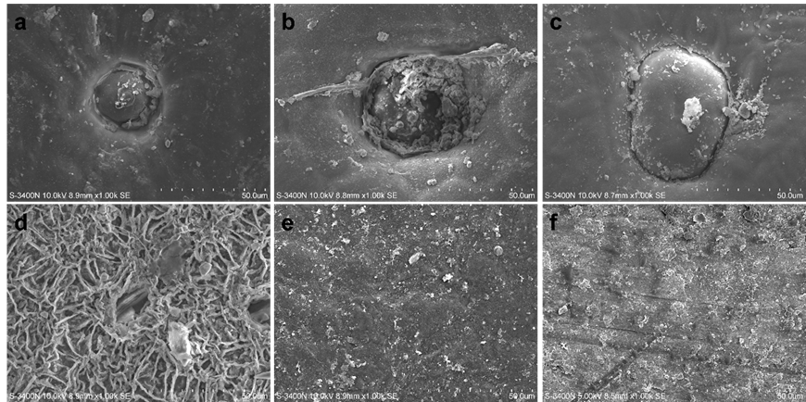
Fig. S1 Scanning electron microscope microstructure of the adaxial leaf surface of six mangrove plants. a A. marina; b A. ilicifolius; c A. corniculatum; d S. apetala; e E. agallocha; f K. candel.

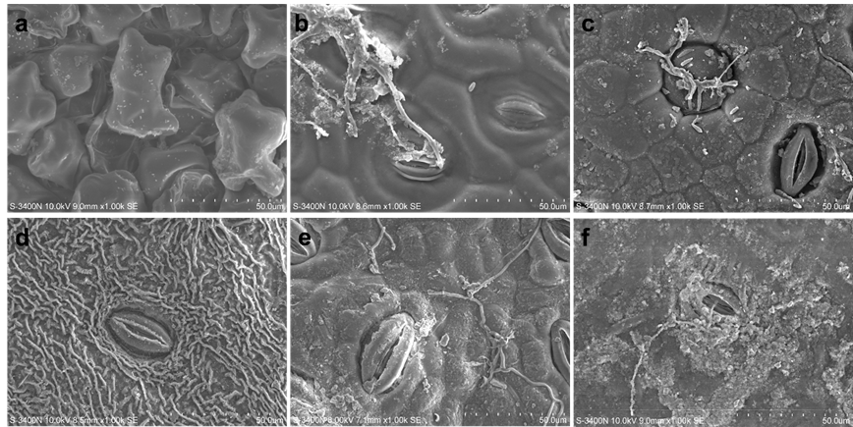
Fig. S2 Scanning electron microscope microstructure of the abaxial of leaf surface of six mangrove plants. a A. marina; b A. ilicifolius; c A. corniculatum; d S. apetala; e E. agallocha; f K. candel.

Fig. S3 Rarefaction curves of the leaf-surface microbial communities in six mangrove plants. a bacterial sobs index; b fungal sobs index; c bacterial Shannon index; d fungal Shannon index. Rarefaction curves were assembled showing the number of OTUs relative to the number of total sequences.

Fig. S4 Relative abundance of bacteria and fungi at genus level (top 15) between with salt glands and without salt glands mangrove plants. a bacteria; b fungi. The labels salt gland and non-salt gland represent mangrove plants with and without salt glands in their leaves, respectively.
Fig. S5 Bacterial a and fungal b genera (only the top 15 genera in relative abundance were displayed) between mangrove species with and without salt glands based on ANCOM-BC2 analysis.

Fig S6 Relative abundance of Pantoea a and Bacillus b genus in six mangrove species. The error bars represent the mean ± SDs.

Fig. S7 Metabolites of strains A and Y25 related to salt stress resistance and nutrient supply.

Fig. S8 Growth-promoting effects of C. islandicus (alone or in combination with A+Y25) on rice seedlings under salt stress. a Phenotype of the effect of the strain on the growth of rice seedlings under salt stress. b Effect of the strain on the length of shoot and root of rice seedlings under salt stress. c Effect of the strain on the weight of fresh and dry rice seedlings under salt stress. CK, no bacteria added. d Effects of exogenous additions on the growth of C. islandicus. e Morphology of C. islandicus. Different lowercase letters indicate significant differences, ANOVA, Tukey’s HSD test, *P ≤ 0.05. The error bars represent the mean ± SDs.
Table S1 BLAST results for isolated strains.
Code of  isolates | Taxonomic position | Similarity | Code of  isolates | Taxonomic position | Similarity
1-2 | Bacillus tequilensis | 100.00% | 9 | Pseudomonas sp. | 99.86%
2-2 | Bacillus sp. | 99.86% | A | Pantoea stewartii | 100.00%
3-1 | Bacillus subtilis | 100.00% | Y25 | Bacillus marisflavi | 100.00%
8 | Bacillus tequilensis | 100.00% | 4 | Penicillium citrinum | 100.00%
28 | Bacillus tequilensis | 99.86% | 7 | Cladosporium sphaerospermum | 100.00%
29 | Bacillus tequilensis | 100.00% | 12 | Penicillium citreosulfuratum | 100.00%
B7 | Planococcus maritimus | 99.93% | 15 | Penicillium crustosum | 100.00%
19 | Bacillus subtilis | 100.00% | 17 | Penicillium sp. | 100.00%
38 | Bacillus stercoris | 100.00% | 20 | Cladosporium tenuissimum | 100.00%
42 | Bacillus subtilis | 100.00% | 21 | Cladosporium sp. | 100.00%
45 | Bacillus sp. | 99.93% | 24 | Penicillium crustosum | 100.00%
49 | Bacillus sp. | 99.93% | 27 | Aspergillus sp. | 99.83%
6 | Bacillus megaterium | 100.00% | 30 | Alternaria tenuissima | 100.00%
35 | Lysinibacillus telephonicus | 99.93% | 31 | Alternaria alternata | 100.00%
40 | Bacillus sp. | 100.00% | 32 | Alternaria sp. | 99.82%
46 | Bacillus aquimaris | 99.72% | 36 | Penicillium glabrum | 100.00%
34 | Streptomyces sp. | 99.71% | 44 | Cladosporium sphaerospermum | 100.00%
41 | Kushneria sp. | 99.93% | 48 | Penicillium crustosum | 100.00%
22 | Altericroceibacterium sp. | 100.00% | 50 | Penicillium glabrum | 99.82%
25 | Psychrobacter sp. | 99.42% | 51 | Penicillium griseofulvum | 100.00%
10 | Staphylococcus xylosus | 99.93% | 37 | Aureobasidium sp. | 100.00%

Table S2 OTUs matched with isolated strains (sequence similarity >97%).
Isolated strains | Retrived ID | Identity (%) | with salt glands |  |  |  | without salt glands
Isolated strains | Retrived ID | Identity (%) | A. marina | A. ilicifolius | A. corniculatum | total count | S. apetala | E. agallocha | K. candel | total count
1-2 Bacillus tequilensis;  3-1 Bacillus subtilis;  8 Bacillus tequilensis;  19 Bacillus subtilis;  28 Bacillus tequilensis;  29 Bacillus tequilensis;  38 Bacillus stercoris;  42 Bacillus subtilis;  45 Bacillus sp. | OTU767 | 97.21 | 0 | 1 | 0 | 1 | 0 | 0 | 7 | 7
6 Bacillus megaterium  40 Bacillus sp. | OTU715 | 100 | 2 | 1 | 0 | 3 | 41 | 292 | 236 | 569
B7 Planococcus maritimus | OTU165 | 99.77 | 0 | 6 | 0 | 6 | 0 | 6 | 15 | 21
34 Streptomyces sp. | OTU1195 | 99.02 | 1 | 3 | 0 | 4 | 0 | 9 | 17 | 26
35 Lysinibacillus telephonicus | OTU117 | 98.83 | 0 | 0 | 0 | 0 | 0 | 1 | 51 | 52
41 Kushneria sp. | OTU2185 | 100 | 20 | 340 | 7 | 367 | 0 | 82 | 10 | 92
22 Altericroceibacterium sp. | OTU980 | 97.29 | 0 | 1 | 0 | 1 | 26 | 6 | 20 | 52
25 Psychrobacter sp. | OTU12 | 100 | 0 | 9 | 0 | 9 | 0 | 0 | 8 | 8
10 Staphylococcus xylosus | OTU1328 | 100 | 11 | 1 | 0 | 12 | 71 | 842 | 34 | 947
9 Pseudomonas sp. | OTU651 | 99.77 | 0 | 0 | 0 | 0 | 239 | 39 | 96 | 374
A Pantoea stewartii | OTU1046 | 99.30 | 0 | 3 | 0 | 3 | 899 | 968 | 108 | 1975
4 Penicillium citrinum | FOTU663 | 100 | 0 | 167 | 5 | 172 | 0 | 0 | 14 | 14
7 Cladosporium sphaerospermum  44 Cladosporium sphaerospermum | FOTU772 | 100 | 3205 | 495 | 1115 | 4815 | 532 | 186 | 372 | 1090
20 Cladosporium tenuissimum | FOTU264 | 100 | 5685 | 844 | 96 | 6625 | 9073 | 9604 | 5906 | 24583
21 Cladosporium sp. | FOTU543 | 100 | 16417 | 2298 | 576 | 19291 | 22971 | 58442 | 15048 | 96461
30 Alternaria tenuissima;  31 Alternaria alternata;  32 Alternaria sp. | FOTU214 | 99.52 | 3938 | 515 | 113 | 4566 | 12581 | 502 | 3040 | 16123
36 Penicillium glabrum | FOTU80 | 100 | 0 | 1 | 0 | 1 | 0 | 3 | 0 | 3
50 Penicillium glabrum | FOTU80 | 99.08 | 0 | 1 | 0 | 1 | 0 | 3 | 0 | 3
Note: OTU is the bacterial ID, FOTU is the fungal ID, the relative abundance of OTUs matched with isolated strains in the microbial communities of plants with and without salt gland structures.

Table S3 Salt tolerance and PGP properties of culturable microorganisms isolated from six mangrove plants.
Taxonomic position | Salt tolerance | Dissolved organic phosphorus | Dissolved inorganic phosphorus | Nitrogen fixation | Potassium dissolving
1-2 Bacillus tequilensis | + | + | - | - | -
2-2 Bacillus sp. | + | + | - | + | -
3-1 Bacillus subtilis | + | - | - | - | -
8 Bacillus tequilensis | + | - | - | - | -
28 Bacillus tequilensis | - | - | - | - | -
29 Bacillus tequilensis | + | - | - | - | -
B7 Planococcus maritimus | + | + | - | - | -
19 Bacillus subtilis | + | - | - | - | -
38 Bacillus stercoris | - | - | - | - | -
42 Bacillus subtilis | ++ | - | - | - | -
45 Bacillus sp. | +++ | - | + | - | -
49 Bacillus sp. | + | + | - | + | -
6 Bacillus megaterium | + | + | - | - | -
35 Lysinibacillus telephonicus | ++ | - | - | - | -
40 Bacillus sp. | + | - | + | - | +
46 Bacillus aquimaris | ++ | ++ | - | + | -
34 Streptomyces sp. | + | - | - | + | -
41 Kushneria sp. | +++ | ++ | - | - | -
22 Altericroceibacterium sp. | ++ | + | - | - | -
25 Psychrobacter sp. | + | - | - | - | -
10 Staphylococcus xylosus | +++ | +++ | - | - | -
9 Pseudomonas sp. | ++ | + | - | + | +
A Pantoea stewartii | +++ | +++ | + | - | +
Y25 Bacillus marisflavi | +++ | ++ | + | + | +
4 Penicillium citrinum | + | - | - | - | -
7 Cladosporium sphaerospermum | ++ | + | - | - | -
12 Penicillium citreosulfuratum | +++ | - | - | - | -
15 Penicillium crustosum | + | - | - | - | -
17 Penicillium sp. | + | + | + | + | -
20 Cladosporium tenuissimum | + | - | - | - | -
21 Cladosporium sp. | ++ | - | - | - | -
24 Penicillium crustosum | +++ | - | - | - | -
27 Aspergillus sp. | ++ | + | - | - | -
30 Alternaria tenuissima | - | - | - | - | -
31 Alternaria alternata | + | - | - | - | -
32 Alternaria sp. | ++ | - | - | - | -
36 Penicillium glabrum | + | - | - | - | -
44 Cladosporium sphaerospermum | ++ | - | - | - | -
48 Penicillium crustosum | - | - | - | - | -
50 Penicillium glabrum | +++ | ++ | - | + | -
51 Penicillium griseofulvum | - | - | - | - | -
37 Aureobasidium sp. | +++ | +++ | - | - | -
Note: +++ indicates strong ability; ++ indicates medium ability; + indicates weak ability; and - indicates that the ability has not been detected.

Table S4 Determination of soil salinity under different treatments.
group | Salinity (mS/cm)
H₂O | 0.070 ± 0.044^{b}
NaCl | 1.958 ± 0.137^{a***}
H₂O+A+Y25 | 0.134 ± 0.023^{b}
NaCl+A+Y25 | 1.947 ± 0.105^{a***}
Note: Different lowercase letters indicate significant differences (ANOVA, Tukey’s HSD test, *P ≤ 0.05, **P ≤ 0.01, ***P ≤ 0.001).

Table S5 Sequences of nucleotides of primers used in qRT-PCR.
Gene Name | Locus Name (CDS) | Primers (5’-3’)
OsActin | LOC_Os10g36650.1 | F:TGGCATCTCTCAGCACATTCC
OsActin | LOC_Os10g36650.1 | R:TGCACAATGGATGGGTCAGA
OsSOS1 | LOC_Os12g44360.2 | F: TACCCAAGAGTGCCTTCGAG
OsSOS1 | LOC_Os12g44360.2 | R: TCTATTGCCTTGCGTTGTCG
OsPIN1 | LOC_Os02g50960.1 | F: CATCACGCTCTTCTCCCTCT
OsPIN1 | LOC_Os02g50960.1 | R:GAGCGTGTACCAGATGATGC
OsCIPK15 | LOC_Os11g02240.1 | F:GCGTGGAAAGCTTACAGAGG
OsCIPK15 | LOC_Os11g02240.1 | R:CTGAAAGCGCACTCAATCCA

