Transgressive Hybrids as Hopeful Holobionts
Additional file 3: Ordination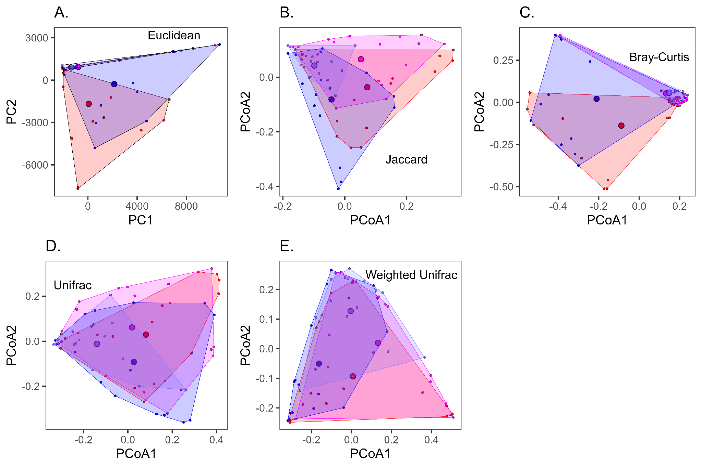
Figure 3.1. Two-dimensional Principal Coordinates Analysis (PCoA) of gut microbiota for populations of A. inornatus from SBluG (red), A. neomexicanus from SBluG (magenta), A. neomexicanus from SNW (purple), and A. marmoratus from SNW (blue) based on amplicon sequence variants (ASVs) in combination with (A) euclidean dissimilarity, (B) Jaccard dissimilarity, (C) Bray-Curtis dissimilarity, (D) UniFrac dissimilarity, and (E) weighted UniFrac dissimilarity.

Table 3.1. Percent variation explained by the first five Principal Coordinate Axes, both individually (%) and cumulatively (Cum%) for PCoA analyses of gut ASVs using Euclidean, Jaccard, Bray-Curtis, UniFrac, and weighted UniFrac distances.
 | PCoA1 |  | PCoA2 |  | PCoA3 |  | PCoA4 |  | PCoA5
 | % | Cum% | % | Cum% | % | Cum% | % | Cum% | % | Cum%
Euclidean  (PCA) | 49.98 | 49.98 | 17.53 | 67.51 | 4.27 | 71.78 | 3.38 | 75.16 | 2.87 | 78.03
Jaccard | 4.39 | 4.39 | 3.5 | 7.89 | 2.4 | 10.29 | 2.09 | 12.37 | 1.92 | 14.3
Bray-Curtis | 17.04 | 17.04 | 7.89 | 24.93 | 5.58 | 30.52 | 3.22 | 33.73 | 3 | 36.73
UniFrac | 18.46 | 18.46 | 10.1 | 28.56 | 5.04 | 33.6 | 4 | 37.61 | 2.91 | 40.52
w-UniFrac | 40.04 | 40.04 | 22.07 | 62.11 | 7.05 | 69.16 | 4.1 | 73.27 | 3.59 | 76.85

Table 3.2. ASVs with the five largest loadings on the first (PCA1) and second (PCA2) Principal Component Axes (Euclidean PCoA) for lizard gut microbiota.
 | Rank | Gut ASV | Loading | %Loading
P  C  A  1 | 1 | Dietzia maris | 0.987407 | 97.50
P  C  A  1 | 2 | Corynebacterium testudinoris | 0.134899 | 1.82
P  C  A  1 | 3 | Brevibacterium linens-salitolerans" | 0.042395 | 0.18
P  C  A  1 | 4 | Salmonella enterica | -0.025747 | 0.07
P  C  A  1 | 5 | Corynebacterium glyciniphilum" | 0.019802 | 0.04
P  C  A  2 | 1 | Corynebacterium testudinoris | -0.970945 | 94.27
P  C  A  2 | 2 | Propionibacteriaceae sp7816-sp7836 | -0.149714 | 2.24
P  C  A  2 | 3 | Dietzia maris | 0.139948 | 1.96
P  C  A  2 | 4 | Brevibacterium linens-salitolerans" | -0.063281 | 0.40
P  C  A  2 | 5 | Salmonella enterica | 0.045693 | 0.21

Table 3.3 Positions of the hybrid gut microbiota from SBluG along the first two ASV PCoA axes. Column 4-5 show p-values for Mann-Whitney U tests assessing whether the positions of hybrid animals along the first PCoA axis is significantly different than the positions of A. inornatus (ino) and A. marmoratus (marm) respectively. Column 9-10 show p-values for Mann-Whitney U tests assessing whether the position of the hybrid animals along the second PCoA axis is significantly different than the positions of A. inornatus (ino) and A. marmoratus (marm) respectively. Yellow is used for tests significantly different at p>0.05.

 | PCoA axis 1  mean |  |  | p-value |  | PCoA axis 2  mean |  |  | p-value
 | neo | ino | marm | ino | marm | neo | ino | marm | ino | marm
euclidean | 779 | -63 | -2138 | 0.0047 | 0.0042 | 942 | -1681 | -284 | 0 | 0.4221
jaccard | 0.052 | 0.073 | -0.043 | 0.6827 | 0.0519 | 0.066 | -0.037 | -0.081 | 0.0081 | 0.001
bray | 0.133 | -0.088 | -0.21 | 0.0012 | 8e-04 | 0.053 | -0.138 | 0.021 | 4e-04 | 0.8318
unifrac | 0.019 | 0.082 | 0.027 | 0.5021 | 0.987 | 0.061 | 0.03 | -0.092 | 0.6121 | 0.0165
wunifrac | 0.133 | 0.008 | -0.162 | 0.1332 | 2e-04 | 0.02 | -0.093 | -0.05 | 0.0656 | 0.2432

Table 3.4 Positions of the hybrid gut microbiota from SNW along the first two ASV PCoA axes. Column 4-5 show p-values for Mann-Whitney U tests assessing whether the positions of hybrid animals along the first PCoA axis is significantly different than the positions of A. inornatus (ino) and A. marmoratus (marm) respectively. Column 9-10 show p-values for Mann-Whitney U tests assessing whether the position of the hybrid animals along the second PCoA axis is significantly different than the positions of A. inornatus (ino) and A. marmoratus (marm) respectively. Yellow is used for tests significantly different at p>0.05.

 | PCoA axis 1  mean |  |  | p-value |  | PCoA axis 2  mean |  |  | p-value
 | neo | ino | marm | ino | marm | neo | ino | marm | ino | marm
euclidean | 1362 | -63 | -2138 | 0.0012 | 9e-04 | 902 | -1681 | -284 | 0 | 0.3183
jaccard | -0.098 | 0.073 | -0.043 | 0.0042 | 0.0597 | 0.043 | -0.037 | -0.081 | 0.2641 | 0.0171
bray | 0.149 | -0.088 | -0.21 | 0.0042 | 0.0015 | 0.058 | -0.138 | 0.021 | 0 | 0.4232
unifrac | -0.14 | 0.082 | 0.027 | 0.0135 | 0.0544 | -0.011 | 0.03 | -0.092 | 0.5196 | 0.2814
wunifrac | -0.003 | 0.008 | -0.162 | 0.4945 | 0.0055 | 0.127 | -0.093 | -0.05 | 8e-04 | 0.0082

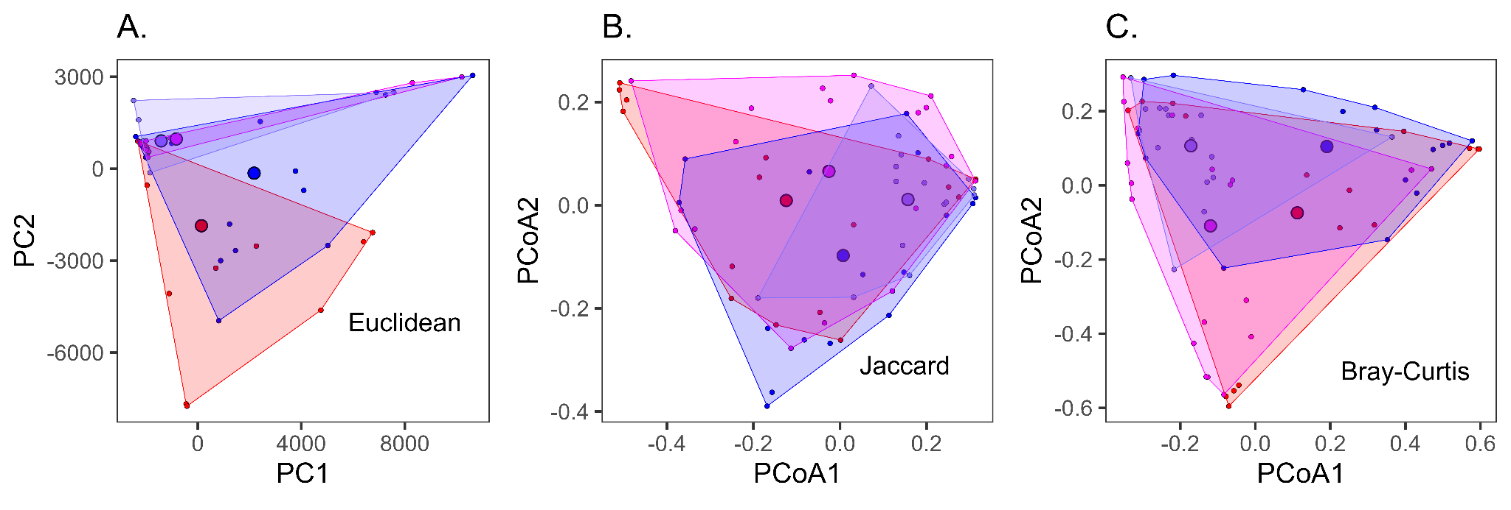
Figure 3.2. Two-dimensional Principal Coordinates Analysis of gut microbiota for populations of A. inornatus from SBluG (red), A. neomexicanus from SBluG (magenta), A. neomexicanus from SNW (purple), and A. marmoratus from SNW (blue) and based on microbial genera in combination with (A) euclidean dissimilarity, (B) Jaccard dissimilarity, and (C) Bray-Curtis dissimilarity.

Table 3.5. Percent variation explained by the first five Principal Coordinate Axes, both individually (%) and cumulatively (Cum%) for PCoA analyses of gut genera using Euclidean, Jaccard, and Bray-Curtis distances.
 | PCoA1 |  | PCoA2 |  | PCoA3 |  | PCoA4 |  | PCoA5
 | % | Cum% | % | Cum% | % | Cum% | % | Cum% | % | Cum%
Euclidean  (PCA) | 43.74 | 43.74 | 16.76 | 60.51 | 9.37 | 69.87 | 5.74 | 75.61 | 3.57 | 79.18
Jaccard | 17.61 | 17.61 | 7.94 | 25.55 | 3.99 | 29.54 | 3.32 | 32.86 | 3.05 | 35.91
Bray-Curtis | 25.41 | 25.41 | 17.41 | 42.82 | 9.47 | 52.28 | 5.77 | 58.05 | 4.4 | 62.46

Table 3.6. Genera with the five largest loadings on the first (PCA1) and second (PCA2) Principal Component Axes (Euclidean PCoA) for lizard gut microbiota.
 | Rank | Gut Genus | Loading | %Loading
P  C  A  1 | 1 | Dietzia | 0.970388 | 94.17
P  C  A  1 | 2 | Corynebacterium | 0.169186 | 2.86
P  C  A  1 | 3 | unclassified Lachnospiraceae | -0.085009 | 0.72
P  C  A  1 | 4 | Geodermatophilus | -0.069416 | 0.48
P  C  A  1 | 5 | Salmonella | -0.055386 | 0.31
P  C  A  2 | 1 | Corynebacterium | -0.946047 | 89.50
P  C  A  2 | 2 | Dietzia | 0.196495 | 3.86
P  C  A  2 | 3 | Salmonella | 0.149812 | 2.24
P  C  A  2 | 4 | unclassified Propionibacteriaceae | -0.141657 | 2.01
P  C  A  2 | 5 | unclassified Lachnospiraceae | 0.074217 | 0.55

Table 3.7 Positions of the hybrid gut microbiota from SBluG along the first two genus PCoA axes. Column 4-5 show p-values for Mann-Whitney U tests assessing whether the positions of hybrid animals along the first PCoA axis is significantly different than the positions of A. inornatus (ino) and A. marmoratus (marm) respectively. Column 9-10 show p-values for Mann-Whitney U tests assessing whether the position of the hybrid animals along the second PCoA axis is significantly different than the positions of A. inornatus (ino) and A. marmoratus (marm) respectively. Yellow is used for tests significantly different at p>0.05.

 | PCoA axis 1  mean |  |  | p-value |  | PCoA axis 2  mean |  |  | p-value
 | neo | ino | marm | ino | marm | neo | ino | marm | ino | marm
euclidean | -832 | 140 | 2176 | 0.1421 | 0.0111 | 971 | -1859 | -144 | 0.0023 | 0.3498
jaccard | -0.026 | -0.124 | 0.007 | 0.3331 | 0.8318 | 0.066 | 0.009 | -0.098 | 0.3331 | 0.01
bray | -0.119 | 0.112 | 0.191 | 0.0219 | 0.0073 | -0.109 | -0.074 | 0.104 | 0.7314 | 0.0123

Table 3.8 Positions of the hybrid gut microbiota from SNW along the first two genus PCoA axes. Column 4-5 show p-values for Mann-Whitney U tests assessing whether the positions of hybrid animals along the first PCoA axis is significantly different than the positions of A. inornatus (ino) and A. marmoratus (marm) respectively. Column 9-10 show p-values for Mann-Whitney U tests assessing whether the position of the hybrid animals along the second PCoA axis is significantly different than the positions of A. inornatus (ino) and A. marmoratus (marm) respectively. Yellow is used for tests significantly different at p>0.05.

 | PCoA axis 1  mean |  |  | p-value |  | PCoA axis 2  mean |  |  | p-value
 | neo | ino | marm | ino | marm | neo | ino | marm | ino | marm
euclidean | -1417 | 140 | 2176 | 0.151 | 0.012 | 907 | -1859 | -144 | 0.0106 | 0.4463
jaccard | 0.157 | -0.124 | 0.007 | 0.0106 | 0.0856 | 0.011 | 0.009 | -0.098 | 0.9224 | 0.0856
bray | -0.172 | 0.112 | 0.191 | 0.0055 | 0.0072 | 0.106 | -0.074 | 0.104 | 0.1102 | 0.9845

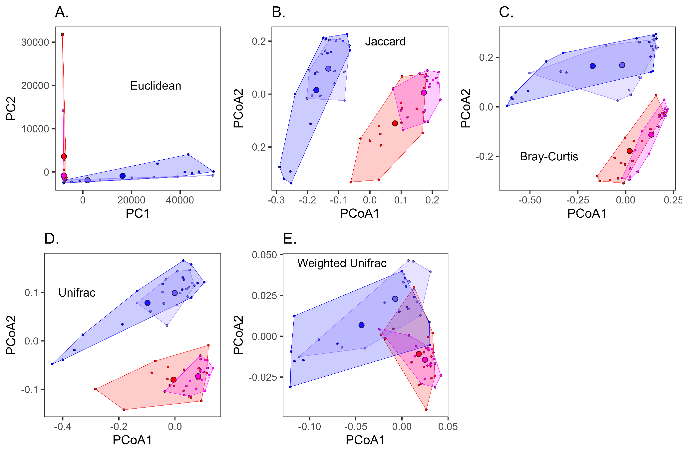
Figure 3.3. Two-dimensional Principal Coordinates Analysis (PCoA) of skin microbiota for populations of A. inornatus from SBluG (red), A. neomexicanus from SBluG (magenta), A. neomexicanus from SNW (purple), and A. marmoratus from SNW (blue) and based on amplicon sequence variants (ASVs) in combination with (A) euclidean dissimilarity, (B) Jaccard dissimilarity, (C) Bray-Curtis dissimilarity, (D) UniFrac dissimilarity, and (E) weighted UniFrac dissimilarity.

Table 3.9. Percent variation explained by the first five Principal Coordinate Axes, both individually (%) and cumulatively (Cum%) for PCoA analyses of skin ASVs using Euclidean, Jaccard, Bray-Curtis, UniFrac, and weighted UniFrac distances.
 | PCoA1 |  | PCoA2 |  | PCoA3 |  | PCoA4 |  | PCoA5
 | % | Cum% | % | Cum% | % | Cum% | % | Cum% | % | Cum%
Euclidean  (PCA) | 73.99 | 73.99 | 8.78 | 82.78 | 3.55 | 86.33 | 2.31 | 88.64 | 1.49 | 90.13
Jaccard | 7.5 | 7.5 | 6.65 | 14.15 | 3.77 | 17.92 | 3.14 | 21.06 | 2.56 | 23.62
Bray-Curtis | 18.62 | 18.62 | 12.52 | 31.14 | 7.29 | 38.43 | 4.56 | 42.99 | 3.62 | 46.61
UniFrac | 11.57 | 11.57 | 6.05 | 17.62 | 3.59 | 21.22 | 2.86 | 24.07 | 2.43 | 26.51
w-UniFrac | 45.57 | 45.57 | 11.12 | 56.69 | 5.21 | 61.9 | 4.67 | 66.56 | 4.17 | 70.74

Table 3.10. ASVs with the five largest loadings on the first (PCA1) and second (PCA2) Principal Component Axes (Euclidean PCoA) for lizard skin microbiota.
 | Rank | Skin ASV | Loading | %Loading
P  C  A  1 | 1 | Fodinibacter luteus | 0.995745 | 99.15
P  C  A  1 | 2 | Arthrobacter agilis | 0.056460 | 0.32
P  C  A  1 | 3 | Nocardioides mesophilus | -0.020697 | 0.04
P  C  A  1 | 4 | Kocuria polaris | 0.020384 | 0.04
P  C  A  1 | 5 | Dietzia maris | -0.019132 | 0.04
P  C  A  2 | 1 | Dietzia maris | 0.986550 | 97.33
P  C  A  2 | 2 | Geodermatophilus africanus-obscurus | -0.074128 | 0.55
P  C  A  2 | 3 | Corynebacterium testudinoris | 0.058295 | 0.34
P  C  A  2 | 4 | Geodermatophilus africanus-obscurus-siccatus | -0.043706 | 0.19
P  C  A  2 | 5 | Aeromicrobium massiliense | 0.042662 | 0.18

Table 3.11 Positions of the hybrid skin microbiota from SNW along the first two ASV PCoA axes. Column 4-5 show p-values for Mann-Whitney U tests assessing whether the positions of hybrid animals along the first PCoA axis is significantly different than the positions of A. inornatus (ino) and A. marmoratus (marm) respectively. Column 9-10 show p-values for Mann-Whitney U tests assessing whether the position of the hybrid animals along the second PCoA axis is significantly different than the positions of A. inornatus (ino) and A. marmoratus (marm) respectively. Yellow is used for tests significantly different at p>0.05.

 | PCoA axis 1  mean |  |  | p-value |  | PCoA axis 2  mean |  |  | p-value
 | neo | ino | marm | ino | marm | neo | ino | marm | ino | marm
euclidean | -1922 | 7799 | -16353 | 0.0023 | 0.5125 | -1914 | 3615 | -885 | 4e-04 | 0.3245
jaccard | -0.133 | 0.08 | -0.172 | 0 | 0.2169 | 0.096 | -0.111 | 0.015 | 0 | 0.8063
bray | -0.019 | 0.02 | -0.173 | 0.8916 | 0.3453 | 0.168 | -0.179 | 0.165 | 0 | 0.8063
unifrac | -0.001 | -0.005 | -0.098 | 0.5986 | 0.5125 | 0.099 | -0.08 | 0.079 | 0 | 0.9674
wunifrac | -0.007 | 0.018 | -0.044 | 0.0048 | 0.0742 | 0.023 | -0.011 | 0.007 | 1e-04 | 0.0453

Table 3.12 Positions of the hybrid skin microbiota from SBluG along the first two ASV PCoA axes. Column 4-5 show p-values for Mann-Whitney U tests assessing whether the positions of hybrid animals along the first PCoA axis is significantly different than the positions of A. inornatus (ino) and A. marmoratus (marm) respectively. Column 9-10 show p-values for Mann-Whitney U tests assessing whether the position of the hybrid animals along the second PCoA axis is significantly different than the positions of A. inornatus (ino) and A. marmoratus (marm) respectively. Yellow is used for tests significantly different at p>0.05.

 | PCoA axis 1  mean |  |  | p-value |  | PCoA axis 2  mean |  |  | p-value
 | neo | ino | marm | ino | marm | neo | ino | marm | ino | marm
euclidean | 7860 | 7799 | -16353 | 0.2569 | 8e-04 | -835 | 3615 | -885 | 0.0441 | 0.5836
jaccard | 0.173 | 0.08 | -0.172 | 0 | 0 | 0.005 | -0.111 | 0.015 | 0.0026 | 0.2561
bray | 0.134 | 0.02 | -0.173 | 0.0014 | 0.0039 | -0.113 | -0.179 | 0.165 | 0.0883 | 0
unifrac | 0.083 | -0.005 | -0.098 | 0.0037 | 1e-04 | -0.073 | -0.08 | 0.079 | 0.4611 | 0
wunifrac | 0.025 | 0.018 | -0.044 | 0.3331 | 0 | -0.014 | -0.011 | 0.007 | 0.5669 | 8e-04

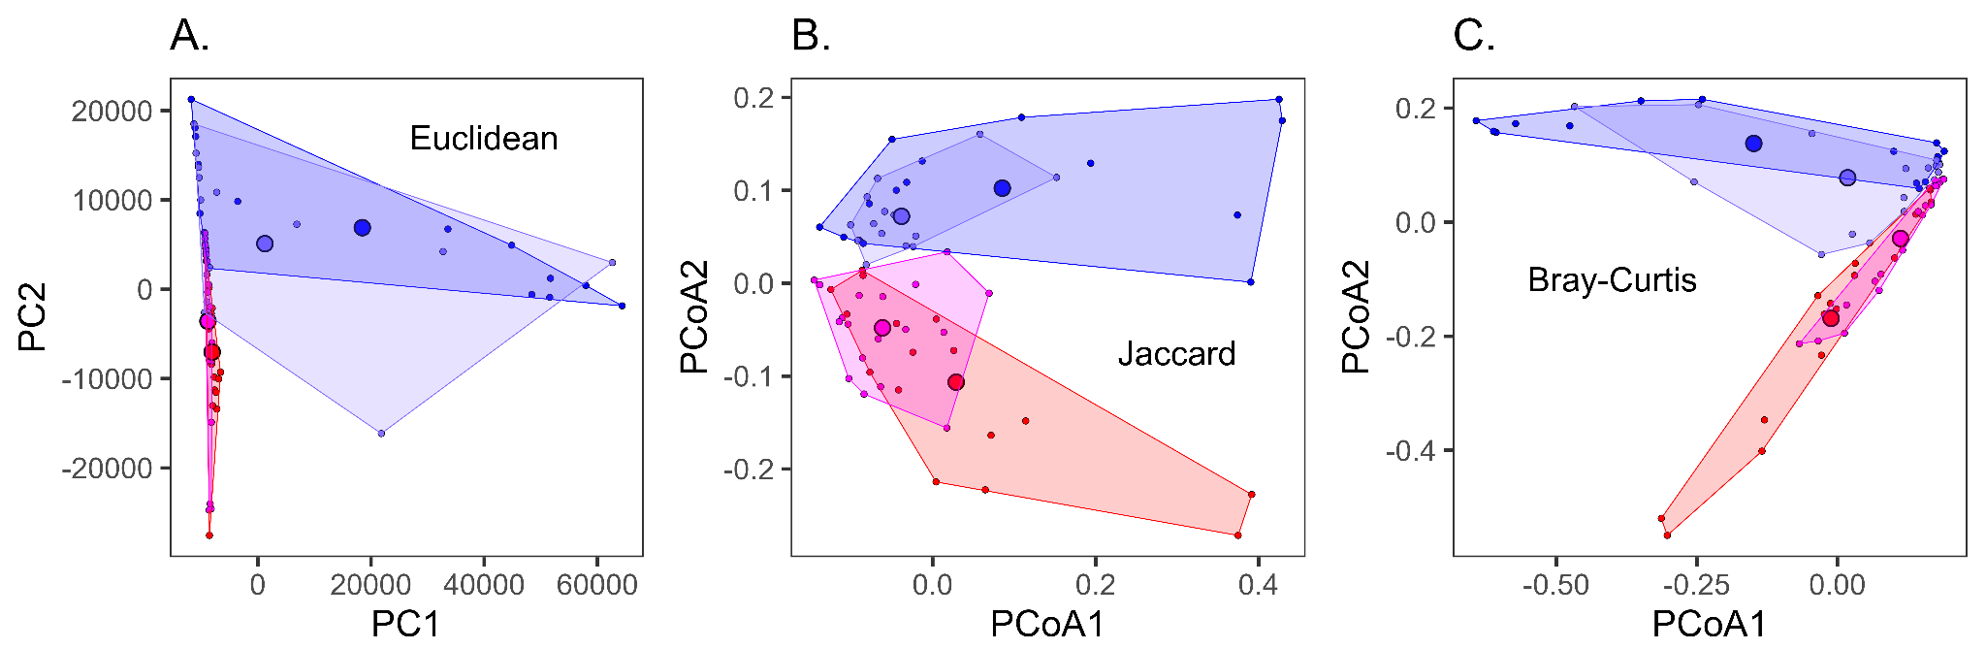Figure 3.4. Two-dimensional Principal Coordinates Analysis (PCoA, A-C) or Non-metric MultiDimensional Scaling (NMDS, D-F) of skin microbiota for populations of A. inornatus from SBluG (red), A. neomexicanus from SBluG (magenta), A. neomexicanus from SNW (purple) and A. marmoratus from SNW (blue) based on microbial genera in combination with (A) euclidean dissimilarity, (B) Jaccard dissimilarity, and (C) Bray-Curtis dissimilarity.

Table 3.13. Percent variation explained by the first five Principal Coordinate Axes, both individually (%) and cumulatively (Cum%) for PCoA analyses of skin genera using Euclidean, Jaccard, and Bray-Curtis distances.
 | PCoA1 |  | PCoA2 |  | PCoA3 |  | PCoA4 |  | PCoA5
 | % | Cum% | % | Cum% | % | Cum% | % | Cum% | % | Cum%
Euclidean  (PCA) | 56.58 | 56.58 | 14.53 | 71.11 | 8.38 | 79.49 | 5.93 | 85.42 | 5.23 | 90.65
Jaccard | 14.79 | 14.79 | 7.62 | 22.41 | 5.63 | 28.04 | 3.87 | 31.91 | 3.36 | 35.27
Bray-Curtis | 33.98 | 33.98 | 17.64 | 51.62 | 11.08 | 62.69 | 7.23 | 69.93 | 4.48 | 74.41

Table 3.14. Genera with the five largest loadings on the first (PCA1) and second (PCA2) Principal Component Axes (Euclidean PCoA) for lizard skin microbiota.
 | Rank | Skin Genus | Loading | %Loading
P  C  A  1 | 1 | Fodinibacter | 0.979675 | 95.98
P  C  A  1 | 2 | Geodermatophilus | -0.120809 | 1.46
P  C  A  1 | 3 | Streptomyces | -0.066442 | 0.44
P  C  A  1 | 4 | Arthrobacter | 0.054813 | 0.30
P  C  A  1 | 5 | Rubrobacter | -0.046422 | 0.22
P  C  A  2 | 1 | Geodermatophilus | 0.705442 | 49.76
P  C  A  2 | 2 | Nocardioides | -0.623731 | 38.90
P  C  A  2 | 3 | Dietzia | -0.143556 | 2.06
P  C  A  2 | 4 | unclassified Lachnospiraceae | -0.117034 | 1.37
P  C  A  2 | 5 | Acinetobacter | -0.097352 | 0.95

Table 3.15 Positions of the hybrid skin microbiota from SBluG along the first two genus PCoA axes. Column 4-5 show p-values for Mann-Whitney U tests assessing whether the positions of hybrid animals along the first PCoA axis is significantly different than the positions of A. inornatus (ino) and A. marmoratus (marm) respectively. Column 9-10 show p-values for Mann-Whitney U tests assessing whether the position of the hybrid animals along the second PCoA axis is significantly different than the positions of A. inornatus (ino) and A. marmoratus (marm) respectively. Yellow is used for tests significantly different at p>0.05.

 | PCoA axis 1  mean |  |  | p-value |  | PCoA axis 2  mean |  |  | p-value
 | neo | ino | marm | ino | marm | neo | ino | marm | ino | marm
euclidean | 1262 | -8056 | 18469 | 0.2814 | 0.3453 | -5108 | 7025 | -6899 | 8.00E-04 | 0.8063
jaccard | -0.038 | 0.029 | 0.085 | 0.2641 | 0.3046 | 0.072 | -0.107 | 0.102 | 0 | 0.1485
bray | 0.018 | -0.011 | -0.149 | 0.2995 | 0.4864 | 0.078 | -0.169 | 0.138 | 0 | 0.0164

Table 3.16 Positions of the hybrid skin microbiota from SBluG along the first two genus PCoA axes. Column 4-5 show p-values for Mann-Whitney U tests assessing whether the positions of hybrid animals along the first PCoA axis is significantly different than the positions of A. inornatus (ino) and A. marmoratus (marm) respectively. Column 9-10 show p-values for Mann-Whitney U tests assessing whether the position of the hybrid animals along the second PCoA axis is significantly different than the positions of A. inornatus (ino) and A. marmoratus (marm) respectively. Yellow is used for tests significantly different at p>0.05.

 | PCoA axis 1  mean |  |  | p-value |  | PCoA axis 2  mean |  |  | p-value
 | neo | ino | marm | ino | marm | neo | ino | marm | ino | marm
euclidean | -8793 | -8056 | 18469 | 0.0023 | 0.3024 | 3563 | 7025 | -6899 | 0.0656 | 0.0187
jaccard | -0.062 | 0.029 | 0.085 | 0.0479 | 0.0557 | -0.048 | -0.107 | 0.102 | 0.0948 | 0
bray | 0.112 | -0.011 | -0.149 | 0.0037 | 0.1675 | -0.029 | -0.169 | 0.138 | 0.015 | 0

