Transgressive Hybrids as Hopeful Holobionts
Additional File 8: 4H Index Analyses
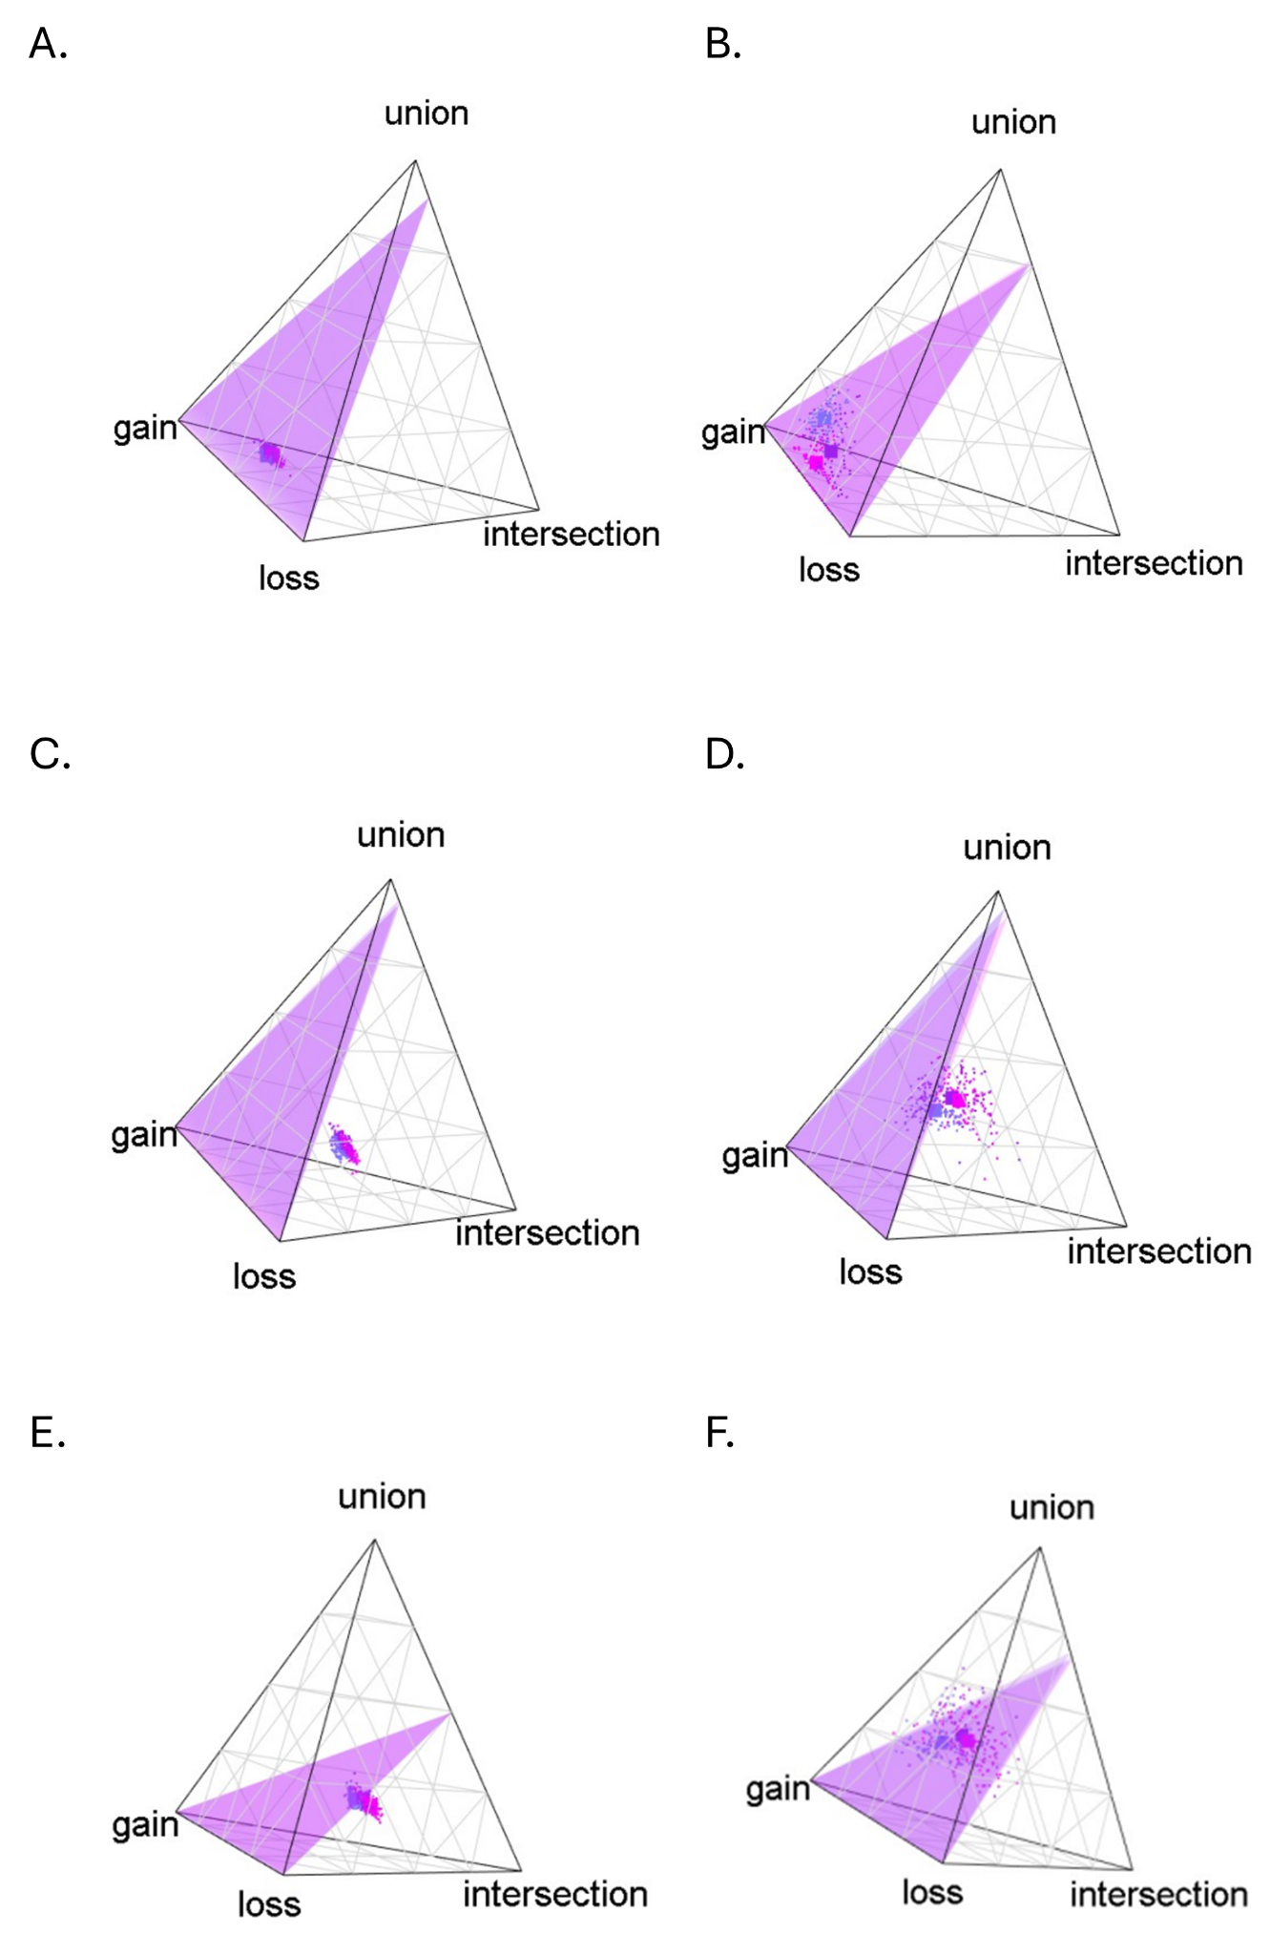
Figure 8.1 Quaternary plots for skin microbiota assuming a 0% core threshold (full, microbiota, A,C and E) and a 50% core threshold (B,D and F). Here we use a Jaccard-inspired metric on ASVs (A,B), a UniFrac-inspired metric on ASVs (C,D) and a Jaccard-inspired metric on genera (E,F).

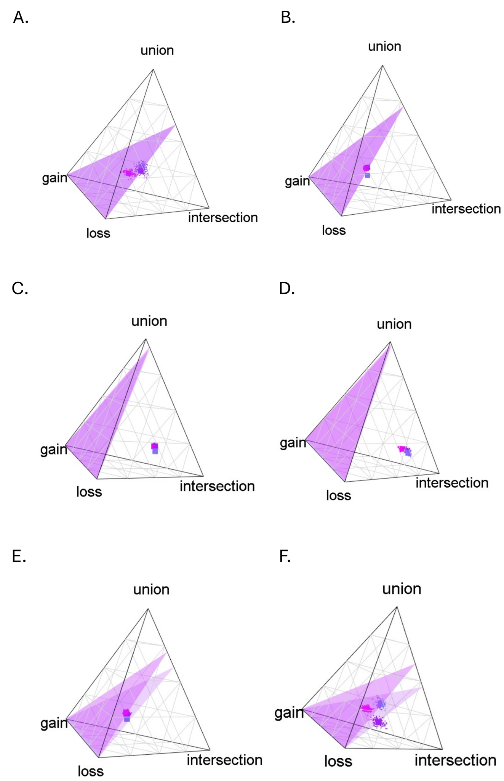
Figure 8.2 Quaternary plots for gut microbiota assuming a 0% core threshold (full, microbiota, A,C and E) and a 50% core threshold (B,D and F). Here we use a Jaccard-inspired metric on ASVs (A,B), a UniFrac-inspired metric on ASVs (C,D) and a Jaccard-inspired metric on genera (E,F).

Table 8.1. The four dimensions (intersection, union, gain, and loss) of the 4H metric for gut and skin microbiota of Aspidoscelis neomexicanus at SBluG, A. neomexicanus at SNW, and A. neomexicanus overall using a Jaccard-inspired 4H metric on ASVs and a core threshold of 0%.
 | intersection | union | Parental axis | gain | loss | Transgressive axis
Gut ASV (both) | 0.291976 | 0.167519 | 0.459495 | 0.2355 | 0.305005 | 0.540505
Gut ASV (SNW) | 0.288655 | 0.14596 | 0.434615 | 0.242212 | 0.323173 | 0.565385
Gut ASV (SBluG) | 0.301845 | 0.156991 | 0.458836 | 0.206907 | 0.334257 | 0.541164
Skin ASV (both) | 0.191526 | 0.24807 | 0.439596 | 0.182442 | 0.377961 | 0.560404
Skin ASV (SNW) | 0.193422 | 0.202381 | 0.395803 | 0.144459 | 0.459738 | 0.604197
Skin ASV (SBluG) | 0.187028 | 0.240872 | 0.4279 | 0.187098 | 0.385002 | 0.5721
Gut Genus (both) | 0.352039 | 0.18224 | 0.534279 | 0.206532 | 0.259189 | 0.465721
Gut Genus (SNW) | 0.339219 | 0.177576 | 0.516795 | 0.240319 | 0.242886 | 0.483205
Gut Genus (SBluG) | 0.362021 | 0.169939 | 0.53196 | 0.164889 | 0.303151 | 0.46804
Skin Genus (both) | 0.227088 | 0.212734 | 0.439822 | 0.232683 | 0.327495 | 0.560178
Skin Genus (SNW) | 0.193313 | 0.203594 | 0.396907 | 0.143356 | 0.459737 | 0.603093
Skin Genus (SBluG) | 0.186878 | 0.23976 | 0.426638 | 0.18652 | 0.386842 | 0.573362

Table 8.2. The four dimensions (intersection, union, gain, and loss) of the 4H metric for gut and skin microbiota of Aspidoscelis neomexicanus at SBluG, A. neomexicanus at SNW, and A. neomexicanus overall using a UniFrac-inspired 4H metric on ASVs and a core threshold of 0%.
 | intersection | union | Parental axis | gain | loss | Transgressive axis
Gut ASV (both) | 0.291976 | 0.167519 | 0.459495 | 0.2355 | 0.305005 | 0.540505
Gut ASV (SNW) | 0.288655 | 0.14596 | 0.434615 | 0.242212 | 0.323173 | 0.565385
Gut ASV (SBluG) | 0.301845 | 0.156991 | 0.458836 | 0.206907 | 0.334257 | 0.541164
Skin ASV (both) | 0.466235 | 0.202241 | 0.668476 | 0.102447 | 0.229077 | 0.331524
Skin ASV (SNW) | 0.467406 | 0.170353 | 0.637759 | 0.078168 | 0.284073 | 0.362241
Skin ASV (SBluG) | 0.459918 | 0.199827 | 0.659746 | 0.109123 | 0.231132 | 0.340254

Table 8.3. The four dimensions (intersection, union, gain, and loss) of the 4H metric for gut and skin microbiota of Aspidoscelis neomexicanus at SBluG, A. neomexicanus at SNW, and A. neomexicanus overall using a Jaccard-inspired 4H metric on ASVs and a core threshold of 50%.
 | intersection | union | Parental axis | gain | loss | Transgressive axis
Gut ASV (both) | 0 | 0.107366 | 0.107366 | 0.3525 | 0.540134 | 0.892634
Gut ASV (SNW) | 0 | 0.157988 | 0.157988 | 0.50857 | 0.333442 | 0.842012
Gut ASV (SBluG) | 0 | 0.05508 | 0.05508 | 0.423589 | 0.521331 | 0.94492
Skin ASV (both) | 0.288093 | 0.243767 | 0.531859 | 0.185853 | 0.282288 | 0.468141
Skin ASV (SNW) | 0.286947 | 0.273862 | 0.560809 | 0.18218 | 0.257011 | 0.439191
Skin ASV (SBluG) | 0.244858 | 0.199172 | 0.44403 | 0.294612 | 0.261357 | 0.55597
Gut Genus (both) | 0.166464 | 0.32791 | 0.494374 | 0.316415 | 0.189211 | 0.505626
Gut Genus (SNW) | 0.148701 | 0.283391 | 0.432092 | 0.402685 | 0.165223 | 0.567908
Gut Genus (SBluG) | 0.178326 | 0.315567 | 0.493893 | 0.283788 | 0.222319 | 0.506107
Skin Genus (both) | 0.357385 | 0.127176 | 0.484562 | 0.204795 | 0.310643 | 0.515438
Skin Genus (SNW) | 0.293998 | 0.268983 | 0.562981 | 0.178201 | 0.258818 | 0.437019
Skin Genus (SBluG) | 0.247156 | 0.199134 | 0.446289 | 0.28939 | 0.264321 | 0.553711
Table 8.4. The four dimensions (intersection, union, gain, and loss) of the 4H metric for gut and skin microbiota of Aspidoscelis neomexicanus at SBluG, A. neomexicanus at SNW, and A. neomexicanus overall using a UniFrac-inspired 4H metric on ASVs and a core threshold of 50%.
 | intersection | union | Parental axis | gain | loss | Transgressive axis
Gut ASV (both) | 0.262693 | 0.323627 | 0.58632 | 0.309406 | 0.104274 | 0.41368
Gut ASV (SNW) | 0.246477 | 0.269075 | 0.515552 | 0.37496 | 0.109488 | 0.484448
Gut ASV (SBluG) | 0.277674 | 0.322314 | 0.599988 | 0.28124 | 0.118772 | 0.400012
Skin ASV (both) | 0.612187 | 0.162919 | 0.775106 | 0.098164 | 0.12673 | 0.224894
Skin ASV (SNW) | 0.615627 | 0.148881 | 0.764508 | 0.082369 | 0.153123 | 0.235492
Skin ASV (SBluG) | 0.58287 | 0.162787 | 0.745657 | 0.144062 | 0.110281 | 0.254343

