Supplementary Tables:
Table 1. Associations between soluble immune factors and S. mitis-binding IgA and IgG (n=40)
 | S. mitis-binding IgA | S. mitis-binding IgG
sE-cad | 0.102 | 0.234*
MMP-9 | 0.424* | -0.021
IL-1α | 0.201 | 0.113
IL-1β | 0.216 | 0.243
IL-8 | 0.222 | 0.158
MIP-1β | 0.394* | 0.187
β -coefficients for multiple linear regression models controlling for Gardnerella abundance. *p<0.05, **p<0.01, ***p<0.001, ****p<0.0001.

Supplementary Figures
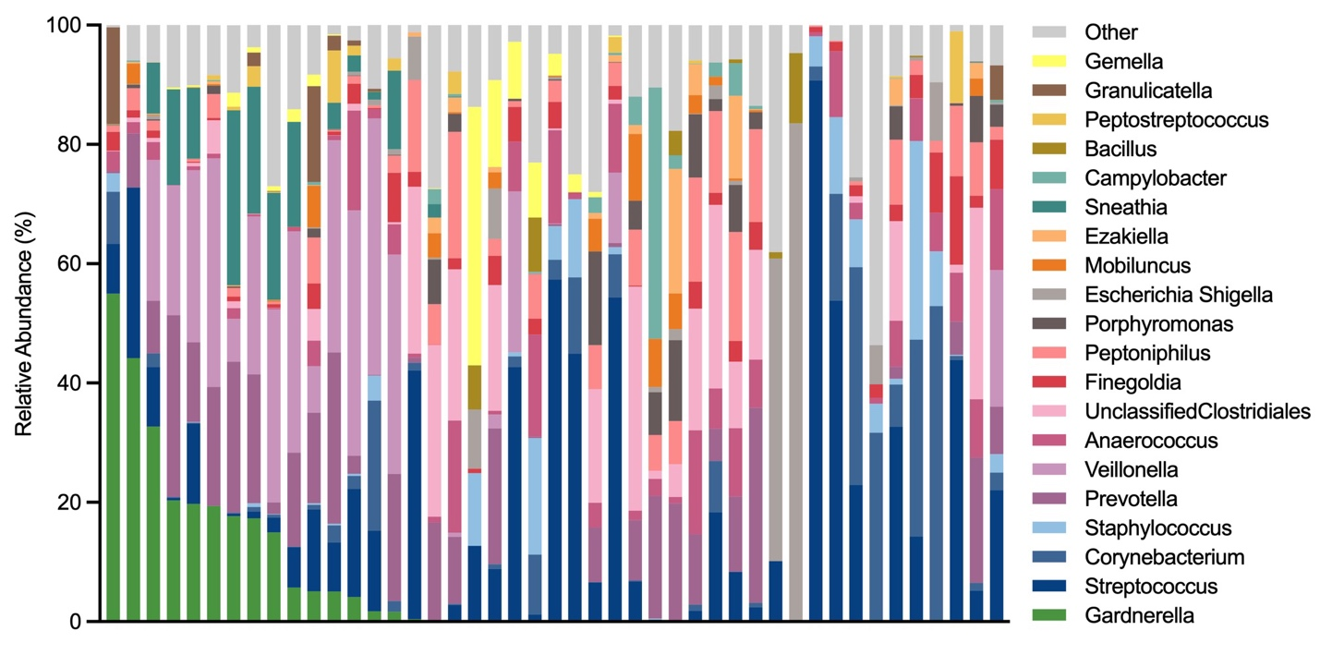
Supplementary Figure 1. Urethral microbiome composition in uncircumcised Ugandan men. Stacked bar graph showing the relative abundance of the 20 most abundant taxa in the penile urethral microbiome, arranged in descending order of Gardnerella relative abundance.

