Supplementary Figures
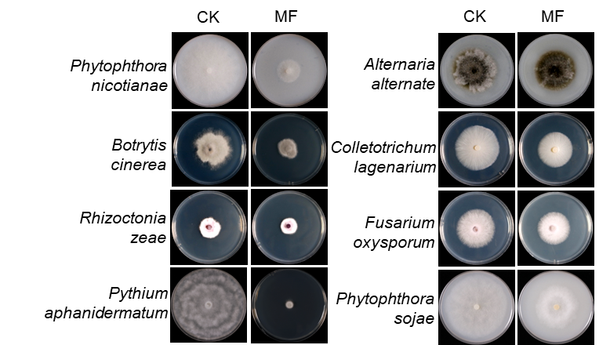
Figure S1. The inhibitory effect of MF on fungi.

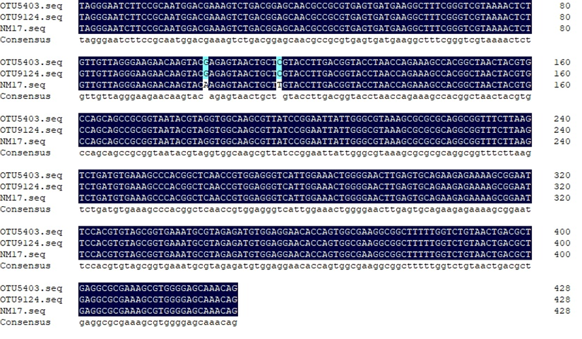
Figure S2. The sequence alignment of OTU5403 (field samples), OTU9124(pot samples) and NM17 strain.
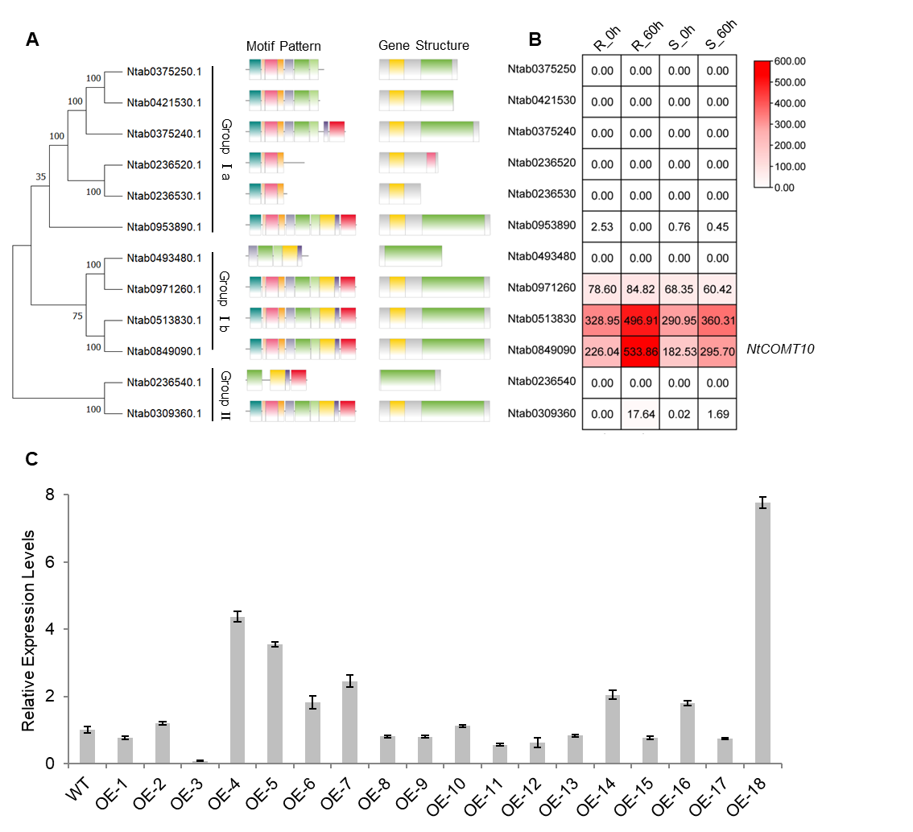
Figure S3. The gene analysis of NtCOMTs10.
A. Phylogenetic relationships, motif patterns, and gene structures of tobacco COMTs
B. Heatmap analysis of COMTs in resistant and susceptible tobacco cultivars. 0 h, before being inoculated with P. nicotianae, 60 h, after inoculation with P. nicotianae.
C. The expression levels of NtCOMT1 in overexpression lines.
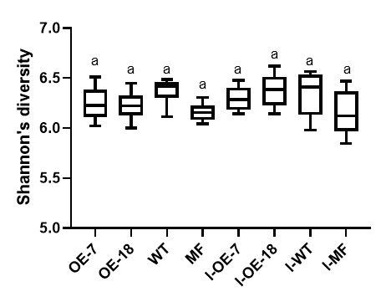
Figure S4. The Shannon’s diversity of wild type, wild type with MF treatment, overexpression lines with or without inoculated P. nicotianae.
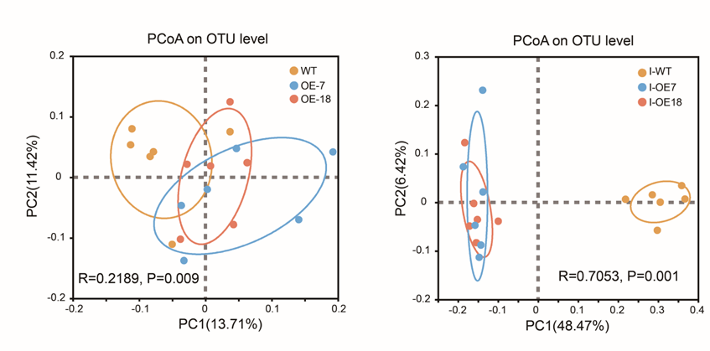
Figure S5. The PCoA on OTU levels of wild type and overexpression lines with or without inoculated P. nicotianae.

