Supplementary Information

PhyloFunc: phylogeny-informed functional distance as a new ecological metric for metaproteomic data analysis

Luman Wang¹, Caitlin M. A. Simopoulos², Joeselle M. Serrana², Zhibin Ning², Yutong Li³, Boyan Sun⁴, Jinhui Yuan⁴, Daniel Figeys²*, Leyuan Li⁴**
¹Department of Health Informatics and Management, School of Health Humanities, Peking University, Beijing 100191, China
²School of Pharmaceutical Sciences and Department of Biochemistry, Microbiology, and Immunology, Faculty of Medicine, the Ottawa Institute of Systems Biology, University of Ottawa, Ottawa, Ontario, K1H 8M5, Canada
³School of Public Health, Jilin University, Changchun 130021, China
⁴State Key Laboratory of Medical Proteomics, Beijing Proteome Research Center, National Center for Protein Sciences (Beijing), Beijing Institute of Lifeomics, Beijing 102206, China
*Corresponding author: Daniel Figeys:, dfigeys@uottawa.ca
**Leyuan Li, lileyuan@ncpsb.org.cn

Table of contents

Supplementary Figures:
Figure S1. The calculation process of PhyloFunc distance, part 1.
Figure S2. The calculation process of PhyloFunc distance, part 2.
Figure S3. The phylogenetic tree of the mouse gut microbiome case dataset.
Figure S4. Comparison of four UniFrac distance metrics applied to the mouse gut microbiome dataset.
Figure S5. The phylogenetic tree of the human gut microbiome case dataset.
Figure S6. Comparison different distances for human gut microbiome by PCoA and statistical analysis between Azathioprine (AZ) and control group (NC).
Figure S7. Comparison different distances for human gut microbiome by PCoA and statistical analysis between Ciprofloxacin (CP) and control group (NC).
Figure S8. Comparison different distances for human gut microbiome by PCoA and statistical analysis between Diclofenac (DC) and control group (NC).
Figure S9. Comparison different distances for human gut microbiome by PCoA and statistical analysis between Nizatidine (NZ) and control group (NC).
Figure S10. Comparison of different distance metrics on same human gut microbiome dataset searched against the UHGG database.

Supplementary Tables:
Table S1. PERMANOVA results between Paracetamol (PR) and control group (NC).
Table S2. PERMANOVA results between Nizatidine (NZ) and control group (NC).
Table S3. PERMANOVA results between Diclofenac (DC) and control group (NC).
Table S4. PERMANOVA results between Ciprofloxacin (CP) and control group (NC).
Table S5. PERMANOVA results between Azathioprine (AZ) and control group (NC).
Table S6. List of primary optimal parameters for classification.
Table S7. List of microbial species used to construct the phylogenetic tree.

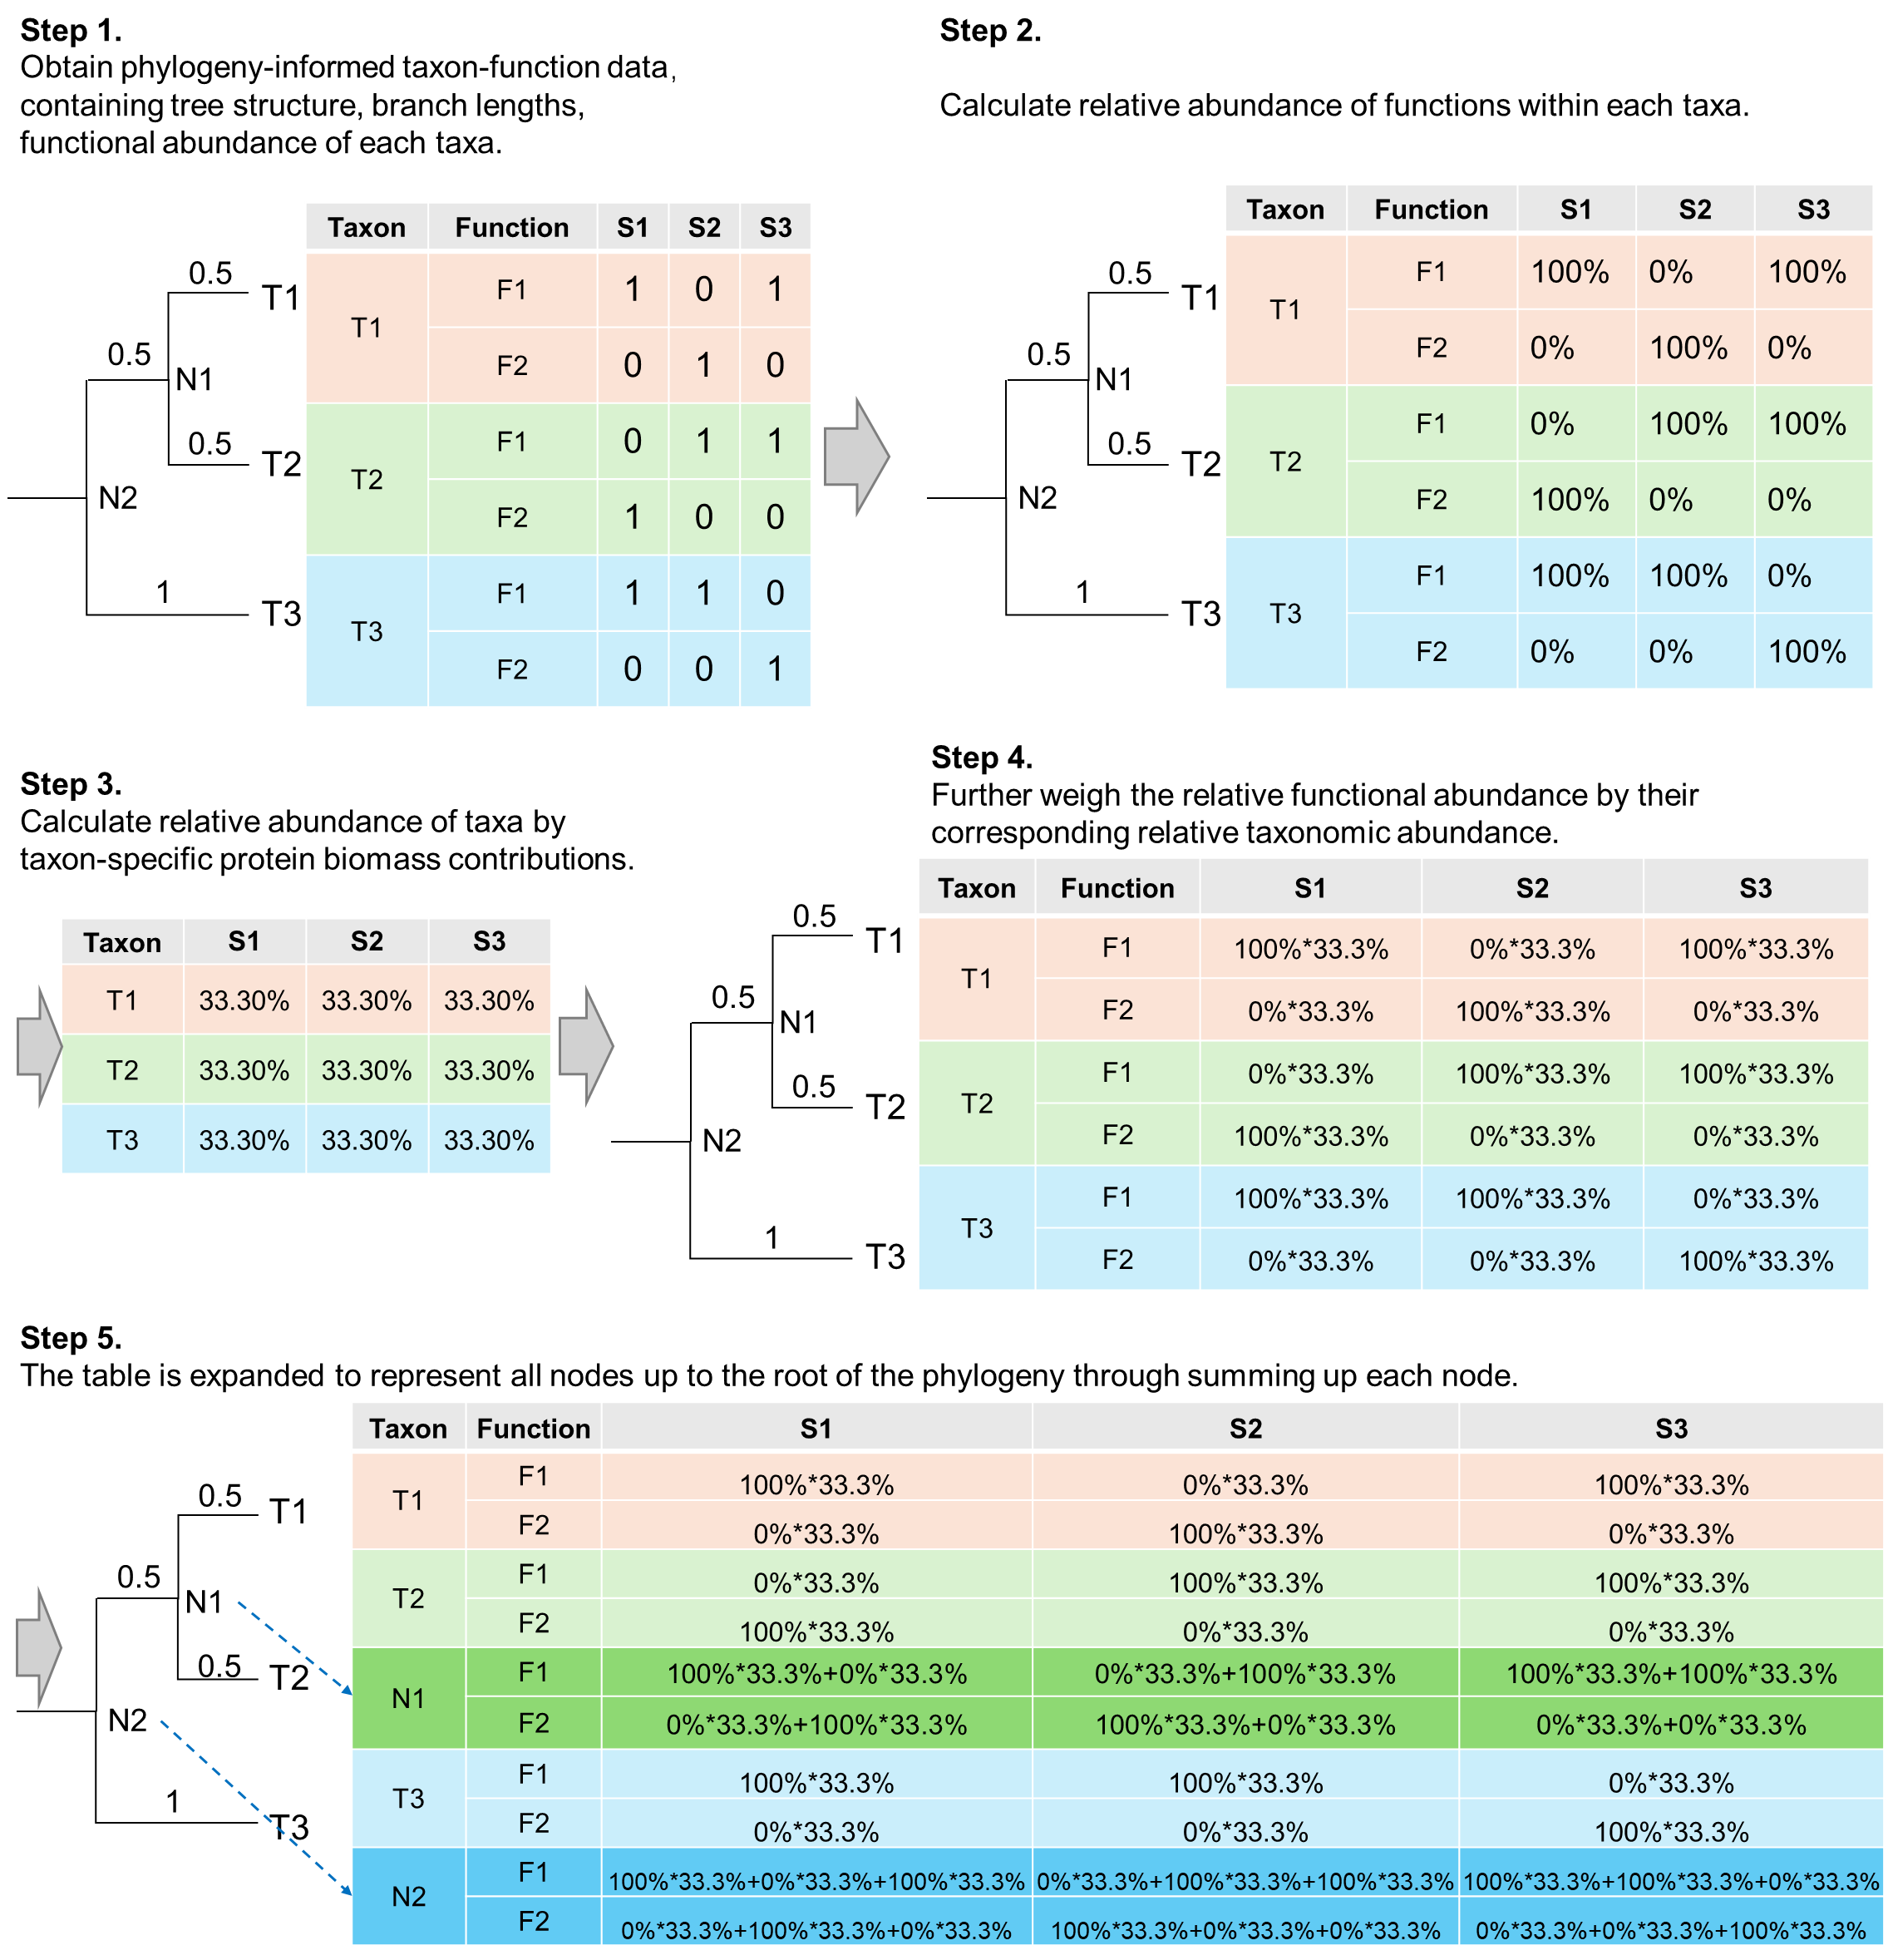
Figure S1. The calculation process of PhyloFunc distance, part 1.
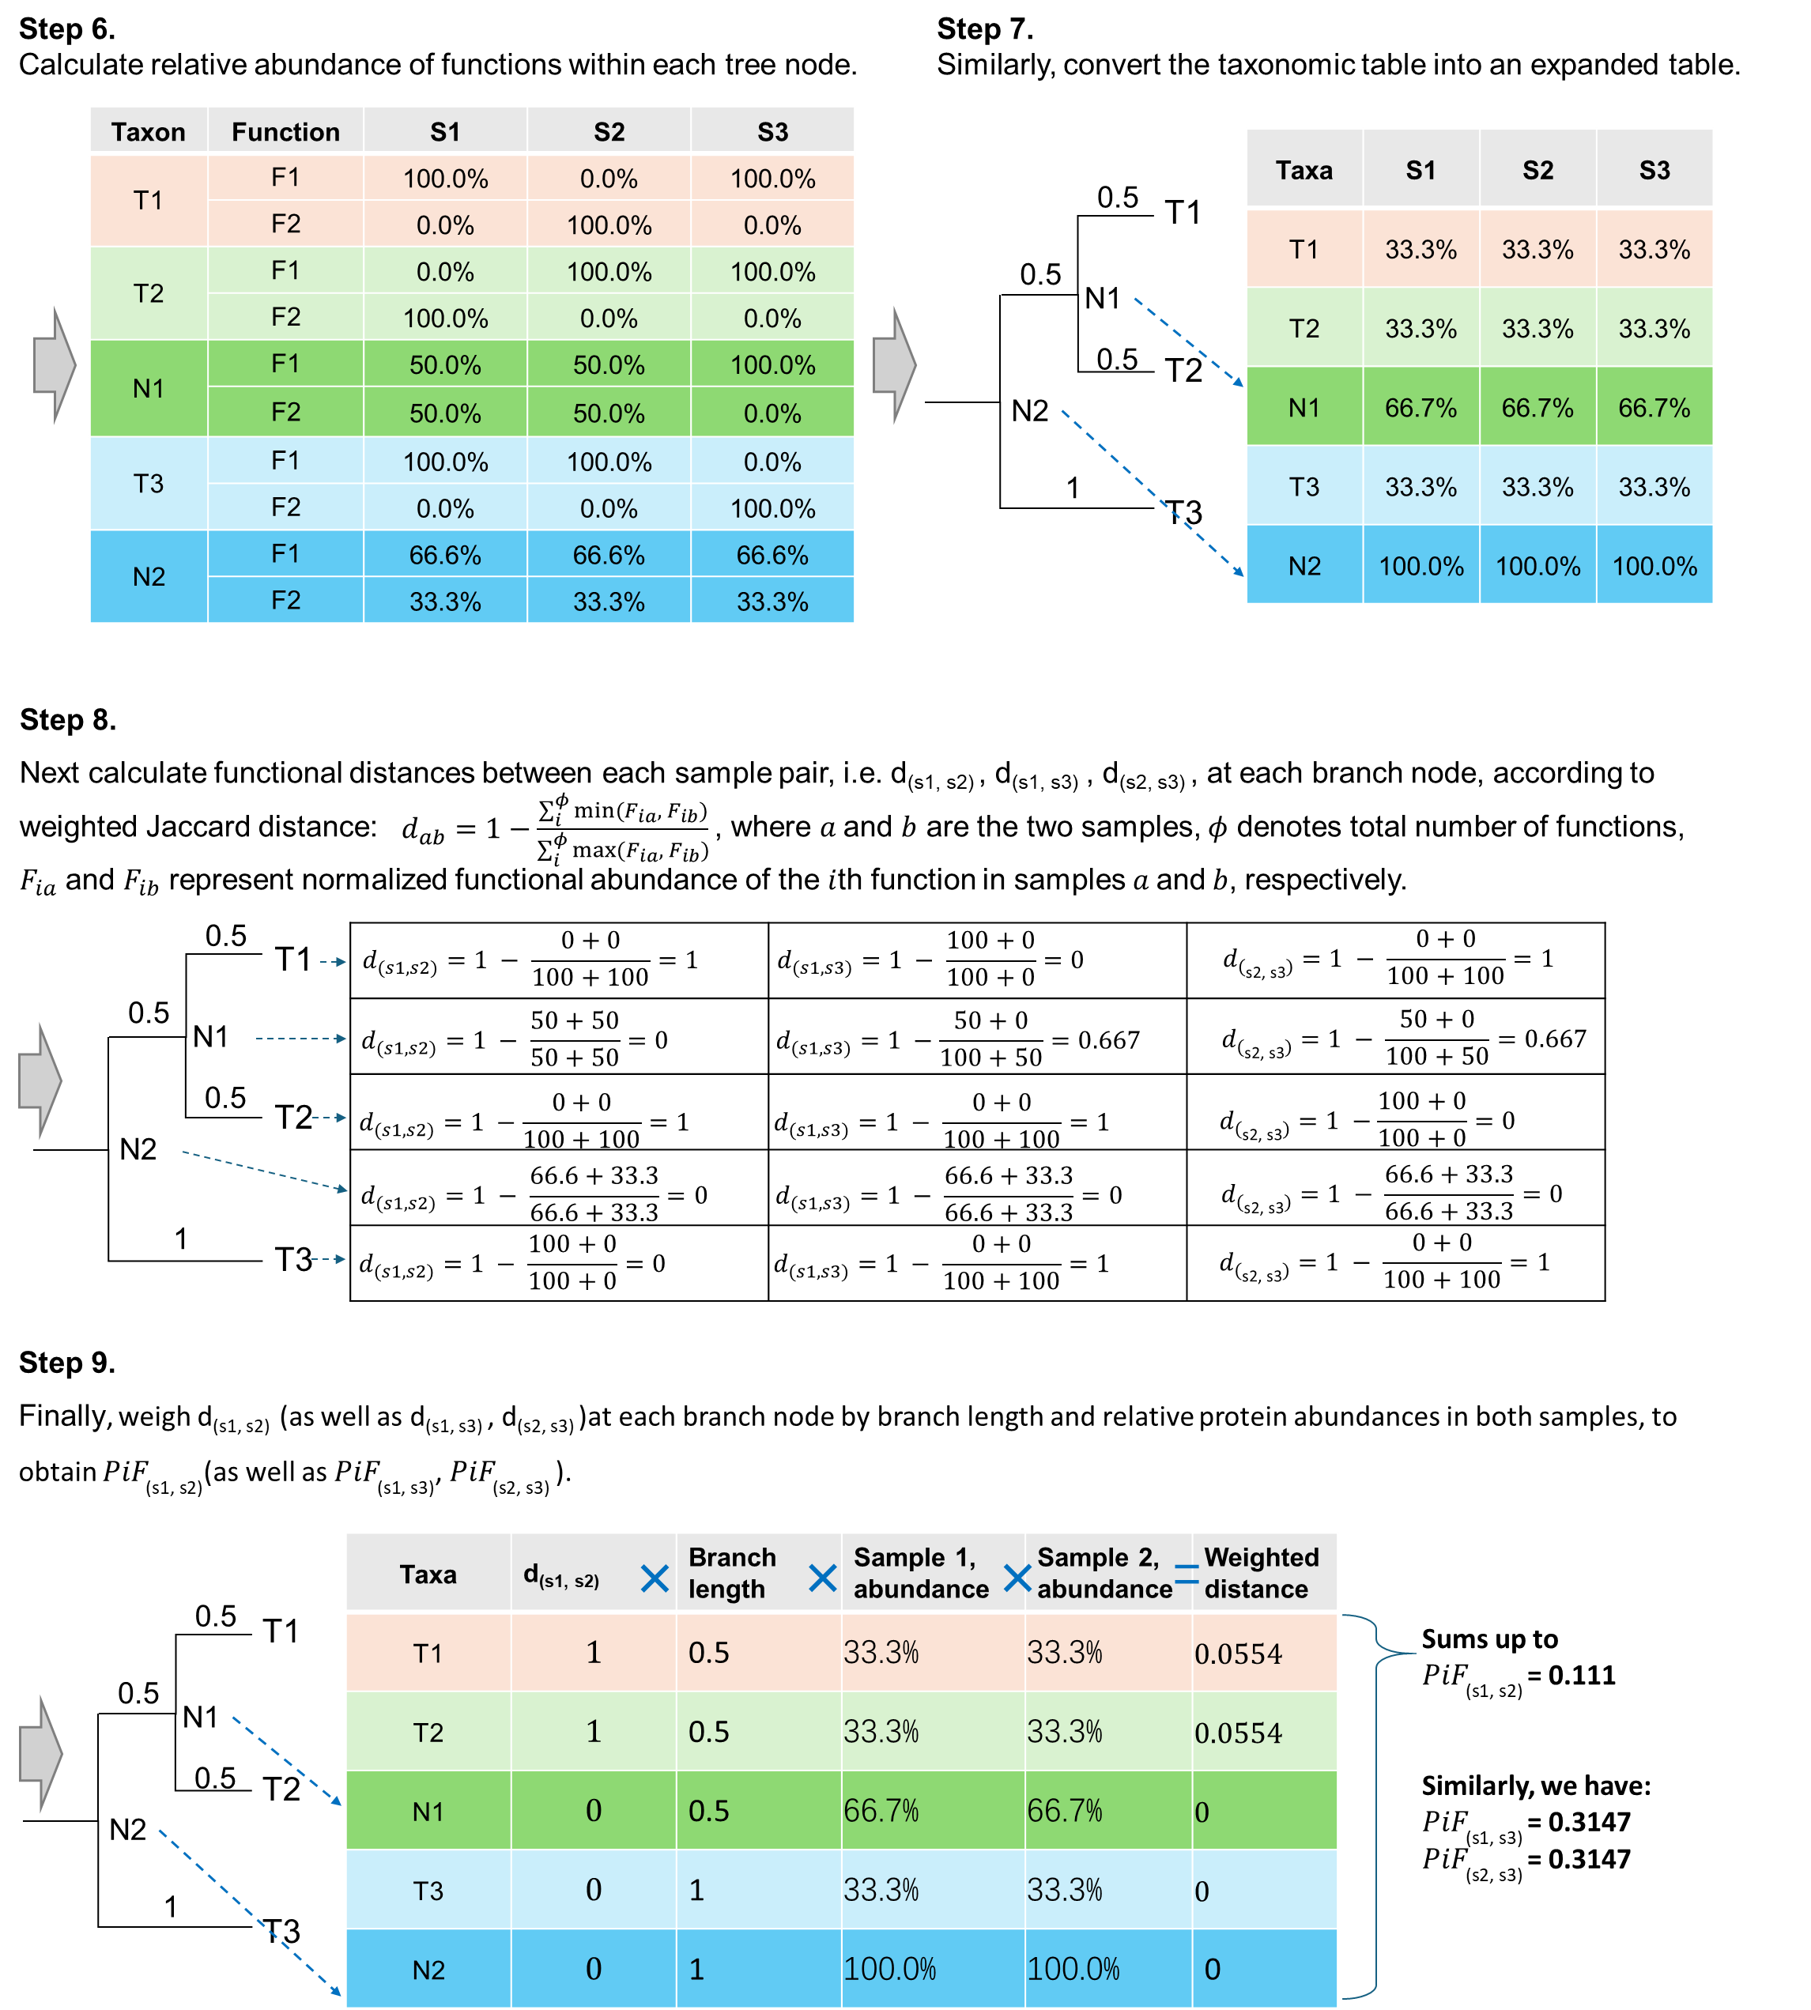
Figure S2.The calculation process of PhyloFunc distance, part 2.

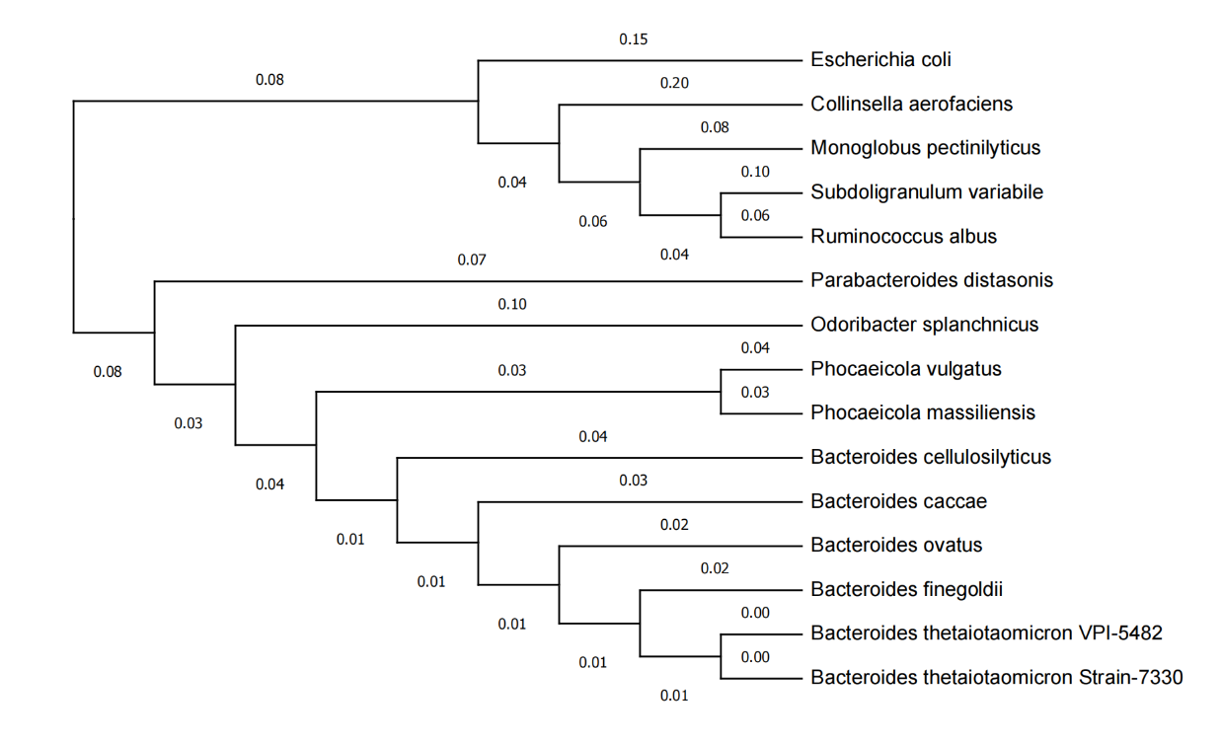
Figure S3. The phylogenetic tree of the mouse gut microbiome case dataset.

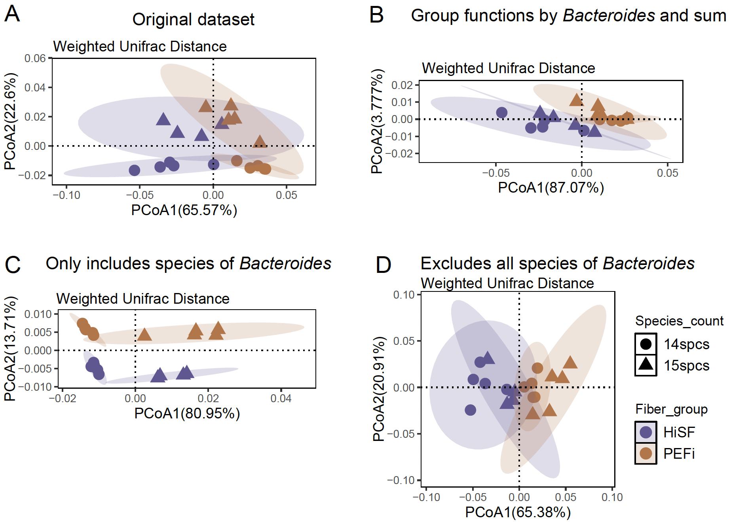
Figure S4. Comparison of four UniFrac distance metrics applied to the mouse gut microbiome dataset. A Based on the complete taxon intensity table. B Based on the sum of functions across Bacteroides species. C Based solely on the species of Bacteroides. D Based on the species excluding Bacteroides.
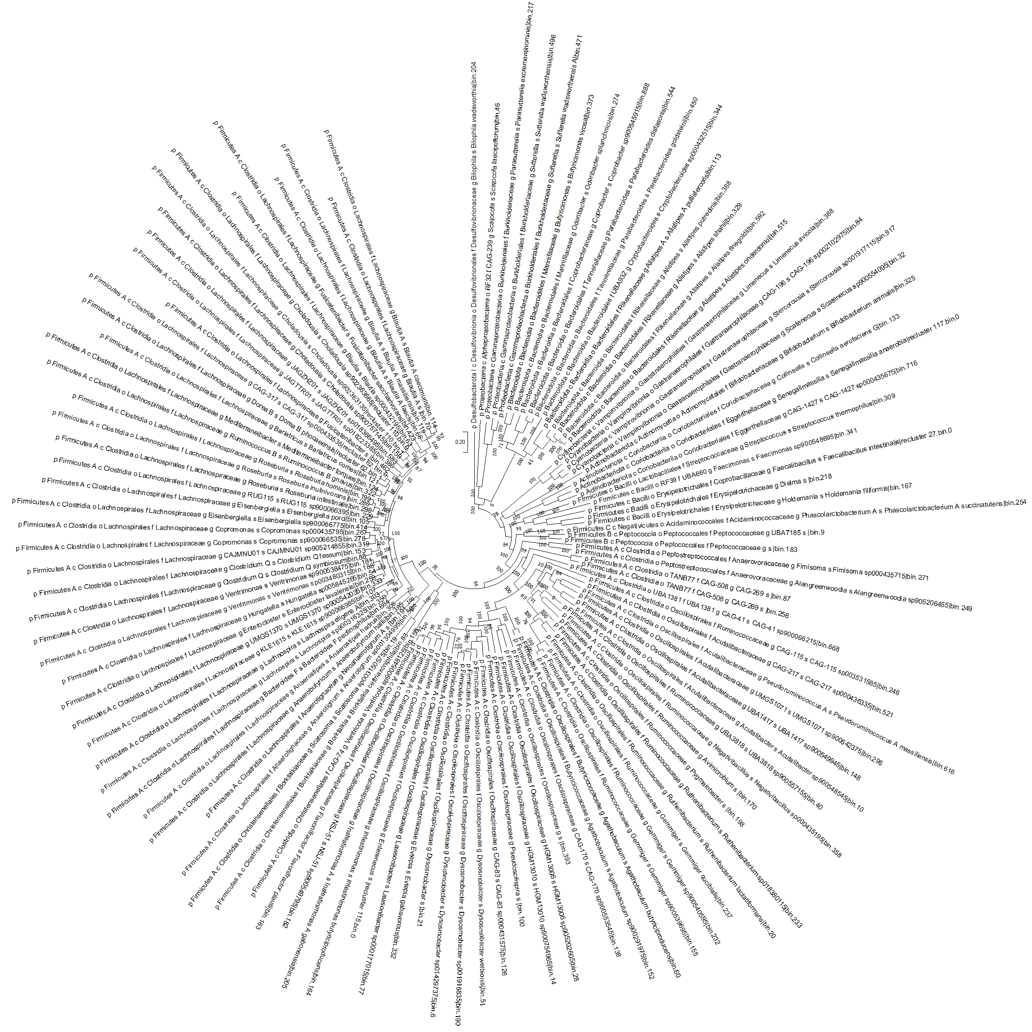
Figure S5. The phylogenetic tree of the human gut microbiome case dataset.
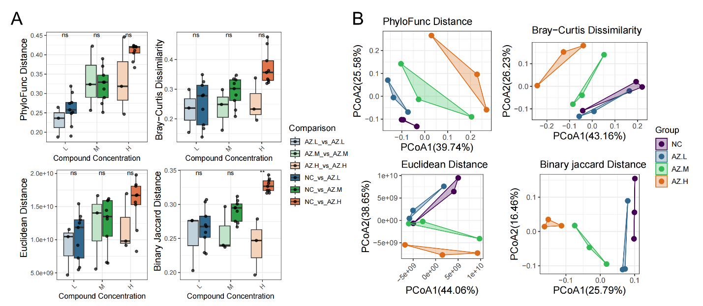
Figure S6. Comparison different distances for human gut microbiome by PCoA and statistical analysis between Azathioprine (AZ) and control group (NC).

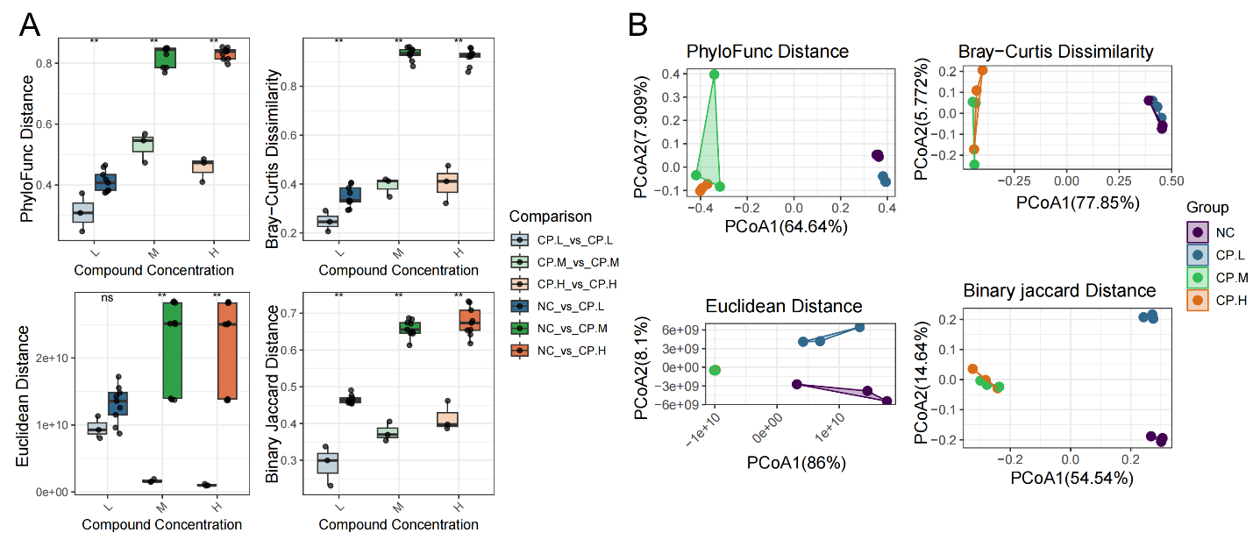
Figure S7. Comparison different distances for human gut microbiome by PCoA and statistical analysis between Ciprofloxacin (CP) and control group (NC).
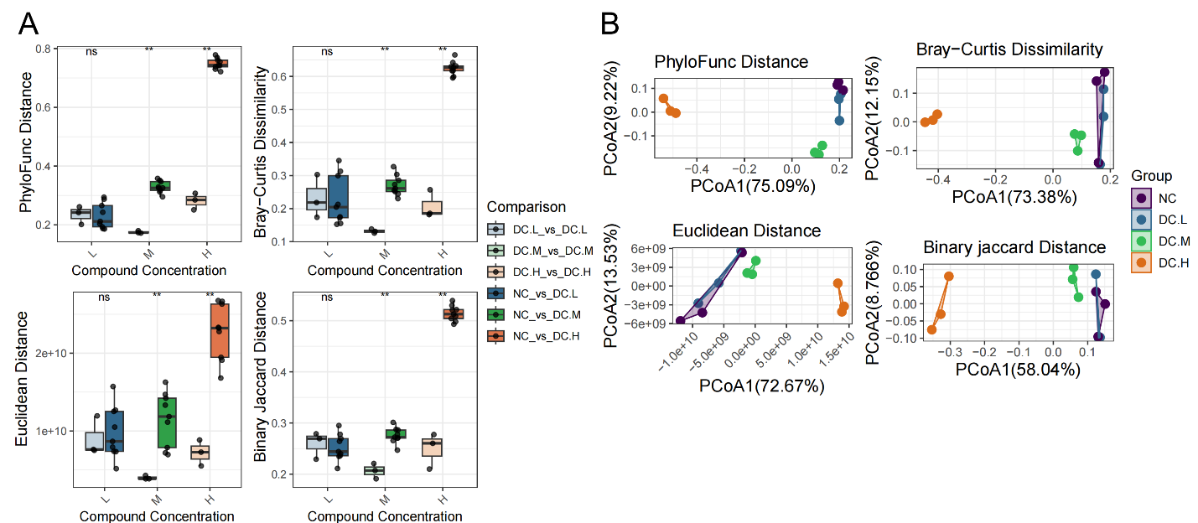
Figure S8. Comparison different distances for human gut microbiome by PCoA and statistical analysis between Diclofenac (DC) and control group (NC).

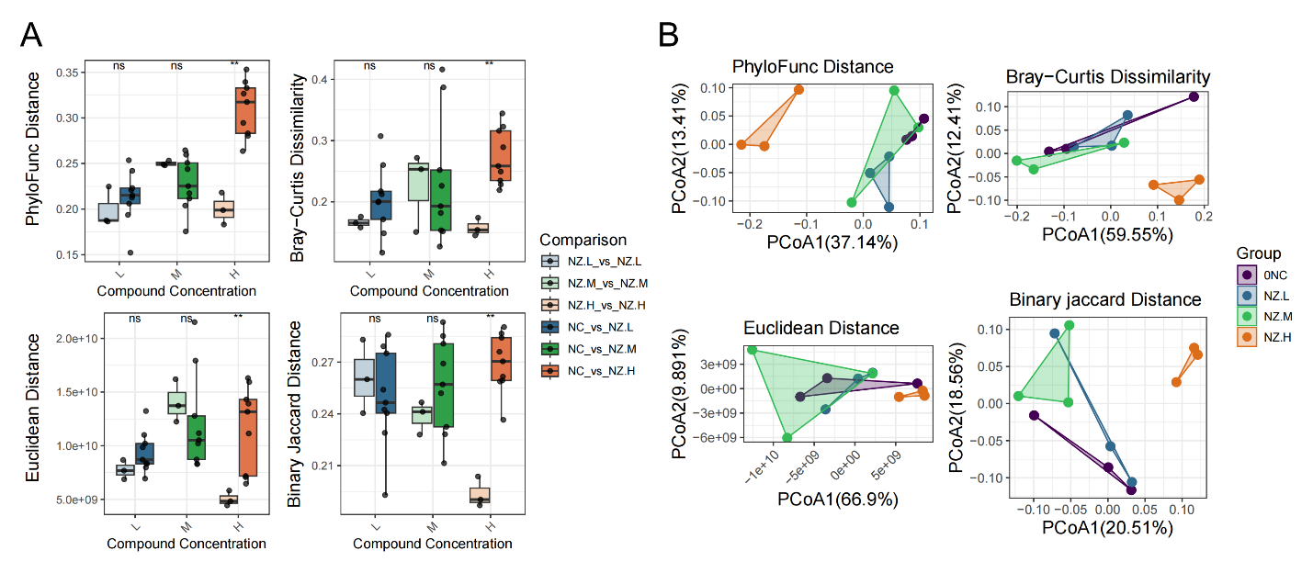
Figure S9. Comparison different distances for human gut microbiome by PCoA and statistical analysis between Nizatidine (NZ) and control group (NC).
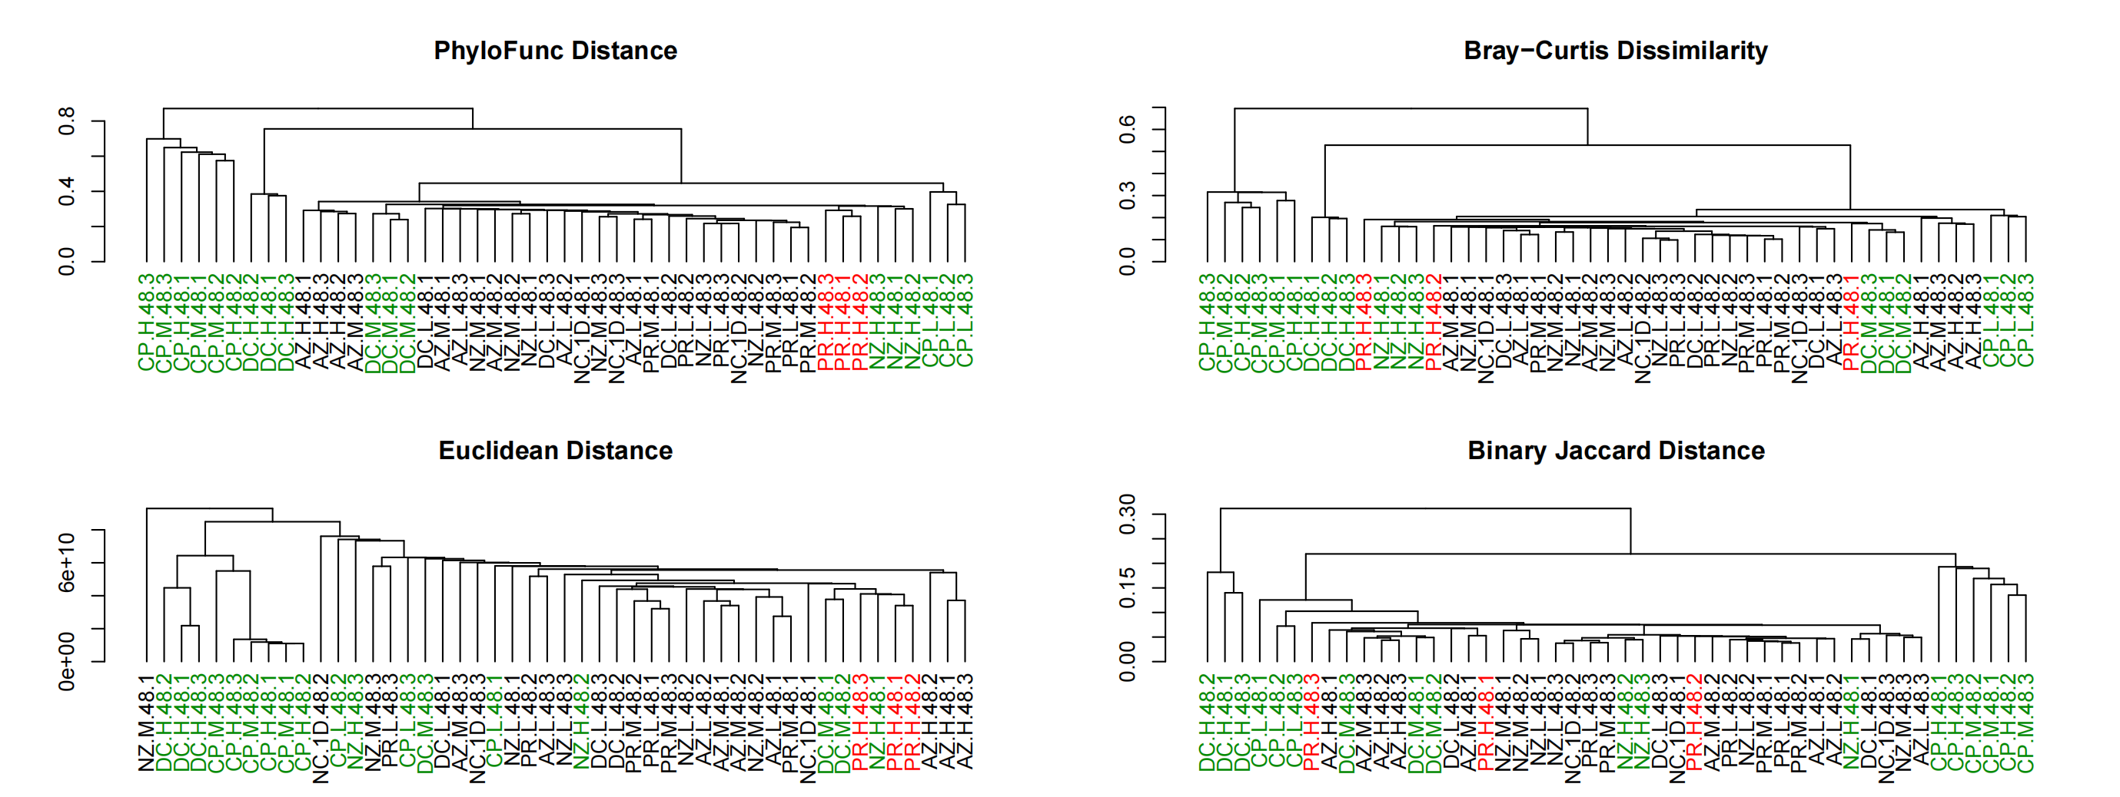
Figure S10. Comparison of different distance metrics on same human gut microbiome dataset searched against the UHGG database. Hierarchical clustering of all samples with taxa based on the MGYG (UHGG) database. Green letters indicate that technical triplicates are shown in a cluster, while red letters mark samples treated with high concentrations of paracetamol (PR).

PhyloFunc distance
Df | SumOfSqs | R² | F | Pr(>F)
3 | 0.16871034 | 0.49931449 | 2.6593646 | 0.0135
8 | 0.16917358 | 0.50068551
11 | 0.33788392 | 1
Bray-Curtis dissimilarity
Df | SumOfSqs | R² | F | Pr(>F)
3 | 0.08789169 | 0.31254796 | 1.21239181 | 0.3032
8 | 0.19331856 | 0.68745204
11 | 0.28121025 | 1
Euclidean distance
Df | SumOfSqs | R² | F | Pr(>F)
3 | 1.5642E+20 | 0.3340671 | 1.33774078 | 0.2596
8 | 3.118E+20 | 0.6659329
11 | 4.6822E+20 | 1
Jaccard distance
Df | SumOfSqs | R² | F | Pr(>F)
3 | 0.10437987 | 0.29888602 | 1.13680428 | 0.2034
8 | 0.24484982 | 0.70111398
11 | 0.34922969 | 1
Table S1. PERMANOVA results between Paracetamol (PR) and control group (NC).

PhyloFunc distance
Df | SumOfSqs | R² | F | Pr(>F)
3 | 0.16958991 | 0.47967117 | 2.45829763 | 0.0059
8 | 0.1839646 | 0.52032883
11 | 0.35355451 | 1
Bray-Curtis dissimilarity
Df | SumOfSqs | R² | F | Pr(>F)
3 | 0.14715114 | 0.43912944 | 2.08784687 | 0.0787
8 | 0.18794628 | 0.56087056
11 | 0.33509742 | 1
Euclidean distance
Df | SumOfSqs | R² | F | Pr(>F)
3 | 3.5321E+20 | 0.44129325 | 2.10626061 | 0.095
8 | 4.4718E+20 | 0.55870675
11 | 8.0039E+20 | 1
Jaccard distance
Df | SumOfSqs | R² | F | Pr(>F)
3 | 0.13040253 | 0.36250231 | 1.51635501 | 0.0131
8 | 0.2293263 | 0.63749769
11 | 0.35972884 | 1
Table S2. PERMANOVA results between Nizatidine (NZ) and control group (NC).

PhyloFunc distance
Df | SumOfSqs | R² | F | Pr(>F)
3 | 1.2199808 | 0.85489838 | 15.7112577 | 0.0001
8 | 0.20706694 | 0.14510162
11 | 1.42704775 | 1
Bray-Curtis dissimilarity
Df | SumOfSqs | R² | F | Pr(>F)
3 | 0.79453707 | 0.79883467 | 10.589428 | 0.0033
8 | 0.2000831 | 0.20116533
11 | 0.99462017 | 1
Euclidean distance
Df | SumOfSqs | R² | F | Pr(>F)
3 | 9.341E+20 | 0.7466147 | 7.85749048 | 0.0026
8 | 3.1701E+20 | 0.2533853
11 | 1.2511E+21 | 1
Jaccard distance
Df | SumOfSqs | R² | F | Pr(>F)
3 | 0.52397317 | 0.68628831 | 5.83370722 | 0.0006
8 | 0.23951524 | 0.31371169
11 | 0.7634884 | 1
Table S3. PERMANOVA results between Diclofenac (DC) and control group (NC).

PhyloFunc distance
Df | SumOfSqs | R² | F | Pr(>F)
3 | 1.97729603 | 0.75838923 | 8.37036899 | 0.0004
8 | 0.62993512 | 0.24161077
11 | 2.60723116 | 1
Bray-Curtis dissimilarity
Df | SumOfSqs | R² | F | Pr(>F)
3 | 2.42112291 | 0.83870249 | 13.86593 | 0.0007
8 | 0.4656253 | 0.16129751
11 | 2.88674821 | 1
Euclidean distance
Df | SumOfSqs | R² | F | Pr(>F)
3 | 1.3363E+21 | 0.83833105 | 13.8279457 | 0.0012
8 | 2.577E+20 | 0.16166895
11 | 1.594E+21 | 1
Jaccard distance
Df | SumOfSqs | R² | F | Pr(>F)
3 | 1.24120418 | 0.72639605 | 7.07978139 | 0.0004
8 | 0.4675113 | 0.27360395
11 | 1.70871548 | 1
Table S4. PERMANOVA results between Ciprofloxacin (CP) and control group (NC).

PhyloFunc distance
Df | SumOfSqs | R2 | F | Pr(>F)
3 | 0.29579173 | 0.47158781 | 2.37989871 | 0.0148
8 | 0.33143341 | 0.52841219
11 | 0.62722513 | 1
Bray-Curtis dissimilarity
Df | SumOfSqs | R2 | F | Pr(>F)
3 | 0.21199135 | 0.4435263 | 2.12541367 | 0.031
8 | 0.26597658 | 0.5564737
11 | 0.47796792 | 1
Euclidean distance
Df | SumOfSqs | R2 | F | Pr(>F)
3 | 3.4339E+20 | 0.37451419 | 1.5966861 | 0.1479
8 | 5.7351E+20 | 0.62548581
11 | 9.169E+20 | 1
Jaccard distance
Df | SumOfSqs | R2 | F | Pr(>F)
3 | 0.18612892 | 0.41984968 | 1.92984317 | 0.0027
8 | 0.25719384 | 0.58015032
11 | 0.44332276 | 1
Table S5. PERMANOVA results between Azathioprine (AZ) and control group (NC).

Table S6. List of primary optimal parameters for classification.
Classification Algorithm | The range of parameter values | Optimal primary parameters | Distance Methods
KNN | n_neighbors: from 2 to 10,  'metric': 'precomputed',  'algorithm': 'brute' | k=2 | Euclidean Distance
KNN |  | k=2 | Bray-Curtis Dissimilarity
KNN |  | k=3 | Binary Jaccard Distance
KNN |  | k=3 | PhyloFunc Distance
MLP | 'activation': ['relu', 'tanh'],  'alpha': [0.001, 0.01],  'hidden_layer_sizes': [(5,), (10,), (15,), (10, 5), (15, 10)],  'learning_rate_init': [0.001, 0.01, 0.1],  'solver': ['adam', 'sgd'] | 'activation': 'tanh',  'alpha': 0.001,  'hidden_layer_sizes': (10, 5), 'learning_rate_init': 0.1,  'solver': 'adam' | Euclidean Distance
MLP |  | 'activation': 'relu',  'alpha': 0.001,  'hidden_layer_sizes': (15,), 'learning_rate_init': 0.01,  'solver': 'adam' | Bray-Curtis Dissimilarity
MLP |  | 'activation': 'tanh',  'alpha': 0.001,  'hidden_layer_sizes': (10,), 'learning_rate_init': 0.1,  'solver': 'sgd' | Binary Jaccard Distance
MLP |  | 'activation': 'tanh',  'alpha': 0.001,  'hidden_layer_sizes': (10, 5), 'learning_rate_init': 0.01,  'solver': 'adam' | PhyloFunc Distance
SVM | 'C': [0.1,1,4,6,5,8,7,9,10],  'kernel': ['precomputed'],  'gamma':[0.01,0.001,0.02] | 'C': 9, 'gamma': 0.01 | Euclidean Distance
SVM |  | 'C': 5, 'gamma': 0.01 | Bray-Curtis Dissimilarity
SVM |  | 'C': 4, 'gamma': 0.01 | Binary Jaccard Distance
SVM |  | 'C': 8, 'gamma': 0.01 | PhyloFunc Distance

Table S7. List of microbial species used to construct the phylogenetic tree.
Microbial Community | Patnode et al. (2019) [19] | GenBank Accession | 16S rRNA bp | Link to 16S rRNA gene sequence used for tree
Bacteroides caccae | Bacteroides caccae TSDC17.2-1.2 | NR_026242.1 | 1,422 | https://www.ncbi.nlm.nih.gov/nuccore/NR_026242.1?report=fasta
Bacteroides cellulosilyticus | Bacteroides cellulosilyticus WH2 | NR_042203.1 | 1,426 | https://www.ncbi.nlm.nih.gov/nuccore/NR_042203.1
Bacteroides finegoldii | Bacteroides finegoldii TSDC17.2-1.1 | NR_041313.1 | 1,485 | https://www.ncbi.nlm.nih.gov/nuccore/NR_041313.1
Bacteroides ovatus ATCC-8483 |  | NR_040865.1 | 1,455 | https://www.ncbi.nlm.nih.gov/nuccore/NR_040865.1
Bacteroides thetaiotaomicron 7330 |  | AY895199.1 | 1,345 | https://www.ncbi.nlm.nih.gov/nuccore/AY895199.1
Bacteroides thetaiotaomicron VPI-5482 |  | NR_074277.1 | 1,483 | https://www.ncbi.nlm.nih.gov/nuccore/NR_074277.1
Collinsella aerofaciens | Collinsella aerofaciens TSDC17.2-1.1/Collinsella aerofaciens TSDC17.2-2.1 | NR_028604.1 | 1,463 | https://www.ncbi.nlm.nih.gov/nuccore/NR_028604.1
Escherichia coli | Escherichia coli TSDC17.2-1.2 | NR_024570.1 | 1,450 | https://www.ncbi.nlm.nih.gov/nuccore/NR_024570.1
Odoribacter splanchnicus | Odoribacter splanchnicus TSDC17.2-1.2 | NR_044636.1 | 1,467 | https://www.ncbi.nlm.nih.gov/nuccore/NR_044636.1
Parabacteroides distasonis | Parabacteroides distasonis TSDC17.2-1.1 | NR_041342.1 | 1,488 | https://www.ncbi.nlm.nih.gov/nuccore/NR_041342.1
Phocaeicola massiliensis | Bacteroides massiliensis TSDC17.2-1.1 | NR_042745.1 | 1,493 | https://www.ncbi.nlm.nih.gov/nuccore/NR_042745.1?report=fasta
Phocaeicola vulgatus ATCC-8483 | Bacteroides vulgatus ATCC-8483 | NR_074515.1 | 1,510 | https://www.ncbi.nlm.nih.gov/nuccore/NR_074515.1
Monoglobus pectinilyticus | Ruminococcaceae TSDC17.2-1.2 | NR_159227.1 | 1,493 | https://www.ncbi.nlm.nih.gov/nuccore/NR_159227.1
Ruminococcus albus | Ruminococcus albus TSDC17.2-1.1/Ruminococcus albus TSDC17.2-1.4 | NR_025929.1 | 1,407 | https://www.ncbi.nlm.nih.gov/nuccore/NR_025929.1
Subdoligranulum variabile | Subdoligranulum variabile TSDC17.2-1.1 | NR_028997.1 | 1,428 | https://www.ncbi.nlm.nih.gov/nuccore/NR_028997.1

