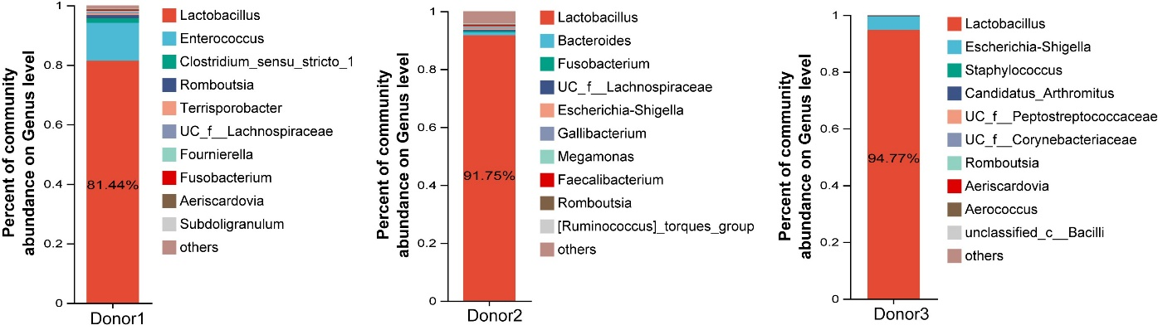
Supplementary Fig. S1
The fecal microbial composition of three candidate donor chickens at the genus level.

