Adaptive Modification of Antiviral Defense Systems in Microbial Community under Cr-Induced Stress
Dan Huang¹, Jingqiu Liao², Jose Luis Balcazar³, Mao Ye^{4, *}, Ruonan Wu⁵,
Dongsheng Wang¹, Pedro J.J. Alvarez⁶, Pingfeng Yu^{1, *}
¹ College of Environmental and Resource Sciences, Zhejiang University, Hangzhou 310058, China
² Department of Civil and Environmental Engineering, Virginia Tech, Blacksburg, VA 24060, United States
³ Catalan Institute for Water Research (ICRA-CERCA), Girona, 17003, Spain
⁴ Key Laboratory of Soil Environment and Pollution Remediation, Institute of Soil Science, Chinese Academy of Sciences, Nanjing 210008, China
⁵ Earth and Biological Sciences Directorate, Pacific Northwest National Lab, Richland, Washington 99352, United States
⁶ Department of Civil and Environmental Engineering, Rice University, Houston, Texas 77005, United State
* Corresponding Authors: yupf@zju.edu.cn (P. Yu), yemao@issas.ac.cn (M. Ye)

This study includes 13 figures and 13 tables of supporting materials, with the tables in the SI Table file.
Figures S1 to S13:
Figure S1. The relative abundance of MAGs carrying defense systems
Figure S2. Abundance of contigs carrying defense systems in four heavy metal-polluted soils.
Figure S3. Proportion of temperate phages in microbial communities in four heavy metal-polluted soils.
Figure S4. Correlation analysis between the top 20 defense systems and the proportion of temperate phages in Cr-contaminated soil from LZ.
Figure S5. Correlation analysis between the top 20 defense systems and the proportion of temperate phages in Cr-contaminated soil from ZY.
Figure S6. Transcriptional expression of Cr resistance genes
Figure S7. Composition of CRISPR-Cas subtype systems
Figure S8. The coverage of CRISPR-Cas system in MAGs
Figure S9. The relative abundance of contigs carrying CRISPR-Cas system
Figure S10. CRISPR spacer sequences carried by MAGs
Figure S11. The life history of viruses associated with the CRISPR-Cas system
Figure S12. Relative abundance of viruses carrying auxiliary metabolic genes (AMGs)
Figure S13. Transcription of contigs with defense systems.

Table S1 to S13:
Table S1: Physiochemical properties of field soils
Table S2: Metagenomic assembly quality metrics (QUAST evaluation)
Table S3: Metadata collection information
Table S4: Distribution of defense systems in MAGs
Table S5: Information on defense systems in meta-analysis samples
Table S6: Distribution of CRISPR-Cas systems in MAGs
Table S7: Spacer information for CRISPR-Cas systems in MAGs
Table S8: Distribution of defense systems across viruses, plasmids, and prokaryotic genomes
Table S9: Host prediction for virus sequences carrying defense systems
Table S10: Virus sequences targeted by phage-carried CRISPR-Cas system spacers
Table S11: Transcriptional activity of defense systems
Table S12: Metagenome accessions and associated metadata
Table S13: Distribution of heavy metal resistance genes

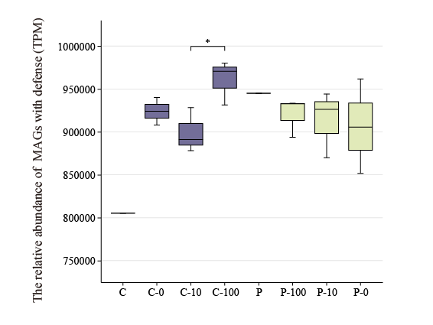
Figure S1. The relative abundance of MAGs carrying defense systems

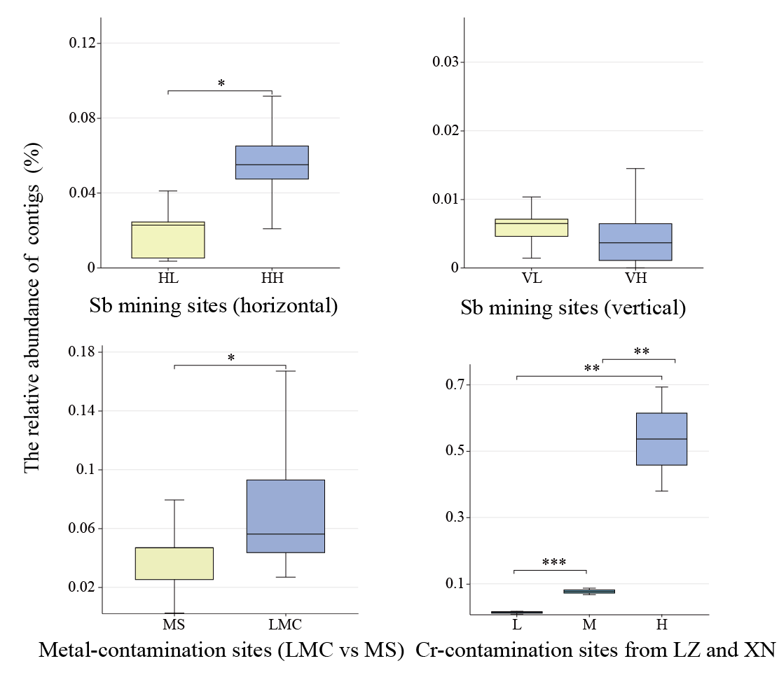
Figure S2. Abundance of contigs carrying defense systems in four heavy metal-polluted soils. (HL: Horizontal sampling in low pollution areas, HH: Horizontal sampling in heavy pollution areas, VL: Vertical sampling in low pollution areas, VH: Vertical sampling in heavy pollution areas, MS: multiple heavy metal, and relatively clean southern soils, LMC: Lan Mu Chang, LZ: Luzhou, ZY: Zhangye).

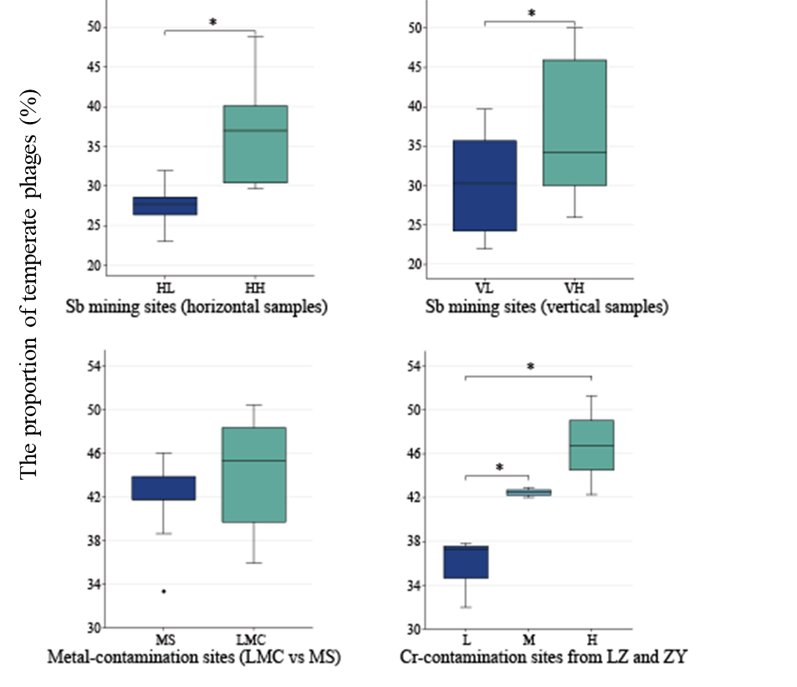
Figure S3. Proportion of temperate phages in microbial communities in four heavy metal-polluted soils. (HL: Horizontal sampling in low pollution areas, HH: Horizontal sampling in heavy pollution areas, VL: Vertical sampling in low pollution areas, VH: Vertical sampling in heavy pollution areas, MS: multiple heavy metal, and relatively clean southern soils, LMC: Lan Mu Chang, LZ: Luzhou, ZY: Zhangye).

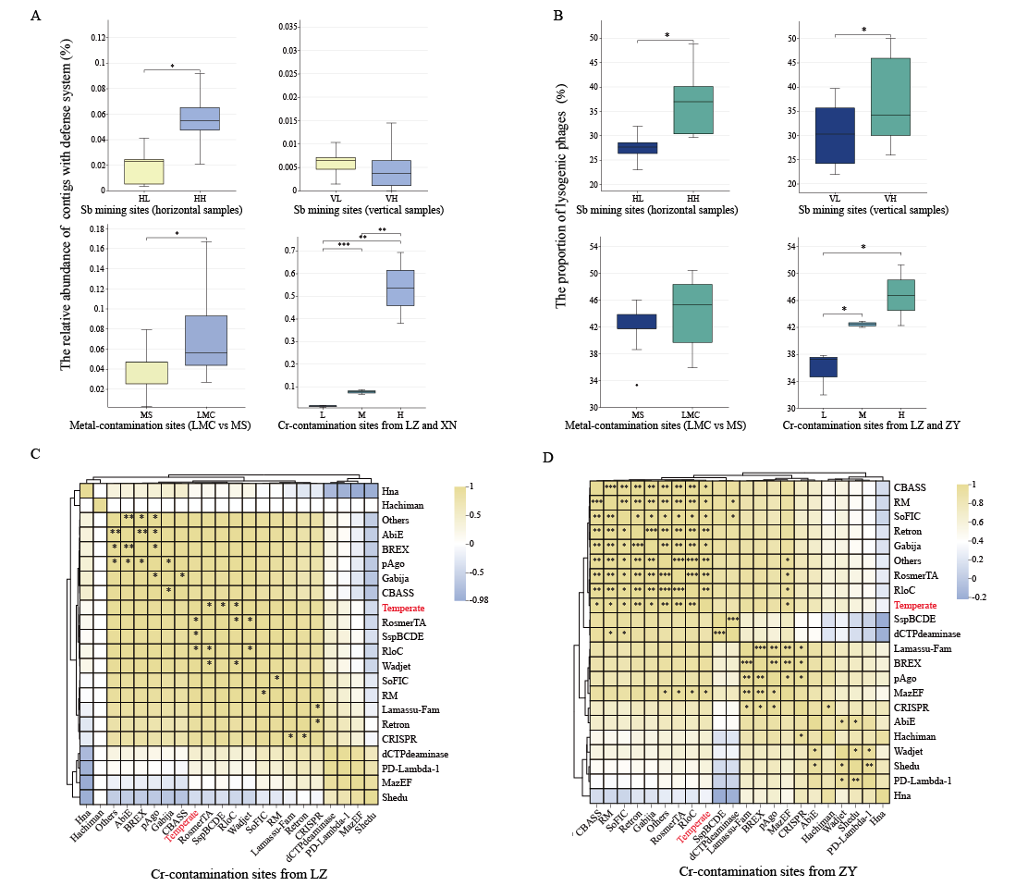
Figure S4. Correlation analysis between the top 20 defense systems and the proportion of temperate phages in Cr-contaminated soil from LZ.

Figure S5. Correlation analysis between the top 20 defense systems and the proportion of temperate phages in Cr-contaminated soil from ZY.

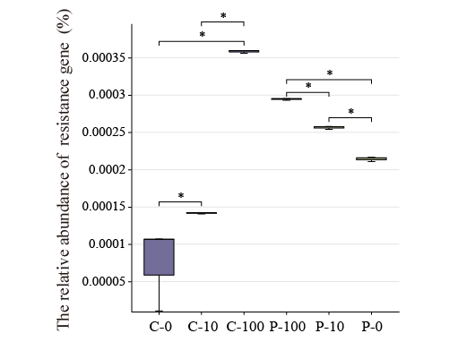
Figure S6. Transcriptional expression of Cr resistance genes

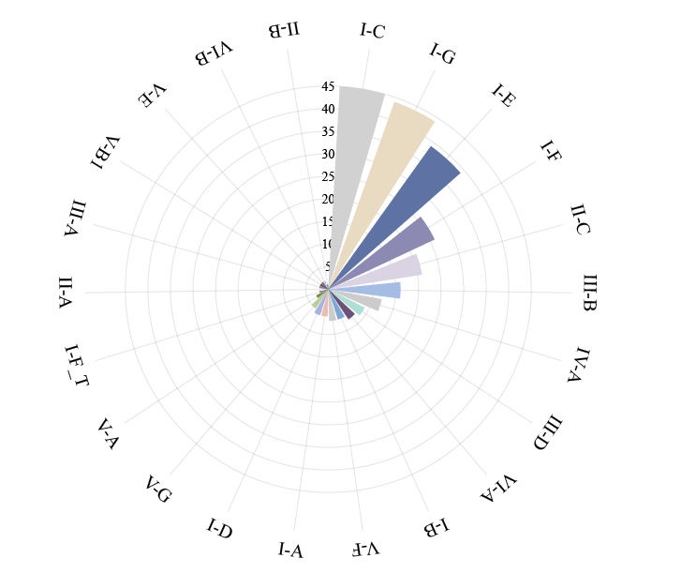
Figure S7. Composition of CRISPR-Cas subtype systems

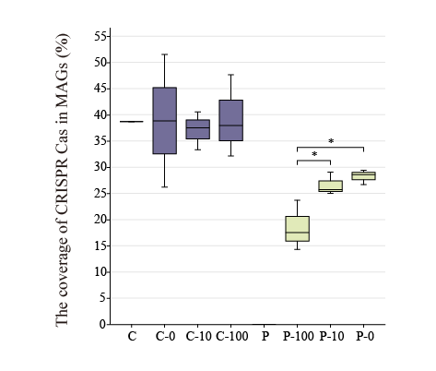
Figure S8. The coverage of CRISPR-Cas system in MAGs

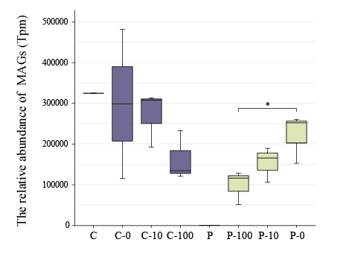
Figure S9. The relative abundance of MAGs carrying CRISPR-Cas system

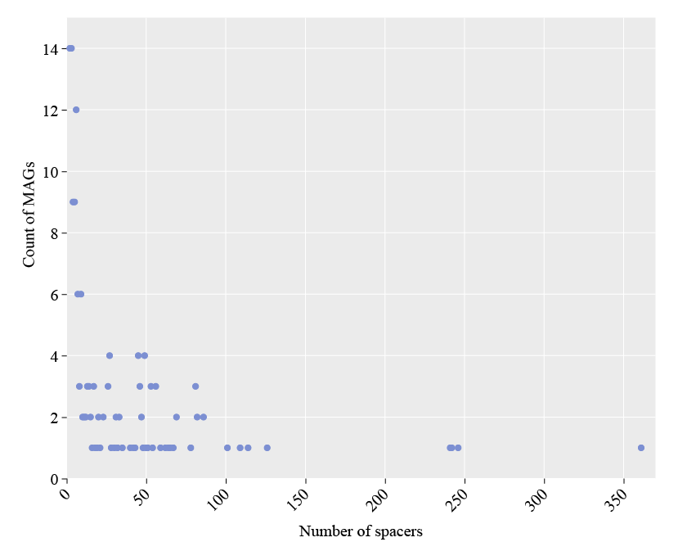
Figure S10. CRISPR spacer sequences carried by MAGs

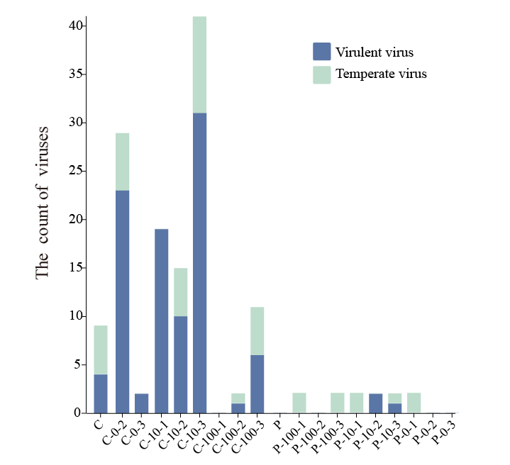
Figure S11. The life history of viruses associated with the CRISPR-Cas system

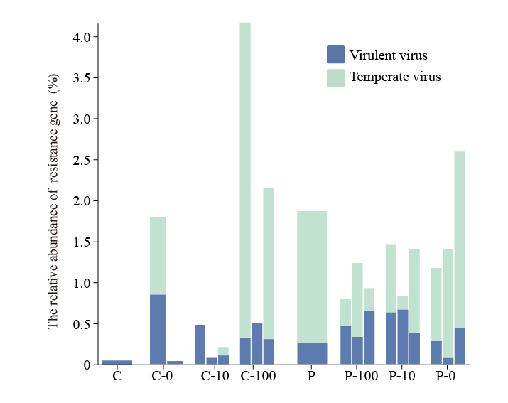
Figure S12. Relative abundance of viruses carrying auxiliary metabolic genes (AMGs)

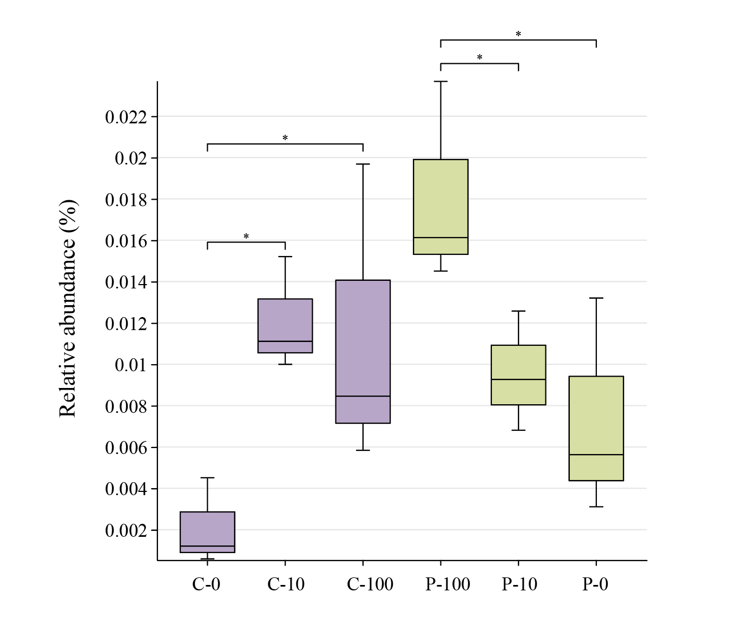
Figure S13. Transcription of contigs with defense systems.

