Supplementary Materials for

Role of nasal microbiota in regulating host anti-influenza immunity in dogs

Jinzhu Geng et al.

*Corresponding author. Email: liuyongjie@njau.edu.cn

Supplementary figures
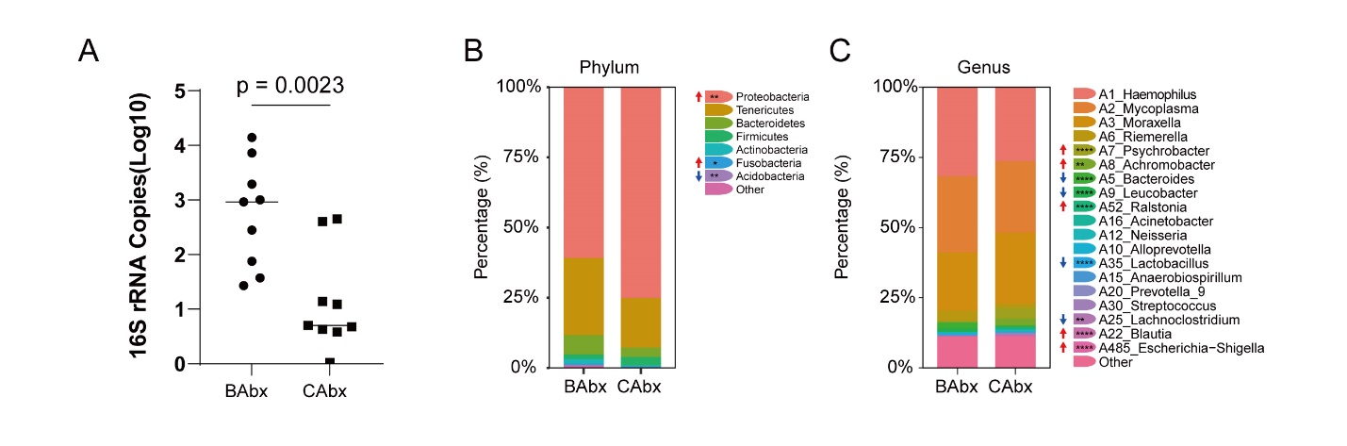
Figure S1 Changes in absolute abundance and species composition of nasal microbiota after antibiotic treatment. (A) The absolute abundance of nasal microbiota was assessed through qPCR following antibiotic treatment. (B) The microbial composition at the phylum and genus levels in the nasal cavity before and after antibiotic treatment. * p < 0.05, ** p < 0.01, and *** p < 0.001 indicate a significant difference between groups before (BAbx) and after (CAbx) antibiotic treatment. All significance levels are determined by the DESeq2 package (Benjamini-Hochberg).

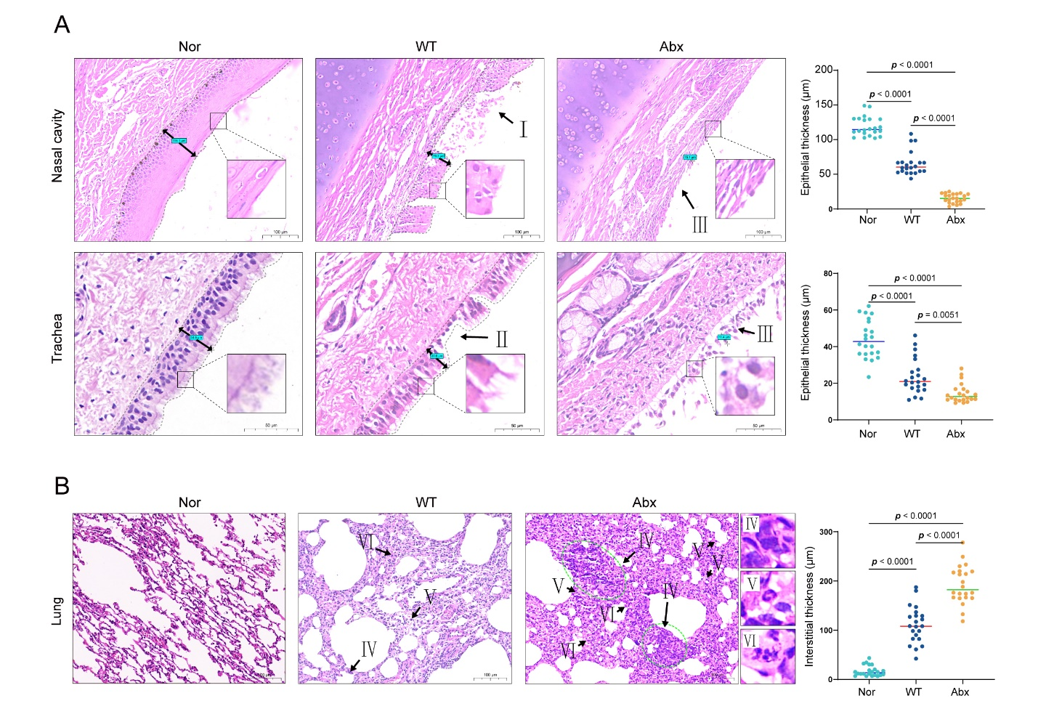

Figure S2 Comparative histological assessment of nasal, tracheal, and lung epithelia among Nor, WT and Abx groups. (A) Examples of histological assessment of nasal and tracheal epithelia in dogs infected with influenza virus at 8 dpi (T3) among the Nor,WT and Abx group. Solid arrows indicate the extension of the epithelium. In the Nor group, both nasal and tracheal mucosae were intact. In the WT group, partial damage was observed in the nasal and tracheal epithelia (Arrows I, II). The Abx group exhibits substantial exfoliation in both nasal and tracheal mucosae (Arrows III). The thickness of nasal and tracheal epithelia was measured using SlideViewer. Statistical analysis was performed using one-way ANOVAs with Tukey’s post-tests. (B) Histological changes associated with influenza virus infection at 8 dpi (T3) among the Nor, WT, and Abx groups. The histopathological examination of lung tissue in the WT group revealed widespread thickening of alveolar walls, accompanied by scattered infiltration of lymphocytes (Arrows IV) and neutrophils (Arrows V). In contrast, the lungs of the Abx group exhibited severe thickening of alveolar walls, accompanied by the infiltration of a large number of lymphocytes and neutrophils, along with a small number of macrophages. Furthermore, the Abx group displayed a significant presence of epithelial proliferation in the lungs, characterized by enlarged nuclei and mitotic patterns, as well as an observable amount of cell necrosis and nuclear fragmentation (Arrows VI). The thickness of alveolar walls was measured using SlideViewer. Statistical analysis was conducted using one-way ANOVAs with Tukey’s post-tests.The results are derived from representative images

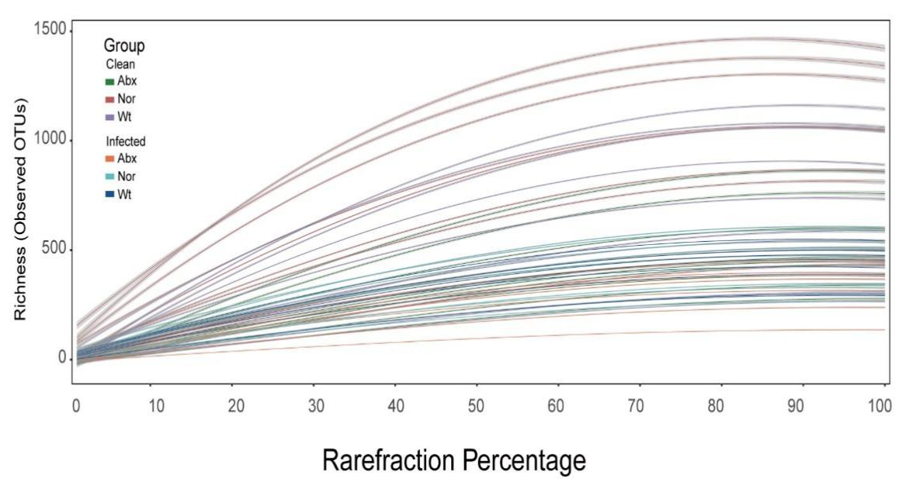

Figure S3 Dilution curve analysis for 16S rRNA gene amplicon sequencing of nasal swab samples.

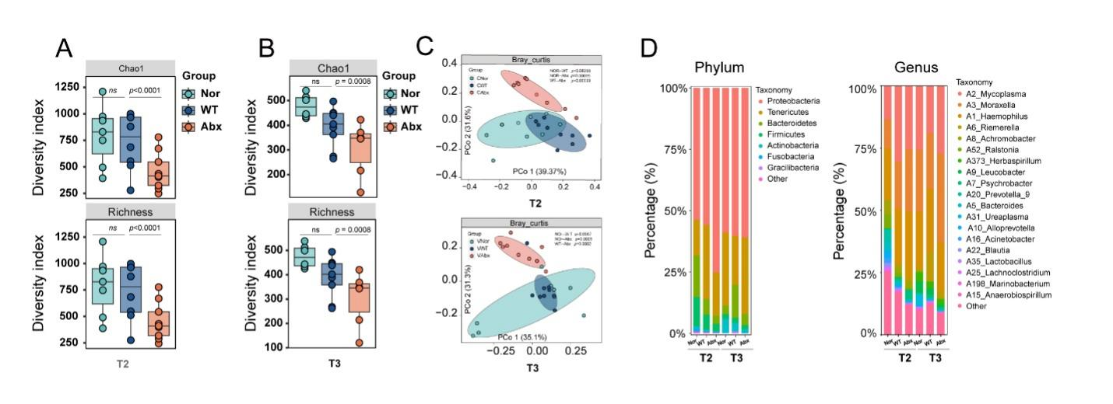

Figure S4 Microbial diversity and composition of canine nasal microbiota after antibiotic treatment and influenza infection. (A) Box plots showing the Richness and Chao diversity indices of the nasal microbiota of dogs in the Nor, WT and Abx groups after antibiotic treatment (T2) (p <0.05, one-way ANOVA test, Tukey's HSD). (B) Box plots showing the Richness and Chao diversity indices of the nasal microbiota in dogs from the Nor, WT, and Abx groups at 8 dpi (T3) following influenza virus infection. (p <0.05, one-way ANOVA test, Tukey's HSD). (C) Principal coordinate analysis (PCoA) of microbial communities utilizing Bray– Curtis distances for samples after antibiotic treatment(T2) or influenza infection(T3). Below and left boxplots show the overall distribution of PCoA 1 and PCoA 2 scores within each group (p <0.05, Wilcoxon rank-sum test). (D) The nasal microbial composition at the phylum and genus levels among Nor, WT and Abx groups after antibiotic treatment(T2) or influenza infection(T3).

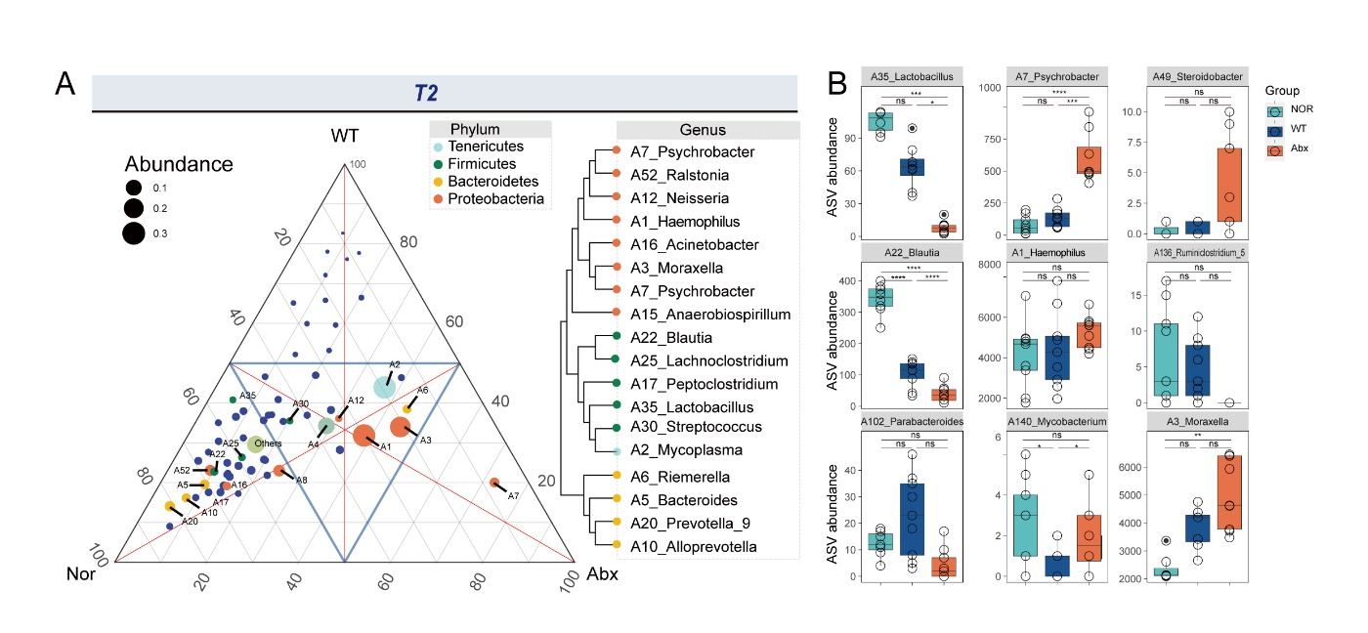

Figures S5 Microbial community distribution and differential genus of canine nasal microbiota among Nor, WT and Abx groups after antibiotic treatment. (A) The ternary plot illustrates the relative enriched genera among three groups after antibiotic treatment (T2). Each dot on the plot represents the most highly abundant genus in the phylum. The size of the dot is proportional to its relative abundance, and its position is determined by the contribution of each subgroup to the overall abundance. (B) A boxplot depicting the differential relative abundance of ASVs among three groups. * p < 0.05, ** p < 0.01, and *** p < 0.001, indicate significant differences between the two groups (one-way ANOVA test, Tukey's HSD).

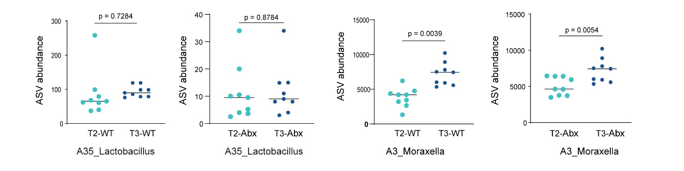

Figures S6 Relative abundance changes of Lactobacillus and Moraxella in nasal cavity pre- and post-infection of influenza virus across WT and Abx group. Scatter plots depict the changes in the relative abundance of Lactobacillus and Moraxella within the nasal cavity before (T2-WT, T2-Abx) and after (T3-WT, T3-Abx) influenza infection within each group (one-way ANOVA test, Tukey's HSD).

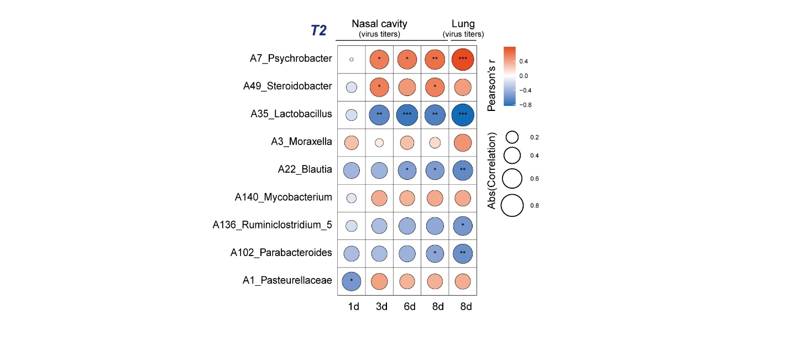

Figure S7 Pearson correlations between the differential relative abundance of ASVs within the nasal microbiome of the WT and Abx groups after antibiotic treatment and the nasal or lung virus titer. * p < 0.05, ** p < 0.01, and *** p < 0.001 indicate significant differences between the two groups (Two-way ANOVA test, Tukey's HSD).

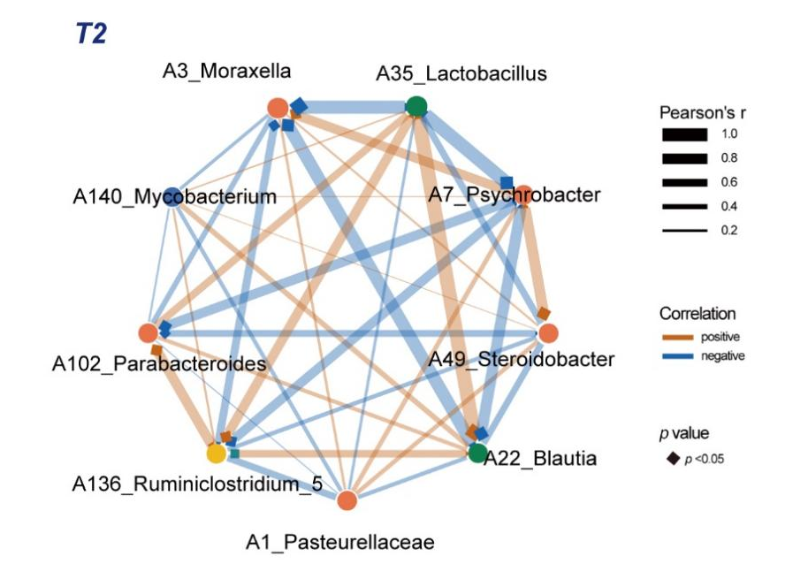

Figure S8 Pearson correlations were calculated for the differential relative abundance of ASVs within the nasal microbiome of the WT and Abx groups after antibiotic treatment.Significance was visually represented by squares, with the coloration of squares and interconnecting lines denoting the directionality of the correlation, either positive or negative. ANOVA test, Tukey's HSD).

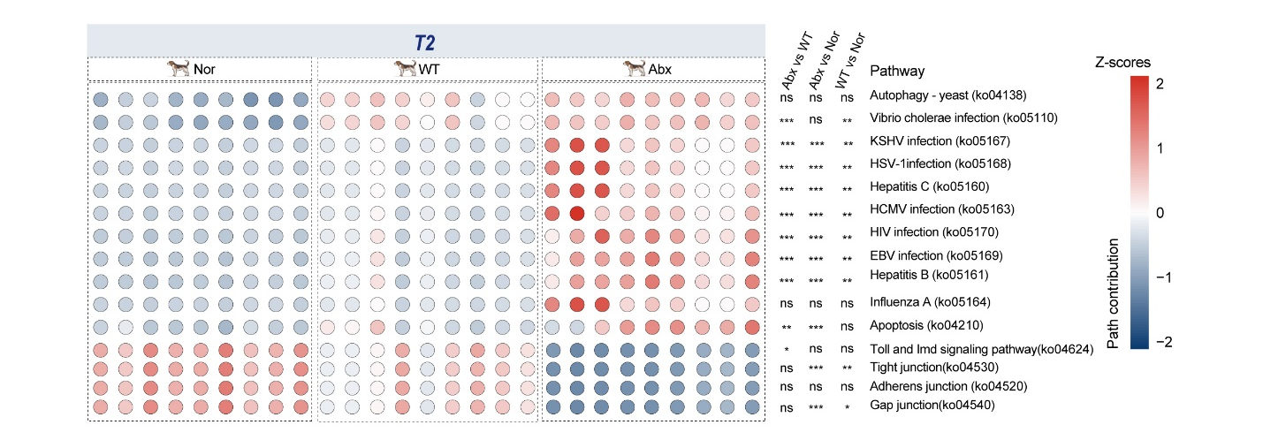

Figure S9 Predicted KEGG pathway contributions in canine nasal microbiota after antibiotic treatment among Nor, WT, and Abx groups. A heatmap illustrates the distinct relative contributions of KEGG pathways, predicted based on the bacterial composition of Nor, WT and Abx , utilizing PICRUSt2. Significance levels, generated by the DESeq2 package, are denoted as follows: * p < 0.05; ** p < 0.01; *** p < 0.001, indicating significant differences between the two groups (Benjamini-Hochberg).

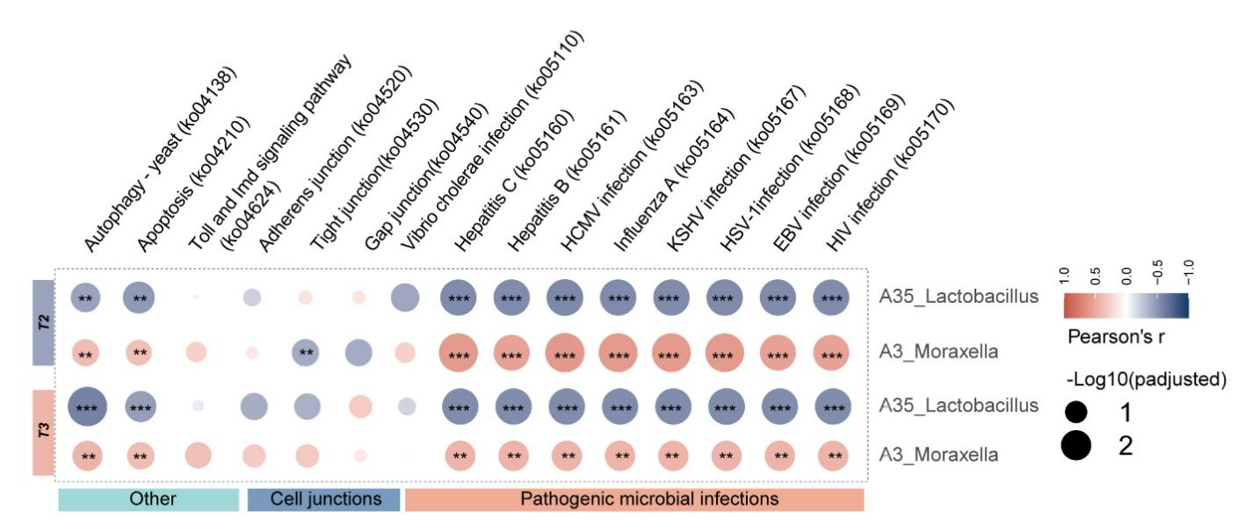

Figure S10 Pearson correlations of relative abundance between Lactobacillus and Moraxella and their respective contributions to KEGG pathways in the WT and Abx groups. Pearson correlations were computed between the relative abundance of Lactobacillus and Moraxella in the WT and Abx groups and the corresponding contributions of KEGG pathways based on the predicted microbiota composition using PICRUSt2. Significance levels are denoted as follows: * p < 0.05; ** p < 0.01; *** p < 0.001, indicating significant differences between the two groups.

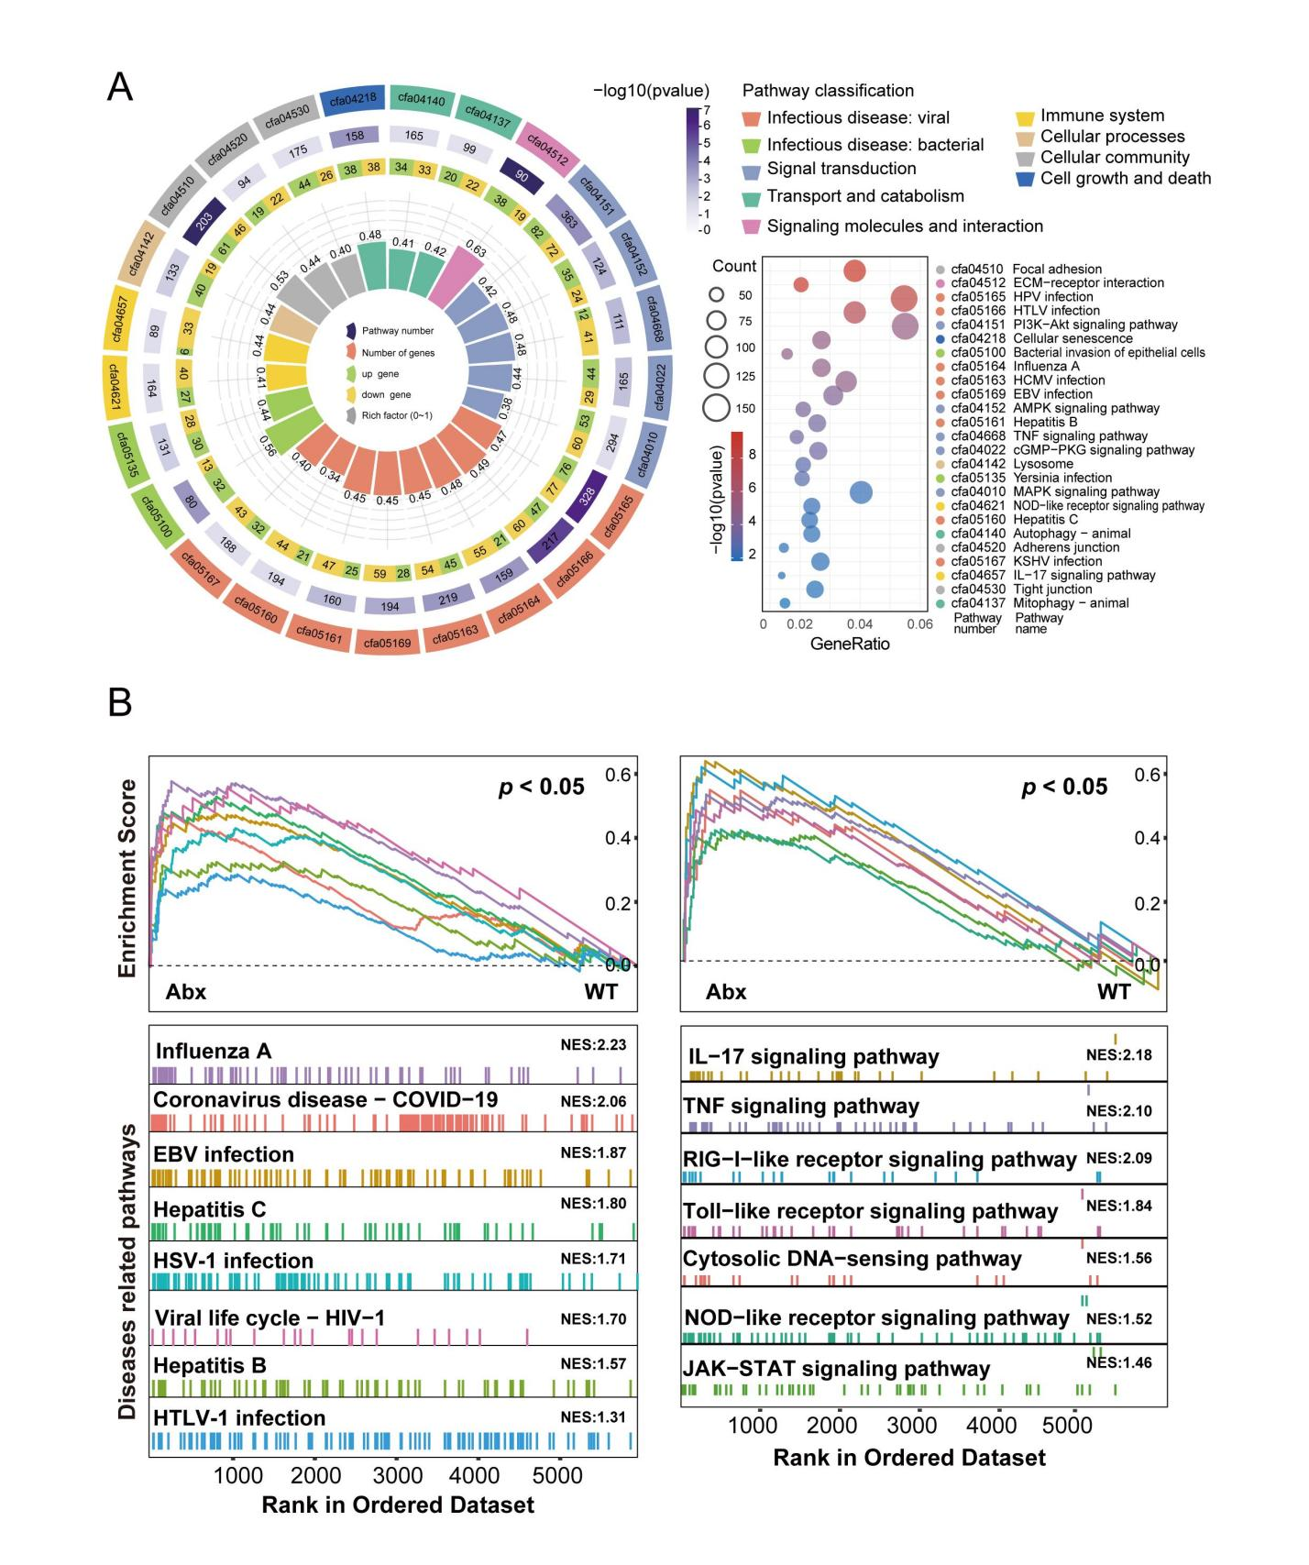

Figure S11 Transcriptomic analysis of viral infection in canine nasal tissue. (A)KEGG enrichment analysis for the differentially expressed genes (DEGs) identified by RNA-seq in the nasal tissue between the WT and Abx groups at T3. The data reveal twenty-five significantly enriched KEGG terms. All significance levels are determined by the DESeq2 package (Benjamini-Hochberg). (B) GSEA analysis for the DEGs. The data unveil the enrichment of pathways linked to viral infections (such as influenza A, EBV infection, hepatitis C, HSV-1 infection, and viral life cycle -HIV-1, and HTLV-1 infection) as well as inflammation (including the IL-17, TNF, Toll-like receptor, cytosolic DNA-sensing, and JAK-STAT signaling pathways) in the nasal tissue of the Abx group after influenza infection, in comparison to the WT group.

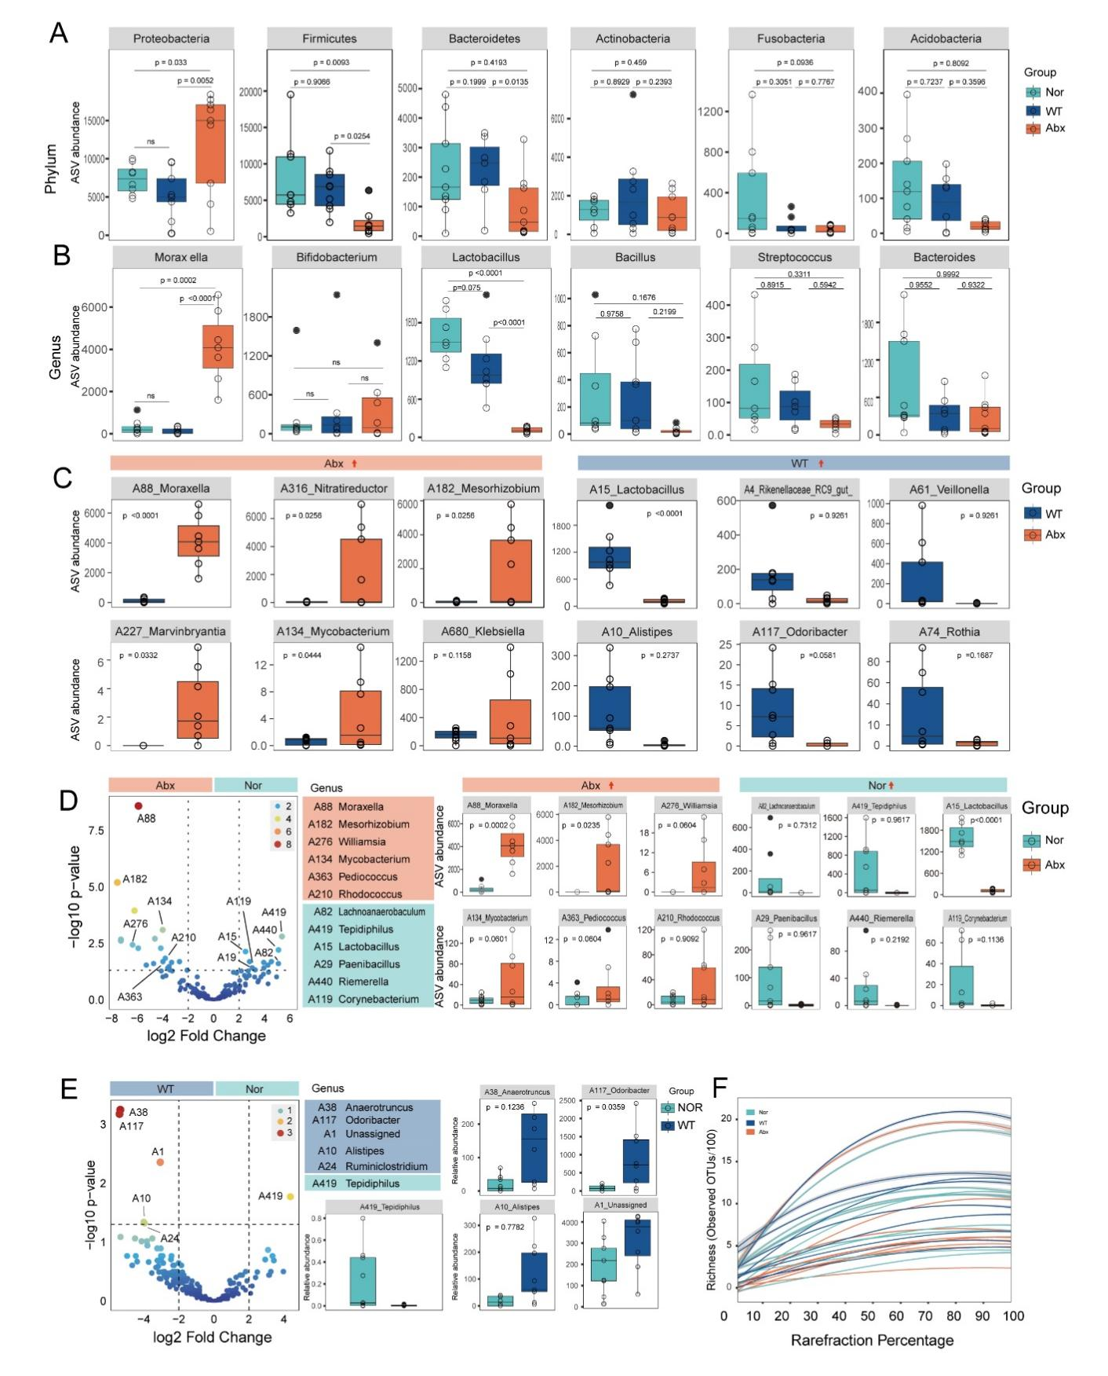

Figure S12 Differential microbial analysis in lung tissue after influenza infection among Nor, WT, and Abx groups. (A) Boxplots depict taxonomic differences at the phylum level between the WT and Abx groups, as identified through Deseq2 analysis. Further statistical analysis was conducted using the one-way ANOVA test, with p-values corrected using Tukey's HSD. (B) Boxplots showcase taxonomic distinctions at the genus level between the WT and Abx groups, discerned through Deseq2 analysis. Subsequent statistical analysis employed the one-way ANOVA test, with p-values adjusted via Tukey's HSD. (C) Boxplots highlight taxa exhibiting increased relative abundance in the Abx group compared to the WT group, and vice versa. Statistical comparisons were conducted using the one-way ANOVA test, with p-values adjusted using Tukey's HSD. (D) Scatter plots and boxplots illustrate differential taxa between the Abx and WT groups, determined through the one-way ANOVA test, with p-values adjusted using Tukey's HSD.(E) Scatter plots and boxplots display differentially abundant taxa between the WT and Nor groups, as identified through the one-way ANOVA test, with p-values adjusted using Tukey's HSD.(F) Rarefraction curve analysis illustrates the sequencing depth of 16S rRNA gene amplicons derived from lung samples, providing insights into the microbial diversity and richness within the specimens.

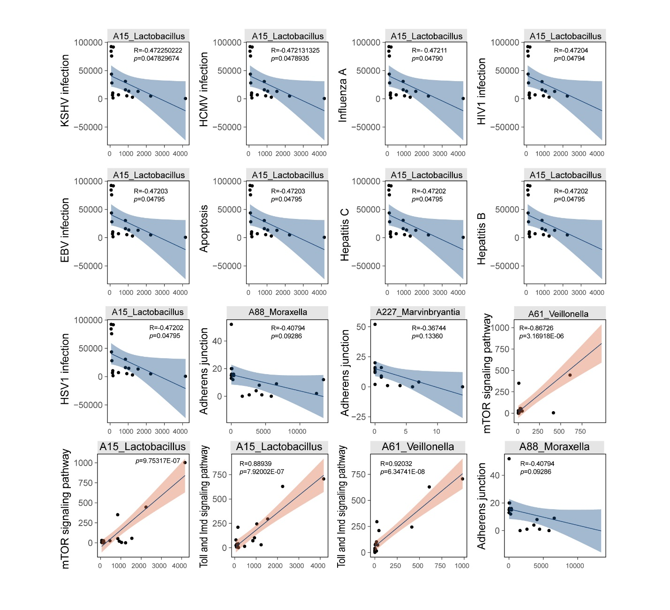

Figure S13 Correlation analysis of ASV abundance and predicted KEGG pathway contributions in nasal microbiome after antibiotic treatment. Pearson correlations were calculated to assess the association between the differential relative abundance of ASVs (Lactobacillus, Moraxella, Marvinbryantia, Veillonella) and the predicted contributions of KEGG pathways based on bacterial composition using PICRUSt2 within both the WT and Abx groups.

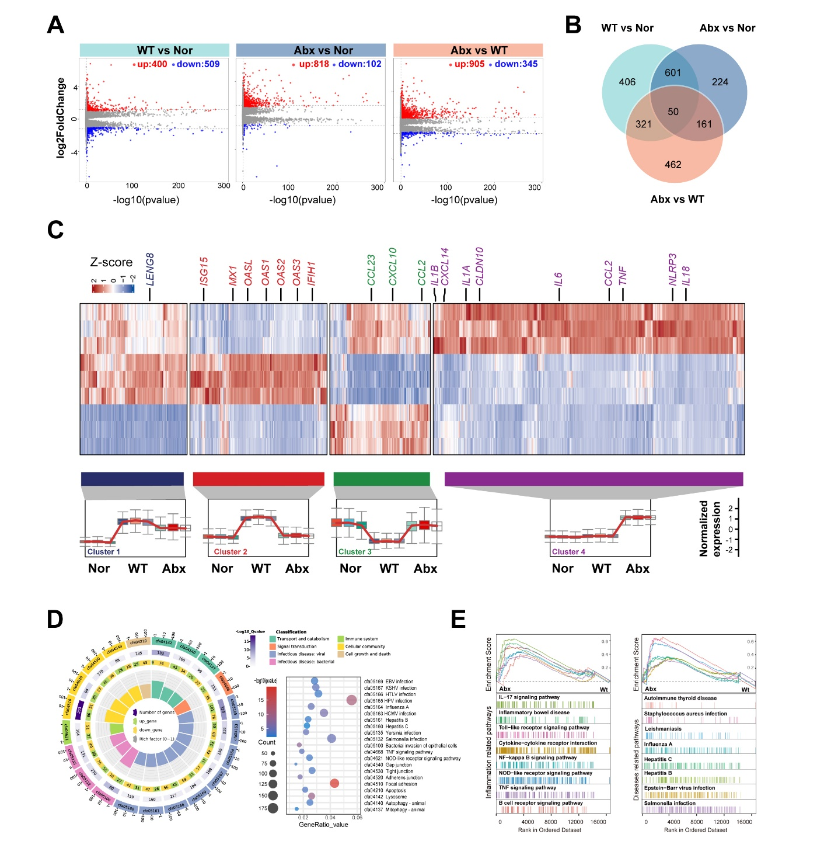

Figure S14 Pathway enrichment analysis of DEGs in lung tissue after influenza infection. (A)Volcano plot of the DEGs of the lung tissue between Nor, WT, and Abx. (B) The Venn diagram showing the shared and unique genes of DEGs. (C)Performing clustering analysis for the DEGs of the lung tissue from three groups using the Fuzzy-c means (FCM) algorithm. (D) GSEA analysis for the DEGs identified by RNA-seq in the lung tissue between the WT and Abx groups after influenza infection. The data unveil the enrichment of pathways linked to disease (such as autoimmune thyroid disease, Staphylococcus aureus infection, Leishmaniasis infection, Salmonella infection, Influenza A, EBV infection, Hepatitis B and Hepatitis C), as well as inflammation (including the IL-17, inflammatory bowel disease, Toll-like receptor, cytosolic DNA-sensing, NF-kappa B, NOD-like receptor, and TNF signaling pathways) in the lung tissue of the Abx group after influenza infection, in comparison to the WT group. (E) KEGG enrichment analysis for the DEGs identified by RNA-seq in the lung tissue between the WT and Abx groups after influenza infection. The results reveal twenty-one significantly enriched KEGG terms. All significance levels were determined by the DESeq2 package (all p < 0.05, Benjamini-Hochberg).

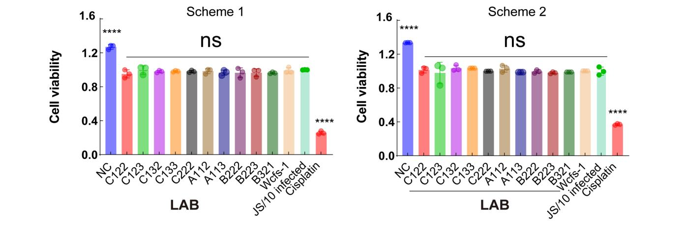

Figure S15 Effect of LAB strains on cell viability in influenza-infected cells under different treatment schemes. Cell viability following treatment with various LAB (Lactic Acid Bacteria) strains under two experimental schemes. Scheme 1 involved an 8-hour pre-treatment with LAB strains (C132, C123, C222, C32, A112, A113, B222, and B321), followed by 24 hours of influenza virus (JS/10) infection. Scheme 2 (right) involved an initial 1-hour infection with influenza virus, followed by co-infection with LAB strains for 24 hours. Controls include NC (uninfected, untreated cells) and cisplatin-treated cells, with cisplatin serving as a control for reduced cell viability due to its cytotoxic effects. LAB-treated groups show no statistically significant difference in viability (ns) compared to controls, while cisplatin treatment leads to a significant reduction in cell viability (one-way ANOVA test ，****, p <0.0001).

Table S1. Primers used for RT- qPCR analyses
Target gene | Primer pairs | Sequence
IFNα | Canis-IFNa-qF | CAACTGGAGGGTCCTGACGC
IFNα | Canis-IFNa-qR | GTCATGTTCCAAGGAGCAGA
IFNβ1 | Canis-IFNβ1-qF | GCAACGACTTGCTTCGATCC
IFNβ1 | Canis-IFNβ1-qR | CCTTCTGGAACTGGCGTGAT
OAS1 | Canis-OAS1-qF | TTCACATCATCTCCACTT
OAS1 | Canis-OAS1-qR | ACCCTTGACAACTTTAGA
PKR | Canis-PKR-qF | AATTGGCTCAGGTGGATATGG
PKR | Canis-PKR-qR | ACCTTCTTGTCGCTATCGTATTT
Myd88 | Canis-Myd88-qF | TCACCATGCTTGATGATCCCT
Myd88 | Canis-Myd88-qR | TTCCAGCTGCCGGATCATTT
Mx1 | Canis-Mx1-qF | GAATCCTGTACCCAATCATGTG
Mx1 | Canis-Mx1-qR | TACCTTCTCCTCATATTGGCT
Mx2 | Canis-Mx2-qF | CAAGCTTTCACCGACACAGC
Mx2 | Canis-Mx2-qR | GGACCTTCCTCAGAACCACG
IL6 | Canis-IL6-qF | CTCTGCACTGAGAAAGGAGATG
IL6 | Canis-IL6-qR | CTCCAGTTTGGGAAGATGTAGG
Caspase3 | Canis-Caspase3-qF | TGCCGAGGTACAGAACTAGA
Caspase3 | Canis-Caspase3-qR | GTCCGCTTCGACTGGTATTT
TNFα | Canis-TNFα-qF | ATCTACTCCCAGGTCCTCTTC
TNFα | Canis-TNFα-qR | GGTTGACCTTTGTCTGGTAGG
Bax | Canis-Bax-qF | GGTTGTTGCCCTCTTCTACTT
Bax | Canis-Bax-qR | TCTCGAAGGAAGTCCAGTGT
GAPDH | Canis-GAPDH-qF | GTGATGCTGGTGCTGAGTATGT
GAPDH | Canis-GAPDH-qR | GGTTCACGCCCATCAC

