MICROBIOTA-DERIVED UROLITHIN A IN MONOCLONAL GAMMOPATHIES AND MULTIPLE MYELOMA THERAPY
Alba Rodríguez-García et al.
SUPPLEMENTARY MATERIAL
Supplementary Table S1. Clinical characteristics of classified patients at each stage of the disease.
 | MGUS | SMM | NDMM | RRMM | CRMM
Patients, n | 11 | 8 | 15 | 7 | 8
Sex
n | 11 | 8 | 15 | 7 | 8
M/F (FEMALE %) | 45 | 63 | 73 | 71 | 88
Age at diagnosis
n | 11 | 8 | 15 | 7 | 8
Median | 72 | 58 | 67 | 74.5 | 58
Range | 51-85 | 28-86 | 49-85 | 67-84 | 49-67
Amount of Mc Ig (g/dL)
n | 11 | 8 | 15 | 6 | 5
Median | 0.48 | 1.17 | 2.89 | 1.32 | 0
Range | 0-1.27 | 0.8-4.3 | 0.08-6.9 | 0.5-3.1 | 0-1.1
BM plasma cells (%)
n | 3 | 7 | 15 | 5 | 4
Median | 7 | 21 | 40 | 26 | 0.75
Range | 6-8 | 7-60 | 2-78 | 1-77 | 0-1
β2-microglobulin (mg/L)
n | 5 | 3 | 11 | 3 | 2
Median | 2 | 2.5 | 3.9 | 3.05 | 5.8
Range | 0.48-2.3 | 2.4-2.5 | 2.4-18.2 | 2.7-3.4 | 2.2-9.4
n > 3.5 mg/L | 0 | 0 | 6 | 0 | 1
Leukocytes (10⁹/L)
n | 11 | 7 | 15 | 7 | 7
Median | 5.5 | 6.4 | 5.4 | 5 | 5.5
Range | 4.1-8.6 | 4.9-7.3 | 2-12.7 | 1.8-13.8 | 0.78-13.4
Hemoglobin (g/dL)
n | 11 | 8 | 15 | 7 | 7
Median | 13.8 | 14.1 | 10.6 | 11.4 | 12.2
Range | 11.1-16.1 | 10.2-16.2 | 7.4-16.7 | 7.6-12.7 | 10.7-14.9
Platelets (10⁹/L)
n | 11 | 7 | 15 | 7 | 7
Median | 210 | 256 | 219 | 115 | 197
Range | 99-364 | 237-274 | 101-414 | 80-217 | 109-350
Calcemia (mg/dL)
n | 9 | 7 | 14 | 7 | 6
Median | 9.7 | 9.4 | 9.6 | 9.6 | 9.65
Range | 9.4-10.1 | 6.4-9.9 | 9-11.2 | 8.3-9.8 | 8.3-12.9
Creatitine (mg/dL)
n | 11 | 8 | 15 | 7 | 6
Median | 0.91 | 0.9 | 0.98 | 1.14 | 0.885
Range | 0.59-1.74 | 0.55-5.36 | 0.54-2.01 | 0.77-4 | 0.85-1.87
Bone lesions
n | 9 | 4 | 15 | 6 | 3
n with lesions (%) | 11.1 | 0 | 66.7 | 83.3 | 67
ISS Stage
n | 0 | 1 | 13 | 4 | 3
Stage I | 0 | 1 | 7 | 0 | 1
Stage II | 0 | 0 | 4 | 2 | 1
Stage III | 0 | 0 | 1 | 2 | 1
MGUS, monoclonal gammopathy of undetermined significance; SMM, smoldering myeloma; MM, multiple myeloma; NDMM, MM at diagnosis; RRMM, MM at relapse/refractory; CRMM, MM in complete remission; n, number of patients; M, male; F, female; Mc Ig, monoclonal immunoglobulin; BM, Bone marrow; ISS, Multiple Myeloma International Staging System
Supplementary Table S2. Type of urolithin and the metabotype of patients and controls with detectable levels of urolithins in feces.
Sample | Group | EA | UroD | UroM6 | UroC | UroM7 | Iso UroA | UroA | UroB | Metabotype
2 | CRMM |  |  |  |  |  |  | X |  | A
11 | NDMM |  |  |  |  |  |  | X | X | B
12 | CRMM |  |  |  | X |  | X | X | X | B
14 | NDMM |  |  |  |  |  |  | X |  | A
15 | MGUS |  |  |  | X |  | X | X |  | B
16 | MGUS |  |  |  |  |  | X | X |  | B
17 | MGUS | X |  | X | X |  | X | X |  | B
23 | control | X |  |  |  |  |  | X |  | A
4 | MGUS | X |  |  |  |  |  |  |  | 0
10 | SMM |  |  |  |  |  |  | X | X | B
12 | control |  |  |  |  |  |  | X |  | A
13 | control |  |  |  |  |  |  | X |  | A
15 | control |  |  |  |  |  | X | X | X | B
16 | MGUS |  |  |  |  |  |  | X |  | A
17 | SMM | X |  | X | X |  |  | X |  | A
18 | SMM |  |  |  |  |  |  | X |  | A
19 | RRMM |  |  |  |  |  |  | X |  | A
MGUS, monoclonal gammopathy of undetermined significance; SMM, smoldering myeloma; MM, multiple myeloma; NDMM, MM at diagnosis; RRMM, MM at relapse/refractory; CRMM, MM in complete remission; EA, ellagic acid; Uro, urolithin.

Supplementary Table S3. Statistical significance p-values adjusted by Benjamini-Hochberg (BH) procedure for the genus taxa included in the study.
genus_taxa | comparison | p_values_raw | p_values_BH
p__Bacillota|c__Clostridia|o__Lachnospirales|f__Lachnospiraceae|g__[Ruminococcus]_gauvreauii_group | NDMM_vs_CT | 0.0251 | 0.0427
p__Actinobacteriota|c__Coriobacteriia|o__Coriobacteriales|f__Coriobacteriales_Incertae_Sedis|g__Raoultibacter | NDMM_vs_CT | 0.032 | 0.0427
p__Bacillota|c__Bacilli|o__Erysipelotrichales|f__Erysipelatoclostridiaceae|g__Erysipelatoclostridium | NDMM_vs_CT | 0.0068 | 0.0272
p__Bacillota|c__Clostridia|o__Lachnospirales|f__Lachnospiraceae|g__[Ruminococcus]_gauvreauii_group | NDMM_vs_MGUS | 0.4852 | 0.4852
p__Bacillota|c__Bacilli|o__Erysipelotrichales|f__Erysipelatoclostridiaceae|g__Erysipelatoclostridium | NDMM_vs_MGUS | 0.3492 | 0.4852
p__Bacillota|c__Clostridia|o__Peptostreptococcales-Tissierellales|f__Peptostreptococcaceae|g__Terrisporobacter | NDMM_vs_RRMM | 0.0343 | 0.0344
p__Bacillota|c__Clostridia|o__Oscillospirales|f__Ruminococcaceae|g__Ruminococcus | NDMM_vs_RRMM | 0.0344 | 0.0344
p__Bacillota|c__Clostridia|o__Oscillospirales|f__Ruminococcaceae|g__Phocea | NDMM_vs_RRMM | 0.0127 | 0.0344
p__Bacillota|c__Clostridia|o__Lachnospirales|f__Lachnospiraceae|g__[Ruminococcus]_gauvreauii_group | NDMM_vs_SMM | 0.009 | 0.036
p__Actinobacteriota|c__Coriobacteriia|o__Coriobacteriales|f__Coriobacteriales_Incertae_Sedis|g__Raoultibacter | NDMM_vs_SMM | 0.1 | 0.1333
p__Bacillota|c__Bacilli|o__Erysipelotrichales|f__Erysipelatoclostridiaceae|g__Erysipelatoclostridium | NDMM_vs_SMM | 0.03 | 0.06
p__Bacillota|c__Clostridia|o__Peptostreptococcales-Tissierellales|f__Peptostreptococcaceae|g__Terrisporobacter | RRMM_vs_CRMM | 0.0363 | 0.0363

Supplementary Table S4. List of primary and secondary antibodies used for Western blot analyses. The name and reference of the commercial company, the source and the dilution of use of the different antibodies used for protein expression are detailed. For the primary antibodies, the protein to which they are directed and the MW of the protein are also mentioned.
Primary antibodies
Protein | MW (kDa) | Name | Reference  (company) | Source | Dilution
BAX | 21 | Anti-Bax | #5023 (Cell Signaling Technology) | Rabbit | 1/1000
Complex I (NDUFB8) | 18 | Total OXPHOS Human WB Antibody Cocktail | Ab110411 (Abcam) | Mouse | 1/10000
Complex II (SDHB) | 29
Complex III subunit II (UQCRC2) | 48
Complex IV subunit II (COX II) | 22
ATP synthase subunit alpha (ATP5A) | 54
NRF2 | 98-118 | Anti-NRF2 | #33649 (Cell Signaling Technology) | Rabbit | 1/500
mTOR | 289 | mTOR (7C10) Rabbit mAb | 2983 (Cell Signaling Technology) | Rabbit | 1/1000
p-mTOR | 289 | Phospho-mTOR (Ser2481) | 2974 (Cell Signaling Technology) | Rabbit | 1/1000
p27 | 27 | Anti-p27-Kip1 | #610241BD Biosciences | Rabbit | 1/500
p53 | 53 | Anti-p53 antibody [PAb 240] | ab26 (Abcam) | Mouse | 1/5000
GAPDH | 37 | GAPDH monoclonal antibody | AM4300 (Invitrogen) | Mouse | 1/10000
Secondary antibodies
Name |  | Reference (Company) |  | Source | Dilution
Anti-rabbit IgG, HRP-linked antibody |  | 7074 (Cell Signaling Technology) |  | Goat | 1/2000
Anti-mouse IgG, HRP-linked antibody |  | 7076 (Cell Signaling Technology) |  | Horse | 1/10000
MW, molecular weight; mTOR, target of rapamycin in mammalian cells; p-mTOR, phosphorylated mTOR; NDUFB8, subunit 8 of the beta subcomplex of NADH dehydrogenase complex I; SDHB, the B subunit of succinate dehydrogenase complex II; MTCO1, the cytochrome c oxidase complex subunit 1 of complex IV; UQCRC2, the cytochrome b-c1 complex subunit 2 of complex III; ATP5A, ATP synthase subunit alpha of complex V; GAPDH, glyceraldehyde-3-phosphate dehydrogenase.
Supplementary Figure 1
A) Proportion (%) of patients with monoclonal gammopathy of undetermined significance (MGUS), smoldering myeloma (SMM), new diagnosed MM (NDMM), MM in complete remission (CRMM) and at relapse/refractory (RRMM) with detectable or undetectable levels of urolithin A in serum. B) Proportion (%) of patients with pre-malignant disease (MGUS and SMM), active-MM (NDMM and RRMM) and CRMM with detectable or undetectable levels of urolithin A in serum. C) Alpha-diversity measured by Chao1, D) Shannon and E) Simpson and F) Pielou indices in all patients that show differences between urolithin producers and non-producers. **P≤0.01, *** P≤0.001.
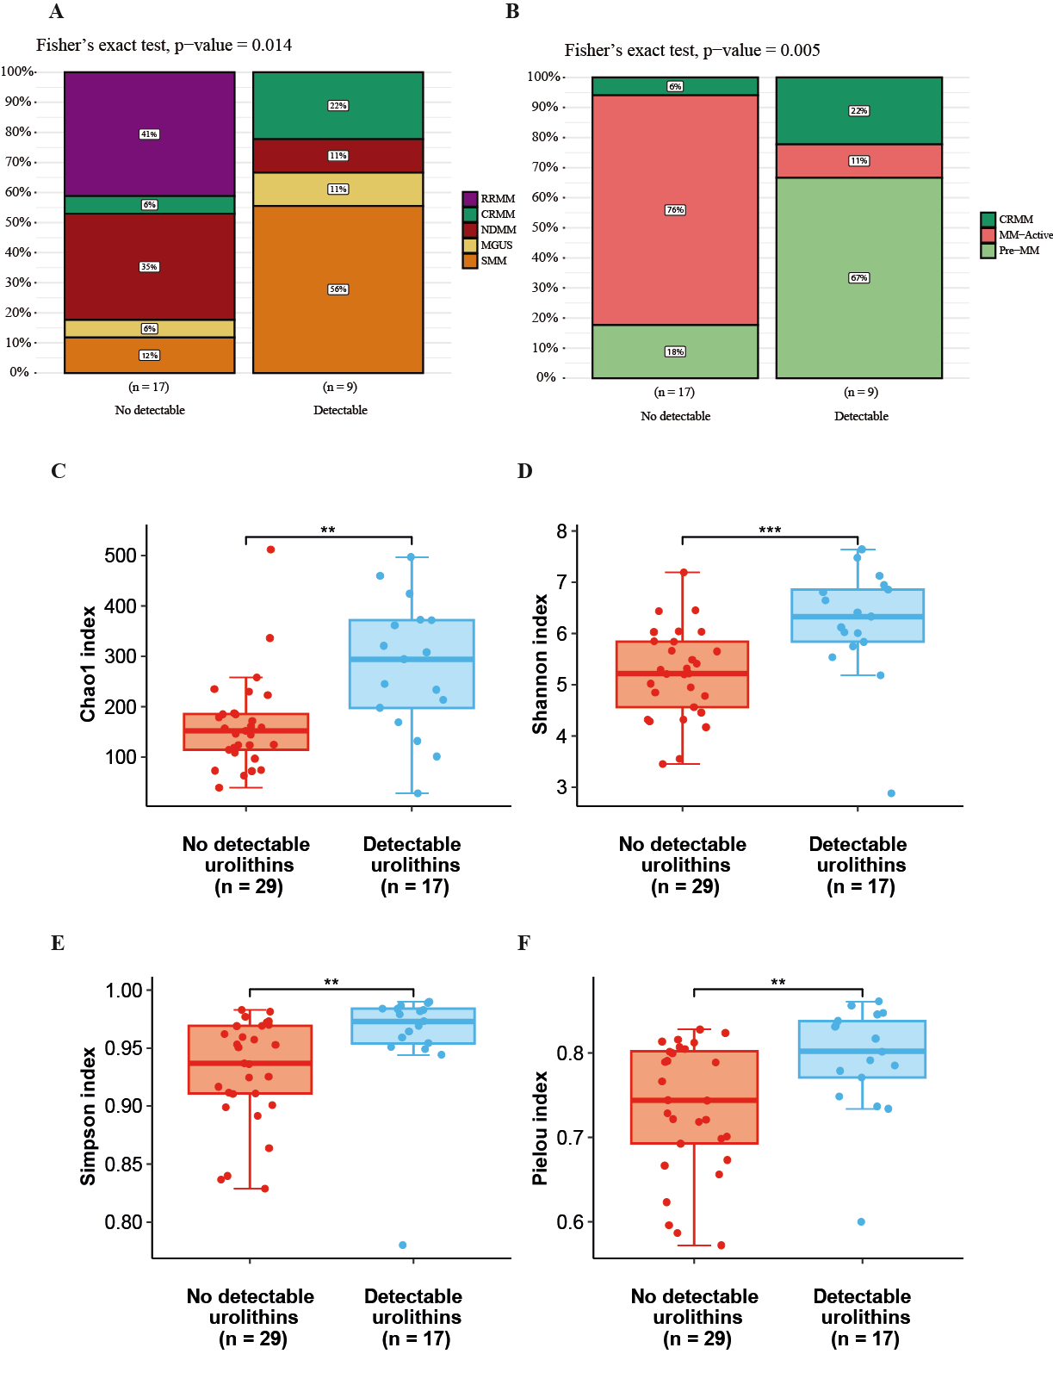
Supplementary Figure 2
A) Taxonomic biomarkers identified by linear discriminant analysis (LDA) effect size (LEfSE) analysis showing differences among multiple myeloma at diagnosis (NDMM) versus control (C) patients, and versus monoclonal gammopathy of undetermined significance (MGUS). B) Relative abundance (%) of the genera Raoultibacter and Erysipelatoclostridium in the progression of disease, from healthy controls (C), MGUS, smoldering multiple myeloma (SMM) and NDMM. C) Relative abundance of genera Ruminococcus and Phocea in NDMM and patients with relapse/refractory disease (RRMM). The results are represented by mean±SEM. * P≤0.05, **P≤0.01.
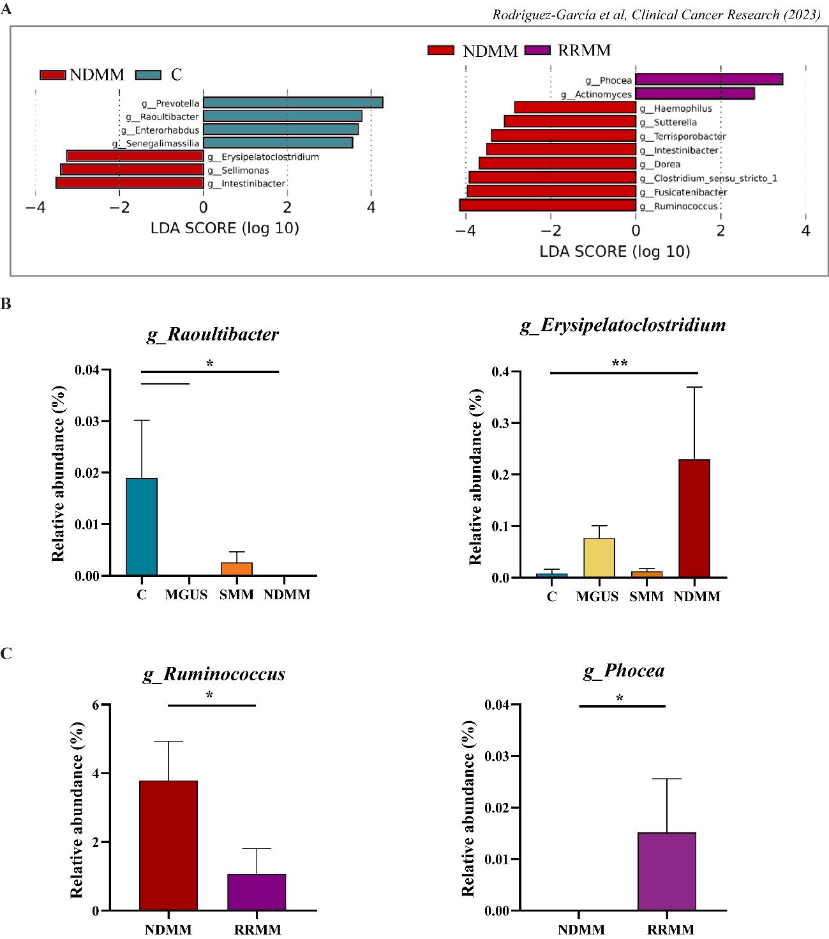
Supplementary Figure 3
A) Normalized isobologram representing combination indices after the treatment with urolithin A and bortezomib in the JJN3 cell line. B) Dose-response curves after 48 hours of exposure to urolithin A in the sensitive JJN3 and resistant JJN3_R-Btz line. Mean ± SEM of data normalized to the control condition is represented. C) Normalized isobologram representing the combination indices after combination treatment with urolithin A and bortezomib in the JJN3_R-Btz line. Btz, bortezomib.

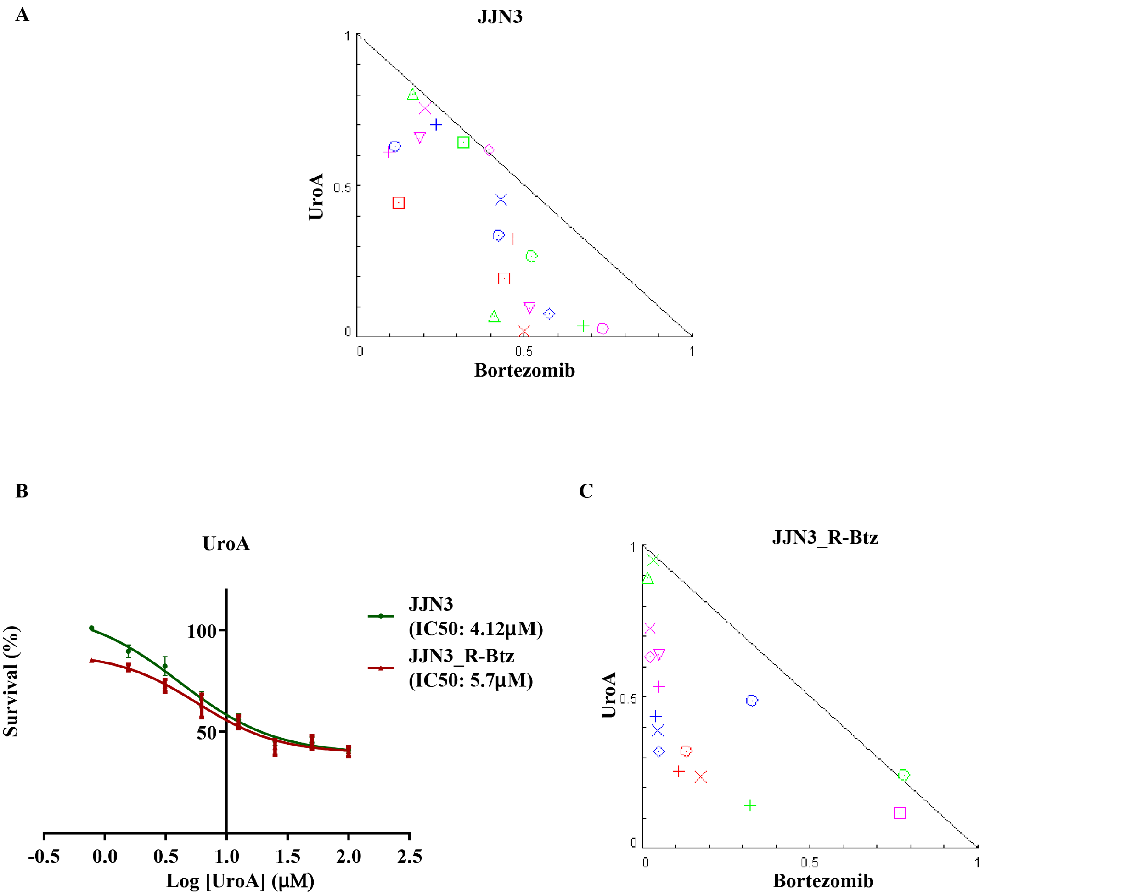

Supplementary Figure 4
A) p53 levels analyzed by Western blot in the bortezomib (Btz) sensitive and resistant JJN3 cell line after exposure to urolithin A (UroA) at 15 µM, Btz at 4 nM and the combination of both (UroA+Btz) for 48 hours. B) p21 expression analyzed by qPCR in the Btz sensitive and resistant JJN3 cell line after exposure to UroA at 15 µM, Btz at 4 nM and the combination of both (UroA+Btz) for 48 hours. C) Expression levels of mTOR and p-mTOR analyzed by Western blot in Btz sensitive and resistant JJN3 cell line after exposure to UroA at 15 µM, Btz at 4 nM and the combination of both (UroA+Btz) for 3 hours. (A-C) The control condition was DMSO under the same conditions as the combination treatment. Bar graphs represent mean ± SEM of expression normalized against the glyceraldehyde 3-phosphate dehydrogenase (GAPDH) loading control (A, C) or GUS housekeeping gene (B). *P≤0.05; **P≤0.01; ***P≤0.001.
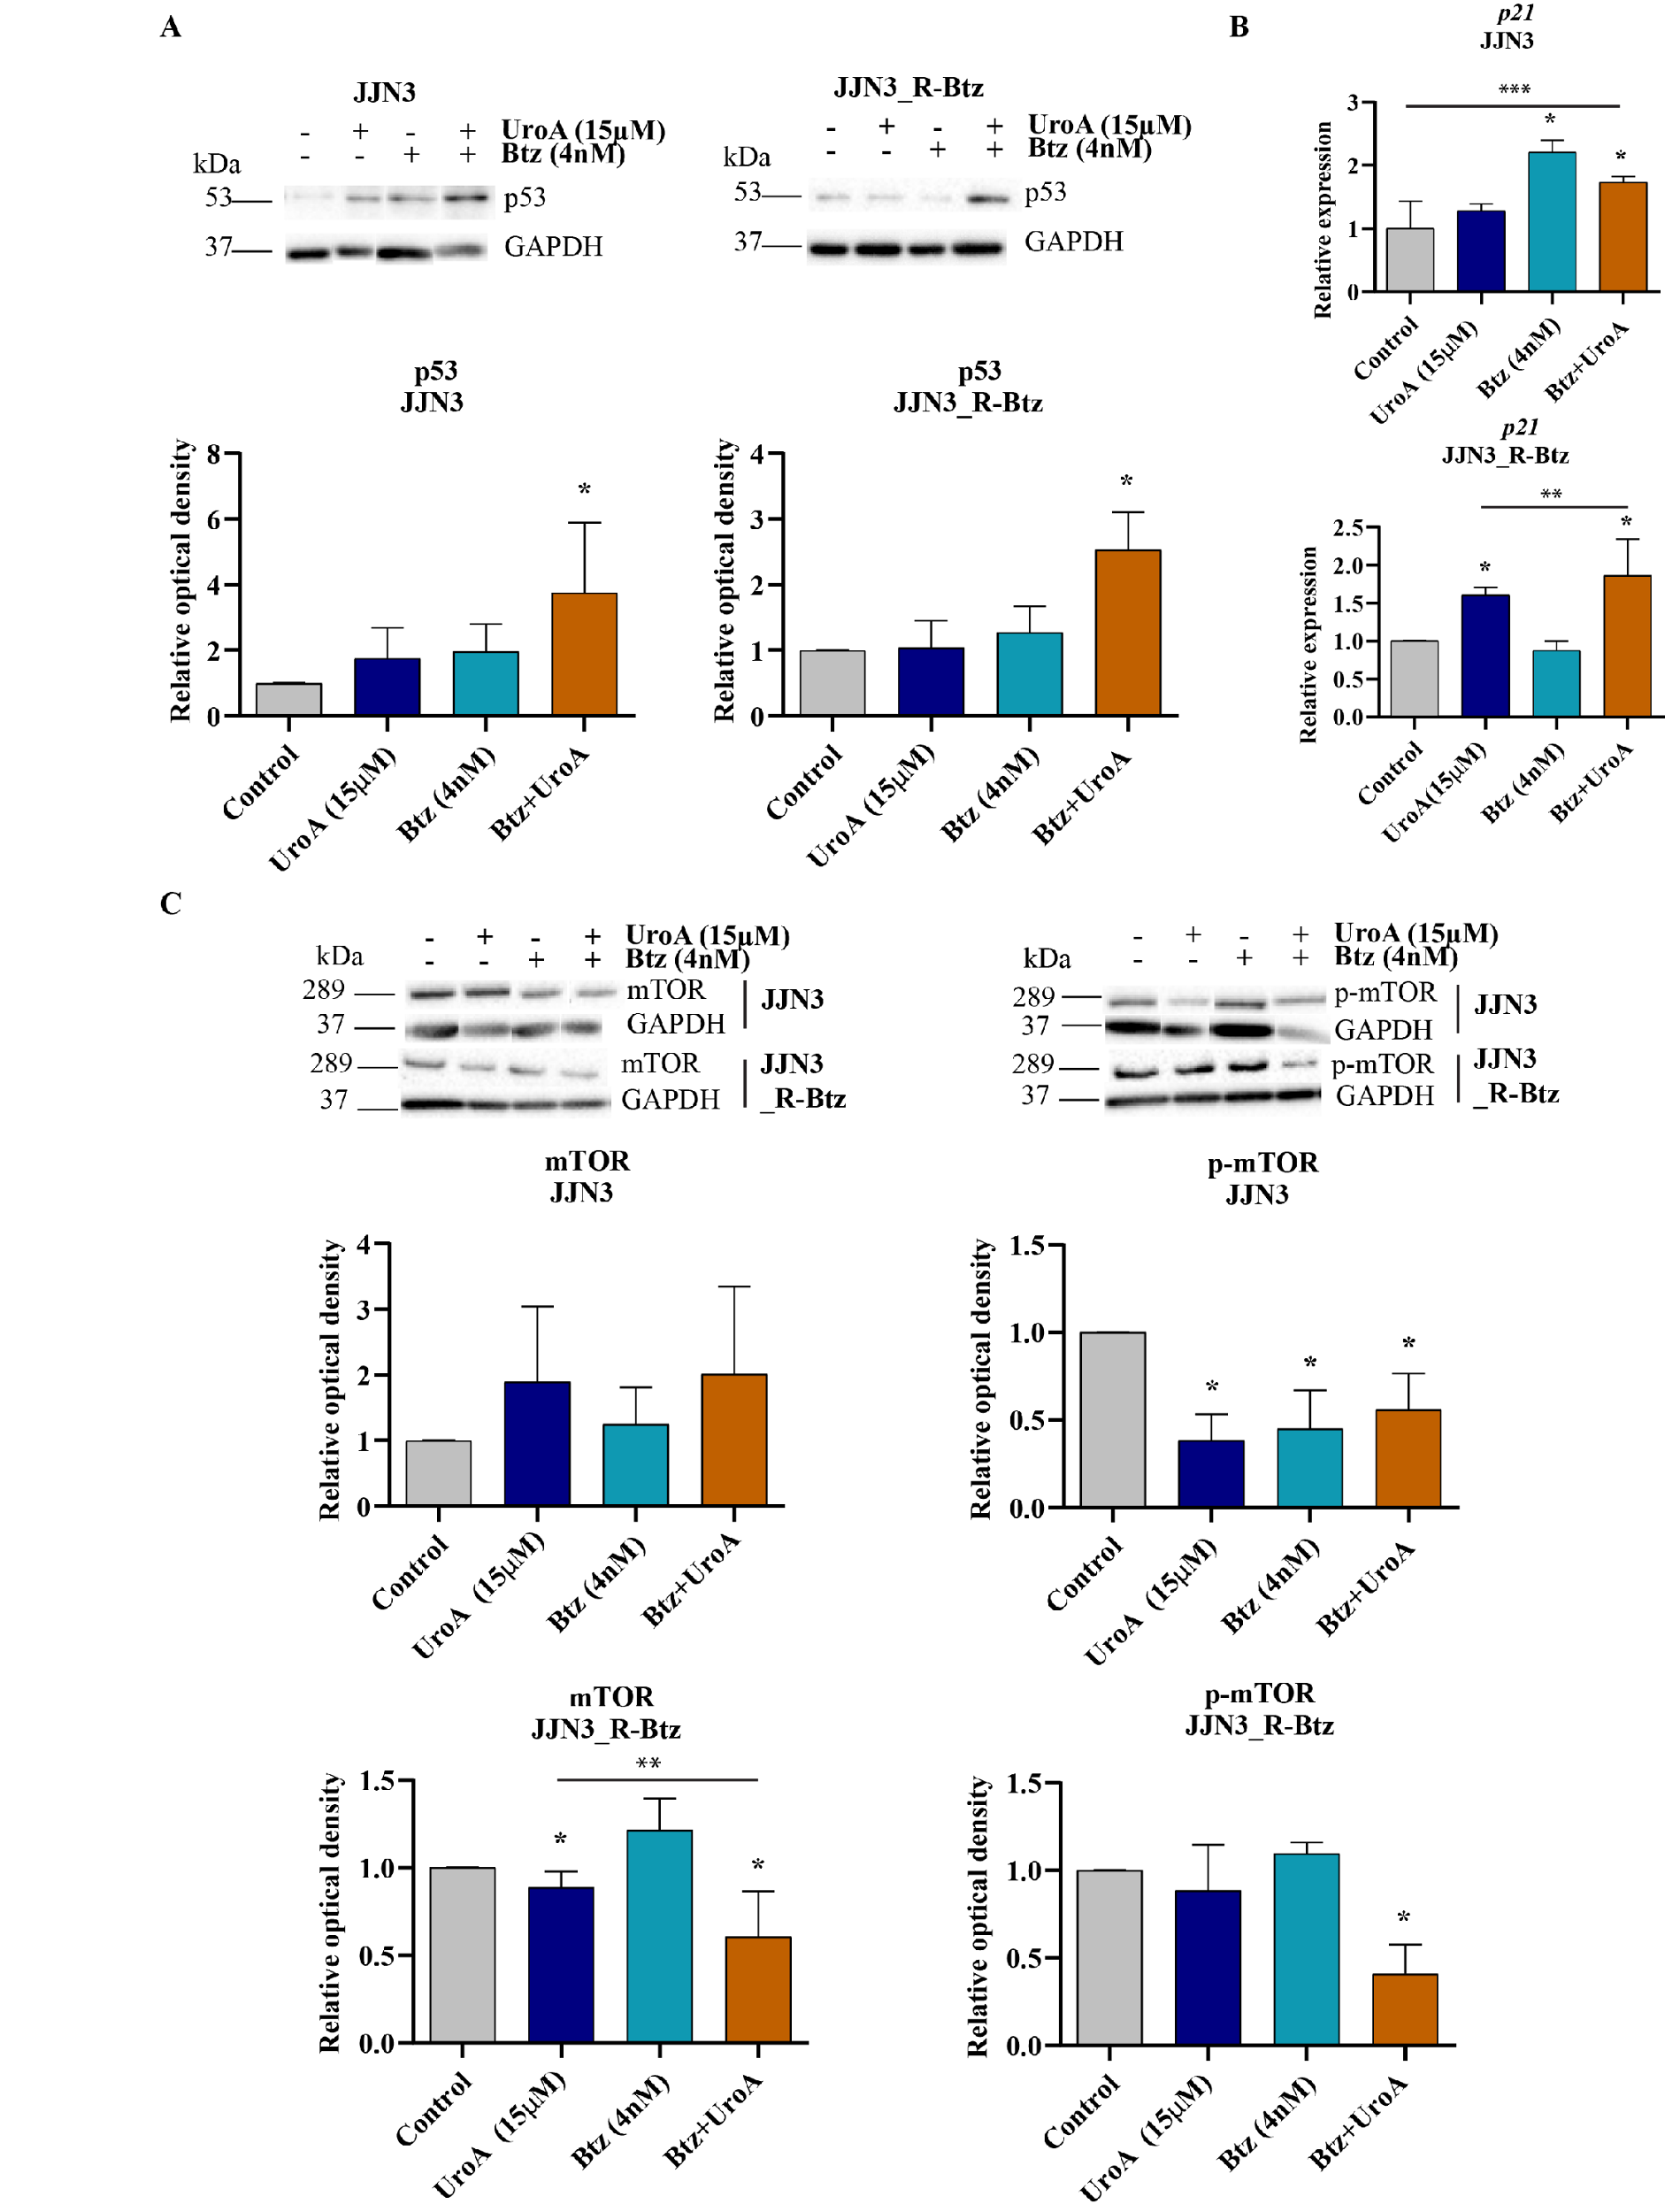
Supplementary Figure 5.
A) Bar chart shows the mean ± SEM of survival percentage in PBMCs from healthy donors upon 48 h exposure to urolithin A (UroA) at 15 μM (n=3) or 30 μM (n=3). B) Bar chart shows the mean ± SEM of survival percentage in T-cells from healthy donors upon 48 h exposure to urolithin A (UroA) at 15 μM (n=3) or 30 μM (n=3). No significant differences were observed.
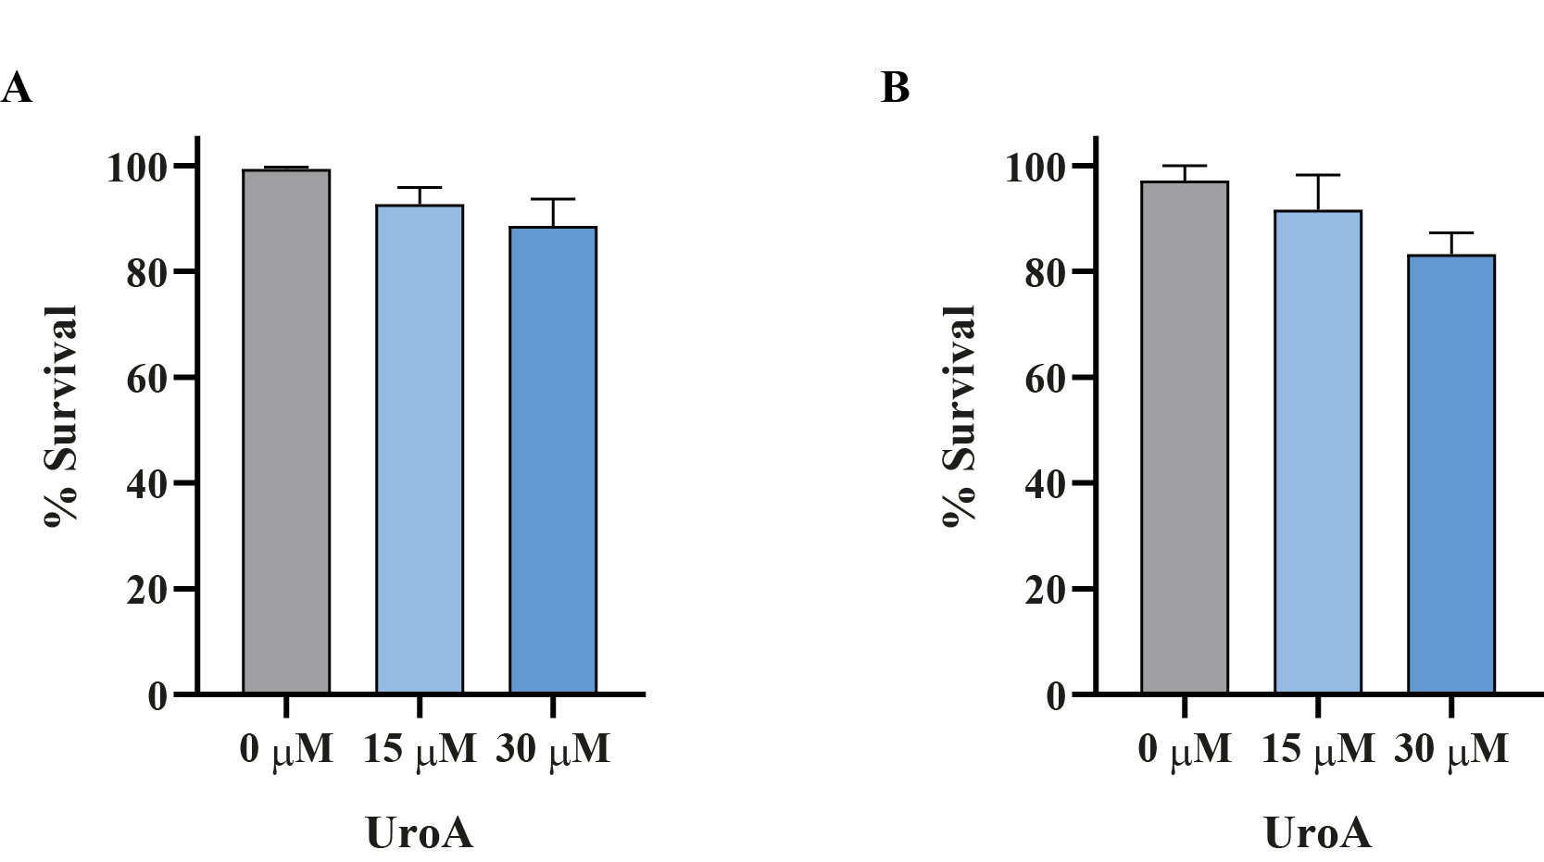
Supplementary Figure 6.
A) Normalized isobologram representing combination indices after the treatment with urolithin A and lenalidomide in the JJN3 cell line. B) Normalized isobologram representing the combination indices after combination treatment with urolithin A and venetoclax in the JJN3 cell line.
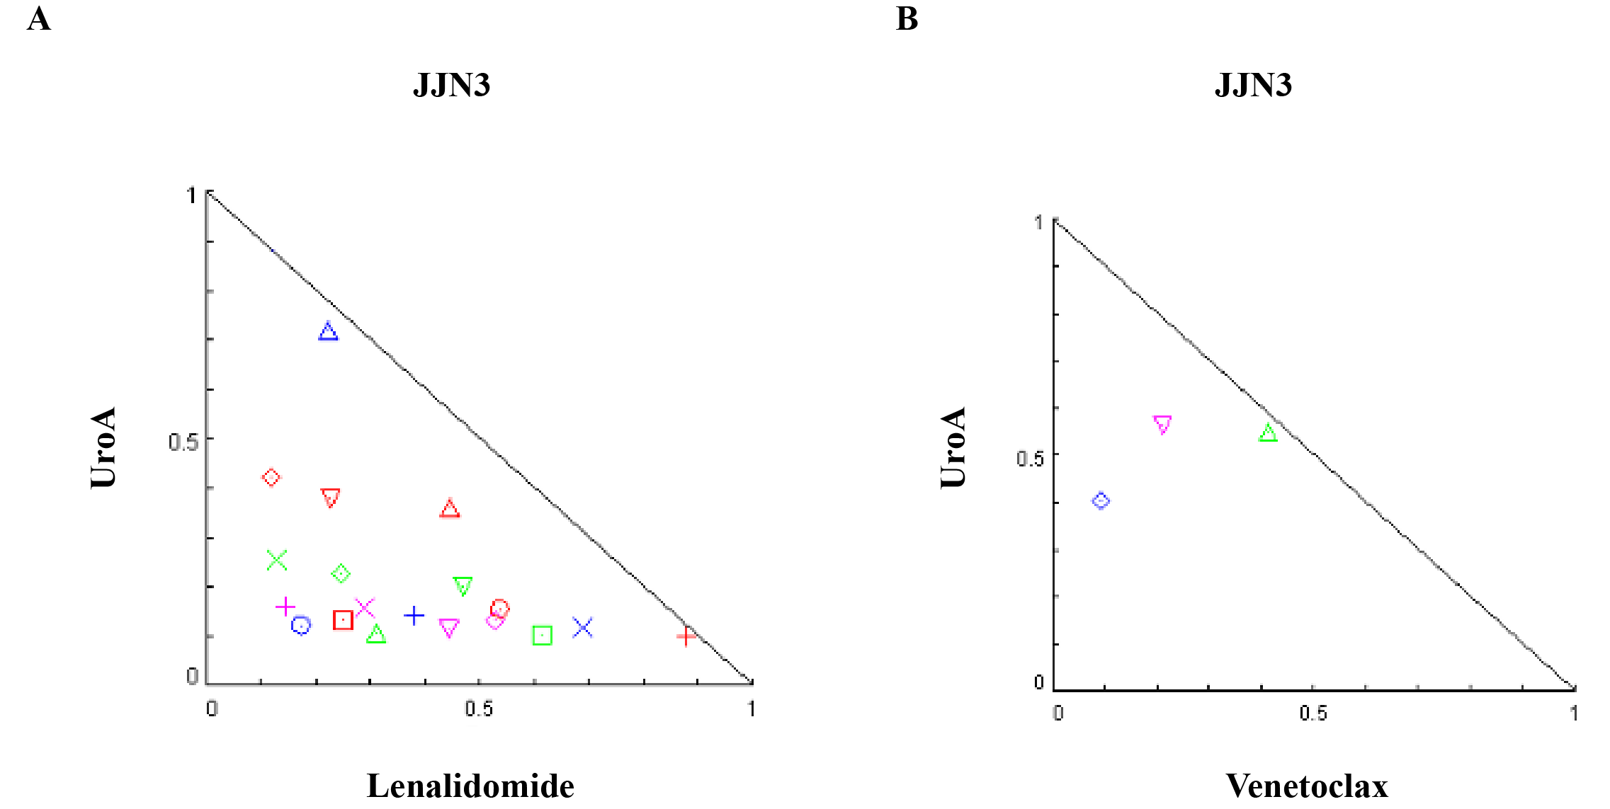
Appendix tables.
Appendix 1. Clinical data of patients at different multiple myeloma stages and healthy control subjects
Appendix 2. Relative abundance of operational taxonomic units (OTUs) across taxonomic ranks, including phylum, class, order, family, genus, and species, in patients at different multiple myeloma stages and healthy control subjects
Appendix 3. Bioinformatics pipeline used for processing raw sequencing data into OTU tables

