DRAMMA: A multifaceted machine learning approach for novel antimicrobial resistance gene detection in metagenomic data

Supplementary materials
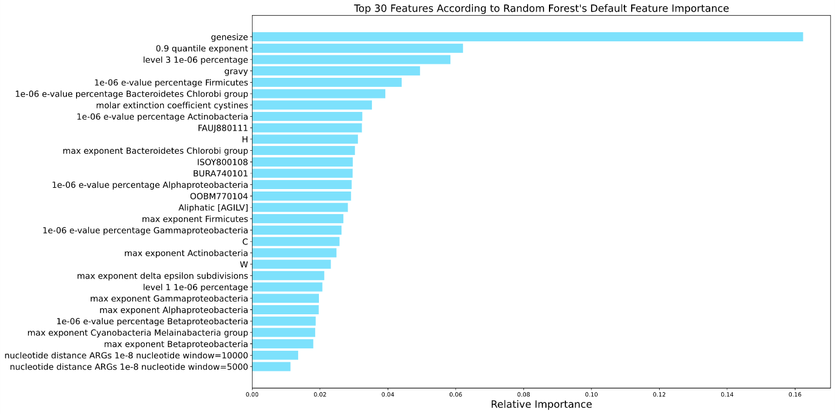
B.
A.
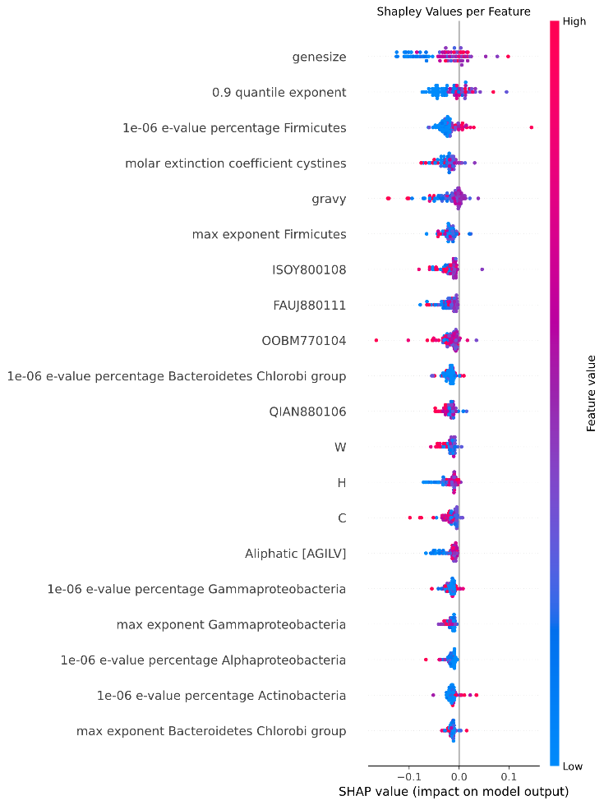
Supplementary Figure 1 | The top 30 features according to Random Forest feature importance. A. The feature importance of the top 30 features selected through Random Forest’s feature importance. B. The SHAP values of the top 30 features. Each data point corresponds to a feature observation, and the color scale reflects the feature value, transitioning from blue (indicating low values) to red (indicating high values). The x-axis is the SHAP value, illustrating its contribution to the model's decision. The sign of the SHAP value indicates whether the feature observation contributes to a positive or negative classification.
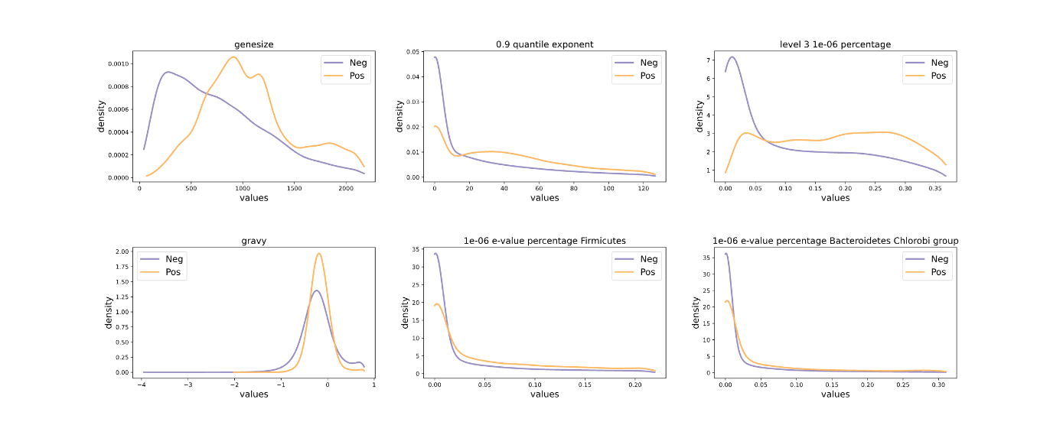
Supplementary Figure 2 | The distribution of the top six features across the positive (ARG) and negative (non-ARG) classes. Extreme values (above the 95% percentile) are not displayed in the plots.

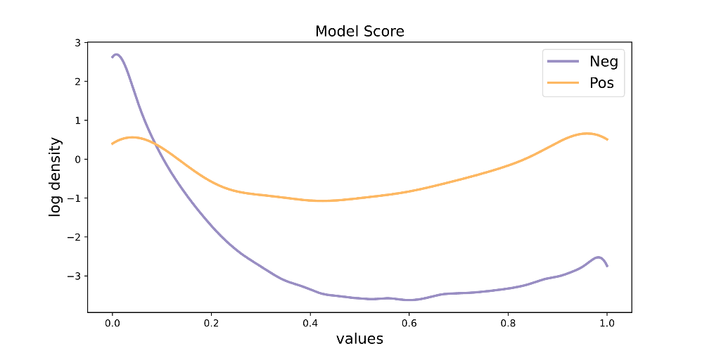
Supplementary Figure 3 | Model score distribution on the external test set. The distribution of the model’s score on the external sewage test set, annotated as positive and negative according to ResfinderFG v.2.0. Density is shown in log scale.

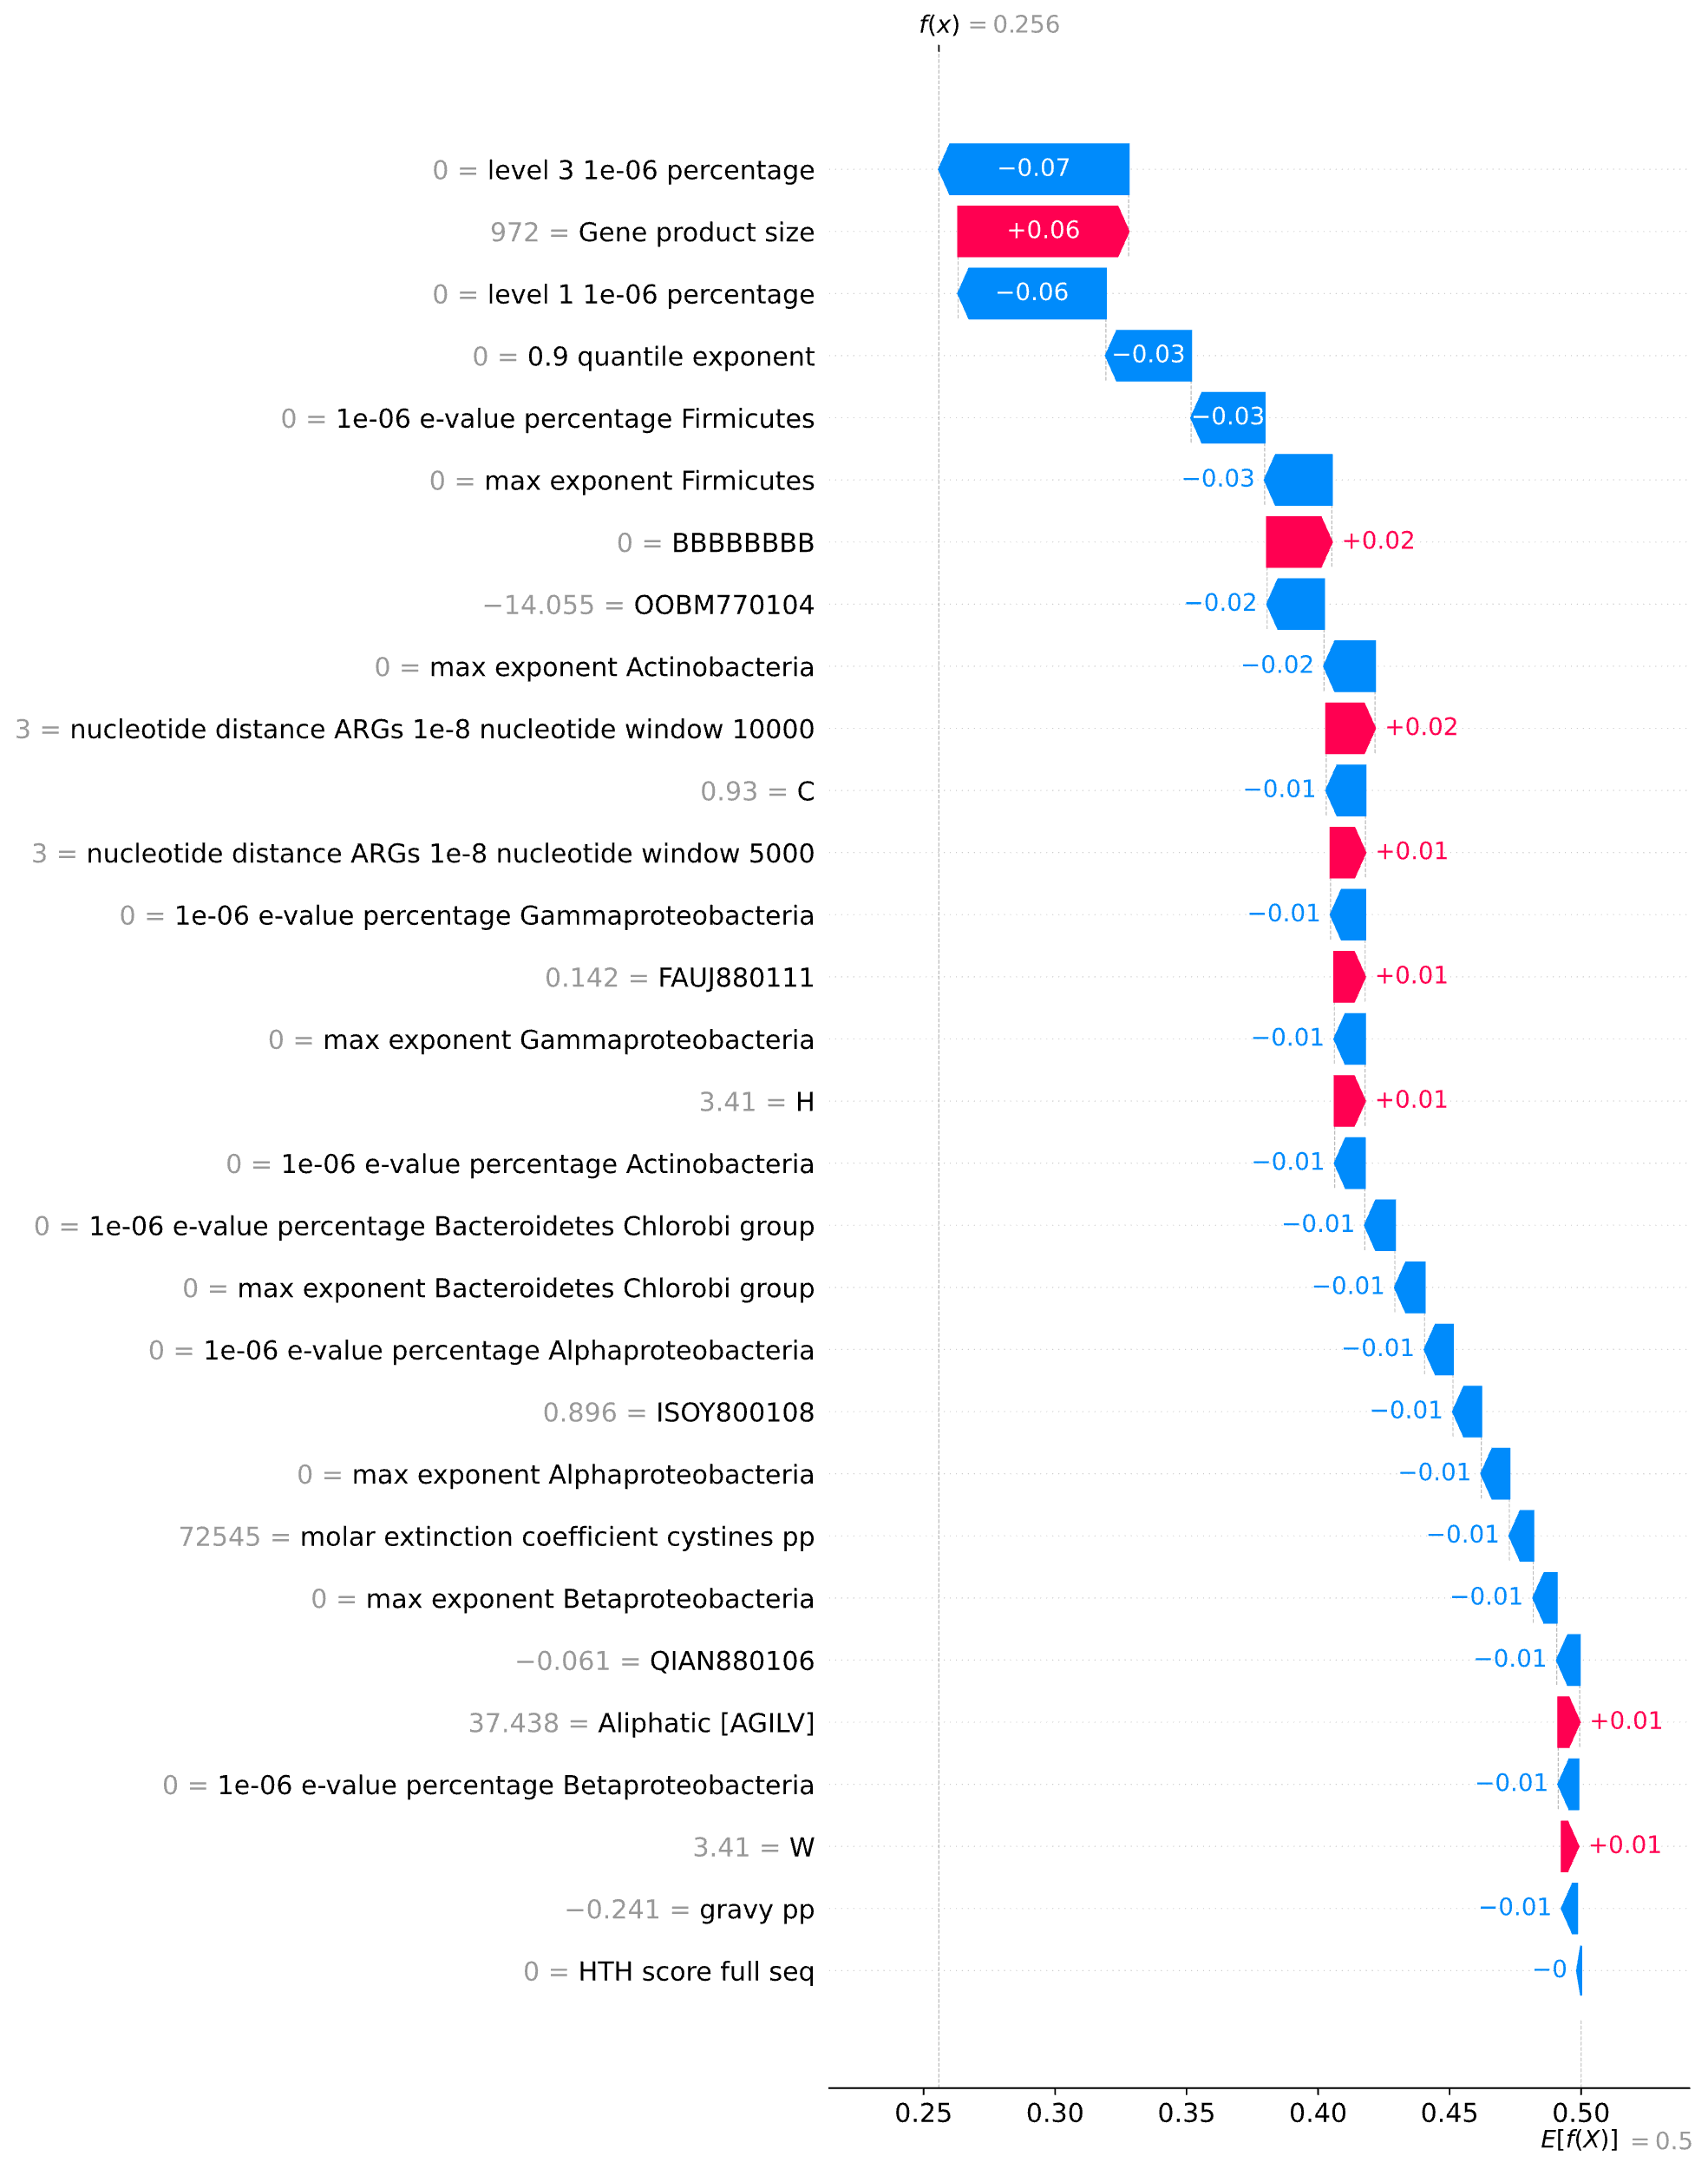
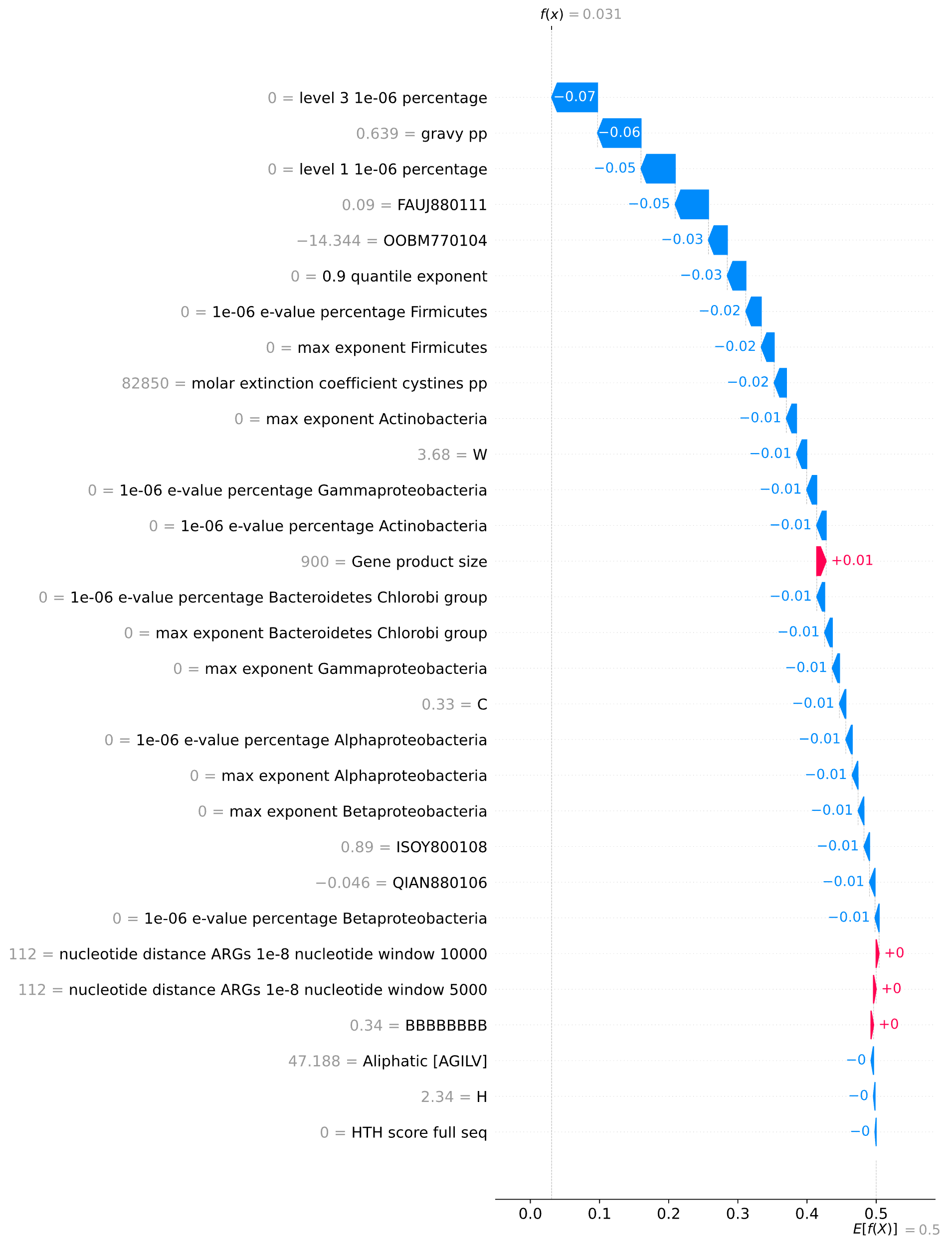
B.
A.
Supplementary Figure 4 | SHAP values analysis of the impact of feature contributions to classification for scrambled E. coli K-12 MG1655 proteins. A. An example of a negative classification of a scrambled sequence (Biotin transporter). B. An example of a positive classification of a scrambled sequence (tRNA U34 carboxymethyltransferase). The x-axis represents DRAMMA’s prediction score, and the y-axis lists the protein features ranked by their impact on the model’s prediction, with their respective values displayed in gray. Red arrows pointing to the right indicate feature values that contribute to a positive classification, whereas blue arrows pointing to the left represent values contributing to a negative classification. The numbers inside or adjacent to the arrows denote SHAP values, quantifying the contribution of each feature value to the prediction. The model score, f(X), is displayed, where positive classifications are defined as $f\left(X\right)≥0.225$.
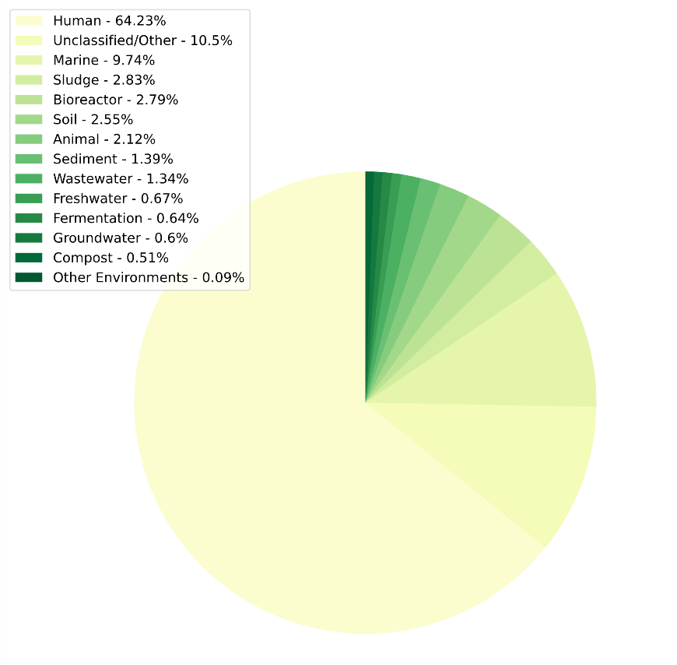
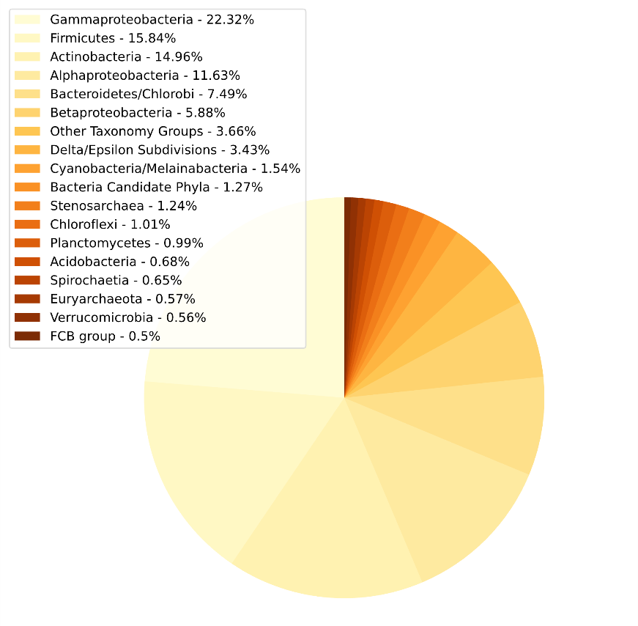
B.
A.
Supplementary Figure 5 | Distribution of all non-ARG in our datasets across different groups. A. Distribution of non-ARG from genomic samples across different taxonomic groups. B. Distribution of non-ARG from metagenomic samples across different environments.

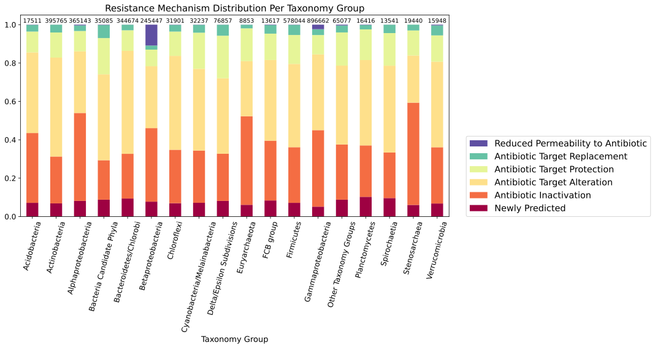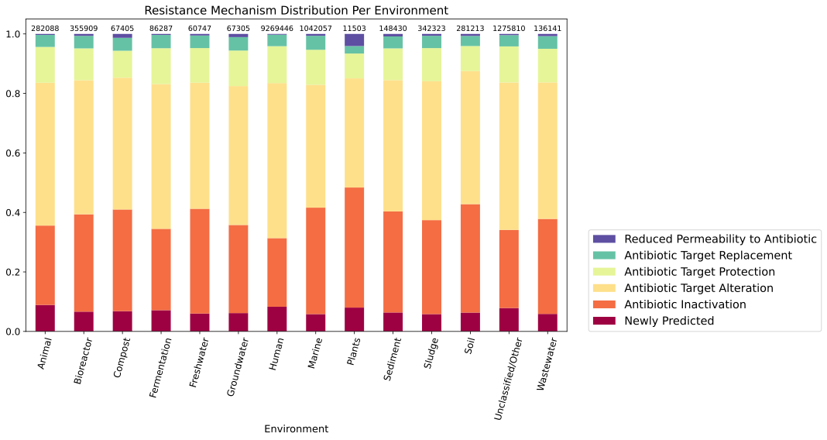
A.
B.
Supplementary Figure 6 | The distributions of predicted resistance mechanisms of the high-ranking ARG candidates. The distribution of resistance mechanisms among candidates across taxonomic groups (A) and ecosystems (B). The number at the top of each bar indicates the total count of ARG candidates in the respective group.
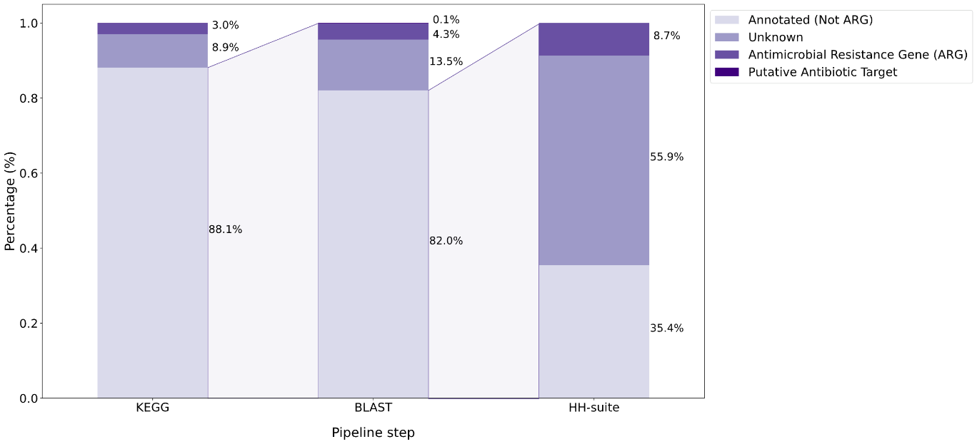
Supplementary Figure 7 | Mapping of ARG candidates’ function. Candidate ARGs were annotated in each of the steps of the prediction mapping pipeline using different tools and databases: KEGG HMM search, BLAST vs. NCBI’s non-redundant protein database, and HH-suite search against PDB and Pfam. In each annotation step, only the result with the best e-value was considered, and unannotated proteins passed to the next annotation step.

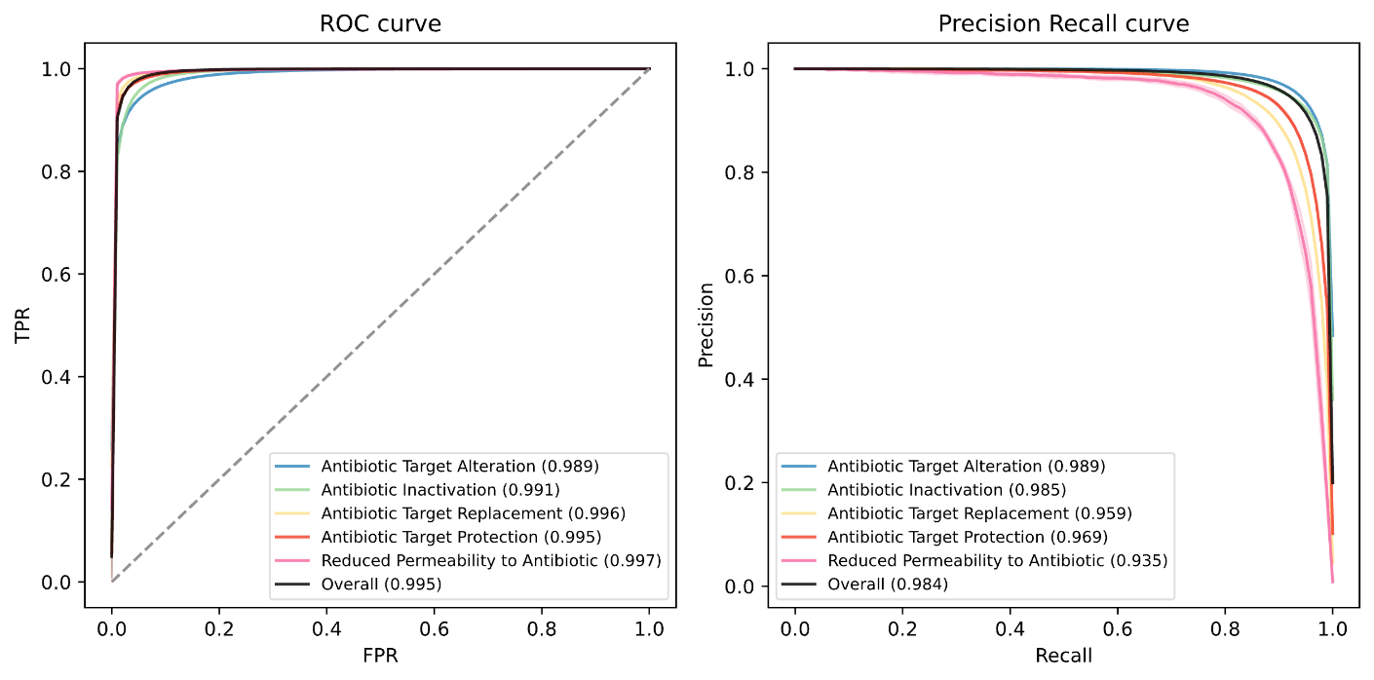
A.
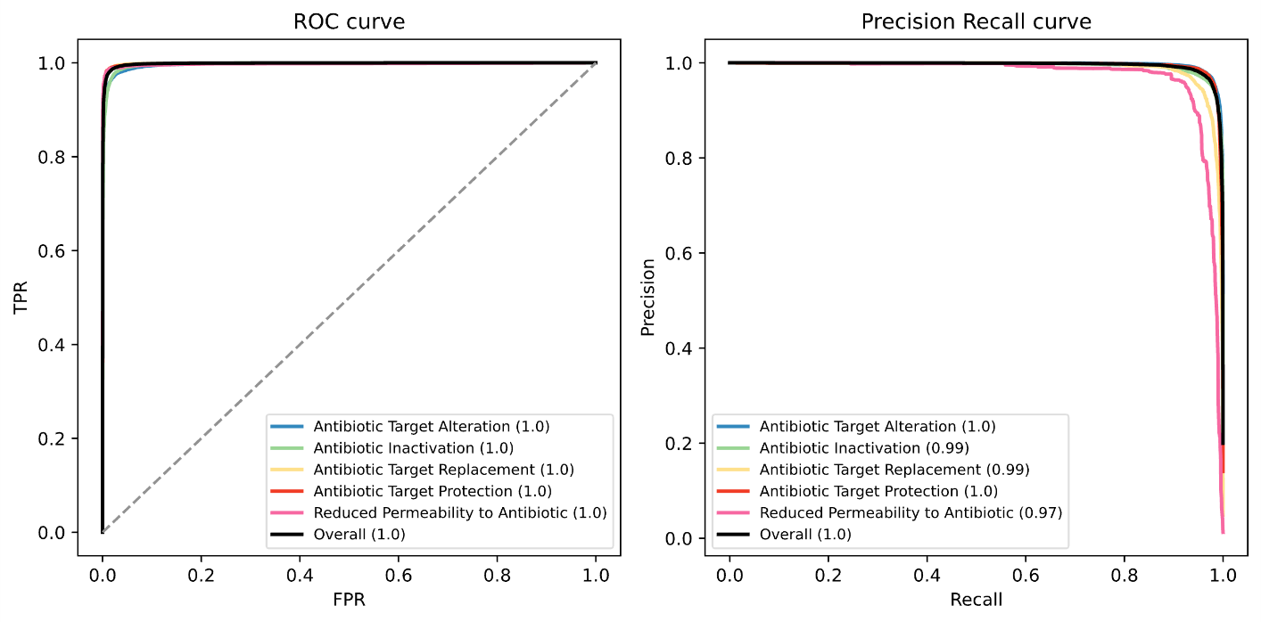
B.
Supplementary Figure 8 | Performance per class of a multiclass resistance mechanism model. A. Mean performance of five-fold cross-validation on a metagenomic dataset. B. Performance on an external dataset of sewage samples. The model was trained and evaluated only on proteins known as ARGs. Left: ROC curve, right: PR curve.
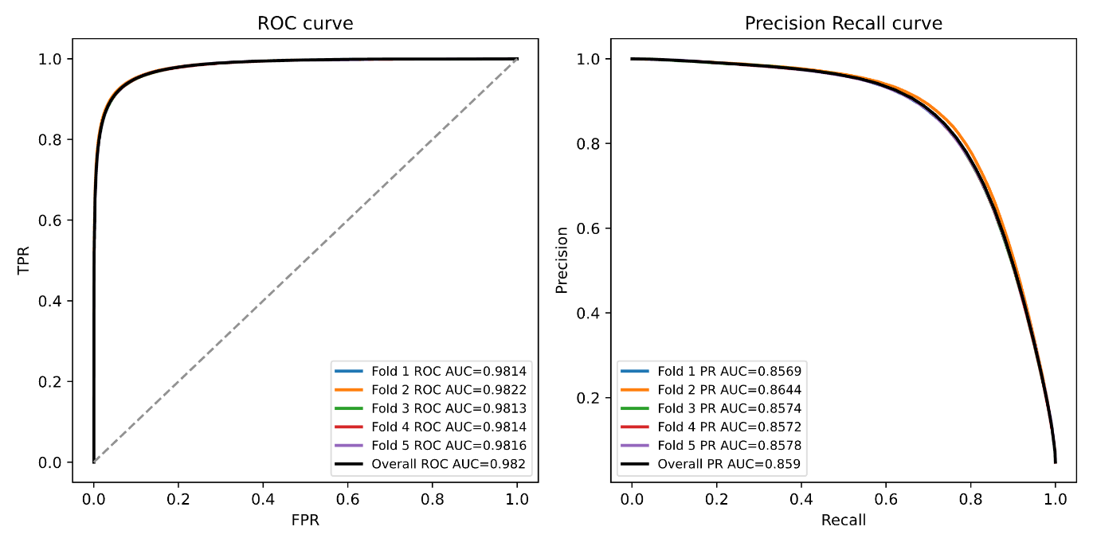
Supplementary Figure 9 | Classification performances over five-fold cross-validation split by sequence similarity. The model was evaluated using a genomic and metagenomic dataset of 30.9 million proteins, containing 5% AMR genes annotated using HMMs from the ARG HMM database.

Supplementary Table 1 | Model’s features. The names of the final 30 features chosen for the model and their description.
Feature name | Feature Category | Description
Gene product size | Amino Acid Properties | The length of the protein in amino acids.
0.9 quantile exponent | HGT Signals | The 0.9 quantile of the best-hit e-value exponent across all taxonomic groups.
level 3 1e-06 percentage | HGT Signals | The percentage of taxonomic groups the protein had a match against with an e-value of no more than 1e-6.
1e-06 e-value percentage Bacteria Firmicutes | HGT Signals | Percentage of organisms from the Bacteria Firmicutes taxonomic group of which the protein matched with an e-value of no more than 1e-6.
1e-06 e-value percentage Bacteria Bacteroidetes Chlorobi group | HGT Signals | Percentage of organisms from the Bacteria Bacteroidetes Chlorobi taxonomic group of which the protein matched with an e-value of no more than 1e-6.
max exponent Bacteria Bacteroidetes Chlorobi group | HGT Signals | The exponent of the e-value of the best hit (in terms of e-value) of the protein against the Bacteria Bacteroidetes Chlorobi taxonomic group.
1e-06 e-value percentage Bacteria Actinobacteria | HGT Signals | Percentage of organisms from the Bacteria Actinobacteria taxonomic group of which the protein matched with an e-value of no more than 1e-6.
H | Amino Acid Properties | Percentage of histidine in the protein.
molar extinction coefficient cystines pp | Amino Acid Properties | The molar extinction coefficient (i.e., a measure of the amount of light a molecule absorbs at a specific wavelength) of the protein assuming the cysteines are oxidized.
1e-06 e-value percentage Bacteria Alphaproteobacteria | HGT Signals | Percentage of organisms from the Bacteria Alphaproteobacteria taxonomic group of which the protein matched with an e-value of no more than 1e-6.
Aliphatic [AGILV] | Amino Acid Properties | Percentage of aliphatic amino acids (alanine, glycine, isoleucine, leucine, valine) in the protein.
level 1 1e-06 percentage | HGT Signals | The percentage of domains (Archaea, Bacteria, Eukaryota, Viruses) the protein had a match against with an e-value of no more than 1e-6.
max exponent Bacteria Firmicutes | HGT Signals | The exponent of the e-value of the best hit (in terms of e-value) of the protein against the Bacteria Firmicutes taxonomic group.
max exponent Bacteria Actinobacteria | HGT Signals | The exponent of the e-value of the best hit (in terms of e-value) of the protein against the Bacteria Actinobacteria taxonomic group.
FAUJ880111 | Amino Acid Properties | The average of the FAUJ880111 amino acid index⁶⁹ values (positive charge in side chain).
gravy pp | Amino Acid Properties | Grand average of hydropathy value (GRAVY index score)
1e-06 e-value percentage Bacteria Gammaproteobacteria | HGT Signals | Percentage of organisms from the Bacteria Gammaproteobacteria taxonomic group of which the protein matched with an e-value of no more than 1e-6.
OOBM770104 | Amino Acid Properties | The average of the OOBM770104 amino acid index⁷⁰ values (average non-bonded energy per residue).
max exponent Bacteria Betaproteobacteria | HGT Signals | The exponent of the e-value of the best hit (in terms of e-value) of the protein against the Bacteria Betaproteobacteria taxonomic group.
C | Amino Acid Properties | Percentage of cysteine in the protein.
max exponent Bacteria Gammaproteobacteria | HGT Signals | The exponent of the e-value of the best hit (in terms of e-value) of the protein against the Bacteria Gammaproteobacteria taxonomic group.
max exponent Bacteria Alphaproteobacteria | HGT Signals | The exponent of the e-value of the best hit (in terms of e-value) of the protein against the Bacteria Alphaproteobacteria taxonomic group.
nucleotide distance all ARGs filtered 1e-8 nucleotide window=10000 | Genomic Context | The distance in nucleotides of the closest gene neighbor in a 10,000 nucleotide window that had a match with an e-value of no more than 1e-8 against our ARG HMM database.
HTH score full seq | Amino Acid Patterns | The highest bit score achieved by aligning the protein against HMM profiles of HTH domains.
nucleotide distance all ARGs filtered 1e-8 nucleotide window=5000 | Genomic Context | The distance in nucleotides of the closest gene neighbor in a 5,000 nucleotide window that had a match with an e-value of no more than 1e-8 against our ARG HMM database.
QIAN880106 | Amino Acid Properties | The average of the QIAN880106 amino acid index⁷¹  values (weights for alpha-helix at the window position of -1, i.e., the effect of the amino acid on the likelihood of the subsequent amino acid being part of an alpha-helix).
ISOY800108 | Amino Acid Properties | The average of the ISOY800108 amino acid index⁷² values (normalized relative frequency of coil).
BBBBBBBB | Amino Acid Patterns | Frequency of an 8-mer of eight consecutive hydrophobic residues.
W | Amino Acid Properties | Percentage of tryptophan in the protein.
1e-06 e-value percentage Bacteria Betaproteobacteria | HGT Signals | Percentage of organisms from the Bacteria Betaproteobacteria taxonomic group of which the protein matched with an e-value of no more than 1e-6.

Supplementary Table 2 | Summary of properties collected for the top ten candidates according to the DRAMMA model score, following filtration (see Methods).
ID | Model Score | Class | KEGG Description | Blast Result Description | Predicted Mechanism | Taxonomic Group | AlphaFold Result Description
Granulicella_mallensis_MP5ACTX8|SAMN02232025|GCA_000178955.2|CP003130.1_02473 | 1 | Annotated (Not ARG) | Two-component system, LuxR family, response regulator FixJ |  | Target alteration | Acidobacteriaceae | Two component transcriptional regulator, LuxR family
human_gut_metagenome|SAMEA104062424|ERS1726317|MGYS00005144|ERZ1108180_ctg3474_00001 | 1 | Annotated (Not ARG) | DNA gyrase subunit A |  | Target alteration | Bacteroidia | DNA gyrase subunit A
marine_metagenome|SAMEA104212404|ERS1871422|MGYS00003954|ERZ806371_ctg186242_00016 | 1 | Annotated (Not ARG) | DNA topoisomerase II |  | Antibiotic inactivation | Bathycoccus sp. RCC1105 virus BpV | DNA topoisomerase 2
marine_metagenome|SAMEA2621287|ERS490714|MGYS00002008|ERZ842013_ctg4_00370 | 1 | Annotated (Not ARG) | tRNA pseudouridine55 synthase |  | Target alteration | Parcubacteria group | tRNA pseudouridine(55) synthase
marine_metagenome|SAMEA2620882|ERS490065|MGYS00002008|ERZ831144_ctg9_00146 | 0.994 | Unknown | Hypothetical protein | Translation initiation factor IF-2 | Target protection | Erythrobacteraceae | Translation initiation factor IF-2
Burkholderia_ambifaria_MEX-5|SAMN00000044|GCA_000182015.1|ABLK01000148.1_00014 | 0.981 | Unknown | Hypothetical protein | Transcriptional regulator, AraC family | Target alteration | Burkholderiaceae | AraC family transcriptional regulator
Tangfeifania_diversioriginum|SAMN05444280|GCA_900141875.1|FQZE01000022.1_00011 | 0.974 | Unknown | Hypothetical protein | alginate export family protein | Target alteration | Bacteroidia | Alginate export
sediment_metagenome|SAMN06266212|SRS2139711|MGYS00003337|ERZ534229_ctg766_00015 | 0.963 | Unknown | Hypothetical protein | hypothetical protein A9Q81_20170 | Target alteration | unclassified Gammaproteobacteria (miscellaneous) | HTH luxR-type domain-containing protein
marine_metagenome|SAMEA2623488|ERS493981|MGYS00002008|ERZ841439_ctg9093_00009 | 0.961 | Unknown | Hypothetical protein | ribosomal RNA small subunit methyltransferase A | Target alteration | unclassified Pelagibacterales | Ribosomal RNA small subunit methyltransferase A
Bacteroides_sp._KCTC_15687|SAMD00143385|GCA_003865075.1|BHWB01000007.1_00158 | 0.953 | Unknown | Large repetitive protein | RHS repeat-associated core domain-containing protein | Antibiotic target alteration | Bacteroidia | RHS repeat-associated core domain-containing protein

Supplementary Table 3 | Databases used for phylogenetic distribution. List of taxonomical databases created for the phylogenetic distribution features, the number of organisms included in the group, and the taxonomic classification of the group.

Database Name | Sizeª | Taxonomic Group
Archaea_Small_Sub_Taxes_of_TACK_group | 17 | TACK group
Archaea_Stenosarchaea_group | 122 | Euryarchaeota
Archaea_Crenarchaeota | 34 | TACK group
Archaea_Small_Sub_Taxes_of_Euryarchaeota | 36 | Euryarchaeota
Archaea_Small_Sub_Taxes_of_DPANN_group | 5 | DPANN group
Archaea_Methanomada_group | 29 | Euryarchaeota
Archaea_unclassified_Euryarchaeota | 32 | Euryarchaeota
Bacteria_Firmicutes | 1,188 | Terrabacteria group
Bacteria_Actinobacteria | 975 | Terrabacteria group
Bacteria_Gammaproteobacteria | 685 | Proteobacteria
Bacteria_Betaproteobacteria | 356 | Proteobacteria
Bacteria_Small_Sub_Taxes_of_PVC_group | 23 | PVC group
Bacteria_Alphaproteobacteria | 811 | Proteobacteria
Bacteria_Bacteroidetes_Chlorobi_group | 629 | FCB group
Bacteria_Cyanobacteria_Melainabacteria_group | 137 | Terrabacteria group
Bacteria_Tenericutes | 61 | Terrabacteria group
Bacteria_Spirochaetia | 39 | Spirochaetes
Bacteria_delta_epsilon_subdivisions | 173 | Proteobacteria
Bacteria_Thermotogae | 13 | Thermotogae
Bacteria_Verrucomicrobia | 25 | PVC group
Bacteria_Small_Sub_Taxes_of_Acidobacteria | 16 | Acidobacteria
Bacteria_Small_Sub_Taxes_of_Proteobacteria | 13 | Proteobacteria
Bacteria_Fusobacteriia | 18 | Fusobacteria
Bacteria_Small_Sub_Taxes_of_Thermodesulfobacteria | 4 | Thermodesulfobacteria
Bacteria_Small_Sub_Taxes_of_Terrabacteria_group | 28 | Terrabacteria group
Bacteria_Small_Sub_Taxes_of_FCB_group | 12 | FCB group
Bacteria_Small_Sub_Taxes_of_Nitrospirae | 12 | Nitrospirae
Bacteria_Synergistia | 11 | Synergistetes
Bacteria_Aquificae | 14 | Aquificae
Bacteria_Chloroflexi | 26 | Terrabacteria group
Bacteria_Small_Sub_Taxes_of_Coprothermobacterota | 1 | Coprothermobacterota
Bacteria_Small_Sub_Taxes_of_Deferribacteres | 5 | Deferribacteres
Bacteria_Small_Sub_Taxes_of_Elusimicrobia | 5 | Elusimicrobia
Bacteria_Small_Sub_Taxes_of_Nitrospinae_Tectomicrobia_group | 2 | Nitrospinae/Tectomicrobia group
Bacteria_Small_Sub_Taxes_of_Chrysiogenetes | 1 | Chrysiogenetes
Bacteria_Small_Sub_Taxes_of_Calditrichaeota | 1 | Calditrichaeota
Bacteria_Small_Sub_Taxes_of_Dictyoglomi | 1 | Dictyoglomi
Eukaryota_Metazoa | 222 | Opisthokonta
Eukaryota_Streptophyta | 79 | Viridiplantae
Eukaryota_Chlorophyta | 14 | Viridiplantae
Eukaryota_Fungi | 543 | Opisthokonta
Eukaryota_Small_Sub_Taxes_of_Cryptophyta | 1 | Cryptophyta
Eukaryota_Small_Sub_Taxes_of_Alveolata | 17 | Alveolata
Eukaryota_Small_Sub_Taxes_of_Euglenozoa | 5 | Euglenozoa
Eukaryota_Small_Sub_Taxes_of_Metamonada | 3 | Metamonada
Eukaryota_Evosea | 7 | Amoebozoa
Eukaryota_Small_Sub_Taxes_of_Opisthokonta | 5 | Opisthokonta
Eukaryota_Small_Sub_Taxes_of_Stramenopiles | 17 | Stramenopiles
Eukaryota_Small_Sub_Taxes_of_Rhodophyta | 4 | Rhodophyta
Eukaryota_Small_Sub_Taxes_of_Heterolobosea | 1 | Heterolobosea
Eukaryota_Small_Sub_Taxes_of_Rhizaria | 1 | Rhizaria
Eukaryota_Small_Sub_Taxes_of_Haptista | 1 | Haptista
Viruses | 6,120 | Viruses
ªNumber of different species in the database.

Supplementary Table 4 | Runtime and performance assessment of five machine learning algorithms across five-fold cross-validation on the development set.
Model Name | Mean PR-AUC | Mean Train Time (Minutes) | Mean Prediction Time (Seconds)
Random Forest | 0.637 | 12.549 | 15.16
LightGBM | 0.495 | 7.732 | 14.5
Xgboost | 0.582 | 7.578 | 11.75
Logistic Regression | 0.184 | 78.313 | 18.47
Multi-layer Perceptron | 0.698 | 108.05 | 18.45

Supplementary Table 5 | The hyperparameters evaluated in our study. The optimized hyperparameters of the Random Forest model, as named by Sklearn, are presented with their respective values.
Hyperparameter Name | Values Checked | Value Chosen
n_estimators | 100, 200, 250, 300, 500, 750 | 750
max_features | "sqrt", "log2", 0.75, 0.8, 0.85, 0.9 | 0.75
oob_score | True, False | False
max_depth | 4, 6, 8, 10, None | None
max_samples | 0.5, 0.75, 0.8, 0.85, 0.9, None | None
class_weight | See Supplementary Table 6 | “balanced”
criterion | "gini", "entropy" | "gini"
min_samples_leaf | 1, 2, 5, 10 | 2
min_impurity_decrease | 0.0, 1e-10, 1e-5, 1e-3 | 1e-10
min_weight_fraction_leaf | 0.0, 0.25, 0.5 | 0

Supplementary Table 6 | Class weights tested. The various class weight allocations evaluated for our model.
Type of class weight
None (Equal weights to both classes)
Balanced: $\frac{totalSamples}{2⋅classSamples}$
$$\frac{1}{\sqrt{classSamples}}$$

Supplementary Dataset 1. Antibiotic resistance gene families retrieved from Resfams, after manual curation. For each family, the resistance mechanism and the drugs they confer resistance to are noted as extracted from both Resfams and CARD databases.
Supplementary Dataset 2. Antibiotic resistance genes retrieved from CARD and HMD-ARG-DB, after manual curation and deduplication, along with their resistance mechanisms, and the drugs they confer resistance to.
Supplementary Dataset 3. The in-house ARG HMM database of genes from Resfams¹⁷, CARD October 2020 release¹⁸, and HMD-ARG-DB²¹ (see Methods), which was used for annotating ARGs in this study.
Supplementary Dataset 4. Results of HMM domain search of novel ARG candidates against the Pfam database.
Supplementary Dataset 5. The profile HMMs of HTH domains extracted from Pfam²⁵, which were used for the creation of the HTH domain feature.
Supplementary Dataset 6. The anti-defense genes and type VI secretion system (T6SS) immunity genes included in our in-house Profile HMM databases used for the creation of the genomic context features.
Supplementary Dataset 7. The profile HMMs of mobility genes extracted from Pfam database²⁵, which were used for the creation of the genomic context features.
Supplementary Dataset 8. HMM database of blacklist proteins collected from Resfams, ResfinderFGv2, HMD-ARG, ARGNet, and CARD (based on both October 2020 and October 2023 versions).

