Additional file 1

Supplementary Table 1. Basic information of each library for sequencing in this study
Sample ID | Tick species | City | Clean reads (paired-end) | Viral reads (%) | Sex | Number of ticks
NX001 | Hy. scupense | Shizuishan | 3985565 | 0.97 | Female | 2
NX002 | Hy. scupense | Shizuishan | 4168234 | 0.20 | Female | 2
NX003 | Hy. scupense | Shizuishan | 31512447 | 1.70 | Male | 2
NX004 | Hy. scupense | Shizuishan | 36174720 | 0.70 | Male | 2
NX005 | Hy. scupense | Shizuishan | 31600752 | 0.91 | Female | 2
NX006 | Hy. scupense | Shizuishan | 34643124 | 0.92 | Female | 2
NX007 | Hy. scupense | Shizuishan | 1772826 | 0.10 | Male | 2
NX008 | Hy. scupense | Shizuishan | 12714664 | 0.09 | Male | 2
NX009 | Hy. scupense | Shizuishan | 5243598 | 2.75 | Female | 2
NX010 | Hy. scupense | Shizuishan | 12812214 | 0.06 | Female | 2
NX011 | Hy. scupense | Shizuishan | 13762502 | 0.10 | Male | 2
NX012 | Hy. scupense | Shizuishan | 12361920 | 0.06 | Male | 2
NX013 | Hy. asiaticum | Zhongwei | 4761259 | 0.38 | Female | 3
NX014 | Hy. asiaticum | Zhongwei | 7025947 | 0.35 | Male | 2
NX015 | Hy. asiaticum | Zhongwei | 11414277 | 0.06 | Female | 3
NX016 | Hy. asiaticum | Zhongwei | 10499910 | 0.12 | Male | 2
NX017 | Hy. asiaticum | Zhongwei | 7917880 | 0.17 | Female | 2
NX018 | Hy. asiaticum | Zhongwei | 10898490 | 0.06 | Male | 2
NX019 | Hy. asiaticum | Zhongwei | 10903499 | 0.12 | Female | 3
NX020 | Hy. asiaticum | Zhongwei | 9435717 | 0.93 | Male | 2
NX021 | Hy. asiaticum | Zhongwei | 10892852 | 0.05 | Female | 2
NX022 | Hy. asiaticum | Zhongwei | 11616603 | 1.71 | Male | 2
NX023 | Hy. asiaticum | Zhongwei | 6538501 | 2.20 | Female | 3
NX024 | Hy. asiaticum | Zhongwei | 11072205 | 1.27 | Male | 2
NX025 | Hy. asiaticum | Wuzhong | 3596269 | 2.60 | Female | 2
NX026 | Hy. asiaticum | Wuzhong | 4582553 | 11.59 | Male | 2
NX027 | Hy. asiaticum | Zhongwei | 11735270 | 0.48 | Female | 2
NX028 | Hy. asiaticum | Zhongwei | 11317933 | 0.35 | Male | 2
NX029 | Hy. asiaticum | Yinchuan | 12295135 | 0.07 | Female | 2
NX030 | Hy. asiaticum | Yinchuan | 10797667 | 0.07 | Male | 2
NX031 | D. nuttalli | Wuzhong | 8556874 | 0.05 | Female | 5
NX032 | D. nuttalli | Wuzhong | 8008361 | 0.03 | Female | 5
NX033 | D. nuttalli | Wuzhong | 6078941 | 0.04 | Male | 5
NX034 | D. nuttalli | Wuzhong | 7587441 | 0.04 | Female | 5
NX035 | D. nuttalli | Wuzhong | 5768338 | 0.07 | Male | 5
NX036 | D. nuttalli | Wuzhong | 5413517 | 0.03 | Female | 5
NX037 | D. nuttalli | Wuzhong | 5645888 | 0.05 | Male | 5
NX038 | D. nuttalli | Wuzhong | 5437369 | 0.04 | Female | 5
NX039 | D. nuttalli | Wuzhong | 5589425 | 0.04 | Male | 5
NX040 | D. nuttalli | Wuzhong | 7036728 | 0.04 | Female | 5
NX041 | D. nuttalli | Wuzhong | 5212652 | 0.05 | Male | 5
NX042 | D. nuttalli | Wuzhong | 5994093 | 0.05 | Female | 5
NX043 | D. nuttalli | Wuzhong | 4159146 | 3.33 | Male | 5
NX044 | D. nuttalli | Guyuan | 6919036 | 0.56 | Male | 5
NX045 | D. nuttalli | Guyuan | 19503215 | 0.50 | Male | 5
NX046 | D. nuttalli | Wuzhong | 6328809 | 0.04 | Female | 5
NX047 | D. nuttalli | Wuzhong | 14353870 | 0.04 | Male | 5
NX048 | D. nuttalli | Wuzhong | 8250148 | 0.05 | Female | 5
NX049 | D. nuttalli | Wuzhong | 6040405 | 0.06 | Male | 5
NX050 | D. nuttalli | Wuzhong | 6524626 | 0.05 | Female | 5
NX051 | D. nuttalli | Wuzhong | 5463462 | 0.03 | Male | 5
NX052 | D. nuttalli | Wuzhong | 6915794 | 0.04 | Female | 5
NX053 | D. nuttalli | Wuzhong | 5752123 | 0.63 | Male | 5
NX054 | D. nuttalli | Wuzhong | 5674194 | 0.07 | Female | 5
NX055 | D. nuttalli | Wuzhong | 9905623 | 0.03 | Female | 5
NX056 | D. nuttalli | Wuzhong | 5014045 | 0.04 | Male | 5
NX057 | D. nuttalli | Wuzhong | 4965791 | 0.03 | Male | 5
NX058 | D. nuttalli | Wuzhong | 7057585 | 0.04 | Female | 5
NX059 | D. nuttalli | Wuzhong | 5174260 | 0.03 | Male | 5
NX060 | D. nuttalli | Wuzhong | 5113965 | 0.04 | Female | 5
NX061 | D. nuttalli | Wuzhong | 5351371 | 0.04 | Male | 5
NX062 | D. nuttalli | Guyuan | 5715113 | 0.20 | Female | 5
NX063 | D. nuttalli | Wuzhong | 7086563 | 0.05 | Female | 5
NX064 | D. nuttalli | Wuzhong | 7773548 | 0.05 | Male | 5
NX065 | D. nuttalli | Wuzhong | 6842565 | 0.03 | Female | 5
NX066 | D. nuttalli | Wuzhong | 10016942 | 0.07 | Male | 5
NX067 | D. nuttalli | Guyuan | 5586046 | 0.06 | Male | 5
NX068 | D. nuttalli | Wuzhong | 5344354 | 0.03 | Female | 5
NX069 | D. nuttalli | Wuzhong | 6357963 | 0.03 | Female | 5
NX070 | D. nuttalli | Wuzhong | 3546574 | 0.08 | Male | 5
NX071 | D. nuttalli | Wuzhong | 3176507 | 0.07 | Male | 5
NX072 | D. nuttalli | Wuzhong | 11574680 | 0.05 | Female | 5
NX073 | D. nuttalli | Wuzhong | 11611615 | 0.05 | Male | 5
NX074 | D. nuttalli | Zhongwei | 6582432 | 0.04 | Female | 5
NX075 | D. nuttalli | Zhongwei | 5596918 | 0.07 | Male | 5
NX076 | D. nuttalli | Zhongwei | 5648743 | 0.04 | Female | 5
NX077 | D. nuttalli | Zhongwei | 5104456 | 0.06 | Male | 5
NX078 | D. nuttalli | Wuzhong | 7448080 | 0.08 | Female | 5
NX079 | D. nuttalli | Guyuan | 6515350 | 0.03 | Female | 5
NX080 | D. nuttalli | Guyuan | 6190245 | 0.04 | Male | 5
NX081 | D. nuttalli | Guyuan | 7289950 | 0.03 | Female | 5
NX082 | D. nuttalli | Guyuan | 7742163 | 0.06 | Male | 5
NX083 | D. nuttalli | Zhongwei | 5905889 | 0.04 | Female | 5
NX084 | D. nuttalli | Zhongwei | 5915180 | 0.03 | Male | 5
NX085 | D. silvarum | Guyuan | 9256236 | 0.35 | Female | 5
NX086 | D. silvarum | Guyuan | 17945091 | 0.04 | Male | 5
NX087 | D. silvarum | Guyuan | 5748737 | 0.05 | Female | 5
NX088 | D. silvarum | Guyuan | 5158037 | 0.05 | Male | 5
NX089 | D. silvarum | Guyuan | 13004991 | 0.78 | Female | 5
NX090 | D. silvarum | Guyuan | 25357494 | 0.67 | Male | 5
NX091 | D. silvarum | Guyuan | 7095979 | 0.74 | Female | 5
NX092 | D. silvarum | Guyuan | 5604924 | 0.14 | Male | 5
NX093 | D. silvarum | Guyuan | 2954451 | 0.07 | Female | 5
NX094 | D. silvarum | Guyuan | 11103968 | 0.12 | Female | 5
NX095 | D. silvarum | Guyuan | 5670559 | 0.10 | Female | 6
NX096 | D. silvarum | Guyuan | 5598359 | 0.05 | Male | 6
NX097 | D. silvarum | Guyuan | 6762189 | 0.06 | Female | 5
NX098 | D. silvarum | Guyuan | 5602927 | 0.26 | Male | 5
NX099 | D. silvarum | Guyuan | 6560342 | 0.11 | Female | 5
NX100 | D. silvarum | Guyuan | 5352018 | 0.05 | Male | 5
NX101 | D. silvarum | Guyuan | 5928971 | 0.07 | Female | 5
NX102 | D. silvarum | Guyuan | 5880060 | 0.06 | Female | 6
NX103 | D. silvarum | Guyuan | 5322915 | 0.11 | Male | 6
NX104 | D. silvarum | Guyuan | 6331526 | 0.04 | Female | 6
NX105 | D. silvarum | Guyuan | 5509280 | 0.04 | Male | 6
NX106 | D. silvarum | Guyuan | 7305119 | 0.09 | Female | 6
NX107 | D. silvarum | Guyuan | 3645232 | 0.08 | Male | 6
NX108 | D. silvarum | Guyuan | 6149317 | 0.07 | Female | 6
NX109 | D. silvarum | Zhongwei | 6098864 | 0.07 | Female | 5
NX110 | D. silvarum | Zhongwei | 6920700 | 0.10 | Male | 5
NX111 | D. silvarum | Guyuan | 6736238 | 0.06 | Female | 5
NX112 | D. silvarum | Guyuan | 5630768 | 0.18 | Male | 5
NX113 | D. silvarum | Wuzhong | 8873695 | 0.13 | Male | 5
NX114 | D. silvarum | Guyuan | 6525053 | 0.07 | Female | 6
NX115 | D. silvarum | Guyuan | 6319531 | 0.07 | Male | 6
NX116 | D. silvarum | Guyuan | 6376910 | 0.27 | Female | 5
NX117 | D. silvarum | Guyuan | 6808610 | 1.20 | Male | 5
NX118 | D. silvarum | Guyuan | 6533158 | 0.13 | Female | 5
NX119 | D. silvarum | Guyuan | 6473567 | 2.29 | Male | 5
NX120 | D. silvarum | Guyuan | 6716293 | 0.04 | Female | 6
NX121 | D. silvarum | Guyuan | 5844105 | 0.05 | Male | 6
NX122 | D. silvarum | Guyuan | 8537304 | 0.05 | Female | 5
NX123 | D. silvarum | Guyuan | 5595716 | 0.10 | Male | 5
NX124 | Hae. qinghaiensis | Guyuan | 22472824 | 1.88 | Male | 15
NX125 | Hae. qinghaiensis | Guyuan | 18329051 | 1.21 | Male | 15
NX126 | Hae. qinghaiensis | Guyuan | 18058084 | 0.15 | Female | 15
NX127 | Hae. qinghaiensis | Guyuan | 15605970 | 0.36 | Female | 15
NX128 | Hae. qinghaiensis | Guyuan | 15341437 | 0.11 | Male | 15
NX129 | Hae. qinghaiensis | Guyuan | 18039026 | 0.18 | Male | 15
NX130 | Hae. qinghaiensis | Guyuan | 26738003 | 0.13 | Female | 15
NX131 | Hae. qinghaiensis | Guyuan | 17339143 | 0.15 | Female | 15
NX132 | Hae. qinghaiensis | Guyuan | 12855063 | 0.84 | Female | 15
NX133 | Hae. qinghaiensis | Guyuan | 11275531 | 1.11 | Female | 16
NX134 | Hae. qinghaiensis | Guyuan | 12084040 | 0.77 | Female | 15
NX135 | Hae. qinghaiensis | Guyuan | 11959179 | 0.59 | Female | 15
NX136 | Hae. qinghaiensis | Guyuan | 13069844 | 0.61 | Male | 15
NX137 | Hae. qinghaiensis | Guyuan | 24912250 | 0.12 | Female | 15
NX138 | Hae. qinghaiensis | Guyuan | 10834758 | 1.50 | Male | 15
NX139 | Hae. japonica | Guyuan | 14587935 | 0.11 | Female | 16
NX140 | Hae. japonica | Guyuan | 12267074 | 0.17 | Female | 16
NX141 | Hae. japonica | Guyuan | 9028659 | 0.20 | Male | 16
NX142 | Hae. japonica | Guyuan | 15914443 | 0.09 | Female | 16
NX143 | Hae. japonica | Guyuan | 23886274 | 0.12 | Male | 16
NX144 | Hae. japonica | Guyuan | 19488438 | 0.10 | Female | 15
NX145 | Hae. japonica | Guyuan | 18280323 | 0.14 | Male | 15
NX146 | Hae. japonica | Guyuan | 14512198 | 0.14 | Female | 16
NX147 | Hae. japonica | Guyuan | 14608201 | 1.28 | Male | 16
NX148 | Hae. japonica | Guyuan | 20246542 | 0.12 | Female | 16
NX149 | Hae. japonica | Guyuan | 13690086 | 1.28 | Male | 16
NX150 | Hae. longicornis | Guyuan | 4413088 | 5.32 | Female | 16
NX151 | Hae. longicornis | Guyuan | 7820333 | 1.40 | Male | 16
NX152 | Hae. longicornis | Guyuan | 9030342 | 0.44 | Male | 16
NX153 | Hae. longicornis | Guyuan | 6240945 | 0.71 | Female | 15
NX154 | Hae. longicornis | Guyuan | 5283796 | 0.24 | Female | 15
NX155 | Hae. longicornis | Guyuan | 6416032 | 4.90 | Male | 15

Supplementary Table 2. Distribution of environmental factors for each tick species
 | Median | Q1 | Q3 | P value
DEM (m)
Hy. scupense | 1142 | 1116 | 1154 | <0.001
Hy. asiaticum | 1304 | 1232 | 1335
D. nuttalli | 1636 | 1509 | 1795.75
D. silvarum | 1910 | 1875.5 | 1951
Hae. longicornis | 1735 | 1694.5 | 1821.25
Hae. qinghaiensis | 1884 | 1882 | 1989
Hae. japonica | 1905 | 1900 | 1952.5
Annual precipitation (mm)
Hy. scupense | 118 | 116 | 161 | <0.001
Hy. asiaticum | 198 | 179 | 214
D. nuttalli | 296 | 254.5 | 404
D. silvarum | 811 | 801 | 825
Hae. longicornis | 808 | 792.25 | 809.5
Hae. qinghaiensis | 812 | 811 | 831
Hae. japonica | 831 | 811 | 837
NDVI
Hy. scupense | 0.09 | 0.06 | 0.19 | <0.001
Hy. asiaticum | 0.11 | 0.1 | 0.13
D. nuttalli | 0.16 | 0.13 | 0.195
D. silvarum | 0.61 | 0.56 | 0.68
Hae. longicornis | 0.58 | 0.505 | 0.723
Hae. qinghaiensis | 0.61 | 0.5 | 0.69
Hae. japonica | 0.67 | 0.57 | 0.72
Annual average relative humidity (%)
Hy. scupense | 46 | 46 | 46 | <0.001
Hy. asiaticum | 48 | 48 | 49
D. nuttalli | 52 | 51 | 54.75
D. silvarum | 70 | 68 | 71
Hae. longicornis | 71 | 70.25 | 71
Hae. qinghaiensis | 70 | 68.5 | 71
Hae. japonica | 71 | 69 | 71.5
Annual sunshine duration (h)
Hy. scupense | 2978 | 2977 | 2979 | <0.001
Hy. asiaticum | 2717 | 2661 | 2770
D. nuttalli | 2818 | 2476 | 3005
D. silvarum | 2098 | 2085 | 2142
Hae. longicornis | 2067 | 2064.75 | 2068.5
Hae. qinghaiensis | 2090 | 2082 | 2140.5
Hae. japonica | 2101 | 2074 | 2139
Annual evaporation (mm)
Hy. scupense | 1531 | 1527 | 1553 | <0.001
Hy. asiaticum | 1442 | 1423 | 1453
D. nuttalli | 1382 | 1260.5 | 1454
D. silvarum | 1068 | 1055 | 1070
Hae. longicornis | 1069 | 1060.75 | 1075
Hae. qinghaiensis | 1060 | 1050 | 1071
Hae. japonica | 1067 | 1050 | 1069
Annual average ground surface temperature (ºC)
Hy. scupense | 13 | 13 | 14 | <0.001
Hy. asiaticum | 14 | 13 | 14
D. nuttalli | 11.5 | 10 | 12
D. silvarum | 10 | 9 | 10
Hae. longicornis | 10 | 10 | 10.75
Hae. qinghaiensis | 9 | 9 | 10
Hae. japonica | 10 | 9 | 10
Annual average temperature (ºC)
Hy. scupense | 10 | 10 | 10 | <0.001
Hy. asiaticum | 10 | 10 | 11
D. nuttalli | 8 | 7 | 8
D. silvarum | 7 | 6 | 7
Hae. longicornis | 7 | 7 | 7.75
Hae. qinghaiensis | 6 | 6 | 7
Hae. japonica | 7 | 6 | 7
Annual average pressure (hPa)
Hy. scupense | 886 | 885 | 891 | <0.001
Hy. asiaticum | 873 | 866 | 879
D. nuttalli | 839 | 818.5 | 849
D. silvarum | 811 | 804 | 813
Hae. longicornis | 818 | 814.25 | 823.25
Hae. qinghaiensis | 804 | 801 | 811
Hae. japonica | 806 | 802.5 | 811
Note: Q1, first quartile; Q3, third quartile; DEM, Digital Elevation Model; NDVI, normalized difference vegetation index.

Supplementary Table 3. Environmental factors predicted by IDW interpolation for tick species or genus
 | Median | Q1 | Q3 | P value
DEM (m)
Hy. scupense | 1146 | 1104 | 1541 | <0.001
Hy. asiaticum | 1369 | 1225 | 1610
D. nuttalli | 1553 | 1418 | 1740
D. silvarum | 1944 | 1793 | 2066
Haemaphysalis | 1895 | 1684 | 2100
Annual precipitation (mm)
Hy. scupense | 179 | 151 | 233 | <0.001
Hy. asiaticum | 222 | 191 | 277
D. nuttalli | 325 | 244 | 385
D. silvarum | 501 | 476 | 522
Haemaphysalis | 635 | 575 | 755
NDVI
Hy. scupense | 0.22 | 0.15 | 0.3 | <0.001
Hy. asiaticum | 0.16 | 0.12 | 0.25
D. nuttalli | 0.17 | 0.13 | 0.24
D. silvarum | 0.33 | 0.28 | 0.38
Haemaphysalis | 0.45 | 0.38 | 0.58
Annual average relative humidity (%)
Hy. scupense | 48 | 47 | 49 | <0.001
Hy. asiaticum | 49 | 47 | 50
D. nuttalli | 54 | 52 | 56
D. silvarum | 61 | 60 | 63
Haemaphysalis | 66 | 64 | 69
Annual sunshine duration (h)
Hy. scupense | 3000 | 2957 | 3044 | <0.001
Hy. asiaticum | 2710 | 2662 | 2829
D. nuttalli | 2727 | 2496 | 2920
D. silvarum | 2281 | 2246 | 2326.5
Haemaphysalis | 2193 | 2155 | 2233
Annual evaporation (mm)
Hy. scupense | 1487 | 1445 | 1512 | <0.001
Hy. asiaticum | 1397 | 1347 | 1446
D. nuttalli | 1358 | 1270 | 1439
D. silvarum | 1118 | 1096 | 1177
Haemaphysalis | 1089 | 1061 | 1178
Annual average ground surface temperature (ºC)
Hy. scupense | 9 | 7 | 10 | <0.001
Hy. asiaticum | 12 | 10 | 12
D. nuttalli | 10 | 9 | 11
D. silvarum | 9 | 9 | 10
Haemaphysalis | 8 | 7 | 10
Annual average temperature (ºC)
Hy. scupense | 5 | 4 | 7 | <0.001
Hy. asiaticum | 8 | 7 | 9
D. nuttalli | 7 | 6 | 8
D. silvarum | 6 | 6 | 7
Haemaphysalis | 5 | 4 | 7
Annual average pressure (hPa)
Hy. scupense | 844 | 813 | 869 | <0.001
Hy. asiaticum | 852 | 831 | 869
D. nuttalli | 837 | 820 | 853
D. silvarum | 804 | 793 | 818
Haemaphysalis | 811 | 790 | 831
Note: Q1, first quartile; Q3, third quartile; DEM, Digital Elevation Model; NDVI, normalized difference vegetation index.

Supplementary Table 4. Viral sequences of this study deposited in GenBank
Accession no. | Sample ID | Species | Sequence length (bp)
PP944994 | China-NX026 | Alpharicinrhavirus bole | 11889
PP944995 | China-NX017 | Alpharicinrhavirus bole | 11924
PP944996 | China-NX140 | Betascleroulivirus betaplasmoparae | 2094
PP944997 | China-NX113 | Ningxia betascleroulivirus 3 | 2097
PP944998 | China-NX113 | Ningxia betascleroulivirus 1 | 1698
PP944999 | China-NX078 | Ningxia betascleroulivirus 2 | 1607
PP945000 | China-NX025 | Bole hyalomma asiaticum virus 1 | 9136
PP945001 | China-NX026 | Bole hyalomma asiaticum virus 1 | 10269
PP945002 | China-NX031 | Botourmiaviridae sp. | 2307
PP945003 | China-NX087 | Botourmiaviridae sp. | 2289
PP945004 | China-NX088 | Botourmiaviridae sp. | 2307
PP945005 | China-NX054 | Botourmiaviridae sp. | 2319
PP945006 | China-NX072 | Botourmiaviridae sp. | 2285
PP945007 | China-NX073 | Botourmiaviridae sp. | 2286
PP945008 | China-NX143 | Ningxia penoulivirus 2 | 2511
PP945009 | China-NX113 | Ningxia betascleroulivirus 4 | 2383
PP945010 | China-NX154 | Ningxia magoulivirus 3 | 2425
PP945011 | China-NX136 | Ningxia penoulivirus 1 | 2908
PP945012 | China-NX106 | Ningxia magoulivirus 2 | 1829
PP945013 | China-NX096 | Ningxia penoulivirus 3 | 2565
PP945014 | China-NX117 | Flaviviridae sp. | 17107
PP945015 | China-NX043 | Flaviviridae sp. | 16608
PP945016 | China-NX090 | Flaviviridae sp. | 16484
PP945017 | China-NX116 | Flaviviridae sp. | 16438
PP945018 | China-NX085 | Flaviviridae sp. | 16408
PP945019 | China-NX143 | Hubei sobemo-like virus 15 | 3064
PP945020 | China-NX099 | Iflaviridae sp. | 9593
PP945021 | China-NX110 | Iflaviridae sp. | 9524
PP945022 | China-NX091 | Iflaviridae sp. | 9523
PP945023 | China-NX119 | Iflaviridae sp. | 9518
PP945024 | China-NX026 | Ningxia arti-like virus 2 | 8792
PP945025 | China-NX013 | Ningxia arti-like virus 2 | 8775
PP945026 | China-NX014 | Ningxia arti-like virus 2 | 8905
PP945027 | China-NX017 | Ningxia arti-like virus 2 | 8762
PP945028 | China-NX143 | Ningxia luteo-like virus | 2608
PP945029 | China-NX133 | Ningxia luteo-like virus | 2588
PP945030 | China-NX154 | Ningxia magoulivirus 1 | 2294
PP945031 | China-NX113 | Magoulivirus deltaplasmoparae | 2012
PP945032 | China-NX137 | Magoulivirus deltaplasmoparae | 1771
PP945033 | China-NX114 | Mitoviridae sp. | 2488
PP945034 | China-NX116 | Mitoviridae sp. | 2529
PP945035 | China-NX077 | Ningxia mito-like virus 1 | 2601
PP945036 | China-NX076 | Ningxia mito-like virus 1 | 2618
PP945037 | China-NX139 | Ningxia duamitovirus 3 | 3977
PP945038 | China-NX117 | Mitoviridae sp. | 1820
PP945039 | China-NX152 | Thrips tabaci associated mitovirus 2 | 2756
PP945040 | China-NX136 | Thrips tabaci associated mitovirus 2 | 2741
PP945041 | China-NX095 | Ningxia duamitovirus 1 | 2456
PP945042 | China-NX106 | Ningxia duamitovirus 1 | 2357
PP945043 | China-NX142 | Ningxia duamitovirus 2 | 2375
PP945044 | China-NX014 | Mivirus boleense | 11139
PP945045 | China-NX023 | Mivirus boleense | 11236
PP945046 | China-NX025 | Mivirus boleense | 11201
PP945047 | China-NX026 | Mivirus boleense | 11154
PP945048 | China-NX013 | Mivirus boleense | 11143
PP945049 | China-NX135 | Ningxia narnavirus 1 | 2687
PP945050 | China-NX140 | Ningxia narnavirus 1 | 2565
PP945051 | China-NX141 | Ningxia narnavirus 2 | 2802
PP945052 | China-NX154 | Erysiphe necator associated narnavirus 6 | 2376
PP945053 | China-NX143 | Erysiphe necator associated narnavirus 6 | 2080
PP945054 | China-NX066 | Erysiphe necator associated narnavirus 6 | 2407
PP945055 | China-NX139 | Erysiphe necator associated narnavirus 6 | 2388
PP945056 | China-NX141 | Erysiphe necator associated narnavirus 6 | 2431
PP945057 | China-NX015 | Ningxia narna-like virus 2 | 2103
PP945058 | China-NX143 | Ningxia narna-like virus 3 | 2407
PP945059 | China-NX020 | Ningxia narna-like virus 4 | 3325
PP945060 | China-NX089 | Ningxia narna-like virus 5 | 3549
PP945061 | China-NX103 | Ningxia narna-like virus 5 | 3417
PP945062 | China-NX152 | Orthomyxoviridae sp. | 1881
PP945063 | China-NX149 | Orthonairovirus huangpiense | 13600
PP945064 | China-NX125 | Orthonairovirus huangpiense | 11914
PP945065 | China-NX149 | Orthonairovirus huangpiense | 4899
PP945066 | China-NX125 | Orthonairovirus huangpiense | 4844
PP945067 | China-NX149 | Orthonairovirus huangpiense | 2065
PP945068 | China-NX125 | Orthonairovirus huangpiense | 1705
PP945069 | China-NX155 | Orthonairovirus huangpiense | 12054
PP945070 | China-NX155 | Orthonairovirus huangpiense | 4721
PP945071 | China-NX155 | Orthonairovirus huangpiense | 1969
PP945072 | China-NX150 | Orthonairovirus huangpiense | 12018
PP945073 | China-NX150 | Orthonairovirus huangpiense | 5110
PP945074 | China-NX150 | Orthonairovirus huangpiense | 1909
PP945075 | China-NX133 | Erysiphe necator associated ourmia-like virus 60 | 2236
PP945076 | China-NX113 | Erysiphe necator associated ourmia-like virus 87 | 2186
PP945077 | China-NX116 | Erysiphe necator associated ourmia-like virus 9 | 2270
PP945078 | China-NX140 | Plasmopara viticola lesion associated ourmia-like virus 32 | 2781
PP945079 | China-NX019 | Erysiphe necator associated ourmia-like virus 55 | 2178
PP945080 | China-NX054 | Partitiviridae sp. | 1400
PP945081 | China-NX054 | Partitiviridae sp. | 1661
PP945082 | China-NX149 | Rhabdoviridae sp. | 11715
PP945083 | China-NX155 | Rhabdoviridae sp. | 11752
PP945084 | China-NX153 | Rhabdoviridae sp. | 11740
PP945085 | China-NX113 | Ningxia tombus-like virus 1 | 3931
PP945086 | China-NX142 | Ningxia tombus-like virus 2 | 3446
PP945087 | China-NX149 | Ningxia tombus-like virus 3 | 3201
PP945088 | China-NX025 | Taishun Tick Virus | 11216
PP945089 | China-NX026 | Taishun Tick Virus | 11274
PP945090 | China-NX023 | Taishun Tick Virus | 11121
PP945091 | China-NX001 | Volzhskoe tick virus | 8800
PP945092 | China-NX001 | Volzhskoe tick virus | 4429
PP945093 | China-NX002 | Volzhskoe tick virus | 8818
PP945094 | China-NX002 | Volzhskoe tick virus | 4435
PP945095 | China-NX003 | Volzhskoe tick virus | 8823
PP945096 | China-NX003 | Volzhskoe tick virus | 4451
PP945097 | China-NX004 | Volzhskoe tick virus | 9529
PP945098 | China-NX004 | Volzhskoe tick virus | 4509
PP945099 | China-NX007 | Volzhskoe tick virus | 8802
PP945100 | China-NX007 | Volzhskoe tick virus | 4446
PP945101 | China-NX008 | Volzhskoe tick virus | 8862
PP945102 | China-NX008 | Volzhskoe tick virus | 4433
PP945103 | China-NX011 | Volzhskoe tick virus | 8812
PP945104 | China-NX011 | Volzhskoe tick virus | 4440
PP945105 | China-NX016 | Volzhskoe tick virus | 8823
PP945106 | China-NX016 | Volzhskoe tick virus | 4446
PP945107 | China-NX023 | Volzhskoe tick virus | 8807
PP945108 | China-NX023 | Volzhskoe tick virus | 4427
PP945109 | China-NX024 | Volzhskoe tick virus | 8836
PP945110 | China-NX024 | Volzhskoe tick virus | 4477
PP945111 | China-NX022 | Volzhskoe tick virus | 8845
PP945112 | China-NX022 | Volzhskoe tick virus | 4448
PP945113 | China-NX019 | Volzhskoe tick virus | 8841
PP945114 | China-NX019 | Volzhskoe tick virus | 4558
PP945115 | China-NX119 | Xinjiang tick associated virus 1 | 2635
PP945116 | China-NX089 | Xinjiang tick associated virus 1 | 2654
PP945117 | China-NX090 | Xinjiang tick associated virus 1 | 2657
PP945118 | China-NX091 | Xinjiang tick associated virus 1 | 2653
PP945119 | China-NX092 | Xinjiang tick associated virus 1 | 2621
PP945120 | China-NX098 | Xinjiang tick associated virus 1 | 2640
PP945121 | China-NX044 | Xinjiang tick associated virus 1 | 2623
PP945122 | China-NX094 | Xinjiang tick associated virus 1 | 2606
PP945123 | China-NX045 | Xinjiang tick associated virus 1 | 2645
PP945124 | China-NX053 | Xinjiang tick associated virus 1 | 2622
PP945125 | China-NX093 | Xinjiang tick associated virus 1 | 2572
PP945126 | China-NX041 | Xinjiang tick associated virus 1 | 2007
PP945127 | China-NX124 | Yanbian Ortho tick virus 1 | 1609
PP945128 | China-NX124 | Yanbian Ortho tick virus 1 | 2789
PP945129 | China-NX124 | Yanbian Ortho tick virus 1 | 2355
PP945130 | China-NX124 | Yanbian Ortho tick virus 1 | 1704
PP945131 | China-NX124 | Yanbian Ortho tick virus 1 | 2387
PP945132 | China-NX134 | Yanbian Ortho tick virus 1 | 2353
PP945133 | China-NX134 | Yanbian Ortho tick virus 1 | 1709
PP945134 | China-NX134 | Yanbian Ortho tick virus 1 | 1655
PP945135 | China-NX135 | Yanbian Ortho tick virus 1 | 1638
PP945136 | China-NX135 | Yanbian Ortho tick virus 1 | 1708
PP945137 | China-NX143 | Yanbian Ortho tick virus 1 | 1708
PP945138 | China-NX143 | Yanbian Ortho tick virus 1 | 1606
PP945139 | China-NX145 | Yanbian Ortho tick virus 1 | 2501
PP945140 | China-NX145 | Yanbian Ortho tick virus 1 | 1710
PP945141 | China-NX145 | Yanbian Ortho tick virus 1 | 1607
PP945142 | China-NX146 | Yanbian Ortho tick virus 1 | 1605
PP945143 | China-NX146 | Yanbian Ortho tick virus 1 | 1699
PP945144 | China-NX139 | Yanbian Ortho tick virus 1 | 1704
PP945145 | China-NX139 | Yanbian Ortho tick virus 1 | 1612
PP945146 | China-NX140 | Yanbian Ortho tick virus 1 | 1698
PP945147 | China-NX140 | Yanbian Ortho tick virus 1 | 1589
PP945148 | China-NX141 | Yanbian Ortho tick virus 1 | 1610
PP945149 | China-NX132 | Yanbian Ortho tick virus 1 | 1703
PP945150 | China-NX132 | Yanbian Ortho tick virus 1 | 1610
PP945151 | China-NX132 | Yanbian Ortho tick virus 1 | 2344
PP945152 | China-NX128 | Yanbian Ortho tick virus 1 | 2374
PP945153 | China-NX128 | Yanbian Ortho tick virus 1 | 1615
PP945154 | China-NX128 | Yanbian Ortho tick virus 1 | 2392
PP945155 | China-NX128 | Yanbian Ortho tick virus 1 | 1702
PP945156 | China-NX129 | Yanbian Ortho tick virus 1 | 2357
PP945157 | China-NX129 | Yanbian Ortho tick virus 1 | 2349
PP945158 | China-NX129 | Yanbian Ortho tick virus 1 | 2400
PP945159 | China-NX129 | Yanbian Ortho tick virus 1 | 1716
PP945160 | China-NX129 | Yanbian Ortho tick virus 1 | 1620
PP945161 | China-NX131 | Yanbian Ortho tick virus 1 | 1684
PP945162 | China-NX131 | Yanbian Ortho tick virus 1 | 2347
PP945163 | China-NX131 | Yanbian Ortho tick virus 1 | 1612
PP945164 | China-NX134 | Yanbian Ortho tick virus 1 | 1013
PP945165 | China-NX134 | Yanbian Ortho tick virus 1 | 1238
PP945166 | China-NX135 | Yanbian Ortho tick virus 1 | 2500
PP945167 | China-NX143 | Yanbian Ortho tick virus 1 | 2344
PP945168 | China-NX146 | Yanbian Ortho tick virus 1 | 2311
PP945169 | China-NX146 | Yanbian Ortho tick virus 1 | 2205
PP945170 | China-NX139 | Yanbian Ortho tick virus 1 | 1774
PP945171 | China-NX139 | Yanbian Ortho tick virus 1 | 2348
PP945172 | China-NX140 | Yanbian Ortho tick virus 1 | 1636
PP945173 | China-NX140 | Yanbian Ortho tick virus 1 | 2342
PP945174 | China-NX141 | Yanbian Ortho tick virus 1 | 1224
PP945175 | China-NX141 | Yanbian Ortho tick virus 1 | 2351
PP945176 | China-NX128 | Yanbian Ortho tick virus 1 | 2346
PP945177 | China-NX131 | Yanbian Ortho tick virus 1 | 2243
PP945178 | China-NX131 | Yanbian Ortho tick virus 1 | 2332
PP945179 | China-NX128 | Ningxia arti-like virus 3 | 5679
PP945180 | China-NX127 | Ningxia arti-like virus 3 | 5925
PP945181 | China-NX144 | Ningxia arti-like virus 3 | 5164
PP945182 | China-NX132 | Ningxia arti-like virus 3 | 5045
PP945183 | China-NX133 | Ningxia arti-like virus 3 | 3111
PP945184 | China-NX140 | Ningxia arti-like virus 3 | 4276
PP945185 | China-NX146 | Ningxia arti-like virus 3 | 3369
PP945186 | China-NX147 | Ningxia arti-like virus 3 | 3647
PP945187 | China-NX113 | Alternaria tenuissima narnavirus 1 | 2404
PP945188 | China-NX019 | Ningxia narna-like virus 1 | 2343
PP945189 | China-NX143 | Ningxia narna-like virus 3 | 1810
PP945190 | China-NX124 | Shanxi tick virus 2 | 12125
PP945191 | China-NX124 | Shanxi tick virus 2 | 4428
PP945192 | China-NX124 | Shanxi tick virus 2 | 1567
PP945193 | China-NX147 | Shanxi tick virus 2 | 12098
PP945194 | China-NX147 | Shanxi tick virus 2 | 4396
PP945195 | China-NX147 | Shanxi tick virus 2 | 1813
PP945196 | China-NX151 | Shanxi tick virus 2 | 12103
PP945197 | China-NX151 | Shanxi tick virus 2 | 1567
PP945198 | China-NX151 | Shanxi tick virus 2 | 4409
PP945199 | China-NX151 | Dali Ortho tick virus 1 | 2237
PP945200 | China-NX151 | Dali Ortho tick virus 1 | 2371
PP945201 | China-NX151 | Dali Ortho tick virus 1 | 1946
PP945202 | China-NX151 | Dali Ortho tick virus 1 | 1485
PP945203 | China-NX151 | Dali Ortho tick virus 1 | 1686
PP945204 | China-NX151 | Dali Ortho tick virus 1 | 949
PP945205 | China-NX149 | Uukuvirus dabieshanense | 6809
PP945206 | China-NX149 | Uukuvirus dabieshanense | 1933
PP945207 | China-NX147 | Uukuvirus dabieshanense | 6629
PP945208 | China-NX147 | Uukuvirus dabieshanense | 1740
PP945209 | China-NX154 | Uukuvirus dabieshanense | 6506
PP945210 | China-NX154 | Uukuvirus dabieshanense | 1968
PP945211 | China-NX155 | Uukuvirus dabieshanense | 6512
PP945212 | China-NX155 | Uukuvirus dabieshanense | 2334
PP945213 | China-NX151 | Uukuvirus dabieshanense | 6502
PP945214 | China-NX151 | Uukuvirus dabieshanense | 1741
PP945215 | China-NX152 | Uukuvirus dabieshanense | 6563
PP945216 | China-NX152 | Uukuvirus dabieshanense | 1882
PP945217 | China-NX153 | Uukuvirus dabieshanense | 6505
PP945218 | China-NX153 | Uukuvirus dabieshanense | 1745
PP945219 | China-NX025 | Bole Tick Virus 1 | 6556
PP945220 | China-NX025 | Bole Tick Virus 1 | 1608
PP945221 | China-NX026 | Bole Tick Virus 1 | 6468
PP945222 | China-NX026 | Bole Tick Virus 1 | 1833
PP945223 | China-NX013 | Bole Tick Virus 1 | 6458
PP945224 | China-NX013 | Bole Tick Virus 1 | 1643
PP945225 | China-NX023 | Bole Tick Virus 1 | 6467
PP945226 | China-NX023 | Bole Tick Virus 1 | 1656
PP945227 | China-NX001 | Bole tick virus 4 | 16935
PP945228 | China-NX027 | Bole tick virus 4 | 16247
PP945229 | China-NX028 | Bole tick virus 4 | 16252
PP945230 | China-NX020 | Bole tick virus 4 | 16241
PP945231 | China-NX022 | Bole tick virus 4 | 16920
PP945232 | China-NX023 | Bole tick virus 4 | 16919
PP945233 | China-NX024 | Bole tick virus 4 | 16944
PP945234 | China-NX025 | Bole tick virus 4 | 16239
PP945235 | China-NX026 | Bole tick virus 4 | 16241
PP945236 | China-NX004 | Bole tick virus 4 | 16239
PP945237 | China-NX009 | Bole tick virus 4 | 16247
PP945238 | China-NX124 | Guyuan Rhabd tick virus 1 | 11462
PP945239 | China-NX134 | Guyuan Rhabd tick virus 1 | 11544
PP945240 | China-NX135 | Guyuan Rhabd tick virus 1 | 11564
PP945241 | China-NX136 | Guyuan Rhabd tick virus 1 | 11543
PP945242 | China-NX137 | Guyuan Rhabd tick virus 1 | 11544
PP945243 | China-NX138 | Guyuan Rhabd tick virus 1 | 11552
PP945244 | China-NX142 | Guyuan Rhabd tick virus 1 | 11564
PP945245 | China-NX144 | Guyuan Rhabd tick virus 1 | 11476
PP945246 | China-NX145 | Guyuan Rhabd tick virus 1 | 11538
PP945247 | China-NX146 | Guyuan Rhabd tick virus 1 | 11639
PP945248 | China-NX147 | Guyuan Rhabd tick virus 1 | 11542
PP945249 | China-NX148 | Guyuan Rhabd tick virus 1 | 11540
PP945250 | China-NX139 | Guyuan Rhabd tick virus 1 | 11524
PP945251 | China-NX140 | Guyuan Rhabd tick virus 1 | 11540
PP945252 | China-NX132 | Guyuan Rhabd tick virus 1 | 11570
PP945253 | China-NX133 | Guyuan Rhabd tick virus 1 | 11545
PP945254 | China-NX125 | Guyuan Rhabd tick virus 1 | 11469
PP945255 | China-NX127 | Guyuan Rhabd tick virus 1 | 11535
PP945256 | China-NX128 | Guyuan Rhabd tick virus 1 | 11536
PP945257 | China-NX129 | Guyuan Rhabd tick virus 1 | 11549
PP945258 | China-NX130 | Guyuan Rhabd tick virus 1 | 11535
PP945259 | China-NX131 | Guyuan Rhabd tick virus 1 | 11474
PP945260 | China-NX151 | Guyuan Rhabd tick virus 1 | 11541
PP945261 | China-NX097 | Ningxia arti-like virus 1 | 9169
PP945262 | China-NX049 | Ningxia arti-like virus 1 | 9812
PP945263 | China-NX038 | Ningxia arti-like virus 1 | 9682
PP945264 | China-NX112 | Ningxia arti-like virus 1 | 9325
PP945265 | China-NX045 | Ningxia arti-like virus 1 | 9243
PP945266 | China-NX046 | Ningxia arti-like virus 1 | 9230
PP945267 | China-NX041 | Ningxia arti-like virus 1 | 9219
PP945268 | China-NX086 | Ningxia arti-like virus 1 | 9216
PP945269 | China-NX113 | Ningxia arti-like virus 1 | 9216
PP945270 | China-NX090 | Ningxia arti-like virus 1 | 9214
PP945271 | China-NX094 | Ningxia arti-like virus 1 | 9213
PP945272 | China-NX064 | Ningxia arti-like virus 1 | 9211
PP945273 | China-NX105 | Ningxia arti-like virus 1 | 9211
PP945274 | China-NX056 | Ningxia arti-like virus 1 | 9210
PP945275 | China-NX110 | Ningxia arti-like virus 1 | 9210
PP945276 | China-NX047 | Ningxia arti-like virus 1 | 9209
PP945277 | China-NX071 | Ningxia arti-like virus 1 | 9208
PP945278 | China-NX117 | Ningxia arti-like virus 1 | 9207
PP945279 | China-NX123 | Ningxia arti-like virus 1 | 9207
PP945280 | China-NX043 | Ningxia arti-like virus 1 | 9207
PP945281 | China-NX088 | Ningxia arti-like virus 1 | 9207
PP945282 | China-NX096 | Ningxia arti-like virus 1 | 9207
PP945283 | China-NX092 | Ningxia arti-like virus 1 | 9206
PP945284 | China-NX053 | Ningxia arti-like virus 1 | 9206
PP945285 | China-NX063 | Ningxia arti-like virus 1 | 9206
PP945286 | China-NX121 | Ningxia arti-like virus 1 | 9205
PP945287 | China-NX087 | Ningxia arti-like virus 1 | 9205
PP945288 | China-NX044 | Ningxia arti-like virus 1 | 9205
PP945289 | China-NX098 | Ningxia arti-like virus 1 | 9205
PP945290 | China-NX067 | Ningxia arti-like virus 1 | 9205
PP945291 | China-NX061 | Ningxia arti-like virus 1 | 9204
PP945292 | China-NX103 | Ningxia arti-like virus 1 | 9204
PP945293 | China-NX072 | Ningxia arti-like virus 1 | 9203
PP945294 | China-NX054 | Ningxia arti-like virus 1 | 9202
PP945295 | China-NX079 | Ningxia arti-like virus 1 | 9202
PP945296 | China-NX100 | Ningxia arti-like virus 1 | 9201
PP945297 | China-NX032 | Ningxia arti-like virus 1 | 9200
PP945298 | China-NX039 | Ningxia arti-like virus 1 | 9199
PP945299 | China-NX120 | Ningxia arti-like virus 1 | 9199
PP945300 | China-NX107 | Ningxia arti-like virus 1 | 9199
PP945301 | China-NX070 | Ningxia arti-like virus 1 | 9199
PP945302 | China-NX114 | Ningxia arti-like virus 1 | 9198
PP945303 | China-NX082 | Ningxia arti-like virus 1 | 9197
PP945304 | China-NX091 | Ningxia arti-like virus 1 | 9197
PP945305 | China-NX106 | Ningxia arti-like virus 1 | 9197
PP945306 | China-NX033 | Ningxia arti-like virus 1 | 9195
PP945307 | China-NX089 | Ningxia arti-like virus 1 | 9195
PP945308 | China-NX066 | Ningxia arti-like virus 1 | 9195
PP945309 | China-NX037 | Ningxia arti-like virus 1 | 9194
PP945310 | China-NX042 | Ningxia arti-like virus 1 | 9194
PP945311 | China-NX118 | Ningxia arti-like virus 1 | 9192
PP945312 | China-NX083 | Ningxia arti-like virus 1 | 9191
PP945313 | China-NX122 | Ningxia arti-like virus 1 | 9187
PP945314 | China-NX119 | Ningxia arti-like virus 1 | 9185
PP945315 | China-NX077 | Ningxia arti-like virus 1 | 9182
PP945316 | China-NX080 | Ningxia arti-like virus 1 | 9173
PP945317 | China-NX084 | Ningxia arti-like virus 1 | 9170
PP945318 | China-NX078 | Ningxia arti-like virus 1 | 9157
PP945319 | China-NX055 | Ningxia arti-like virus 1 | 9155
PP945320 | China-NX085 | Ningxia arti-like virus 1 | 9148
PP945321 | China-NX040 | Ningxia arti-like virus 1 | 9135
PP945322 | China-NX068 | Ningxia arti-like virus 1 | 9107
PP945323 | China-NX119 | Ningxia arti-like virus 1 | 9053
PP945324 | China-NX117 | Ningxia arti-like virus 1 | 9046
PP945325 | China-NX123 | Ningxia arti-like virus 1 | 9046
PP945326 | China-NX115 | Ningxia arti-like virus 1 | 9052
PP945327 | China-NX070 | Ningxia arti-like virus 1 | 9046
PP945328 | China-NX071 | Ningxia arti-like virus 1 | 9037
PP945329 | China-NX036 | Ningxia arti-like virus 1 | 9034
PP945330 | China-NX037 | Ningxia arti-like virus 1 | 9043
PP945331 | China-NX041 | Ningxia arti-like virus 1 | 9048
PP945332 | China-NX035 | Ningxia arti-like virus 1 | 9048
PP945333 | China-NX031 | Ningxia arti-like virus 1 | 9041
PP945334 | China-NX073 | Ningxia arti-like virus 1 | 9079
PP945335 | China-NX042 | Ningxia arti-like virus 1 | 9030
PP945336 | China-NX039 | Ningxia arti-like virus 1 | 9053
PP945337 | China-NX075 | Ningxia arti-like virus 1 | 9047
PP945338 | China-NX084 | Ningxia arti-like virus 1 | 8858
PP945339 | China-NX026 | Ningxia arti-like virus 2 | 8656
PP945340 | China-NX013 | Ningxia arti-like virus 2 | 8654
PP945341 | China-NX017 | Ningxia arti-like virus 2 | 8650
PP945342 | China-NX145 | Ningxia arti-like virus 3 | 8695
PP945343 | China-NX048 | Ningxia arti-like virus 1 | 8518
PP945344 | China-NX059 | Ningxia arti-like virus 1 | 8626
PP945345 | China-NX108 | Ningxia arti-like virus 1 | 6505
PP945346 | China-NX057 | Ningxia arti-like virus 1 | 5912
PP945347 | China-NX075 | Ningxia arti-like virus 1 | 5881
PP945348 | China-NX076 | Ningxia arti-like virus 1 | 5606
PP945349 | China-NX074 | Ningxia arti-like virus 1 | 9193
PP945350 | China-NX095 | Ningxia arti-like virus 1 | 4226
PP945351 | China-NX081 | Ningxia arti-like virus 1 | 3923
PP945352 | China-NX109 | Ningxia arti-like virus 1 | 3830
PP945353 | China-NX116 | Ningxia arti-like virus 1 | 3728
PP945354 | China-NX115 | Ningxia arti-like virus 1 | 3683
PP945355 | China-NX069 | Ningxia arti-like virus 1 | 3575
PP945356 | China-NX111 | Ningxia arti-like virus 1 | 3502
PP945357 | China-NX085 | Ningxia arti-like virus 1 | 5849
PP945358 | China-NX099 | Ningxia arti-like virus 1 | 8869
PP945359 | China-NX118 | Ningxia arti-like virus 1 | 6230
PP945360 | China-NX102 | Ningxia arti-like virus 1 | 3390
PP945361 | China-NX121 | Ningxia arti-like virus 1 | 5760
PP945362 | China-NX114 | Ningxia arti-like virus 1 | 5236
PP945363 | China-NX081 | Ningxia arti-like virus 1 | 5515
PP945364 | China-NX065 | Ningxia arti-like virus 1 | 4473
PP945365 | China-NX069 | Ningxia arti-like virus 1 | 3622
PP945366 | China-NX083 | Ningxia arti-like virus 1 | 3945
PP945367 | China-NX025 | Ningxia arti-like virus 2 | 7698
PP945368 | China-NX023 | Ningxia arti-like virus 2 | 7772
PP945369 | China-NX129 | Ningxia arti-like virus 3 | 5537
PP945370 | China-NX136 | Ningxia arti-like virus 3 | 5999
PP945371 | China-NX139 | Ningxia arti-like virus 3 | 6093
PP945372 | China-NX137 | Ningxia arti-like virus 3 | 4320
PP945373 | China-NX151 | Sclerotinia sclerotiorum virga-like virus 1 | 1800
PP945374 | China-NX151 | Sclerotinia sclerotiorum virga-like virus 1 | 1771
PP945375 | China-NX078 | Ningxia virga-like virus | 1820
PP945376 | China-NX078 | Ningxia virga-like virus | 1791
PP945377 | China-NX145 | Ningxia arti-like virus 3 | 8544
PP945378 | China-NX143 | Ningxia arti-like virus 3 | 8676
PP945379 | China-NX134 | Ningxia arti-like virus 3 | 8710
PP945380 | China-NX148 | Ningxia arti-like virus 3 | 8666
PP945381 | China-NX149 | Ningxia arti-like virus 3 | 8679
PP945382 | China-NX141 | Ningxia arti-like virus 3 | 8679
PP945383 | China-NX147 | Orthomyxoviridae sp. | 2418
PP945384 | China-NX147 | Orthomyxoviridae sp. | 2390
PP945385 | China-NX147 | Orthomyxoviridae sp. | 1704
PP945386 | China-NX154 | Orthomyxoviridae sp. | 2361
PP945387 | China-NX154 | Orthomyxoviridae sp. | 2386
PP945388 | China-NX154 | Orthomyxoviridae sp. | 1648
PP945389 | China-NX155 | Orthomyxoviridae sp. | 2354
PP945390 | China-NX155 | Orthomyxoviridae sp. | 2389
PP945391 | China-NX155 | Orthomyxoviridae sp. | 1641
PP945392 | China-NX151 | Orthomyxoviridae sp. | 2388
PP945393 | China-NX151 | Orthomyxoviridae sp. | 2513
PP945394 | China-NX151 | Orthomyxoviridae sp. | 2344
PP945395 | China-NX151 | Orthomyxoviridae sp. | 1700
PP945396 | China-NX152 | Orthomyxoviridae sp. | 2394
PP945397 | China-NX152 | Orthomyxoviridae sp. | 2343
PP945398 | China-NX152 | Orthomyxoviridae sp. | 1701
PP945399 | China-NX114 | Phenuiviridae sp. | 1953
PP945400 | China-NX114 | Phenuiviridae sp. | 6673
PP945401 | China-NX115 | Phenuiviridae sp. | 1913
PP945402 | China-NX115 | Phenuiviridae sp. | 6624
PP945403 | China-NX116 | Phenuiviridae sp. | 6620
PP945404 | China-NX116 | Phenuiviridae sp. | 1934
PP945405 | China-NX117 | Phenuiviridae sp. | 6624
PP945406 | China-NX117 | Phenuiviridae sp. | 1979
PP945407 | China-NX118 | Phenuiviridae sp. | 1957
PP945408 | China-NX118 | Phenuiviridae sp. | 6644
PP945409 | China-NX120 | Phenuiviridae sp. | 2019
PP945410 | China-NX120 | Phenuiviridae sp. | 6622
PP945411 | China-NX122 | Phenuiviridae sp. | 6632
PP945412 | China-NX122 | Phenuiviridae sp. | 1899
PP945413 | China-NX123 | Phenuiviridae sp. | 6624
PP945414 | China-NX123 | Phenuiviridae sp. | 1972
PP945415 | China-NX085 | Phenuiviridae sp. | 6663
PP945416 | China-NX085 | Phenuiviridae sp. | 1965
PP945417 | China-NX087 | Phenuiviridae sp. | 6627
PP945418 | China-NX087 | Phenuiviridae sp. | 1896
PP945419 | China-NX088 | Phenuiviridae sp. | 6647
PP945420 | China-NX088 | Phenuiviridae sp. | 1926
PP945421 | China-NX089 | Phenuiviridae sp. | 1936
PP945422 | China-NX089 | Phenuiviridae sp. | 6640
PP945423 | China-NX090 | Phenuiviridae sp. | 6641
PP945424 | China-NX090 | Phenuiviridae sp. | 1382
PP945425 | China-NX091 | Phenuiviridae sp. | 1927
PP945426 | China-NX091 | Phenuiviridae sp. | 6625
PP945427 | China-NX092 | Phenuiviridae sp. | 1962
PP945428 | China-NX092 | Phenuiviridae sp. | 6699
PP945429 | China-NX093 | Phenuiviridae sp. | 1983
PP945430 | China-NX044 | Phenuiviridae sp. | 6624
PP945431 | China-NX044 | Phenuiviridae sp. | 1945
PP945432 | China-NX094 | Phenuiviridae sp. | 6654
PP945433 | China-NX094 | Phenuiviridae sp. | 1902
PP945434 | China-NX045 | Phenuiviridae sp. | 1926
PP945435 | China-NX045 | Phenuiviridae sp. | 6686
PP945436 | China-NX047 | Phenuiviridae sp. | 6623
PP945437 | China-NX047 | Phenuiviridae sp. | 1955
PP945438 | China-NX095 | Phenuiviridae sp. | 6643
PP945439 | China-NX095 | Phenuiviridae sp. | 2036
PP945440 | China-NX096 | Phenuiviridae sp. | 1917
PP945441 | China-NX096 | Phenuiviridae sp. | 6619
PP945442 | China-NX062 | Phenuiviridae sp. | 6663
PP945443 | China-NX062 | Phenuiviridae sp. | 1905
PP945444 | China-NX097 | Phenuiviridae sp. | 6632
PP945445 | China-NX097 | Phenuiviridae sp. | 1910
PP945446 | China-NX098 | Phenuiviridae sp. | 1952
PP945447 | China-NX098 | Phenuiviridae sp. | 6623
PP945448 | China-NX099 | Phenuiviridae sp. | 1948
PP945449 | China-NX099 | Phenuiviridae sp. | 6623
PP945450 | China-NX101 | Phenuiviridae sp. | 6632
PP945451 | China-NX101 | Phenuiviridae sp. | 1990
PP945452 | China-NX067 | Phenuiviridae sp. | 6672
PP945453 | China-NX067 | Phenuiviridae sp. | 1939
PP945454 | China-NX102 | Phenuiviridae sp. | 6642
PP945455 | China-NX102 | Phenuiviridae sp. | 1955
PP945456 | China-NX103 | Phenuiviridae sp. | 6633
PP945457 | China-NX103 | Phenuiviridae sp. | 1948
PP945458 | China-NX104 | Phenuiviridae sp. | 1767
PP945459 | China-NX104 | Phenuiviridae sp. | 6624
PP945460 | China-NX106 | Phenuiviridae sp. | 6653
PP945461 | China-NX106 | Phenuiviridae sp. | 2000
PP945462 | China-NX107 | Phenuiviridae sp. | 2017
PP945463 | China-NX107 | Phenuiviridae sp. | 6620
PP945464 | China-NX108 | Phenuiviridae sp. | 1895
PP945465 | China-NX108 | Phenuiviridae sp. | 6622
PP945466 | China-NX109 | Phenuiviridae sp. | 6638
PP945467 | China-NX109 | Phenuiviridae sp. | 1962
PP945468 | China-NX110 | Phenuiviridae sp. | 1945
PP945469 | China-NX110 | Phenuiviridae sp. | 6624
PP945470 | China-NX112 | Phenuiviridae sp. | 1933
PP945471 | China-NX112 | Phenuiviridae sp. | 6667
PP945472 | China-NX078 | Phenuiviridae sp. | 6626
PP945473 | China-NX078 | Phenuiviridae sp. | 1981
PP945474 | China-NX113 | Phenuiviridae sp. | 6639
PP945475 | China-NX113 | Phenuiviridae sp. | 1896
PP945476 | China-NX093 | Phenuiviridae sp. | 6618

Supplementary Table 5. Information of viruses detected in this study
Family | Genus | Species | Genome type | Number of libraries
Artiviridae |  | Ningxia arti-like virus 1 | dsRNA | 83
Artiviridae |  | Ningxia arti-like virus 2 | dsRNA | 6
Artiviridae |  | Ningxia arti-like virus 3 | dsRNA | 18
Partitiviridae |  | Partitiviridae sp. | dsRNA | 1
Chuviridae | Mivirus | Mivirus boleense | ssRNA(-) | 5
Nairoviridae | Orthonairovirus | Orthonairovirus huangpiense | ssRNA(-) | 4
Nairoviridae |  | Shanxi tick virus 2 | ssRNA(-) | 3
Orthomyxoviridae | Quaranjavirus | Orthomyxoviridae sp. | ssRNA(-) | 5
Orthomyxoviridae | Quaranjavirus | Yanbian Ortho tick virus 1 | ssRNA(-) | 13
Orthomyxoviridae | Thogotovirus | Dali Ortho tick virus 1 | ssRNA(-) | 1
Phenuiviridae | Phlebovirus | Bole Tick Virus 1 | ssRNA(-) | 4
Phenuiviridae | Uukuvirus | Uukuvirus dabieshanense | ssRNA(-) | 7
Phenuiviridae |  | Phenuiviridae sp. | ssRNA(-) | 39
Rhabdoviridae | Alpharicinrhavirus | Alpharicinrhavirus bole | ssRNA(-) | 2
Rhabdoviridae |  | Guyuan Rhabd tick virus 1 | ssRNA(-) | 23
Rhabdoviridae |  | Rhabdoviridae sp. | ssRNA(-) | 3
Rhabdoviridae |  | Taishun Tick Virus | ssRNA(-) | 3
Peribunyaviridae |  | Volzhskoe tick virus | ssRNA(-) | 12
Flaviviridae |  | Flaviviridae sp. | ssRNA(+) | 5
Flaviviridae |  | Bole tick virus 4 | ssRNA(+) | 11
Iflaviridae |  | Iflaviridae sp. | ssRNA(+) | 4
Iflaviridae |  | Bole hyalomma asiaticum virus 1 | ssRNA(+) | 2
Botourmiaviridae | Betascleroulivirus | Betascleroulivirus betaplasmoparae | ssRNA(+) | 1
Botourmiaviridae | Betascleroulivirus | Ningxia betascleroulivirus 1 | ssRNA(+) | 1
Botourmiaviridae | Betascleroulivirus | Ningxia betascleroulivirus 2 | ssRNA(+) | 1
Botourmiaviridae | Betascleroulivirus | Ningxia betascleroulivirus 3 | ssRNA(+) | 1
Botourmiaviridae | Betascleroulivirus | Ningxia betascleroulivirus 4 | ssRNA(+) | 1
Botourmiaviridae | Magoulivirus | Magoulivirus deltaplasmoparae | ssRNA(+) | 2
Botourmiaviridae | Magoulivirus | Ningxia magoulivirus 1 | ssRNA(+) | 1
Botourmiaviridae | Magoulivirus | Ningxia magoulivirus 2 | ssRNA(+) | 1
Botourmiaviridae | Magoulivirus | Ningxia magoulivirus 3 | ssRNA(+) | 1
Botourmiaviridae | Ourmiavirus | Erysiphe necator associated ourmia-like virus 55 | ssRNA(+) | 1
Botourmiaviridae | Ourmiavirus | Erysiphe necator associated ourmia-like virus 60 | ssRNA(+) | 1
Botourmiaviridae | Ourmiavirus | Erysiphe necator associated ourmia-like virus 87 | ssRNA(+) | 1
Botourmiaviridae | Ourmiavirus | Erysiphe necator associated ourmia-like virus 9 | ssRNA(+) | 1
Botourmiaviridae | Ourmiavirus | Plasmopara viticola lesion associated ourmia-like virus 32 | ssRNA(+) | 1
Botourmiaviridae | Penoulivirus | Ningxia penoulivirus 1 | ssRNA(+) | 1
Botourmiaviridae | Penoulivirus | Ningxia penoulivirus 2 | ssRNA(+) | 1
Botourmiaviridae | Penoulivirus | Ningxia penoulivirus 3 | ssRNA(+) | 1
Botourmiaviridae |  | Botourmiaviridae sp. | ssRNA(+) | 6
Mitoviridae | Duamitovirus | Ningxia duamitovirus 1 | ssRNA(+) | 2
Mitoviridae | Duamitovirus | Ningxia duamitovirus 2 | ssRNA(+) | 1
Mitoviridae | Duamitovirus | Ningxia duamitovirus 3 | ssRNA(+) | 1
Mitoviridae | Mitovirus | Thrips tabaci associated mitovirus 2 | ssRNA(+) | 2
Mitoviridae |  | Mitoviridae sp. | ssRNA(+) | 3
Mitoviridae |  | Ningxia mito-like virus 1 | ssRNA(+) | 2
Narnaviridae | Narnavirus | Alternaria tenuissima narnavirus 1 | ssRNA(+) | 1
Narnaviridae | Narnavirus | Erysiphe necator associated narnavirus 6 | ssRNA(+) | 5
Narnaviridae | Narnavirus | Ningxia narnavirus 1 | ssRNA(+) | 2
Narnaviridae | Narnavirus | Ningxia narnavirus 2 | ssRNA(+) | 1
Narnaviridae |  | Ningxia narna-like virus 1 | ssRNA(+) | 1
Narnaviridae |  | Ningxia narna-like virus 2 | ssRNA(+) | 1
Narnaviridae |  | Ningxia narna-like virus 3 | ssRNA(+) | 2
Narnaviridae |  | Ningxia narna-like virus 4 | ssRNA(+) | 1
Narnaviridae |  | Ningxia narna-like virus 5 | ssRNA(+) | 2
Tombusviridae | Luteovirus | Ningxia luteovirus | ssRNA(+) | 2
Tombusviridae |  | Ningxia tombus-like virus 1 | ssRNA(+) | 1
Tombusviridae |  | Ningxia tombus-like virus 2 | ssRNA(+) | 1
Tombusviridae |  | Ningxia tombus-like virus 3 | ssRNA(+) | 1
Solemoviridae |  | Hubei sobemo-like virus 15 | ssRNA(+) | 1
Solemoviridae |  | Xinjiang tick associated virus 1 | ssRNA(+) | 12
Virgaviridae |  | Sclerotinia sclerotiorum virga-like virus 1 | ssRNA(+) | 1
Virgaviridae |  | Ningxia virga-like virus | ssRNA(+) | 1

Supplementary Table 6. Novel viruses identified in this study
Family | Species | Number of libraries |  | aa identity with closest hit | Closest hit (GenBank accession no.)
Botourmiaviridae | Ningxia betascleroulivirus 1 | 1 |  | 82.52% | Betascleroulivirus thetaplasmoparae (NC_076772)
Botourmiaviridae | Ningxia betascleroulivirus 2 | 1 |  | 86.74% | Betascleroulivirus epsilonplasmoparae (NC_076769)
Botourmiaviridae | Ningxia betascleroulivirus 3 | 1 |  | 87.62% | Plasmopara viticola lesion associated ourmia-like virus 43 (NC_076773)
Botourmiaviridae | Ningxia magoulivirus 1 | 1 |  | 71.64% | Magoulivirus sigmaplasmoparae (NC_076757)
Botourmiaviridae | Ningxia penoulivirus 1 | 1 |  | 85.58% | Botourmiaviridae sp. (ON812867)
Botourmiaviridae | Ningxia penoulivirus 2 | 1 |  | 79.42% | Botourmiaviridae sp. (ON585114)
Botourmiaviridae | Ningxia betascleroulivirus 4 | 1 |  | 88.16% | Botourmiaviridae sp. (ON812907)
Botourmiaviridae | Ningxia magoulivirus 2 | 1 |  | 69.8% | Botourmiaviridae sp. (ON813037)
Botourmiaviridae | Ningxia magoulivirus 3 | 1 |  | 68.4% | Botourmiaviridae sp. (ON585090)
Botourmiaviridae | Ningxia penoulivirus 3 | 1 | 59.64% |  | Botourmiaviridae sp. (ON812867)
Narnaviridae | Ningxia narna-like virus 1 | 1 |  | 65.73% | Ustilaginoidea virens narnavirus 2 (ON791664)
Narnaviridae | Ningxia narna-like virus 2 | 1 |  | 72.77% | Leptosphaeria biglobosa narnavirus 7 (OP441717)
Narnaviridae | Ningxia narna-like virus 3 | 1 |  | 67.4% | Sclerotinia sclerotiorum narnavirus 5 (OK573450)
Narnaviridae | Ningxia narna-like virus 4 | 1 |  | 80.93% | Plasmopara viticola lesion associated narnavirus 34 (MN539851)
Narnaviridae | Ningxia narna-like virus 5 | 1 |  | 64.18% | Sanya narnavirus 4 (MZ209876)
Narnaviridae | Ningxia narnavirus 1 | 2 |  | 51.15%-51.27% | Narnaviridae sp. (ON812013)
Narnaviridae | Ningxia narnavirus 2 | 1 |  | 73.84% | Narnaviridae sp. (ON812013)
Mitoviridae | Ningxia duamitovirus 1 | 1 |  | 89.96% | Soybean leaf-associated mitovirus 1 (KT598238)
Mitoviridae | Ningxia duamitovirus 2 | 1 |  | 62.12% | Thrips tabaci associated mitovirus 2 (MN714678)
Mitoviridae | Ningxia mito-like virus 1 | 2 |  | 76.29% | Mitoviridae sp. (MZ680028)
Mitoviridae | Ningxia duamitovirus 3 | 1 |  | 55.23% | Rhizoctonia cerealis duamitovirus (OQ999717)
Tombusviridae | Ningxia luteovirus | 1 |  | 86.27% | Cheeloo luteovirus 2 (OR148390)
Tombusviridae | Ningxia tombus-like virus 1 | 1 |  | 87.25% | Erysiphe necator associated tombus-like virus 7 (MN627447)
Tombusviridae | Ningxia tombus-like virus 2 | 1 |  | 49.3% | Sanya tombus−like virus 5 (OM514406)
Tombusviridae | Ningxia tombus-like virus 3 | 1 |  | 55.19% | Magnaporthe oryzae RNA virus (NC_026137)
Virgaviridae | Ningxia virga-like virus | 1 |  | 64.36% | Erysiphe necator associated abispo virus 9 (MN611697)
aa, amino acid

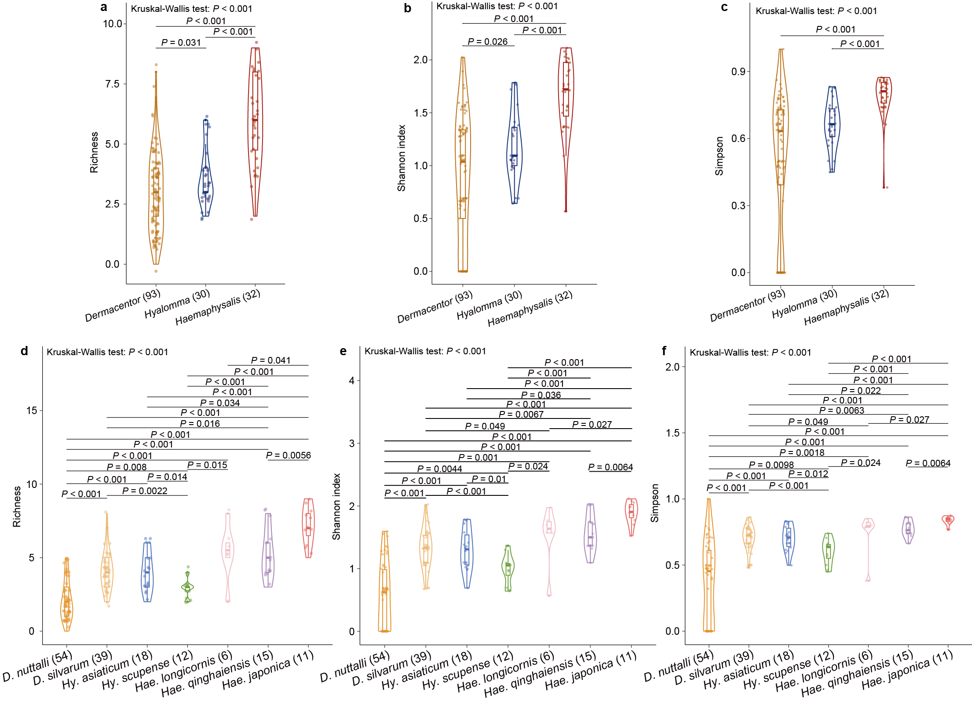
Supplementary Fig. 1 Alpha diversity of viromes at the order level among tick genera or species by using only complete virus genomes. a, Richness indexes of viromes were compared among three tick genera. b, Shannon indexes of viromes were compared among three tick genera. c, Simpson indexes of viromes were compared among three tick genera. d, Richness indexes of viromes were compared among seven tick species. e, Shannon indexes of viromes were compared among seven tick species. f, Simpson indexes of viromes were compared among seven tick species. Boxplot elements: centre line, median; box limits, upper and lower quartiles; whiskers (error bars), the highest and lowest points within 1.5 interquartile range of the upper and lower quartiles. The P value was calculated using a two‑sided Wilcoxon rank‑sum test for pairwise comparisons and a Kruskal‒Wallis test for multiple comparisons.

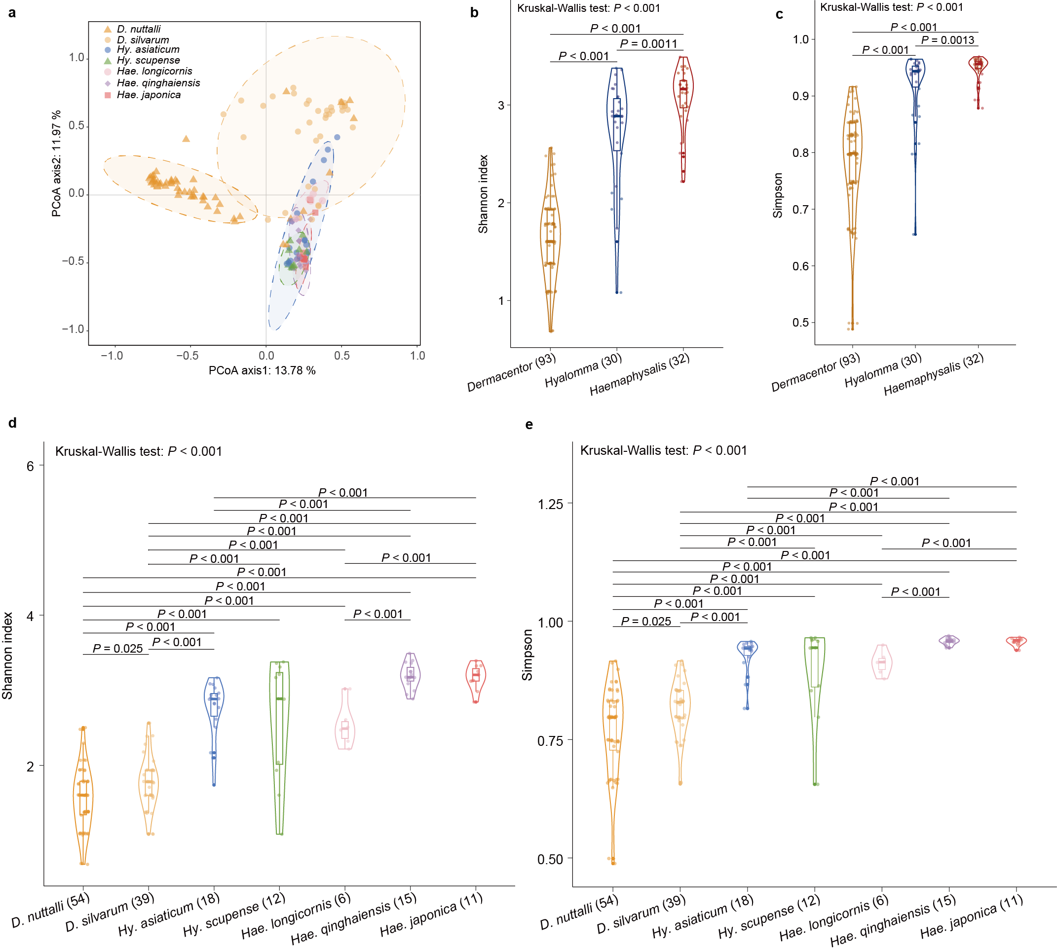
Supplementary Fig. 2 Alpha diversity of viromes at the genus level among tick genera or species. a, Between-group clustering of viromes among seven tick species by Principal Coordinate Analysis of Bray-Curtis dissimilarities, with axes 1 (11.97%) and 2 (13.78%). b, Shannon indexes of viromes were compared among three tick genera. c, Simpson indexes of viromes were compared among three tick genera. d, Shannon indexes of viromes were compared among seven tick species. e, Simpson indexes of viromes were compared among seven tick species. Boxplot elements: centre line, median; box limits, upper and lower quartiles; whiskers (error bars), the highest and lowest points within 1.5 interquartile range of the upper and lower quartiles. The P value was calculated using a two‑sided Wilcoxon rank‑sum test for pairwise comparisons and a Kruskal‒Wallis test for multiple comparisons.

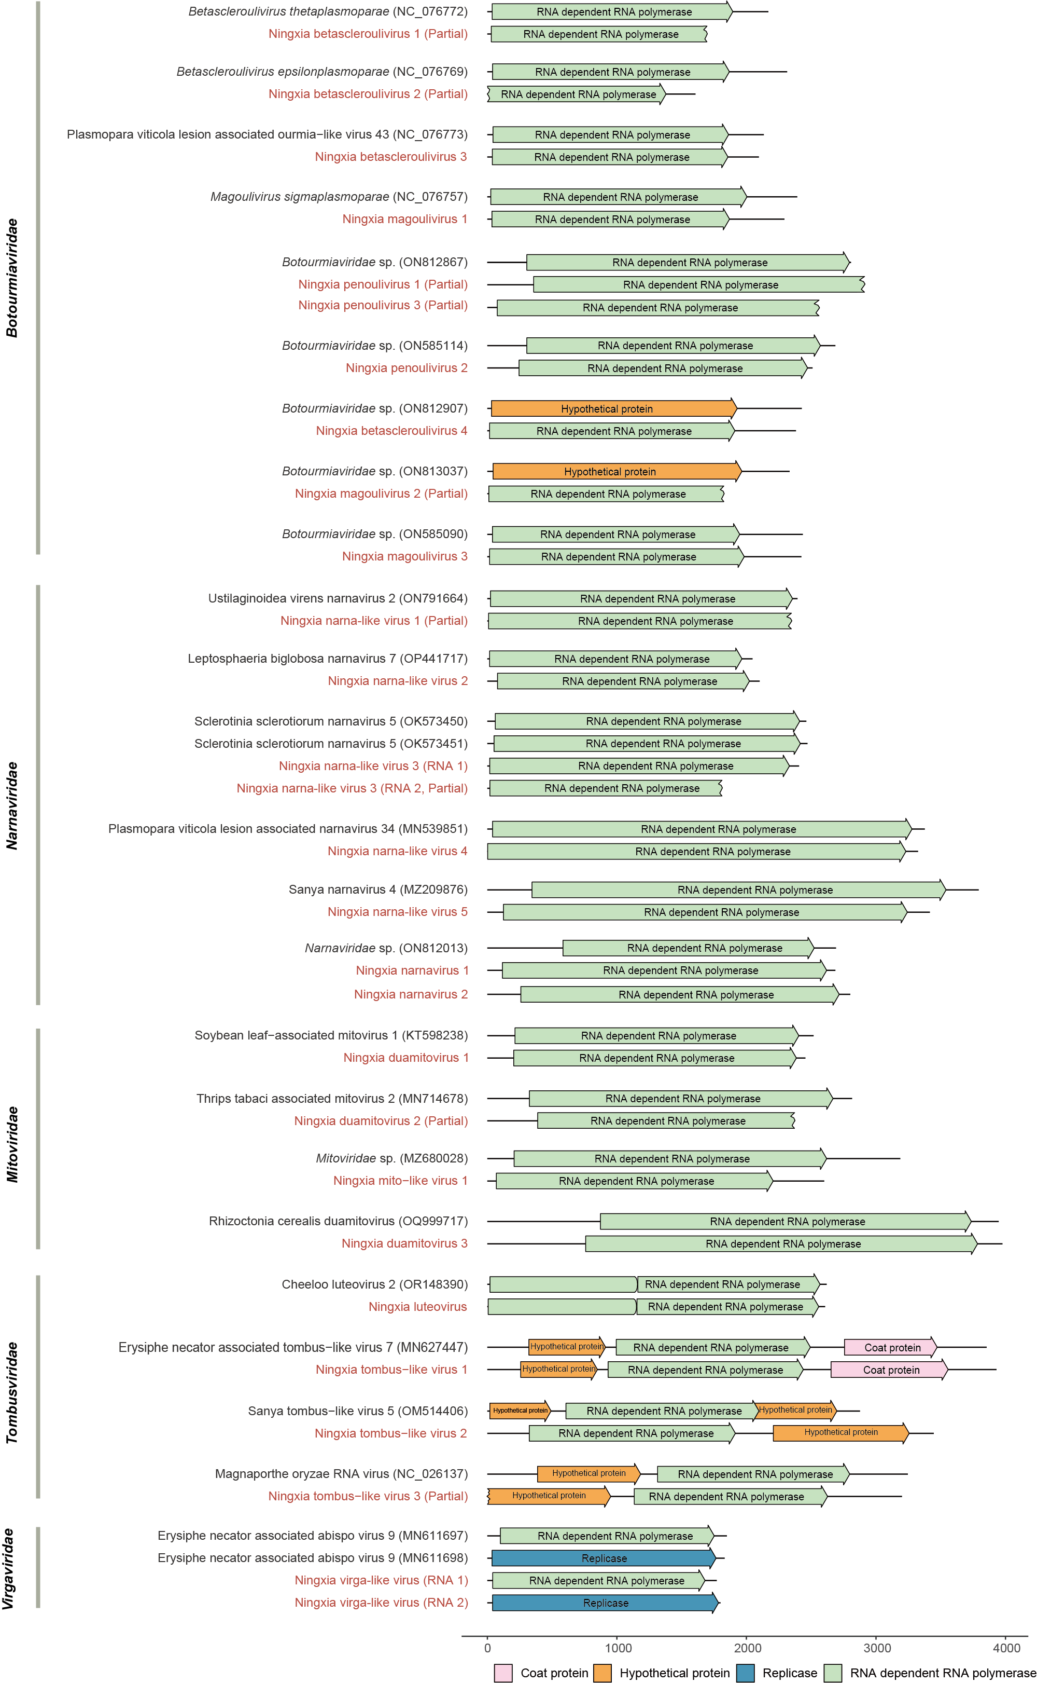
Supplementary Fig. 3 Genome structure of novel viruses detected in this study. The genomes are drawn to a unified length scale. Viruses identified in this study are highlighted in red. The bottom scale indicates the length of nucleotides.

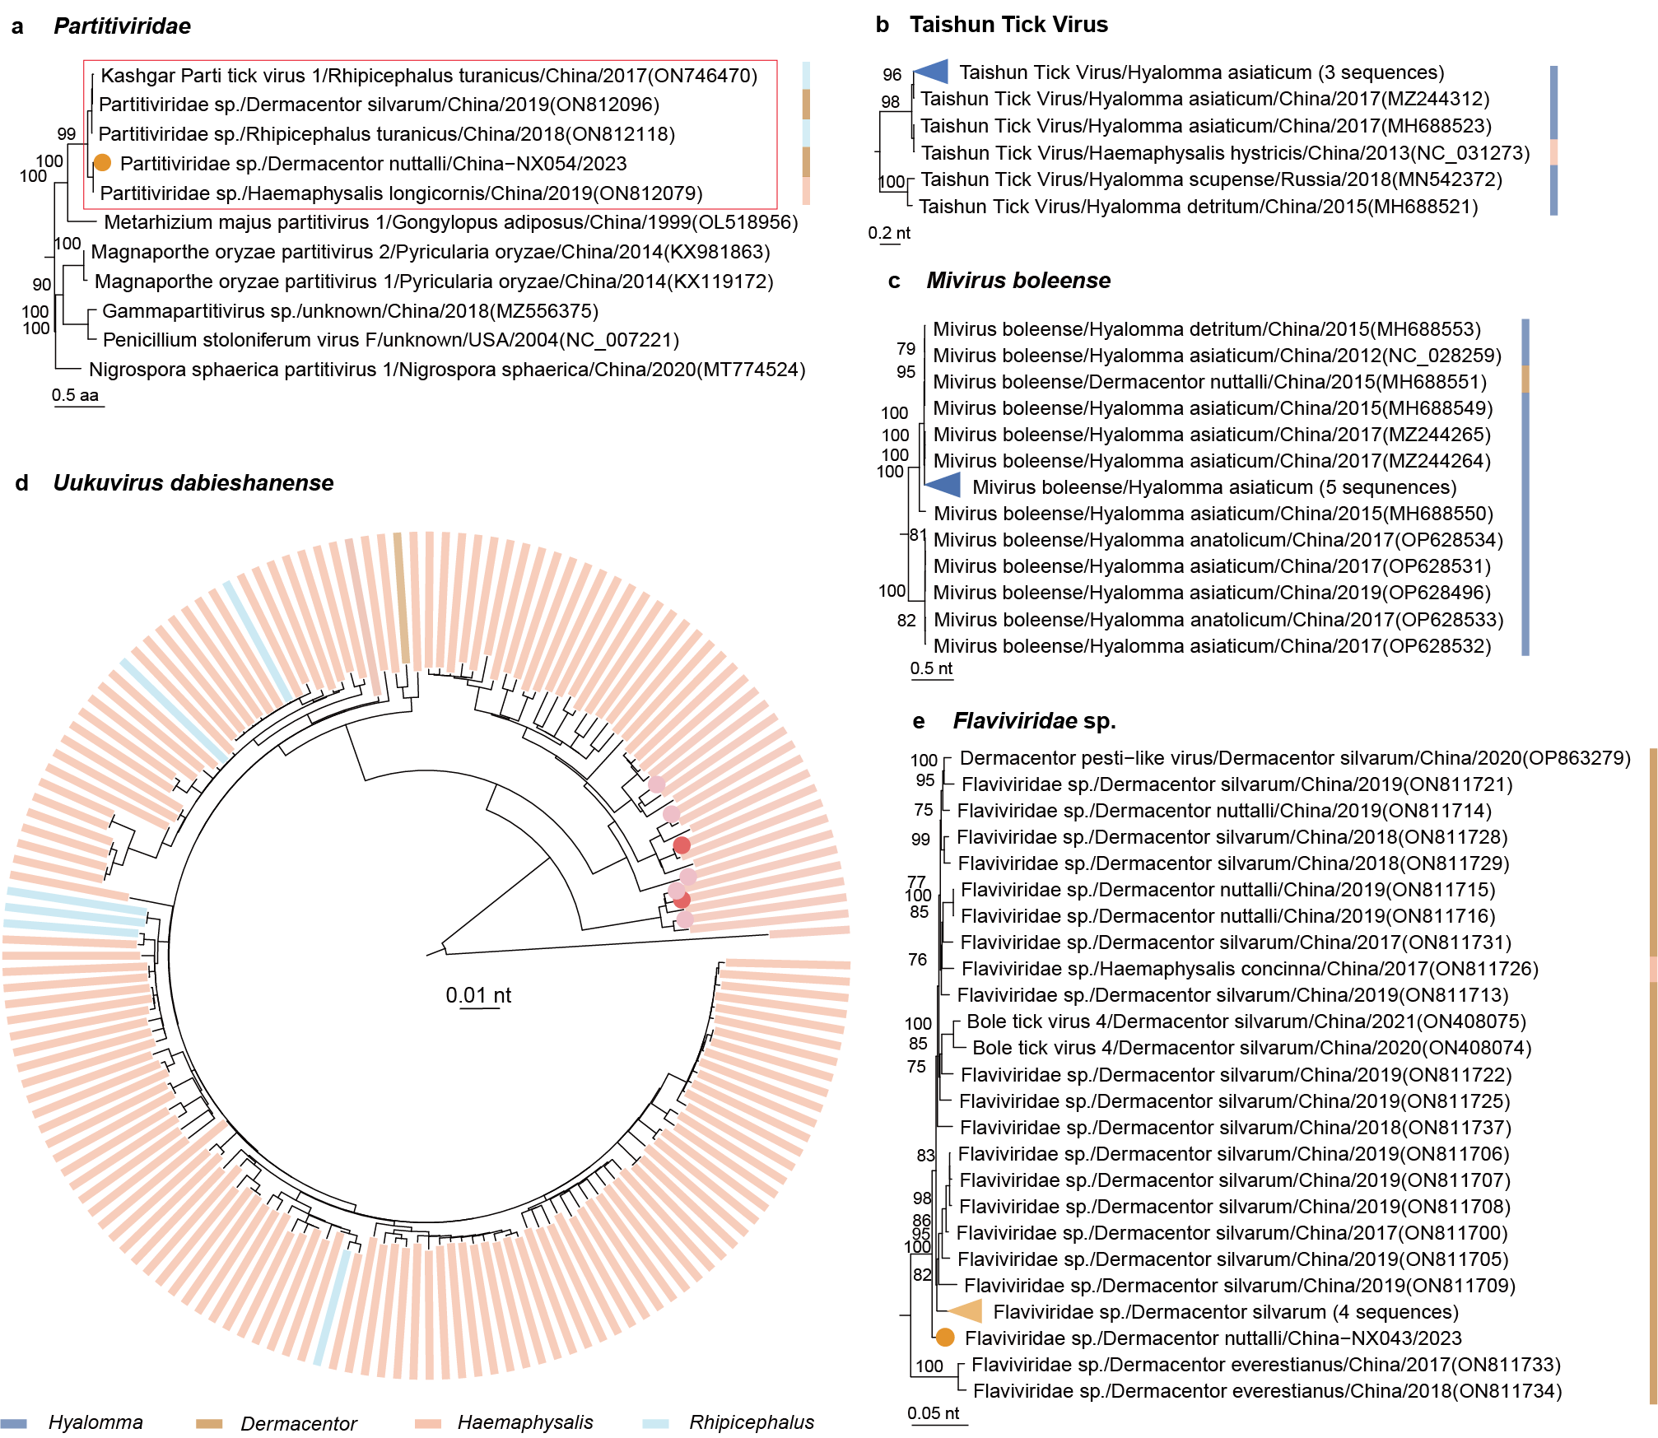
Supplementary Fig. 4 Phylogenetic analysis of tick-genus-specific viruses reported in other tick genera. a, Phylogeny of viruses in the family Partitiviridae based on RdRp protein. b, Phylogeny of Taishun Tick Virus based on RdRp gene. c, Phylogenetic tree of Mivirus boleense based on RdRp gene. d, Phylogeny of Uukuvirus dabieshanense based on RdRp gene. e, Phylogeny of Flaviviridae sp. based on RdRp gene. The reported tick genera of viruses are represented by colors. The sequences in the red box are the same virus species.

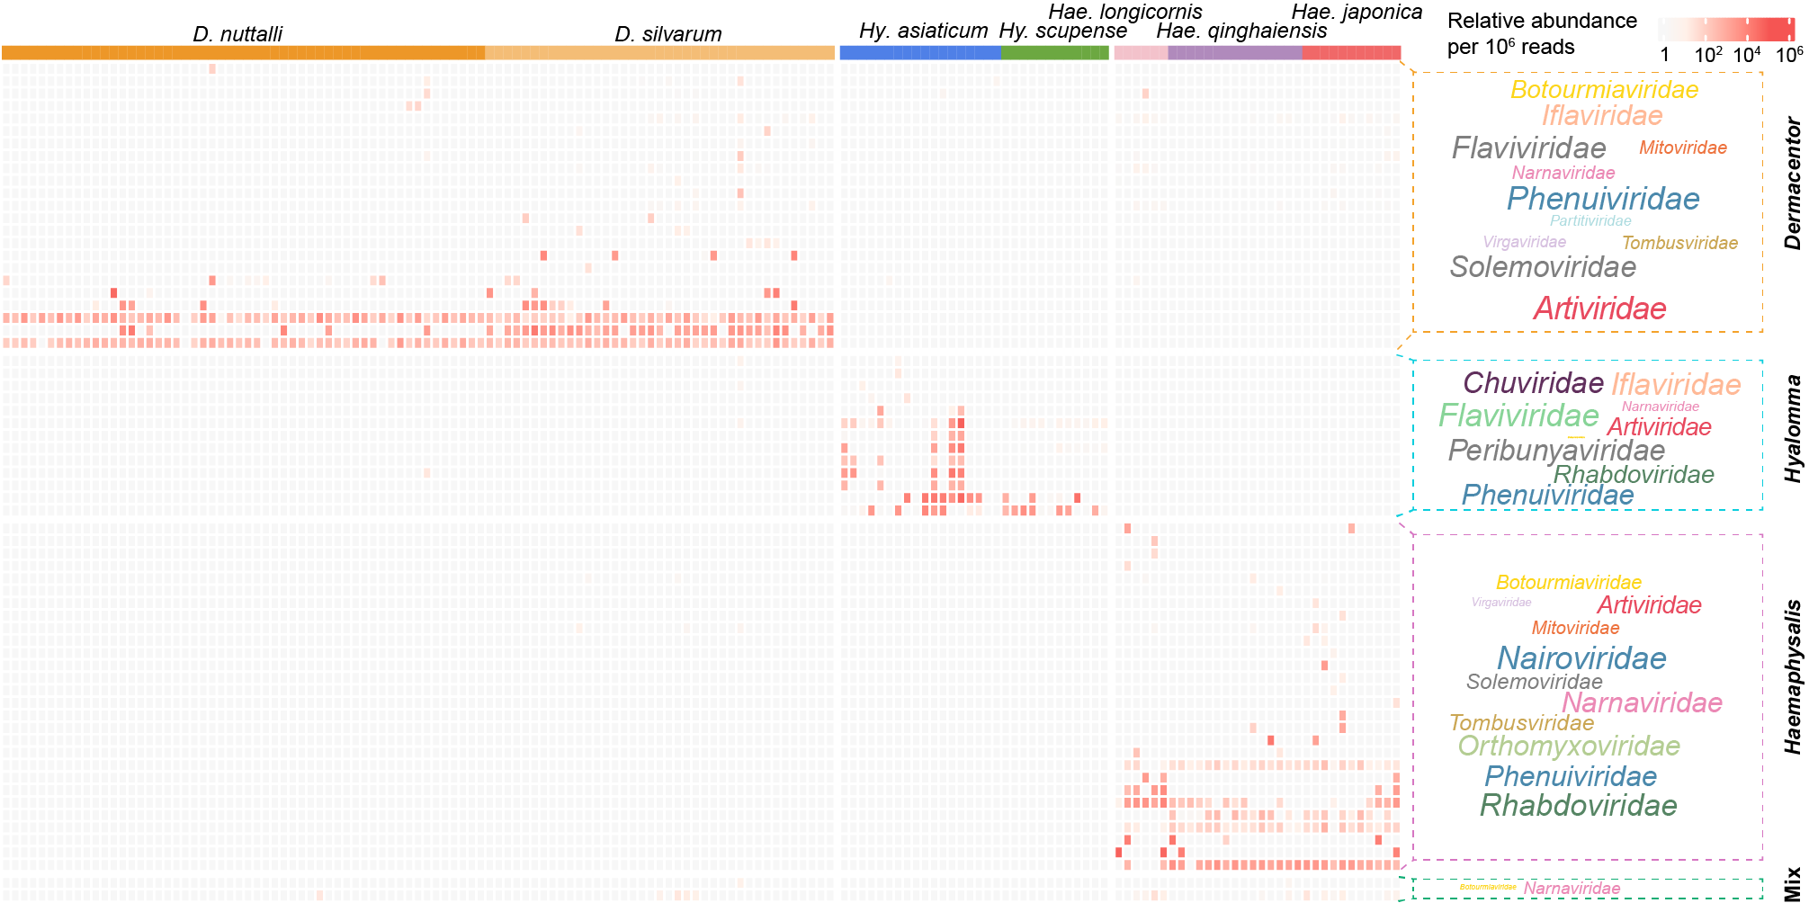
Supplementary Fig. 5 Heatmap plot of relative abundance for virus species detected in this study. The font size of the virus family in the right text box was scaled to the relative abundance of reads in each virus family.

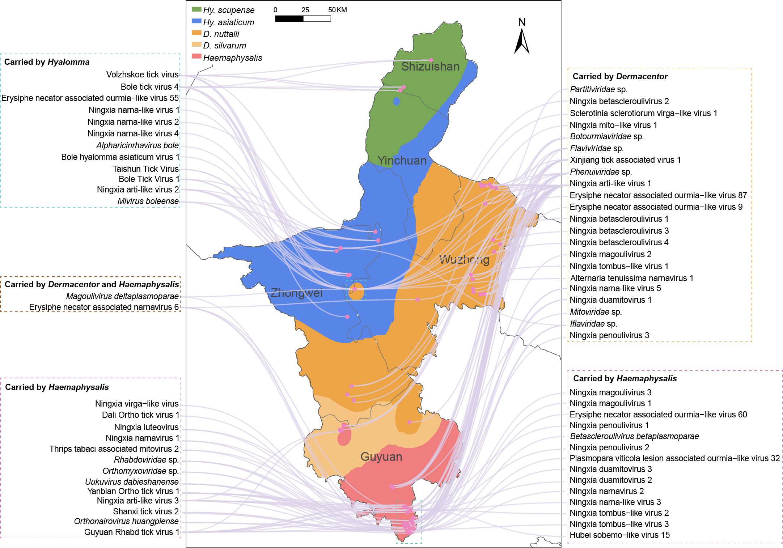
Supplementary Fig. 6 Combination of tick spatial clustering map based on inverse distance weighted (IDW) analysis and virus species detected in this study. Different colored boxes represent different tick species. The green boxes in the geographic map indicate the presence of two or more tick species.

