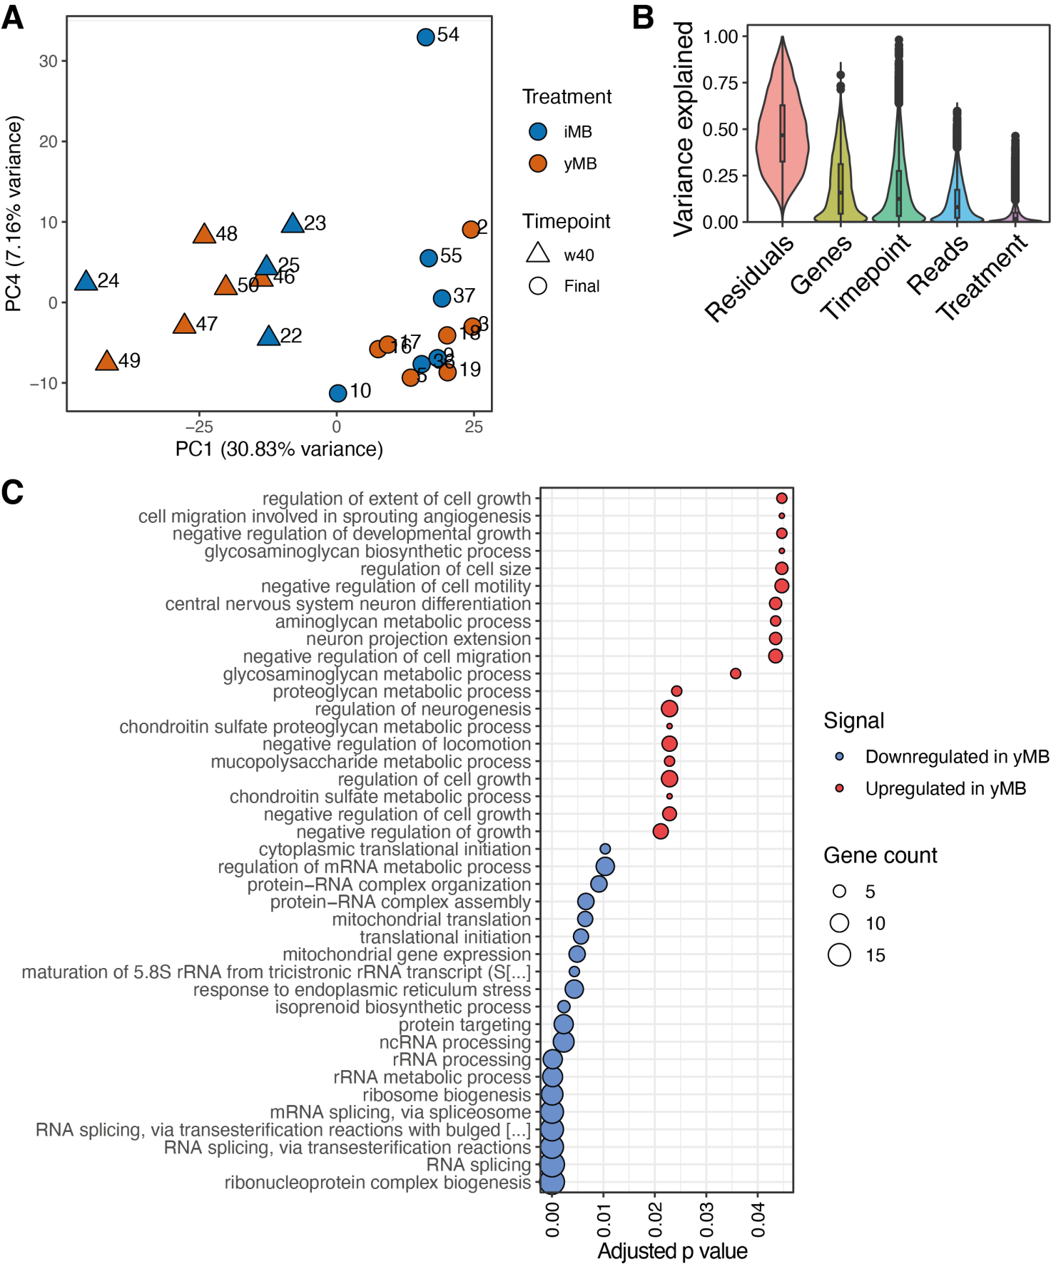
Figure S1: Bulk transcriptional adaptations to the microbiome rejuvenation in ileum tissue. Bulk RNA sequencing was performed on ileum tissue of 40- and 120-week-old yMB and iMB mice. A) Principal component plot. B) Genes which expression changes contributed to the observed variance attributed to timepoint or treatment model. C) Enriched functions among genes that were contributed to treatment explained variance.
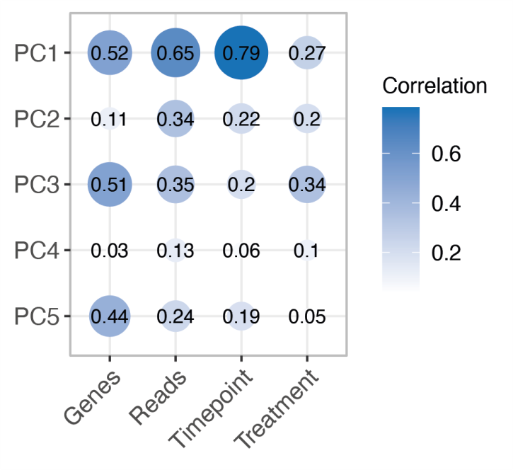
Figure S2: Principal component analysis for bulk RNAseq data. Canonical correlation of the relationship between the five first principal components and the particular groups of interest. “Treatment” corresponds to either iMB or yMB, “Timepoint” corresponds to the time of microbial transfer, “Reads” corresponds to a measure of library depth per sample, and “Genes” corresponds to a measure of library depth for genes present in all samples.
Figure S3: Cell proportions as determined from single cell RNAseq data. A-B) Box plots of cell type proportions in epithelial cells (A) and immune cells (B) separated by treatment. iMB cell proportions are colored in blue and yMB in red. Cell proportions were calculated for each individual sample. Nonparametric t test statistics were used to compare the two treatments with corresponding p-value for each comparison.
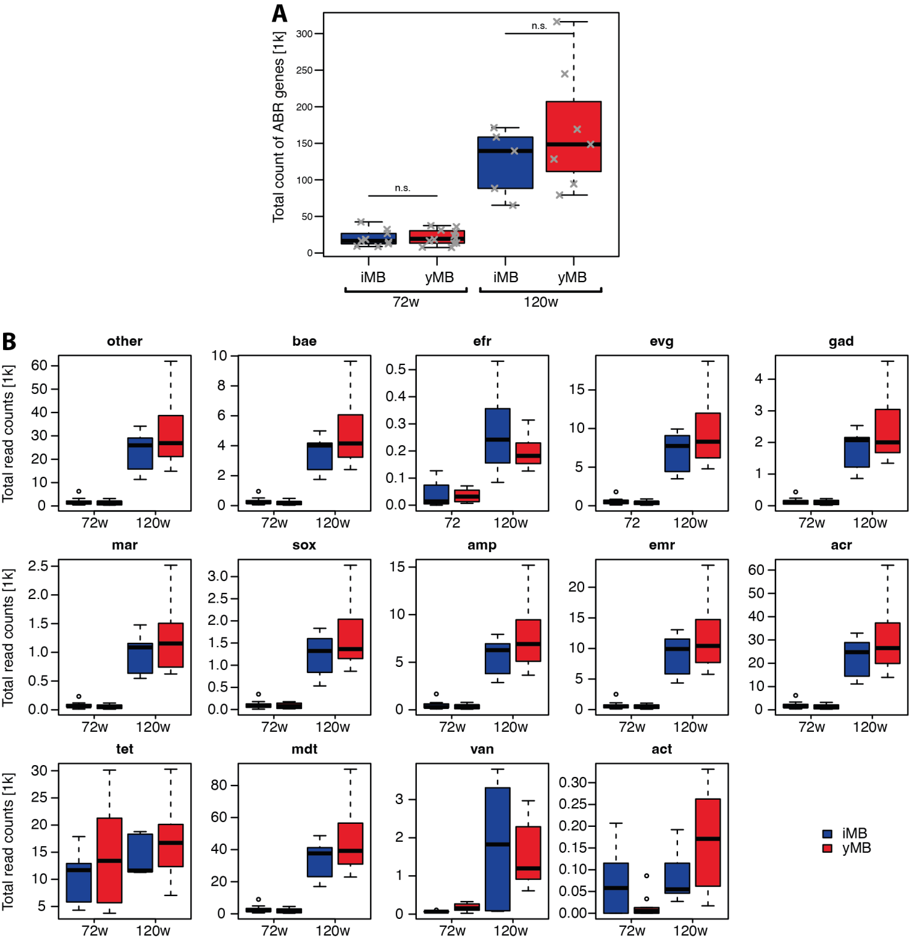
Figure S4: Antibiotic resistance gene counts do not differ among yMB and iMB. Counts of (A) total and (B) individual antibiotic resistance genes were determined in the metagenomic data from 72w and 120w samples of the yMB and iMB treatment groups.
Table S1: Enriched KEGG pathways in fecal yMB and iMB metagenomes.
Pathway description | ID | GeneRatio | BgRatio | p value
Antifolate resistance | ko01523 | 3/189 | 4/865 | 0.03453911
Arginine biosynthesis | ko00220 | 7/189 | 16/865 | 0.0402238
Atrazine degradation | ko00791 | 3/189 | 3/865 | 0.01030198
Biosynthesis of amino acids | ko01230 | 24/189 | 60/865 | 0.00075241
Biosynthesis of cofactors | ko01240 | 38/189 | 99/865 | 5.05E-05
Biosynthesis of secondary metabolites | ko01110 | 57/189 | 203/865 | 0.01015892
DNA replication | ko03030 | 4/189 | 6/865 | 0.0229027
Homologous recombination | ko03440 | 10/189 | 14/865 | 8.84E-05
Mismatch repair | ko03430 | 7/189 | 10/865 | 0.00141367
Nicotinate and nicotinamide metabolism | ko00760 | 8/189 | 19/865 | 0.03647414
Nucleotide excision repair | ko03420 | 4/189 | 5/865 | 0.00920413
One carbon pool by folate | ko00670 | 8/189 | 12/865 | 0.00099776
Oxidative phosphorylation | ko00190 | 11/189 | 27/865 | 0.01931251
Peptidoglycan biosynthesis | ko00550 | 5/189 | 10/865 | 0.04563347
Phenylalanine, tyrosine and tryptophan biosynthesis | ko00400 | 6/189 | 11/865 | 0.01737731
Purine metabolism | ko00230 | 16/189 | 48/865 | 0.04015466
Pyrimidine metabolism | ko00240 | 12/189 | 32/865 | 0.02964892
Terpenoid backbone biosynthesis | ko00900 | 6/189 | 10/865 | 0.00962898
Thiamine metabolism | ko00730 | 8/189 | 13/865 | 0.00211115

Table S2: Enriched gene functions in bulk and single cell RNA sequencing data. The three worksheets contain (i) the legend with information on the terms and data and the enriched gene functions in (ii) bulk and (iii) single cell RNA sequencing data. Celltype = Cell type annotated for the single cell analysis. Signal = Gene down- or upregulated when compared between yMB and iMB interventition. ID = Gene ontology identification code. Description = Gene ontology description. We focused on Biological process. GeneRatio = Ratio of identified genes divided by all genes of the respective GO category. BgRatio = Ratio of the size of the geneset compared to all unique genes in entire collection. pvalue = Significance value. qvalue = FDR-adjusted p value. geneID = GeneIDs that contributed to the GO term. Count = Number of genes that contributed to the GO term. SYMBOL = Gene SYMBOL that contributed to the GO term.
The table can be accessed via this permanent link: https://tinyurl.com/3az899ds

Table S3: Antibodies used for FACS analyses of isolated intestinal cells.
Type | Target protein | Fluorochrome | Dilution | Isotype | Company | Catalogue number
Target antibody | CD11b | PE | 1:100 | mono rat IgG2b | eBioscience | 12-0112
Target antibody | CD11b | APC | 1:100 | mono rat IgG2bk | eBioscience | 17-0112
Isotype control | CD11b | APC | 1:100 | mono rat IgG2bk | eBioscience | 17-4031
Target antibody | CD11c | APC | 1:50 | Armenian Hamster IgG | eBioscience | 17-0114
Isotype control | CD11c | APC | 1:50 | Armenian Hamster IgG | eBioscience | 17-4888
Target antibody | CD19 | APC | 1:40 | rat IgG2a kappa | eBioscience | 17-0193-80
Isotype control | CD19 | APC | 1:40 | rat IgG2a kappa | eBioscience | 17-4321
Target antibody | CD25 | FITC | 1:4 | mono rat, IgG2b k | Immunotools | 22-150253
Isotype control | CD25 | FITC | 1:4 | Rat IgG2b, k | Immunotools | 22225033
Target antibody | CD4 | FITC | 1:6 | Rat IgG2b | Immunotools | 22150043
Target antibody | CD4 | PE | 1:6 | mono rat IgG2b | Immunotools | 22150044
Isotype control | CD4 | PE | 1:6 | rat IgG2b | Immunotools | 22225034
Isotype control | CD8a | eFluor660 | 1:40 | rat IgG2a kappa | eBioscience | 50-4321
Target antibody | CD95 | PE | 1:6 | Armenian Hamster IgG2 | BD | 554258
Isotype control | CD95 | PE | 1:6 | Hamster IgG2 | BD | 553965
Target antibody | EpCam | APC | 1:10 | rat IgG2aK | Biolegend | 118214
Isotype control | EpCam | APC | 1:10 | rat IgG2aK | Biolegend | 400512
Target antibody | Ly6G | FITC | 1:100 | rat, IgG2b kappa | eBioscience | 11-5931
Isotype control | Ly6G | FITC | 1:100 | rat-IgG2b | eBioscience | 11-4031
Isotype control | MHC I | FITC | 1:100 | mouse IgG2a, k | eBioscience | 11-4724
Target antibody | MHCI | FITC | 1:100 | mouse IgG2a, k | eBioscience | 11-5999
Target antibody | MHCII | PE | 1:100 | rat IgG2b | eBioscience | 12-5322
Isotype control | MHCII | PE | 1:100 | rat IgG2b | eBioscience | 12-4031

