Supplementary informations for

Adaptive strategies of Caribbean sponge holobionts beyond the mesophotic zone

Benoît Paix^{1,*}, Alexane Thivet², Celso Domingos³, Özlem Erol⁴, Niels van der Windt^{2,5}, Young H. Choi⁴, Nicole J. de Voogd^{2,4,*}

¹ UMR CARRTEL, INRAE - Université Savoie Mont-Blanc, Thonon-les-Bains, France
² Naturalis Biodiversity Center, Leiden, The Netherlands
³ CIIMAR-Interdisciplinary Centre of Marine and Environmental Research, University of
Porto, Avenida General Norton de Matos, S/N, 4450-208 Matosinhos, Portugal
⁴ Natural Products Laboratory, Institute of Biology (IBL), Leiden University, PO Box 9505, 2333 BE, Leiden, the Netherlands
⁵ Institute of Environmental Sciences (CML), Leiden University, The Netherlands

* Corresponding authors: benoit.paix@gmail.com, n.j.de.voogd@biology.leidenuniv.nl

Supplementary material and methods

Supplementary information on the primer choice and comparisons for the archaeal community composition
To ensure that the prokaryotic-specific 515F-Y-926R primers (Parada et al., 2016) could cover the archaeal diversity as much as already-existing archaeal primers, a preliminary comparison test has been performed with 6 Hexactinellida samples (2 Conorete, 2 Dactylocalyx, 1 Lefroyella and 1 Hexactinella). These samples were amplified and sequenced with (i) 515F-Y-926R primers (Parada et al., 2016) and (ii) archaeal-specific Uni519F (5’-CAGCMGCCGCGGTAA-3’)-1000R (5’-GGCCATGCACYWCYTCTC-3’) primers (Ovreås et al., 1997; Takahashi et al., 2014). These latter archaeal-specific primers were chosen for this comparison as they were used by Steinert et al., 2020, for other Hexactinellida specimens. Our primer comparison test revealed a highly comparable archaeal community diversity and composition between datasets from both primers, as observed in the Figure S17, and confirmed by the Mantel test performed with the Bray-Curtis distance matrices (r = 0.84, p = 0.003).

Supplementary information on the metabolomics data processing
The parameters used for the data processing with Metaboscape through the T-ReX 3D processing workflow are:
Parameter | Positive ion mode
Peak Detection
Intensity threshold (counts) | 6000
Minimum Peak Length (spectra) | 11
Feature Signal  Calibration | Intensity
Mass recalibration RT | auto-detect
Mass recalibration List  Recursive Feature Extraction | Na Formate pos
Minimum Peak Length recursive (spectra) | 7
Minimum # Features for Extraction (analysis) | 1
Bucket Filter
Presence of features in minimum # of analysis 1
(analysis)
MS/MS Import Configuration
Perform MS/MS import | Yes
MS/MS import method | Maxsum*
Group by collision energy  Ranges | Yes
Mass Range Start (m/z) | 100
Mass Range End (m/z) | 1650
Keep isotope pattern information from all | Yes
Ion Deconvolution
EIC Correlation | 0.8
Primary Ion | [M+H]⁺
Seed Ions | [M+Na]⁺; [M+K]⁺
Common Ions | [M-H2O+H]⁺

* In case multiple MS/MS spectra exist for the same precursor, then the intensities of each MS/MS spectrum are summed and the one with the highest sum is selected.

Supplementary information on the building of the FBMN within GNPS
The precursor ion mass tolerance was set to 0.05 Da and the MS/MS fragment ion tolerance to 0.05 Da. A feature-based molecular network (FBMN) was then created where edges were filtered to have a cosine score above 0.70 and more than 5 matched peaks. Further, edges between two nodes were kept in the network if and only if each of the nodes appeared in each others respective top 10 most similar nodes. Finally, the maximum size of a molecular family was set to 100, and the lowest scoring edges were removed from molecular families until the molecular family size was below this threshold. The spectra in the network were then searched against GNPS spectral libraries (Wang et al., 2016; Horai et al., 2010). The library spectra were filtered in the same manner as the input data. All matches kept between network spectra and library spectra were required to have a score above 0.7 and at least 5 matched peaks.

Supplementary tables

Table S1. Summary of the sample list. The color corresponds to the color codes used for all figures.
* indicates sponge species that could not be collected at least in triplicate in the same photic zone.
Sample name | Class | Species | Photic zone | Depth (m) | Sampling date
Ps1.1 | Demospongiae | Petrosia sp. 1 * | Mesophotic | 89 | 23.04.2022
Ne.1 | Demospongiae | Neopetrosia eurystomata | Mesophotic | 94 | 23.04.2022
Sz.1 | Demospongiae | Svenzea zeai | Mesophotic | 95 | 23.04.2022
Sz.3 | Demospongiae | Svenzea zeai | Mesophotic | 95 | 23.04.2022
Ck.1 | Demospongiae | Cinachyrella kuekenthali * | Mesophotic | 100 | 23.04.2022
Sz.2 | Demospongiae | Svenzea zeai | Mesophotic | 100 | 23.04.2022
Gc.1 | Demospongiae | Geodia aff. curacaoensis | Mesophotic | 105 | 23.04.2022
Ne.3 | Demospongiae | Neopetrosia eurystomata | Mesophotic | 105 | 23.04.2022
Ne.4 | Demospongiae | Neopetrosia eurystomata | Mesophotic | 105 | 23.04.2022
Pw.1 | Demospongiae | Petrosia aff. weinbergi * | Mesophotic | 106 | 23.04.2022
Ne.2 | Demospongiae | Neopetrosia eurystomata | Mesophotic | 107 | 23.04.2022
Gs1.1 | Demospongiae | Geodia sp. 1 * | Mesophotic | 121 | 23.04.2022
Ah.2 | Demospongiae | Aciculites higginsii | Upper rariphotic | 127 | 23.04.2022
Ah.3 | Demospongiae | Aciculites higginsii | Upper rariphotic | 127 | 23.04.2022
Ah.1 | Demospongiae | Aciculites higginsii | Upper rariphotic | 129 | 23.04.2022
Ps2.1 | Demospongiae | Petrosia sp. 2 * | Upper rariphotic | 129 | 23.04.2022
Gi.1 | Demospongiae | Gastrophanella implexa * | Upper rariphotic | 151 | 23.04.2022
B.m.1 | Demospongiae | Biemna microacanthosigma * | Lower rariphotic | 258 | 23.04.2022
Pm.1 | Demospongiae | Penares mastoideus * | Lower rariphotic | 262 | 23.04.2022
Gm.1 | Demospongiae | Geodia cf. megastrella * | Lower rariphotic | 266 | 23.04.2022
Cl.2 | Demospongiae | Calthropella lithistina * | Lower rariphotic | 267 | 23.04.2022
Gs2.1 | Demospongiae | Geodia sp. 2 * | Lower rariphotic | 267 | 23.04.2022
To.1 | Demospongiae | Topsentia ophiraphidites * | Lower rariphotic | 295 | 22.04.2022
Cl.1 | Demospongiae | Calthropella lithistina * | Lower rariphotic | 300 | 22.04.2022
Dp.8 | Hexactinellida | Dactylocalyx pumiceus | Upper rariphotic | 132 | 30.03.2023
Dp.9 | Hexactinellida | Dactylocalyx pumiceus | Upper rariphotic | 144 | 30.03.2023
Dp.5 | Hexactinellida | Dactylocalyx pumiceus | Upper rariphotic | 145 | 30.03.2023
Dp.6 | Hexactinellida | Dactylocalyx pumiceus | Upper rariphotic | 145 | 30.03.2023
Dp.7 | Hexactinellida | Dactylocalyx pumiceus | Upper rariphotic | 145 | 30.03.2023
Dp.3 | Hexactinellida | Dactylocalyx pumiceus | Upper rariphotic | 174 | 23.04.2022
Dp.4 | Hexactinellida | Dactylocalyx pumiceus | Upper rariphotic | 174 | 23.04.2022
Vl.6 | Hexactinellida | Verrucocoeloidea liberatorii | Upper rariphotic | 176 | 30.03.2023
Vl.7 | Hexactinellida | Verrucocoeloidea liberatorii | Upper rariphotic | 176 | 30.03.2023
Vl.8 | Hexactinellida | Verrucocoeloidea liberatorii | Upper rariphotic | 176 | 30.03.2023
Ls.4 | Hexactinellida | Lefroyella sp. * | Upper rariphotic | 194 | 30.03.2023
Cp.5 | Hexactinellida | Conorete pourtalesi | Lower rariphotic | 238 | 30.03.2023
Cp.6 | Hexactinellida | Conorete pourtalesi | Lower rariphotic | 238 | 30.03.2023
Cp.7 | Hexactinellida | Conorete pourtalesi | Lower rariphotic | 238 | 30.03.2023
Hx.2 | Hexactinellida | Hexactinella sp. | Lower rariphotic | 238 | 30.03.2023
Hx.3 | Hexactinellida | Hexactinella sp. | Lower rariphotic | 238 | 30.03.2023
Cp.2 | Hexactinellida | Conorete pourtalesi | Lower rariphotic | 262 | 23.04.2022
Cp.4 | Hexactinellida | Conorete pourtalesi | Lower rariphotic | 262 | 23.04.2022
Dp.2 | Hexactinellida | Dactylocalyx pumiceus | Lower rariphotic | 262 | 23.04.2022
Cp.8 | Hexactinellida | Conorete pourtalesi | Lower rariphotic | 267 | 30.10.2018
Cp.3 | Hexactinellida | Conorete pourtalesi | Lower rariphotic | 268 | 23.04.2022
Dp.1 | Hexactinellida | Dactylocalyx pumiceus | Lower rariphotic | 268 | 23.04.2022
Vl.1 | Hexactinellida | Verrucocoeloidea liberatorii | Lower rariphotic | 268 | 23.04.2022
Vl.2 | Hexactinellida | Verrucocoeloidea liberatorii | Lower rariphotic | 268 | 23.04.2022
Vl.3 | Hexactinellida | Verrucocoeloidea liberatorii | Lower rariphotic | 268 | 23.04.2022
Vl.4 | Hexactinellida | Verrucocoeloidea liberatorii | Lower rariphotic | 268 | 23.04.2022
Vl.5 | Hexactinellida | Verrucocoeloidea liberatorii | Lower rariphotic | 268 | 23.04.2022
Ls.1 | Hexactinellida | Lefroyella sp. | Lower rariphotic | 282 | 22.04.2022
Ht.1 | Hexactinellida | Heterotella sp. nov. | Lower rariphotic | 288 | 22.04.2022
Ht.2 | Hexactinellida | Heterotella sp. nov. | Lower rariphotic | 288 | 22.04.2022
Cp.1 | Hexactinellida | Conorete pourtalesi | Lower rariphotic | 298 | 22.04.2022
Hx.1 | Hexactinellida | Hexactinella sp. | Lower rariphotic | 301 | 22.04.2022
Ls.2 | Hexactinellida | Lefroyella sp. | Lower rariphotic | 301 | 22.04.2022
Ls.3 | Hexactinellida | Lefroyella sp. | Lower rariphotic | 301 | 22.04.2022
Ms.1 | Hexactinellida | Myliusia sp. nov. * | Lower rariphotic | 302 | 22.04.2022
Ht.3 | Hexactinellida | Heterotella sp. nov. | Lower rariphotic | 305 | 30.10.2018
Sponge associated fauna
NA | Anthozoa | Vitrumanthus schrieri | Lower rariphotic | 268 | 23.04.2022
NA | Malacostraca | Eiconaxius caribbaeus | Lower rariphotic | 262 | 23.04.2022

Table S2. Results of the two-way PERMANOVA tests conducted with the sponge class and the photic zone factors, for both metabarcoding and metabolomics datasets. D.f., F, R² and p correspond to degrees of freedom, F ratio, coefficient of determination, and p-value, respectively
Dataset | Factor tested | D.f. | Sum of squares | R² | F | p
Meta-  barcoding | Sponge class | 1 | 2.25974339 | 0.08591288 | 5.8653859 | 0.001
Meta-  barcoding | Photic zone | 2 | 2.40547206 | 0.09145332 | 3.12181949 | 0.001
Meta-  barcoding | Sponge class * Photic zone | 1 | 1.2183296 | 0.04631951 | 3.16229412 | 0.001
Meta-  barcoding | Residual | 53 | 20.419185 | 0.77631428 | NA | NA
Meta-  barcoding | Total | 57 | 26.3027301 | 1 | NA | NA
Metabo-  lomics | Sponge class | 1 | 3872.228 | 0.070284 | 4.451549 | 0.001
Metabo-  lomics | Photic zone | 2 | 2300.252 | 0.041752 | 1.322195 | 0.006
Metabo-  lomics | Sponge class * Photic_zone | 1 | 1078.9 | 0.019583 | 1.240313 | 0.05
Metabo-  lomics | Residual | 55 | 47842.35 | 0.868381 | NA | NA
Metabo-  lomics | Total | 59 | 55093.73 | 1 | NA | NA

Table S3. Results of the multivariate pairwise adonis test comparing five groups of sponge samples gathered according to their sponge class and photic zone, for both metabarcoding and metabolomics datasets. M, UR, and LR correspond to the mesophotic, upper rariphotic, and lower rariphotic zones, respectively. F, R^{2,} and p correspond to the F ratio, coefficient of determination, and p-value, respectively
Dataset | Pairwise comparison | Sum of squares | F | R² | p
Meta-  barcoding | Hexactinellida LR vs Demospongiae M | 0.0130 | 6.241 | 0.155 | 0.003
Meta-  barcoding | Hexactinellida LR vs Demospongiae LR | 0.0120 | 5.369 | 0.156 | 0.006
Meta-  barcoding | Hexactinellida LR vs Hexactinellida UR | 0.0074 | 3.006 | 0.081 | 0.052
Meta-  barcoding | Hexactinellida LR vs Demospongiae UR | 0.0090 | 3.859 | 0.121 | 0.019
Meta-  barcoding | Demospongiae M vs Demospongiae LR | 0.0043 | 7.748 | 0.341 | 0.001
Meta-  barcoding | Demospongiae M vs Hexactinellida UR | 0.0098 | 7.280 | 0.267 | 0.001
Meta-  barcoding | Demospongiae M vs Demospongiae UR | 0.0031 | 5.036 | 0.265 | 0.005
Meta-  barcoding | Demospongiae LR vs Hexactinellida UR | 0.0096 | 6.979 | 0.318 | 0.001
Meta-  barcoding | Demospongiae LR vs Demospongiae UR | 0.0032 | 12.343 | 0.578 | 0.003
Meta-  barcoding | Hexactinellida UR vs Demospongiae UR | 0.0074 | 4.956 | 0.261 | 0.022
Metabo-  lomics | Hexactinellida LR vs Demospongiae M | 2583.95 | 2.901 | 0.077 | 0.001
Metabo-  lomics | Hexactinellida LR vs Demospongiae LR | 2059.88 | 2.348 | 0.073 | 0.001
Metabo-  lomics | Hexactinellida LR vs Hexactinellida UR | 974.32 | 1.120 | 0.032 | 0.14
Metabo-  lomics | Hexactinellida LR vs Demospongiae UR | 2092.46 | 2.342 | 0.077 | 0.001
Metabo-  lomics | Demospongiae LR vs Demospongiae M | 1212.10 | 1.405 | 0.076 | 0.008
Metabo-  lomics | Demospongiae LR vs Demospongiae UR | 1083.63 | 1.274 | 0.113 | 0.023
Metabo-  lomics | Demospongiae LR vs Hexactinellida UR | 1868.60 | 2.287 | 0.125 | 0.001
Metabo-  lomics | Demospongiae M vs Demospongiae UR | 1275.44 | 1.432 | 0.087 | 0.009
Metabo-  lomics | Demospongiae M vs Hexactinellida UR | 2294.26 | 2.689 | 0.114 | 0.001
Metabo-  lomics | Demospongiae UR vs Hexactinellida UR | 1974.53 | 2.350 | 0.144 | 0.001

Table S4. Results of the nested PERMANOVA tests conducted with the “sponge genus” factor nested within each “sponge class” factor, for both metabarcoding and metabolomics datasets. D.f., F, R² and p correspond to degrees of freedom, F ratio, coefficient of determination, and p-value, respectively
Dataset | Factor tested | D.f. | Sum of squares | R² | F | p
Meta-  barcoding | Sponge class | 1 | 2.259743 | 0.085913 | 10.82349 | 0.001
Meta-  barcoding | Sponge class / Sponge genus | 17 | 15.90052 | 0.60452 | 4.479924 | 0.001
Meta-  barcoding | Residual | 39 | 8.142471 | 0.309568 | NA | NA
Meta-  barcoding | Total | 57 | 26.30273 | 1 | NA | NA
Metabo-  lomics | Class_host | 1 | 3872.228 | 0.070 | 4.967 | 0.001
Metabo-  lomics | Sponge class / Sponge genus | 17 | 19260.480 | 0.350 | 1.453 | 0.001
Metabo-  lomics | Residual | 41 | 31961.019 | 0.580 | NA | NA
Metabo-  lomics | Total | 59 | 55093.727 | 1.000 | NA | NA

Table S5. Summarized results of the significant multivariate pairwise adonis comparisons within sponge genus, for both metabarcoding and metabolomics datasets. F, R^{2,} and p correspond to the F ratio, coefficient of determination, and p-value, respectively.
Dataset | Pairwise comparison | Sum of squares | F | R² | p
Metabar-coding | Lefroyella vs Neopetrosia | 0.00523906 | 41.4445051 | 0.89234464 | 0.03
Metabar-coding | Lefroyella vs Verrucocoeloidea | 0.01726565 | 134.439986 | 0.93076709 | 0.001
Metabar-coding | Lefroyella vs Hexactinella | 0.0018457 | 8.62206806 | 0.63294854 | 0.032
Metabar-coding | Lefroyella vs Dactylocalyx | 0.00381299 | 8.06953216 | 0.42316361 | 0.001
Metabar-coding | Lefroyella vs Conorete | 0.0151288 | 82.3261723 | 0.89168835 | 0.005
Metabar-coding | Lefroyella vs Petrosia | 0.00255957 | 8.21184424 | 0.6215517 | 0.026
Metabar-coding | Lefroyella vs Geodia | 0.00480402 | 12.8215718 | 0.71944113 | 0.019
Metabar-coding | Lefroyella vs Svenzea | 0.00309843 | 9.20254244 | 0.64795036 | 0.03
Metabar-coding | Lefroyella vs Aciculites | 0.00438964 | 35.503539 | 0.876554 | 0.032
Metabar-coding | Lefroyella vs Heterotella | 0.00099723 | 4.81729681 | 0.49069483 | 0.038
Metabar-coding | Neopetrosia vs Verrucocoeloidea | 0.01915322 | 200.189898 | 0.95697689 | 0.007
Metabar-coding | Neopetrosia vs Dactylocalyx | 0.00751745 | 15.7449931 | 0.61157496 | 0.003
Metabar-coding | Neopetrosia vs Conorete | 0.01758884 | 111.913674 | 0.92556673 | 0.006
Metabar-coding | Calthropella vs Verrucocoeloidea | 0.0128796 | 124.850423 | 0.9397819 | 0.019
Metabar-coding | Calthropella vs Dactylocalyx | 0.00467829 | 8.88526002 | 0.49679233 | 0.017
Metabar-coding | Calthropella vs Conorete | 0.01181092 | 68.534448 | 0.89547191 | 0.018
Metabar-coding | Verrucocoeloidea vs Hexactinella | 0.01176412 | 81.484416 | 0.90053536 | 0.008
Metabar-coding | Verrucocoeloidea vs Dactylocalyx | 0.03102167 | 85.7471905 | 0.85111247 | 0.001
Metabar-coding | Verrucocoeloidea vs Conorete | 0.05495612 | 372.279926 | 0.96375685 | 0.001
Metabar-coding | Verrucocoeloidea vs Petrosia | 0.01388056 | 69.8887473 | 0.88591529 | 0.01
Metabar-coding | Verrucocoeloidea vs Geodia | 0.01884016 | 80.6500849 | 0.89960969 | 0.005
Metabar-coding | Verrucocoeloidea vs Svenzea | 0.01409991 | 66.3529963 | 0.88056215 | 0.011
Metabar-coding | Verrucocoeloidea vs Aciculites | 0.0173875 | 184.707594 | 0.95353822 | 0.006
Metabar-coding | Verrucocoeloidea vs Heterotella | 0.01113463 | 79.2769507 | 0.89804813 | 0.009
Metabar-coding | Hexactinella vs Dactylocalyx | 0.00294304 | 5.64582675 | 0.36085193 | 0.003
Metabar-coding | Hexactinella vs Conorete | 0.01122939 | 54.5482095 | 0.85837524 | 0.006
Metabar-coding | Dactylocalyx vs Conorete | 0.02736767 | 68.6467152 | 0.82067437 | 0.001
Metabar-coding | Dactylocalyx vs Petrosia | 0.00359733 | 6.31009759 | 0.38688288 | 0.007
Metabar-coding | Dactylocalyx vs Geodia | 0.006976 | 11.5960222 | 0.53695176 | 0.004
Metabar-coding | Dactylocalyx vs Svenzea | 0.00446347 | 7.66141307 | 0.43379389 | 0.008
Metabar-coding | Dactylocalyx vs Aciculites | 0.00629095 | 13.2144952 | 0.56923466 | 0.009
Metabar-coding | Dactylocalyx vs Heterotella | 0.00190949 | 3.68805768 | 0.26943616 | 0.012
Metabar-coding | Conorete vs Petrosia | 0.01248329 | 47.9944898 | 0.84209 | 0.002
Metabar-coding | Conorete vs Geodia | 0.01723654 | 58.4105863 | 0.86648981 | 0.006
Metabar-coding | Conorete vs Svenzea | 0.01148638 | 41.9229762 | 0.82326249 | 0.005
Metabar-coding | Conorete vs Aciculites | 0.01597357 | 102.641788 | 0.91938502 | 0.012
Metabar-coding | Conorete vs Heterotella | 0.00959747 | 47.5259862 | 0.84078119 | 0.005
Metabo-lomics | Conorete vs Lefroyella | 1401.263345 | 1.689045381 | 0.144498146 | 0.003
Metabo-lomics | Conorete vs Hexactinella | 1113.436064 | 1.314648936 | 0.12745455 | 0.049
Metabo-lomics | Conorete vs Calthropella | 1600.656439 | 1.889794356 | 0.191085303 | 0.017
Metabo-lomics | Conorete vs Svenzea | 1612.116222 | 1.953908422 | 0.178375457 | 0.009
Metabo-lomics | Conorete vs Neopetrosia | 2190.840979 | 2.628688083 | 0.208152111 | 0.004
Metabo-lomics | Conorete vs Petrosia | 1665.989698 | 1.896363957 | 0.1740364 | 0.005
Metabo-lomics | Conorete vs Aciculites | 2044.543599 | 2.355695111 | 0.207446139 | 0.005
Metabo-lomics | Conorete vs Geodia | 1835.762546 | 2.21888216 | 0.18159453 | 0.001
Metabo-lomics | Conorete vs Dactylocalyx | 1758.044958 | 2.191615014 | 0.127481625 | 0.001
Metabo-lomics | Conorete vs Verrucocoeloidea | 1332.986913 | 1.611870356 | 0.103246461 | 0.008
Metabo-lomics | Heterotella vs Neopetrosia | 1608.428747 | 1.944174546 | 0.279972016 | 0.042
Metabo-lomics | Heterotella vs Geodia | 1142.557535 | 1.401722198 | 0.218960173 | 0.028
Metabo-lomics | Heterotella vs Dactylocalyx | 1055.502635 | 1.34721289 | 0.118726325 | 0.038
Metabo-lomics | Heterotella vs Verrucocoeloidea | 1341.434393 | 1.635912643 | 0.153810275 | 0.012
Metabo-lomics | Lefroyella vs Svenzea | 1127.614706 | 1.586429832 | 0.240863392 | 0.026
Metabo-lomics | Lefroyella vs Neopetrosia | 1673.36145 | 2.249828992 | 0.272712197 | 0.03
Metabo-lomics | Lefroyella vs Petrosia | 1359.286813 | 1.684392689 | 0.251988889 | 0.033
Metabo-lomics | Lefroyella vs Aciculites | 1665.753705 | 2.114157155 | 0.297176055 | 0.037
Metabo-lomics | Lefroyella vs Geodia | 1231.778602 | 1.679067798 | 0.21865516 | 0.027
Metabo-lomics | Lefroyella vs Dactylocalyx | 1211.856755 | 1.633467169 | 0.129296823 | 0.004
Metabo-lomics | Lefroyella vs Verrucocoeloidea | 1490.199462 | 1.933810661 | 0.162044691 | 0.003
Metabo-lomics | Hexactinella vs Neopetrosia | 1528.282679 | 2.016756931 | 0.287420093 | 0.023
Metabo-lomics | Hexactinella vs Geodia | 1279.116247 | 1.715563797 | 0.255460874 | 0.026
Metabo-lomics | Hexactinella vs Dactylocalyx | 1031.760591 | 1.378043633 | 0.121114286 | 0.008
Metabo-lomics | Hexactinella vs Verrucocoeloidea | 1092.403853 | 1.398058149 | 0.134453773 | 0.008
Metabo-lomics | Calthropella vs Dactylocalyx | 1540.655338 | 2.088038631 | 0.188314516 | 0.016
Metabo-lomics | Calthropella vs Verrucocoeloidea | 1700.631084 | 2.199384729 | 0.215638961 | 0.029
Metabo-lomics | Svenzea vs Neopetrosia | 1321.780668 | 1.83984181 | 0.268988942 | 0.024
Metabo-lomics | Svenzea vs Geodia | 1135.189711 | 1.607407697 | 0.243273576 | 0.034
Metabo-lomics | Svenzea vs Dactylocalyx | 1697.840875 | 2.328909319 | 0.188898244 | 0.011
Metabo-lomics | Svenzea vs Verrucocoeloidea | 1826.588713 | 2.404990743 | 0.210871784 | 0.005
Metabo-lomics | Neopetrosia vs Petrosia | 1350.887486 | 1.658298862 | 0.249057439 | 0.029
Metabo-lomics | Neopetrosia vs Aciculites | 1800.607826 | 2.263384999 | 0.311615727 | 0.026
Metabo-lomics | Neopetrosia vs Geodia | 1661.47933 | 2.245334557 | 0.272315761 | 0.03
Metabo-lomics | Neopetrosia vs Dactylocalyx | 2254.248316 | 3.024367282 | 0.21565089 | 0.002
Metabo-lomics | Neopetrosia vs Verrucocoeloidea | 2322.923449 | 2.999568655 | 0.230743707 | 0.002
Metabo-lomics | Petrosia vs Geodia | 1092.317003 | 1.36126903 | 0.213993312 | 0.025
Metabo-lomics | Petrosia vs Dactylocalyx | 1742.177094 | 2.241811548 | 0.183127435 | 0.003
Metabo-lomics | Petrosia vs Verrucocoeloidea | 1891.448956 | 2.326663971 | 0.205414761 | 0.005
Metabo-lomics | Aciculites vs Geodia | 1226.260616 | 1.565424475 | 0.238434618 | 0.03
Metabo-lomics | Aciculites vs Dactylocalyx | 2099.309444 | 2.734947617 | 0.214759236 | 0.012
Metabo-lomics | Aciculites vs Verrucocoeloidea | 2257.174676 | 2.813232913 | 0.238142508 | 0.008
Metabo-lomics | Geodia vs Dactylocalyx | 1560.413681 | 2.109186183 | 0.160893754 | 0.001
Metabo-lomics | Geodia vs Verrucocoeloidea | 1884.724231 | 2.453043687 | 0.196983464 | 0.006
Metabo-lomics | Dactylocalyx vs Verrucocoeloidea | 1960.099173 | 2.569527594 | 0.1462491 | 0.001

Table S6. Summary of the differential analyses conducted on the metabarcoding (phylogenetical heat trees) and metabolomics (PLS-DA) datasets.
Dataset | Comparison level | Sponge class |  | Photic zone for Demospongiae |  |  | Photic zone for Hexactinellida
Dataset | Group specificity (higher values) | Demospongiae | Hexactinellida | Mesophotic | Upper-rariphotic | Lower-rariphotic | Upper-rariphotic | Lower-rariphotic
Metabarcoding | Bacterial community | Chloroflexi (Dehalococcoidia and Caldilineaceae), Nitrospirota (Nitrospira genus), Acidobacteriota (Vicinamibacterales), Entotheonellaeota (Entotheonellaceae). | Planctomycetota (Phycisphaeraceae and Pirellulaceae), Enterobacterales (Vibrio), Prochlorococcus MIT931, Bacteroidia (Fulvitalea). | SAR202 and Caldilineaceae, Spirochaetota (Spirochaeta), Vicinamibacterales. | Microtrichaceae, Entotheonellaceae, Nitrosococcaceae, and Woeseiaceae | Dadabacteriales, Thermoanaerobaculaceae, TK10 cluster (Chloroflexi) | Leptospiraceae, Prochlorococcus, Rhodobacteraceae, SAR11 Clade Ia, Coxiella | Vibrio, Fluvitalea, Phycisphaeraceae
Metabarcoding | Archaeal community | Candidatus Nitrosopumilus | Cenarchaeum | Candidatus Nitrosopumilus | - | Cenarchaeum | - | Cenarchaeum
Metabolomics | Phospholipids | lyso-PC(C17:0), lyso-PC(O-C17:0), lyso-PC(C17:1), lyso-PC(O-C18:0), lyso-PI(C19:0), lyso-PI(C18:0) | lyso-PC(C20:4), lyso-PC(C18:0), lyso-PC(C20:5), lyso-PC(C19:0), and lyso-PC(C20:1), lyso-PE(C20:4) | - | - | lyso-PC(O-C18:0), PC(O-C18:0/O-1:0) | lyso-PS(C15:1), lyso-PC(C22:5), lyso-PE(C22:2), lyso-PE(C22:4), lyso-PE(C20:4) | -
Metabolomics | Other compounds | - | Aphrocallistin and derivatives | rhodosamine and salsolinol | - | Gln-Lys, Gln-Pro | Leu-Leu, Leu-Val | xanthurenic acid

Table S7. List of biomarker metabolites (VIP score > 2) annotated by LC-HRMS/MS and involved in the discriminations between the two sponge classes (Demospongiae vs Hexactinellida). P values correspond to the result of the T-test using the “sponge class” factor. Color codes correspond to mean normalized concentrations. Annotation confidence levels are determined according to Schymanski et al., 2014. ª Constructor statistical match factor (comparison of theoretical and experimental isotopic patterns); ^{b} Abbreviations: PC: phosphatidylcholine; PE: phosphatidylethanolamine; PI: phosphatidylinositol; n.i.: not identified; n.f.: not fragmented.
VIP number | VIP score Comp. 1 | m/z | RT (s) | Molecular formula | Adduct | Mass err (ppm) | mσ ª | Annotation confidence | Putative annotation ^{b} | MSMS fragments | T-test p-values | Demo-spongiae | Hexacti-nellida
VIP 01 | 4.08 | 510.3521 | 960 | C₂₅H₅₂NO₇P | [M+H]⁺ | 6.5 | 14.3 | 2a | Lyso-PC(C17:0) | 184.0721 [C₅H₁₅NO₄P]⁺ ; 258.1065 [C₈H₂₁NO₆P]⁺ | < 2.2e-16
VIP 02 | 4.03 | 261.1412 | 276 | C₁₁H₂₀N₂O₅ | [M+H]⁺ | 12.8 ? | 11.3 | 3 | Glutamylisoleucine ? | 130.0478 [C₅H₈NO₃]⁺ | < 2.2e-16
VIP 03 | 3.95 | 544.3351 | 900 | C₂₈H₅₀NO₇P | [M+H]⁺ | 2.2 | 73 | 2a | Lyso-PC(C20:4) | 526.3283 [C₂₈H₄₉NO₆P]⁺ ; 258.1132 [C₈H₂₁NO₆P]⁺ ; 184.0724 [C₁₅H₁₅NO₅P]⁺ | < 2.2e-16
VIP 04 | 3.83 | 524.3677 | 1068 | C₂₆H₅₄NO₇P | [M+H]⁺ | 6.5 | n.a. | 2a | Lyso-PC(C18:0) | 506.3622 [C₂₆H₅₃NO₆P]⁺ ; 258.0952 [C₈H₂₁NO₆P]⁺ ; 184.0720 [C₁₅H₁₅NO₅P]⁺ | < 2.2e-16
VIP 05 | 3.52 | 264.157 | 126 | C₁₀H₁₈N₂O₅ | [M+NH₄]⁺ | 2.4 | 0.63 | 3 | Glutamylvaline ? | 162.0839 [C₅H₁₂N₃O₃]+ ; 170.0893 [C₇H₁₂N₃O₂]+ | 3.31e-12
VIP 08 | 3.42 | 190.0455 | 66 | C₈H₉NO₃ | [M+Na]⁺ | 10.4 | 11.8 | 4 | Hydroxyphenylglycine ? | n.f. | 5.617e-13
VIP 09 | 3.39 | 168.0647 | 72 | C₈H₉NO₃ | [M+H]⁺ | 4.6 | 13.8 | 4 | Hydroxyphenylglycine ? | n.f. | 5.617e-13
VIP 10 | 3.36 | 496.3727 | 1026 | C₂₅H₅₄NO₆P | [M+H]⁺ | 8.2 | n.a. | 2a | Lyso-PC(O-C17:0) | 204.0864 ; 184.0724 [C₁₅H₁₅NO₄P]⁺ | 5.669e-10
VIP 11 | 3.32 | 542.3205 | 846 | C₂₈H₄₈NO₇P | [M+H]⁺ | 6.7 | n.a. | 2a | Lyso-PC(C20:5) | 507.4401 ; 235.1931 ; 198.0814 ; 184.0736 [C₁₅H₁₅NO₅P]⁺ | 4.457e-11
VIP 12 | 3.06 | 241.1536 | 96 | C₁₂H₂₀N₂O₃ | [M+H]⁺ | 4.3 | n.a. | 4 | Unidentified C₁₂H₂₀N₂O₃ | 149.1148 [C₇H₁₇O₃]⁺ ; 181.1005 [C₉H₁₃N₂O₂]⁺ ; 196.0969 [C₁₀H₁₄NO₃]⁺ | 3.928e-09
VIP 13 | 3.04 | 539.0407 / 541.0402 | 522 | C₂₀H₂₄Br₂N₆O₂ | [M+H]⁺ | -0.4 | 21.1 | 2a | Aphrocallistin | 134.0602 [C₈H₈NO]⁺ ; 148.0616 [C₆H₆N₅]⁺ ; 163.0865 [C₇H9N5]⁺ ; 176.0930 [C₈H₁₀N₅]⁺ ; 190.1080 [C₉H₁₂N₅]⁺ ; 374.0587 [C₁₅H₂₁BrN₅O]⁺ ; 376.08 [C₁₆H₁₉BrN₅O]⁺ | 0.000004
VIP 14 | 3.04 | 508.3408 | 900 | C₂₅H₅₀NO₇P | [M+H]⁺ | -2.1 | n.a. | 2a | Lyso-PC(C17:1) | 184.0731 [C₁₅H₁₅NO₅P]⁺ | 4.791e-08
VIP 15 | 2.92 | 231.0819 | 90 | C₉H₁₄N₂O₃S | [M+H]⁺ | -9.3 | 33.1 | 4 | Methionylalanine derivative ? | 146.0811 [C₆H₁₂NO₃]⁺ | 5.626e-08
VIP 16 | 2.70 | 510.3872 | 1068 | C₂₆H₅₆NO₆P | [M+H]⁺ | 6.5 | n.a. | 2a | Lyso-PC(O-C18:0) | 184.0725 [C₅H₁₅NO₄P]⁺ ; 240.1040 [C₈H₁₉NO₅P]⁺ ; 258.1134 [C₈H₂₁NO₆P]⁺ | 8.208e-07
VIP 17 | 2.68 | 538.3838 | 1122 | C₂₇H₅₆NO₇P | [M+H]⁺ | 5.4 | 64.4 | 2a | Lyso-PC(C19:0) | 184.0721 [C₅H₁₅NO₄P]+ ; 258.1055 [C₈H₂₁NO₆P]+ ; 355.3181 [C₂₂H₄₃O₃]+ ; 520.3720 [C₂₇H₅₅NO₆P]+ | 8.819e-09
VIP 18 | 2.63 | 198.0848 | 72 | C₈H₁₁N₃O₃ | [M+H]⁺ | 12.7 | 24.8 | 3 | Methylated aminoacid derivative | 184.0667 [M-CH₂+H]+ [C₇H₁₀N₃O₃]⁺ ; 139.0127 [C₅H₃N₂O₃]⁺ | 3.114e-07
VIP 19 | 2.58 | 597.3366 | 1134 | C₂₈H₅₃O₁₁P | [M+H-H₂O]⁺ | 5.4 | 63.1 | 3 | Lyso-PI(C19:0) ? | 155.0107 [C₃H₈O₅P]⁺ | 0.000019
VIP 20 | 2.44 | 550.3618 | 1092 | C₂₈H₅₆NO₇P | [M+H]⁺ | 6.8 | 50.7 | 2a | Lyso-PC(C20:1) | 532.3716 [C₂₈H₅₅NO₆P]⁺ [M-H₂O+H]⁺ ; 184.07 [C₁₅H₁₅NO₅P]⁺ | 0.000004
VIP 21 | 2.43 | 187.1075 | 66 | C₈H₁₄N₂O₃ | [M+H]⁺ | 6.3 | 4.7 | 3 | Alanylproline | 141.050 [C₇H₁₃N₂O]⁺ | 2.076e-08
VIP 22 | 2.41 | 271.0231 | 522 | C₂₀H₂₄Br₂N₆O₂ | 2[M+H]⁺ | -0.4 | 21.1 | 2a | Aphrocallistin fragment | 134.0602 [C₈H₈NO]⁺ ; 163.0865 [C₉H₁₁N₂O]⁺ ; 190.1079 [C₈H₁₆NO₄]⁺ ; 197.9659 [C₆H₅BrN₃]⁺ ? | 0.000200
VIP 23 | 2.41 | 583.3221 | 1074 | C₂₇H₅₃O₁₂P ? | [M+H-H₂O]⁺ | 3.6 | n.a. | 3 | Lyso-PI(C18:0) ? | 155.0097 [C₃H₈O₅P]⁺ | 0.000002
VIP 24 | 2.41 | 502.2896 | 864 | C₂₅H₄₄NO₇P | [M+H]⁺ | 6.3 | 32.2 | 2a | Lyso-PE(C20:4) | 361.2854 [M-141.0189]⁺ [M-C₂H₈NO₄P]⁺ [C₂₃H₃₇O₃]⁺ | 0.000025
VIP 25 | 2.39 | 569.0453 | 504 | C₂₁H₂₆Br₂N₆O₃ | [M+H]⁺ | 9.3 | 23.7 | 2a | Aphrocallistin derivative | 527.0654 [C₁₉H₂₅Br₂N₆O₂]⁺ ; 220.1176 [C₁₀H₁₄N₅O]⁺ ; 206.0986 [C₉H₁₂N₅O]⁺ ; 193.0951 [C₁₀H₁₃N₂O₂]⁺ ; 178.1175 [C₈H₁₂N₅]⁺ ; 137.0832 [C₆H₉N₄]⁺ | 0.000093
VIP 26 | 2.24 | 189.103 | 108 | C₁₁H₉NO | [M+NH₄]⁺ | -4 | 41.7 | 4 | n.i. | 172.0771 [C₁₁H₁₀NO]⁺ ; [M+H]⁺ ; 160.0719 [C₁₀H₁₀NO]⁺ | 1.299e-09
VIP 27 | 2.11 | 206.0444 | 276 | C₁₀H₇NO₄ | [M+H]⁺ | 1.7 | 4.6 | 2a | Xanthurenic acid | 132.0436 [C₈H₆NO]⁺ ; 160.377 [C₉H₆NO₂]⁺ ; 178.0484 [C₉H₈NO₃]⁺ | 0.001329
VIP 28 | 2.07 | 246.1685 | 324 | C₁₂H₂₃NO₄ | [M+H]⁺ | 3.8 | 10 | 2b | Valerylcarnitine | 187.0989 [C₉H₁₅O₄]⁺ ; 144.1036 [C₇H₁₄NO₂]⁺ ; 133.0459 [C₅H₉O₄]⁺ | 0.000135
 |  |  |  |  |  |  |  |  |  | Color code for normalized concentrations |  | -1.2 | 1.2

Table S8. List of biomarker metabolites (VIP score > 3) annotated by LC-HRMS/MS and involved in the photic zone discriminations for the Demospongiae samples. M, UR, and LR corresponds to the mesophotic, upper rariphotic, and lower rariphotic zones, respectively). P values correspond to the result of the one-way ANOVA test using the “photic zone” factor. Color codes correspond to mean normalized concentrations. Annotation confidence levels are determined according to Schymanski et al., 2014.ª Constructor statistical match factor (comparison of theoretical and experimental isotopic patterns). ^{b} Abbreviations: PC: phosphatidylcholine; PAF: platelet activating factor; n.i.: not identified; n.f.: not fragmented. ^{c} Compound previously identified in Table S7.
VIP number | VIP score Comp. 1 | m/z | RT (s) | Molecular formula | Adduct | Mass err (ppm) | mσ ª | Annotation confidence | Putative annotation ^{b} | MSMS fragments | ANOVA p-values | M | UR | LR
VIP 16 ^{c} | 5.0305 | 510.3872 | 1068 | C₂₆H₅₆NO₆P | [M+H]⁺ | 6.5 | n.a. | 2a | Lyso-PC(O-C18:0) (Lyso-PAF) | 184.0725 [C₅H₁₅NO₄P]⁺ ; 240.1040 [C₈H₁₉NO₅P]⁺ ; 258.1134 [C₈H₂₁NO₆P]⁺ | 0.00020
VIP 29 | 4.886 | 176.1268 | 72 | C₈H₁₇NO₃ | [M+H]⁺ | 7.5 | 7.2 | 2b | Rhodosamine | 174.1071 [C₈H₁₆NO₃]⁺ ; 156.0571 [C₇H₁₀NO₃]⁺ ; 144.0948 [C₇H₁₄NO₂]⁺ ; 128.1012 [C₇H₁₄NO]⁺ | 0.00043
VIP 30 | 4.6516 | 155.0811 | 72 | C₇H₁₀N₂O₂ | [M+H]⁺ | 2.6 | 8.3 | 4 | C₇H₁₀N₂O₂. Cyclo-(Pro-Gly) ? | 137.0704 [C₇H₉N₂O]+ [M-H₂O+H]⁺ | 0.00001
VIP 31 | 4.3934 | 174.1253 | 90 | C₇H₁₅N₃O₂ | [M+H]⁺ | -9.1 | 2 | 4 | C₇H₁₅N₃O₂ | 157.1018 [C₇H₁₃N₂O₂]⁺ [M-NH₄+H]⁺ ; 156.1072 [M-H₂O+H]⁺ ; 138.0854 | 0.00356
VIP 32 | 4.2348 | 522.3866 | 1218 | C₂₇H₅₆NO₆P | [M+H]⁺ | 10 | n.a. | 2a | PC(O-C18:1/O-C1:0) (PAF) | 184.0712 [C₅H₁₅NO₄P]⁺ ; 304.1273 [C₁₃H₂₃NO₅P]⁺ | 0.00508
VIP 33 | 4.1814 | 166.0845 | 138 | C₉H₁₁NO₂ | [M+H]⁺ | 10.4 | 6.9 | 3 | C₉H₁₁NO₂: Phenylalanine ? | 130.0623 [C₉H₈N]⁺ | 0.00002
VIP 34 | 3.768 | 367.1375 | 132 | C₁₉H₁₈N₄O₄ | [M+H]⁺ | 6.9 | 10.8 | 4 | Unidentified alkaloid C₁₉H₁₈N₄O₄ | 130.0628 [C₉H₈N]⁺ or [C₄H₈N₃O₂] ; 144.0764 [C₅H₁₀N₃O₂]⁺ ; 156.0758 [C₆H₁₀N₃O₂]⁺ ; 170.0547 [C₆H₈N₃O₃]⁺ ; 184.0706 [C₇H₁₀N₃O₃]⁺ ; 202.0812 [C₇H₁₂N₃O₄]⁺ ; 230.0740 ; 254.0770 [C₁₅H₈N₃]⁺ ; 332.1011 [C₁₉H₁₄N₃O₃]⁺ | 0.00609
VIP 35 | 3.7431 | 180.1014 | 90 | C₁₀H₁₃NO₂ | [M+H]⁺ | 2.7 | 31.3 | 2b | Salsolinol | 162.0810 [M-H₂O+H]⁺ [C₁₀H₁₂NO]⁺ ; 136.1129 [C₉H₁₄N]⁺ ; 134.0855 [C₉H₁₂N]⁺ ; 121.10 [C₉H₁₃]⁺ | 0.00393
VIP 36 | 3.5946 | 146.1184 | 72 | C₇H₁₅NO₂ | [M+H]⁺ | -5.7 | n.a. | 4 | C₇H₁₅NO₂ Methyl-isoleucine ? | n.f. | 0.00466
VIP 37 | 3.427 | 137.0462 | 96 | C₅H₄N₄O ? | [M+H]⁺ | -3.3 | 22.7 | 4 | C₅H₄N₄O Hypoxanthine ? | n.f. | 0.00119
VIP 38 | 3.2477 | 204.1344 | 90 | C₈H₁₈N₃O₃ | [M+H]⁺ | -0.6 | 26.3 | 2b | Glycyl-Lysine (Gly-Lys) | 134.0828 [C₅H₁₂NO₃]⁺ ; 158.1274 [C₇H₁₆N₃O]⁺ | 0.02500
VIP 39 | 3.2132 | 226.1189 | 72 | C₁₀H₁₇N₃O₃ | [M+H-H₂O]⁺ | -1.2 | 5.5 | 2b | Glutaminyl-proline (Gln-Pro) | 208.1080 [C₁₀H₁₄N₃O₂]⁺ ; 184.1081 [C₈H₁₄N₃O₂]⁺ ; 182.1235 [C₉H₁₆N₃O]⁺ ; 180.1125 [C₉H₁₄N₃O]⁺ ; 167.0800 [C₈H₁₁N₂O₂]⁺ ; 140.1188 [C₇H₁₄N₃]⁺ ; 138.1037 [C₇H₁₂N₃]⁺ | 0.02790
VIP 40 | 3.211 | 144.079 | 282 | C₅H₆N₂O₂ | [M+NH₄] | -15.7 | 17.4 | 4 | C₅H₆N₂O₂: Thymine ? | 127.0470 [C₅H₇N₂O₂]+ [M-NH₄+H]⁺ | 0.07770
VIP 41 | 3.0934 | 187.1075 | 66 | C₈H₁₄N₂O₃ | [M+H]⁺ | 6.3 | 4.7 | 3 | Alanyl-proline (Ala-Pro) | 141.050 [C₇H₁₃N₂O]⁺ | 0.00085
VIP 42 | 3.0814 | 614.3621 | 996 | C₃₇H₄₇N₃O₅ ? | [M+H]⁺ | 1.2 | 90.4 | 5 | n.i. | 354.3335 [C₂₂H₄₄NO₂]⁺ ? | 0.03350
 |  |  |  |  |  |  |  |  |  | Color code for normalized concentrations |  | -1.3 | 0 | 1.3

Table S9. List of biomarker metabolites (VIP score > 3) annotation by LC-HRMS/MS and involved in the photic zone discriminations for the Hexactinellida samples. UR and LR correspond to the upper rariphotic and lower rariphotic zones, respectively). P values correspond to the result of the T-test using the “photic zone” factor. Color codes correspond to mean normalized concentrations. Annotation confidence levels are determined according to Schymanski et al., 2014. ª Constructor statistical match factor (comparison of theoretical and experimental isotopic patterns). ^{b} Abbreviations: PS: phosphatidylserine; PC: phosphatidylcholine; PE: phosphatidylethanolamine; PG: phosphatidylglycerol; n.i.: not identified; n.f.: not fragmented. ^{c} Compounds previously identified in Table S7. ^{d} Compound previously identified in Table S8.
VIP number | VIP score Comp. 1 | m/z | RT (s) | Molecular formula | Adduct | Mass err (ppm) | mσ ª | Annotation confidence | Putative annotation ^{b} | MSMS fragments | T-test p-values | UR | LR
VIP 43 | 4.969 | 482.2465 | 810 | C₂₁H₄₀NO₉P | [M+H]⁺ | 10 | 13.6 | 2a | Lyso-PS(C15:1) | 297.2395 [M-phosphoserine+H]⁺ ; 242.0367 [C₆H₁₃NO₇P]⁺ ; 223.2024 [C₁₅H₂₇O]⁺ ; 205.1929 [C₁₅H₂₅]⁺ ; 155.0093 [C₃H₈O₅P]⁺ | 0.0002
VIP 27 ^{c} | 4.17 | 206.0466 | 276 | C₁₀H₇NO₄ | [M+H]⁺ | -8.8 | 2 | 2a | Xanthurenic acid | 132.0451 [C₈H₆NO]⁺ ; 160.390 [C₉H₆NO₂]⁺ ; 178.0506 [C₉H₈NO₃]⁺ | 0.0187
VIP 44 | 4.1524 | 570.3514 | 906 | C₃₀H₅₂NO₇P | [M+H]⁺ | 7.1 |  | 2a | Lyso-PC(C22:5) | 184.072 [C₅H₁₅NO₄P]⁺ | 0.0026
VIP 45 | 3.9814 | 231.1687 | 72 | C₁₁H₂₂N₂O₃ | [M+H]⁺ | 6.9 | 7 | 2b | Isoleucylvaline or Leucylvaline (Ile-Val or Leu-Val) | 130.0848 [C₆H₁₂NO₂]⁺ ; 144.1365 [C₈H₁₈NO]⁺; 154.0907 [C₈H₁₂NO₂]⁺; 172.0858 [C₈H₁₄NO₃]⁺ ; 189.1963 [C₉H₂₁N₂O₂]⁺ | 0.0002
VIP 46 | 3.8551 | 245.183 | 72 | C₁₂H₂₄N₂O₃ | [M+H]⁺ | 12.2 | 10.2 | 2b | Leucyl-leucine (Leu-Leu) | 130.0867 [C₆H₁₂NO₂]⁺ ; 142.1188 [C₈H₁₆NO]⁺ ; 168.0990 [C₉H₁₄NO₂]⁺ ;172.0975 [C₈H₁₄NO₃]⁺; 186.1130 [C₉H₁₆NO₃]⁺ ; 201.2020 [C₁₁H₂₅N₂O]⁺ | 0.0003
VIP 47 | 3.7094 | 534.3533 | 1050 | C₂₇H₅₂NO₇P | [M+H]⁺ | 4 | 20.7 | 2a | Lyso-PE(C22:2) | 393.3341 [M+H-141]⁺ [M+H-C₂H₈NO₄P]⁺ [C₂₅H₄₅O₃]⁺ | 0.0074
VIP 48 | 3.5729 | 794.5976 | 1170 | C₄₆H₈₄NO₇P | [M+H]⁺ | 10.4 | n.a. | 3 | PC(O-C38:5) | 184.0706 [C₅H₁₅NO₄P]⁺ | 0.0140
VIP 49 | 3.5465 | 188.0681 | 306 | C₆H₉N₃O₄ | [M+H]⁺ | -7.9 | 25.9 | 3 | Imidazole derivative. Hydroymetronidazole ? | 170.0560 [C₆H₈N₃O₃]⁺ ; 144.0790 [C₅H₁₀N₃O₂]⁺ ; 142.0604 [C₅H₈N₃O₂]⁺ | 0.0031
VIP 50 | 3.5265 | 530.3205 | 936 | C₂₇H₄₈NO₇P | [M+H]⁺ | 2.6 | 8.9 | 2a | Lyso-PE(C22:4) | 389.2995 [M+H-141]⁺ [M+H-C₂H₈NO₄P]⁺ [C₂₅H₄₁O₃]⁺ | 0.0124
VIP 51 | 3.4346 | 235.165 | 66 | C₁₀H₂₂N₂O₄ | [M+H]⁺ | 1 | 21.8 | 4 | Unidentified C₁₀H₂₂N₂O₄ | 176.0349 [C₉H₆NO₃]⁺ | 0.0092
VIP 38 ^{d} | 3.2128 | 204.1344 | 90 | C₈H₁₇N₃O₃ | [M+H]⁺ | -0.6 | 26.3 | 2b | Glycyl-Lysine (Gly-Lys) | 134.0828 [C₅H₁₂NO₃]⁺ ; 158.1274 [C₇H₁₆N₃O]⁺ | 0.0605
VIP 52 | 3.1951 | 570.3487 | 924 | C₃₀H₅₂NO₇P | [M+H]⁺ | 11.8 | 32.2 | 2a | Lyso-PC(C22:5) | 184.0689 [C₅H₁₅NO₄P]⁺ | 0.0026
VIP 53 | 3.193 | 196.0751 | 72 | C₅H₁₀N₂O₃S ? | [M+NH4]⁺ ? | -0.3 | 31 | 3 | Cysteinyl-Glycine ? | 179.0509 [C₅H₁₁N₂O₃S]⁺ [M-NH₄+H]⁺ | 0.0322
VIP 54 | 3.1379 | 271.11802 | 1110 | C₁₇H₂₂N₂O | [M+H]⁺ | -8.5 | n.a. | 4 | Unidentified C17H22N2O | 138.1293 [C₉H₁₆N]⁺ | 0.0114
VIP 55 | 3.1219 | 685.4383 | 1410 | C₃₇H₆₇O₁₀P | [M+H-H₂O]⁺ | 8.2 | 37.3 | 4 | PG(C31:4) ? | n.f. | 0.0086
VIP 24 ^{e} | 3.0975 | 502.2896 | 864 | C₂₅H₄₄NO₇P | [M+H]⁺ | 6.3 | 32.2 | 2a | Lyso-PE(C20:4) | 361.2854 [M-141.0189]⁺ [M-C₂H₈NO₄P]⁺ [C₂₃H₃₇O₃]⁺ | 0.0353
VIP 56 | 3.0127 | 810.5935 | 1170 | C₄₆H₈₄NO₈P | [M+H]⁺ | 8.9 | 60.8 | 3 | PC(C38:4) | 184.0727 [C₅H₁₅NO₄P]⁺ | 0.0469
 |  |  |  |  |  |  |  |  |  | Color code for normalized concentrations |  | -1 | 1

Supplementary figures

Figure S1. Workflow of the complementary approaches, combining 16S and 28S rRNA gene barcoding of sponges, 16S rRNA gene metabarcoding of the microbiome, UHPLC-MS metabolomics of holometabolome.
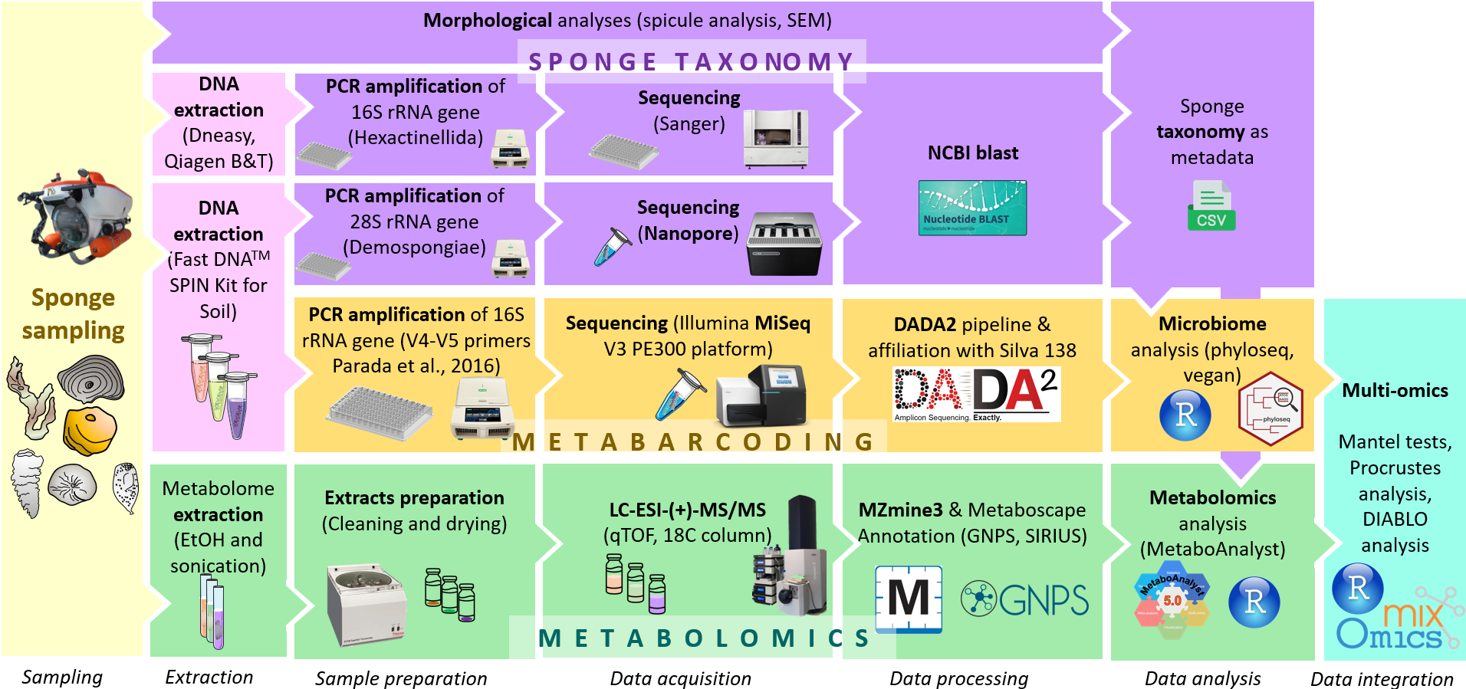

Figure S2. Map of the sampling site. A. Location of Curaçao and bathymetry data. B. Detailed map of the study area. The red circle indicates the Curaçao substation location. The red polygon indicates the reef area covered during the subdives (approximately 0.5 km²).
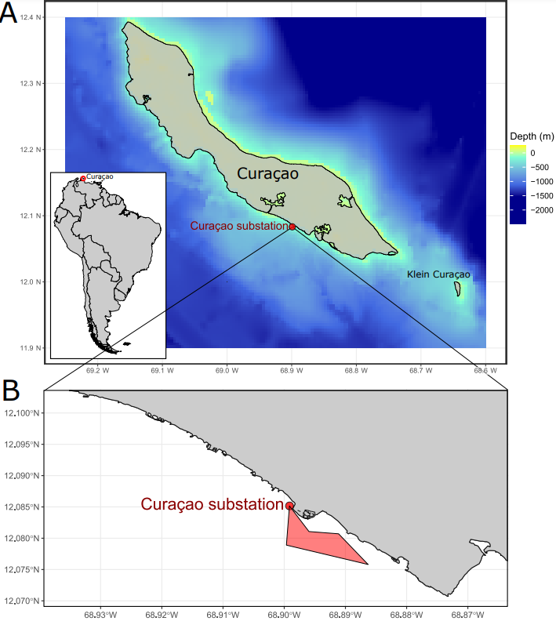

Figure S3. Pictures of collected sponge specimens.
A. Specimen of Petrosia aff. weinbergi. B. Specimen of Neopetrosia eurystomata. C. Frament of Svenzea zeai D. Specimen of Cinachyrella kuekenthali E. Specimen of Geodia aff. Curacaoensis. F. Specimen of Petrosia sp. G. Specimen of Gastrophanella implexa. H. Specimen of Aciculites higginsii. I. Specimen of Topsentia ophiraphidites. J. Fragment of Calthropella lithistina. K. Fragment of Biemna microacanthosigma. L. Specimen of Geodia cf. megastrella. M. Specimen of Penares mastoideus. N. Specimen of Dactylocalyx pumiceus. O. Specimen of Leyfroyella sp. P. Fragments of Conorete pourtalesi. Q. Specimen of Verrucocoeloidea liberatorii. R. Specimen of Heterotella sp. S. Specimen of Myliusia callocyathus. T. Specimen of Hexactinella sp. Scale bars on the bottom right sides of the pictures correspond to 2 cm.

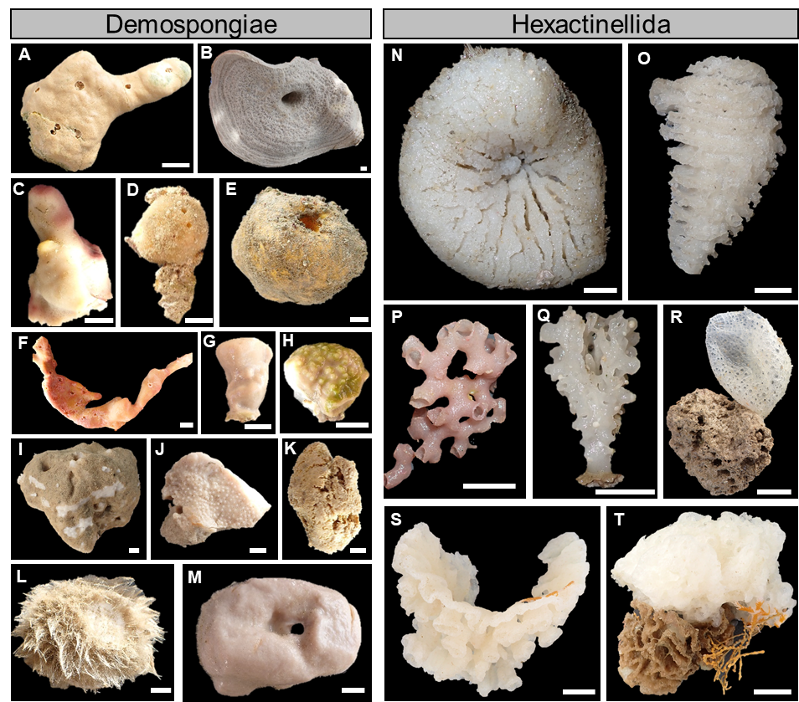

Figure S4. Pictures of the hexactinellid-associated fauna.
A. Picture of in situ Verrucocoeloidea liberatorii specimens colonized by the Vitrumanthus schrieri zoanthids. B. Picture of a collected Verrucocoeloidea liberatorii specimen colonized by the Vitrumanthus schrieri zoanthids. C. Pictures of a collected Conorete pourtalesi specimen colonized by the Vitrumanthus schrieri zoanthids. D. Picture of Eiconaxius caribbaeus specimens corresponding to a shrimp couple inhabiting the cavities of a Conorete pourtalesi specimen. E. Picture of a couple (male on the left, and female with eggs on the right) of Eiconaxius caribbaeus specimens. Red arrows indicate the location of the zoanthids. Blue arrows indicate the location of the shrimps. Scale bars on the bottom right sides of the pictures B, C, and E correspond to 1 cm.
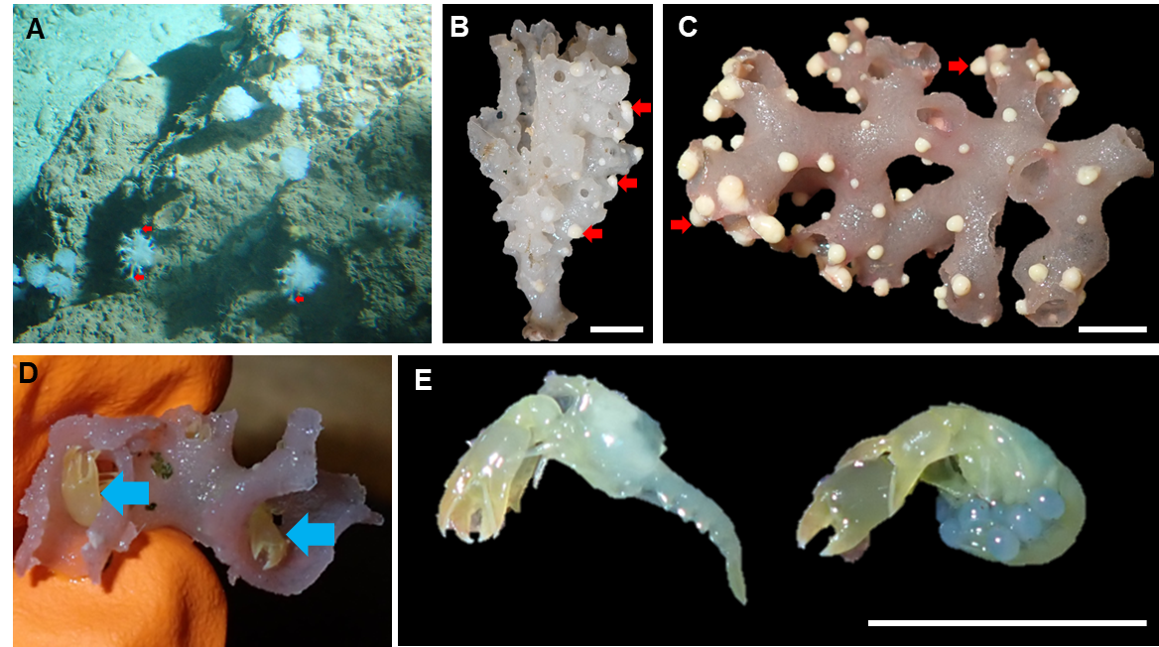

Figure S5. α-diversity analysis of the sponge-associated prokaryotic communities and holometabolomes.
A. Rarefaction curves of the 16S rRNA gene reads. B. Boxplots of the α-diversity metrics (Shannon, Chao1, and Pielou indices) of the prokaryotic communities associated with the Demospongiae and Hexactinellida samples in their respective photic zones (mesophotic, upper rariphotic, and lower rariphotic). Lowercase indices indicate results from the Wilcoxon pairwise test. C. Boxplots of the α-chemodiversity measure (Shannon index) of the holometabolome associated with Demospongiae and Hexactinellida samples in their respective photic zones (mesophotic, upper rariphotic, and lower rariphotic). Lowercase indices indicate the results of Tukey’s HSD pairwise test.
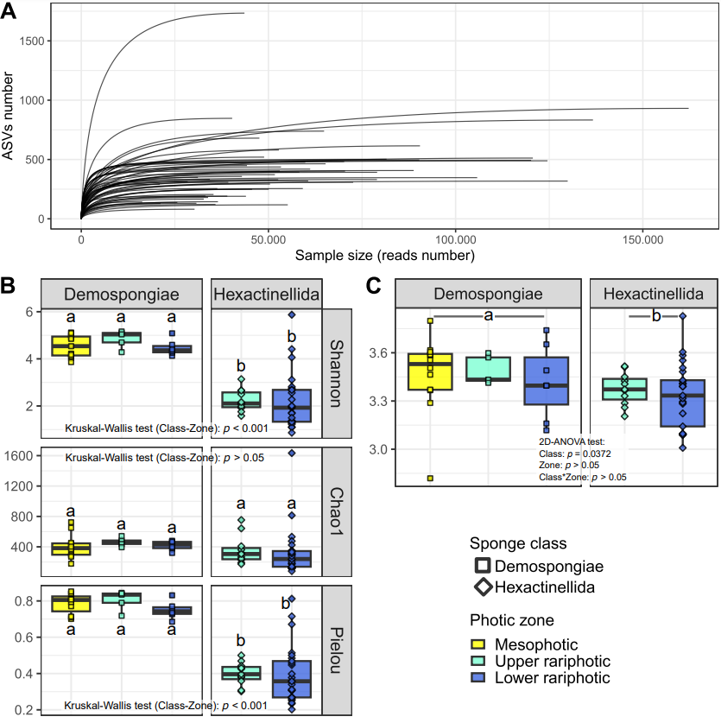

Figure S6. Barplots of the prokaryotic community composition at the family level associated with the Demospongiae and Hexactinellida samples in their respective photic zones (mesophotic, upper rariphotic, and lower rariphotic). “Other” corresponds to families below 5%. Sample name abbreviations are listed in Table S1
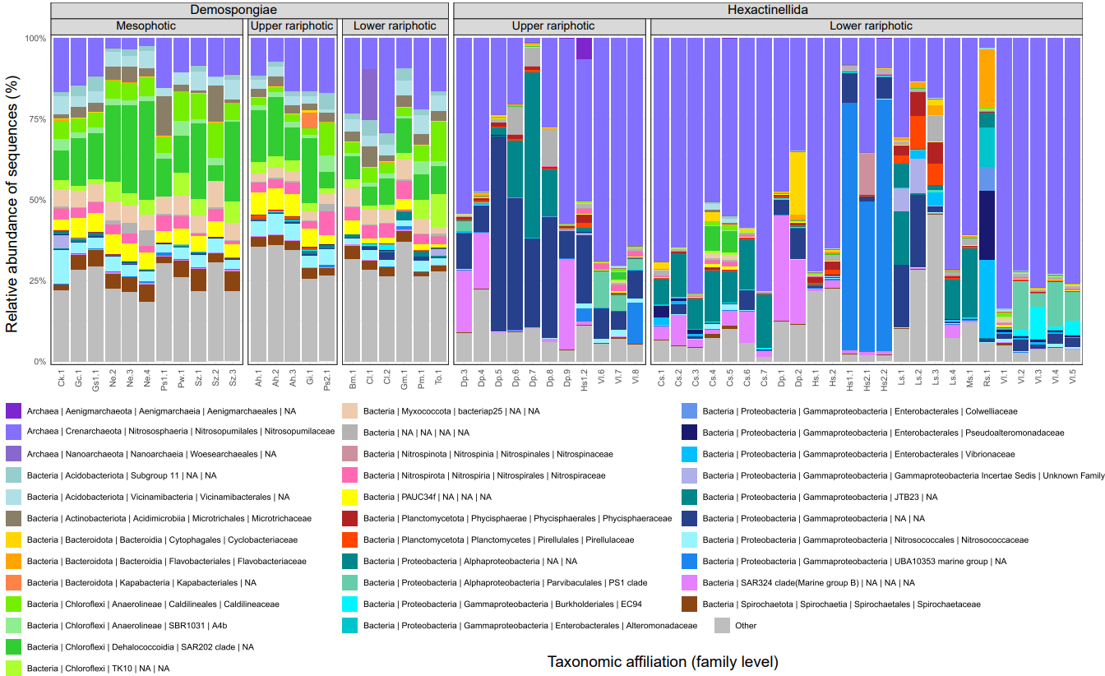

Figure S7. Barplots of the archaeal community composition at the genus level associated with the Demospongiae and Hexactinellida samples in their respective photic zones (mesophotic, upper rariphotic, and lower rariphotic). “Other” corresponds to families below 1%. Sample name abbreviations are listed in Table S1
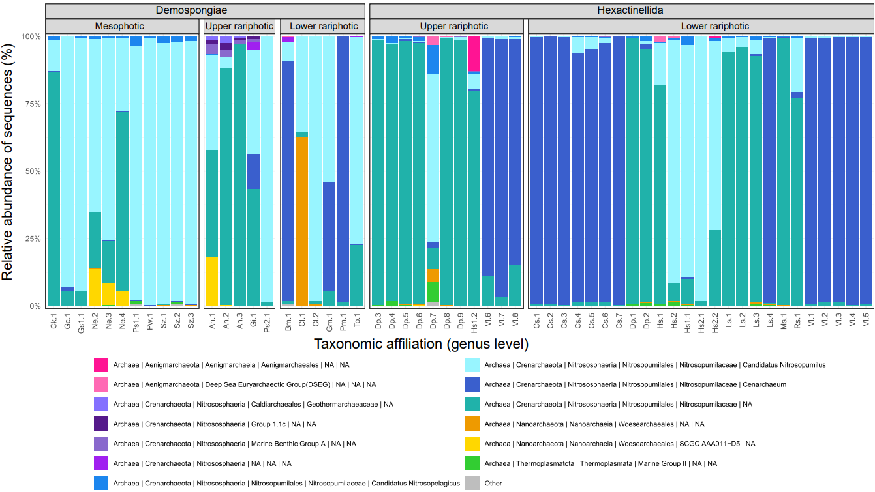

Figure S8. Phylogenetical heat tree representing the taxa significantly and differentially abundant between Demospongiae and Hexactinellida samples.
For each taxon, (i) the colors of their associated nodes correspond to the log2 fold change between Demospongiae and Hexactinellida samples, (ii) the size of the nodes corresponds to the relative abundance of each taxon.
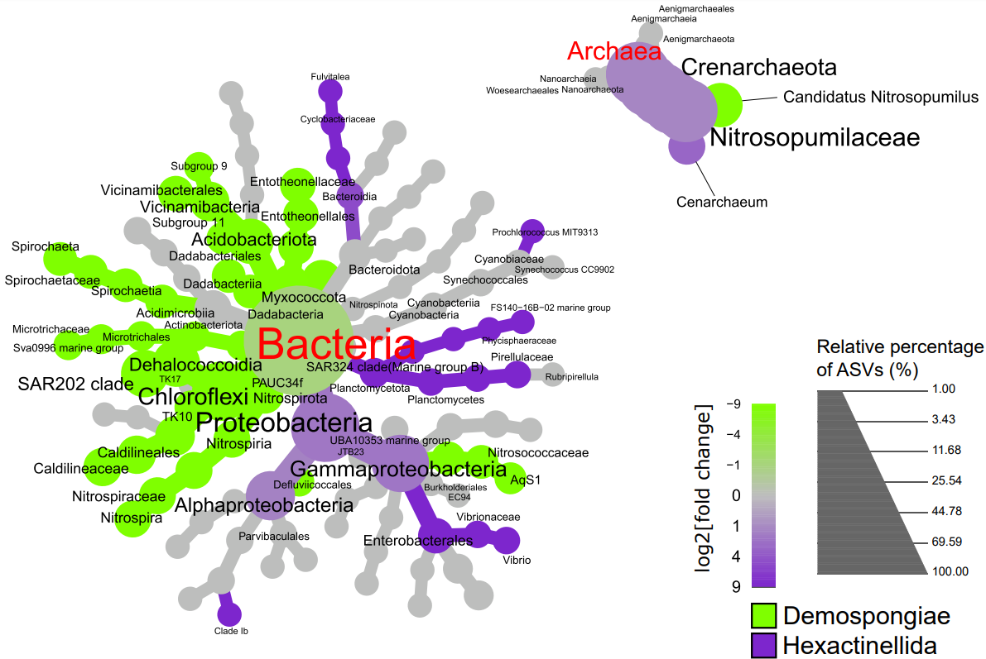

Figure S9. Phylogenetical heat trees performed with Hexactinellida samples, and representing taxa significantly and differentially abundant between upper and lower rariphotic samples.
For each taxon, (i) the colors of their associated nodes correspond to the log2 fold change between the ratio of the mean relative abundance within samples of each zone, (ii) the size of the nodes corresponds to the relative abundance of each taxon.
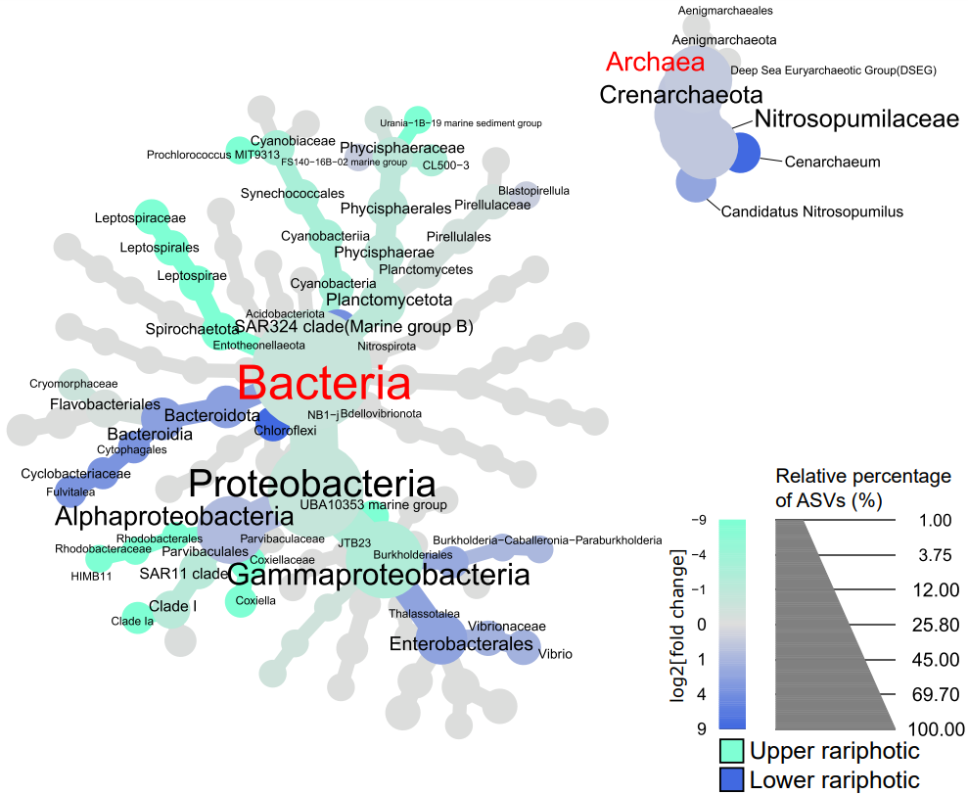

Figure S10. PLS-DA plots of the holometabolomes conducted with the photic zone as a supervised factor, for both Demospongiae (A) and Hexactinellida (B) subseted datasets.
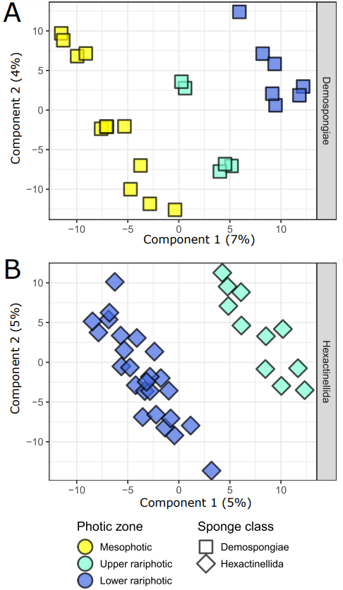

Figure S11. FBMN analysis. A. Overall representation of the clusters (≥3 nodes) of the FBMN built with the MS/MS data. Abbreviations: PC: phosphatidylcholine; PE: for phosphatidylethanolamine. The network also includes 32 clusters with 2 nodes and 1201 unbound nodes.
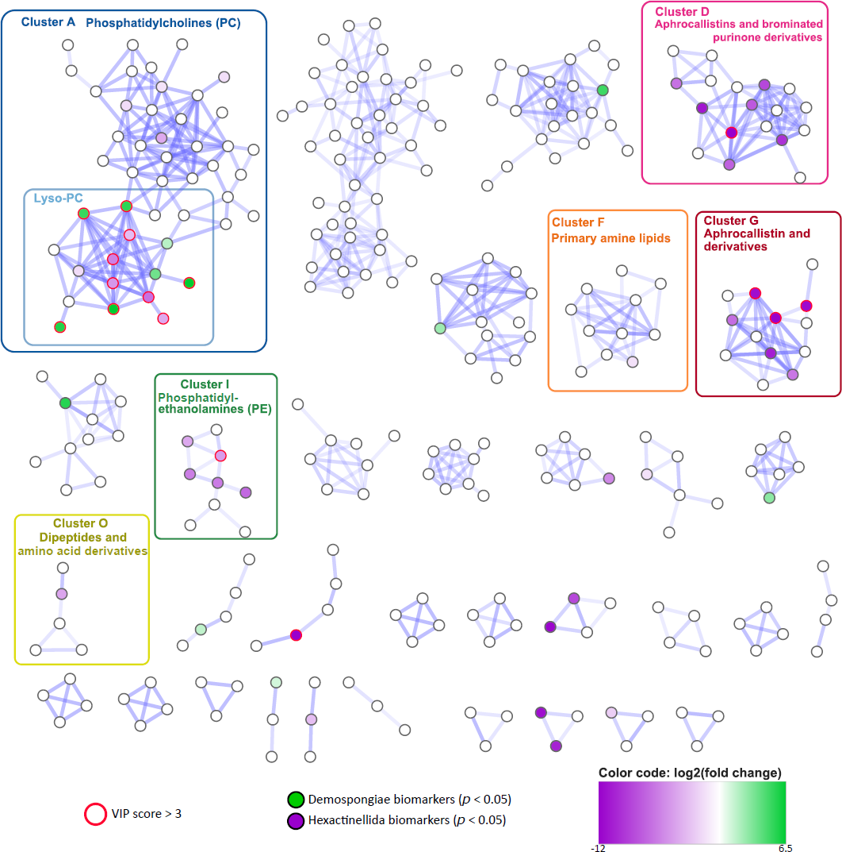

Figure S12. Annotation of phospholipids identified within clusters A and D. Abbreviations: PC: phosphatidylcholine; PE: for phosphatidylethanolamine.
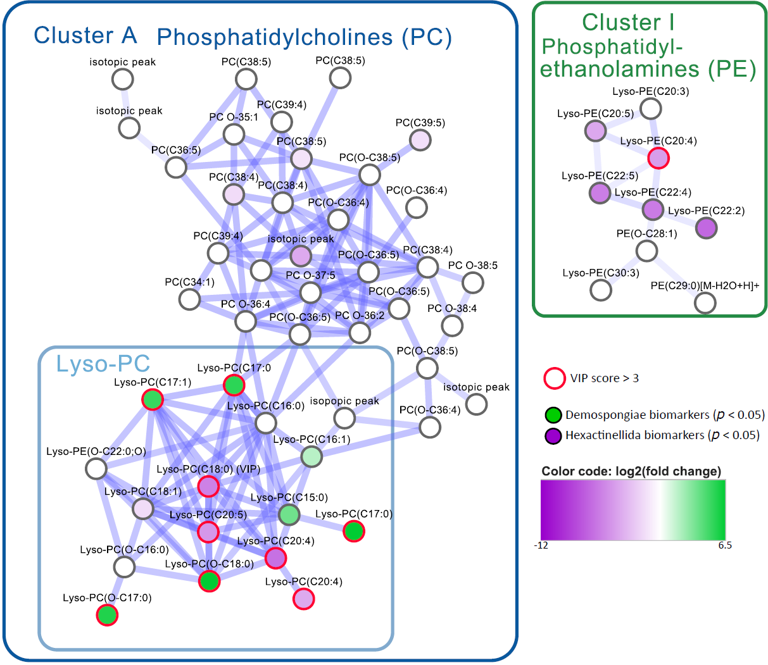

Figure S13. Annotation of brominated compounds identified within clusters D and G. The names “Aphrocallistin A”, “Aphrocallistin B”, and “Aphrocallistin C” were chosen according to Young et al., 2021. The name “Aphrocallistin” used in the manuscript and originally described by Wright et al., 2009 refers to “Aphrocallistin A”.
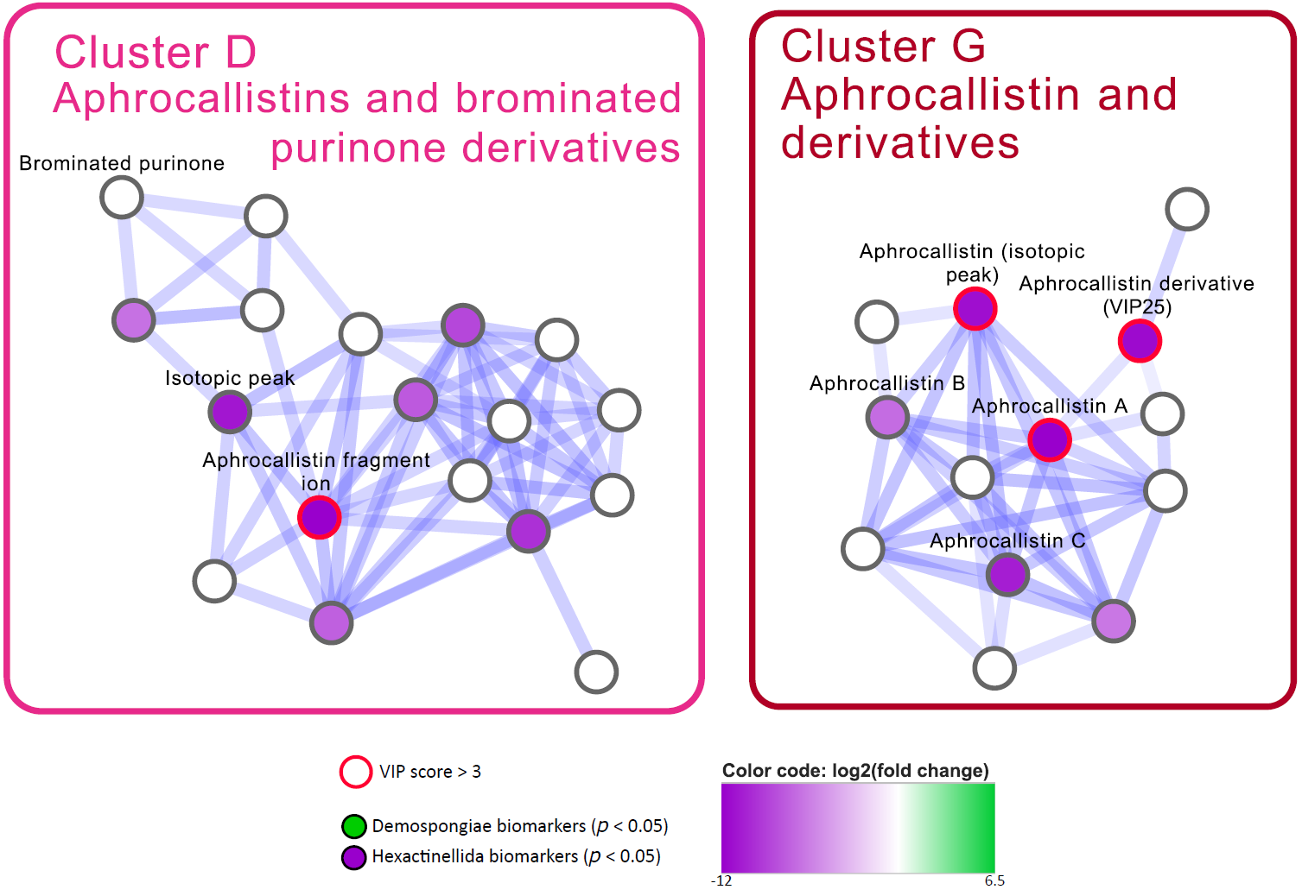

Figure S14. HRMS/MS data (A) and putative MS fragmentation (B) of VIP n°13 identified as aphrocallistin (Wright et al., 2009). The yellow box corresponds to a zoom on the 1:2:1 isotopic pattern of the precursor ion cluster, being characteristic of dibrominated compounds.
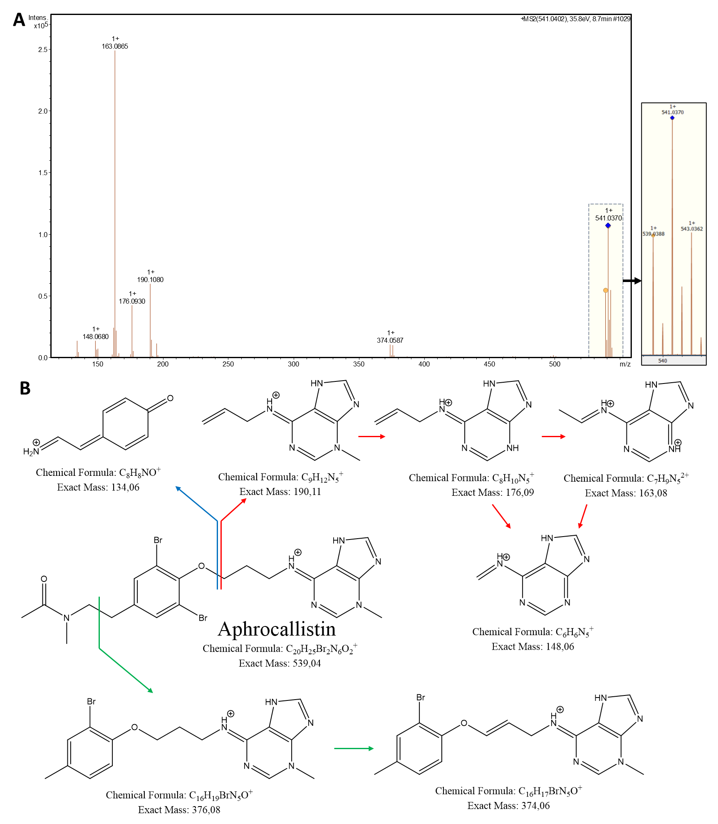

Figure S15. Normalized concentrations of VIP n°13, 25, and 28, identified as aphrocallistin, an aphrocallistin derivative, and xanthurenic acid, respectively. Lower case indices indicate the results of HSD Tukey’s tests for pairwise comparison between genera.
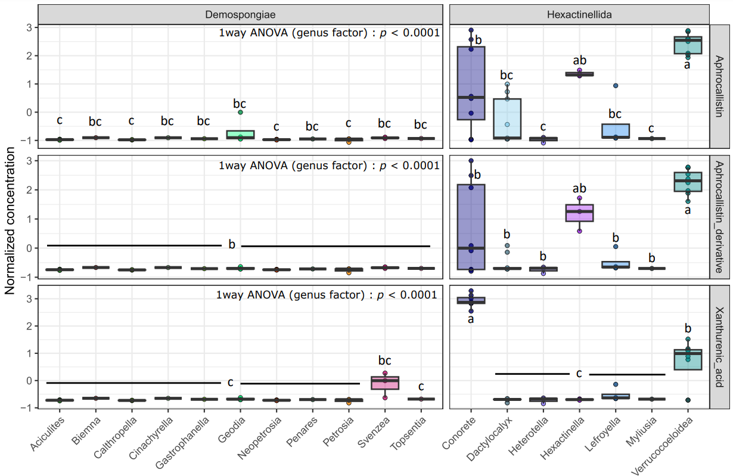

Figure S16. HRMS/MS data and match with the GNPS Library Spectrum CCMSLIB of VIP n°27 identified as xanthurenic acid.
This MS/MS data also matched the MS/MS data of xanthurenic acid within MassBank (MassBank Record: MSBNK-Fiocruz-FIO00659) and Bonnard et al., 2021.
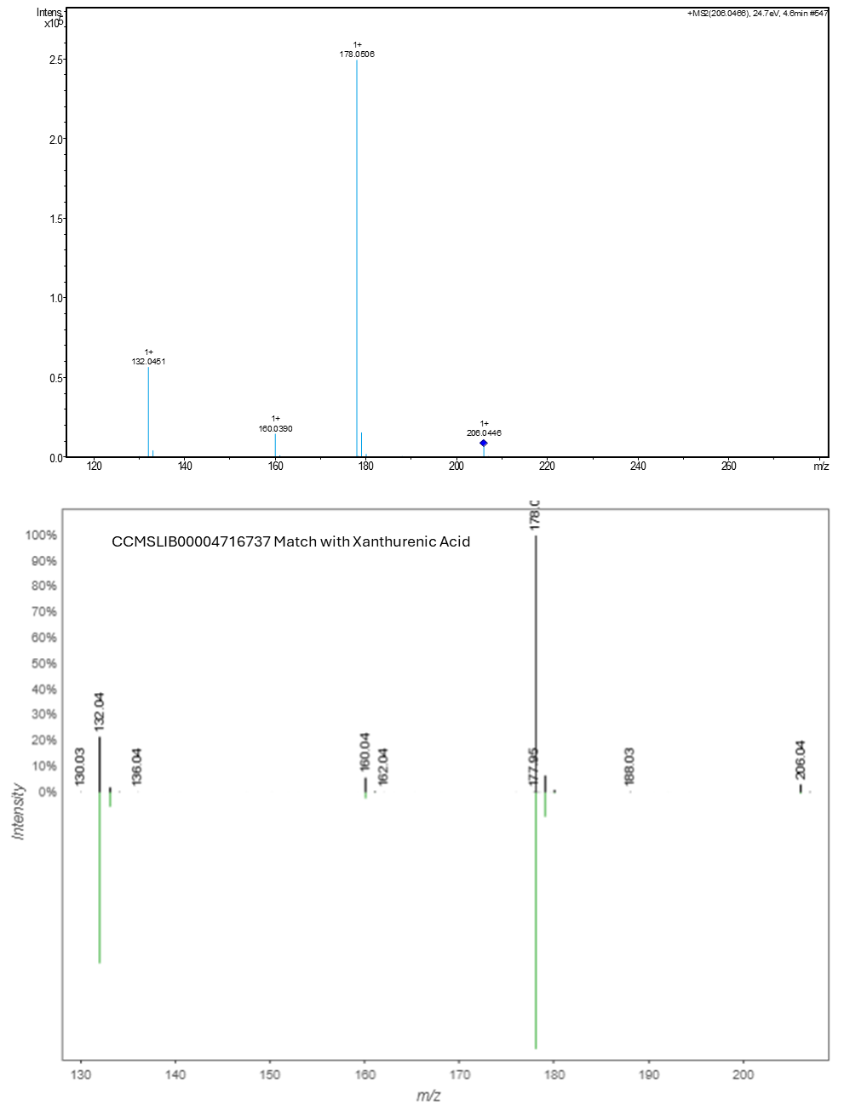

Figure S17. Barplots of the archaeal community composition obtained with 6 of the Hexactinellida samples with (A) the 515F-Y-926R primers (Parada et al., 2016), and (B) archaeal-specific Uni519F-1000R primers (Ovreås et al., 1997; Kolganova et al., 2002). The barplot obtained from both datasets were obtained by keeping only the archaeal sequences. “Other” corresponds to families below 1%. Sample name abbreviations are listed in Table S1.

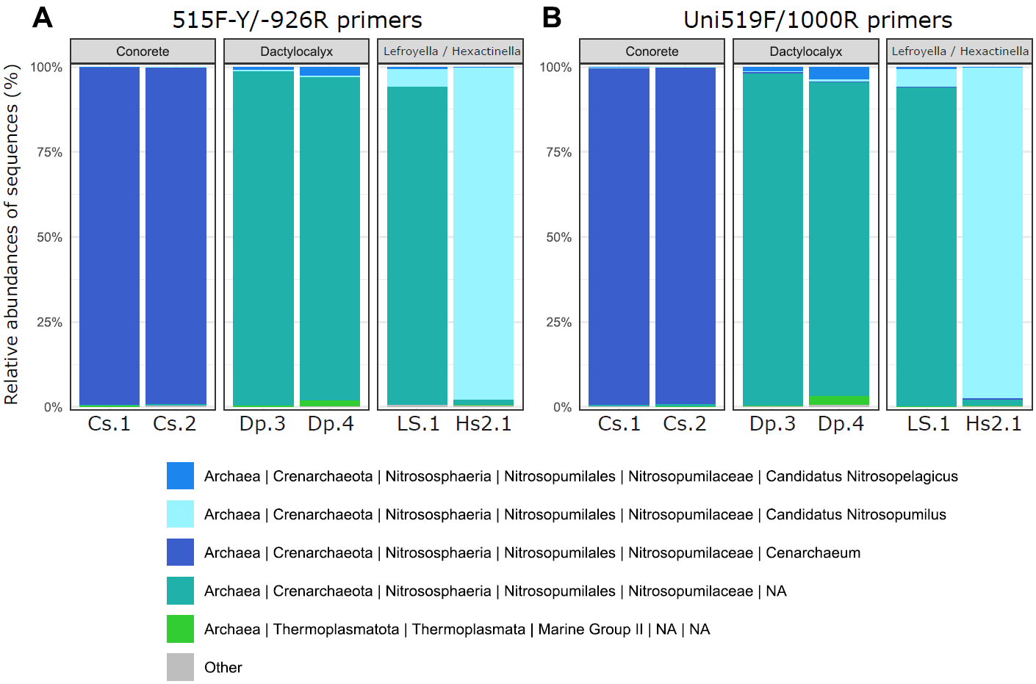

References for supplementary information
Bonnard, M., Boury, B., and Parrot, I. (2021) Xanthurenic Acid in the Shell Purple Patterns of Crassostrea gigas: First Evidence of an Ommochrome Metabolite in a Mollusk Shell. Molecules 26: 7263.

Horai, H., Arita, M., Kanaya, S., Nihei, Y., Ikeda, T., Suwa, K., et al. (2010) MassBank: a public repository for sharing mass spectral data for life sciences. J Mass Spectrom 45: 703–714.

Ovreås, L., Forney, L., Daae, F.L., and Torsvik, V. (1997) Distribution of bacterioplankton in meromictic Lake Saelenvannet, as determined by denaturing gradient gel electrophoresis of PCR-amplified gene fragments coding for 16S rRNA. Applied and Environmental Microbiology 63: 3367–3373.

Parada, A.E., Needham, D.M., and Fuhrman, J.A. (2016) Every base matters: assessing small subunit rRNA primers for marine microbiomes with mock communities, time series and global field samples. Environ Microbiol 18: 1403–1414.

Schymanski, E.L., Jeon, J., Gulde, R., Fenner, K., Ruff, M., Singer, H.P., and Hollender, J. (2014) Identifying small molecules via high resolution mass spectrometry: Communicating confidence. Environ Sci Technol 48: 2097–2098.

Takahashi, S., Tomita, J., Nishioka, K., Hisada, T., and Nishijima, M. (2014) Development of a Prokaryotic Universal Primer for Simultaneous Analysis of Bacteria and Archaea Using Next-Generation Sequencing. PLOS ONE 9: e105592.

Wang, M., Carver, J.J., Phelan, V.V., Sanchez, L.M., Garg, N., Peng, Y., et al. (2016) Sharing and community curation of mass spectrometry data with Global Natural Products Social Molecular Networking. Nat Biotechnol 34: 828–837.

Wright, A.E., Roth, G.P., Hoffman, J.K., Divlianska, D.B., Pechter, D., Sennett, S.H., et al. (2009) Isolation, Synthesis, and Biological Activity of Aphrocallistin, an Adenine-Substituted Bromotyramine Metabolite from the Hexactinellida Sponge Aphrocallistes beatrix. J Nat Prod 72: 1178–1183.

Young, R.M. et al. (2021) New apoptosome inhibitors from Irish deep-sea zoanthid. Poster in European Conference on Marine Natural Products 2021 (Galway). https://www.universityofgalway.ie/media/collegeofscience/schools/schoolofnaturalsciences/zoology/docs/ZoanthidPoster.pdf

