Supporting Information

Synthetic bacterium-facilitated colonization of nitrogen-fixing bacteria for remodeling the rhizosphere microbiome and improving plant yield
Shuo Liu^{1,2}, Zirun Zhao¹, Yuxin Ji¹, Hangqi Zhu¹, Yingfeng Sun,³ Mingchun Li¹ & Qilin Yu¹*
1 National Key Laboratory of Intelligent Tracking and Forecasting for Infectious Diseases, College of Life Sciences, Nankai University, Tianjin 300071, China
2 College of Environmental Science and Engineering, Tianjin Key Laboratory of Environmental Remediation and Pollution Control, Nankai University, Tianjin 300350, China
3 Tianjin Key Laboratory of Agricultural Animal Breeding and Healthy Husbandry, College of Animal Science and Veterinary Medicine, Tianjin Agricultural University, Tianjin, 300392, China
* Corresponding author. E-mail: yuqilin@mail.nankai.edu.cn

Fig. S1 Effect of NFB inoculation on nitrogen-fixing bacterial numbers (a), nitrogenase activity (b), total nitrogen (TN, c) and plant fresh weight (FW, d) in the rhizosphere soil. The asterisks indicate significant difference between the two groups, while the letters “ns” indicate no significant difference (P < 0.05).

Fig. S2 High capacity of the synthetic bacterium EcCMC to bind to the polysaccharide-exposed NFB. (a) Confocal images of NFBs (NKN632 plus NKN643 with equal cell numbers) and the control Pseudomonas soli NKB1431. The bacterial cells were stained using FITC-labeled ConA (FITC-ConA) for observation. (b) PCC of DAPI and FITC evaluated using the Image J software. (c) Confocal images of the control EcM cells and the synthetic EcCMC cells after stained using FITC-labeled NFB polysaccharide (FITC-NFB PS). (d) PCC of mCherry and FITC evaluated using the Image J software. (e) Confocal images of the mixture of EcM plus NFBs or that of EcCMC plus NFBs after 1 h of co-incubation. The asterisks indicate significant difference between the two groups (P < 0.05). The white squares indicate the regions amplified on the right.
Fig. S3 Confocal images of NKN632, NKN643 and the control Achromobacter denitrificans NK531 after stained by FITC-ConA.

Fig. S4 PCCs of mCherry & DAPI (a) and mCherry & FITC for the confocal images of EcM plus NFBs or that of EcCMC plus NFBs in Fig. 2e.

Fig. S5 The confocal images of the roots in Figure 1 with higher magnification. The white squares were amplified on the right.

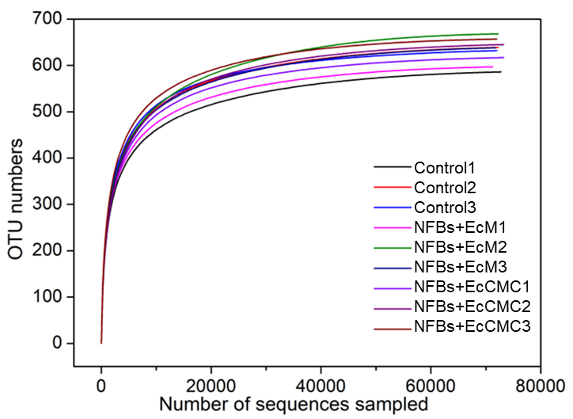
Fig. S6 Rarefaction curves of microbiome for the root samples of Astragalus sinicus.

Fig. S7 The capacity of EcM and EcCMC to adsorb the fungal polysaccharide. The polysaccharides used in this study was generated by Aspergillus niger, and used for the adsorption experiment with the final concentration of 1 mg/mL in PBS. The bacterial cells were used with the final concentration of 2×10⁸ cells/mL. The mixture was incubated at room temperature for 1 h, followed by centrifugation at 12,000 rpm for 5 min. The remained contents of polysaccharide in the supernatant were determined.

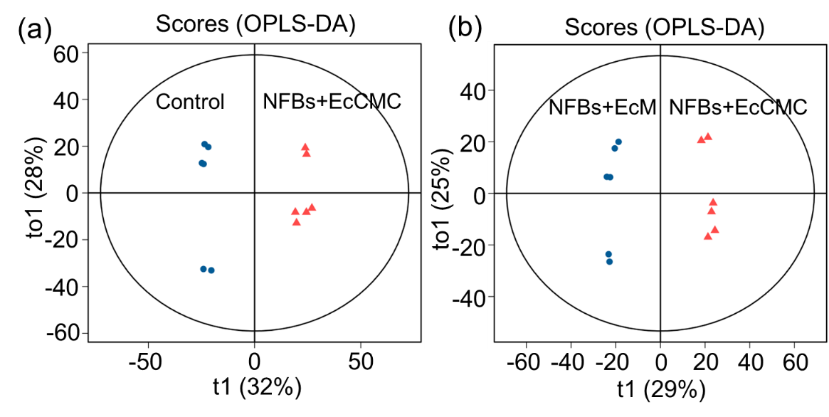
Fig. S8 OPLS-DA score plots of the Astragalus sinicus rhizosphere soils with different treatments. (a) Control vs. NFBs+EcCMC (R²X = 0.594, R²Y = 0.991, Q² = 0.934). (b) NFBs+EcM vs. NFBs+EcCMC (R²X = 0.71, R²Y = 0.993, Q² = 0.925).

Fig. S9 Nitrogen fixation and enzymatic activity of rhizosphere soils treated by NFBs with the assistance of EcM (NFBs+EcM) or EcCMC (NFBs+EcCMC) after 28 days of culturing. (a) Nitrogenase activity, (b) total nitrogen, (c) soil organic matter, (d) urease activity, (e) ACP activity, and (f) CAT activity of the Astragalus sinicus with different treatments. The asterisks (*) indicate significant difference between the groups (P < 0.05).

Fig. S10 Quantification of damaged root cells in the histological images of Astragalus sinicus.

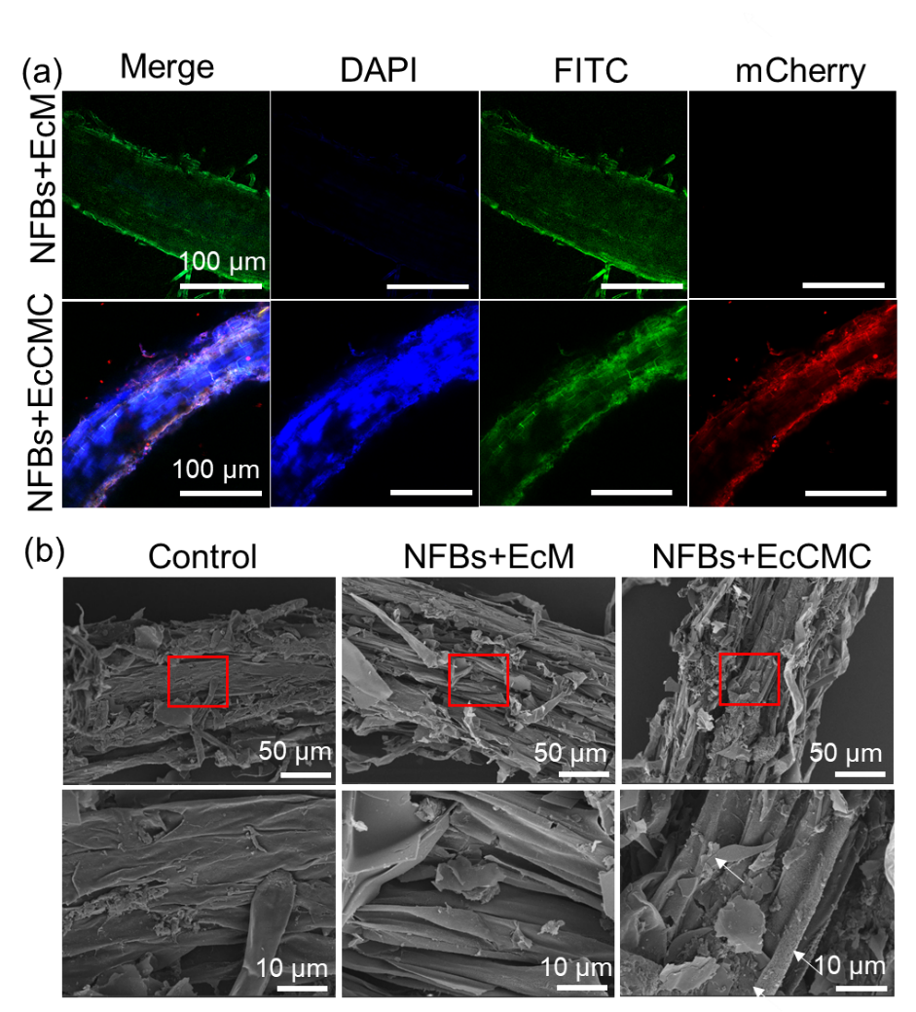
Fig. S11 EcCMC-assisted recruitment and colonization of the nitrogen-fixing bacteria (NFBs) to Medicago sativa roots. (a) Confocal microscopic images of the roots treated by NFBs and EcM or NFBs and EcCMC. (b) SEM images of the treated roots.

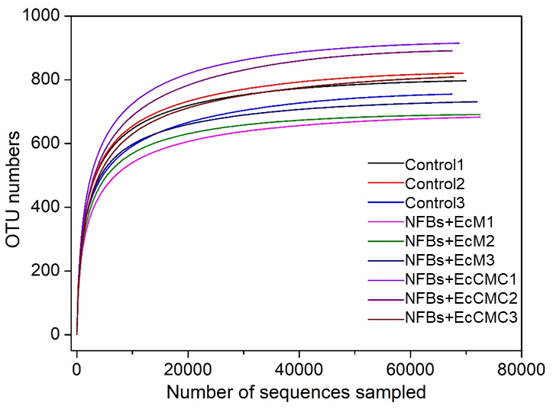
Fig. S12 Rarefaction curves of bacterial compositions in the rhizosphere soil of Medicago sativa.

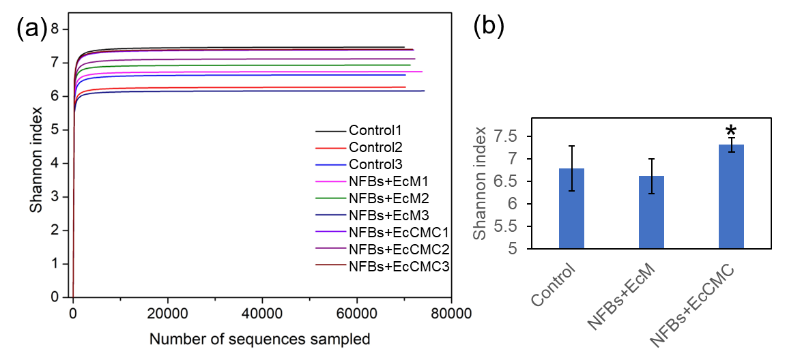
Fig. S13 Shannon curves (a) and Shannon index (b) of the rhizosphere bacteria on the treated Medicago sativa.

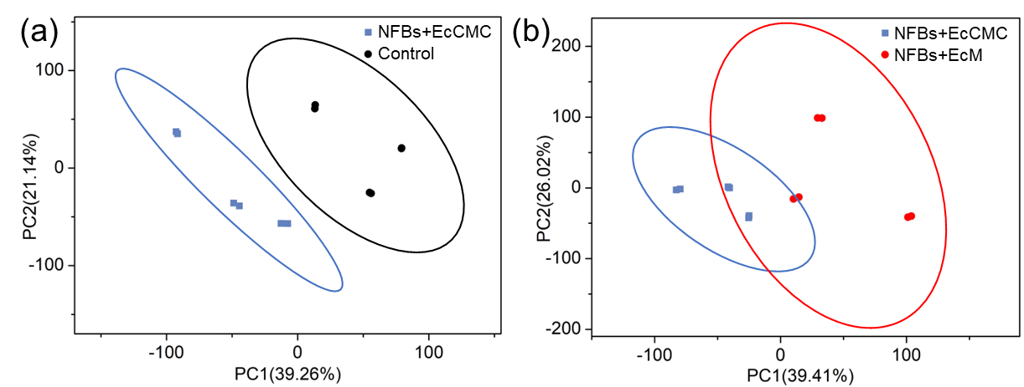
Fig. S14 PCA comparison of differential metabolites for Medicago sativa with different treatments. (a) NFBs+EcCMC vs. Control and (b) NFBs+EcCMC vs. NFBs+EcM.

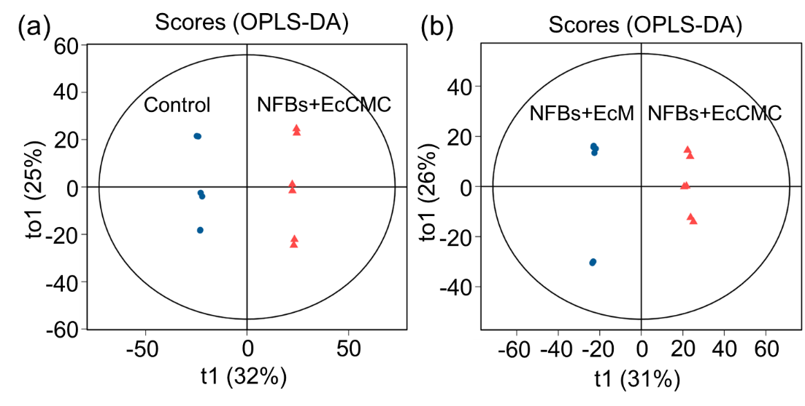
Fig. S15 OPLS-DA score plots of the Medicago sativa rhizosphere metabolites with different treatments. (a) Control vs. NFBs+EcCMC (R²X = 0.717, R²Y = 0.999, Q² = 0.982). (b) NFBs+EcM vs. NFBs+EcCMC (R²X = 0.772, R²Y = 0.998, Q² = 0.986).

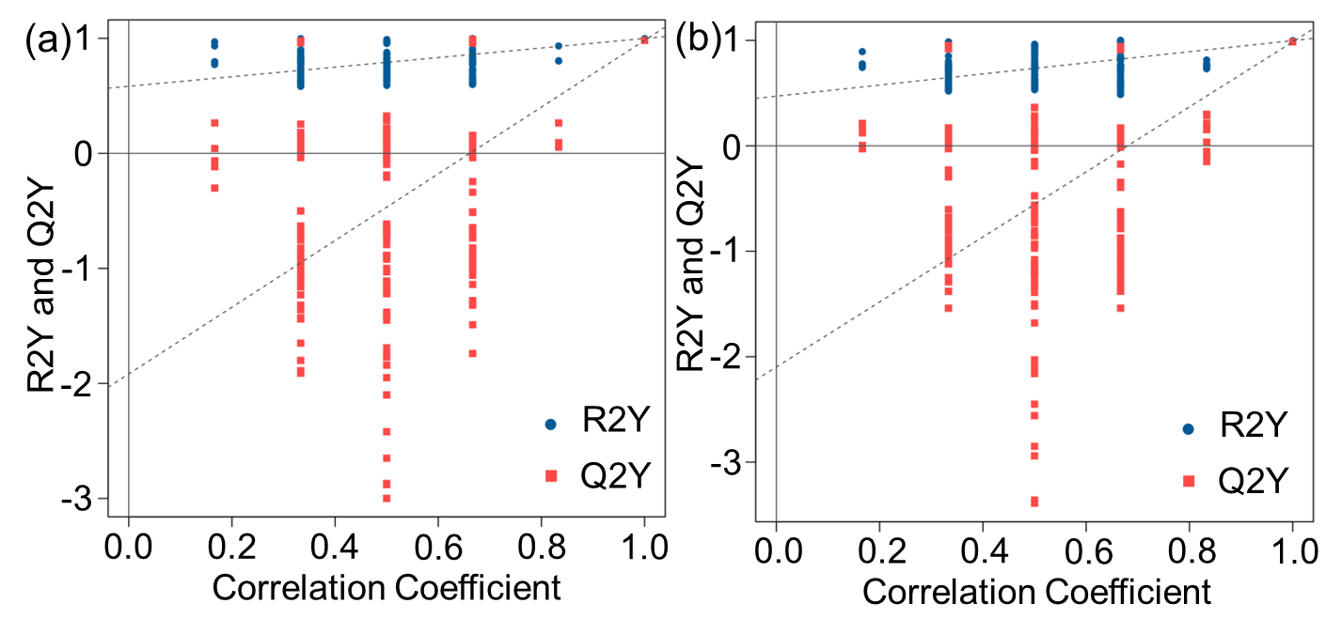
Fig. S16 Permutation tests in PLS-DA model with the same components as the OPLS-DA model for Medicago sativa during metabolomic analysis. 100 permutations were performed. Model validation showed (a) Control vs. NFBs+EcCMC and (b) NFBs+EcCMC vs. NFBs+EcM.

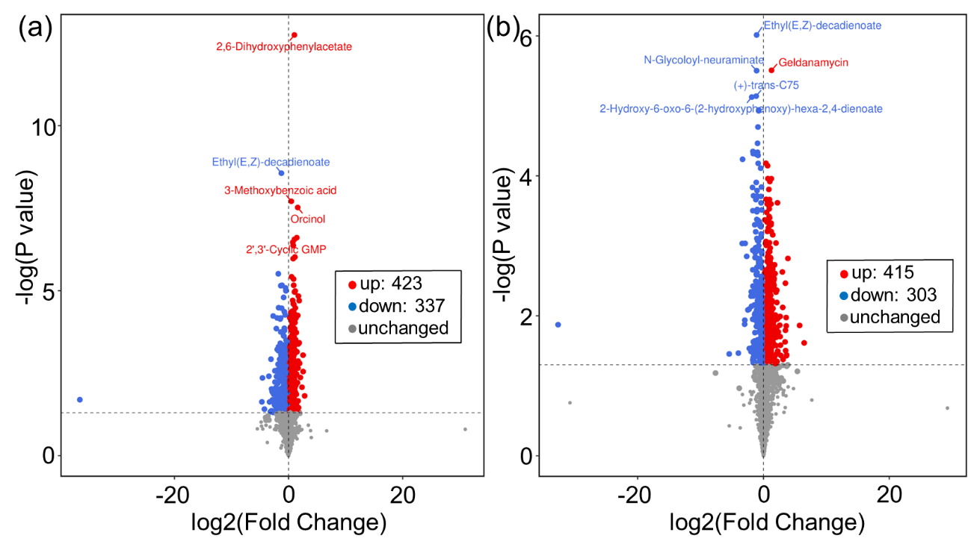
Fig. S17 Comparative metabolomic profiling of the root-microbiome system for Medicago sativa. (a) NFBs+EcCMC vs. Control and (b) NFBs+EcCMC vs. NFBs+EcM. The differential metabolites with P value < 0.05 and Fold change (FC) > 2 (red dots) or < 0.5 (blue dots) were marked with color.

