Environmental Variability Drives Functional Plasticity in the Gill-Associated Microbiome of Lithodes santolla: A Meta-Transcriptomic Perspective
Alexandra Brante ^{1,2}, Paulina Bustos ^{3,4}, Claudio Ortega-Muñoz ^{1,2}, Eliana Paola Acuña Gómez ², Vicenzo Brante ³ and Rodolfo Farlora ^{4,5} *
*Corresponding author: R. Farlora, Laboratorio de Biotecnología Acuática y Genómica Reproductiva (LABYGER), Facultad de Ciencias, Universidad de Valparaíso, Gran Bretaña 1111, Playa Ancha, Valparaíso 2360102, Chile. Phone Number: +56322508200. E-mail: rodolfo.farlora@uv.cl ORCID ID: https://orcid.org/0000-0002-0048-1102.
1. Programa de Magíster en Ciencias Biológicas mención Biodiversidad y Conservación, Instituto de Biología, Facultad de Ciencias, Universidad de Valparaíso.
2. Centro de Estudios del Cuaternario de Fuego - Patagonia y Antártica (CEQUA), Punta Arenas, Chile.
3. Laboratorio de Microbiología Integrativa e Innovación Tecnológica (MIIB-Lab), Instituto de Biología, Facultad de Ciencias, Universidad de Valparaíso, Valparaíso, Chile
4. Centro de Investigación y Gestión de Recursos Naturales (CIGREN), Universidad de Valparaíso, Valparaíso, Chile.
5. Laboratorio de Biotecnología Acuática y Genómica Reproductiva (LABYGER), Instituto de Biología, Facultad de Ciencias, Universidad de Valparaíso, Valparaíso, Chile.
Supplementary Information
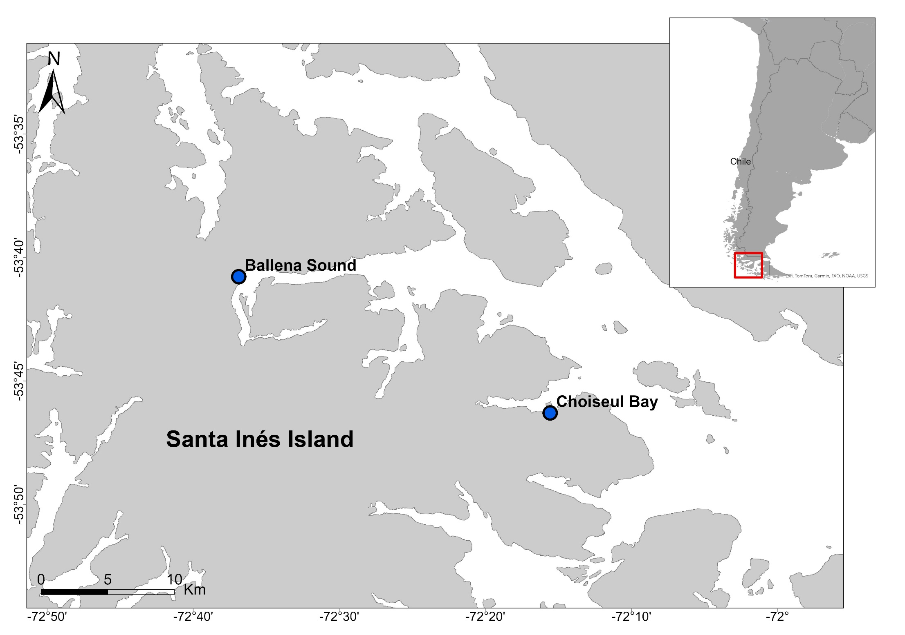
Figure S1 Map of the study area in southern Chile. Sampling sites at Ballena Sound and Choiseul Bay are indicated with blue dots. Both locations are situated on Santa Inés Island of the Strait of Magellan.
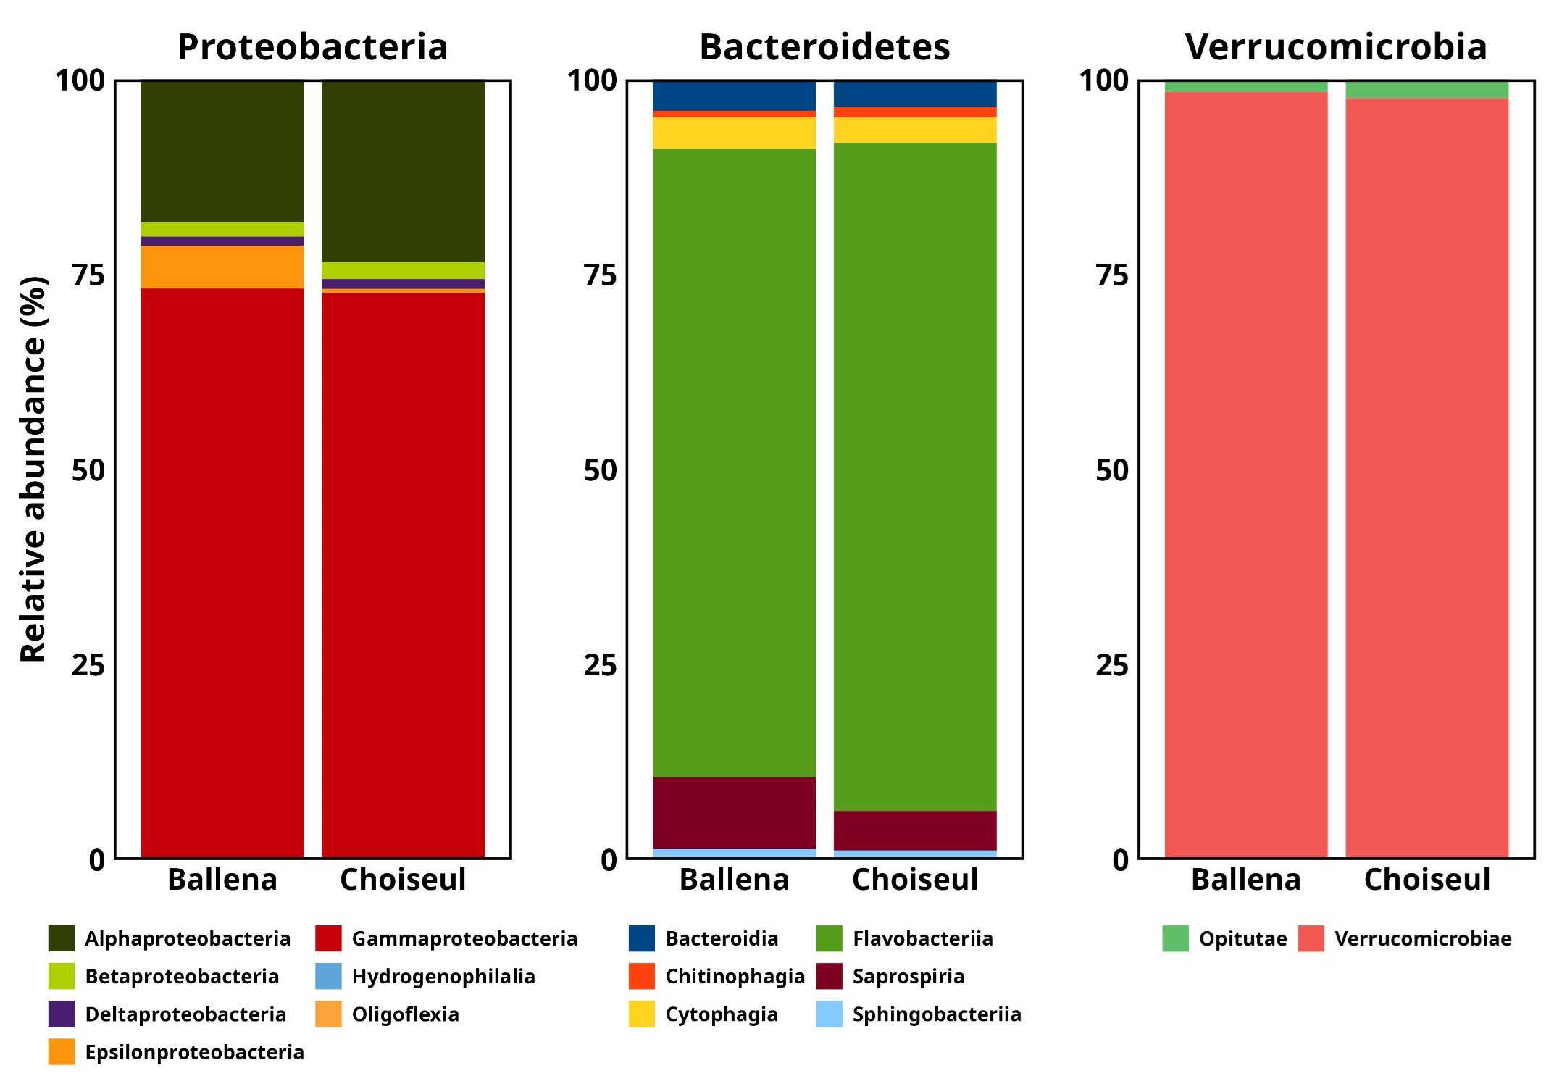
Figure S2 Relative abundance of bacterial classes within the dominant phyla Proteobacteria, Bacteroidetes, and Verrucomicrobia associated with the gills of Lithodes santolla across two locations. Stacked bar plots represent the relative abundance (%) of bacterial classes within each phylum from samples collected at Ballena Sound and Choiseul Bay.

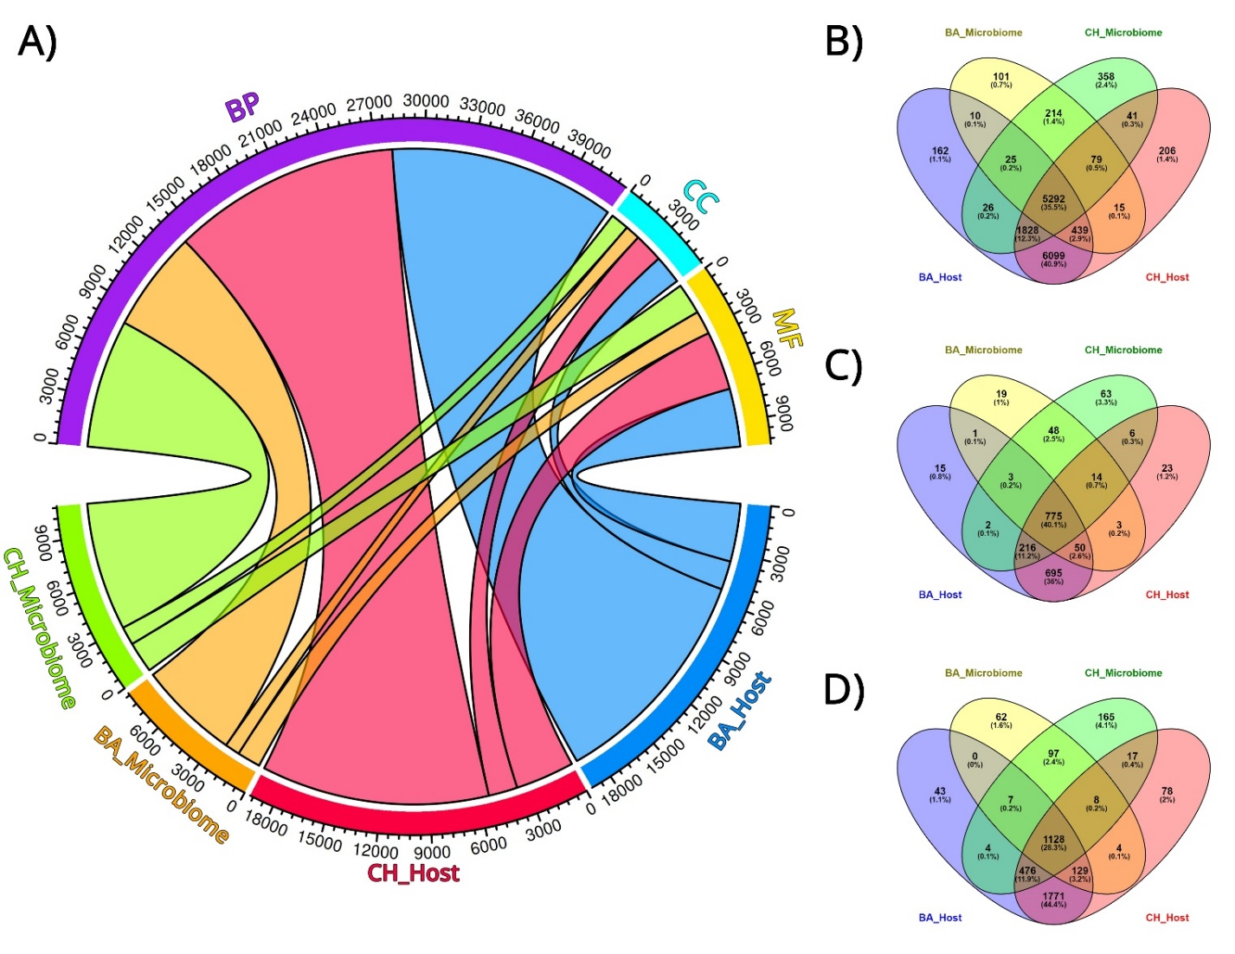
Figure S3 Functional annotation and shared GO terms between Lithodes santolla and its microbiome in Ballena Sound (BA) and Choiseul Bay (CH). (A) Circos plot showing the distribution of GO terms across datasets: BA Host (blue), CH Host (red), BA Microbiome (orange), and CH Microbiome (green). GO categories: Biological Process (BP, purple), Cellular Component (CC, cyan), and Molecular Function (MF, yellow). (B–D) Venn diagrams of shared and unique GO terms for (B) BP, (C) CC, and (D) MF.
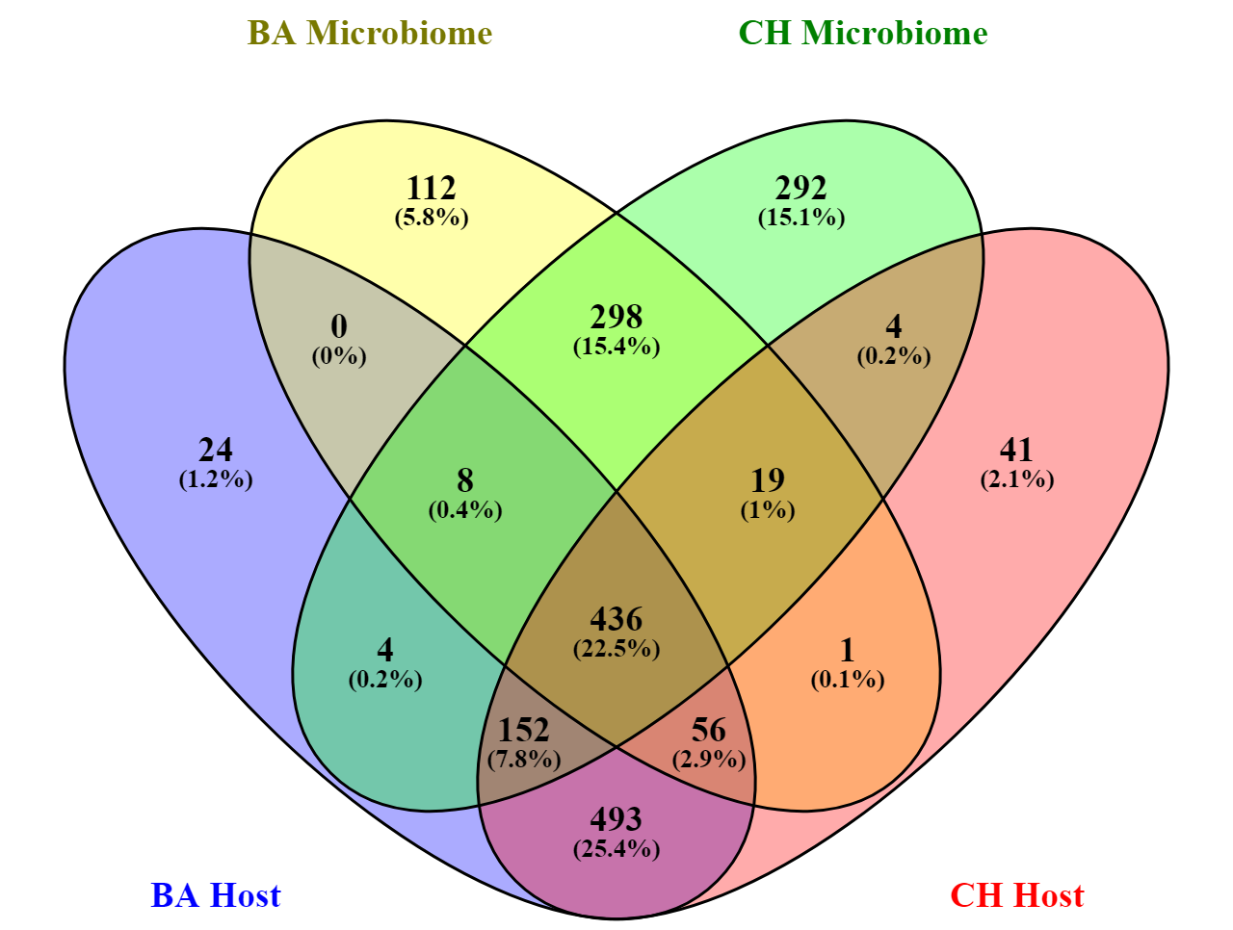
Figure S4 Venn diagram of shared and unique Enzyme Classes (EC) between holobiont components (host and microbiome) of Ballena Sound (BA) and Choiseul Bay (CH).
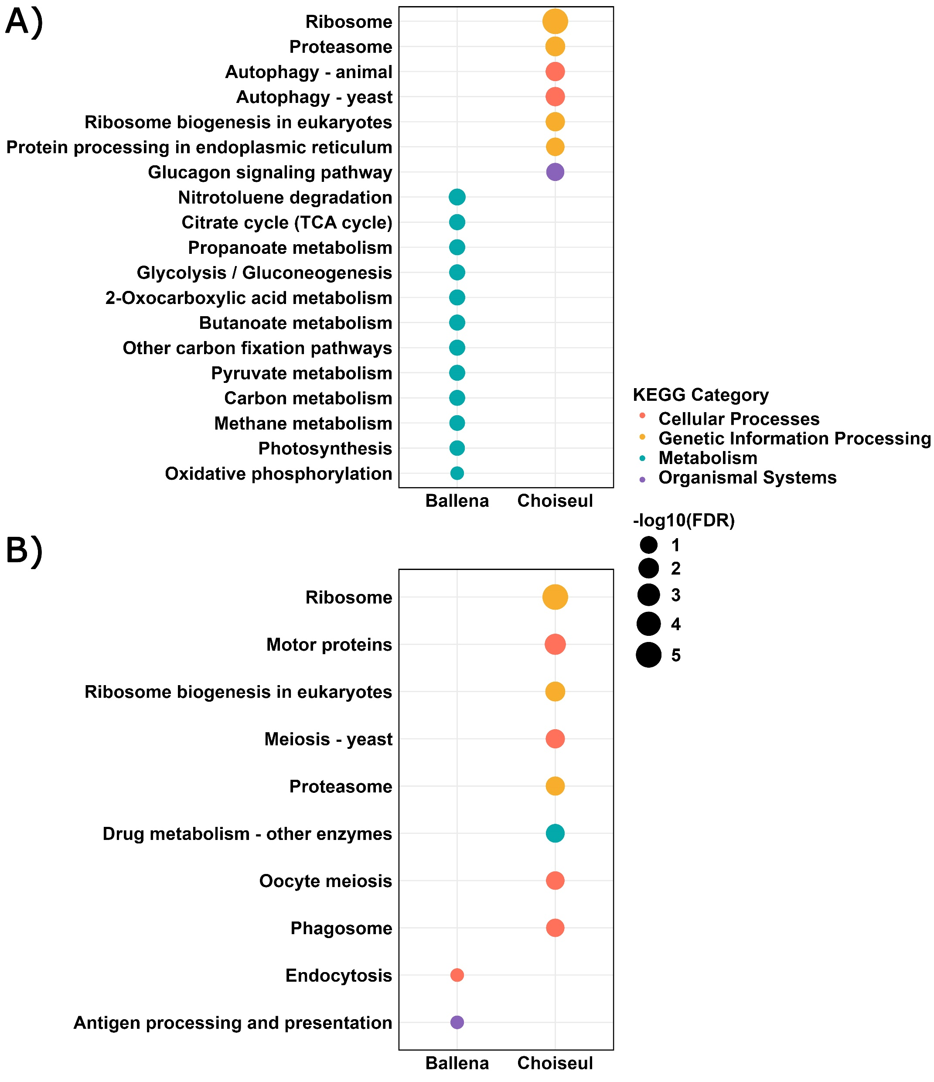
Figure S5 Enriched KEGG pathways (FDR < 0.05) for (A) Host and (B) Microbiome under Ballena and Choiseul conditions. Bubble size represents the significance of pathway enrichment (-log10(FDR)), with larger circles corresponding to higher significance. Colors indicate KEGG pathway categories.
Table S1 Morphometric measurements of each individual.
Sampling site | Sample ID | Sex | CL (mm) | CW (mm) | Body Weight (g)
Ballena Sound | CM1223 | Male | 111.0 | 85.0 | 385
Ballena Sound | CM1231 | Male | 74.4 | 62.4 | 185
Ballena Sound | CM1241 | Male | 89.5 | 80.6 | 323
Ballena Sound | CM1264 | Male | 85.5 | 69.7 | 238
Ballena Sound | CM1272 | Male | 86.5 | 73.3 | 299
Choiseul Bay | CM1101 | Male | 99.3 | 80.0 | 248
Choiseul Bay | CM1112 | Male | 91.1 | 75.2 | 227
Choiseul Bay | CM1125 | Male | 88.4 | 68.2 | 212
Choiseul Bay | CM1155 | Male | 75.5 | 62.0 | 138
Choiseul Bay | CM1195 | Male | 66.0 | 55.0 | 96.0

Table S2 Physicochemical conditions of sampling sites.
Sampling site | pH | T (°C) | Dissolved Oxygen (mg/L) | Oxygen Saturation (%) | Salinity (PSU)
Ballena Sound | 8.03 | 7.63 | 9.86 | 92.31 | 24.66
Choiseul  Bay | 8.03 | 8.74 | 11.2 | 95.36 | 29.21

Table S3 RNA extraction quality and sequencing read statistics from Lithodes santolla samples in Ballena Sound and Choiseul Bay.
Sampling site | Sample | Total RNA (μg) | A260/280 | IQ | Raw reads | Clean reads
Ballena Sound | CM1223 | 29.2800 | 2.15 | 7.8 | 39,476,492 | 30,799,216
Ballena Sound | CM1231 | 17.4080 | 2.14 | 8.4 | 45,409,316 | 33,802,624
Ballena Sound | CM1241 | 24.8000 | 2.11 | 8.7 | 41,153,724 | 32,311,992
Ballena Sound | CM1264 | 26.8480 | 2.14 | 8.3 | 43,781,506 | 32,849,162
Ballena Sound | CM1272 | 31.0400 | 2.09 | 8.0 | 42,973,504 | 33,179,344
Choiseul Bay | CM1101 | 38.3040 | 2.08 | 8.3 | 48,214,986 | 36,559,454
Choiseul Bay | CM1112 | 5.4400 | 2.14 | 8.2 | 42,974,042 | 31,859,034
Choiseul Bay | CM1125 | 20.3200 | 2.14 | 8.5 | 47,894,734 | 35,417,990
Choiseul Bay | CM1155 | 17.7920 | 2.15 | 8.1 | 47,906,876 | 37,547,254
Choiseul Bay | CM1195 | 19.2640 | 2.06 | 7.8 | 39,852,918 | 28,378,262

Table S4 Assembly completeness assessment with BUSCO against eukaryote and prokaryote orthologs datasets.
Assembly | Reference dataset | Complete | Single copy | Duplicate | Fragmented | Missing
Global | Arthropoda | 94.1 | 63.9 | 30.2 | 3.4 | 2.5
Global | Eukaryote | 99.2 | 66.3 | 32.9 | 0.8 | 0.0
Global | Prokaryote | 65.3 | 17.7 | 47.6 | 10.9 | 23.8
Ballena | Arthropoda | 92.5 | 70.0 | 22.5 | 4.6 | 2.9
Ballena | Eukaryote | 96.9 | 71.4 | 25.5 | 3.1 | 0.0
Ballena | Prokaryote | 63.0 | 22.8 | 40.2 | 9.0 | 28.0
Choiseul | Arthropoda | 92.6 | 69.0 | 23.6 | 4.4 | 3.0
Choiseul | Eukaryote | 96.1 | 74.5 | 21.6 | 3.5 | 0.4
Choiseul | Prokaryote | 63.4 | 17.4 | 46.0 | 10.9 | 25.7

Table S6 Number of predicted ORFs corresponding to different enzyme classes
Enzyme class | Ballena Host | Ballena microbiome | Choiseul Host | Choiseul microbiome
EC1: Oxidoreductases | 1,138 | 850 | 1,200 | 1,577
EC2: Transferases | 4,032 | 1,201 | 4,049 | 2,824
EC3: Hydrolases | 3,009 | 822 | 3,183 | 1,564
EC4: Lyases | 373 | 254 | 405 | 497
EC5: Isomerases | 265 | 194 | 247 | 397
EC6: Ligases | 353 | 331 | 347 | 692
Total ORFs | 9,170 | 3,652 | 9,341 | 7,551
Percentage (%) | 30.9 | 12.3 | 31.4 | 25.4

