Table S1. Initial analysis of alpha and beta diversity of olive groups tolerant and susceptible to VWO.
Statistically significant p-values are highlighted in bold type and italics.

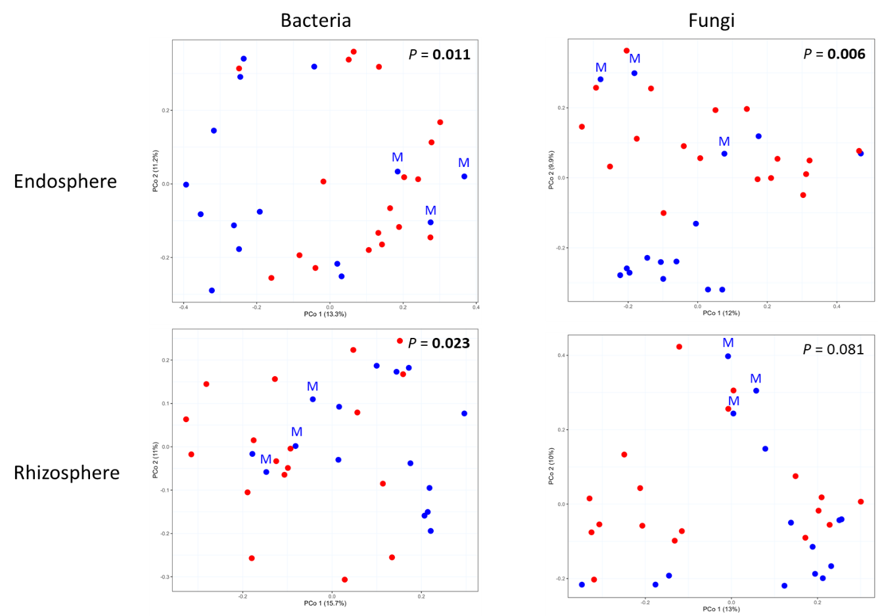
Figure S1. Principal Coordinate Analisis (PCoA) of belowground microbial communities.
VWO-tolerant cultivars are shown in blue and VWO-susceptible cultivars in red. M = cultivar ‘Maarri’. Statistically significant p-values of PERMANOVA test are highlighted in bold type and italics.

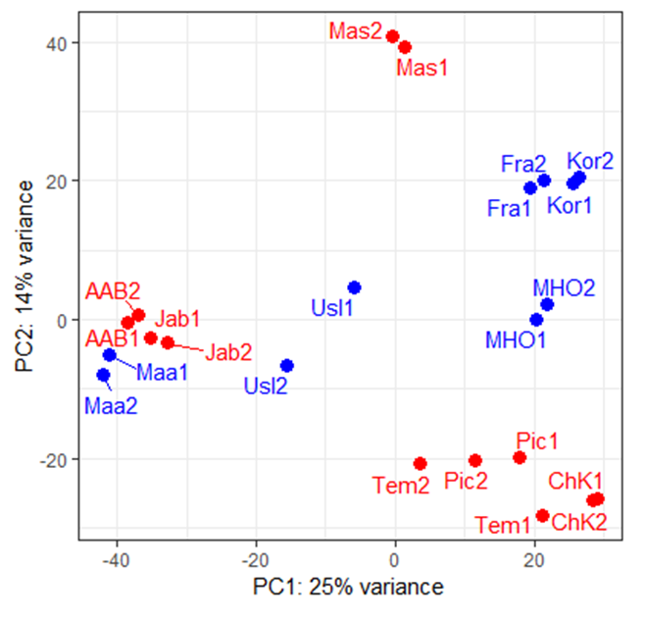Figure S2. Principal Component Analysis (PCA) for host transcriptomic response. VWO-tolerant cultivars are shown in blue and VWO-susceptible cultivars in red. Two trees (replicates) for each cultivar. AAB =Abbadi Abou Gabra-842, Jab = Jabali, Maa = Maarri, Usl =Uslu, Mas = Mastoidis, Tem = Temprano, Pic = Picual, Fra = Frantoio, Kor = Koroneiki, MHO = Manzanillera de Huércal-Overa, ChK = Chemlal de Kabylie.

