Additional file 2
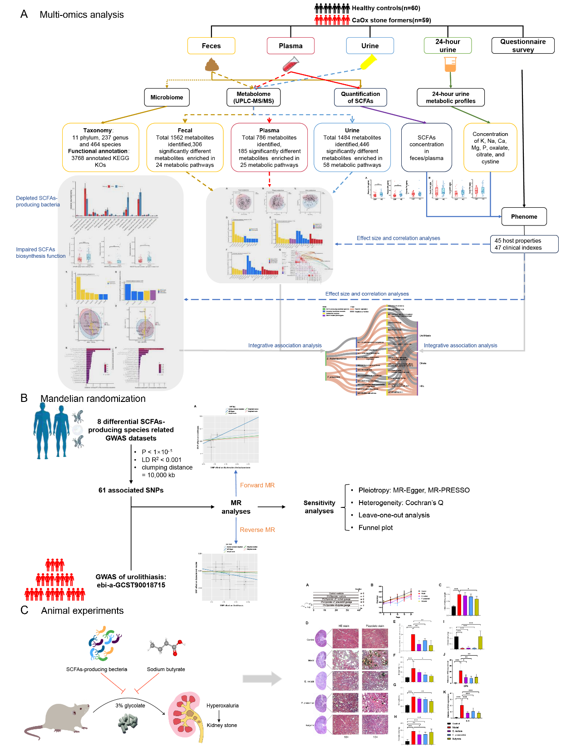
Fig. S1 Overview of the multi-omics workflow for investigating calcium oxalate (CaOx) kidney stone formation. A Plasma, fecal, midstream urine, and 24-hour urine samples were collected from 119 participants, including 59 CaOx stone formers (CSF) and 60 healthy controls (HC). Detailed questionnaires were completed by all participants. Fecal shotgun metagenomic sequencing was performed, along with widely targeted metabolomics analyses of feces, midstream urine, and plasma. Targeted quantification of short-chain fatty acids (SCFAs) in plasma and feces, as well as 24-hour urine chemical analyses, were also conducted. Integrative multi-omics analysis was performed to explore interactions and associations across different omics data. B Using genome-wide association study (GWAS) datasets from public databases, two-sample Mendelian randomization (MR) analysis was conducted to investigate the causal relationships between bacterial species with significantly altered abundance in the CSF group and urinary stone formation. C A hyperoxaluria rat model was established by administering 3% glycolate. Eubacterium rectale, Faecalibacterium prausnitzii, and sodium butyrate were administered via gavage to evaluate their effects on kidney stone formation.
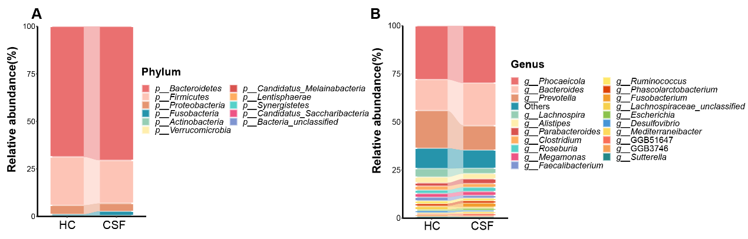
Fig. S2 Taxonomic distribution of gut microbiota at the phylum and genus levels in CaOx stone formers (CSF) and healthy controls (HC). A Relative abundance of the 11 detected phyla in CSF and HC. B Relative abundance of the top 20 most prevalent genera in CSF and HC.

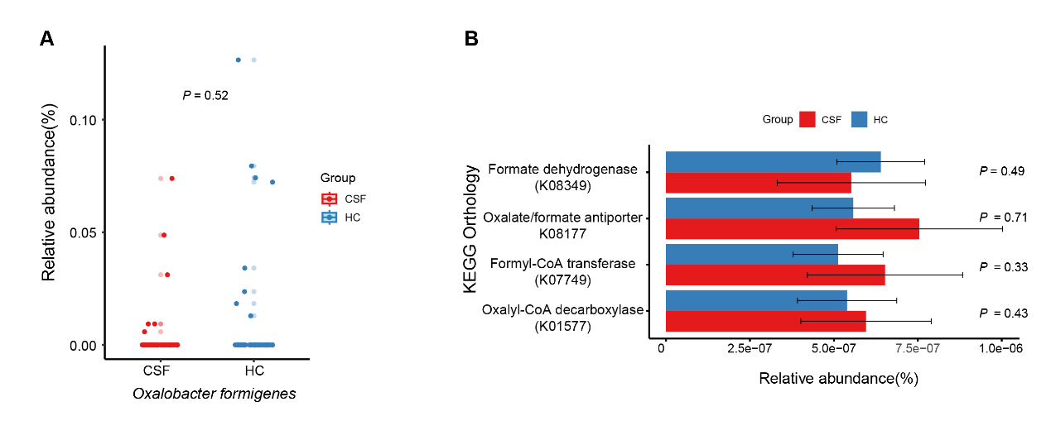Fig. S3 Differences in the abundance of Oxalobacter formigenes and KEGG orthologs (KOs) involved in oxalate metabolism between CaOx stone formers (CSF) and healthy controls (HC).

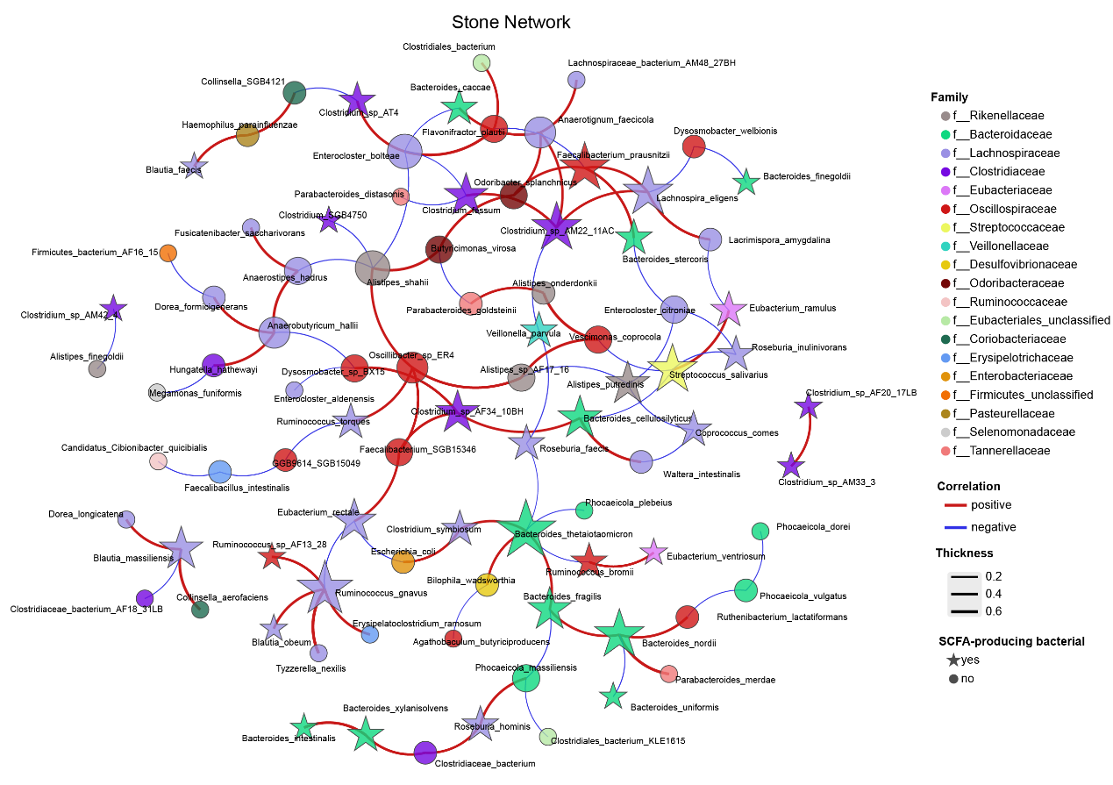
Fig. S4 Co-abundance networks of species for CaOx stone formers.
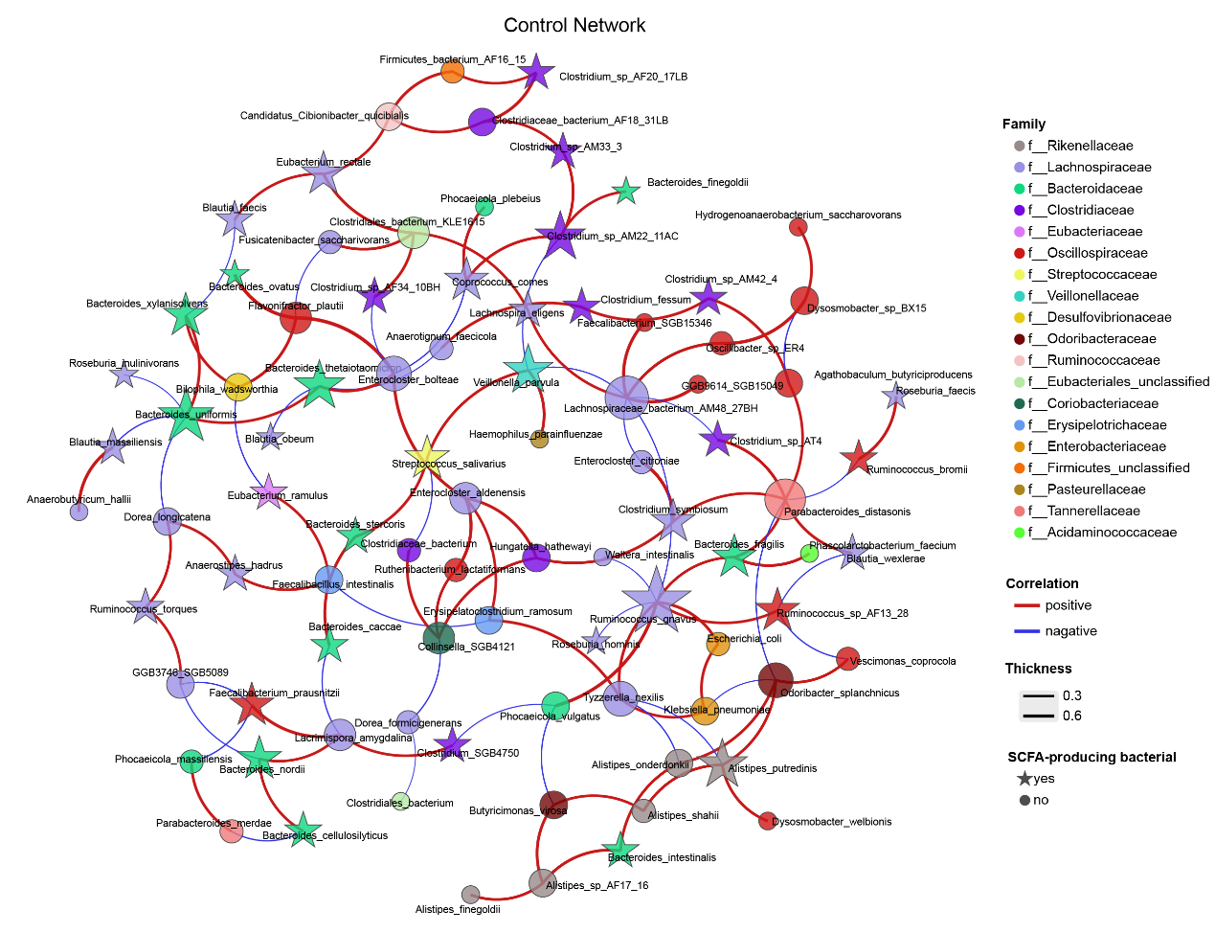
Fig. S5 Co-abundance networks of species for healthy controls.
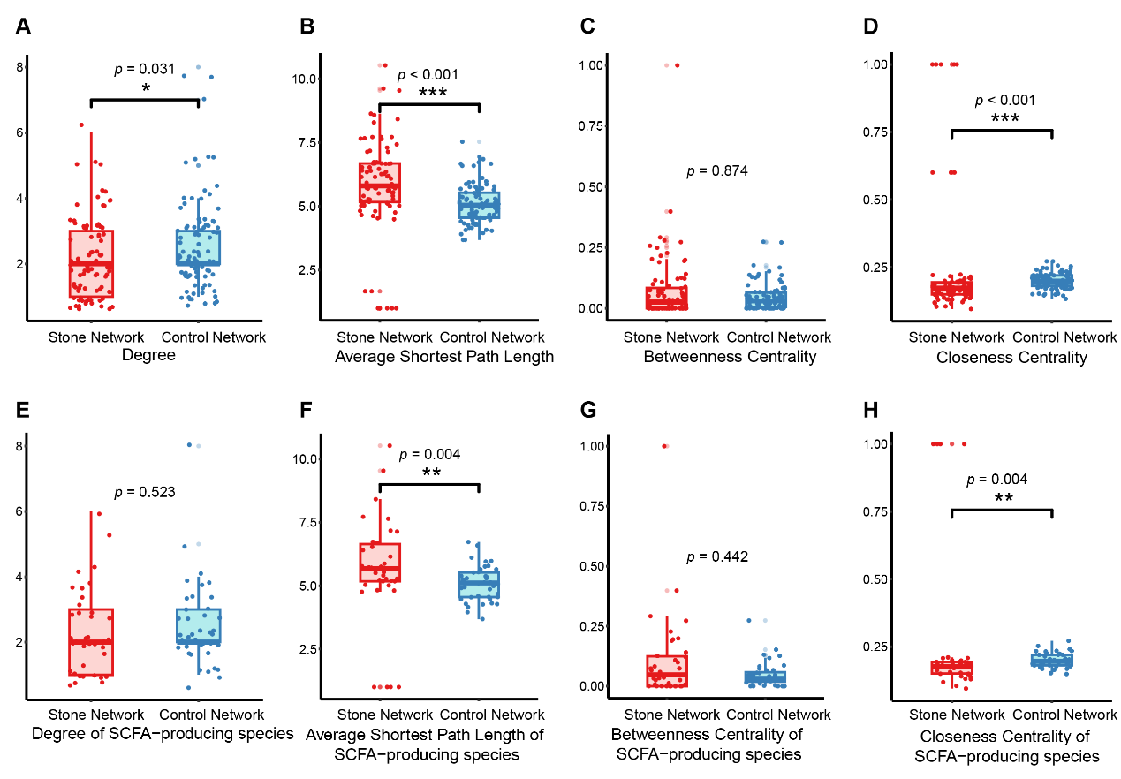Fig. S6 Alterations in the co-abundance network of gut microbiota species in CaOx stone formers (CSF). A–D Comparisons of global network properties between the Stone Network and Control Network, including degree (A), average shortest path length (B), betweenness centrality (C), and closeness centrality (D) for all nodes (microbial species). E–F Comparisons of the same network metrics for SCFA-producing bacterial species in the Stone and Control Network, including degree (E), average shortest path length (F), betweenness centrality (G), and closeness centrality (H). * P < 0.05, ** P < 0.01, ***P < 0.001.
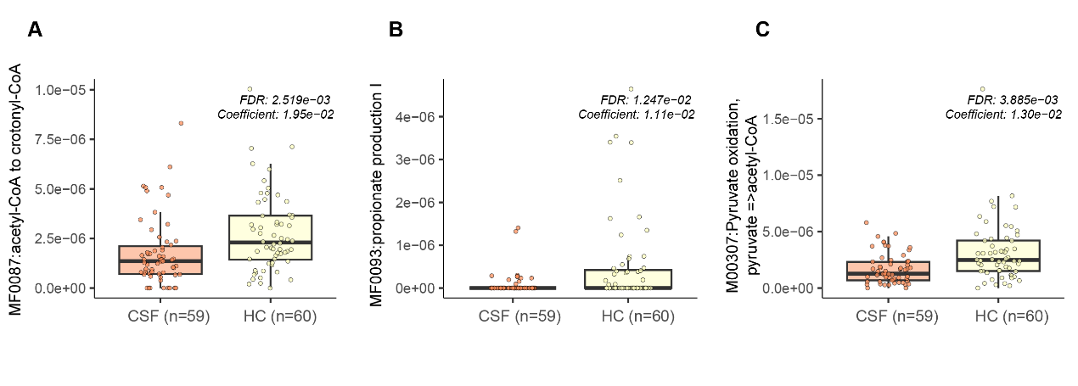
Fig. S7. Validation of SCFA synthesis-related functional modules that were differentially abundant between CaOx stone formers (CSF) and healthy controls (HC) based on MaAsLin2 analysis.
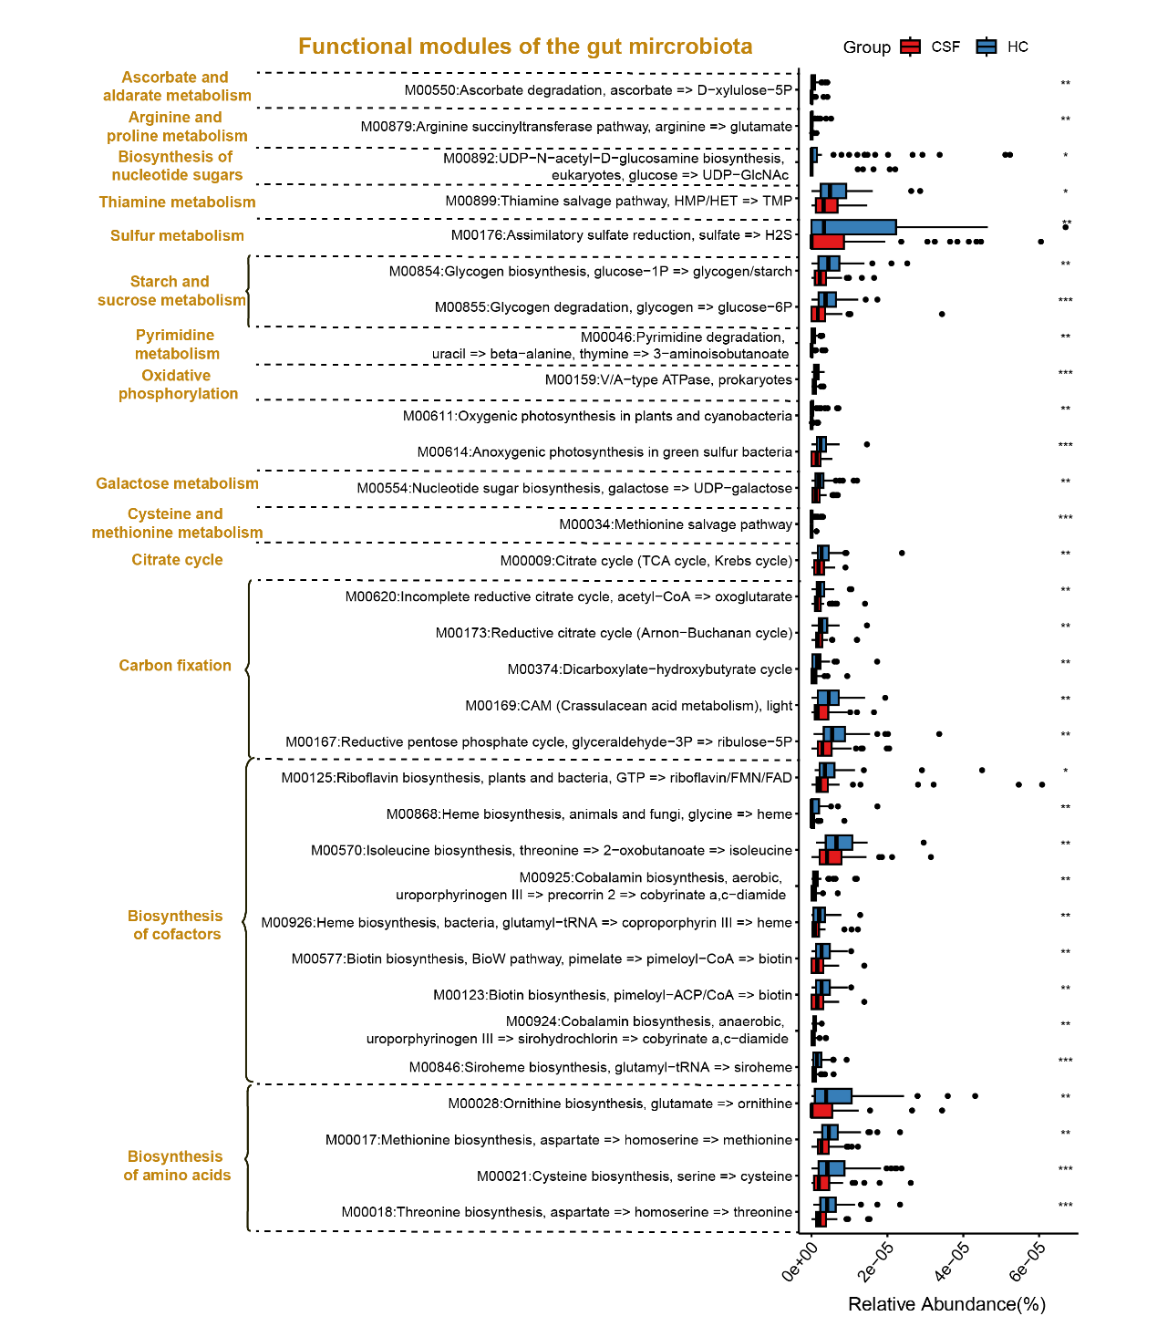
Fig. S8 Comparison of microbial functional modules, based on the KEGG module reference framework, between CaOx stone formers (CSF) and healthy controls (HC).

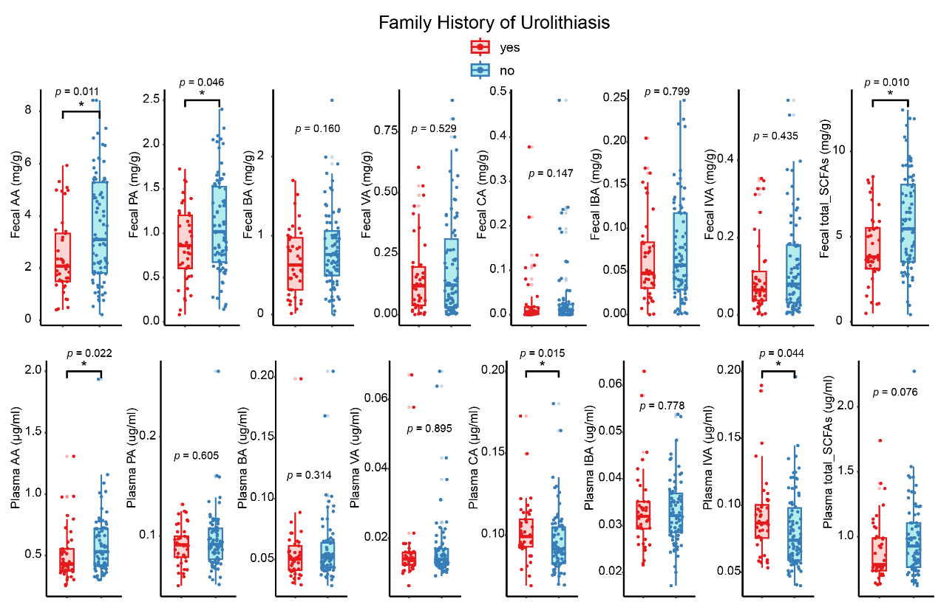Fig. S9 Differences in fecal and plasma SCFAs between individuals with and without a family history of urolithiasis. AA = acetic acid; PA = propionic acid; BA = butyric acid; IBA = isobutyric acid; VA = valeric acid; IVA = isovaleric acid; CA = caproic acid.

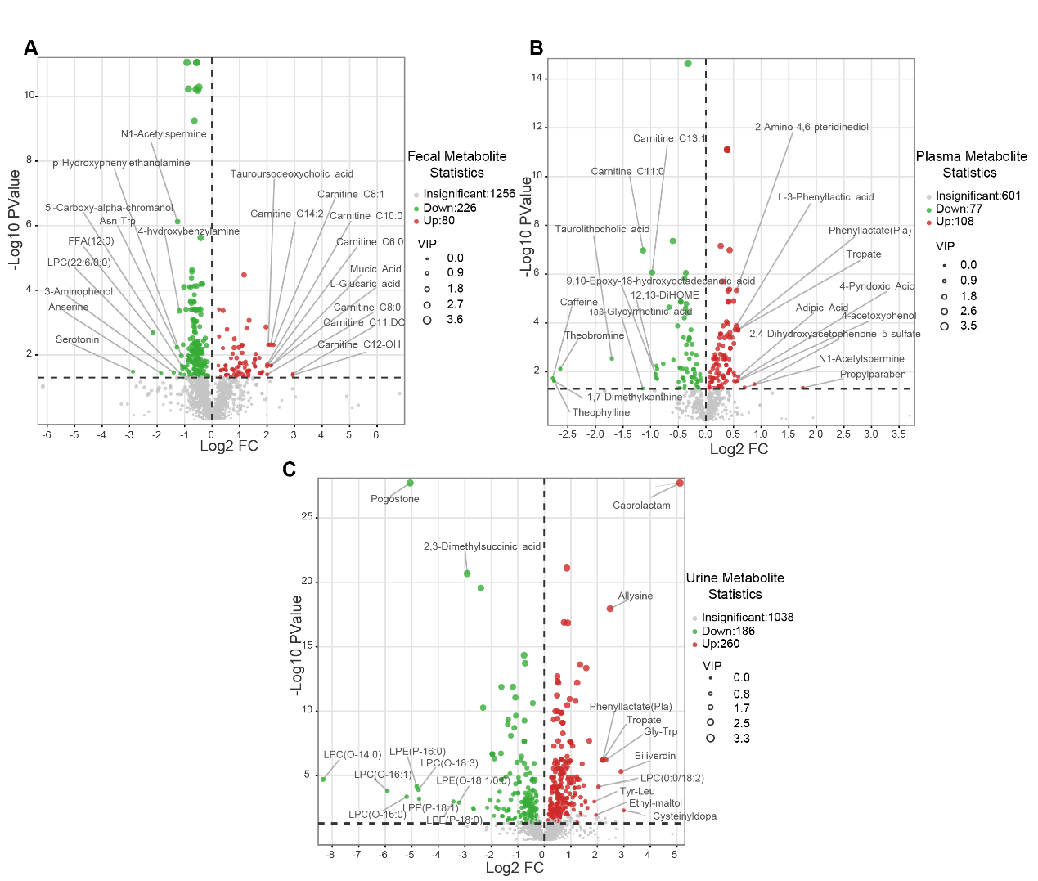Fig. S10 Characteristics of fecal (A), plasma (B), and urinary (C) metabolite profiles in CaOx stone formers (CSF) and healthy controls (HC). The X-axis shows the log₂-transformed fold change (CSF vs. HC), while the Y-axis displays the −log₁₀-transformed p-values from Student’s t-test. The point size indicates the variable importance in projection (VIP) values based on the OPLS-DA model. Red points indicate metabolites upregulated in CSF, whereas green points represent those downregulated.
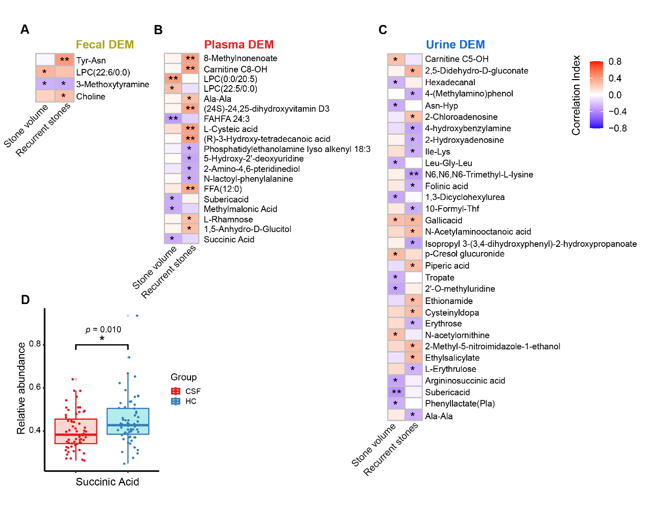
Fig. S11 Correlations between differential metabolites and stone-related parameters. A Partial correlation analysis between fecal differential metabolites and stone parameters. B Partial correlation analysis between plasma differential metabolites and stone parameters. C Partial correlation analysis between urinary differential metabolites and stone parameters. D Comparison of plasma succinic acid levels between CaOx stone formers (CSF) and healthy controls (HC). The partial correlation coefficients are color-coded: positive correlations in red and negative correlations in blue. * P < 0.05, ** P < 0.01. DEM= differentially expressed metabolites.
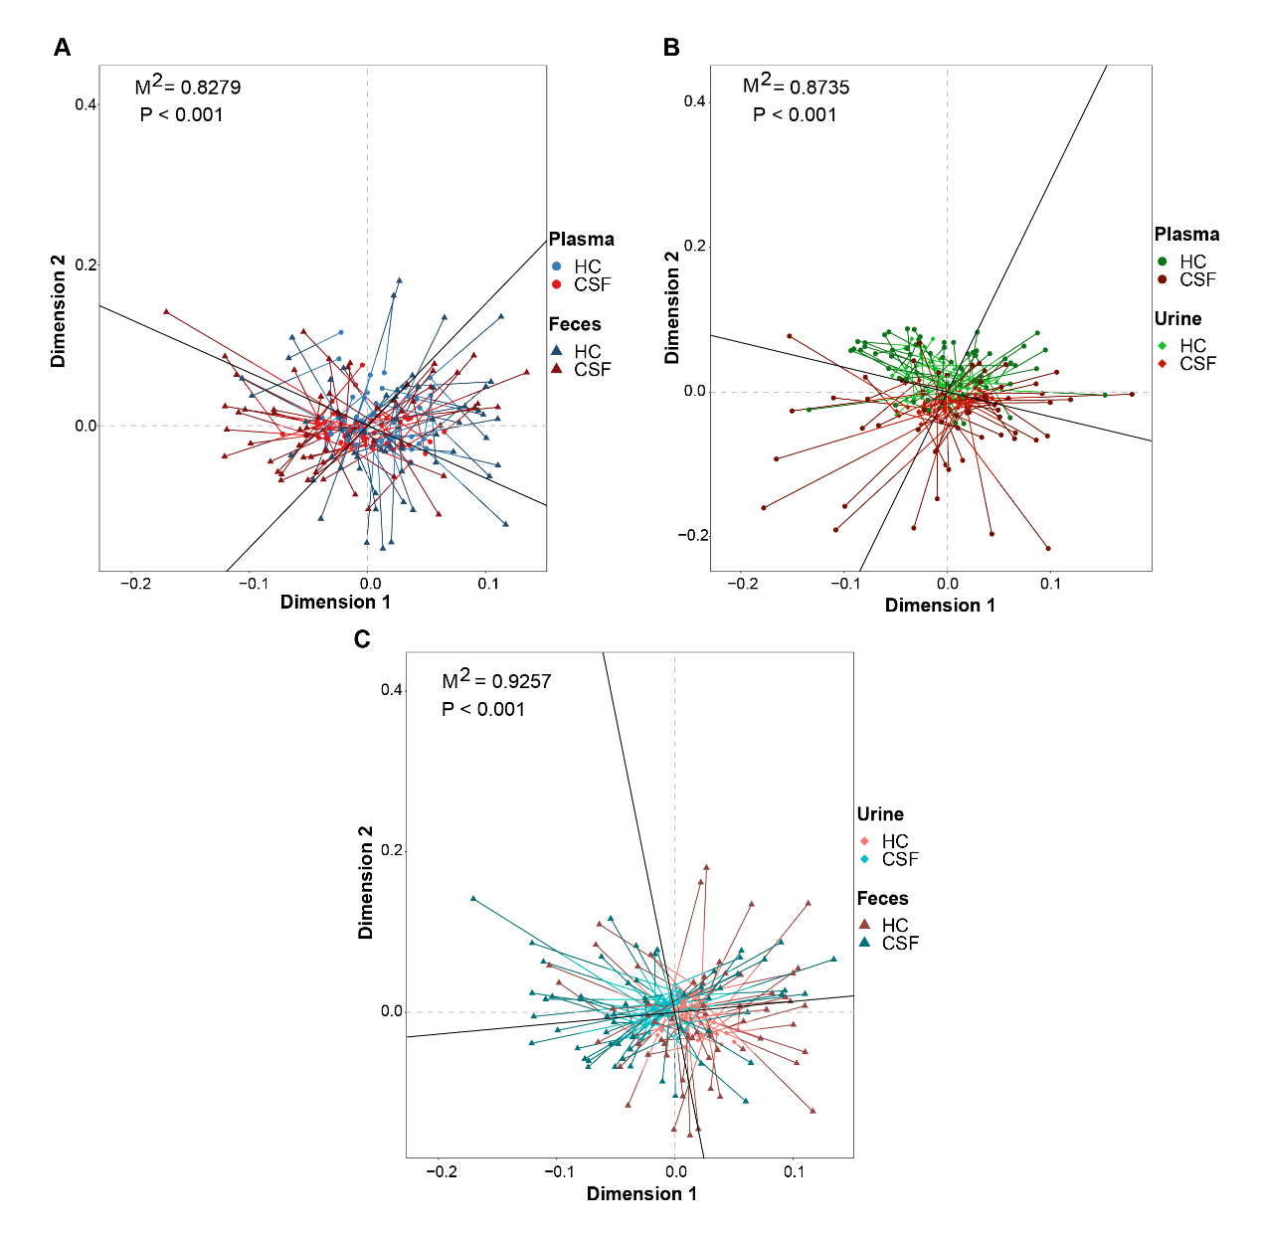
Fig. S12 Procrustes Analysis. A Procrustes analysis of fecal versus plasma metabolomes. Fecal and plasma samples are represented as triangles and circles, respectively. Samples from the same individual are connected by red lines (CaOx stone formers) and blue lines (healthy controls). B Procrustes analysis of plasma versus urinary metabolomes. Plasma and urine samples are shown as circles and diamonds, respectively. Samples from the same individual are connected by red lines (CaOx stone formers) and green lines (healthy controls). C Procrustes analysis of fecal versus urinary metabolomes. Urine and fecal samples are represented as diamonds and triangles, respectively. Samples from the same individual are connected by red lines (CaOx stone formers) and teal lines (healthy controls).

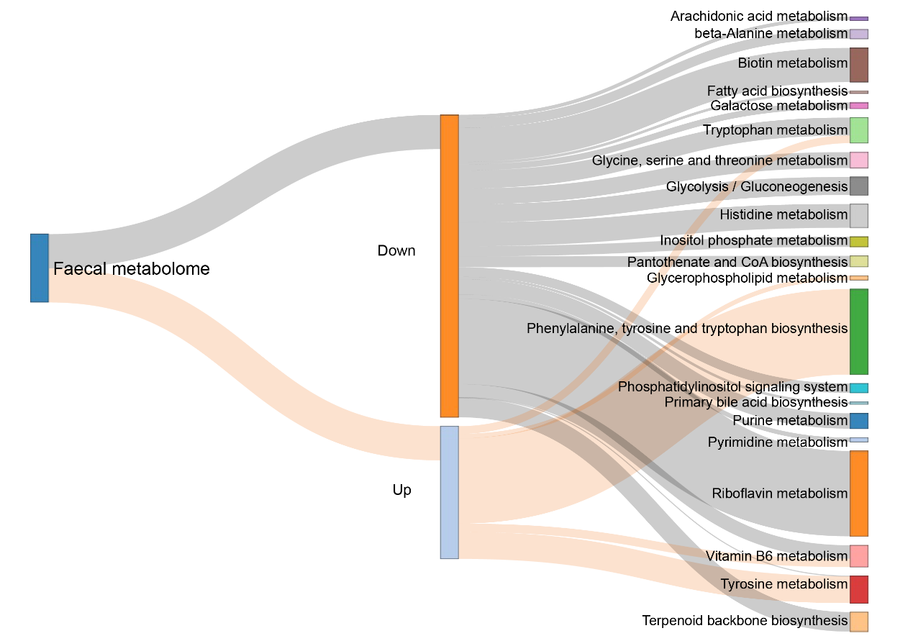 Fig. S13 KEGG pathway enrichment analysis of differential metabolites in the fecal metabolome between CaOx stone formers (CSF) and healthy controls (HC) (Impact > 0). Edge width represents the impact value of metabolites in the corresponding metabolic pathway. "Up" indicates metabolites upregulated in CSF compared to HC, while "Down" indicates downregulated metabolites.
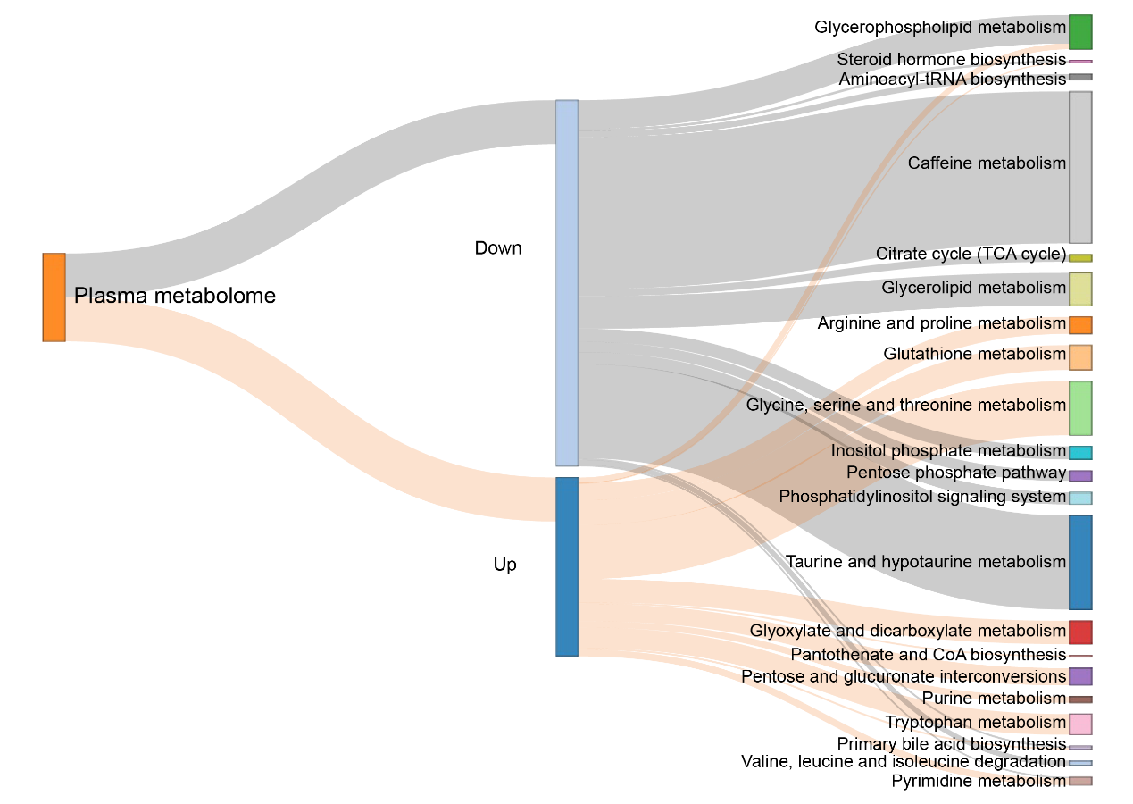 Fig. S14 KEGG pathway enrichment analysis of differential metabolites in the plasma metabolome between CSF and HC (Impact > 0). Edge width represents the impact value of metabolites in the corresponding metabolic pathway. "Up" indicates metabolites upregulated in CSF compared to HC, while "Down" indicates downregulated metabolites.
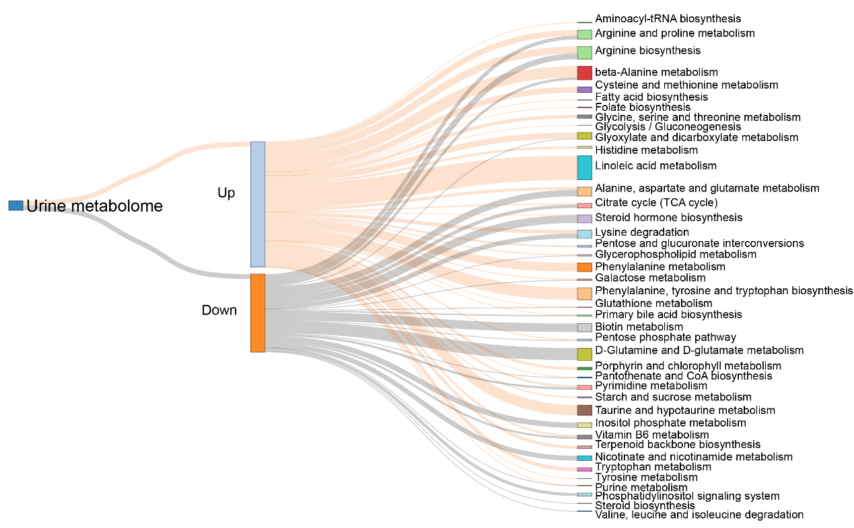 Fig. S15 KEGG pathway enrichment analysis of differential metabolites in the urinary metabolome between CSF and HC (Impact > 0). Edge width represents the impact value of metabolites in the corresponding metabolic pathway. "Up" indicates metabolites upregulated in CSF compared to HC, while "Down" indicates downregulated metabolites.
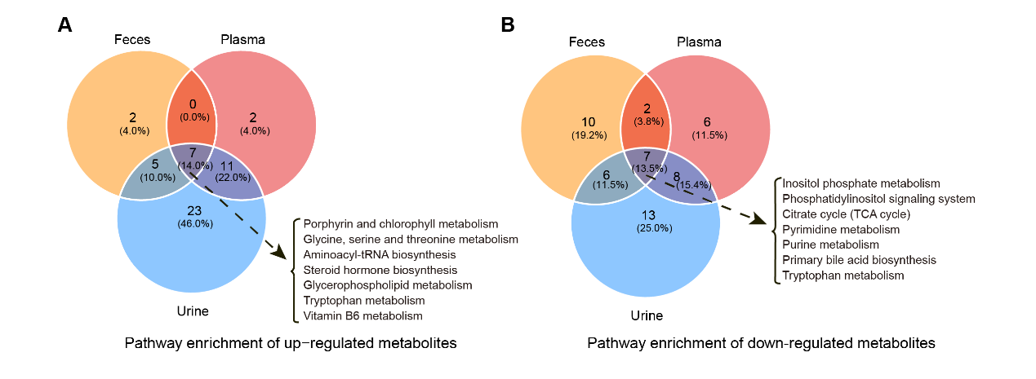Fig. S16 Overlap of enriched pathways of differential metabolites in fecal, plasma, and urine metabolomes. A Venn diagram showing the overlap of enriched pathways for upregulated metabolites in the fecal, plasma, and urinary metabolomes of CSF. B Venn diagram showing the overlap of enriched pathways for downregulated metabolites in the fecal, plasma, and urinary metabolomes of CSF.
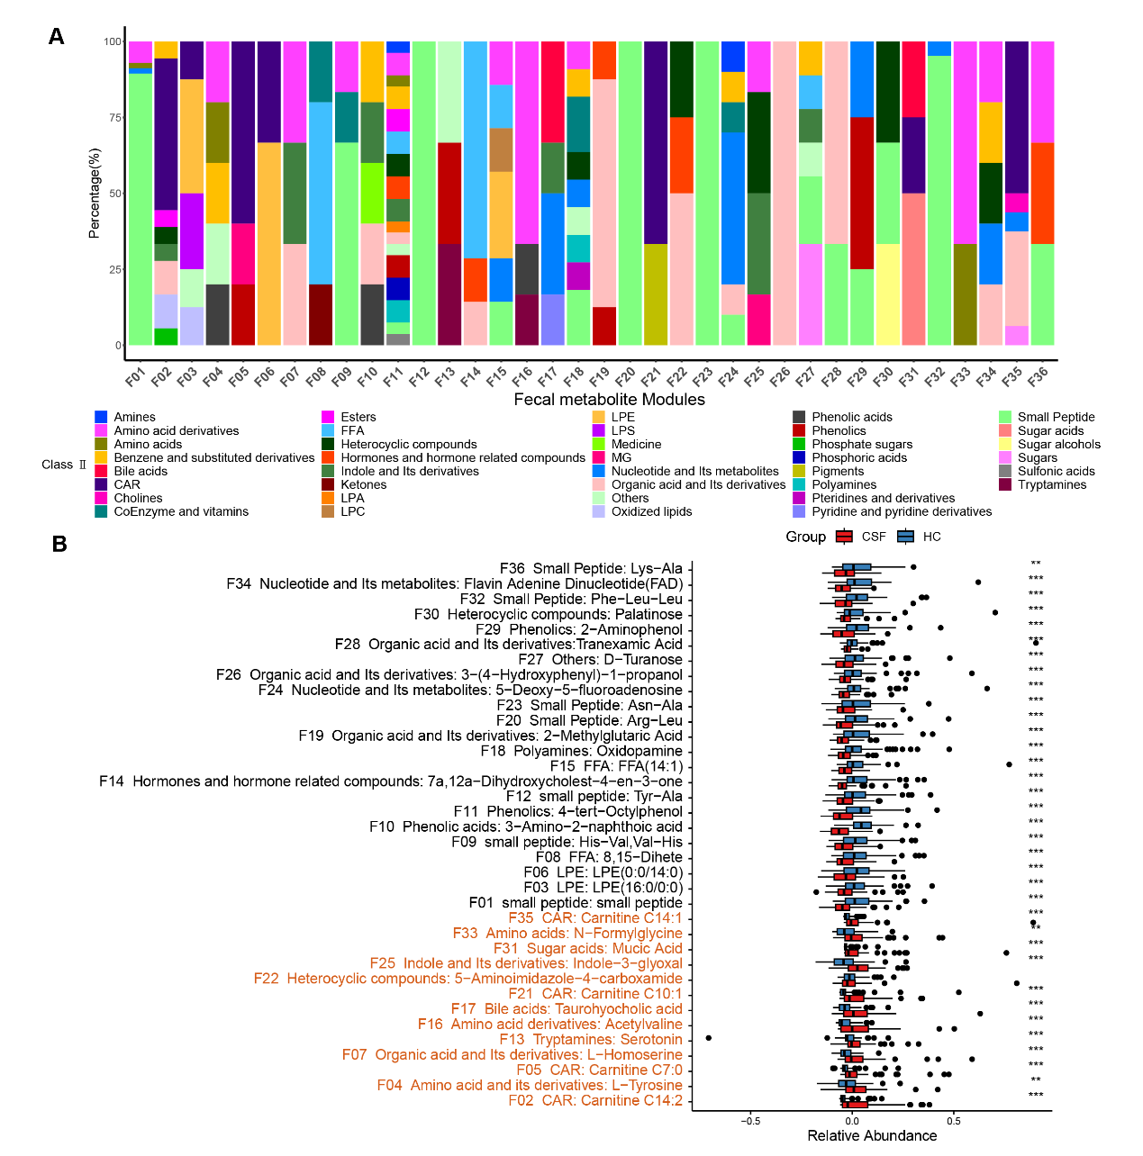
Fig. S17 Clustering and comparison of co-varying differential metabolite clusters (metabolite modules) in fecal metabolomics using WGCNA. (A) Stacked bar chart showing the proportions of Class II substance classifications of metabolites within the fecal metabolic modules. (B) Comparison of fecal metabolic modules between CaOx stone formers (CSF) and healthy controls (HC). The metabolite module number is followed by the Class II substance categories corresponding to the core metabolites in the metabolite module, along with the names of the core metabolites. *P < 0.05, **P < 0.01, and ***P < 0.001.
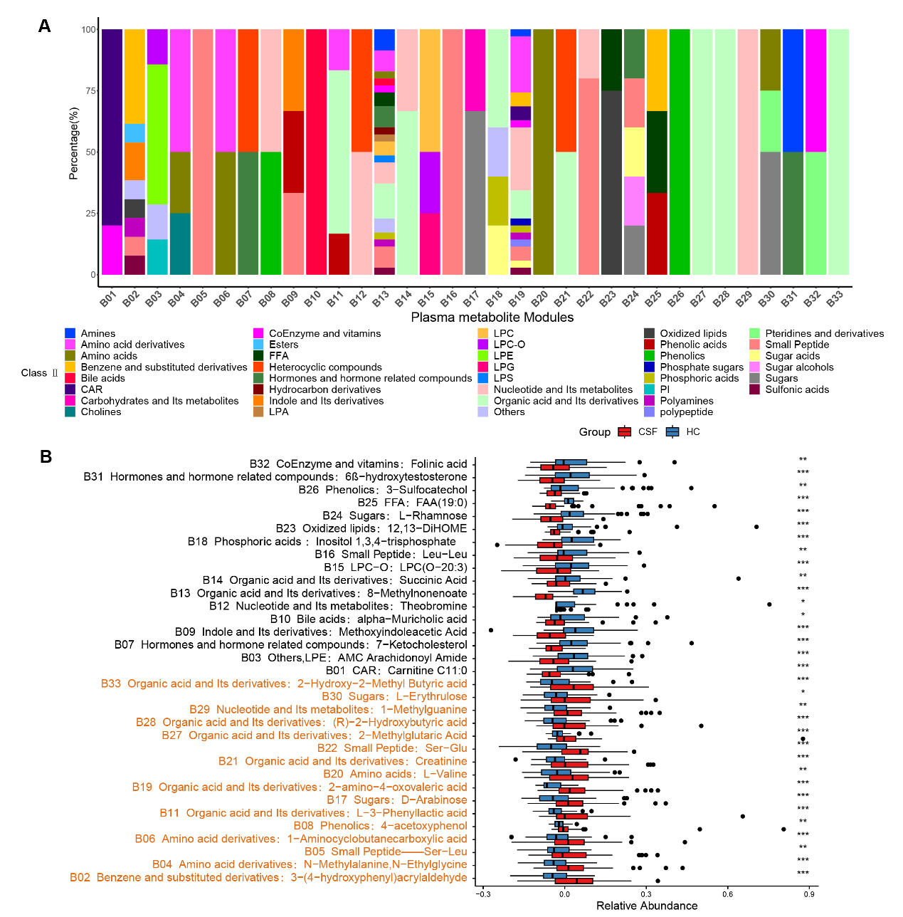
Fig. S18 Clustering and comparison of co-varying differential metabolite clusters (metabolite modules) in plasma metabolomics using WGCNA. (A) Stacked bar chart showing the proportions of Class II substance classifications of metabolites within the plasma metabolic modules. (B) Comparison of plasma metabolic modules between CaOx stone formers (CSF) and healthy controls (HC). The metabolite module number is followed by the Class II substance categories corresponding to the core metabolites in the metabolite module, along with the names of the core metabolites. *P < 0.05, **P < 0.01, and ***P < 0.001.
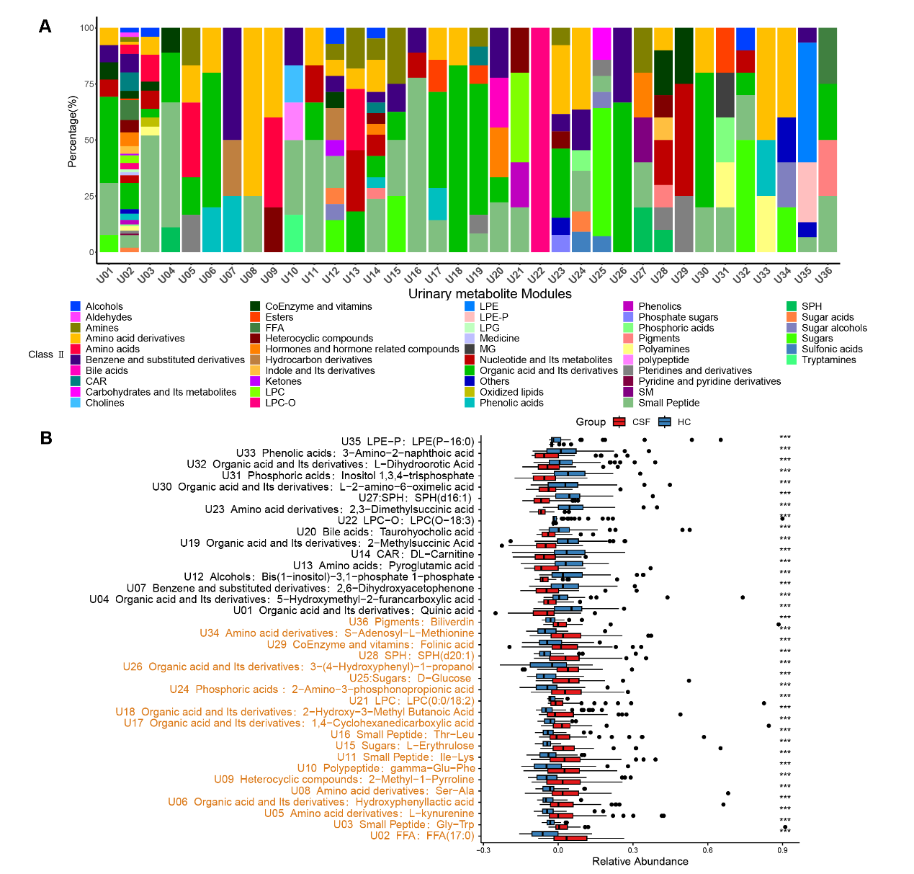
Fig. S19 Clustering and comparison of co-varying differential metabolite clusters (metabolite modules) in urinary metabolomics using WGCNA. (A) Stacked bar chart showing the proportions of Class II substance classifications of metabolites in the urinary metabolic modules. (B) Comparison of urinary metabolic modules between CaOx stone formers (CSF) and healthy controls (HC). The metabolite module number is followed by the Class II substance categories corresponding to the core metabolites in the metabolite module, along with the names of the core metabolites. *P < 0.05, **P < 0.01, and ***P < 0.001.
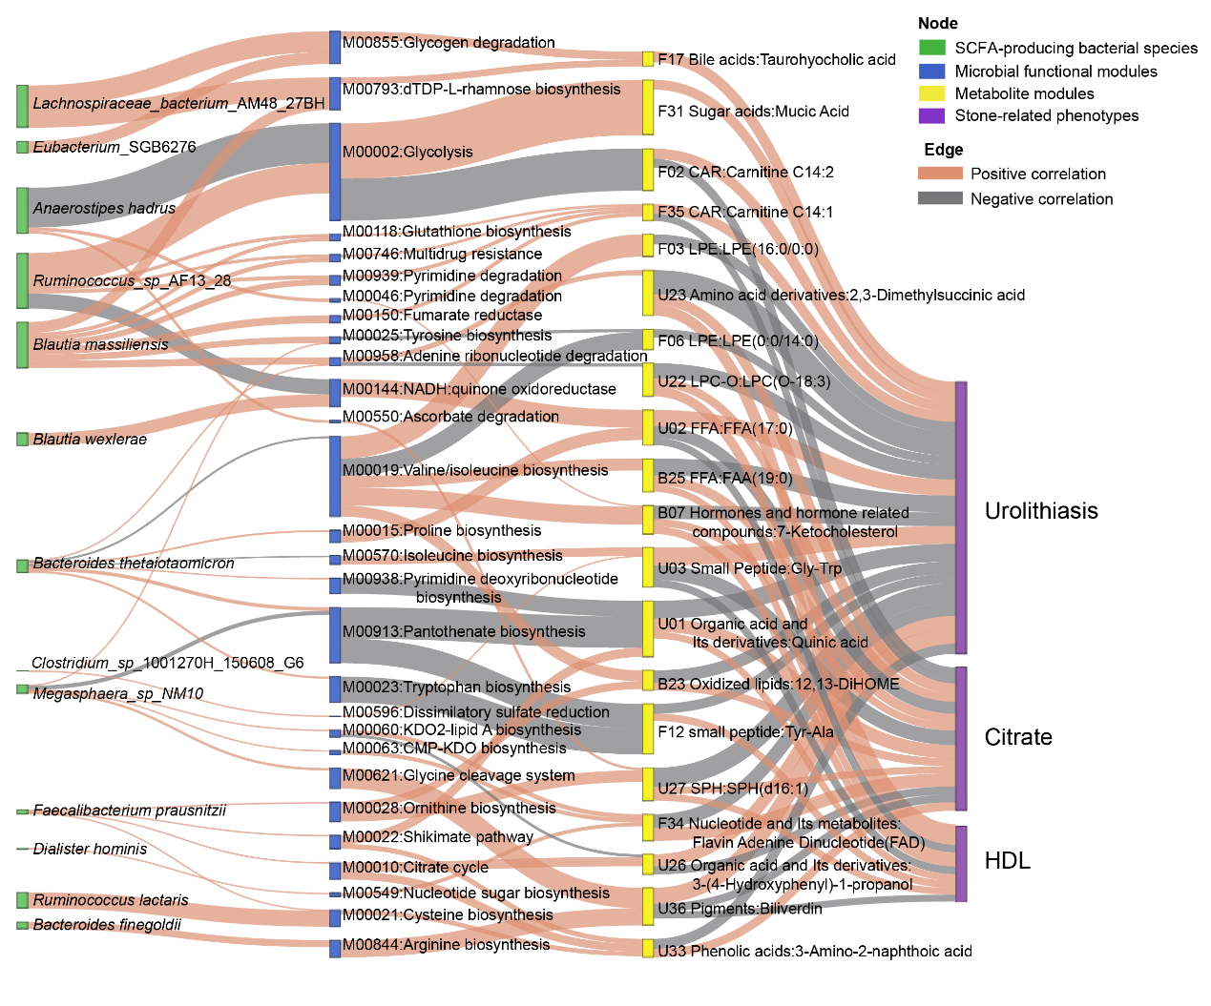
Fig. S20 Associations among SCFA-producing bacterial species, microbial functional modules, metabolite modules, and stone-related phenotypes. Associations between bacterial species abundance and microbial functional modules, and between microbial functional modules and metabolite modules, were assessed using MaAsLin2, adjusting for gender, age, and BMI. Associations between metabolite modules and stone-related phenotypes were evaluated using partial correlation analysis with the same covariate adjustments. Grey edges indicate negative correlations, while orange edges indicate positive correlations.

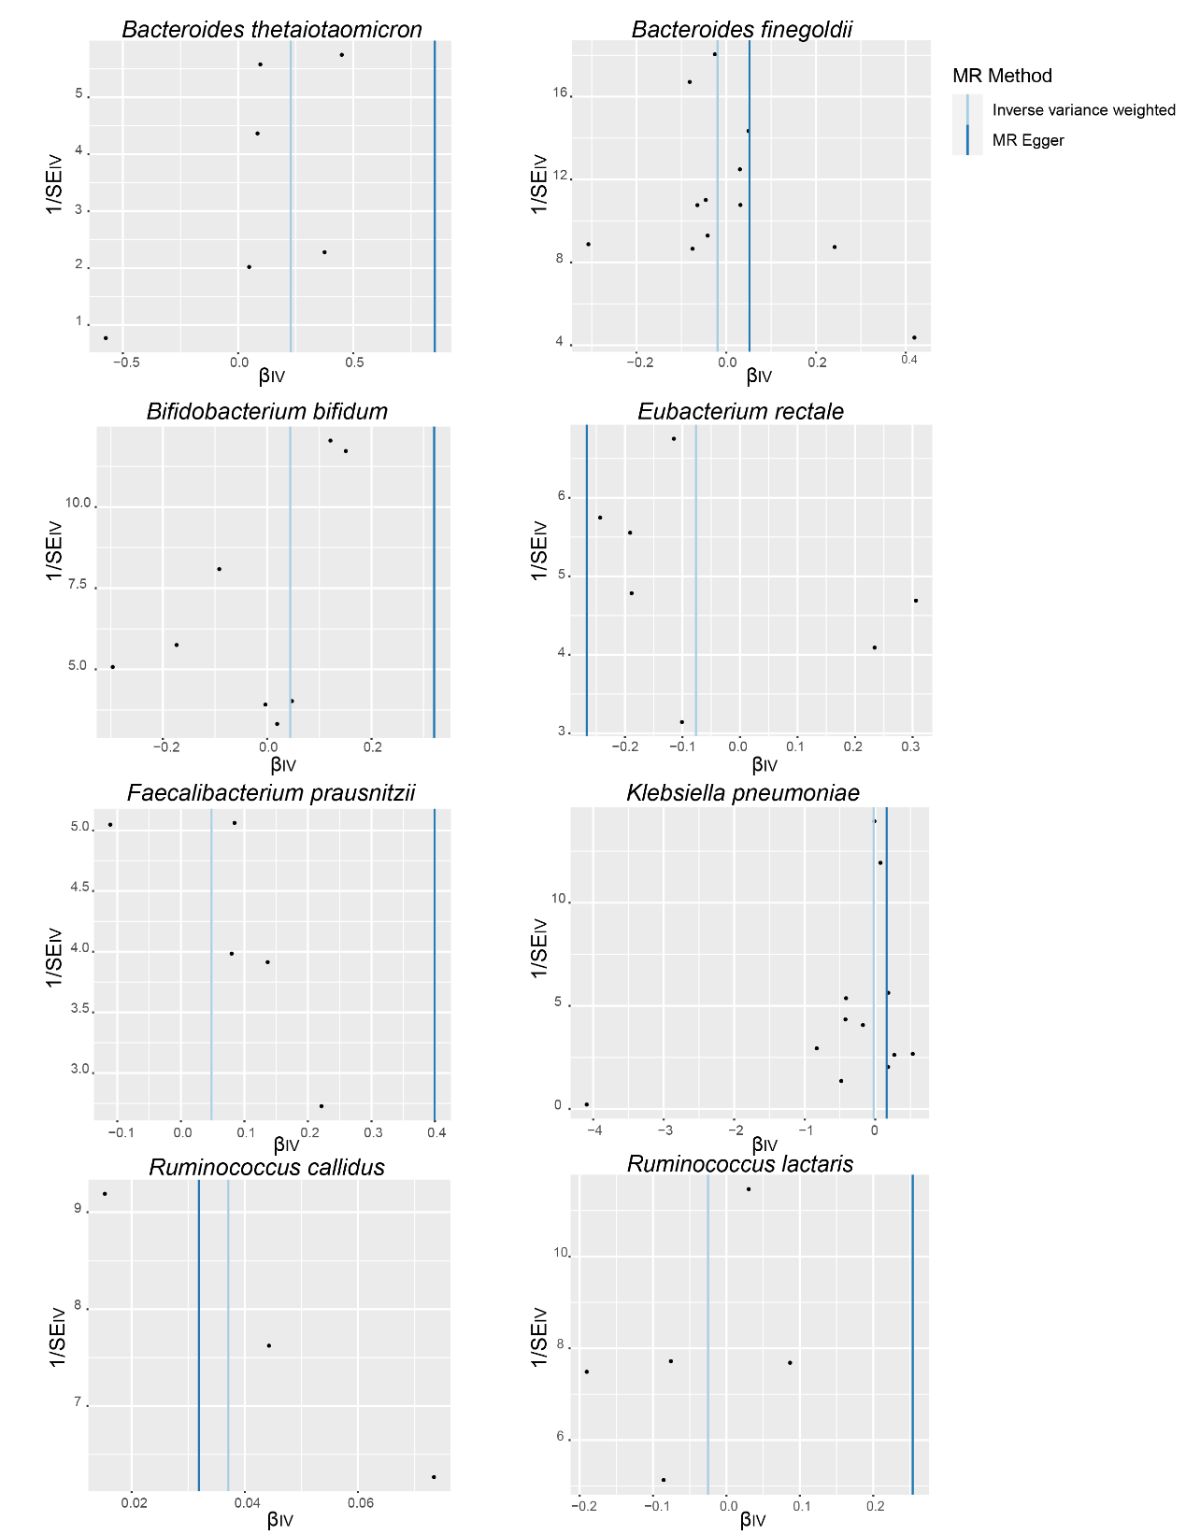
Fig. S21 Funnel plots for gut microbiota on urolithiasis.

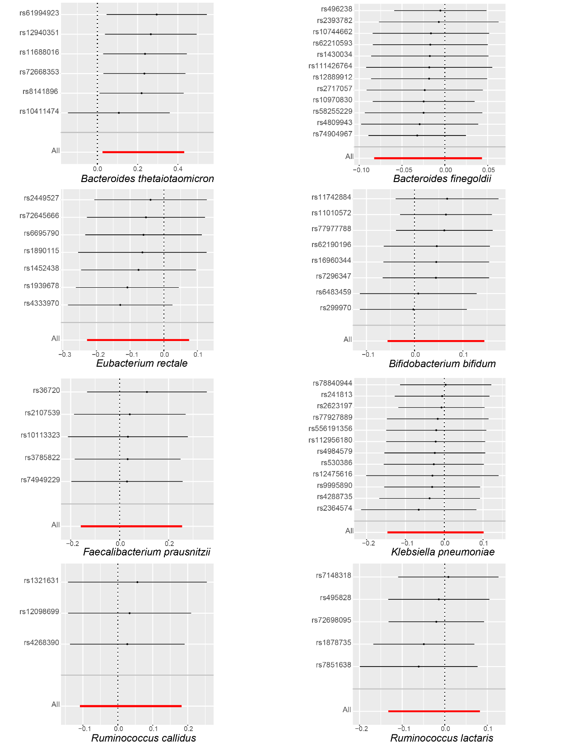
Fig. S22 Leave-one-out plots for the causal association between gut microbiota and urolithiasis.

