Putative promiscuous symbionts in deep-sea corals and crinoids may contribute to nitrogen cycling
Flúvio Modolon^{1,2,5}, Alessandro do N. Garritano^{3,4}, Lillian J. Hill¹, Gustavo Duarte^{1,2}, Amanda Bendia⁴, Rafael B. de Moura⁵, Vivian Pellizari⁴, Torsten Thomas³ & Raquel S. Peixoto²
¹Laboratory of Molecular Microbial Ecology, Institute of Microbiology Paulo de Góes, Federal University of Rio de Janeiro, Rio de Janeiro 21941-901, Brazil
²Red Sea Research Center, Biological and Environmental Science and Engineering Division, King Abdullah University of Science and Technology, Thuwal, 23955, Saudi Arabia
³Centre for Marine Science and Innovation; School of Biological, Earth and Environmental Sciences, The University of New South Wales, Sydney, NSW, Australia
⁴School of Life and Environmental Sciences, The University of Sydney, Sydney, New South Wales, Australia.
⁵Oceanographic Institute, University of Sao Paulo, São Paulo, São Paulo, Brazil
⁶Institute of Biology, Federal University of Rio de Janeiro, Rio de Janeiro, 21941-901, Brazil

Content
Supplementary Figure S1. Sørensen dissimilarity for D. pertusum and S. variabilis associated with crinoids and those not associated with them. D. pertusum, p-value = 0.400; for S. solenosmilia, p-value = 0.812; PERMANOVA.
Supplementary Figure S2. Individualized fluorescent channels used in FISH observation using Endozoicomonas spp. (left panel) and AOA probes (right panel).
Supplementary Figure S3. Fluorescent channels used in FISH observation using probes for Endozoicomonas spp. (left panel) and AOA (right panel).
Supplementary Figure S4. FISH images using NonSense (antisense) probing (Non-Eubac) to test for probe specificity.
Supplementary Figure S5. Correlation analysis (Spearman correlation) between 15 most abundant ASV families and nitrogen forms (nitrate, nitrite and ammonium) and dissolved organic carbon (DOC).

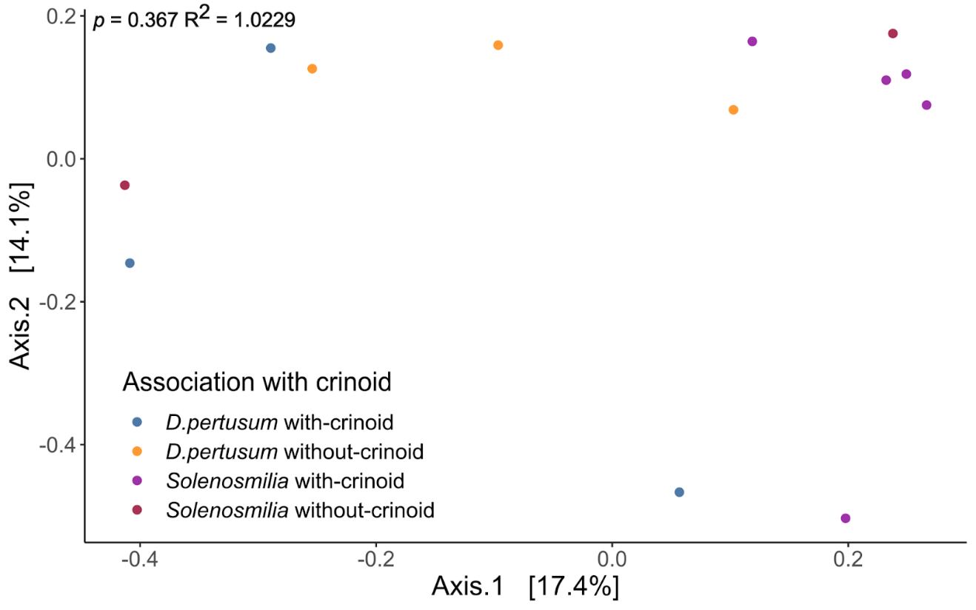
Supplementary Figure S1. Sørensen dissimilarity for D. pertusum and S. variabilis associated with crinoids and those not associated with them. D. pertusum, p-value = 0.400; for S. solenosmilia, p-value = 0.812; PERMANOVA.

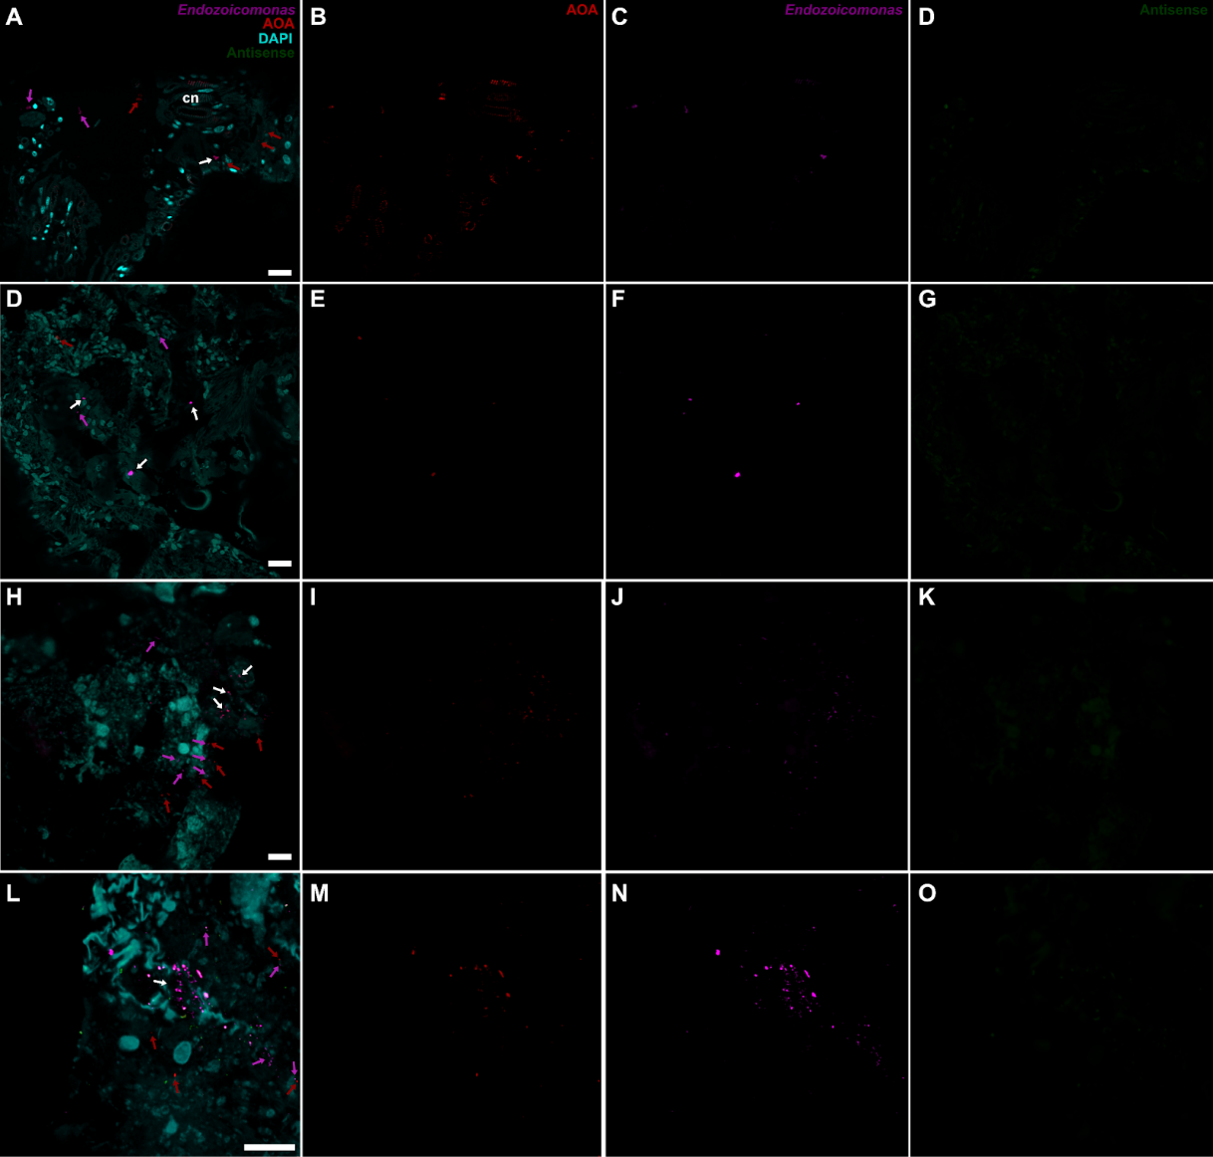
Supplementary Figure S2. Individualized fluorescent channels used in FISH observation using Endozoicomonas spp. and AOA probes. Fluorophore Alexa637 was used for Endozoicomonas probes (Endozoi663 and Endozoi736). Alexa637 also applied for AOA. Alexa594 for Antinsense probes (NonEubac and NonArch). Cn = Cnidocyte. Purple arrows highlight signals for Endozoicomonas probes; red arrows highlight signals for AOA probes; white arrows pinpoint overlaps with antisense signals.

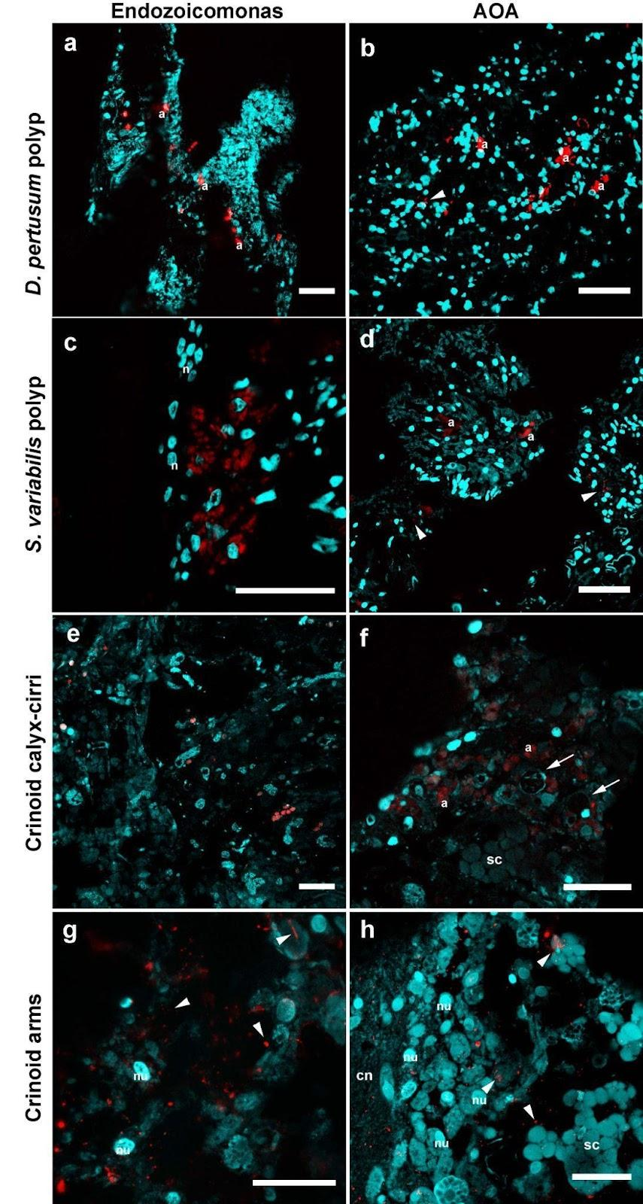
Supplementary Figure S3. Fluorescent channels used in FISH observation using probes for Endozoicomonas spp. (left panel) and AOA (right panel). Fluorophores Alexa637 was used for all probes. Bars = 5 µm. Cn = cnidocyte; nu = nucleus; sc = secretory cells; a = aggregates (putative).

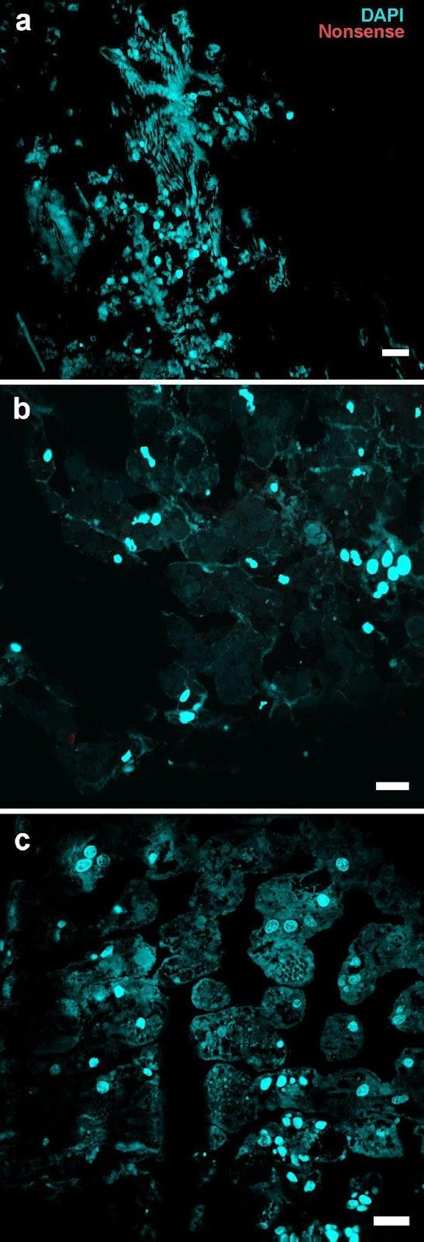
Supplementary Figure S4. FISH images using NonSense (antisense) probing (Non-Eubac) to test for probe specificity in samples from Desmophyllum pertusum tissue (A), Solenosmilia variabilis tissue (B) and Crinoid calyx-cirri tissue (C). In cyan-blue is DAPI and in red the non-sense probe (fluorophore Alexa637). Bars = 10 µm.

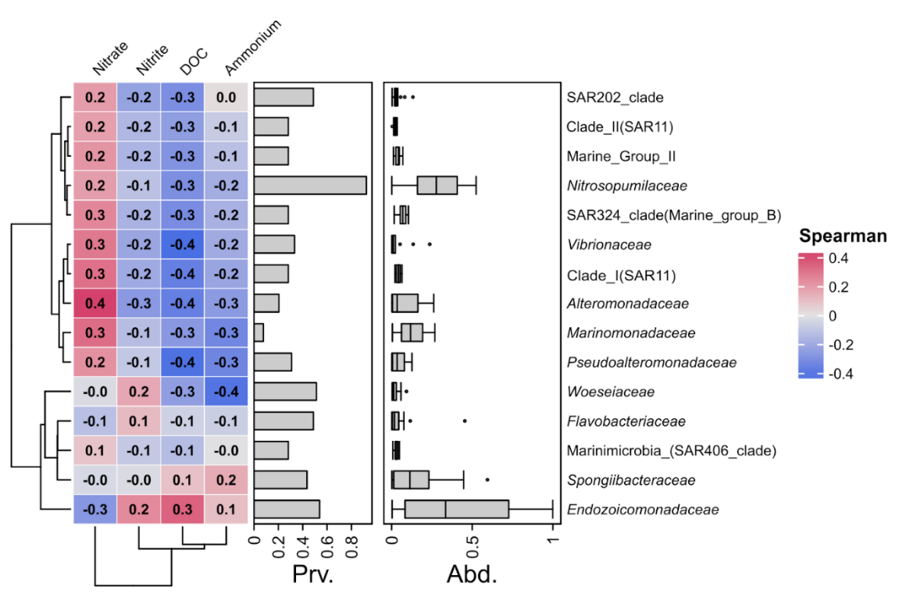
Supplementary Figure S5. Correlation analysis (Spearman correlation) between 15 most abundant ASV families and nitrogen forms (nitrate, nitrite and ammonium) and dissolved organic carbon (DOC). Prv. and Abd. indicates the prevalence and abundance of the taxa. Dendograms clusterized the rows (taxa) and columns (factors) by similarity.

Supplementary Tables:
Supplementary Table S1. Taxonomic classification of deep-sea corals and crinoids by CO1 sequencing.
Supplementary Table S2. Summary reads statistics from amplicon sequencing and ASV table with raw read count.
Supplementary Table S3. Genomic features from annotation of MAG-CC1 using Prokka pipeline.
Supplementary Table S4. Set of genes retrieved from pangenomic analysis of Endozoicomonas genus.
Supplementary Table S5. Metadata related to sampling sites.
Supplementary Table S6. Genome set and accession IDs used for phylogenomic and pangenomic analysis.
Supplementary Table S7. List of probes used for fluorescence in situ hybridisation (FISH).

