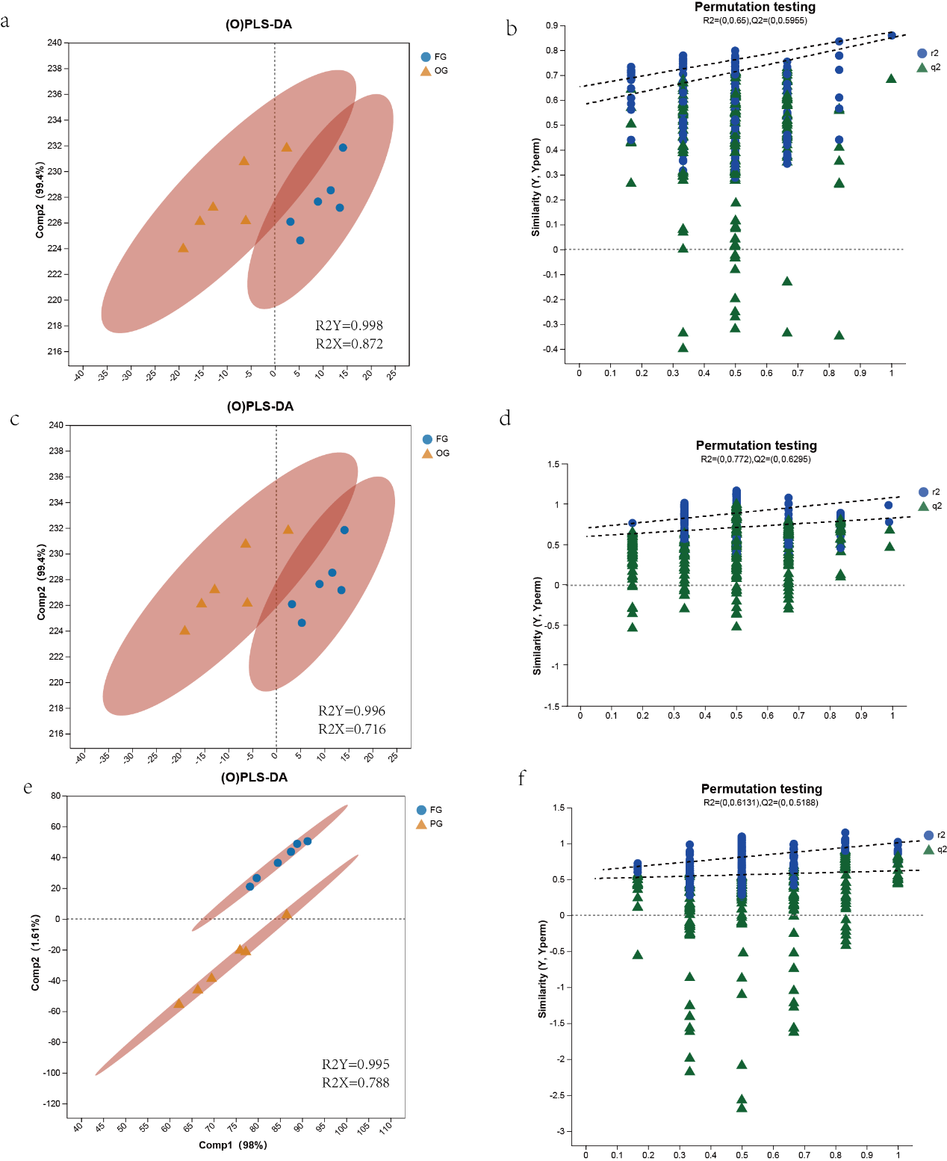 Fig. S7 Rumen Metabolic Analysis of Dairy Cows with Different Parities. R²X and R²Y represent the explanatory rates of the constructed model for the X and Y matrices, respectively, while R²X (cum) and R²Y (cum) denote the cumulative explanatory rates. Q² indicates the predictive ability of the model. The closer these three indicators are to 1, the more stable and reliable the model is. A Q² value greater than 0.5 indicates good predictive ability of the model, while a Q² value less than 0.5 indicates poor predictive ability.

