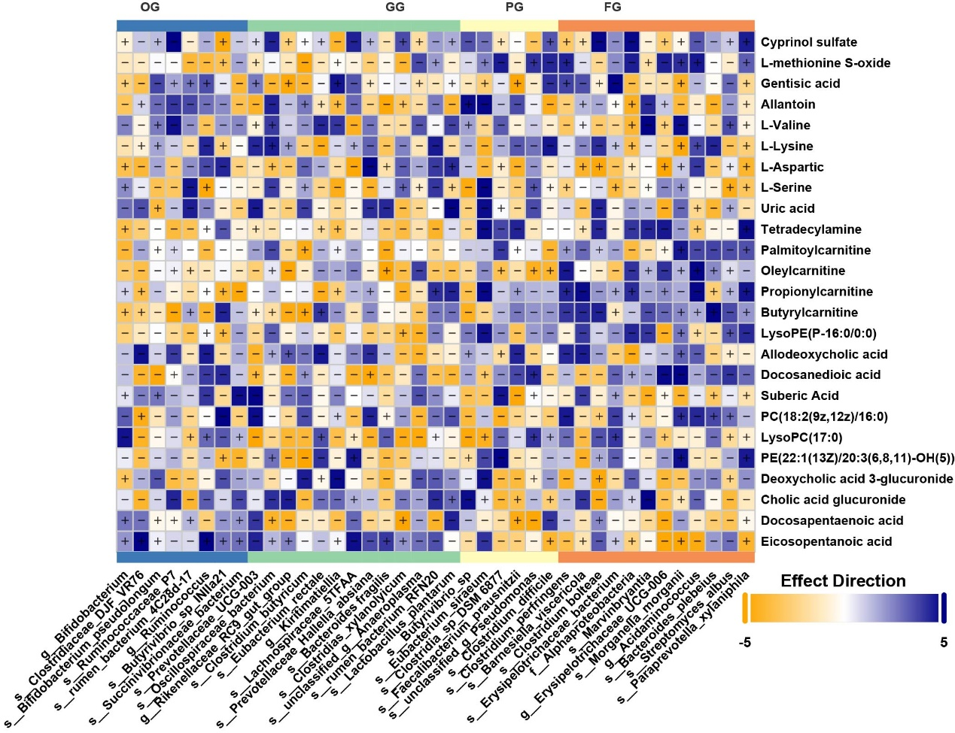
Fig. S6 Correlation analysis between rumen microbiota and serum metabolome.

