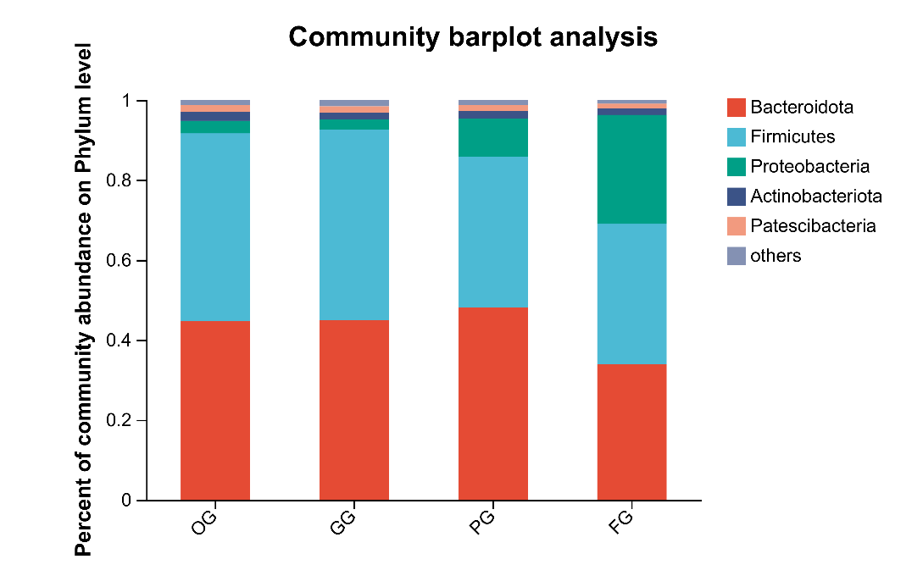
Fig. The phylum-level distribution of rumen microbiota.

