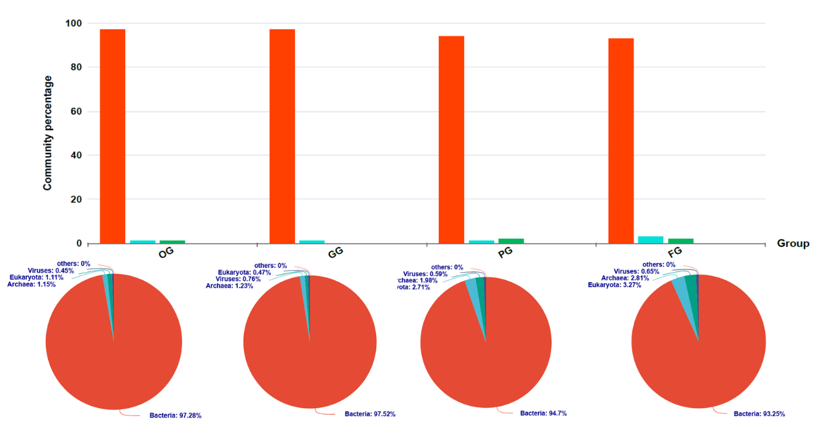
Taxonomic classification of rumen microbiota
B
A
A

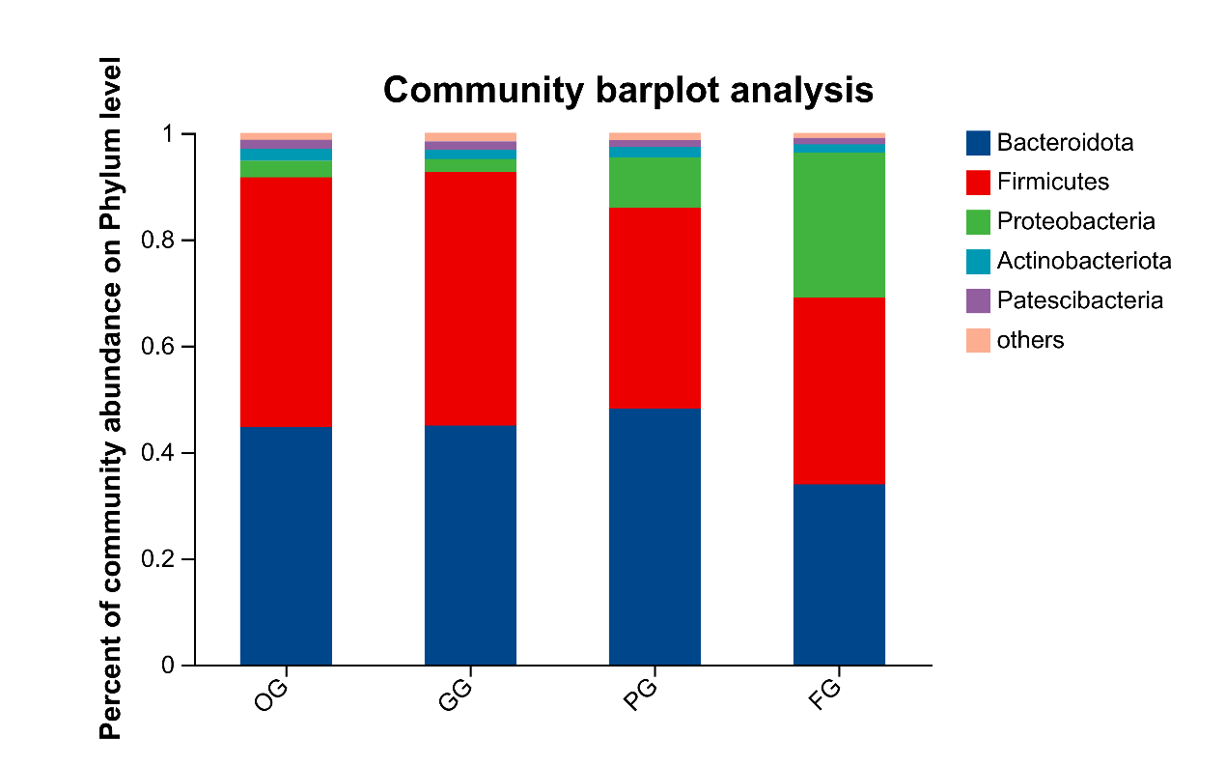

A. Relative abundance of bacteria, archaea, viruses, and eukaryotes in the rumen microbiota among different groups; B. Phylum-level distribution of bacterial taxa across different groups

