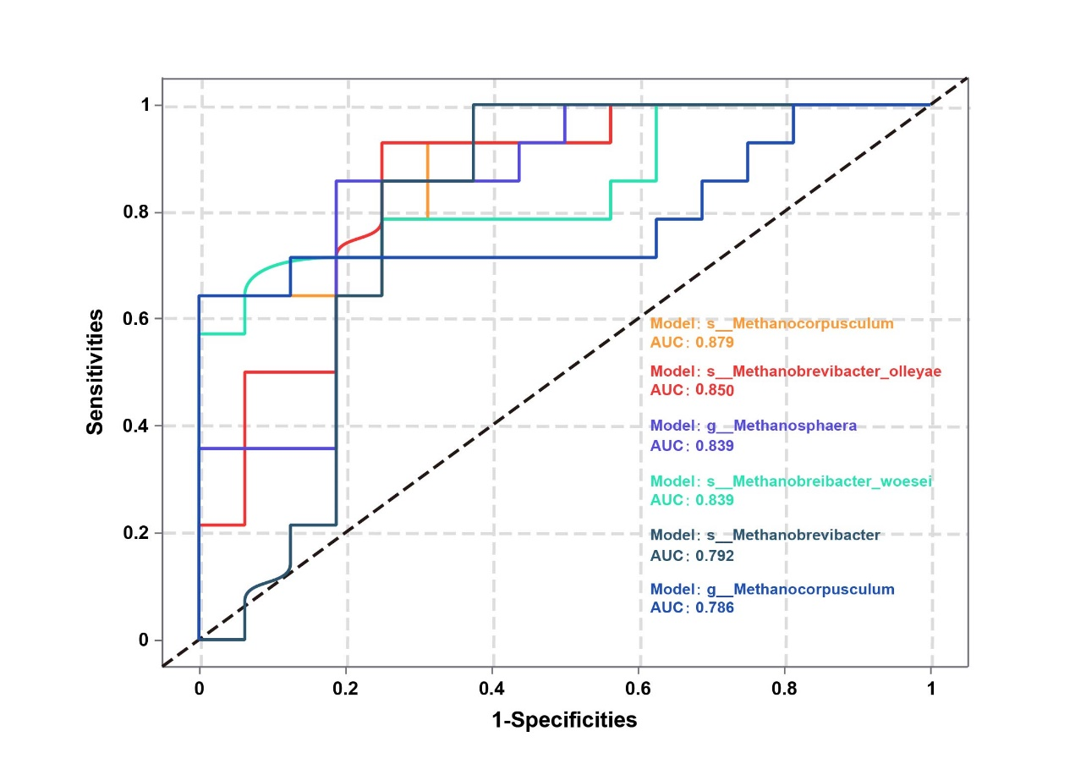
Fig. 1. Prediction analyses based on the random forest model of archaeal. Including s__Methanocorpusculum, s__Methanobrevibacter_olleyae, g__Methanosphaera, s__Methanobreibacter_woeser, s__Methanobreibacte and g__Methanocorpusculum.

