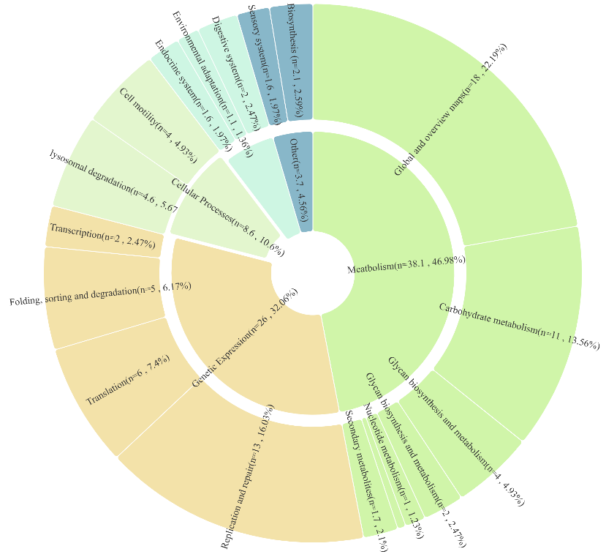
A
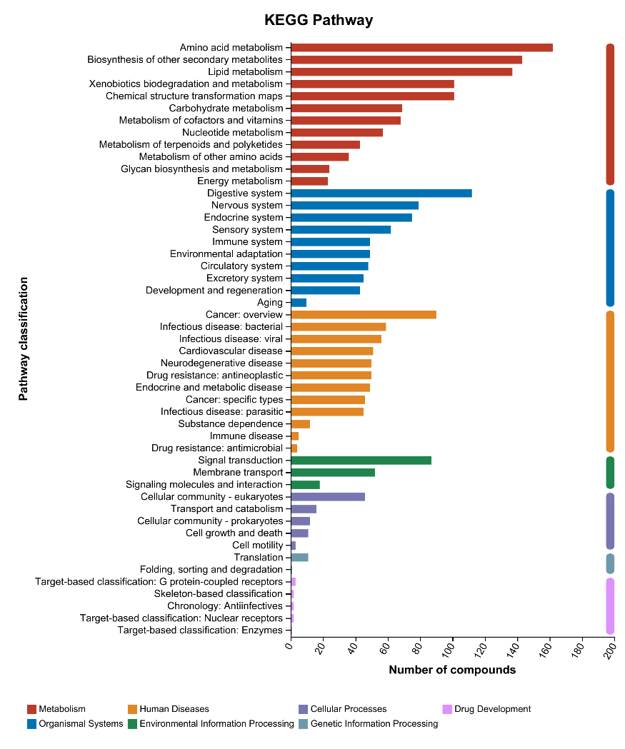

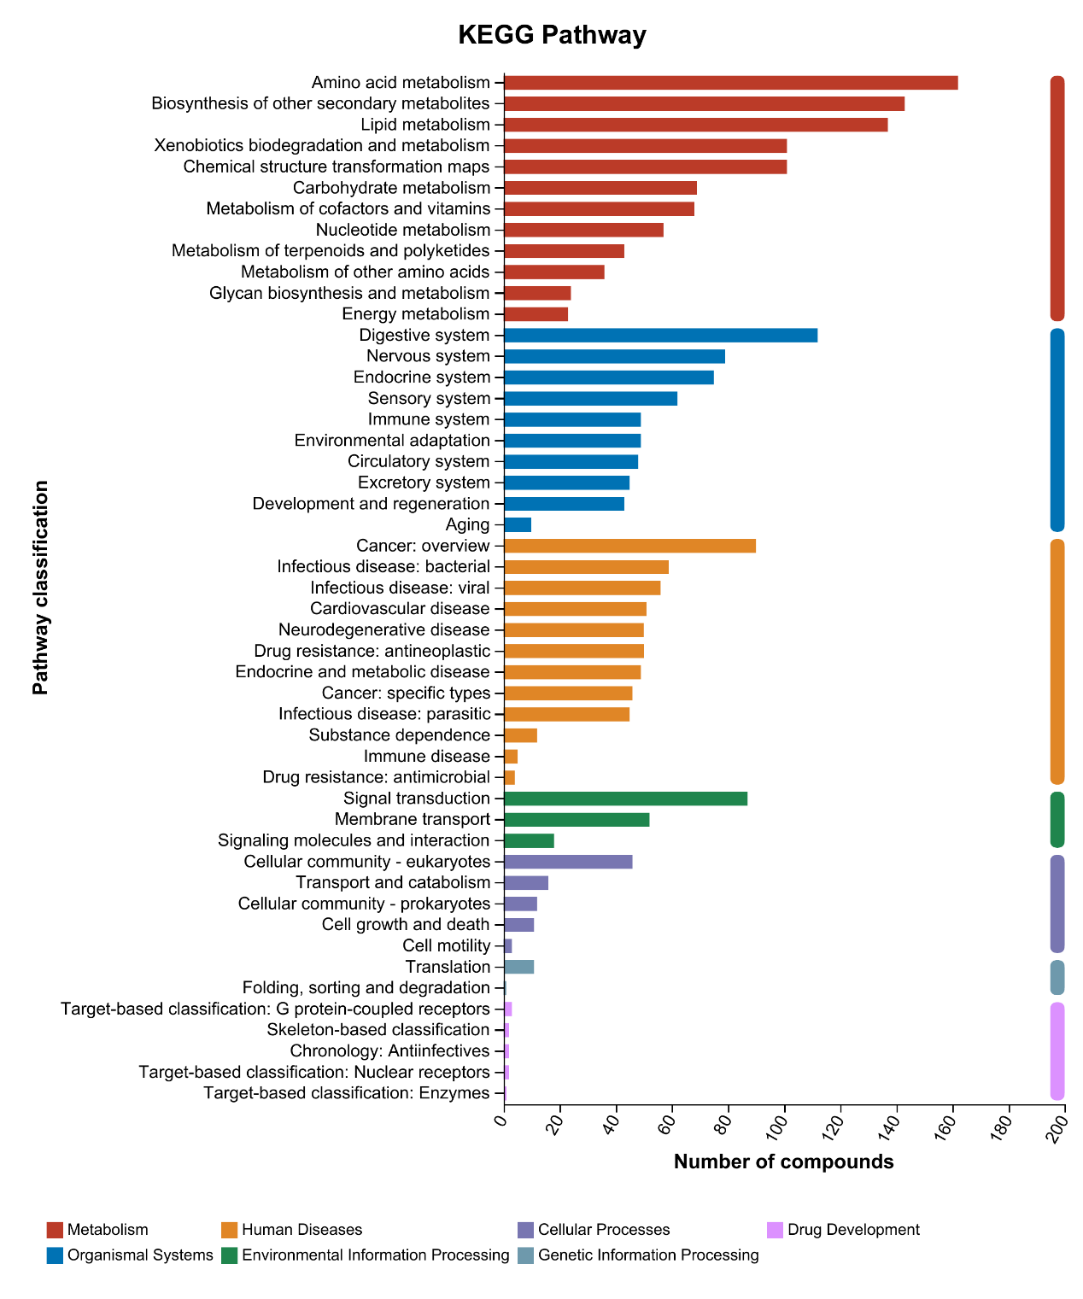
B

Figure 5S A Functional overview of the rumen microbiome; B Enrichment of metabolic pathways in the rumen microbiome.

