Supplemental information
Gut microbiota variation derives differential performance in leaf beetles across host plants
Xiayu Li^{1,#}, Yanping Zhang^{1,#}, Xiaotong Chen¹, Yuxin Zhang¹, Owais Khan¹, Letian Xu^{1, *}
¹Centre for Behavioral Ecology and Evolution (CBEE) & Arachnid Resources Centre of Hubei, School of Life Sciences, Hubei University, Wuhan, China.
# These authors contribute equally.
* Correspondence to: Letian Xu.
Email: Letian Xu: letian0926@163.com; Xiayu Li: xiayuli9866@163.com; Yanping Zhang: zzzyp8566@163.com; Xiaotong Chen: cxt8637@126.com; Yuxin Zhang: zyxin0221@163.com; Owais Khan: owaiskhanmkd12@gmail.com.

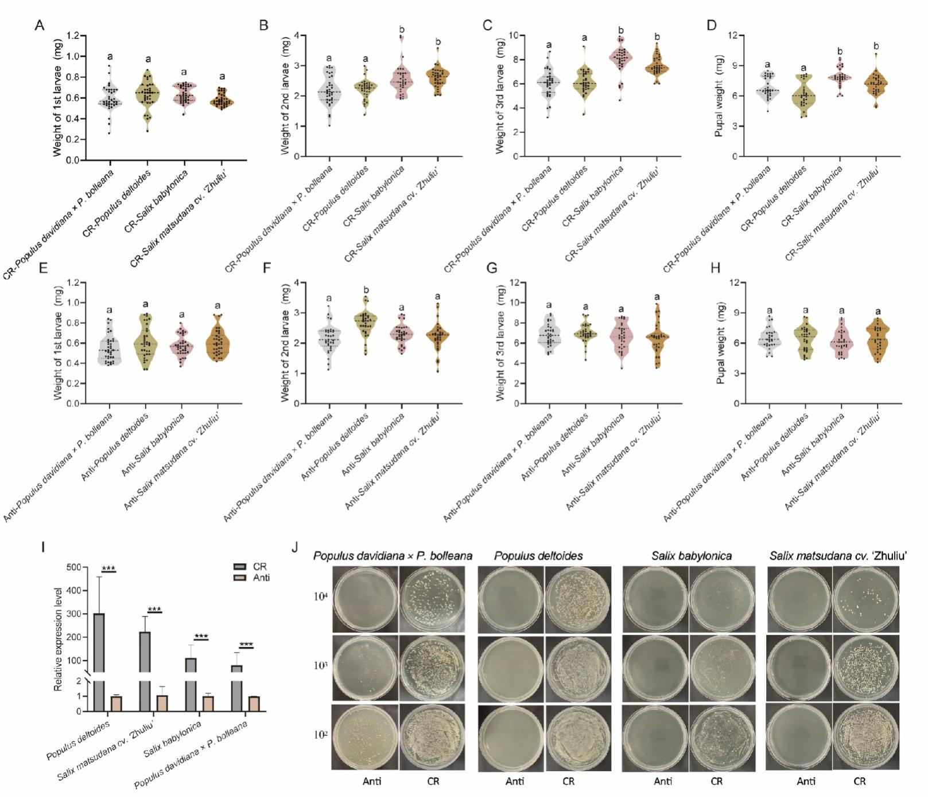
Supplemental Figures
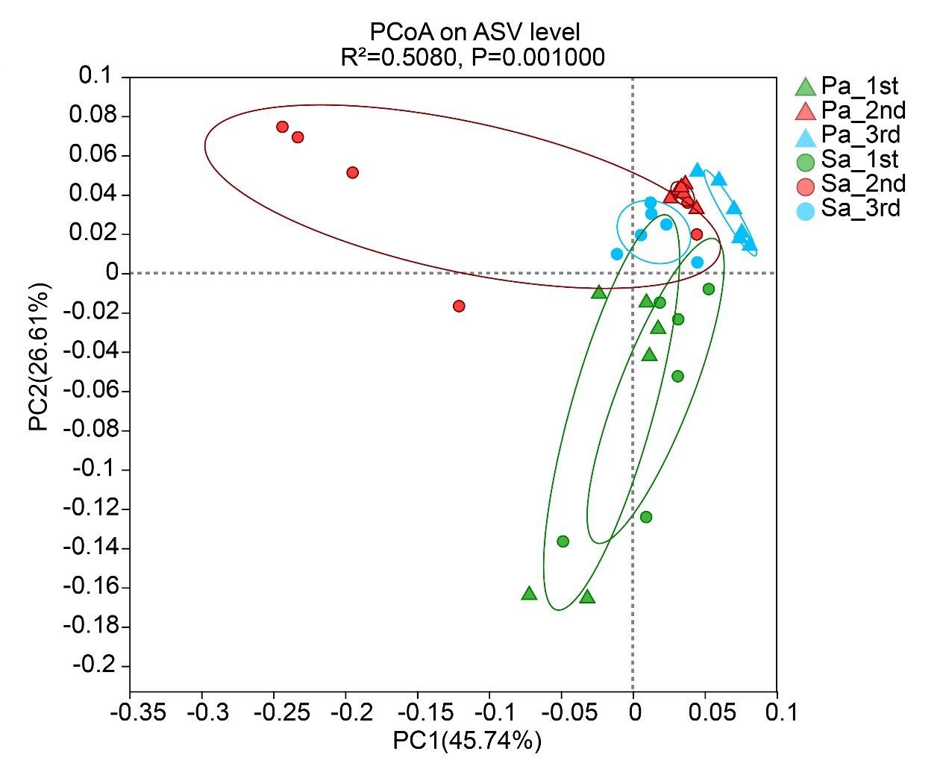
Fig. S1. The role of gut microbiota in the differential phenotypes of Plagiodera versicolora caused by different hosts plants. (A-D) Body weights of larvae at three instars and pupae stage after feeding on conventional rearing (CR) four plants leaves (n = 29-35). (E-H) Body weights of larvae at three instars and pupae stage after feeding on antibiotic (Anti) four plants leaves (n = 27-35). (I) Relative quantification of 16S rRNA in the gut microbiota of larvae fed on CR and Anti treated leaves of four plants. (J) The plate spreading conditions of gut microbiota from larvae fed on CR and Anti treated leaves of four plants under different dilution gradients. Statistical analysis: One-way ANOVA with Bonferroni post-hoc test was used for panels A-H, where same letters indicate no significant differences between groups. Independent samples t-tests for panel I, *P < 0.05, **P < 0.01, ***P < 0.001, NS indicates not significant.
Fig. S2 Principal Coordinate Analysis (PCoA) of P. versicolora larval gut microbiota based on weighted_unifrac dissimilarity. Samples represent P. versicolora larvae from three different instars (1st, 2nd, and 3rd) reared on two distinct host plants: Populus davidiana × P. bolleana (Pa) and Salix babylonica (Sa). Each point represents an individual sample (n=6).
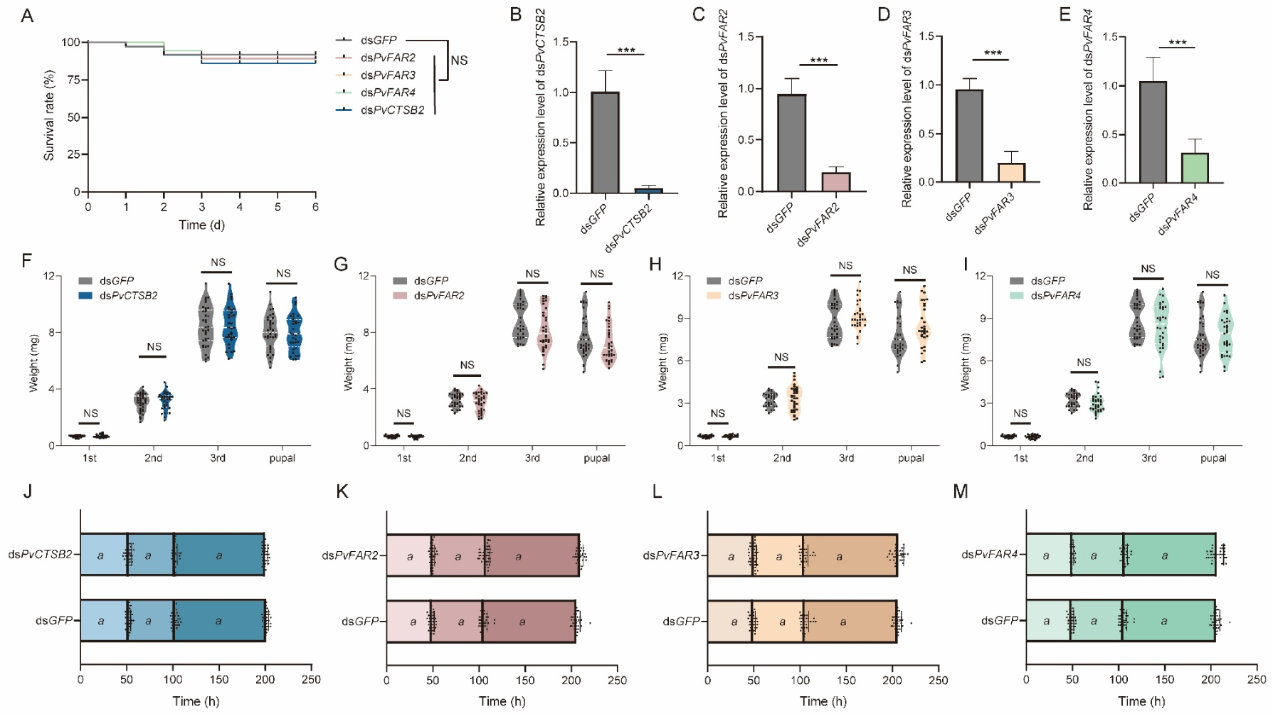
Fig. S3. Effects of knockdown of genes involved in cutin biosynthesis pathway on Plagiodera versicolora performance when feeding on Salix babylonica (Sa). (A) Survival curves of larvae feeding on leaves coated with dsGFP. (B-E) Relative expression levels of target genes under different treatments (n = 6). (F-I) Body weights of larvae at three instars and pupae stage after feeding on Sa leaves coated with four different dsRNAs (n = 29-35). (J-M) Developmental duration of P. versicolora larvae feeding on Sa leaves treated with four different dsRNAs (n = 29-35). Statistical analysis: Independent samples t-tests for panels B-M, *P < 0.05, **P < 0.01, ***P < 0.001. Different letters indicate significant differences at P < 0.05. Log-rank (Mantel-Cox) test for panel A, NS indicates not significant.
Supplemental table
Table S1. Primers used in this study
Primer name | Primer sequence (5'-3')
q16s-F | TCCTACGGGAGGCAGCAGT
q16s-R | GGACTACCAGGGTATCTAATCCTGTT
q18s-F | CTTCCTCGTCGGAGCATTCT
q18s-R | GTTCGCCTTAACTGCCATCAA
PvABCG1-F | TAATACGACTCACTATAGGGTCAAACGACCAATCCAGT
PvABCG1-R | TAATACGACTCACTATAGGGAGATGACTCCGACGAAAG
PvABCG5-F | TAATACGACTCACTATAGGGTGTTGCTGTCGGCTTTAC
PvABCG5-R | TAATACGACTCACTATAGGGAACCTTTGTGGGCGTGT
PvFAR1-F | TAATACGACTCACTATAGGGATGCTGGTATCAGAAGTCG
PvFAR1-R | TAATACGACTCACTATAGGGCATTTCGTGAAGGTGTAAGT
PvFAR2-F | TAATACGACTCACTATAGGGTGGCAGAGGTAGACTTGGA
PvFAR2-R | TAATACGACTCACTATAGGGGCAGATTGTCCATTTCGTC
PvFAR3-F | TAATACGACTCACTATAGGGAGTTGTCGTGGAAGTTTCG
PvFAR3-R | TAATACGACTCACTATAGGGATTTCGGGCATTCTCGTT
PvFAR4-F | TAATACGACTCACTATAGGGAACCAACTACTACGCCCACG
PvFAR4-R | TAATACGACTCACTATAGGGAAACTTCCTCGCACCCAAT
PvCTSB1-F | TAATACGACTCACTATAGGGATACTCAAACACGGTCCAA
PvCTSB1-R | TAATACGACTCACTATAGGGTACGGAGTGTCTAAAGGAAA
PvCTSB2-F | TAATACGACTCACTATAGGGCCCACAGGTTTGAAACAGA
PvCTSB2-R | TAATACGACTCACTATAGGGCACATTGCGGAGTATCGTAG
q-PvABCG1-F | TGGCAGTATCTTCAACCC
q-PvABCG1-R | CGCTACCCTCCACAGTAA
q-PvABCG5-F | CCACTTACAGGACTCGCTAT
q-PvABCG5-R | GCCCAGAGTACCAAACTGA
q-PvFAR1-F | ACATACAGTGCCAGCTTACTT
q-PvFAR1-R | TTCAACCGCTTCCACAGAG
q-PvFAR2-F | GCAACTCCGACAGATACGC
q-PvFAR2-R | CGTTGTTCAGTGGCATCCT
q-PvFAR3-F | CAGGCAACATCGTGGTCT
q-PvFAR3-R | GCAGTTCACTGAAGGGTTT
q-PvFAR4-F | CCAACACTTACGGCACCCT
q-PvFAR4-R | CGTCAAAGCCTTGAGCATCT
q-PvCTSB1-F | GCCTGCTTGTGACAGTTT
q-PvCTSB1-R | ATTGGACCGTGTTTGAGTA
q-PvCTSB2-F | GCTTTCGCTTTGCTGGCTCT
q-PvCTSB2-R | GGTCGTCTGAAGGCTGTTG

