Title: Total and different types of olive oil consumption, gut microbiota, and cognitive function changes in older adults

Supplementary Material:
Supplementary methods.
Supplementary Figure 1. Flowchart of the study population.
Supplementary Figure 2. Proportion of variation in the microbial communities explained by olive oil consumption, baseline cognitive function and covariates.
Supplementary Figure 3. Associations between baseline gut microbial overall composition and 2-y changes in cognitive function.
Supplementary Figure 4. Path diagram of the casual mediation analysis models with all potential exposure-mediator-outcome combinations assessed.
Supplementary Table 1. Baseline characteristics of the study population according to tertiles of energy-adjusted common olive oil consumption
Supplementary Table 2. Cross-sectional association between baseline energy-adjusted olive oil consumption and overall gut microbial composition.
Supplementary Table 3. PERMANOVA test results based on Aitchison distance across tertiles of baseline olive oil consumption.
Supplementary Table 4. Results of MaAsLin2 analysis of associations between energy-adjusted olive oil consumption and gut microbial genus-level features (q<0.25).
Supplementary Table 5. Prospective associations of identified olive oil consumption-related microbial signatures with changes in cognitive function after a 2-year follow-up.
Supplementary references

Supplementary methods

Cognitive function assessment
A Spanish validated version of the Mini-Mental State Examination (MMSE) is a 30-point cognitive screening questionnaire, consisting of two sections [1,2]. The first section evaluates cognitive functions such as orientation, memory, and attention through vocal responses. The second section assesses the ability to name, follow verbal and written commands, write a sentence spontaneously and copy a complex polygon. A higher MMSE score indicates better cognitive performance.
The Clock Drawing Test (CDT) is another cognitive screening instrument primarily used to evaluate visuospatial and visuo-constructive capacities, verbal and numerical knowledge, symbolic and conceptual representation, hemi-attention, memory, and executive function (including organization, planning, and parallel processing) [3,4]. The validated Spanish version used has a score range from 0 to 7 [5].
The validated Spanish version of Verbal Fluency Tests (VFTs) examine verbal ability and executive function, consisting of two parts: 1) the semantic verbal fluency task-animal category version (VFT-a), where participants were requested to name as many different animals as possible in 60 seconds; and 2) the phonemic verbal fluency task-letter “p” version (VFT-p), where participants list as many words as possible starting with the letter P (avoiding names of people or places or repetitions of the same word with different suffixes) in 60 seconds. The total raw score for each task corresponds to the number of correct words produced [6,7].
The Digit Span Tests (DSTs) of the WAIS-III Spanish version assesses attention and memory [8,9,10]. The DST forward recall (DST-f) evaluates attention and short-term memory capacity by having participants orally repeat a series of random single digits in the same order as they were heard, with the sequence varying in length from three to nine. The DST backward recall (DST-b) tests working memory capacity by requiring participants to repeat a series of random single digits in reverse order, with the sequence varying from two to eight. The performance on the DSTs is reported by direct scores for forward (ranging from 1 to 16) and backward (ranging from 1 to 14) task performance.
The Trail Making Tests (TMTs), frequently used to assess executive function, consists of 25 circles spread out over two sheets of paper (parts A and B). In part A (TMT-A), assessing attention and processing speed capacities, participants connect consecutive numbers (1–2–3–4-…) in the correct order by drawing a line. In part B (TMT-B), examining cognitive flexibility, participants connect consecutive numbers and letters in an alternating numeric and alphabetic sequence (1-A-2-B-3-C-…). Each part is scored according to the time taken to complete the task; thus, lower scores represent better performance [10,11,12].

Fecal microbial DNA extraction and 16S ribosomal RNA (rRNA) amplicon sequencing
Baseline stool samples were collected post-randomization from participants randomly selected at PREDIMED-Plus centers before the intervention commenced. Participants collected the samples at home following detailed illustrated instructions and frozen for preservation until delivery to the laboratory. Upon arrival, stool samples were separated into 250mg aliquots and stored at −80ºC until microbial DNA extraction. Prior to DNA extraction, the stool samples were disrupted in a 5min lysis step using FastPrep-24TM 5G Homogenizer (MP Biomedicals, Santa Ana, CA, USA), followed by microbial DNA extraction using the QIAmp PowerFecal DNA kit (Qiagen, Hilden, Germany) according to the manufacturer’s instructions. Subsequently, the extracted DNA was stored at −20ºC until further processing. DNA concentration and purity were evaluated using the Qubit 2.0 Fluorometer-dsDNA Broad Range (BR) Assay Kit (Thermo Fisher Scientific, Waltham, MA, USA). TheV4 region (515F-806R) of the prokaryotic 16S rRNA gene was amplified in triplicate PCR reactions. The PCR reaction mix was prepared in a total volume of 35 µl, containing a 0.7µl unique barcoded primer (515F-n and 806R-n, 10µM each per reaction), 0.7µl dNTPs mixture, 0.35µl Phusion Green Hot Start II High-Fidelity DNA Polymerase (2U/µl; Thermo Scientific, Landsmeer, The Netherlands), 7µl 5× Phusion Green HF Buffer, and 25.5µl DNAse-RNAse-free water (Promega, Madison, WI, USA). PCR conditions included an initial denaturation step at 98°C for 30 seconds, followed by 25 cycles of denaturation at 98ºC for 10 seconds, annealing at 50ºC for 10 seconds, elongation at 72ºC for 10 seconds, and a final extension step at 72ºC for 7min. PCR products were visualized on a 1% agarose gel (approximately 290bp) and purified with CleanPCR kit (CleanNA, Alphen Aan den Rijn, The Netherlands). The DNA concentration of the purified PCR products was quantified using the Qubit dsDNA BR Assay Kit. Subsequently, sequencing libraries were constructed using 200ng of purified PCR product and sequenced on an Illumina Novaseq platform. To ensure data quality, artificial mock communities were included in each library as positive controls, and negative control samples were also included in each library, using as DNA template, nuclease free-water or material from DNA extraction blanks to detect potential contaminant sequences. Raw sequence data were processed using the NG-Tax pipeline [13], with a read length of 100nt. Paired-end libraries were demultiplexed, and only read pairs with perfectly matching barcodes were used for downstream analysis. Amplicon sequence variants (ASVs) were determined with the default settings and taxonomy was assigned using the USEARCH algorithm [14] and the Silva database (v138.1) [15].
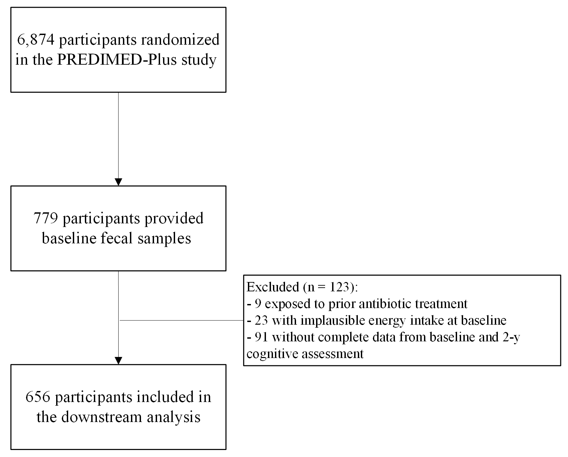

Figure 1. Flowchart of the study population.

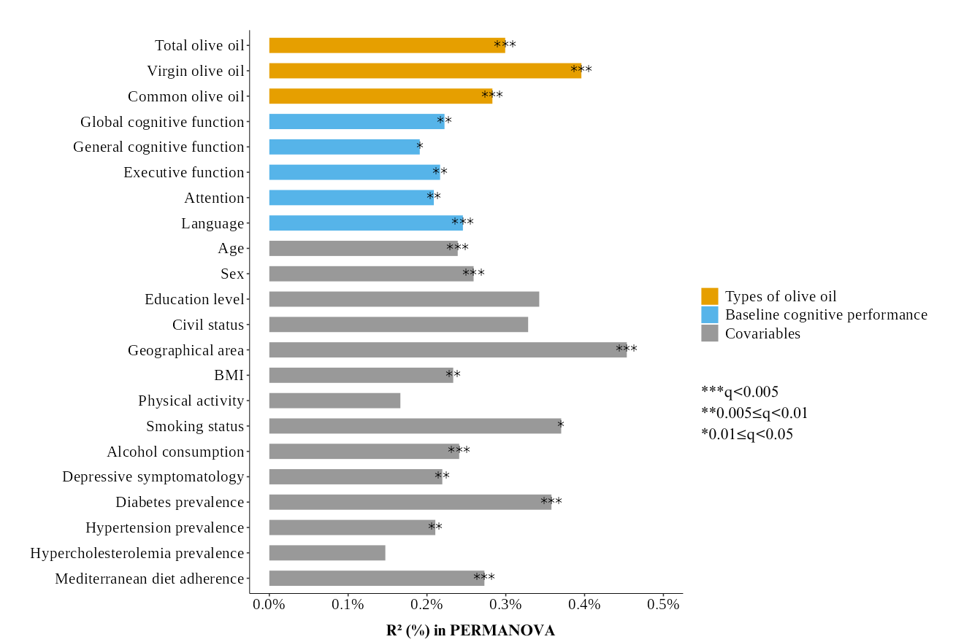
Figure 2. Proportion of variation in the microbial communities explained by olive oil consumption, baseline cognitive function and covariates as quantified by PERMANOVA using Aitchison distance. The q values (false discovery rate adjusted p value) were calculated using the Benjamini-Hochberg method with a target rate of 0.05. Abbreviations: BMI, body mass index; PERMANOVA, permutational multivariate analysis of variance

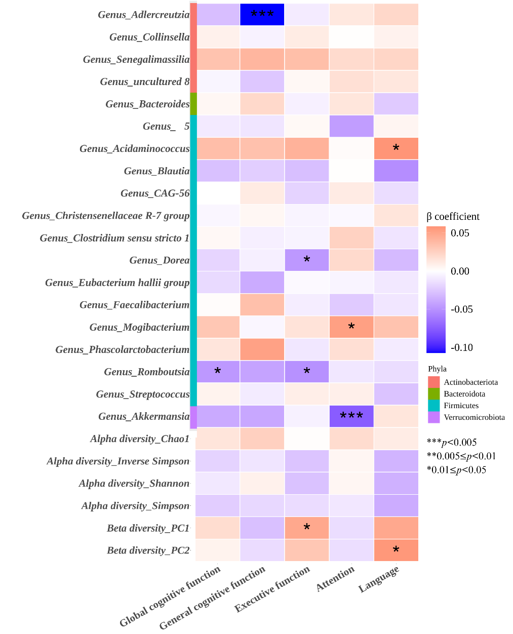
Figure 3. Associations of overall gut microbial composition and olive oil-related microbial features with 2-y changes in cognitive function. The blue-to-red gradient of the heatmap represents the magnitude and direction of the associations (β-coefficients) for gut microbial variables derived from multivariable linear regression models with changes in cognitive function as outcomes. All continuous predictors were converted to z scores before analysis, and genus-level relative abundances were clr-transformed before z-conversion. All models were fully adjusted for respective cognitive composite scores at baseline, age (years), sex, PREDIMED-Plus groups of randomization, geographical area (Catalonia or Valencia), educational level (primary or lower, high school, or college), civil status (single, divorced, separated, married, or widower), BMI (kg/m²), physical activity (METs-min/day), smoking status (never, former, or current smoker), alcohol consumption in g/day and adding the quadratic term, depressive symptomatology (yes or no), prevalence of diabetes (yes or no), hypertension (yes or no), and hypercholesterolemia (yes or no), and Mediterranean diet adherence (modified 12-point MEDAS score). The effect size reflects the scaled unit change of alpha diversity indices (Chao1, Simpson, Shannon, and Inverse Simpson), beta diversity (PC1 and PC2), and clr-transformed relative abundances of the genus-level taxa. Beta diversity was quantified using Aitchison distance. Asterisks denote significance levels (*p<0.05; **p<0.01; ***p<0.005), p<0.05 was deemed statistically significant. Abbreviations: BMI, body mass index; clr, centered log-ratio; MEDAS, Mediterranean diet adherence screener; METs, metabolic equivalents; PC, principal component; PREDIMED-Plus, PREvención con DIeta MEDiterránea-Plus.
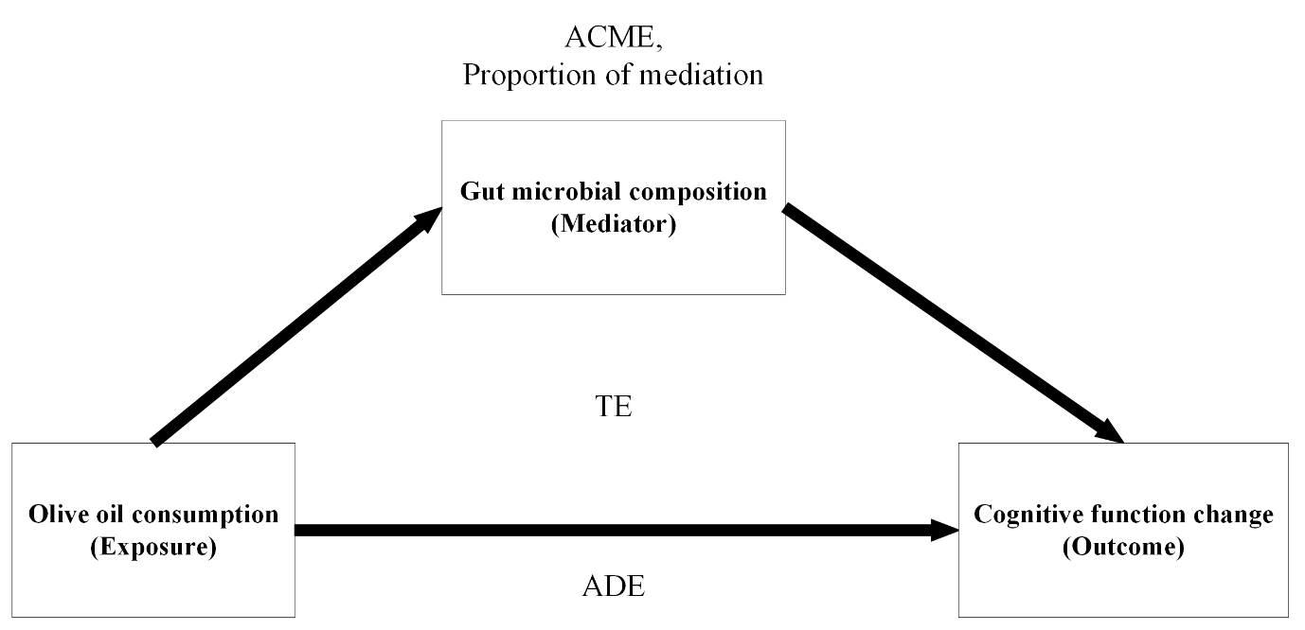
Figure 4. Path diagram of the casual mediation analysis models. The average causal mediation effect (ACME) denoted the indirect effects of the olive oil consumption on cognitive changes through the mediators. The average direct effect (ADE) represented the effects of the baseline olive oil consumption on cognitive changes without the involvement of a mediator. The proportion of mediation was calculated via dividing the ACME by the total effect (TE), which encompasses all direct and indirect effects of the exposure on the outcome.

Table 1. Baseline characteristics of the study population according to tertiles of energy-adjusted common olive oil consumptionª.
 | Overall  (n = 656) | T1  (n = 219) | T2  (n = 219) | T3  (n = 218)
Women, n (%) | 314 (48) | 66 (30) | 118 (54) | 130 (60)
Age, y | 65.0 (4.9) | 64.4 (5.0) | 65.4 (4.9) | 65.3 (4.8)
Education level, n (%)
Primary school or less | 355 (54) | 93 (43) | 125 (57) | 137 (63)
High school | 183 (28) | 68 (31) | 62 (28) | 53 (24)
College | 118 (18) | 58 (27) | 32 (15) | 28 (13)
Civil status, n (%)
Single, divorced or separated | 87 (13) | 27 (12) | 26 (12) | 34 (16)
Married | 504 (77) | 174 (80) | 174 (80) | 156 (72)
Widower | 65 (10) | 18 (8) | 19 (9) | 28 (13)
Geographically area, n (%)
Catalonia | 403 (61) | 136 (62) | 154 (70) | 113 (52)
Valencia | 253 (39) | 83 (38) | 65 (30) | 105 (48)
Intervention group, n (%) | 312 (48) | 102 (47) | 109 (50) | 101 (46)
BMI, kg/m² | 32.7 (3.5) | 32.4 (3.4) | 33.0 (3.6) | 32.8 (3.5)
Waist circumference, cm | 107.5 (10.1) | 107.7 (9.5) | 107.6 (10.4) | 107.3 (10.6)
Smoking status, n (%)
Never smoker | 312 (48) | 86 (39) | 118 (54) | 108 (50)
Former smoker | 255 (39) | 102 (47) | 77 (35) | 76 (35)
Smoker | 89 (14) | 31 (14) | 24 (11) | 34 (16)
Physical activity, METs-min/day | 372 (350) | 395 (369) | 370 (345) | 350 (336)
Modified MedDiet score, 12-point MEDAS | 6.9 (1.6) | 6.76 (1.89) | 7.09 (1.48) | 6.80 (1.51)
Type 2 diabetes, n (%) | 174 (27) | 51 (23) | 55 (25) | 68 (31)
Hypertension, n (%) | 532 (81) | 172 (79) | 176 (80) | 184 (84)
Hypercholesterolemia, n (%) | 434 (66) | 130 (59) | 138 (63) | 166 (76)
Depressive symptomatology, n (%) | 127 (19) | 30 (14) | 44 (20) | 53 (24)
Global cognitive function, z-score | 0.00 (1.00) | 0.22 (0.94) | -0.09 (0.95) | -0.13 (1.07)
General cognitive function, z-score | 0.00 (1.00) | 0.14 (0.92) | -0.01 (0.95) | -0.13 (1.11)
Executive function, z-score | 0.00 (1.00) | 0.23 (0.98) | -0.13 (0.96) | -0.10 (1.03)
Attention, z-score | 0.00 (1.00) | 0.16 (0.88) | -0.05 (0.91) | -0.11 (1.17)
Language, z-score | 0.00 (1.00) | 0.22 (1.02) | -0.18 (0.93) | -0.04 (1.01)
Energy intake, kcal/d | 2,474 (502) | 2,939 (303) | 2,235 (192) | 2,248 (553)
Fatty acids intake, % of total energy
Monounsaturated | 22 (4) | 21 (3) | 23 (4) | 21 (5)
Polyunsaturated | 7 (2) | 7 (2) | 7 (2) | 7 (2)
Saturated | 10 (2) | 11 (2) | 10 (2) | 10 (2)
Fibre, g/d | 27 (8) | 29 (9) | 26 (7) | 26 (8)
Alcohol, g/d | 11 (14) | 16 (16) | 7 (9) | 9 (14)
Vegetables, g/d | 349 (140) | 352 (152) | 326 (124) | 368 (141)
Fruits, g/d | 368 (203) | 394 (233) | 337 (170) | 373 (198)
Legumes, g/d | 20 (10) | 21 (11) | 20 (10) | 18 (10)
Cereals, g/d | 160 (69) | 195 (65) | 143 (58) | 141 (71)
Dairy products, g/d | 307 (177) | 344 (179) | 284 (178) | 293 (168)
Meat, g/d | 161 (55) | 175 (58) | 153 (53) | 153 (52)
Fish, g/d | 107 (46) | 116 (48) | 104 (44) | 102 (46)
Nuts, g/d | 17 (16) | 20 (17) | 16 (15) | 15 (16)
Confectionery products, g/d | 25 (27) | 31 (28) | 18 (19) | 26 (29)
Data are presented as n (%) and mean (SD) for categorical and continuous variables, respectively.
ªAdjustment for total energy intake with the residual method. Dietary variables presented in accordance with tertiles of energy-adjusted common olive oil consumption were raw values before energy adjustment.
Abbreviations: BMI, body mass index; MedDiet, Mediterranean diet; MEDAS, Mediterranean Diet Adherence Screener; METs, metabolic equivalents; SD, standard deviation; T, tertile.

Table 2. Cross-sectional association between baseline energy-adjusted olive oil consumption and overall gut microbial compositionª.
 | Continuous  (per 10 g/d increment) |  | T1  (low) | T2  (medium) | T3  (high)
 | β (95% CI) | p | Reference | β (95% CI) | β (95% CI) | p-trend^{b}
Total olive oil
Alpha diversity, Chao1
Basic model | 1.013 [0.064, 1.963] | 0.037 | reference | 3.228 [-0.036, 6.491] | 4.504 [1.238, 7.770] | 0.005
Socio-demographically adjusted model | 0.881 [-0.074, 1.835] | 0.070 | reference | 2.363 [-1.034, 5.760] | 3.885 [0.573, 7.197] | 0.023
Fully adjusted model | 0.701 [-0.257, 1.658] | 0.151 | reference | 0.990 [-2.476, 4.456] | 2.972 [-0.372, 6.315] | 0.111
Alpha diversity, Simpson
Basic model | 0.000 [-0.006, 0.006] | 0.986 | reference | 0.006 [-0.015, 0.026] | -0.008 [-0.029, 0.012] | 0.664
Socio-demographically adjusted model | 0.000 [-0.006, 0.006] | 0.908 | reference | 0.004 [-0.017, 0.025] | -0.010 [-0.031, 0.011] | 0.531
Fully adjusted model | 0.000 [-0.006, 0.006] | 0.953 | reference | 0.007 [-0.015, 0.029] | -0.008 [-0.030, 0.013] | 0.652
Alpha diversity, Shannon
Basic model | 0.013 [-0.014, 0.040] | 0.333 | reference | 0.075 [-0.017, 0.167] | 0.058 [-0.034, 0.150] | 0.129
Socio-demographically adjusted model | 0.012 [-0.015, 0.038] | 0.402 | reference | 0.064 [-0.032, 0.160] | 0.050 [-0.043, 0.144] | 0.213
Fully adjusted model | 0.007 [-0.020, 0.034] | 0.593 | reference | 0.031 [-0.066, 0.129] | 0.029 [-0.065, 0.124] | 0.495
Alpha diversity, Inverse Simpson
Basic model | 0.202 [-0.348, 0.751] | 0.472 | reference | 1.565 [-0.326, 3.455] | 0.546 [-1.346, 2.438] | 0.319
Socio-demographically adjusted model | 0.157 [-0.399, 0.712] | 0.580 | reference | 1.303 [-0.674, 3.280] | 0.352 [-1.576, 2.280] | 0.498
Fully adjusted model | 0.122 [-0.440, 0.685] | 0.669 | reference | 1.061 [-0.974, 3.097] | 0.133 [-1.830, 2.097] | 0.690
Beta diversity, PC1
Basic model | -0.946 [-1.571, -0.321] | 0.003 | reference | -3.712 [-5.854, -1.569] | -3.557 [-5.701, -1.412] | <0.001
Socio-demographically adjusted model | -0.900 [-1.534, -0.266] | 0.005 | reference | -3.780 [-6.029, -1.530] | -3.545 [-5.739, -1.352] | <0.001
Fully adjusted model | -0.744 [-1.377, -0.111] | 0.021 | reference | -2.885 [-5.171, -0.598] | -3.006 [-5.212, -0.800] | 0.004
Beta diversity, PC2
Basic model | -0.127 [-0.647, 0.393] | 0.632 | reference | -0.736 [-2.528, 1.056] | -0.025 [-1.819, 1.769] | 0.768
Socio-demographically adjusted model | -0.155 [-0.679, 0.369] | 0.561 | reference | -1.155 [-3.022, 0.711] | -0.305 [-2.125, 1.515] | 0.529
Fully adjusted model | -0.188 [-0.724, 0.347] | 0.490 | reference | -1.487 [-3.425, 0.452] | -0.465 [-2.335, 1.405] | 0.409
Virgin olive oil
Alpha diversity, Chao1
Basic model | 1.086 [0.428, 1.744] | 0.001 | reference | 4.217 [0.927, 7.507] | 4.884 [1.624, 8.145] | 0.002
Socio-demographically adjusted model | 0.974 [0.307, 1.641] | 0.004 | reference | 3.309 [-0.113, 6.731] | 4.294 [0.999, 7.588] | 0.009
Fully adjusted model | 0.861 [0.189, 1.532] | 0.012 | reference | 3.023 [-0.418, 6.464] | 3.890 [0.607, 7.173] | 0.016
Alpha diversity, Simpson
Basic model | 0.002 [-0.002, 0.006] | 0.361 | reference | 0.013 [-0.007, 0.034] | 0.006 [-0.014, 0.026] | 0.342
Socio-demographically adjusted model | 0.002 [-0.002, 0.006] | 0.420 | reference | 0.013 [-0.009, 0.034] | 0.006 [-0.015, 0.026] | 0.400
Fully adjusted model | 0.002 [-0.002, 0.006] | 0.340 | reference | 0.015 [-0.007, 0.037] | 0.007 [-0.014, 0.028] | 0.321
Alpha diversity, Shannon
Basic model | 0.020 [0.001, 0.038] | 0.037 | reference | 0.105 [0.013, 0.198] | 0.085 [-0.007, 0.177] | 0.025
Socio-demographically adjusted model | 0.019 [0.000, 0.037] | 0.054 | reference | 0.096 [-0.001, 0.192] | 0.078 [-0.015, 0.171] | 0.049
Fully adjusted model | 0.016 [-0.003, 0.035] | 0.090 | reference | 0.093 [-0.004, 0.190] | 0.071 [-0.022, 0.163] | 0.066
Alpha diversity, Inverse Simpson
Basic model | 0.458 [0.077, 0.839] | 0.019 | reference | 2.377 [0.474, 4.281] | 1.744 [-0.143, 3.630] | 0.019
Socio-demographically adjusted model | 0.430 [0.041, 0.818] | 0.030 | reference | 2.223 [0.234, 4.212] | 1.637 [-0.279, 3.552] | 0.037
Fully adjusted model | 0.416 [0.021, 0.810] | 0.039 | reference | 2.278 [0.260, 4.297] | 1.568 [-0.358, 3.494] | 0.041
Beta diversity, PC1
Basic model | -0.776 [-1.210, -0.342] | <0.001 | reference | -3.196 [-5.368, -1.024] | -2.683 [-4.836, -0.530] | 0.003
Socio-demographically adjusted model | -0.749 [-1.192, -0.305] | <0.001 | reference | -3.156 [-5.433, -0.878] | -2.638 [-4.832, -0.445] | 0.005
Fully adjusted model | -0.621 [-1.066, -0.177] | 0.006 | reference | -2.667 [-4.946, -0.388] | -2.259 [-4.434, -0.085] | 0.016
Beta diversity, PC2
Basic model | -0.067 [-0.429, 0.295] | 0.717 | reference | -0.826 [-2.636, 0.984] | -0.476 [-2.269, 1.318] | 0.451
Socio-demographically adjusted model | -0.105 [-0.472, 0.263] | 0.577 | reference | -1.323 [-3.205, 0.559] | -0.795 [-2.607, 1.017] | 0.241
Fully adjusted model | -0.131 [-0.508, 0.246] | 0.496 | reference | -1.454 [-3.383, 0.474] | -0.835 [-2.675, 1.005] | 0.217
Common olive oil
Alpha diversity, Chao1
Basic model | -1.481 [-2.521, -0.440] | 0.005 | reference | 0.864 [-2.455, 4.183] | -3.900 [-7.256, -0.544] | 0.003
Socio-demographically adjusted model | -1.321 [-2.366, -0.276] | 0.013 | reference | 0.591 [-2.735, 3.917] | -3.975 [-7.351, -0.600] | 0.004
Fully adjusted model | -1.226 [-2.263, -0.188] | 0.021 | reference | 0.345 [-3.031, 3.720] | -3.314 [-6.724, 0.095] | 0.019
Alpha diversity, Simpson
Basic model | -0.005 [-0.011, 0.002] | 0.144 | reference | 0.001 [-0.020, 0.022] | -0.019 [-0.039, 0.002] | 0.038
Socio-demographically adjusted model | -0.005 [-0.011, 0.002] | 0.165 | reference | 0.000 [-0.021, 0.021] | -0.019 [-0.040, 0.002] | 0.040
Fully adjusted model | -0.005 [-0.011, 0.002] | 0.158 | reference | 0.003 [-0.019, 0.025] | -0.018 [-0.040, 0.004] | 0.043
Alpha diversity, Shannon
Basic model | -0.033 [-0.063, -0.004] | 0.025 | reference | -0.017 [-0.110, 0.076] | -0.132 [-0.226, -0.038] | 0.003
Socio-demographically adjusted model | -0.031 [-0.061, -0.002] | 0.037 | reference | -0.025 [-0.118, 0.069] | -0.141 [-0.236, -0.046] | 0.002
Fully adjusted model | -0.030 [-0.060, -0.001] | 0.042 | reference | -0.028 [-0.123, 0.067] | -0.125 [-0.221, -0.029] | 0.008
Alpha diversity, Inverse Simpson
Basic model | -0.897 [-1.497, -0.297] | 0.003 | reference | 0.089 [-1.820, 1.998] | -3.042 [-4.972, -1.112] | <0.001
Socio-demographically adjusted model | -0.862 [-1.468, -0.256] | 0.005 | reference | -0.046 [-1.969, 1.877] | -3.167 [-5.118, -1.215] | <0.001
Fully adjusted model | -0.847 [-1.454, -0.239] | 0.006 | reference | 0.054 [-1.916, 2.025] | -2.900 [-4.890, -0.910] | <0.001
Beta diversity, PC1
Basic model | 0.790 [0.102, 1.478] | 0.025 | reference | 1.585 [-0.587, 3.757] | 4.981 [2.785, 7.177] | <0.001
Socio-demographically adjusted model | 0.747 [0.050, 1.444] | 0.036 | reference | 1.513 [-0.685, 3.712] | 4.866 [2.635, 7.098] | <0.001
Fully adjusted model | 0.603 [-0.086, 1.292] | 0.086 | reference | 1.454 [-0.770, 3.678] | 4.009 [1.762, 6.256] | <0.001
Beta diversity, PC2
Basic model | 0.013 [-0.559, 0.585] | 0.964 | reference | 0.644 [-1.181, 2.468] | 0.972 [-0.873, 2.816] | 0.429
Socio-demographically adjusted model | 0.069 [-0.506, 0.644] | 0.814 | reference | 0.437 [-1.397, 2.270] | 0.814 [-1.046, 2.675] | 0.469
Fully adjusted model | 0.089 [-0.493, 0.672] | 0.764 | reference | 0.462 [-1.432, 2.355] | 0.955 [-0.957, 2.868] | 0.390
Basic model adjusted for age (years), and sex.
Socio-demographically adjusted model further adjusted for geographical area (Catalonia or Valencia), educational level (primary or lower, high school, or college), civil status (single, divorced, separated, married, or widower).
Fully adjusted model further adjusted for BMI (kg/m²), physical activity (METs-min/day), smoking status (never, former, or current smoker), alcohol consumption in g/day and adding the quadratic term, depressive symptomatology (yes or no), prevalence of diabetes (yes or no), hypertension (yes or no), and hypercholesterolemia (yes or no), and Mediterranean diet adherence (modified 12-point MEDAS score).
ª Values are β-coefficients [95% CI] estimated from linear regression models. In the continuous model, β-coefficients represent changes in microbial community composition indices associated with 10g increment in olive oil consumption per day. In the categorical model, β-coefficients represent changes in microbial community composition indices in each tertile of olive oil consumption versus reference tertile (T1). p<0.05 was deemed statistically significant.
^{b} Linear trend was calculated by assigning the median values of each tertile of olive oil and treating these values across tertiles as a continuous variable in the linear regression models.
Abbreviations: BMI, body mass index; CI, confidence interval; MEDAS, Mediterranean diet adherence screener; METs, metabolic equivalents; PC, principal component.

Table 3. PERMANOVA test results based on Aitchison distance across tertiles of baseline olive oil consumption.
 | Df | SumOfSqs | R² | F | Pr(>F)
Total olive oil
Basic model | 2 | 8448 | 0.00494 | 1.6224 | 0.001
Socio-demographically adjusted model | 2 | 7408 | 0.00433 | 1.4268 | 0.001
Fully adjusted model | 2 | 6419 | 0.00375 | 1.2421 | 0.008
Virgin olive oil
Basic model | 2 | 8011 | 0.00468 | 1.5382 | 0.001
Socio-demographically adjusted model | 2 | 7051 | 0.00412 | 1.3579 | 0.002
Fully adjusted model | 2 | 6502 | 0.00380 | 1.2581 | 0.011
Common olive oil
Basic model | 2 | 10416 | 0.00609 | 2.0028 | 0.001
Socio-demographically adjusted model | 2 | 9458 | 0.00553 | 1.8240 | 0.001
Fully adjusted model | 2 | 8223 | 0.00480 | 1.5928 | 0.001
PERMANOVA with 999 permutations was performed to test for significant beta diversity clustering across tertiles of olive oil consumption, using the adonis2 function with the argument “by” set to “margin” in the R package vegan (version 2.6-4).
Basic model adjusted for age (years), and sex.
Socio-demographically adjusted model further adjusted for geographical area (Catalonia or Valencia), educational level (primary or lower, high school, or college), civil status (single, divorced, separated, married, or widower).
Fully adjusted model further adjusted for BMI (kg/m²), physical activity (METs-min/day), smoking status (never, former, or current smoker), alcohol consumption in g/day and adding the quadratic term, depressive symptomatology (yes or no), prevalence of diabetes (yes or no), hypertension (yes or no), and hypercholesterolemia (yes or no), and Mediterranean diet adherence (modified 12-point MEDAS score).
Pr(>F) < 0.05 deemed as significant.
Abbreviations: BMI, body mass index; MEDAS, Mediterranean diet adherence screener; METs, metabolic equivalents; PERMANOVA, permutational multivariate analysis of variance; SumOfSqs, sum of squares.

Table 4. Results of MaAsLin2 analysis of associations between energy-adjusted olive oil consumption and gut microbial genus-level features (q<0.25).
feature | coef | stderr | pval | qval | olive oil consumption variable | phylum
Clostridium_sensu_stricto_1 | -0.0014032 | 0.00040269 | 0.00052678 | 0.04068622 | TOO | Firmicutes
Adlercreutzia | -0.00017886 | 5.1964E-05 | 0.00061536 | 0.04481845 | TOO | Actinobacteriota
Phascolarctobacterium | 0.00172685 | 0.00057116 | 0.00259986 | 0.10328539 | TOO | Firmicutes
Bacteroides | 0.00939733 | 0.00309807 | 0.00251765 | 0.10328539 | TOO | Bacteroidota
Collinsella | -0.00081368 | 0.00028567 | 0.00453714 | 0.16185565 | TOO | Actinobacteriota
Senegalimassilia | -0.00027193 | 9.8642E-05 | 0.00600516 | 0.18098319 | TOO | Actinobacteriota
Dorea | -0.00080654 | 0.00030873 | 0.0092011 | 0.22464377 | TOO | Firmicutes
Acidaminococcus | 0.00069689 | 0.00026552 | 0.00888176 | 0.22464377 | TOO | Firmicutes
Eubacterium_hallii_group | -0.00162071 | 0.00063078 | 0.01041551 | 0.23341418 | TOO | Firmicutes
Blautia | -0.00386566 | 0.00159803 | 0.01584192 | 0.29518294 | TOO | Firmicutes
Akkermansia | -0.00336851 | 0.00145346 | 0.02078839 | 0.33559923 | TOO | Verrucomicrobiota
uncultured_8 | -0.00035487 | 0.00016293 | 0.02976513 | 0.40968068 | TOO | Actinobacteriota
Romboutsia | -0.00090249 | 0.00043639 | 0.03903446 | 0.4211695 | TOO | Firmicutes
CAG.56 | 0.00016472 | 7.8479E-05 | 0.03622213 | 0.4211695 | TOO | Firmicutes
___5 | -0.00093763 | 0.00051765 | 0.07056291 | 0.51578465 | TOO | Firmicutes
Christensenellaceae_R.7_group | 0.00116271 | 0.00070859 | 0.10131654 | 0.59630069 | TOO | Firmicutes
Mogibacterium | -0.000148 | 9.4078E-05 | 0.11617026 | 0.60980665 | TOO | Firmicutes
Streptococcus | -0.00060566 | 0.00082285 | 0.46196558 | 0.88135502 | TOO | Firmicutes
Faecalibacterium | 0.00073656 | 0.00110439 | 0.50505172 | 0.89474529 | TOO | Firmicutes
Adlercreutzia | -0.0001623 | 3.6346E-05 | 9.4494E-06 | 0.0015016 | VOO | Actinobacteriota
Eubacterium_hallii_group | -0.0016407 | 0.00044147 | 0.00021986 | 0.02401928 | VOO | Firmicutes
Dorea | -0.00075591 | 0.00021638 | 0.00050982 | 0.04455857 | VOO | Firmicutes
Akkermansia | -0.00331693 | 0.00101879 | 0.00119095 | 0.07065989 | VOO | Verrucomicrobiota
Bacteroides | 0.00703774 | 0.00217831 | 0.00129803 | 0.07306593 | VOO | Bacteroidota
Clostridium_sensu_stricto_1 | -0.00090447 | 0.00028384 | 0.00151065 | 0.07346704 | VOO | Firmicutes
Collinsella | -0.00063955 | 0.00020074 | 0.00151305 | 0.07346704 | VOO | Actinobacteriota
uncultured_8 | -0.00036073 | 0.0001142 | 0.00165951 | 0.07633724 | VOO | Actinobacteriota
Blautia | -0.00343285 | 0.00112161 | 0.00230168 | 0.10058342 | VOO | Firmicutes
Streptococcus | -0.00165271 | 0.00057564 | 0.00422687 | 0.1357134 | VOO | Firmicutes
Romboutsia | -0.00087918 | 0.00030618 | 0.00422164 | 0.1357134 | VOO | Firmicutes
Phascolarctobacterium | 0.00115951 | 0.00040224 | 0.00407639 | 0.1357134 | VOO | Firmicutes
___5 | -0.00104079 | 0.00036292 | 0.00427016 | 0.1357134 | VOO | Firmicutes
Acidaminococcus | 0.00051457 | 0.00018677 | 0.00603452 | 0.16743397 | VOO | Firmicutes
Mogibacterium | -0.00016967 | 6.5998E-05 | 0.01037129 | 0.22381493 | VOO | Firmicutes
CAG.56 | 0.00013989 | 5.5146E-05 | 0.01142608 | 0.22957233 | VOO | Firmicutes
Senegalimassilia | -0.00015759 | 6.9557E-05 | 0.02381071 | 0.34397614 | VOO | Actinobacteriota
Faecalibacterium | 0.00166711 | 0.00077472 | 0.03178184 | 0.39449704 | VOO | Firmicutes
Christensenellaceae_R.7_group | -0.00058621 | 0.00049921 | 0.24072204 | 0.74351577 | VOO | Firmicutes
Streptococcus | 0.00322687 | 0.00088563 | 0.00029078 | 0.03125854 | COO | Firmicutes
Christensenellaceae_R.7_group | 0.00277225 | 0.000764 | 0.00030785 | 0.03125854 | COO | Firmicutes
Adlercreutzia | 0.00017584 | 5.6581E-05 | 0.00196981 | 0.09564537 | COO | Actinobacteriota
Eubacterium_hallii_group | 0.00199884 | 0.00068464 | 0.00362956 | 0.13792346 | COO | Firmicutes
Faecalibacterium | -0.00310655 | 0.00119457 | 0.00952345 | 0.24480881 | COO | Firmicutes
Dorea | 0.0008502 | 0.0003357 | 0.01155919 | 0.25432235 | COO | Firmicutes
Akkermansia | 0.00393228 | 0.0015789 | 0.01300962 | 0.2584183 | COO | Verrucomicrobiota
uncultured_8 | 0.00044121 | 0.0001769 | 0.01287844 | 0.2584183 | COO | Actinobacteriota
___5 | 0.00137488 | 0.0005615 | 0.01461137 | 0.26576233 | COO | Firmicutes
Mogibacterium | 0.00022987 | 0.00010206 | 0.0246391 | 0.35919754 | COO | Firmicutes
Romboutsia | 0.00103091 | 0.00047419 | 0.03007073 | 0.39346828 | COO | Firmicutes
Blautia | 0.00362139 | 0.00173912 | 0.03771349 | 0.41756802 | COO | Firmicutes
Collinsella | 0.0005642 | 0.0003117 | 0.07075822 | 0.49498009 | COO | Actinobacteriota
Bacteroides | -0.00568462 | 0.00338441 | 0.09351682 | 0.55168952 | COO | Bacteroidota
CAG.56 | -0.00013908 | 8.5425E-05 | 0.10399513 | 0.57892833 | COO | Firmicutes
Acidaminococcus | -0.00040406 | 0.00028973 | 0.16363075 | 0.65872526 | COO | Firmicutes
Phascolarctobacterium | -0.00072556 | 0.00062464 | 0.24584353 | 0.73584674 | COO | Firmicutes
Clostridium_sensu_stricto_1 | 0.00049959 | 0.00044144 | 0.2581762 | 0.74853349 | COO | Firmicutes
Senegalimassilia | 5.4613E-05 | 0.00010784 | 0.61273575 | 0.92248826 | COO | Actinobacteriota
Microbial features at genus-level with a minimum relative abundance of 0.1% in at least 10% of all samples were included and the relative abundance of these features was clr-transformed before conducting the MaAsLin2 models. The models were adjusted for age (years), sex, geographical area (Catalonia or Valencia), educational level (primary or lower, high school, or college), civil status (single, divorced, separated, married, or widower), BMI (kg/m²), physical activity (METs-min/day), smoking status (never, former, or current smoker), alcohol consumption in g/day and adding the quadratic term, depressive symptomatology (yes or no), prevalence of diabetes (yes or no), hypertension (yes or no), and hypercholesterolemia (yes or no), and Mediterranean diet adherence (modified 12-point MEDAS score). All high-dimensional tests were corrected for multiple comparison by controlling the false discovery rate using the Benjamini–Hochberg method with a target rate of 0.25 for q values.
Abbreviations: BMI, body mass index; clr, centered log-ratio; coef, coefficient; COO, common olive oil; MaAsLin2, Microbiome Multivariable Association with Linear Models; MEDAS, Mediterranean diet adherence screener; METs, metabolic equivalents; pval, p-value; q-val, q value; stderr, standard error; TOO, total olive oil; VOO, virgin olive oil.

Table 5. Prospective associations of identified olive oil consumption-related microbial signatures with changes in cognitive function after a 2-year follow-up.
Features | Beta estimate | lower95 | upper95 | p-value | q-value | Outcome
Genus_Adlercreutzia | -0.02976548 | -0.074556436 | 0.015025477 | 0.192376511 | 0.882413722 | Global cognitive function
Genus_Collinsella | 0.007616628 | -0.036813736 | 0.052046992 | 0.736502555 | 0.962790887 | Global cognitive function
Genus_Senegalimassilia | 0.033770338 | -0.009826991 | 0.077367666 | 0.12873706 | 0.818806163 | Global cognitive function
Genus_uncultured 8 | -0.004730075 | -0.048093727 | 0.038633576 | 0.8304597 | 0.962790887 | Global cognitive function
Genus_Bacteroides | 0.004475254 | -0.039101766 | 0.048052274 | 0.840240555 | 0.962790887 | Global cognitive function
Genus_ 5 | -0.009418334 | -0.05237257 | 0.033535902 | 0.666925737 | 0.962790887 | Global cognitive function
Genus_Acidaminococcus | 0.036171536 | -0.007843409 | 0.080186481 | 0.107072386 | 0.782452051 | Global cognitive function
Genus_Blautia | -0.028598598 | -0.072903631 | 0.015706436 | 0.205419319 | 0.882413722 | Global cognitive function
Genus_CAG-56 | 0.000170096 | -0.043011535 | 0.043351726 | 0.993830688 | 0.993830688 | Global cognitive function
Genus_Christensenellaceae R-7 group | -0.004291381 | -0.048218795 | 0.039636033 | 0.847928882 | 0.962790887 | Global cognitive function
Genus_Clostridium sensu stricto 1 | 0.003753357 | -0.03938304 | 0.046889754 | 0.864384163 | 0.962790887 | Global cognitive function
Genus_Dorea | -0.01913298 | -0.063355886 | 0.025089926 | 0.395869518 | 0.962790887 | Global cognitive function
Genus_Eubacterium hallii group | -0.016942681 | -0.06247971 | 0.028594348 | 0.465277247 | 0.962790887 | Global cognitive function
Genus_Faecalibacterium | 0.001469283 | -0.042058339 | 0.044996905 | 0.947171432 | 0.978057457 | Global cognitive function
Genus_Mogibacterium | 0.03139897 | -0.011905844 | 0.074703784 | 0.154988546 | 0.866112462 | Global cognitive function
Genus_Phascolarctobacterium | 0.014661426 | -0.028514184 | 0.057837036 | 0.50512277 | 0.962790887 | Global cognitive function
Genus_Romboutsia | -0.047594548 | -0.090731928 | -0.004457167 | 0.030636161 | 0.671865097 | Global cognitive function
Genus_Streptococcus | 0.006957446 | -0.037285516 | 0.051200407 | 0.757571693 | 0.962790887 | Global cognitive function
Genus_Akkermansia | -0.039090837 | -0.081925894 | 0.00374422 | 0.073599391 | 0.699194214 | Global cognitive function
Genus_Adlercreutzia | -0.107299935 | -0.167491254 | -0.047108616 | 0.000496761 | 0.047192308 | General cognitive function
Genus_Collinsella | -0.005883193 | -0.066130535 | 0.054364149 | 0.847993281 | 0.962790887 | General cognitive function
Genus_Senegalimassilia | 0.040666195 | -0.018487008 | 0.099819398 | 0.177498272 | 0.882413722 | General cognitive function
Genus_uncultured 8 | -0.025704947 | -0.084435511 | 0.033025617 | 0.390406357 | 0.962790887 | General cognitive function
Genus_Bacteroides | 0.021590268 | -0.037432002 | 0.080612538 | 0.472822452 | 0.962790887 | General cognitive function
Genus_ 5 | -0.011967813 | -0.070249075 | 0.046313449 | 0.686907488 | 0.962790887 | General cognitive function
Genus_Acidaminococcus | 0.034567532 | -0.025054426 | 0.09418949 | 0.255334045 | 0.911455029 | General cognitive function
Genus_Blautia | -0.022462462 | -0.082557372 | 0.037632449 | 0.463218479 | 0.962790887 | General cognitive function
Genus_CAG-56 | 0.011331799 | -0.047205114 | 0.069868712 | 0.703966573 | 0.962790887 | General cognitive function
Genus_Christensenellaceae R-7 group | 0.004499757 | -0.05486075 | 0.063860264 | 0.88171376 | 0.962790887 | General cognitive function
Genus_Clostridium sensu stricto 1 | -0.007151902 | -0.065563526 | 0.051259723 | 0.81006969 | 0.962790887 | General cognitive function
Genus_Dorea | -0.007449703 | -0.067460781 | 0.052561376 | 0.807485547 | 0.962790887 | General cognitive function
Genus_Eubacterium hallii group | -0.038539015 | -0.100171494 | 0.023093464 | 0.219933882 | 0.882413722 | General cognitive function
Genus_Faecalibacterium | 0.035108503 | -0.023831042 | 0.094048048 | 0.242551494 | 0.911455029 | General cognitive function
Genus_Mogibacterium | -0.003972682 | -0.062838951 | 0.054893586 | 0.894611709 | 0.965774004 | General cognitive function
Genus_Phascolarctobacterium | 0.051915404 | -0.006412471 | 0.110243278 | 0.08097835 | 0.699358475 | General cognitive function
Genus_Romboutsia | -0.042573665 | -0.101067601 | 0.015920272 | 0.153424967 | 0.866112462 | General cognitive function
Genus_Streptococcus | -0.009278899 | -0.069183876 | 0.050626079 | 0.761100792 | 0.962790887 | General cognitive function
Genus_Akkermansia | -0.040767914 | -0.098833401 | 0.017297572 | 0.168465081 | 0.882413722 | General cognitive function
Genus_Adlercreutzia | -0.009084548 | -0.056893304 | 0.038724207 | 0.709167654 | 0.962790887 | Executive function
Genus_Collinsella | 0.010973945 | -0.036388295 | 0.058336185 | 0.649267181 | 0.962790887 | Executive function
Genus_Senegalimassilia | 0.035964029 | -0.010532015 | 0.082460073 | 0.129285184 | 0.818806163 | Executive function
Genus_uncultured 8 | 0.003924197 | -0.042306672 | 0.050155067 | 0.867670983 | 0.962790887 | Executive function
Genus_Bacteroides | -0.006722659 | -0.05319592 | 0.039750602 | 0.776454232 | 0.962790887 | Executive function
Genus_ 5 | 0.003646555 | -0.042152386 | 0.049445495 | 0.875804822 | 0.962790887 | Executive function
Genus_Acidaminococcus | 0.042881102 | -0.004044729 | 0.089806933 | 0.07321729 | 0.699194214 | Executive function
Genus_Blautia | -0.029512338 | -0.076836138 | 0.017811461 | 0.221172581 | 0.882413722 | Executive function
Genus_CAG-56 | -0.020181777 | -0.066177358 | 0.025813804 | 0.38921643 | 0.962790887 | Executive function
Genus_Christensenellaceae R-7 group | -0.005139076 | -0.051994491 | 0.041716339 | 0.829541176 | 0.962790887 | Executive function
Genus_Clostridium sensu stricto 1 | -0.005464831 | -0.051470046 | 0.040540385 | 0.815631747 | 0.962790887 | Executive function
Genus_Dorea | -0.047737523 | -0.094755799 | -0.000719248 | 0.046607115 | 0.671865097 | Executive function
Genus_Eubacterium hallii group | -0.002516511 | -0.051068813 | 0.04603579 | 0.91896263 | 0.970016109 | Executive function
Genus_Faecalibacterium | -0.008374502 | -0.05477436 | 0.038025357 | 0.723140734 | 0.962790887 | Executive function
Genus_Mogibacterium | 0.015895975 | -0.03030303 | 0.062094979 | 0.499498657 | 0.962790887 | Executive function
Genus_Phascolarctobacterium | -0.010887067 | -0.056941547 | 0.035167413 | 0.642654751 | 0.962790887 | Executive function
Genus_Romboutsia | -0.050993469 | -0.097002972 | -0.004983966 | 0.02989139 | 0.671865097 | Executive function
Genus_Streptococcus | 0.009499756 | -0.037675526 | 0.056675039 | 0.692654353 | 0.962790887 | Executive function
Genus_Akkermansia | -0.006341662 | -0.052120017 | 0.039436693 | 0.785685559 | 0.962790887 | Executive function
Genus_Adlercreutzia | 0.013027166 | -0.041554776 | 0.067609107 | 0.639457558 | 0.962790887 | Attention
Genus_Collinsella | 0.000815681 | -0.053390486 | 0.055021849 | 0.976435656 | 0.987383659 | Attention
Genus_Senegalimassilia | 0.020404451 | -0.032782874 | 0.073591776 | 0.451521429 | 0.962790887 | Attention
Genus_uncultured 8 | 0.017478208 | -0.035395549 | 0.070351965 | 0.516486518 | 0.962790887 | Attention
Genus_Bacteroides | 0.014318391 | -0.03874616 | 0.067382942 | 0.596388956 | 0.962790887 | Attention
Genus_ 5 | -0.045296086 | -0.097511427 | 0.006919255 | 0.088965781 | 0.704312433 | Attention
Genus_Acidaminococcus | 0.002010521 | -0.05171427 | 0.055735313 | 0.941441583 | 0.978057457 | Attention
Genus_Blautia | 0.000794287 | -0.053262487 | 0.054851061 | 0.976990147 | 0.987383659 | Attention
Genus_CAG-56 | 0.011247776 | -0.041348511 | 0.063844063 | 0.674669928 | 0.962790887 | Attention
Genus_Christensenellaceae R-7 group | -0.003235651 | -0.05674211 | 0.050270808 | 0.905511075 | 0.966556766 | Attention
Genus_Clostridium sensu stricto 1 | 0.025341369 | -0.027205798 | 0.077888536 | 0.343989865 | 0.962790887 | Attention
Genus_Dorea | 0.020860235 | -0.033035484 | 0.074755954 | 0.447506472 | 0.962790887 | Attention
Genus_Eubacterium hallii group | -0.004831387 | -0.060457769 | 0.050794995 | 0.864626696 | 0.962790887 | Attention
Genus_Faecalibacterium | -0.024149795 | -0.077170364 | 0.028870774 | 0.37143054 | 0.962790887 | Attention
Genus_Mogibacterium | 0.05273979 | 0.000114329 | 0.10536525 | 0.049505849 | 0.671865097 | Attention
Genus_Phascolarctobacterium | 0.017863819 | -0.034742497 | 0.070470135 | 0.50512405 | 0.962790887 | Attention
Genus_Romboutsia | -0.010914599 | -0.063607686 | 0.041778487 | 0.684325754 | 0.962790887 | Attention
Genus_Streptococcus | 0.008768131 | -0.045099214 | 0.062635476 | 0.749347492 | 0.962790887 | Attention
Genus_Akkermansia | -0.075505378 | -0.127515456 | -0.0234953 | 0.004502618 | 0.21387436 | Attention
Genus_Adlercreutzia | 0.021893532 | -0.034301276 | 0.078088339 | 0.444518297 | 0.962790887 | Language
Genus_Collinsella | 0.007052993 | -0.04859003 | 0.062696017 | 0.80351173 | 0.962790887 | Language
Genus_Senegalimassilia | 0.023221877 | -0.03145182 | 0.077895574 | 0.404561797 | 0.962790887 | Language
Genus_uncultured 8 | 0.013523081 | -0.040779532 | 0.067825694 | 0.624991665 | 0.962790887 | Language
Genus_Bacteroides | -0.024151436 | -0.078683039 | 0.030380168 | 0.384790037 | 0.962790887 | Language
Genus_ 5 | 0.005386197 | -0.048449675 | 0.05922207 | 0.844308022 | 0.962790887 | Language
Genus_Acidaminococcus | 0.058214359 | 0.003197238 | 0.11323148 | 0.038126766 | 0.671865097 | Language
Genus_Blautia | -0.052661238 | -0.108234381 | 0.002911904 | 0.06323249 | 0.699194214 | Language
Genus_CAG-56 | -0.015477129 | -0.069552607 | 0.038598348 | 0.574286716 | 0.962790887 | Language
Genus_Christensenellaceae R-7 group | 0.014686046 | -0.040373281 | 0.069745372 | 0.60061206 | 0.962790887 | Language
Genus_Clostridium sensu stricto 1 | -0.012271001 | -0.066265533 | 0.041723531 | 0.655546837 | 0.962790887 | Language
Genus_Dorea | -0.031843752 | -0.087198256 | 0.023510752 | 0.259045114 | 0.911455029 | Language
Genus_Eubacterium hallii group | -0.010397331 | -0.067443203 | 0.046648542 | 0.720528703 | 0.962790887 | Language
Genus_Faecalibacterium | -0.011443213 | -0.065988619 | 0.043102192 | 0.680499133 | 0.962790887 | Language
Genus_Mogibacterium | 0.033717728 | -0.02055518 | 0.087990635 | 0.222925572 | 0.882413722 | Language
Genus_Phascolarctobacterium | -0.008876323 | -0.063034676 | 0.045282031 | 0.747676864 | 0.962790887 | Language
Genus_Romboutsia | -0.015713987 | -0.06990465 | 0.038476676 | 0.569266444 | 0.962790887 | Language
Genus_Streptococcus | -0.027383811 | -0.082774824 | 0.028007202 | 0.332015011 | 0.962790887 | Language
Genus_Akkermansia | 0.01424587 | -0.039512709 | 0.068004449 | 0.60298162 | 0.962790887 | Language
Genus-level relative abundances of these microbial signatures were clr-transformed and then converted to z scores before analysis. The multivariable linear regression models were adjusted for respective cognitive composite scores at baseline, age (years), sex, geographical area (Catalonia or Valencia), PREDIMED-Plus groups of randomization, educational level (primary or lower, high school, or college), civil status (single, divorced, separated, married, or widower), BMI (kg/m²), physical activity (METs-min/day), smoking status (never, former, or current smoker), alcohol consumption in g/day and adding the quadratic term, depressive symptomatology (yes or no), prevalence of diabetes (yes or no), hypertension (yes or no), and hypercholesterolemia (yes or no), and Mediterranean diet adherence (modified 12-point MEDAS score). All of the p values estimated from the models were corrected for multiple comparisons using the Benjamini-Hochberg procedure (q values).
Abbreviations: BMI, body mass index; clr, centered log-ratio; MEDAS, Mediterranean diet adherence screener; METs, metabolic equivalents; PREDIMED-Plus, PREvención con DIeta MEDiterránea-Plus.

Supplementary references
1. Folstein MF. Folstein SE. McHugh PR. ‘Mini-mental state’: A practical method for grading the cognitive state of patients for the clinician. J Psychiatr Res 1975; 12: 189–198.
2. Blesa R. Pujol M. Aguilar M et al. Clinical validity of the ‘mini-mental state’ for Spanish speaking communities. Neuropsychologia 2001; 39: 1150–1157.
3. Shulman KI. Clock-drawing: is it the ideal cognitive screening test? Int J Geriatr Psychiatry 2000; 15: 548–561.
4. Aprahamian I. Martinelli JE. Neri AL. Yassuda MS. The Clock Drawing Test: A review of its accuracy in screening for dementia. Dement Neuropsychol 2009; 3: 74–80.
5. Del Ser Quijan T. García De Yébenes MJ. Sánchez Sánchez F et al. Evaluación cognitiva del anciano. Datos normativos de una muestra poblacional española de más de 70 años. Med Clin (Barc) 2004; 122: 727–740.
6. Benton AL. Hamsher K SA. Multilingual Aphasia Examination (3rd ed.). San Antonio. TX: The Psychological Corporation 1994;
7. Peña-Casanova J. Quiñones-Úbeda S. Gramunt-Fombuena N et al. Spanish Multicenter Normative Studies (NEURONORMA Project): Norms for Verbal Fluency Tests. Archives of Clinical Neuropsychology 2009; 24: 395–411.
8. Wechsler D. Wechsler Adult Intelligence Scale-III. San Antonio. Texas: The Psychological Corporation 1997;
9. Wechsler D. WAIS III. Escala de inteligencia de Wechsler para adultos-III. Manual técnico. Madrid:TEA Ediciones 1999;
10. Peña-Casanova J. Quiñones-Úbeda S. Quintana-Aparicio M et al. Spanish Multicenter Normative Studies (NEURONORMA Project): Norms for Verbal Span. Visuospatial Span. Letter and Number Sequencing. Trail Making Test. and Symbol Digit Modalities Test. Archives of Clinical Neuropsychology 2009; 24: 321–341.
11. Reitan R. Trail Making Test: Manual for administration and scoring. Tuscon: Reitan Neuropsychology Laboratory 1992;
12. Llinàs-Reglà J. Vilalta-Franch J. López-Pousa S. Calvó-Perxas L. Torrents Rodas D. Garre-Olmo J. The Trail Making Test: Association With Other Neuropsychological Measures and Normative Values for Adults Aged 55 Years and Older From a Spanish-Speaking Population-Based Sample. Assessment 2017; 24: 183–196.
13. Ramiro-Garcia J. Hermes GDA. Giatsis C et al. NG-Tax. a highly accurate and validated pipeline for analysis of 16S rRNA amplicons from complex biomes. F1000Res 2018; 5.
14. Edgar RC. Search and clustering orders of magnitude faster than BLAST. Bioinformatics 2010; 26: 2460–2461.
15. Quast C. Pruesse E. Yilmaz P et al. The SILVA ribosomal RNA gene database project: improved data processing and web-based tools. Nucleic Acids Res 2013; 41.

