Supplementary materials
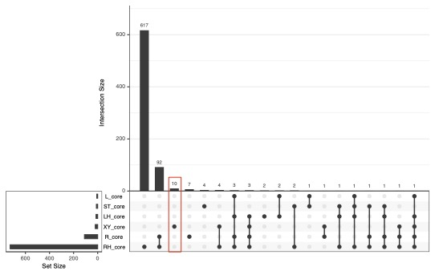
Supplementary Fig.1 Shared and unique core ASVs among plant compartments and bulk soil. Abbreviations: BK, bulk soil; RH, rhizosphere; R, root endosphere; XY, xylem sap; ST, stem endosphere; LH, phyllosphere; L, leaf endosphere.

Supplementary Fig.2 Relative abundance of culturable core ASVs in xylem sap across 109 different cucumber germplasms.
Abbreviations: ASV, amplicon sequence variant.

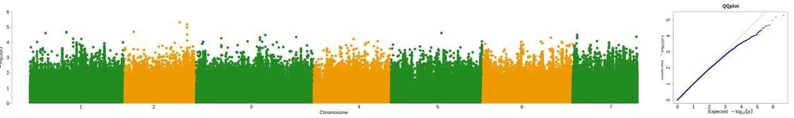
Supplementary Fig.3 GWAS of Stenotrophomonas ASV_1 abundance in xylem sap across 109 cucumber germplasms.
Abbreviations: GWAS, genome-wide association study; ASV, amplicon sequence variant.

