Long-Term Continuous Cropping Reshapes Soybean Rhizosphere Microbiome and Metabolome to Alleviate Allelopathic Stress and Enhance Disease Suppression
Xue Zhang¹, Jinxin Liu¹, Yonggang Li^{1,*}, Junjie Ding

¹College of Plant Protection, Northeast Agricultural University, Harbin 150030, China;
²Jiamusi Branch of Heilongjiang Academy of Agricultural Sciences, Jiamusi 154000, China;

*Corresponding author:
Y. G. Li; E-mail: neaulyg@126.com

Supplementary Methods
Long-term field trial of soybean CC
This study employed a chronosequence approach to investigate the impact of LTCC of soybean within a large, contiguous modern agricultural demonstration zone at the Democratic Experimental Station of Heilongjiang Academy of Agricultural Sciences (E 126°85′, N 45°85′). The site featured a uniform black loam soil. At the time of sampling, key soil physicochemical properties were stable across all CC durations, confirming the effectiveness of the fertilization regime (Table S1). All plots received uniform management with inorganic fertilizers. These were applied annually as a single basal dose at rates of 45 kg N ha⁻¹ (as urea), 90 kg P₂O₅ ha⁻¹ (as superphosphate), and 45 kg K₂O ha⁻¹ (as potassium chloride). A series of adjacent plots, previously under an identical 2-year maize / 1-year soybean rotation, were converted to continuous soybean cropping at staggered intervals, yielding a chronosequence of plots with 1, 7, 13, 19, and 25 years of continuous monoculture (designated CC1, CC7, CC13, CC19, and CC25, respectively) at the time of sampling. To obtain a representative soil profile for each duration and minimise spatial heterogeneity, soil samples from the three replicate field plots per duration were bulked and homogenised. From this composite sample, subsamples were then taken in triplicate for subsequent soil physicochemical and omics analyses, constituting analytical rather than biological replicates. All plots received uniform management practices throughout the study.
Pot Experiment for Plant Phenotyping
A separate pot experiment was conducted under controlled conditions to assess the plant growth response to the legacy effect of CC soils (Fig. 1a). In each plot, five soil cores were collected from random locations along an 'S'-shaped transect. From each core, the upper ~5 cm of soil containing recent crop residues was removed, and soil from the 5–15 cm depth (the plough layer) was retained for analysis. The collected soil samples were passed through a 20-mesh sieve, thoroughly mixed, and stored for subsequent experiments. The soybean cultivar 'Heinong 531' was selected for this study. The seeds were surface-sterilized using 0.5% (v/v) sodium hypochlorite solution (NaClO) for 5 min, followed by three sterile-water rinses. The sterilized seeds were sown in soil mixtures prepared with different CC year soils (natural CC soil : vermiculite = 3:1, v:v). Each treatment comprised 10 pots (25.5 × 21× 17.5 cm), with ten plants per pot. Growth parameters of soybean plants were monitored throughout the experiment.
Field Sampling for Molecular Analysis
Rhizosphere soil and root samples were collected from the LTCC chronosequence plots during the peak flowering stage (R2) of soybean development. To obtain the rhizosphere soil, plant roots were carefully uprooted, and loosely attached soil was gently tapped off. Dead branches, tree roots, stones, and other debris were removed, and the soil was sieved through a 2 mm mesh. For each CC treatment, three spatially independent field plots served as biological replicates (n=3). From each plot, five individual plants were sampled and their rhizosphere soil was composited into one sample per plot.
A portion of the soil was air-dried for soil chemical property assessment. Soil and roots samples were stored at −80 ℃ for subsequent microbial community and metabolite analysis, with a portion of the rhizosphere soil was preserved in glycerol for the culture-dependent analysis.
Metabolite profiling
Untargeted metabolite levels were analyzed from lyophilised soil and roots (Fig. 1b). The analysis was performed on six independent biological replicates for each of the five CC treatments, resulting in a total of 60 samples. Widely targeted metabolome analyses were performed by Biomarker Technologies Co., Ltd. (Beijing, China). Freeze-dried soil and root samples were ground into powder, and 50 mg of the powder was used for metabolite extraction. The extracted samples were analyzed using an UPLC-ESI-MS/MS system (UPLC, ExionLC™ AD; MS, Applied Biosystems 6500 QTRAP). The acquired raw data were processed using the MetaXPro software (Chinese Academy of Sciences, Shanghai, China) for peak detection, alignment, and quantification. Metabolite identification was performed by matching the MS/MS spectra and chromatographic retention times against an in-house standard database maintained by the service provider. The identification of the distinct metabolic pathways was conducted using the Kyoto Encyclopedia of Genes and Genomes (KEGG) database in conjointly with the Plant Metabolic Network (PMN) , with a focus on Glycine max (L.) Merr. To functionally validate the activity of key metabolites identified from the rhizosphere soil metabolome, we performed an in vitro bioassay using high-purity commercial standards. The compounds were selected based on their significant fold-changes in the soil. Each compound was dissolved in 5% (v/v) ethanol to create stock solutions, which were then incorporated into potato dextrose agar (PDA) or carrot agar (CA) to achieve final concentrations of 0.2, 0.5, 1.0, 2.0, and 5.0 µg/mL. A control treatment containing an equal volume of the solvent (5% ethanol) was included. Agar disks containing fresh mycelium of root rot pathogens (previously isolated from continuous-cropping SRR samples and confirmed to be pathogenic through Koch's postulates) were inoculated into the centers of the plates, with four replicates per treatment. The plates were then incubated at 25 ℃, an optimal temperature for the growth of these pathogens, for 96 h to ensure measurable mycelial growth during the active linear phase while preventing overgrowth.
Extraction and identification of phenolic acid components in soil
The extraction of soil phenolic acids was performed following the method of Hartley and Buchan (1979) [31]. These compounds were selected as they are the most frequently reported and biologically relevant phenolic acids associated with allelopathy and autotoxicity in soybean CC systems [32, 33]. Briefly, 25 g of fresh soil was weighed and transferred into in a 50 mL centrifuge tube. Then, 25 mL of 1 mol/L sodium hydroxide (NaOH) was added, and the mixture was incubated overnight. The next day, the mixture was shaken for 30 min. After centrifugation, the filtered solution was acidified with 12 mol/L hydrochloric acid (HCl) to pH 2.5. After 2 h, the sample was centrifuged to remove humic acid and adjusted to a final volume of 25 mL. The supernatant was directly analyzed by High Performance Liquid Chromatography (HPLC), with each sample measured in triplicate.
1 mg of p-coumaric acid, ferulic acid, benzoic acid, and p-hydroxybenzoic acid standards was accurately weighed and transferred into a 10 mL volumetric flask. The standards were dissolved in a 50% methanol aqueous solution and brought to volume to prepare a 1 mg/mL phenolic acid standard mixture. The mixture solution was then diluted 2-, 10-, 50-, and 100-fold with 50% methanol aqueous solution to generate a series of standard sample mixture solutions.
Additionally, 10 mg of each of the four phenolic acid standards were accurately weighed and transferred into separate 10 mL volumetric flasks. Each standard was dissolved in a 50% methanol aqueous solution and brought to volume to obtain individual phenolic acid solutions at a concentration of 1 mg/mL. These individual solutions were used to determine the retention time of each phenolic acid standard in the mixed standard analysis.
Bioinformatics analysis of metagenomics
Metagenomics analyses were conducted by Biomarker Technologies Co., Ltd. (Beijing, China). Genomic DNA from soil and roots was extracted using the DNeasy® PowerSoil® Kit (DP336, TIANGEN Biochemical Technology Co., Ltd, Beijing, China) following the manufacturer's instructions. Following DNA quality assessment, libraries were constructed from qualified samples through fragmentation, end repair, A-tailing, adapter ligation, size selection, and PCR enrichment. The libraries were sequenced on an Illumina HiSeq 2500 platform (PE150 mode), and the resultant raw data were processed to remove low-quality reads—specifically those containing adapters, with an 'N' content exceeding 10%, or with over 50% of bases having a Phred quality score (Q) ≤ 20. The ensuing high-quality data were assessed for quality metrics (Q20, Q30, GC content) prior to de novo assembly into contigs using MEGAHIT. Genes longer than 500 bp were predicted from these contigs using MetaGeneMark, clustered with CD-HIT to create a non-redundant gene set, and functionally annotated by aligning against the Non-Redundant (NR) and Kyoto Encyclopedia of Genes and Genomes (KEGG) databases using DIAMOND. This study included three biological replicates for each of the five CC years for both rhizosphere soil and root endosphere samples (Fig. 1b).
Determination of soil enzyme activity
The activities of eight soil enzymes key in soil carbon (C), nitrogen (N), and phosphorus (P) cycling were measured using commercial assay kits (Suzhou Grace Biotechnology Co., Ltd.) according to the manufacturer's protocols (Fig. 1b). The assays were performed as follows: sucrase (S-SC) and cellulase (S-CL) activities, both involved in C cycling, were determined by the 3,5-dinitrosalicylic acid method, quantifying reducing sugars produced from sucrose and cellulose hydrolysis, respectively [28]; urease (S-UE; N cycling) activity was determined by the indophenol blue colorimetric method, measuring ammonium-N released from urea hydrolysis [29]; neutral protease (S-NPT; N cycling) activity was determined by the ninhydrin colorimetric method, quantifying amino acids released from casein hydrolysis; neutral phosphatase (S-NP; P cycling) activity was determined by the colorimetric determination of p-nitrophenol released from disodium phenyl phosphate [29]; dehydrogenase (S-DHA), an indicator of general microbial activity, was determined by the iodonitrotetrazolium chloride formazan method, measuring the reduction of TTC to TPF; and catalase (S-CAT), an indicator of soil oxidative activity, was determined by the ultraviolet spectrophotometric method, tracking the decomposition of hydrogen peroxide [30].
Isolation and identification of cultivable key bacteria
To probe for microbes resilient to long-term monoculture stress, potential disease-suppressive microorganisms were isolated from the rhizosphere soil and root samples of the CC25 plot, which represents the endpoint of the CC chronosequence. A 10 g aliquot of soil sample and ground root sample was added to 90 mL of sterile water, and the suspension was serially diluted to 10⁻⁵. A 0.1 mL of the diluted suspension was spread onto Luria-Bertani culture (LB) agar, Reasoner's 2A Agar (R2A), Trypose Soya Agar (TSA), and Pseudomonas Agar Base (CN), followed by incubation at 28 ℃ for 24 h (Fig. 1c). Bacterial colonies were selected based on morphology, color, and margin characteristics and further purified by streaking onto fresh plates. Rhizosphere bacteria with antagonistic effects against SRR pathogens were screened using the plate confrontation method in vitro. To confirm the presence of these bacterial isolates in the soybean rhizosphere, a BLAST similarity analysis was performed by aligning the 16S rRNA sequences of the bacterial isolates with those of taxa belonging to the same genus. Highly homologous sequences were aligned and Neighbor-Joining (NJ) trees were constructed with MEGA (version 11.4.1, developed by Mega Limited, Auckland, New Zealand).
Pot experiment for plant growth promotion
In this pot experiment, sterile LB (CK) and ten bacterial suspensions (DD) were inoculated onto soybean seedlings cultivated in 14-year conditioned soil (sourced from the subsequent stage of the same field plot previously identified as the critically stressed CC13 environment) (Fig. 1c). None of the treatments in this potting experiment were supplemented with pathogens. After 30 days, plant height and fresh weight were measured [38].
In vitro characterization of bacterial plant growth-promoting traits
The isolated strains were screened for a range of key plant growth-promoting (PGP) traits relevant to mitigate common stressors in CC systems. These traits encompassed root colonisation potential (biofilm formation), phytohormone modulation [indole-3-acetic acid (IAA) production, 1-aminocyclopropane-1-carboxylate (ACC) deaminase activity], and nutrient solubilisation/uptake (nitrogen fixation, siderophore production). Biofilm formation was quantified using a crystal violet staining assay adapted from Yue et al. (2025) [34]. Overnight cultures of bacterial isolates in LB broth were diluted 1:100 in fresh Minimal Salts Glycerol Glutamate (MSgg) medium. Aliquots (200 µL) of the diluted suspension were transferred into wells of a sterile, flat-bottomed 96-well polystyrene microtiter plate. The plate was incubated statically at 37 ℃ for 5 h to allow biofilm formation. After incubation, the planktonic cells were carefully aspirated. The adherent biofilms were washed gently three times with 200 µL of phosphate-buffered saline (PBS) and then stained with 180 µL of a 0.1% (w/v) crystal violet solution for 20 minutes. Following staining, the unbound dye was removed, and the wells were rinsed thoroughly with PBS. The bound crystal violet was solubilised by adding 200 µL of 96% ethanol to each well and incubating for 15 minutes with gentle agitation. Sterile MSgg medium subjected to the same protocol served as the negative control. The absorbance of the solubilised dye was measured at 590 nm using a microplate reader. All experiments were performed with at least three biological replicates. A strain was classified as a biofilm producer if its mean absorbance value was at least twice that of the negative control. Indole-3-acetic acid (IAA) production quantified colorimetrically using Salkowski's reagent after incubation in tryptic soy broth supplemented with 5 mM L-tryptophan for 48 h [35]. Azotobacter sucrose and Chrome Azurol S (CAS) agar plates were inoculated with 20 µL bacterial suspension and cultured at 28 ℃ for 5 days. Clear zones were observed on Azotobacter sucrose plates, and yellow-orange halos were observed on CAS plates, indicating that the strain had the ability of nitrogen fixation and siderophore production, respectively [36]. The growth promotion ability of bacteria was quantitatively determined by the ratio (D/d) of clear zone or yellow-orange halo diameter (D) to colony diameter (d). The evaluation of ACC deaminase activity was performed in two stages according to the method of Brígido et al. (2015) [37]. All bacterial isolates first underwent high-throughput screening using a microplate reader (SuPerMax 3500). The top-performing strains from this screen were then selected for precise quantification in subsequent assays. In this second validation stage, calibration curves were calculated using different concentrations of standard α-ketobutyrate in 0.1 M TRIS-HCl (pH 8.0), and the absorbance of the reaction mixture at 540 nm was measured using a NanoDrop One spectrophotometer (Thermo Scientific, Shanghai, China). All treatments were tested in quadruplicate with three parallels.
Colonization of the rhizoplane by bacteria
To track and quantify the root colonisation ability of the inoculated strains, we employed rifampicin-resistant mutants of the beneficial bacterial strains selected from our earlier screening, following a well-established method in rhizosphere ecology [39-40]. Mutants were generated by subculturing these strain on LB agar containing progressively higher rifampicin concentrations (5 to 100 µg/mL). A mutant exhibiting wild-type-level antagonism was selected for the subsequent colonisation assay to ensure the resistance marker did not compromise its ecological fitness.
Rifampicin-resistant mutants strains were diluted to 10⁸ cfu/mL in sterile distilled water. The roots of 15-day-old soybean seedlings were immersed in the bacterial suspension for 20 min to constitute the positive treatment,while control seedlings were immersed in sterile distilled water. All seedlings were then transplanted into sterile potting medium. To monitor colonisation dynamics, root samples (1 g fresh weight) were harvested at 1, 3, 5, 10, and 15 days post-inoculation [41]. The roots were homogenised in sterile phosphate buffer, and the homogenate was allowed to settle. Serial dilutions of the supernatant were prepared, and 100 µL aliquots were plated onto LB agar amended with 100 µg/mL rifampicin. After incubation, the number of rifampicin-resistant colony-forming units (CFU) was counted. The entire experiment was repeated three times independently.
Determination of pairwise interactions among bacterial isolates
After culturing monocultures of all strains in tryptic soy broth (TSB) for 48 h, viable cells were removed by centrifugation (8, 000 ×g, 10 min), and the supernatant was incubated overnight at 30 ℃ until OD₆₀₀=0.5. 20 µL of supernatant from one strain and 2 µL overnight cultures from other strains were added to 180 µL of culture media. The bacterial supernatant was replaced with an equal amount of sterile culture media as a control. All treatments were incubated at 30 ℃ for 24 h (170 rpm) and the optical density was measured at 600 nm. The type of pairwise interaction between two species was determined by calculating the ratio of bacterial concentration OD₆₀₀ treated with supernatant to the single bacterial concentration OD₆₀₀. An interaction was classified as positive if the ratio of OD_{(YC + supernatant)} to OD_{(YC)} was greater than 1, and as antagonistic if the ratio was less than 1. All treatments were tested in triplicate.
Evaluation of SynComs (SC) on soybean growth in the greenhouse and field
A one-year greenhouse and field experiment was conducted during the growing season in 2024 at the horticultural station of Northeast Agricultural University and Democratic Experiment Station (CC plot for 14 years) (Harbin, China, E 126°78′, N 45°85′ ) (Fig. 1c). The climate is continental, with a mean annual precipitation ranges of 529 mm. The experiments were arranged on a randomized complete block design with three replicates. To verify the efficacy of the approaches devised to mitigate CCO, soil-borne pathogens (SRR: Fusarium oxysporum, F. equiseti, Phomopsis longicolla)[42] were inoculated via the sorghum grain method at 4% (w/w) of the total substrate mass. There were four different treatments: ① CKP: pathogen-inoculated control; ② SC: synthetic community of beneficial bacteria + pathogen; ③ Chemical fungicide (FM): fludioxonil-metalaxyl-M + pathogen; ④ Soil extract, soybean rhizosphere soil extract from different CC years + pathogen. In greenhouse, a 10 mL of bacterial suspension (1.0×10⁸ cfu/mL) was inoculated at 10 and 30 days post-planting, while the control was inoculated with equivalent volume of sterile water. The field experiment was conducted at the Democracy Experiment Station using a field plot with 14 years of continuous soybean cultivation. Each 5 m ridge contained 50 sown soybean seeds. Following sowing, soil was inoculated with 20× diluted SC fermentation broth through 200 mL root irrigation, with untreated soybeans under natural conditions serving as controls. Except for the control, the inoculated amounts of other treated bacteria were consistent. Soybean growth indicators were recorded at different developmental stages. The severity of SRR was assessed using the rating criteria of Zhang et al. (2025) [43]. The disease index (DI) and control efficacy were then calculated with the following formulae:
DI = Σ(number of diseased samples at each scale × number of relative ratings)/(total number of surveyed samples × highest disease grade) × 100.
Control efficacy (%)= (DI of CKP - DI of SC) / DI of CKP× 100.
Statistical analysis
Data analysis was performed using IBM SPSS Statistics (v23.0), Microsoft Excel (2019), and R (v4.1.3). Differences in microbial community composition and plant biomass among CC treatments were assessed using one-way analysis of variance (one-way ANOVA) with Tukey's HSD test. Multivariate analyses including Principal Component Analysis (PCA), Redundancy Analysis (RDA), Orthogonal Partial Least Squares Discriminant Analysis (OPLS-DA) were performed using the ropls package in R to visualize group separations and identify key discriminating variables. A metagenome-based correlation network was constructed at the genus level using the psych and igraph packages, retaining statistically significant correlations (|ρ| > 0.6, P < 0.05) for network inference. Weighted Gene Co-expression Network Analysis was implemented using the WGCNA package to identify co-abundant metabolite modules and explore their associations with microbial taxa. Additional analyses conducted in R included calculation of Shannon diversity index, generation of heatmaps, Mantel tests, and examination of relationships between soil properties and microbial taxa using correlation analysis. For the Permutational multivariate analysis of variance (PERMANOVA) of microbial community composition, significance was assessed using 9999 permutations. Data for IAA production, ACC deaminase activity and standard soil properties were compiled and pre-processed in Microsoft Excel.

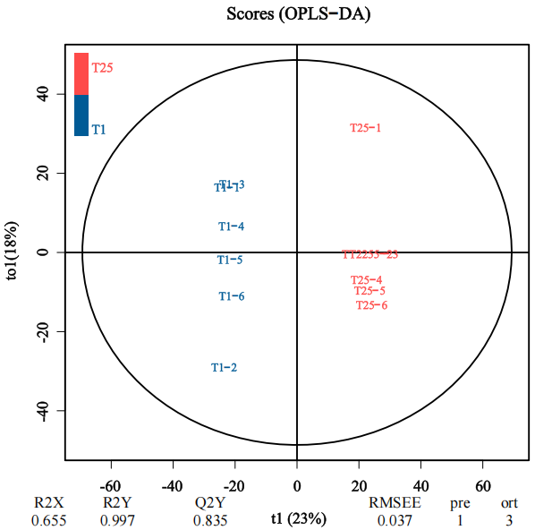  b  a | 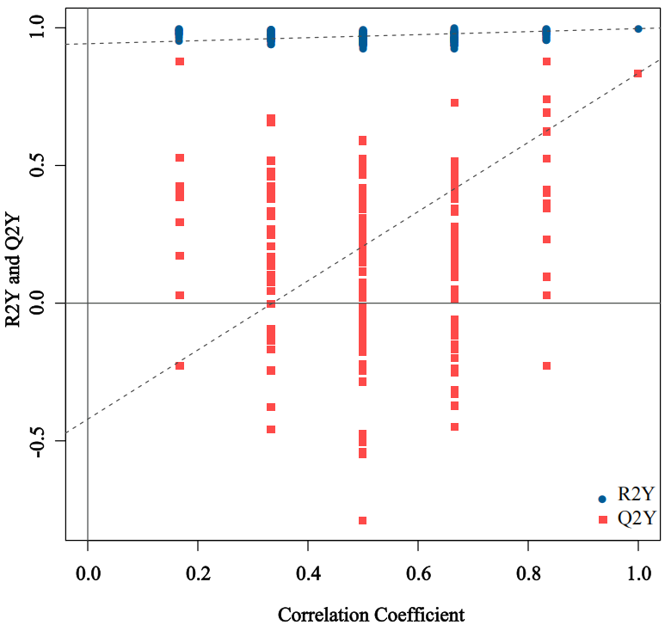
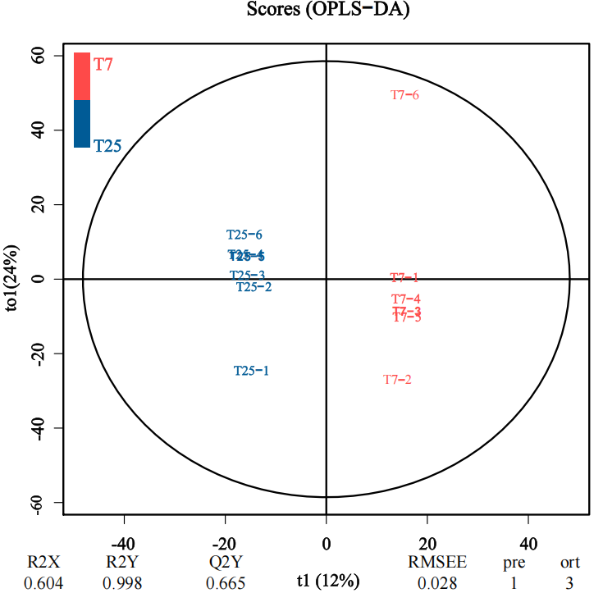  d  c | 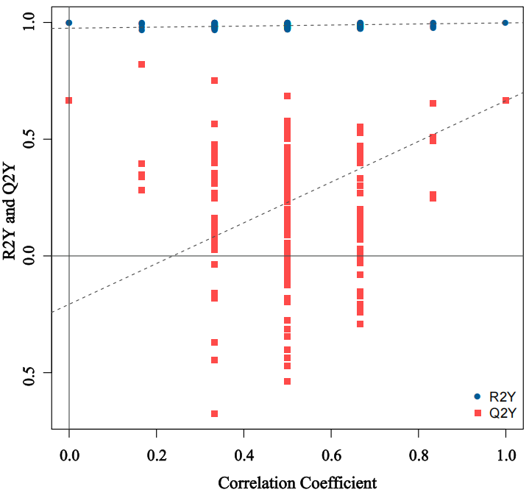
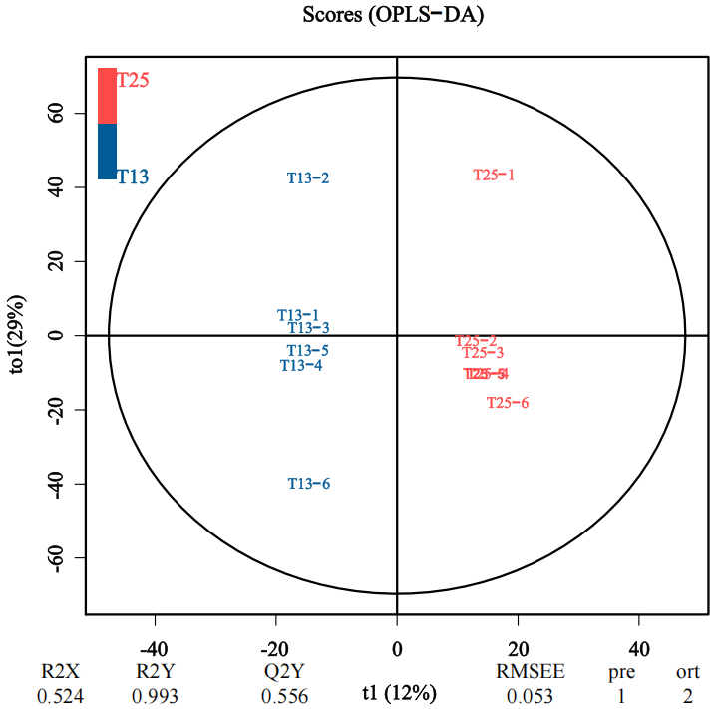  f  e | 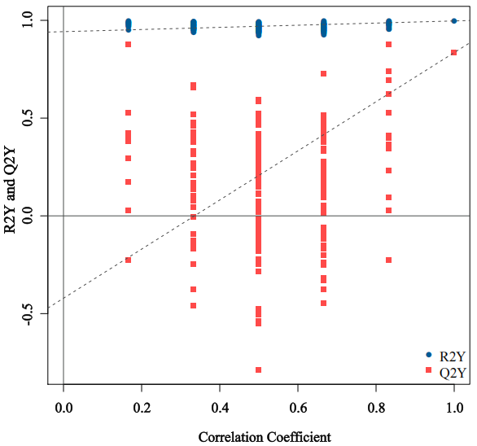
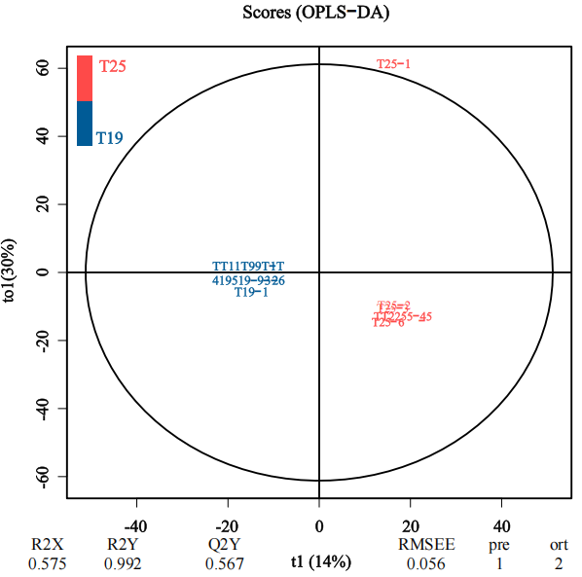  h  g | 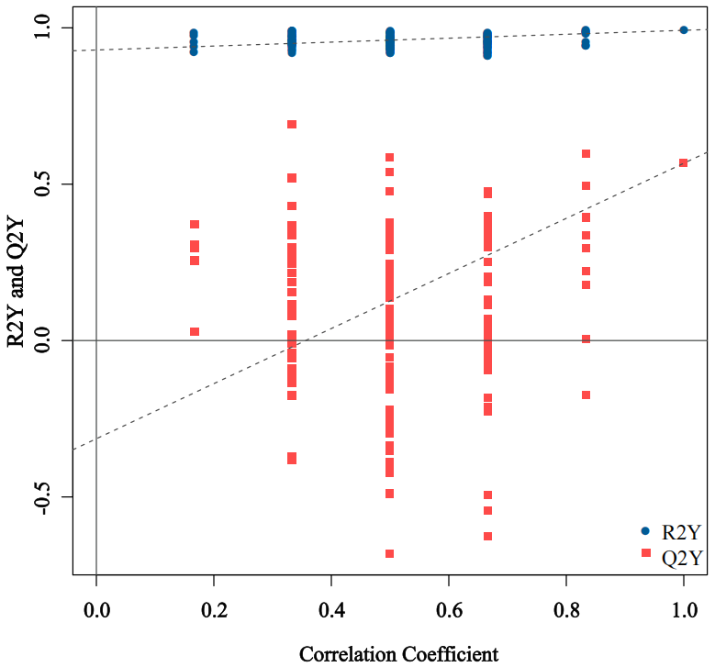
Figure S1 Differential analysis of metabolites in rhizosphere soil of soybean under different continuous cropping (CC) years. (a, c, e, g) Orthogonal partial least squares-discriminant analysis (OPLS-DA). n=6. (b, d, f, h) Permutation test. The x-axis represents the correlation between permuted group labels and the original model's groupings. The y-axis shows the corresponding R²Y (blue) and Q²Y (red) values, where the values at x=1 are those from the original, non-permuted model. The dashed lines indicate the linear regression fits for the R²Y and Q²Y data points, respectively. A model is considered valid and not overfitted if the regression line for Q²Y has a negative intercept on the y-axis. Furthermore, predictive robustness is indicated when the majority of the blue R²Y points are located above the red Q²Y points. n=6. T, rhizosphere soil.

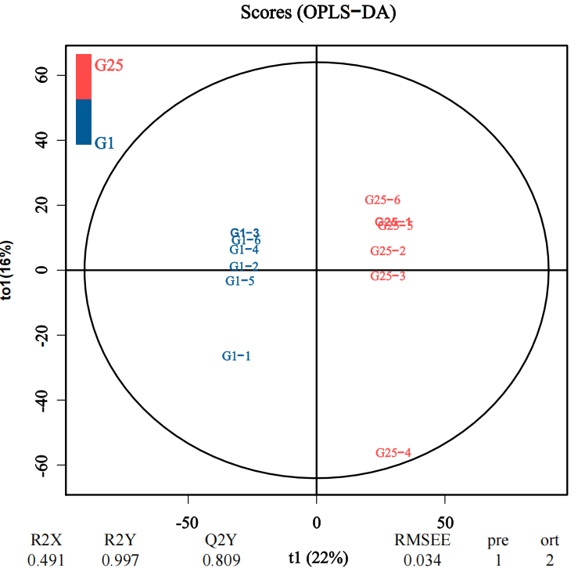  b  a | 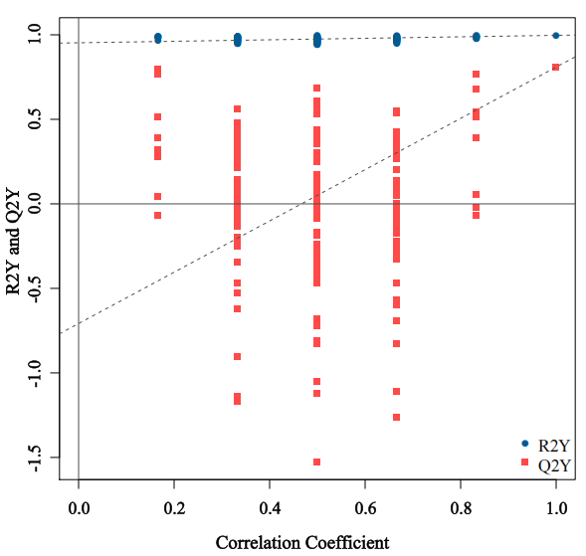
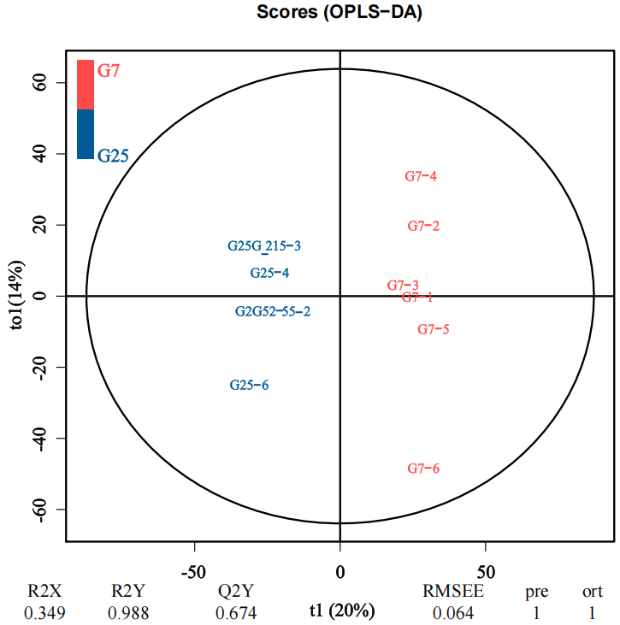  d  c | 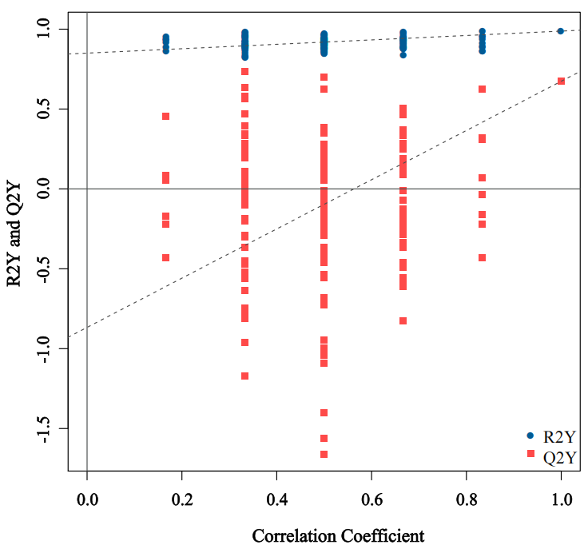
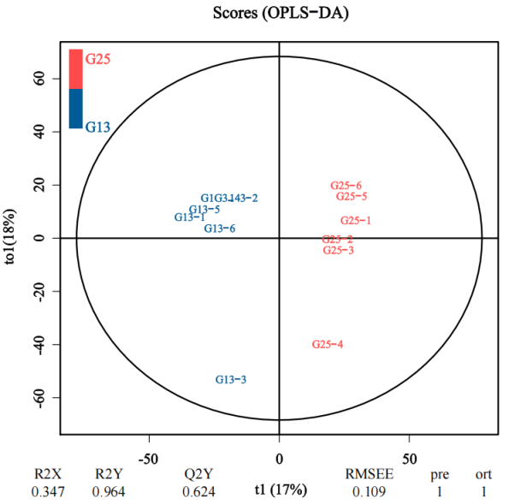  f  e | 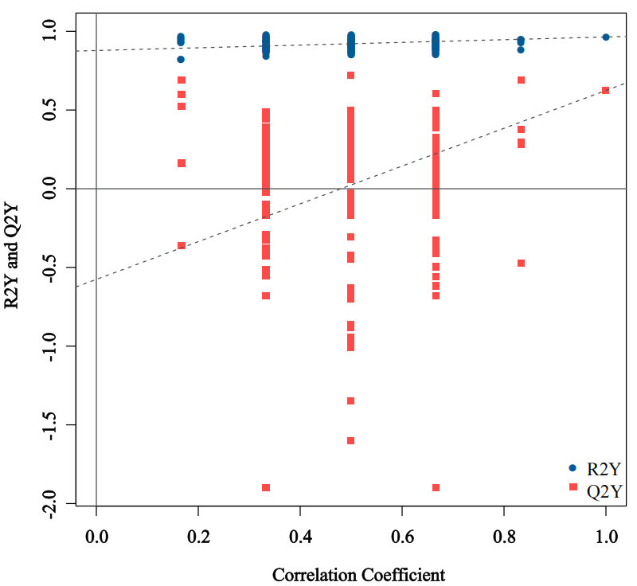
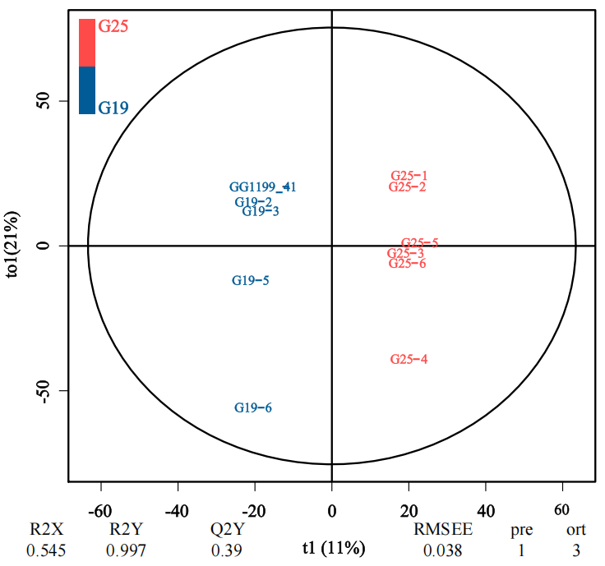  h  g | 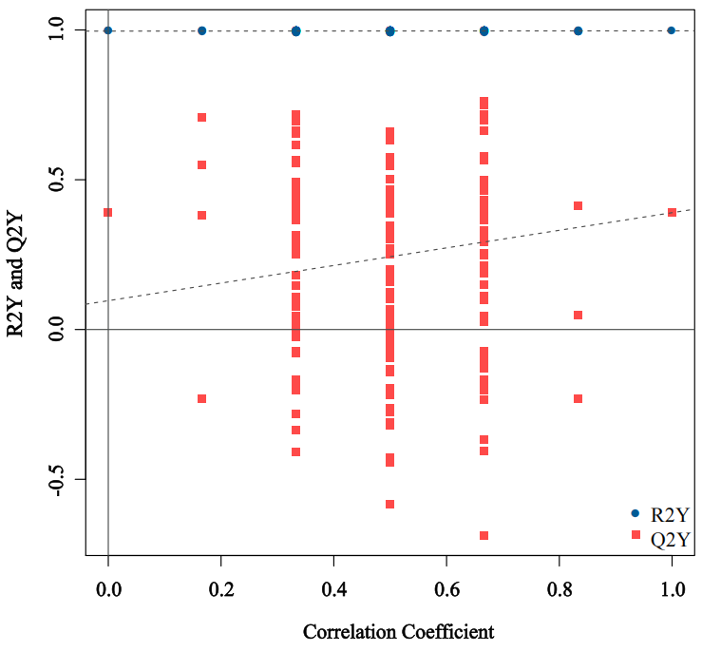
Figure S2 Differential analysis of metabolites in root endosphere of soybean under different continuous cropping (CC) years. (a, c, e, g) Orthogonal partial least squares-discriminant analysis (OPLS-DA). n=6. (b, d, f, h) Permutation test. The x-axis represents the correlation between permuted group labels and the original model's groupings. The y-axis shows the corresponding R²Y (blue) and Q²Y (red) values, where the values at x=1 are those from the original, non-permuted model. The dashed lines indicate the linear regression fits for the R²Y and Q²Y data points, respectively. A model is considered valid and not overfitted if the regression line for Q²Y has a negative intercept on the y-axis. Furthermore, predictive robustness is indicated when the majority of the blue R²Y points are located above the red Q²Y points. n=6. G, root endosphere.

a | b
d
c
e
Figure S3 Quantities of beneficial differential metabolites and antioxidant enzyme activities in soybean rhizosphere soil and root endosphere under different continuous cropping (CC) years. (a, b) Quantities of beneficial differential metabolites in (a) rhizosphere soil and (b) root endosphere of soybeans under different CC years compared to CC1. (c) Polyphenol oxidase (PPO) activity in soybean roots. (d) Catalase (CAT) activity in soybean roots. Values followed by different letters indicate significant differences according to the least significant difference (LSD) test (P <0.05). (e) Heatmap of oxidoreductase activity and module correlation.

bD
a
c | d
Figure S4 Classification of beneficial metabolites in soybean rhizosphere soil under different continuous cropping (CC) years. (a) CC7 vs. CC1. (b) CC13 vs. CC1. (c) CC19 vs. CC1. (d) CC25 vs. CC1.

a | b
c | d
Figure S5 Classification of beneficial metabolites in soybean root endosphere under different continuous cropping (CC) years. (a) CC7 vs. CC1. (b) CC13 vs. CC1. (c) CC19 vs. CC1. (d) CC25 vs. CC1.

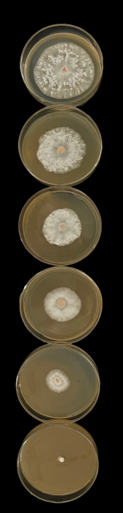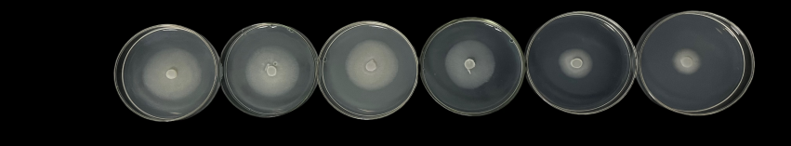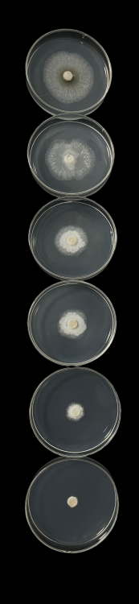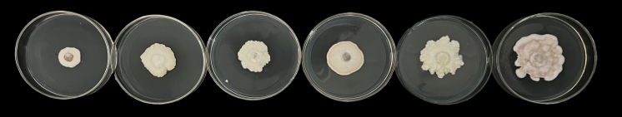
Fo

C
a
CKK
0.20K
0.50K
1.00K
2.00K
5.00K
Ps
Ft
Pl
b | cc

Figure S6 Accumulation of the top ten differential metabolites in rhizosphere soil and the effect of 3-methylthiopropanol on soybean root rot (SRR) pathogens. (a) Effect of 3-methylthiopropanol on the growth of major SRR pathogens. Fo, Fusarium oxysporum; Pl, Phomopsis longicolla; Ft, F. tricinctum; Ps, Phytophthora sojae. (b, c) Dynamic changes in the content of four major phenolic acid allelopathic substances in soybean rhizosphere soil. Values followed by different letters indicate significant differences according to the least significant difference (LSD) test (P < 0.05).

b  a | c
g  e  d | f
h | i
Figure S7 Characteristics of rhizosphere soil in soybeans under different continuous cropping (CC) years. (a) Soil sucrase activity (S-SC). (b) Soil dehydrogenase activity (S-DHA). (c) Soil cellulase activity (S-CL). (d) Soil catalase activity (S-CAT). (e) Soil urease activity (S-UE). (f) Soil neutral protease activity (S-NPT). (g) Soil neutral phosphatase activity (S-NP). (h) Soil polyphenol oxidase activity (S-PPO). (i) Soil pH. Values followed by different letters indicate significant differences according to the least significant difference (LSD) test (P < 0.05).

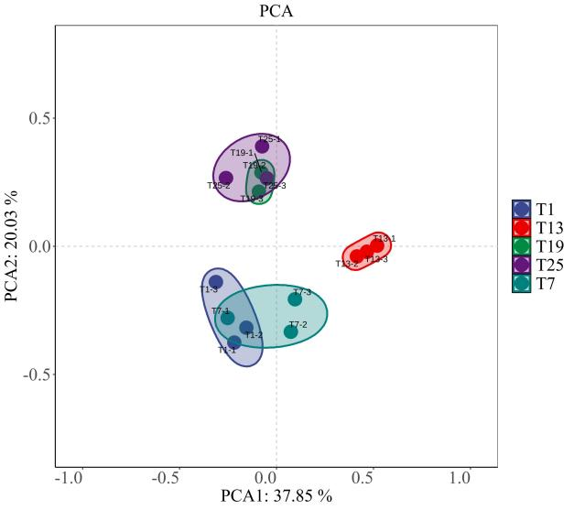  a | 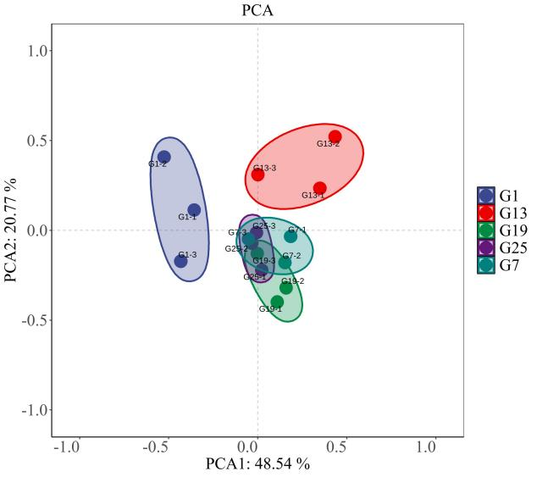  b
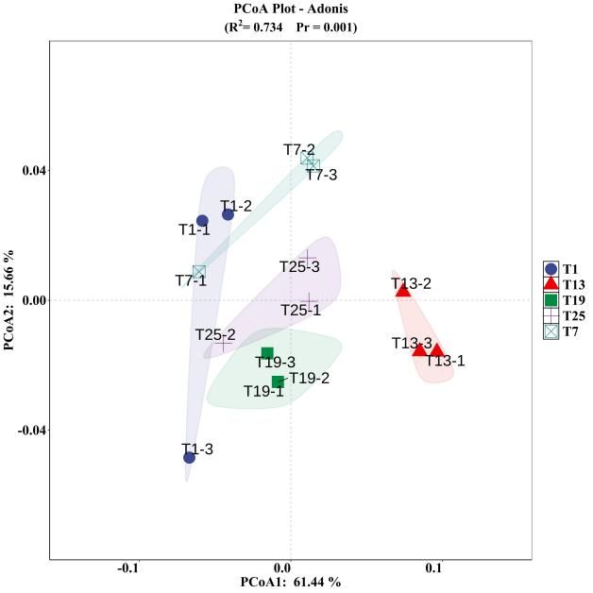  c | 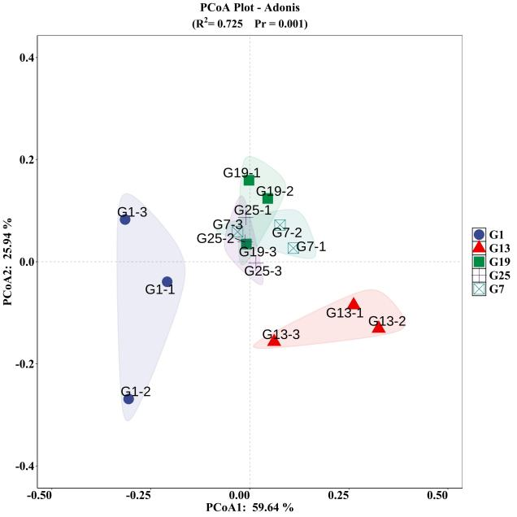  d
Figure S8 Differential analysis of microbial community in rhizosphere soil (a, c) and root endosphere (b, d) of soybean under different continuous cropping (CC) years. (a, c) Principal component analysis (PCA). n = 3. (b, d) PERMANOVA was used to test for significant differences in microbial community composition between the rhizosphere soil and the root endosphere across the continuous cropping chronosequence [(R² = 0.734, P = 0.001, 9999 permutations)].

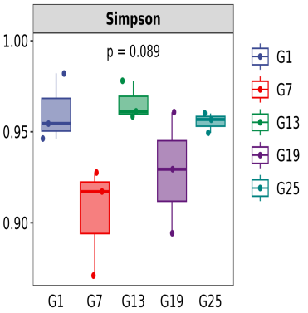  b  a | 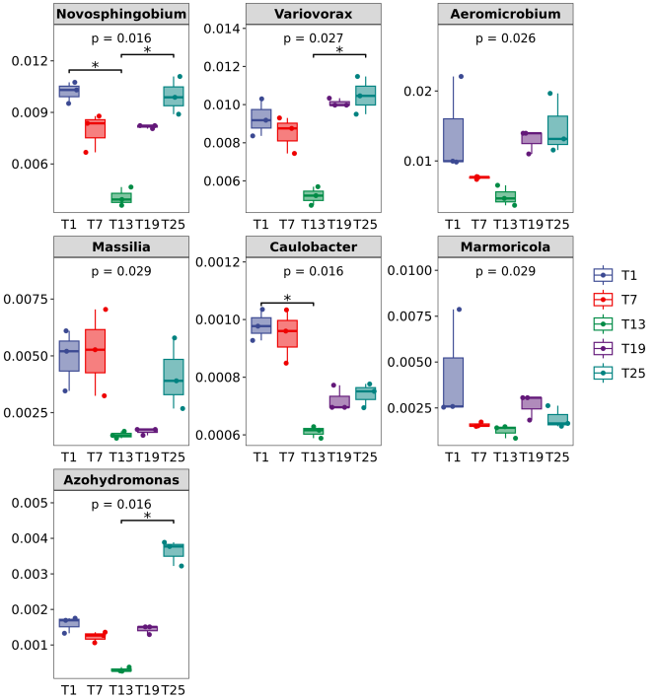
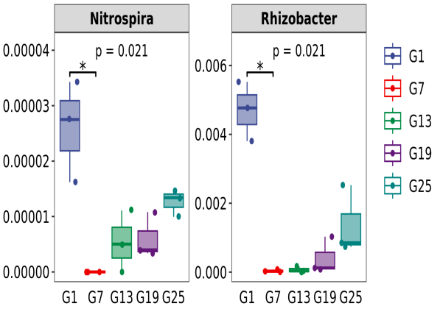
c
Figure S9 Alpha diversity, microbial network analysis, and cultivable bacterial abundance in soybean rhizosphere soil and root endosphere under different continuous cropping (CC) years. (a) Simspon diversity analysis of root endosphere. (b, c) Cultivable bacterial genera with significant differences in abundance due to depletion.

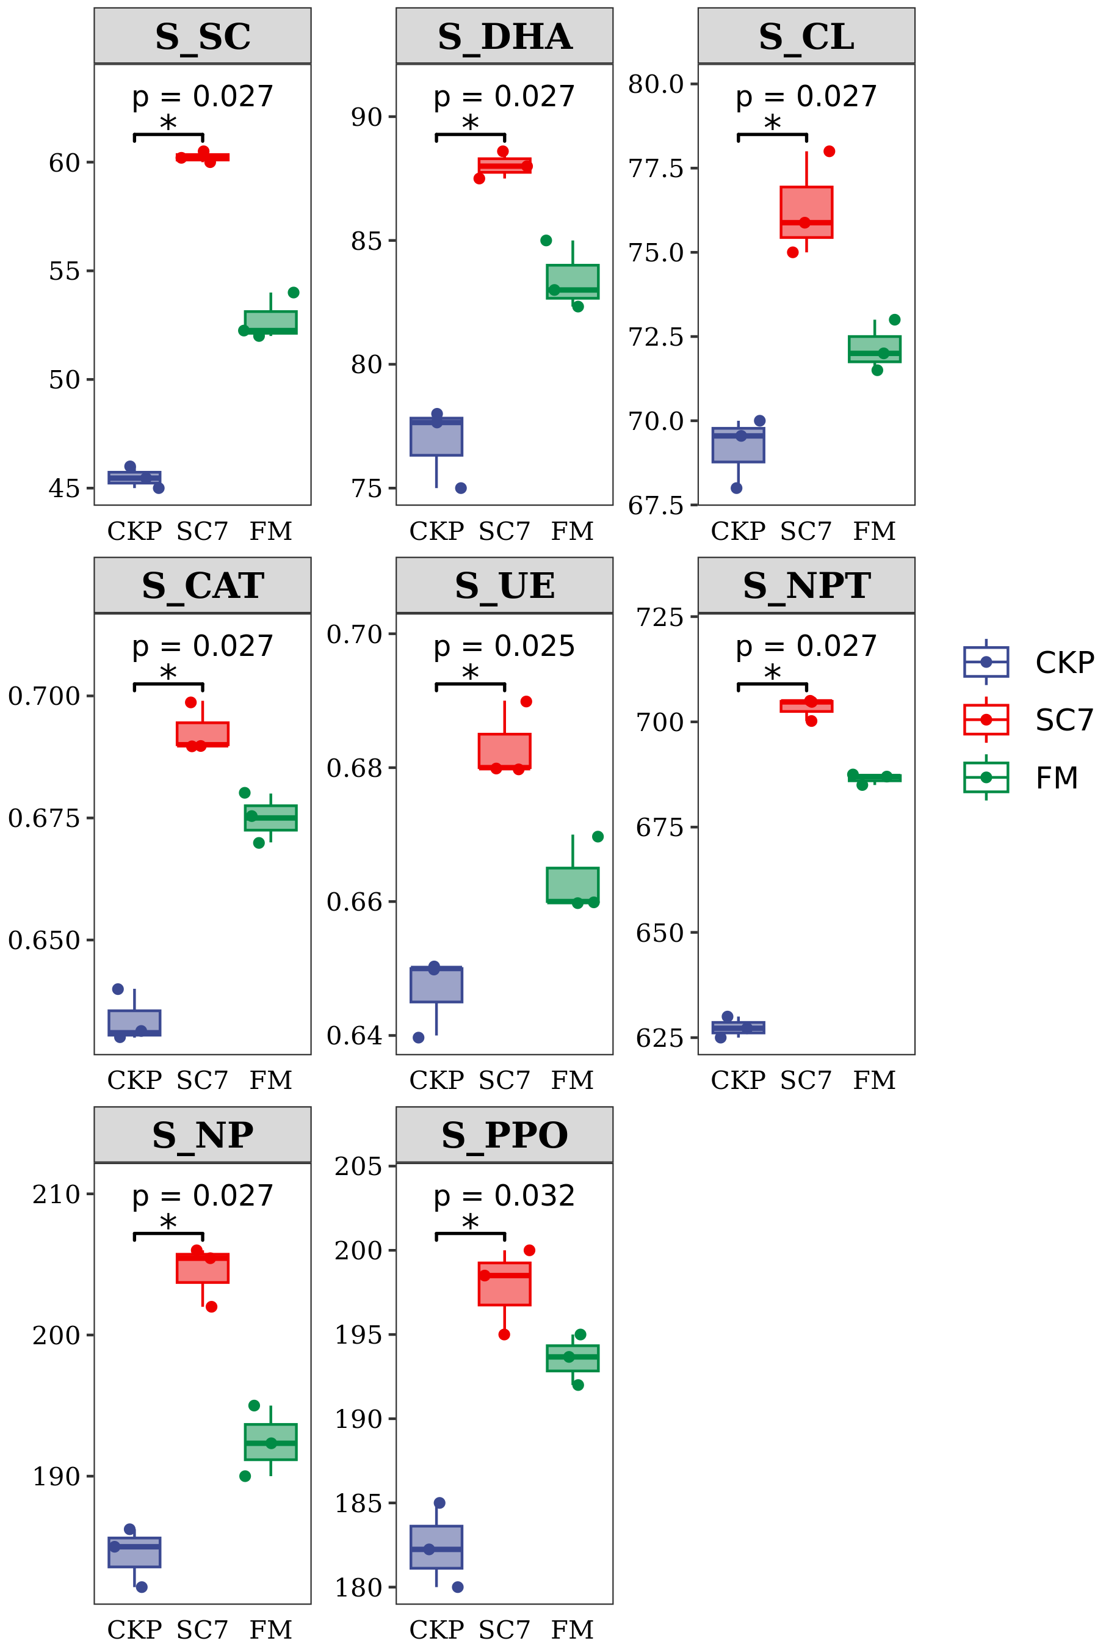
Figure S10 Response of soil enzyme activity to SC7 treatment.

Table S1 Soil physicochemical properties at the time of sampling across the CC chronosequence
CC Duration | pHª | Organic Matter (g/kg) | Available N (mg/kg) | Available P (mg/kg) | Available K (mg/kg)
CC1 | 7.18 ± 0.08 a | 15.6 ± 0.4 a | 149.7 ± 4.7 a | 50.1 ± 2.2 a | 198.8 ± 6.2 a
CC7 | 7.22 ± 0.07 a | 15.3 ± 0.5 a | 154.1 ± 4.2 a | 53.2 ± 3.1a | 203.3 ± 5.7 a
CC13 | 7.15 ± 0.09 a | 15.8 ± 0.6 a | 147.9 ± 6.0 a | 49.8 ± 2.5 a | 195.9 ± 7.2 a
CC19 | 7.20 ± 0.06 a | 15.5 ± 0.4 a | 152.5 ± 5.5 a | 52.3 ± 2.0 a | 201.5 ± 5.4 a
CC25 | 7.17 ± 0.08 a | 15.4 ± 0.5 a | 150.2 ± 4.5 a | 51.5 ± 3.5 a | 199.6 ± 6.1 a
ªDifferent letters indicate significant differences between treatments (P < 0.05).

 | Depleted genus
 | T1 | T7 | T13 | T19 | T25
1 | Rhizobium | Rudaea | Kosakonia | Agrobacterium | －
2 | Pseudoxanthomonas | Rhizophagus | － | － | －
3 | Pseudolabrys | Pseudoxanthomonas | － | － | －
4 | Nitrospira | Pseudomonas | － | － | －
5 | Niastella | Nocardioides | － | － | －
6 | Agrobacterium | Mucilaginibacter | － | － | －
7 | － | Marmoricola | － | － | －
8 | － | Gaiella | － | － | －
9 | － | Enterobacter | － | － | －
10 | － | Actinoplanes | － | － | －
Table S2 Depleted genera in soybean rhizosphere soil under different continuous cropping (CC) years

Table S3 Depleted genera in soybean root endosphere under different continuous cropping (CC) years
 | Depleted genus
 | G1 | G7 | G13 | G19 | G25
1 | Conexibacter | Actinoplanes | Actinoplanes | Gaiella | Gaiella
2 | － | Aeromicrobium | Aeromicrobium | Gemmatirosa | Gemmatirosa
3 | － | Azohydromonas | Agrobacterium | Solirubrobacter | －
4 | － | Conexibacter | Ancylomarina | － | －
5 | － | Gaiella | Burkholderia | － | －
6 | － | Gemmatirosa | Clostridium | － | －
7 | － | Marmoricola | Conexibacter | － | －
8 | － | Nitrospira | Gaiella | － | －
9 | － | Phenylobacterium | Gemmatirosa | － | －
10 | － | Ralstonia | Marmoricola | － | －
11 | － | Reyranella | Nitrospira | － | －
12 | － | Solirubrobacter | Pseudolabrys | － | －
13 | － | Variovorax | Pseudomonas | － | －
14 | － | － | Pseudoxanthomonas | － | －
15 | － | － | Reyranella | － | －
16 | － | － | Solirubrobacter | － | －
17 | － | － | Sphingosinicella | － | －

Table S4 Construction of core microbiota

SynCom (SC) | Taxa
1 | Enterobacter
2 | Pseudomonas
3 | Burkholderia
4 | Pseudomonas+Enterobacter
5 | Enterobacter+Burkholderia
6 | Pseudomonas+Burkholderia
7 | Pseudomonas+Enterobacter+Burkholderia

