Fig. S1. Schematic representation of the study and sampling design of the trial.

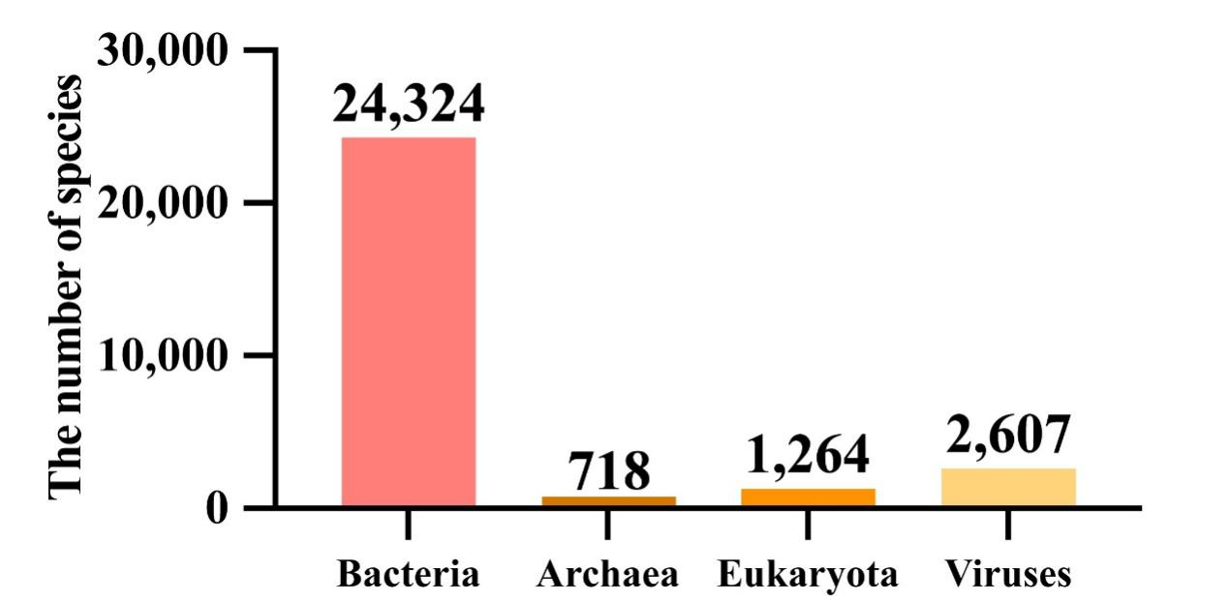
Fig. S2. The number of identified species in each domain.

Fig. S3. The distribution of different rumen microbiota between EL (A) and PL (B) cows based on LEfSe analysis.

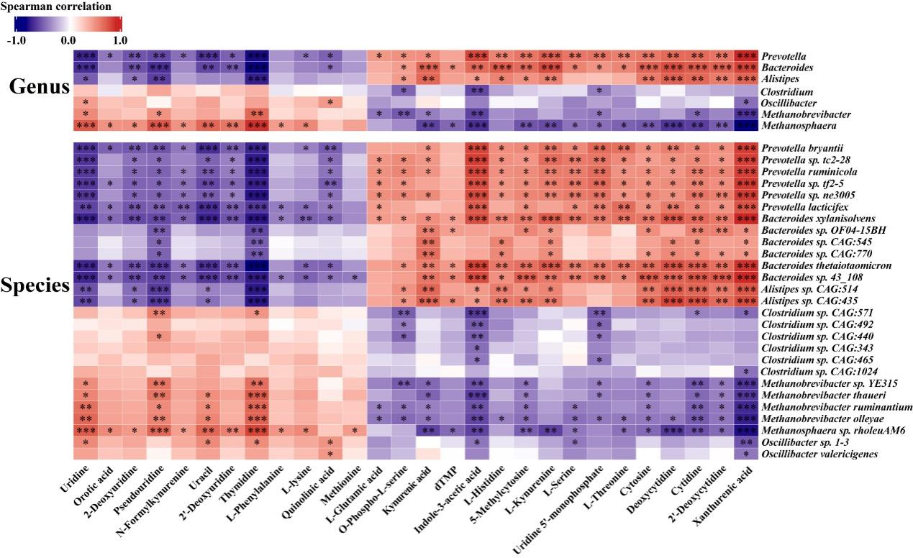
Fig. S4. The spearman correlations between the significantly differential microbiota and the enriched tryptophan metabolism pathway. The genera and species were selected from the significantly differential microbiota that were significantly correlated with metabolic stress, and the metabolites were enriched in the tryptophan metabolism. *Represents the correlation P < 0.05, **P < 0.01, and ***P < 0.001.

Fig. S5. The distribution of enriched KEGG pathways in the rumen of EL cows and PL cows. (A) Level 1 pathway. (B). Level 2 pathway.

Fig. S6. Percentages of numbers of main metabolite subclasses in (A) serum and (B) rumen.

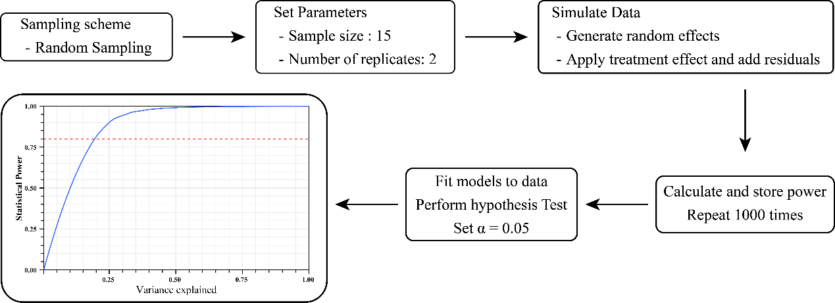
Fig. S7. Monte Carlo simulation protocol under the experimental design. The simulation protocol employed a random sampling scheme with two replicates per experimental unit, systematically evaluating the statistical robustness of our approach.

Fig. S8. Monte Carlo simulation of power-sample size relationships. A sample size of n = 15 achieved 80% statistical power for all phenotypes except for GLU, NEFA, LPS, SAA, and HPT.

Fig. S9. Monte Carlo simulation of power-residual variance relationships. Statistical power exceeded 0.80 at residual variance levels below 0.125 for all phenotypes except NEFA, LPS, SAA, and HPT.

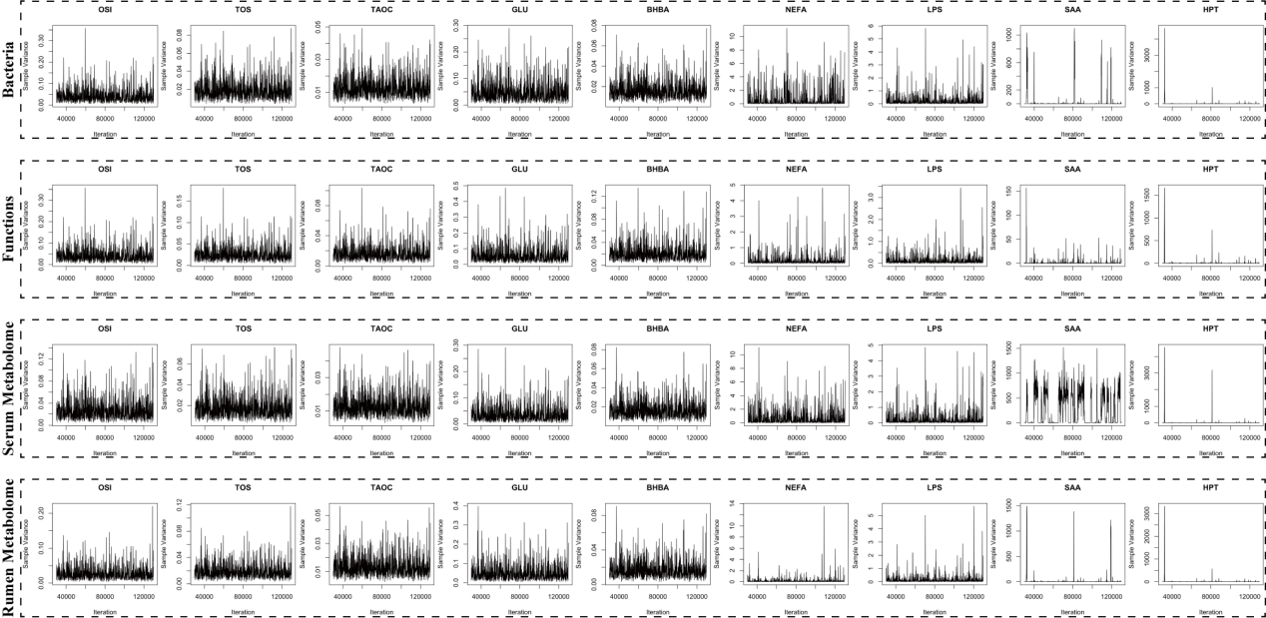
Fig. S10. MCMC trace plots of variance component estimates for host phenotypes.

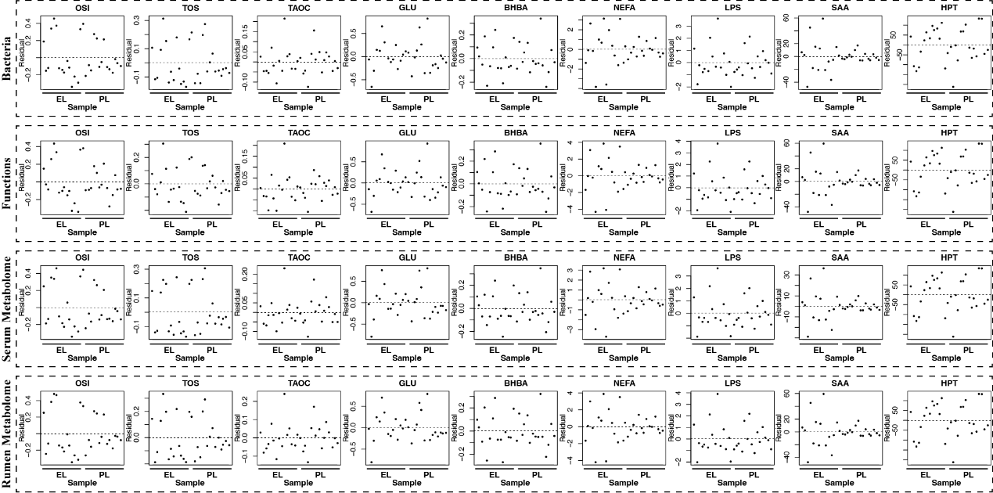
Fig. S11. Scatter plots of sample residual distributions. Residual distributions for NEFA, LPS, SAA, and HPT showed greater size and dispersion, while other phenotypes were markedly more concentrated.
Fig. S12. Monte Carlo simulation of power-sample size relationships after refitting the models. All phenotypes except SAA attained a statistical power of > 0.8 at n = 15; SAA showed substantial improvement and approached this threshold.

Fig. S13. Monte Carlo simulation of power-residual variance relationships after refitting the models. Statistical power was maintained at or above 0.80 for the re-modeled phenotypes NEFA, LPS, SAA, and HPT, at residual variance levels below 0.125.

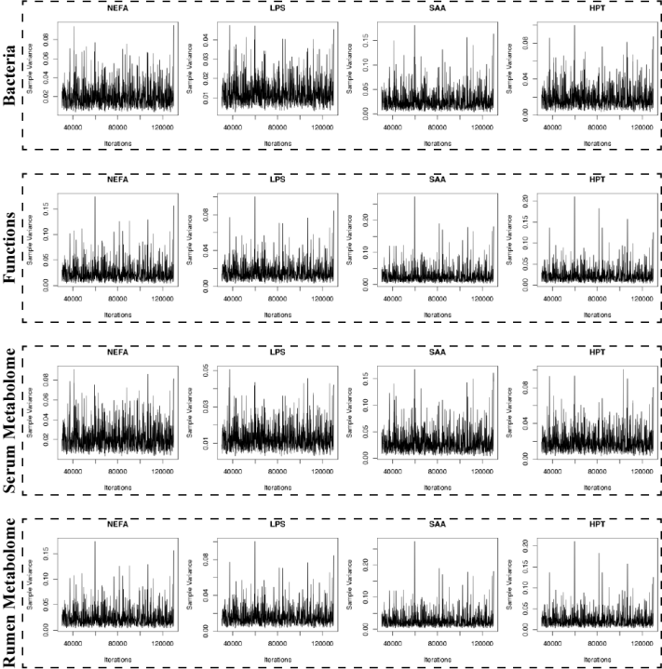
Fig. S14. MCMC trace plots of refitted models that demonstrated improved convergence of variance component estimates for NEFA, LPS, SAA, and HPT.

R script snippet for LMM analysis
library(lme4qtl)
set.seed(123)
n <- 30
RM <- matrix(rnorm(n^2), n, n)
RM <- (RM + t(RM)) / 2
diag(RM) <- 1
df <- data.frame(Sample = factor(1:n), DIM = rnorm(n, mean = 50, sd = 10),Trait = rnorm(n))
model <- relmatLmer(Trait ~ DIM + (1 | Sample), data,relmat=list(Sample=RM))
vc <- VarCorr(model)
var_sample <- as.numeric(vc$Sample)
var_resid <- attr(vc, "sc")^2
R2 <- var_sample / (var_sample + var_resid)
cat("Microbiome explained variance (R²):", round(R2, 4), "\n")

