Two worlds beneath: Distinct microbial strategies of the rock-attached and planktonic subsurface biosphere
Alisha Sharma¹, Kirsten Küsel^{1,2,3}, Carl-Eric Wegner¹, Olga Maria Pérez-Carrascal^{1,2}, Martin Taubert^{1,2}
¹Aquatic Geomicrobiology, Institute of Biodiversity Ecology and Evolution, Friedrich Schiller University Jena, Dornburger Strasse 159, 07743, Jena, Germany
²Cluster of Excellence Balance of the Microverse, Friedrich Schiller University Jena, Grüne Aue, 07745, Jena, Germany
³German Center for Integrative Biodiversity Research (iDiv) Halle-Jena-Leipzig, Puschstrasse 4, 04103, Leipzig, Germany
⁴BIOMICS-Group, Heinrich Heine University, Düsseldorf, Universitätsstraße 1, 40225 Düsseldorf, Germany

Keywords: Biofilms; Chemolithoautotrophy; Carbonate rock; Groundwater; Metagenomics

*Corresponding author: Martin Taubert (martin.taubert@uni-jena.de)

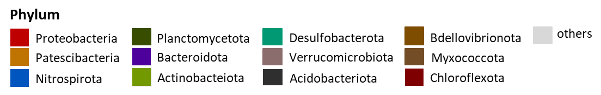
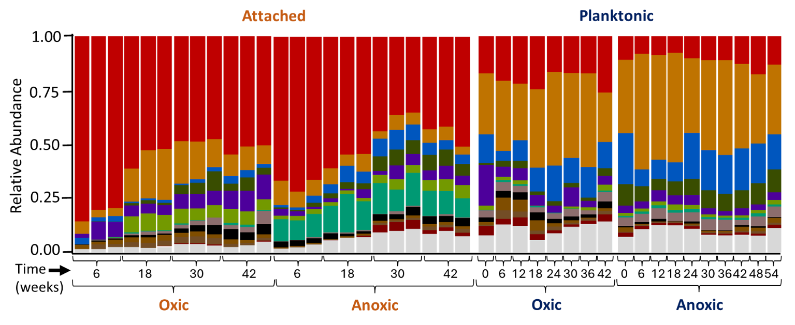

Figure S1: Taxonomic composition of bacterial community. Taxonomic profiles were derived from read abundance obtained through Illumina MiSeq sequencing of bacterial 16S rRNA genes from DNA extracted from passive samplers and in situ groundwater under oxic and anoxic conditions. Passive sampler material were collected at four time points with three replicates per condition (n = 24). In situ groundwater samples were collected at eight time points under oxic conditions and ten time points under anoxic conditions. The figure displays the 12 most abundant bacterial phyla across all samples, ranked by mean relative abundance; all remaining phyla are grouped under the category “others”. No explicit abundance cutoff was applied.

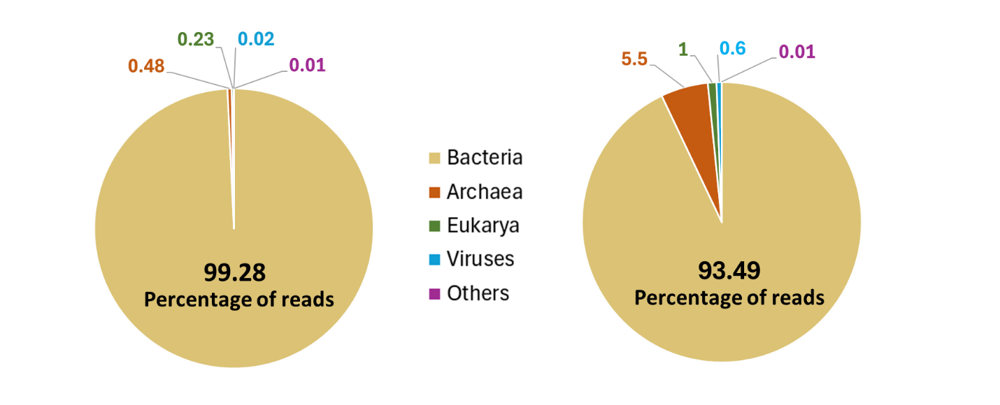
A
B
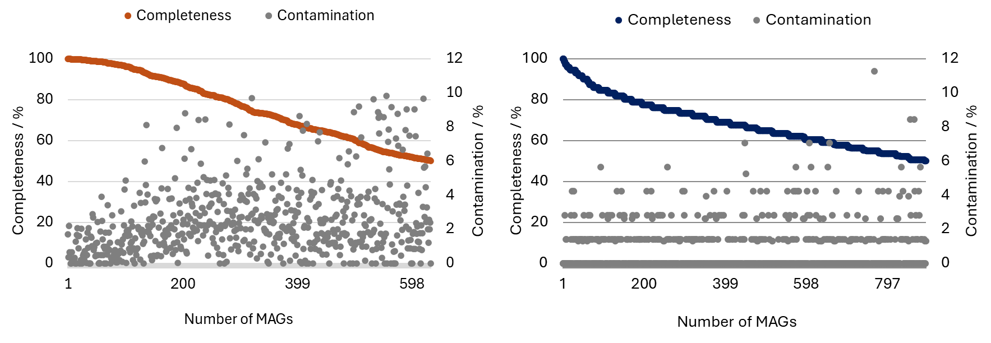
Figure S2: (A) Community composition of the rock-attached and groundwater microbes based on metagenomic reads obtained from 10 samples each of bioreactor experiment and passive samplers exposed to oxic (well H41) and anoxic (well H52) groundwater of Hainich CZE. (B) quality of dereplicated MAGs obtained. Only medium- and high-quality MAGs from rock-attached (orange) and planktonic (blue) microbial communities were included in the analysis, with each black dot in the figure representing the contamination level of the corresponding MAG.

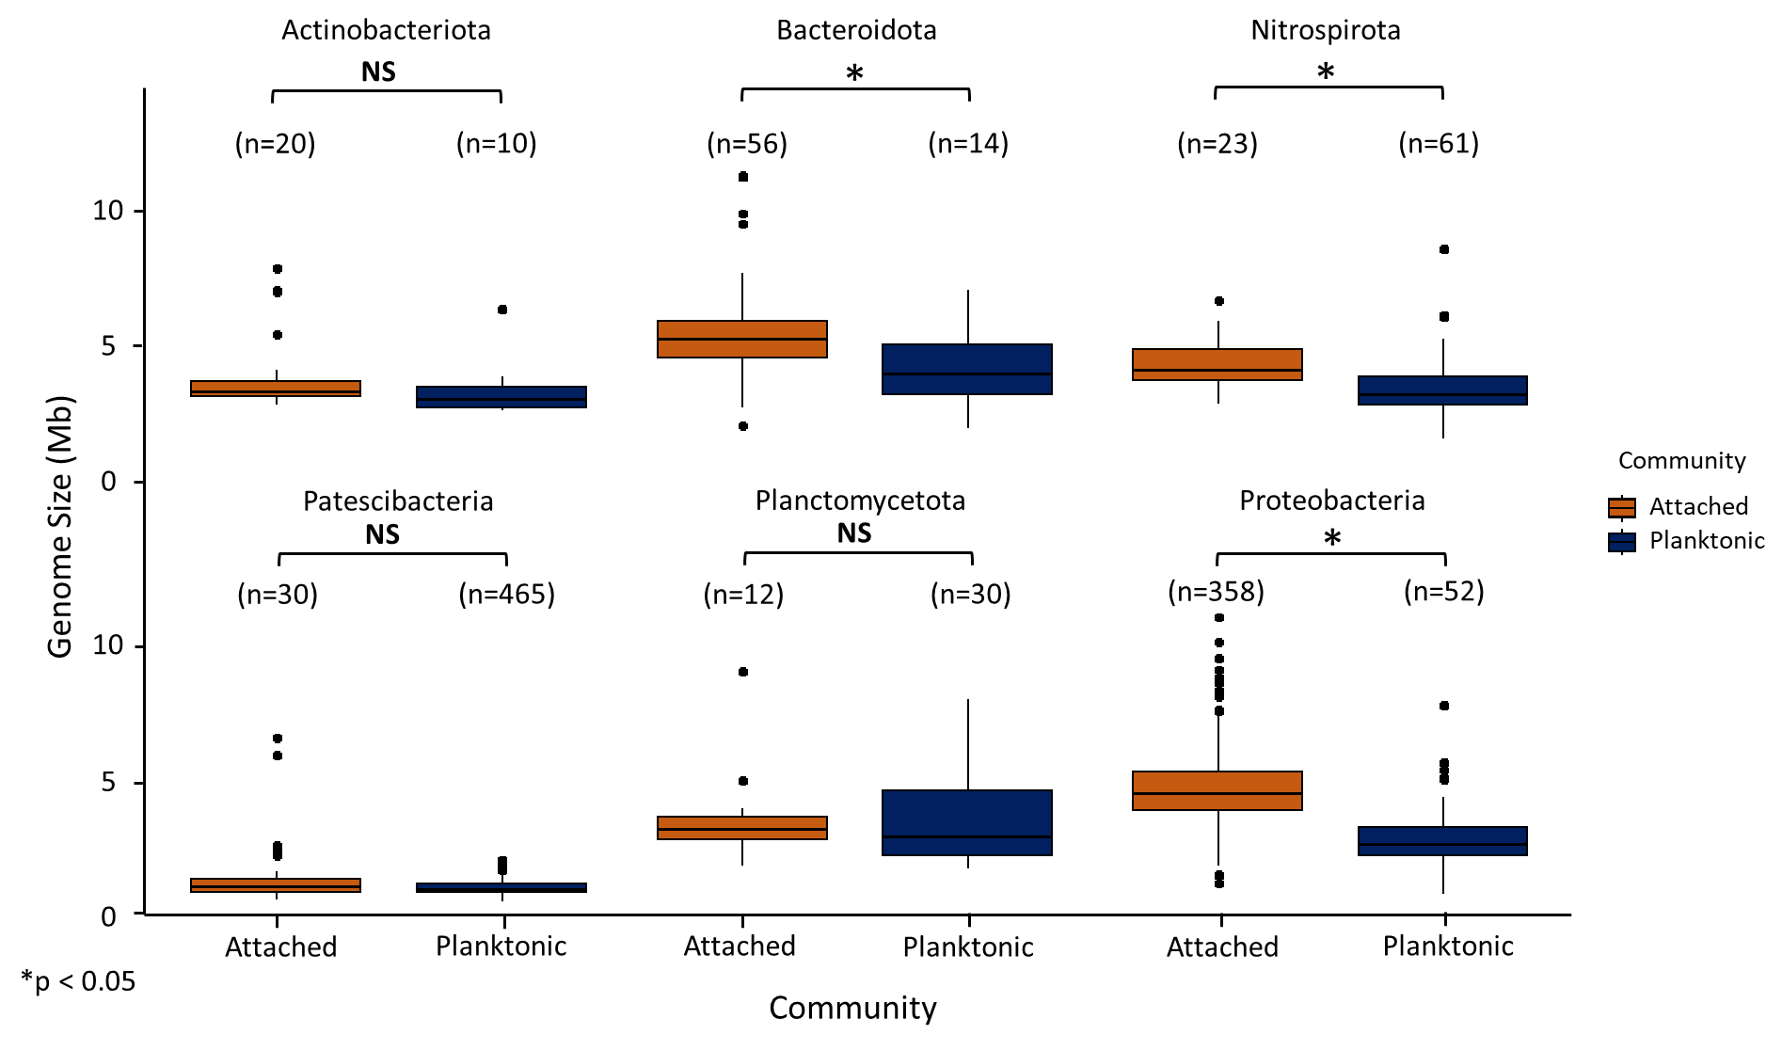
Figure S3: Genome size differences between attached and planktonic phyla with more than 10 MAGs. The data was derived from checkM analysis and genome size of each MAG was corrected for completeness and contamination. Statistical significance is denoted as not significant (NS) for p > 0.05, * for p ≤ 0.05, and *** for p ≤ 0.001
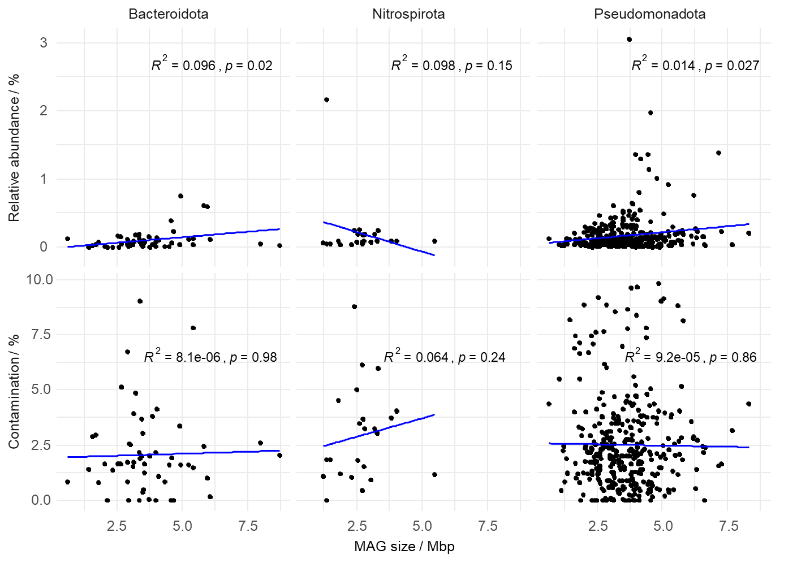 Figure S4. Correlations of attached MAG sizes with relative abundance and contamination. Plots showing MAG sizes vs. relative abundance (top row) and CheckM contamination (bottom row) for attached MAGs of phyla showing higher MAG sizes in the attached vs. planktonic dataset. Regression lines are shown in blue. Spearman correlations (R² and p-values) are indicated on each panel. While two correlations are nominally significant (p = 0.02), the effect sizes are extremely small (R² < 0.1), indicating that relative abundance or contamination has no substantial influence on MAG size.

