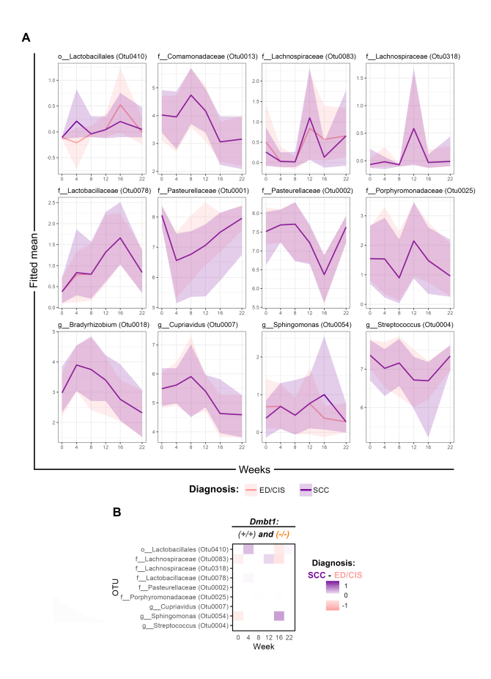
Figure S1. Significantly different OTUs between diagnosis in Dmbt1^{+/+} and Dmbt1^{-/-} mice at any timepoint. A) Fitted average values (CLR-transformed) for significant OTUs between OSCC and ED/CIS over time in Dmbt1^{+/+} and Dmbt1^{-/-} as analyzed by LSVCMM. B) Heatmap summarizing comparisons between Dmbt1^{+/+} and Dmbt1^{-/-}.

