Supplementary information for
Cross-Kingdom Genomic Variation in Chicken Gut Microbiomes: Insights from China’s Diverse Local Breeds

Jiayu Zhang ^{1†}, Le Xu ^{2,3†}, Xuehai Ge ^{4†}, Xiannian Zi ^{2†}, Shiyu Chen ², Chen Liu ², Kun Wang ^{2,3}, Jinping Zhou ⁴, Tengfei Dou ^{2,3}, Jonathan W.C. Wong ¹, Qiuye Lin ^{5*}, Xiangtao Kang ^{2,6*}, Zhenhui Cao ^{2,3*}

¹ Research Center for Eco-environmental Engineering, Dongguan University of Technology, Dongguan 523808, China
² Faculty of Animal Science and Technology, Yunnan Agricultural University, Kunming 650201, China
³ Key Laboratory of Animal Nutrition and Feed Science of Yunnan Province, Kunming 650201, China
⁴ College of Food Science and Technology, Yunnan Agricultural University, Kunming 650201, China
⁵ School of Ethnic Medicine, Yunnan Minzu University, Kunming 650504, China
⁶ College of Animal Science and Technology, Henan Agricultural University, Zhengzhou 450046, China
*Correspondence: caozhenhui@ynau.edu.cn (Zhenhui Cao); xtkang2001@263.net (Xiangtao Kang); linqiuye@ymu.edu.cn (Qiuye Lin)
†Jiayu Zhang, Le Xu, Xuehai Ge, and Xiannian Zi contributed equally to this study.
This file includes:
Supplemental Figures：
Figure S1. Geographical distribution and photographs of ten Yunnan indigenous chicken breeds.
Figure S2. Distribution of viral genomic organizations across DNA and RNA viruses.
Figure S3. Relative abundances of dominant microbial taxa at various taxonomic levels in prokaryotic (A–C), DNA viral (D–G), and RNA viral (H–J) communities from chicken feces.
Figure S4. Comparison of NGS and ONT for SV and SNV detection in DNA viruses.
Figure S5. Number of SVs and SNVs in prokaryotic, DNA viral, and RNA viral communities in the feces of different Yunnan indigenous chicken breeds.
Figure S6. SV and SNV densities in dominant phyla of prokaryotes (A), DNA viruses (B), and RNA viruses (C).
Figure S7. Density distributions of SV and SNV frequencies across different virus categories.
Figure S8. Virus-prokaryote associations at the phylum level based on CRISPR spacer alignment.
Figure S9. SV (A) and SNV (B) densities in viruses with various prokaryotic hosts.
Figure S10. HGT network among prokaryotes and viruses.
Figure S11. Number of horizontally transferred genes in each viral functional category of viral SVs and SNVs.
Figure S12. Pearson correlation analysis of SV/SNV density with genomic and ecological features in prokaryotes (A), DNA viruses (B), and RNA viruses (C).

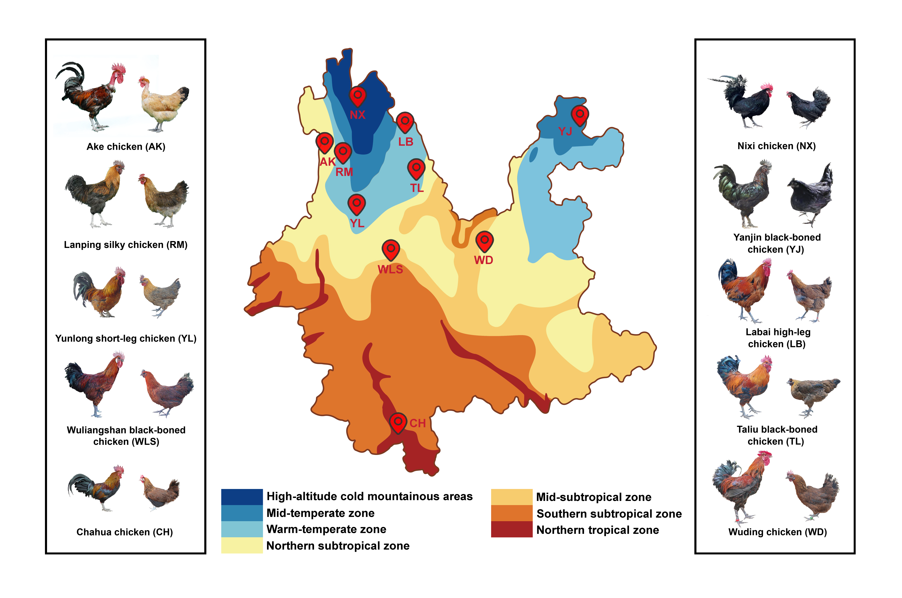
Figure S1. Geographical distribution and photographs of ten Yunnan indigenous chicken breeds.

Figure S2. Distribution of viral genomic organizations across DNA and RNA viruses.
Figure S3. Relative abundances of dominant microbial taxa at various taxonomic levels in prokaryotic (A–C), DNA viral (D–G), and RNA viral (H–J) communities from chicken feces. Panel G shows the classified families within the DNA viral community. The relative abundances of prokaryotic and DNA viral communities were calculated using metagenomic datasets, whereas those of RNA viral communities were calculated using metatranscriptomic datasets.
Figure S4. Comparison of NGS and ONT for SV and SNV detection in DNA viruses. *, p < 0.05; **, p < 0.01; ***, p < 0.001; NS, not significant.

Figure S5. Number of SVs and SNVs in prokaryotic, DNA viral, and RNA viral communities in the feces of different Yunnan indigenous chicken breeds.

Figure S6. SV and SNV densities in dominant phyla of prokaryotes (A), DNA viruses (B), and RNA viruses (C).

Figure S7. Density distributions of SV and SNV frequencies across different virus categories. (A, B) SV (A) and SNV (B) density in viruses infecting prokaryotic and eukaryotic hosts. (C, D) SV (C) and SNV (D) density in viruses categorized by genomic type: dsDNA, ssDNA, dsRNA, and ssRNA. Viruses that could not be unambiguously classified were excluded from the analysis. Vertical dashed lines indicate the mean value of SV/SNV number per 1 kb for each category. *, p < 0.05; **, p < 0.01; ***, p < 0.001; NS, not significant.

Figure S8. Phage-prokaryote associations at the phylum level based on CRISPR spacer alignment. The chord width and bar length represent the number of phage-host linkages.

Figure S9. SV (A) and SNV (B) densities in viruses with various prokaryotic hosts.

Figure S10. HGT network among prokaryotes and viruses. The arrows on the edge indicate the direction of gene transfer.

Figure S11. Number of horizontally transferred genes in each viral functional category of viral SVs and SNVs.
Figure S12. Pearson correlation analysis of SV/SNV density with genomic and ecological features in prokaryotes (A), DNA viruses (B), and RNA viruses (C). SV and SNV densities are expressed as counts per 1 Kb. HGT receptor/donor number refers to the number of microbial receptors and donors involved in HGT events. Niche breadth indicates the range of chicken breeds a microbe can inhabit, quantified using Levin’s niche breadth index. Host number refers to the number of prokaryotic hosts for viruses. Infected phage number refers to the number of bacteriophages infecting prokaryotes. *, p < 0.05; **, p < 0.01; ***, p < 0.001.

