Supplementary Materials for

Periodontal Pathogen Induces Gingipain-Dependent Gut Microbiome Dysbiosis in Exacerbating Intestinal Inflammation
Ming Li et al.

*Corresponding author. Email: zhenjiangxu@ncu.edu.cn

This PDF file includes:

Figs. S1 to S15
Tables S1 to S3

Supplementary Fig. 1. a Representative immunofluorescence images and quantification of ZO-1 in colon sections. ZO-1 was stained in green and nuclei are counterstained with DAPI (blue). b The expression levels of ZO-1 were quantified as Mean Fluorescence Intensity (MFI) per field (n=4 per group). c Representative immunofluorescence images and quantification of E-cadherin in colon sections. E-cadherin is stained in red and nuclei are counterstained with DAPI (blue). Scale bar=100μm. d The expression levels of E-cadherin were quantified as Mean Fluorescence Intensity (MFI) per field (n=5 per group). e-i The relative mRNA expressions of Occludin (d), Muc2 (e), TGF-β (f), SAA1 (g), and SAA2 (h) in colon tissues in the Pg treatment experiment (n=4 per group). The data were presented as the mean ± SEM and evaluated by one-way ANOVA with Tukey’s test. *p ≤ 0.05, **p ≤ 0.01, ***p ≤ 0.001.

Supplementary Fig. 2. a-c The relative mRNA expressions of SAA1 (a), SAA2 (b), and SAA3 (c) in colon tissues from the Th17 inhibition experiment. The data were presented as the mean ± SEM and evaluated by one-way ANOVA with Tukey’s test. n=6 per group. *p ≤ 0.05, **p ≤ 0.01, ***p ≤ 0.001.
Supplementary Fig. 3. The impact of Th17 inhibition on the gut microbiota of mice. a-b Alpha diversity analysis of the gut microbiota from the Th17 inhibition experiment measured with the Shannon index and observed ASVs. c-d Bray-Curtis and Weighted UniFrac distances based PCoA of the gut microbiota from the Th17 inhibition experiment. e-f The microbiota composition at the phylum and genus levels. n=7 per group, two cages. *p ≤ 0.05, **p ≤ 0.01, ***p ≤ 0.001.

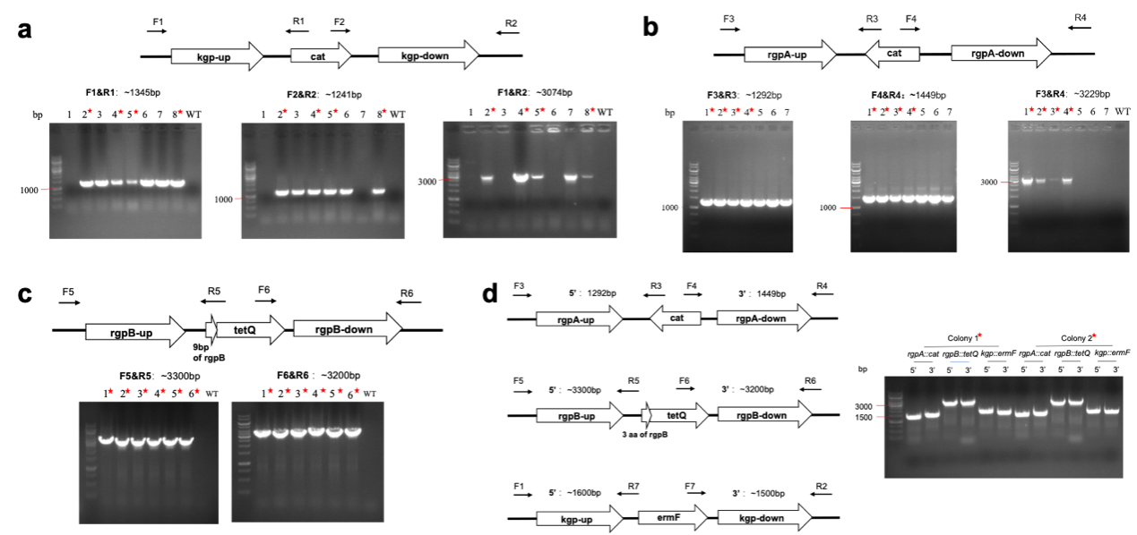
Supplementary Fig. 4. PCR confirmation of gingipain mutants. a Validation of single knockout mutant ▲Kgp (Pg.W83 △kgp::cat). b Validation of single knockout mutant ▲RgpA (Pg.W83 △rgpA::cat). c Validation of double knockout mutant ▲RgA/B (Pg.W83 △rgpA::cat △rgpB::tetQ). The gene rgpB was knocked out in ▲the RgpA mutant. d Validation of the triple knockout mutant ▲KRAB (Pg. W83 △rgpA::cat △rgpB::tetQ △kgp::ermF). The gene kgp was knocked out in the ▲RgA/B mutant. The red star indicated the correct colony.

Supplementary Fig. 5 a Representative immunofluorescence images of colonic sections. IL-17A is labeled in red, and nuclei are counterstained with DAPI (blue). Scale bar = 50μm; b Quantification of IL-17A⁺ cells. Cell numbers were counted across the entire scanned area. Data are expressed as the number of IL-17A⁺ cells per high-power field (HPF, at 40 magnification) (mean ± SEM, n = 4 per group).

Supplementary Fig. 6. a-e The relative mRNA expressions of ZO-1 (a), Occludin (b), Muc2 (c), SAA1 (d), and SAA2 (e) in colon tissues from the gingipain-knockout strains experiment. The data were presented as the mean ± SEM and evaluated by one-way ANOVA with Tukey’s test. n=6 per group. *p ≤ 0.05, **p ≤ 0.01, ***p ≤ 0.001.

Supplementary Fig. 7. The background microbiota of mice before treatment. a-b Alpha diversity analysis of the gut microbiota from the Pg treatment experiment measured with Shannon index and observed ASVs. c-d Bray-Curtis and Weighted UniFrac distances based PCoA of the gut microbiota from the Pg treatment experiment. e-f The microbiota composition at the phylum and genus levels. n=5 per group, two cages.

Supplementary Fig. 8. a The number of common or unique genera among different groups in the Venn diagram from the Pg treatment experiment. b Alpha diversity analysis of gut microbiota from the Pg treatment experiment measured with observed ASVs. c Weighted_UniFrac distance based PCoA of gut microbiota from the Pg treatment experiment. d Bacterial taxa of differential abundance among groups with the LDA scores derived from LEfSe analysis (LDA > 2.0) in the Pg treatment experiment. f LEfSe taxonomic cladogram illustrating taxa of differential abundances between microbiome communities.

Supplementary Fig. 9 a-i The box plots indicate the relative abundances of each bacterial group at the genus level in the Pg treatment experiment analyzed using Maaslin2 (Faecalibaculum, Clostridia_UCG-014, Dubosiella, Muribaculum, Bacteroides, Escherichia-Shigella, Helicobacter, Enterorhabdus, and Alloprevotella). n=5 per group, two cages. *p ≤ 0.05, **p ≤ 0.01, ***p ≤ 0.001.

Supplementary Fig. 10. a The number of common or unique genera among different groups in the Venn diagram in the gingipain-knockout strains experiment. b c Alpha diversity analysis of gut microbiota measured with Faith’s PD and Observed ASVs in the gingipain-knockout strains experiment. d Weighted UniFrac distance-based PCoA of gut microbiota in the gingipain-knockout strains experiment. e The microbiota composition at the phylum level. f Bacterial taxa of differential abundance among groups with the LDA scores derived from LEfSe analysis (LDA > 2.0) in the gingipain-knockout strains experiment.

Supplementary Fig. 11. Gut microbiota phenotype prediction based on Bugbase was conducted for the Pg treatment experiment (left) and gingipain-knockout strains experiment (right). a Contains mobile element. b Facultatively anaerobic. c Gram negative. d Gram positive. e Forms_biofilms. * p < 0.05; * * p < 0.01 and * ** p < 0.001

Supplementary Fig. 12. The relative levels of Pg in colonic tissues and colonic contents. a The Pg levels in the colonic contents of mice from the Pg treatment experiment (n=5 per group, two cages). b The Pg levels in colonic contents from mice in the gingipain-deficient Pg animal experiment; c The Pg levels in the colonic tissues from mice in the gingipain-deficient Pg animal experiment. The ΔCT is calculated by subtracting the CT value of the 16S universal primer from the CT value of the Pg-specific primer. A lower ΔCT value indicates a higher relative abundance of Pg(n=7 per group, two cages). *p ≤ 0.05, **p ≤ 0.01, ***p ≤ 0.001.

Supplementary Fig. 13. a-f The relative mRNA expressions of Occludin (a), ZO-1(b), MUC2 (c), SAA1 (d), SAA2 (e), SAA3 (f) in colon tissues from the co-housing experiment. The data were presented as the mean ± SEM and evaluated by one-way ANOVA with Tukey’s test. n=6 per group. *p ≤ 0.05, **p ≤ 0.01, ***p ≤ 0.001
Supplementary Fig. 14. a Alpha diversity analysis of gut microbiota in the co-housing experiment measured with Faith’s PD and Observed ASVs. c Weighted UniFrac distance based PCoA of gut microbiota in the co-housing experiment. d The microbiota composition of feces at the phylum level. e LEfSe taxonomic cladogram illustrating taxa of differential abundances between microbiome communities.

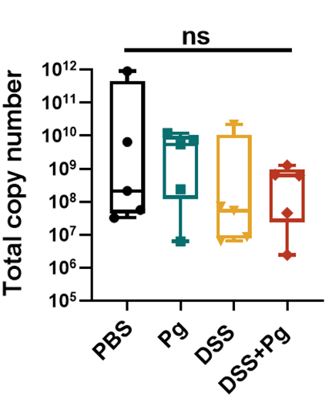

Supplementary Fig. 15 The total bacterial copy number in the Pg treatment experiment. n=5 per group, two cages.

Table S1 The plasmids used in this study.
plasmid | antibiotic resistance
pUC19 | Amp
pKN-kgp-cat | Cm
pKN-rgpA-cat | Cm
pUC19-rgpB-tetQ | Amp，Tet
pUC19-kgp-ermF | Amp，Em

Table S2 The primers used for the construction of knockout mutants.
Primer | Sequence (5'→3')
kgp-F1 | ATCAGCGTGGTCGTGATACGATCGGACAGGGAGATTAC
kgp-R1 | TGCCGATCAACGTCTCAACTTTAAAACAATTTATGGTCGTGATTC
kgp-F2 | TGCTACGCCTGAATAAGTGAACTCGCTGTAAAGTAAATCTG
kpg-R2 | GATCTCAAGAAGATCCTTTGATAACGGAGGGAGGGAAAAG
rgpA-F1 | ATCAGCGTGGTCGTGAAACTTCTCTTGCAGCAGTAC
rgpA-R1 | TGCTACGCCTGAATAAGTGAACTCGCTATCAAGTAAATCTGTC
rgpA-F2 | TGCCGATCAACGTCTCAAGAGCAATCGAAACAAACTTG
rgpA-R2 | TCTCAAGAAGATCCTTTGATTCGTCTCGGATGGCATC
cat-F | TGAGACGTTGATCGGCAC
cat-R | TCACTTATTCAGGCGTAGCAAC
ori-F | TCACGACCACGCTGATG
ori-R | ATCAAAGGATCTTCTTGAGATCC
rgpB-F1 | ACGACGGCCAGTGAATTCGGAGCTCATGAGTTGGCTGTCATGAC
rgpB-R1 | TTGCTTGAATTAGTTTTTTATTTG
rgpB-F2 | AGCCTCTATGAATGGCAAAGTAATTCACACTGCAATTCTC
rgpB-R2 | TGACCATGATTACGCCAAAGCTTGGTTGAGGGTACGGTG
tetQ-F | ACAAATAAAAAACTAATTCAAGCAAATGAATATTATAAATTTAGGAATTCTTGCTC
tetQ-R | TGCCATTCATAGAGGCTATTATATG
kgp-F3 | ACGGCCAGTGAATTCGAGCTCTACGATCGGACAGGGAGATTAC
kgp-R3 | TGTTGCAAATACCGATGAGCAACTTTAAAACAATTTATGGTCGTGATTC
kgp-F4 | TGGCGATGGAGCGGAAACGTACTCGCTGTAAAGTAAATCTG
kgp-R4 | ACCATGATTACGCCAAAGCTTAACGGAGGGAGGGAAAAG
ermF-F | TGCTCATCGGTATTTGCAAC
ermF-R | ACGTTTCCGCTCCATC
F1 | ACATGGCTGTACGATTTCTAC
R1（F4） | AGGTACATTGAGCAACTGAC
F2（R3） | TGTGATGGCTTCCATGTCG
R2 | TCTCTTCATTGTCTCGGCTC
F3 | TGCTCCTGAGGTATGGAGAC
R4 | TGGCAGAAGATCAGGATGGAG
F5 | ACCTATAAGTATCCCAAGGCAG
R5 | ACAACGTCTCGAAGTCTC
F6 | ACAGACATTGCTGGAAGAAC
R6 | ACCACGTTCTACGTCGTAG
F7 | TGTCTATGAGGTAGGTCCTG
R7 | TCACAACCGACAACTTGAAC

Table S3 The primer sequences used for the analysis of gene expression in the colon.
Primer target | Forward Sequence | Reverse sequence
SAA1 | CATTTGTTCACGAGGCTTTCC | GTTTTTCCAGTTAGCTTCCTTCATGT
SAA2 | TGATGCTGCCCAAAGG | GCCAGGAGGTCTGTAGTAA
SAA3 | GCAACTACTGGGTTGAGATA | ATTCAGCACATTGGGATG
RORγT | TGTCCTGGGCTACCCTACTG | GTGCAGGAGTAGGCCACATT
IL-6 | ACTTCCATCCAGTTGCCTTCTTGG | TTAAGCCTCCGACTTGTGAAGTGG
IL-17 | CAAGAAATCCTGGTCCTTCG | GAGCATCTTCTCCAACCTGAA
TGF-β | CTCCCGTGGCTTCTAGTGC | GCCTTAGTTTGGACAGGATCTG
Muc2 | CAACAAGCTTCACCACAATCTC | CAGACCAAAAGCAGCAAGGT
Occludin | TCACTTTTCCTGCGGTGACT | GGGAACGTGGCCGATATAATG
ZO-1 | AGGACACCAAAGCATGTGAG | GGCATTCCTGCTGGTTACA
GAPDH | AGGTCGGTGTGAACGGATTTG | TGTAGACCATGTAGTTGAGGTCA

