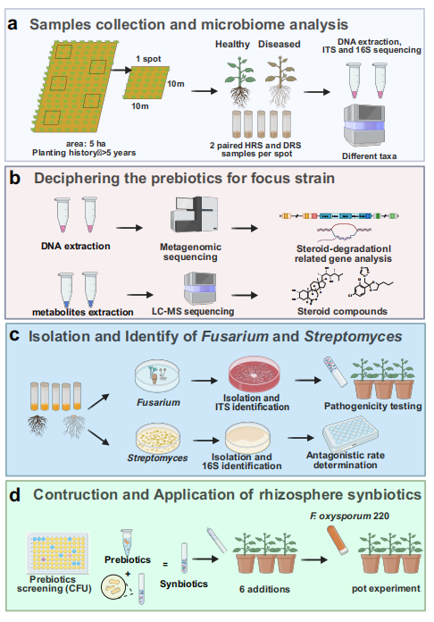
Figure S1. a Sampling and rhizosphere microbiome analysis of this study. b Deciphering the prebiotics for Streptomyces using multi-omics approach and Screening prebiotics based on in vivo test. c Construction of Fusarium and Streptomyces resource bank and properties of candidate strains. d Screening prebiotics based on in vivo interaction, and construction of synbiotic fertilizers.
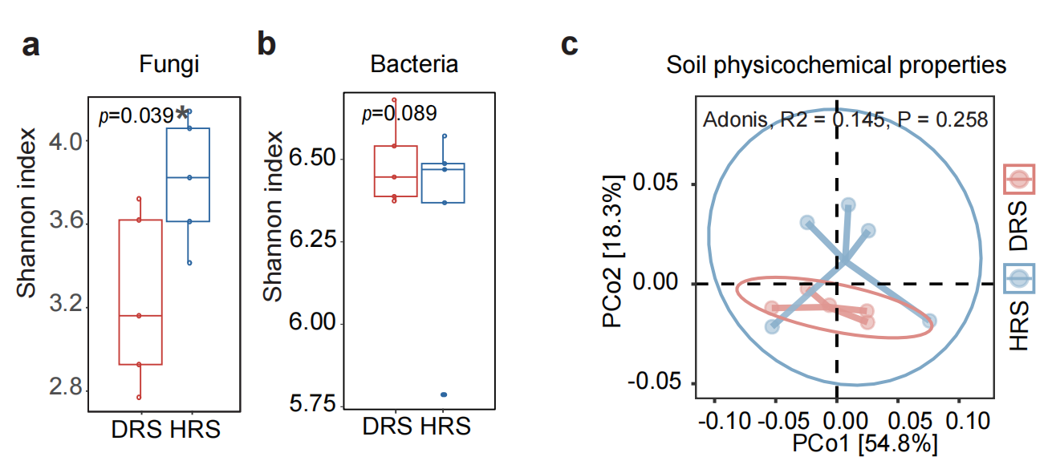
Figure S2. a-b Box plot of rhizosphere fungal (c) and bacterial (d) shannon index. c Principal Co-ordinates Analysis (PCoA) of soil physicochemical properties composition base on the different indicators. Based on the calculation of the alpha diversity, the Shannon index of the fungal community was significantly greater in the HRS than the DRS samples (Fig. S2a; Wilcoxon test; P = 0.039), but principal coordinate analysis (PCoA) analysis with Bray-Curtis distance show no significant differences between the two soil types (Adonis, R² = 0.086, P = 0.734) (Fig. S2a). The result of bacterial Shannon index analysis revealed no clear significant difference of alpha diversity in the HRS and DRS samples (Fig. S2b; Wilcoxon test; P = 0.089). However, PCoA analysis with Bray-Curtis distance revealed significant differences in the composition of bacterial communities between HRS and DRS samples (Fig. S2b; Adonis, R² = 0.188, P = 0.026), which indicated that the difference in the health symptoms of A. sinensis is due to differences in rhizosphere bacterial communities community structure between HRS and DRS, rather than differences in α-diversity.

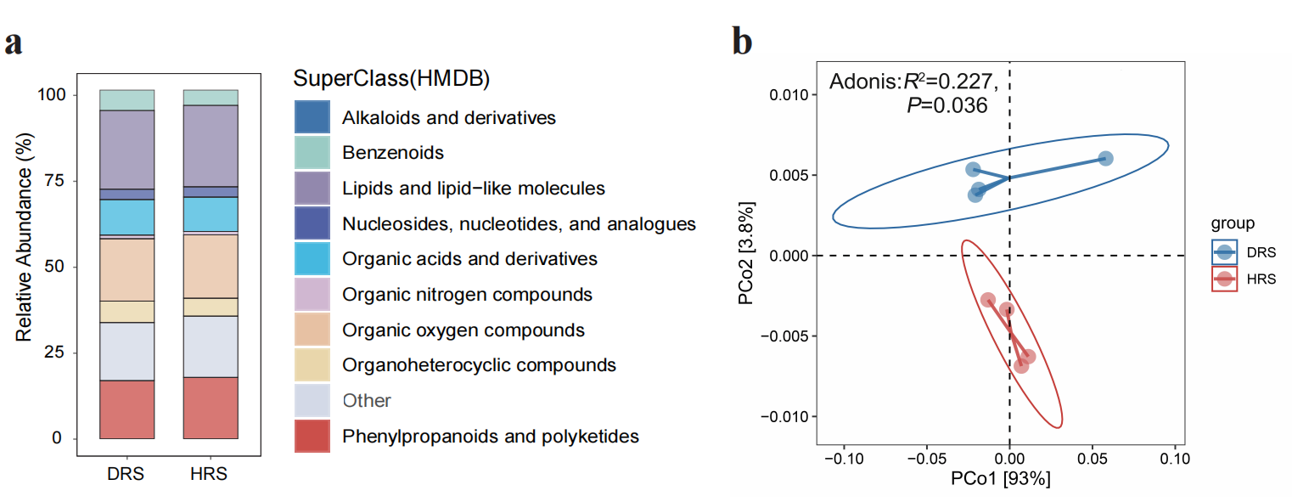
Figure S3 a Stacked bar chart of the top 10 rhizosphere metabolites (super class). b PCoA of rhizosphere microbial functional genes base on KEGG (Kyoto Encyclopedia of Genes and Genomes).
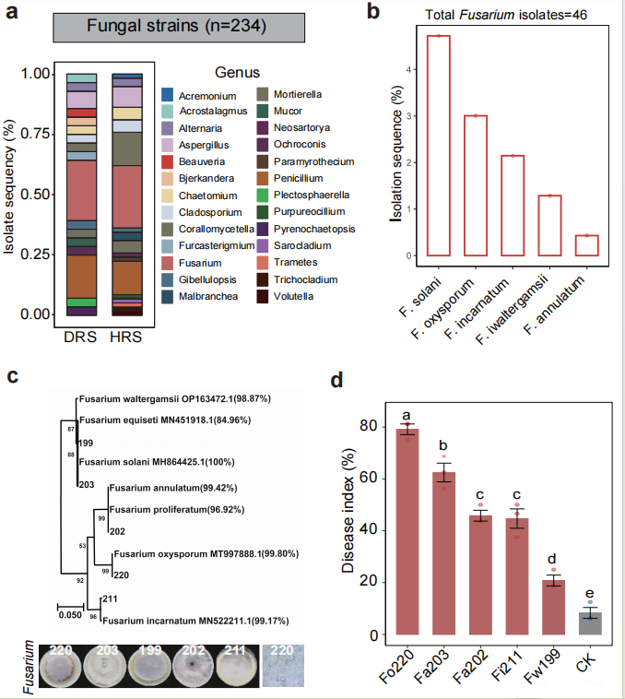
Figure S4 a Isolation sequence (%) of different rhizosphere fungal strains. b Isolation frequency (%) of different rhizosphere Fusarium species. c Evolutionary tree constructed by Fusarium’s ITS sequences based on neighbor-joining adjacency method. d Root rot disease incidence in A. sinensis with Fusarium isolates infection. CK, control (non-inoculated).
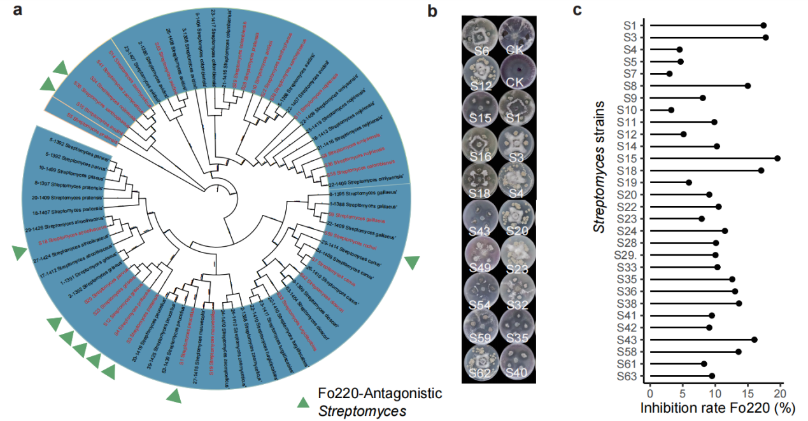
Figure S5 a Cladogram showing the phylogenetic relationship among the cultured Streptomyces strains (identified using their 16S rRNA sequences). Accession numbers of isolates obtained from the National Center for Biotechnology Information (NCBI) database are displayed in regular letters. Streptomyces strains with antagonistic ability are highlighted with green triangular protrusions. b Pictures display the in vitro inhibitory effects of the Streptomyces strains on Fusarium oxysporum 220 (Fo220) using a potato dextrose agar assay. In the image, the top left photograph shows the control Fo220 medium without inoculation of the tested Streptomyces strain. c The bacterial species names and inhibition rate (%) of different Streptomyces strain.
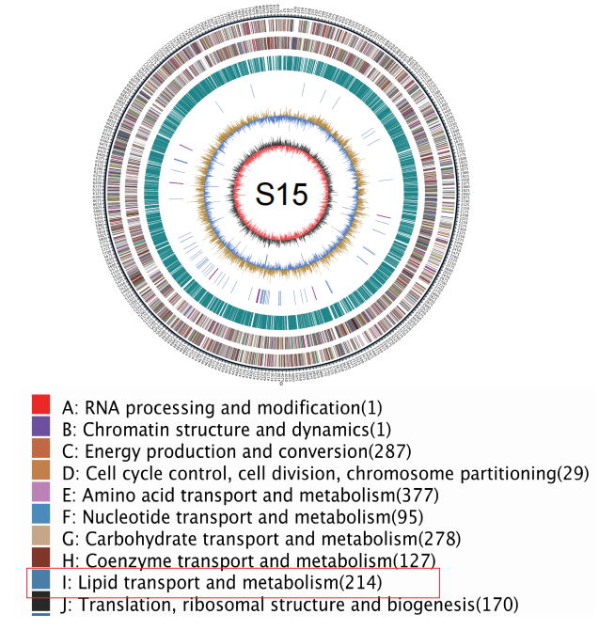
Figure S6 Circular map of the Streptomyces sp. S15 genome. the red box represents genes related to lipid transport and metabolism. The red box represents genes related to lipid transport and metabolism.
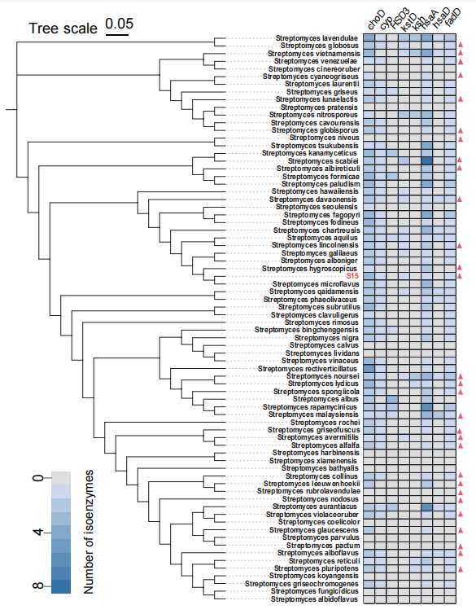
Figure S7 Neighbor-joining tree showing the phylogenetic relationship among the Streptomyces sp. obtained from the NCBI database. Heatmap shows number of isoenzymes of steroid degradation related genes in Streptomyces sp. Streptomyces species detected in rhizosphere of A. sinensis from the metagenome data are highlighted with red triangular protrusions.
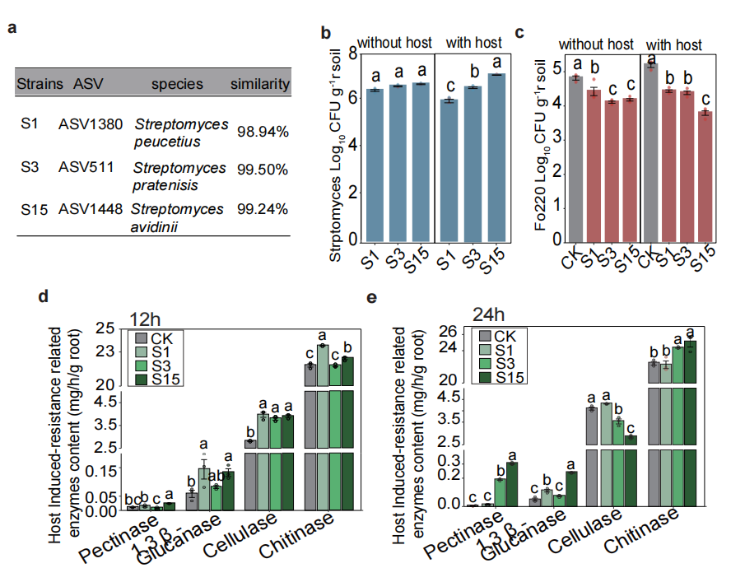
Figure S8 a Three Streptomyces’s similar species and homologous ASVs. The colonization ability of Streptomyces S15 (b) and Fusarium Fo220 (c) in the rhizosphere soil between the with and without host plants. Induction of root enzyme activityrelated to cell wall components of Fusarium (pectinase, 1,3 β-glucanase, cellulase and chitinase) in A. sinensis by three Streptomyces strains at 12 h (d) and 24 h (e) after inoculation. When the isolated Fusarium and Streptomyces were co-inoculated into soil with or without plants, we found that among these three Streptomyces isolates, Streptomyces isolates S15 showed higher rhizosphere colonization ability, compared to both S1 and S3 in the presence of plants (Fig. S8b), while there was a significant difference in the rhizosphere colonization ability of Fusarium Fo220 (Fig. S8c). Then, we hypothesized that the S15 treatment also could reduce root rot disease in plants by activating the induced systemic resistance (ISR) -related enzyme in root. We tested this hypothesis by detecting the activities of pectinase, 1,3 β-glucanase, cellulase, and chitinase in the plant root. Compared with the CK, treatment with S1, S3, and S15 increased the activities of 1,3 β-glucanase, cellulase, and chitinase in root at both 12 and 24 h after inoculation (Fig. S8d and S8e). Compared with the CK, treatment with S1, S3, and S15 increased the activities of pectinase, 1,3 β-glucanase, and chitinase in root at 24 days after inoculation. Moreover, compared with S1 and S3, Streptomyces S15 significantly increased the activities of pectinase and 1,3 β-glucanase, which can enhance the plant's ability to lyse fungal cell walls. These data show that the Streptomyces S15 inoculation reduced rhizosphere Fusarium number not only by inhibiting Fusarium growth but also by priming enzyme-mediated ISR in plant rot. CK, control.
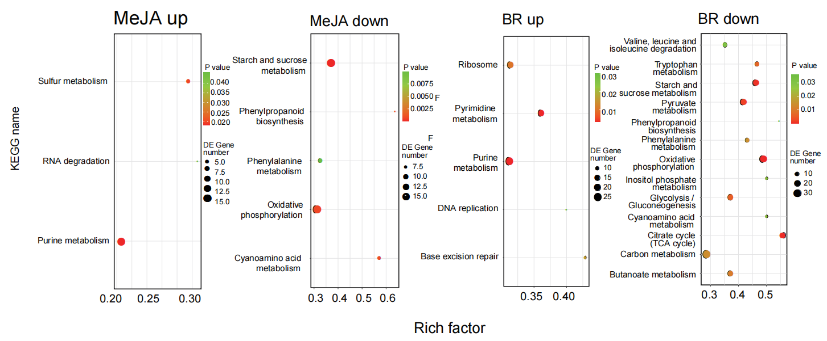
Figure S9 Transcriptome analyses of Streptomyces strain S15 when treated with methyl jasmonate and brassinolide. a PCoA analysis of S15’s genes . b Bubble plot showing KEGG pathways analysis of DEGs from S15s transcriptome data. RNA-seq was performed to reveal the molecular mechanisms by which methyl jasmonate and brassinolide promoted the growth of Streptomyces S15. Principal component analysis (PCoA) and hierarchical clustering analyses of transcriptome data revealed a high similarity among the three biological replicates within each treatment (Fig S9a). In S15, the presence of methyl jasmonate resulted in 1,248 DEGs, of which 537 were upregulated, and 711 genes were downregulated. 862 genes were upregulated and 1103 genes were downregulated when coinoculated with brassinolide (fold change >2 or <0.05, P < 0.05; Fig. S9b). KEGG pathway analysis of DEGs revealed that sulfur metabolism, RNA degradation, and purine metabolism were significantly enriched by methyl jasmonate, and ribosome and pyrimidine metabolism, purine metabolism, DNA replication, and base excision repair were significantly enriched by brassinolide (P value < 0.05, Fig S9b). Meanwhile, starch and sucrose metabolism, phenylpropanoid biosynthesis, phenylalanine metabolism, oxidative phosphorylation, and cyanoamino acid metabolism were significantly decreaseed by methyl jasmonate, and valine, leucine and isoleucine degradation, tryptophan metabolism, starch and sucrose metabolism, pyruvate metabolism, phenylpropanoid biosynthesis, phenylalanine metabolism, oxidative phosphorylation, inositol phosphate, glycolysis / gluconeogenesis, cyanoamino acid metabolism, citrate cycle (TCA cycle), carbon metabolism, and butanoate metabolism were significantly decreaseed by brassinolide (P value < 0.05, Fig S9b). Consistent with our expectation, purine metabolism, fatty acid metabolism and pyrimidine metabolism were upregulated in the presence of lipids, while the starch and sucrose metabolism, pyruvate metabolism, phenylalanine metabolism, carbon metabolism, tryptophan metabolism, cyanoamino acid metabolism, and butanoate metabolism were downregulated in the presence of lipids (Fig S9b). This might be due to the different responses of cellular metabolic pathways to lipids.
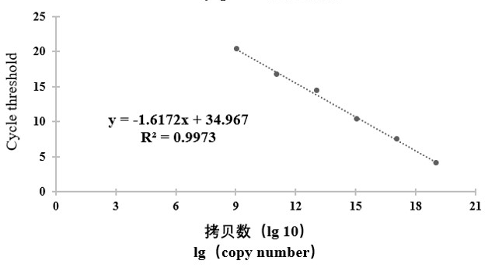
Figure S10 Fluorescence quantitative standard curve of pathogenic fungus F. oxysporum.

