Supplemental figures
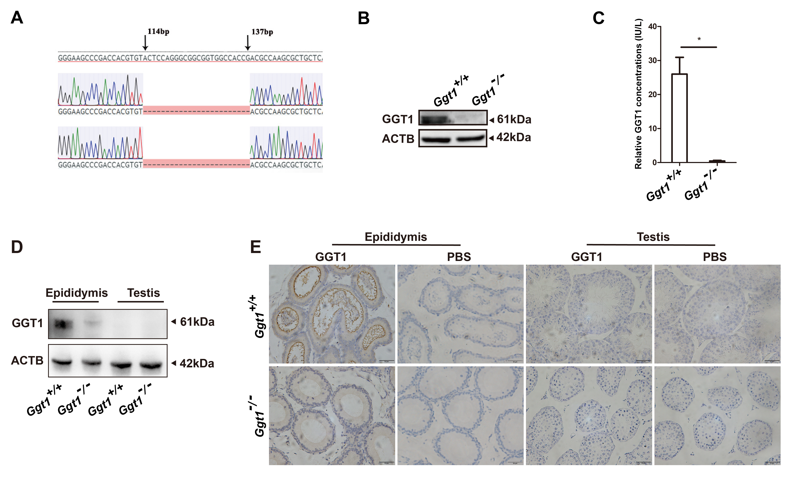
Supplementary Fig. 1 Validation of Ggt1 knockout efficiency. (A) Schematic using CRISPR/Cas9-mediated deletion of bases on exon 2 of Ggt1. (B) Western blot analysis of GGT1 in kidney tissues of Ggt1^{+/+} and Ggt1^{-/-} male mice. ACTB is the control. (C) ELISA analysis of GGT1 level in serum of Ggt1^{+/+} and Ggt1^{-/-} male mice (n = 3). (D) Western blot analysis of GGT1 in the testis and epididymis tissues from Ggt1^{+/+} and Ggt1^{-/-} mice. (E) Immunohistochemistry staining for GGT1 in the testis and epididymis tissues from Ggt1^{+/+} and Ggt1^{-/-} mice. PBS was used as primary antibody-negative control. Scale bars = 50 μm. Data are presented as mean ± SEM. *p < 0.05.
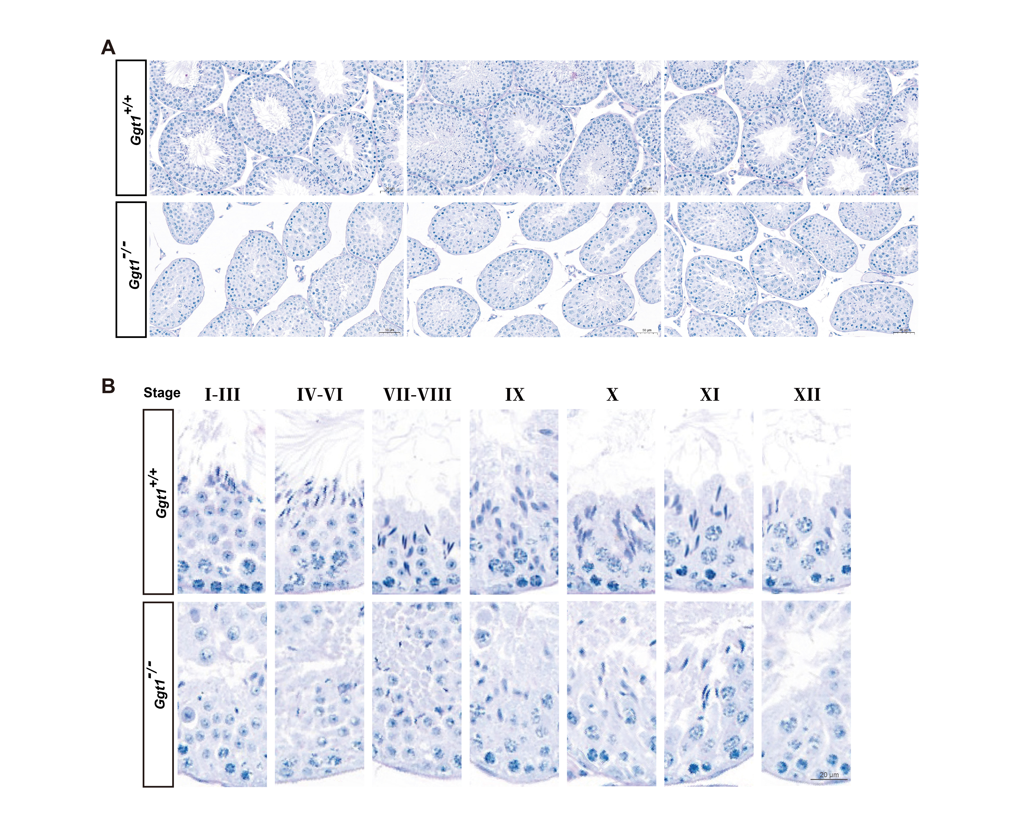
Supplementary Fig. 2 PAS staining of testicular tissue sections of Ggt1^{+/+} and Ggt1^{-/-} mice. (A) Representative image of PAS staining for testis sections from Ggt1^{+/+} and Ggt1^{-/-} mice. Scale bar = 50 μm. (B) Different stages of seminiferous tubules in PAS-stained Ggt1^{+/+} and Ggt1^{-/-} testes. Scale bar = 20 μm.
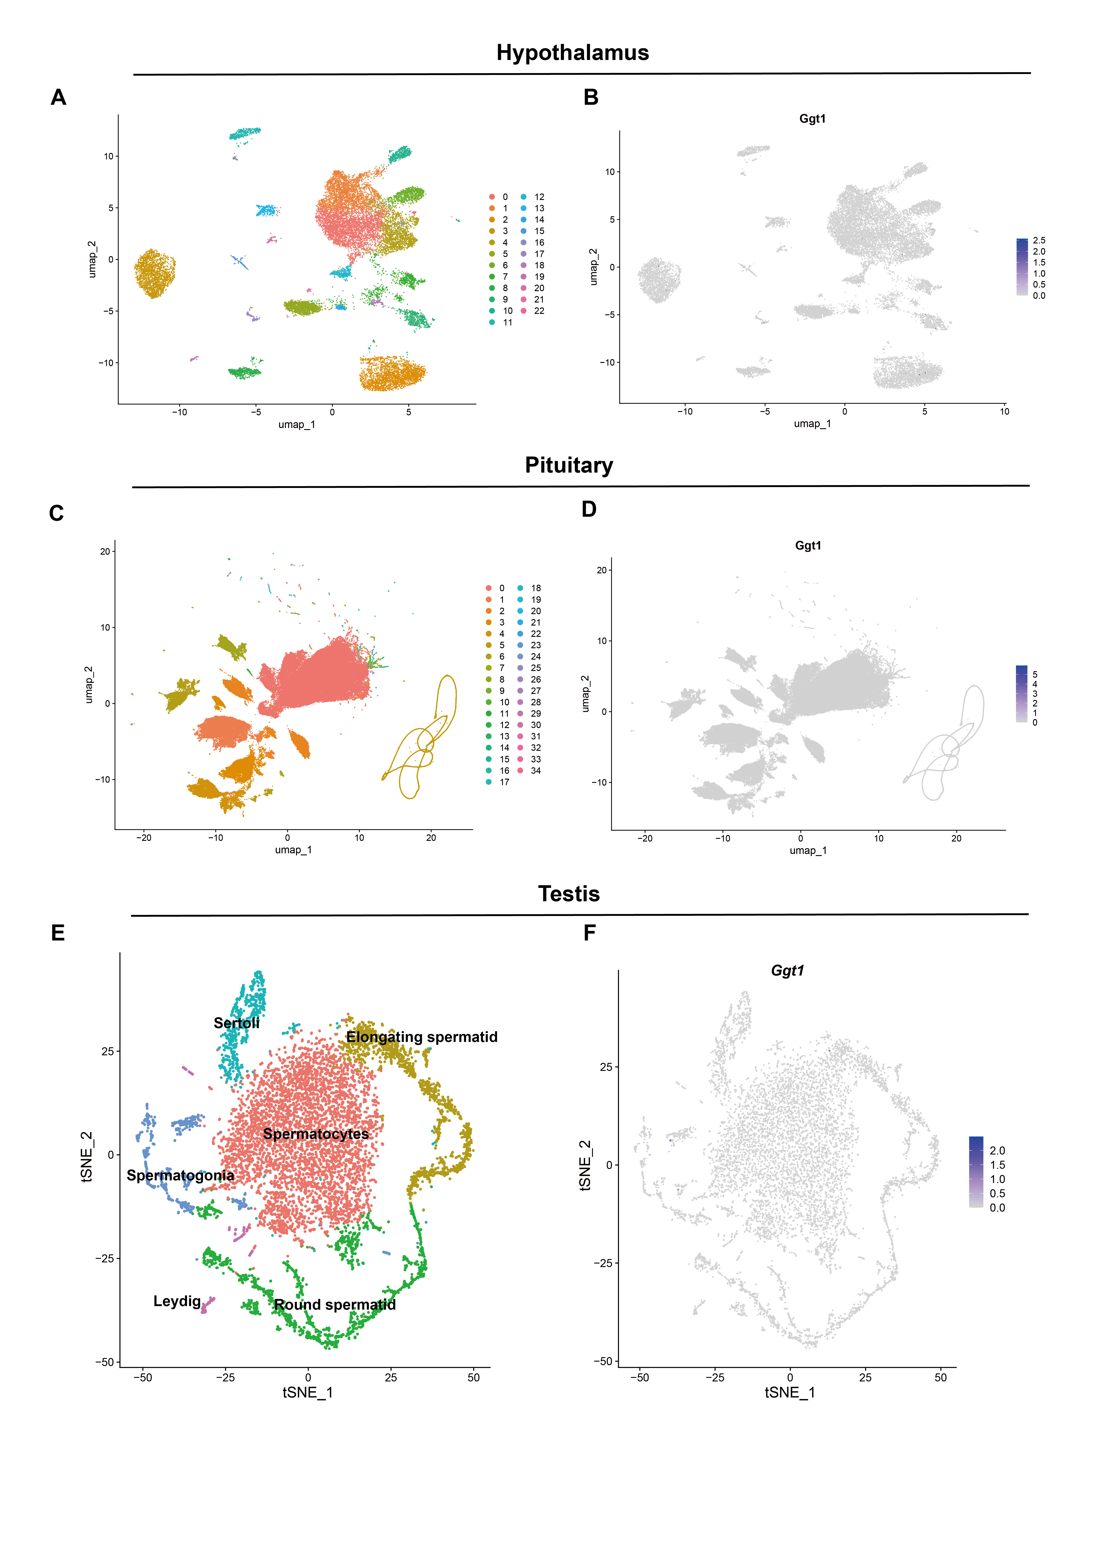
Supplementary Fig. 3 Reanalyses for the scRNA-seq data of the hypothalamus, pituitary, and testes from Ggt1^{+/+} mice. (A) Uniform manifold approximation and projection (UMAP) plot of hypothalamic cell clusters in hypothalamus defined by reanalyzing scRNA-seq data from GEO (GSE212068). (B) Expression patterns of Ggt1 in hypothalamus cast on the UMAP plot. (C) UMAP plot of pituitary cell clusters in pituitary defined by reanalyzing scRNA-seq data from GEO (GSE146619). (D) Expression patterns of Ggt1 in pituitary cast on the UMAP plot. (E) t-distributed stochastic neighbor embedding (t-SNE) plot of testicular cell clusters in testes defined by reanalyzing scRNA-seq data from OMIX (OMIX1000). (F) Expression patterns of Ggt1 cast on the t-SNE plot. Purple (or gray) represents a high (or low) expression level as shown on the color key at the right.
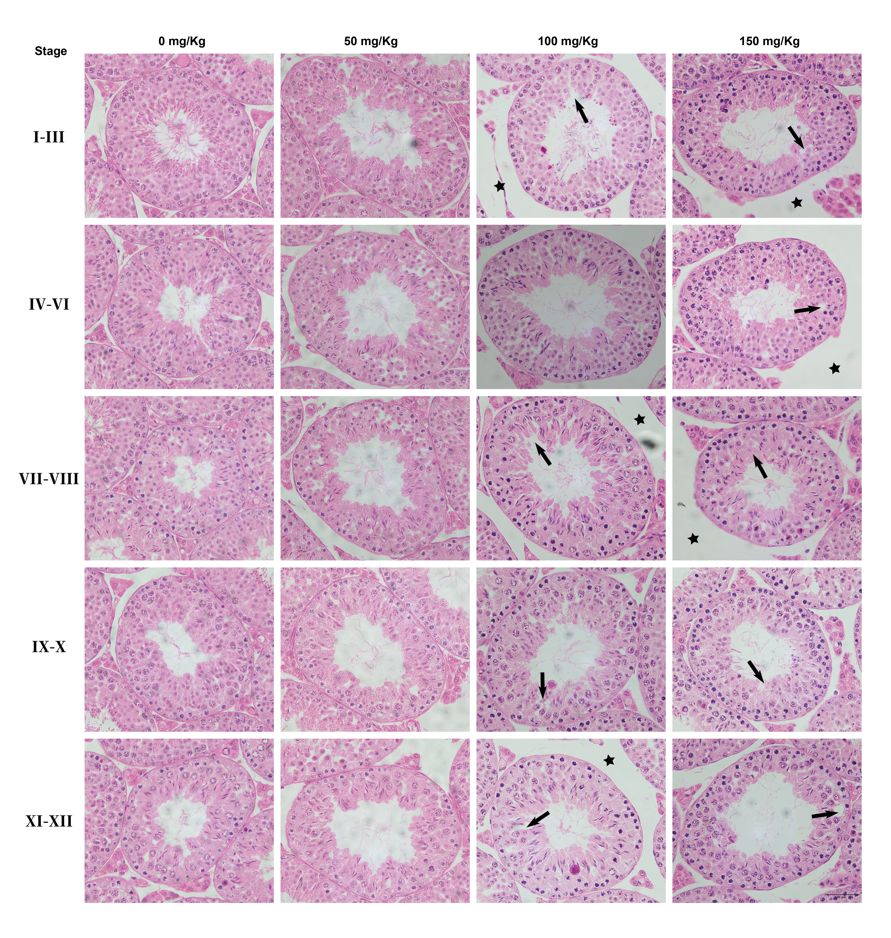
Supplementary Fig. 4 H&E staining of testicular tissue sections of PAGly treated mice. Different stages of seminiferous tubules in H&E-stained testes of PAGly treated mice. Arrows indicate abnormal seminiferous tubules, and stars indicate the abnormal interstitial spaces of seminiferous tubules. Scale bar = 50 μm.
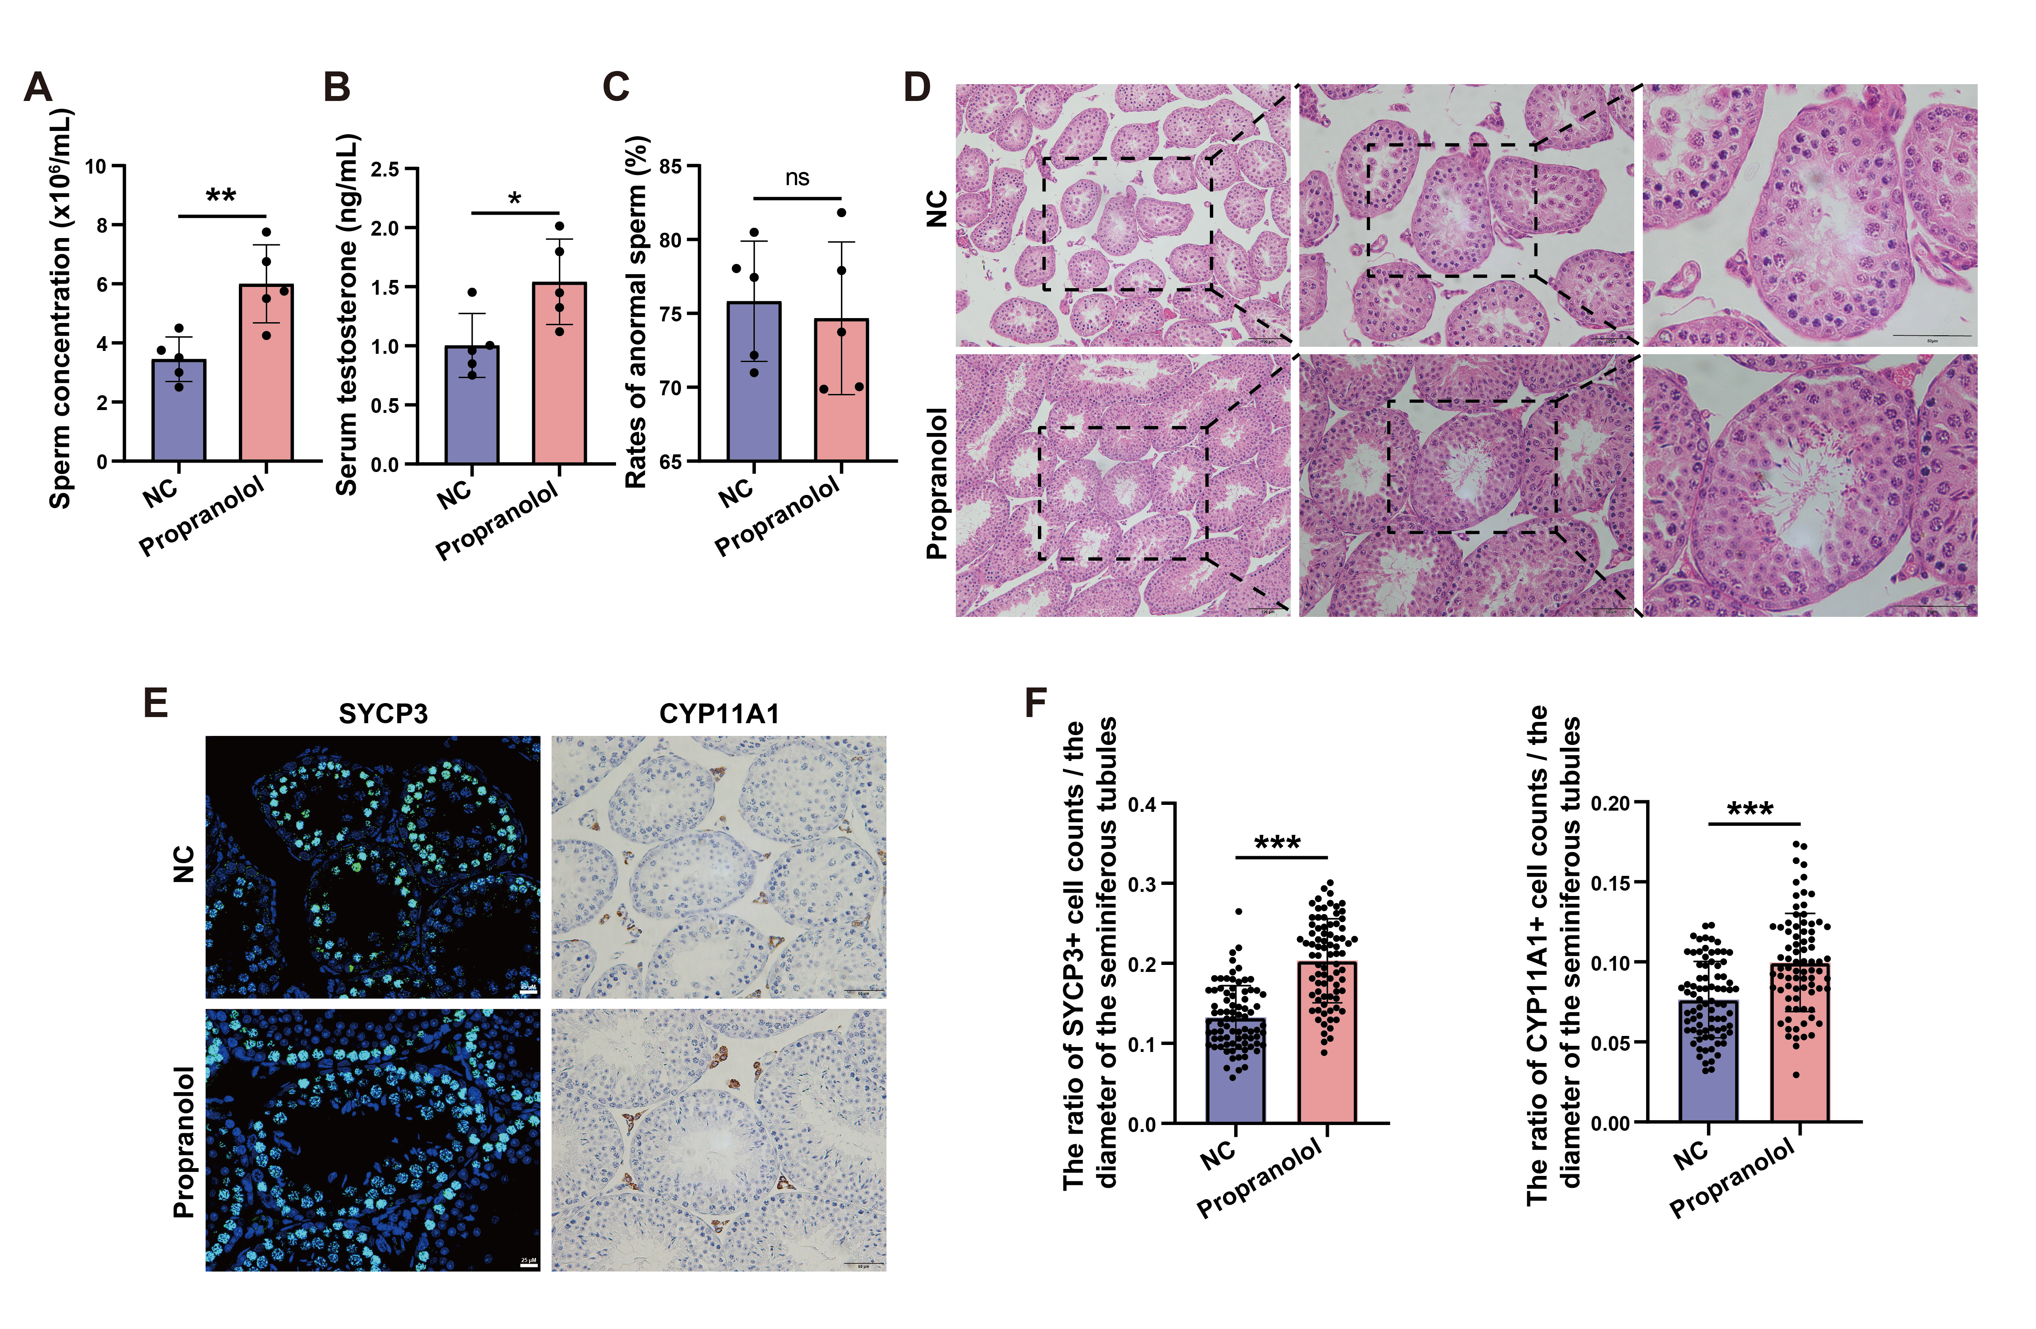
Supplementary Fig. 5 Propranolol treatment alleviates spermatogenic impairment in Ggt1^{-/-} male mice. Male Ggt1^{-/-} mice at age 7 weeks were randomly divided into two groups, and the two groups were injected with propranolol (a PAGly blocker) at 5 PM every day for 35 consecutive days at doses of 0 mg/kg (NC) and 5 mg/kg (Propranolol), respectively. (A) Sperm concentration in Ggt1^{-/-} male mice treated with propranolol (n = 5). (B) ELISA analysis of total testosterone level in serum of Ggt1^{-/-} male mice treated with propranolol (n = 5). (C) The rates of abnormal sperm in Ggt1^{-/-} male mice treated with propranolol (n = 5). (F) H&E staining of testis sections from Ggt1^{-/-} male mice treated with propranolol. Scale bar = 50 μm. (E) Immunofluorescence staining for SYCP3 (spermatocyte marker), and immunohistochemistry staining for CYP11A1 (Leydig cell marker) in testis tissues. Scale bars = 25 μm, 50 μm. (F) Statistical analysis of the ratio of the numbers of spermatocytes and Leydig cells to the diameter of the seminiferous tubules. The number of positive cells was quantified in 80 seminiferous tubules from 4 mice. Data are presented as mean ± SEM. *p < 0.05; **p < 0.01; ***p < 0.001; ns nonsignificant.
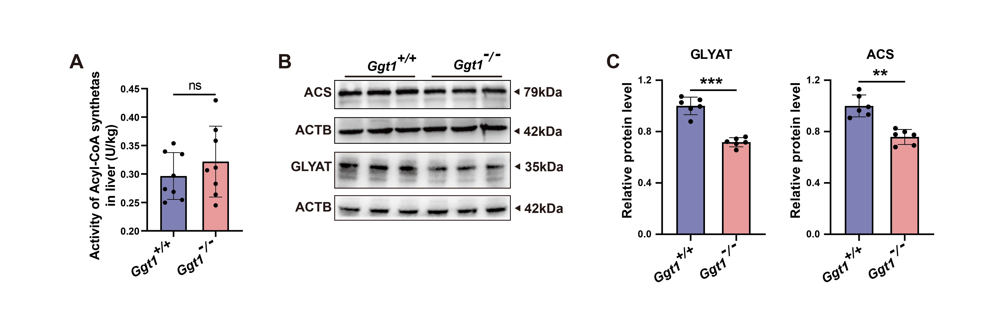
Supplementary Fig. 6 Detection of hepatic acyl-CoA synthetase and Glycine N-acyltransferase in Ggt1^{+/+} and Ggt1^{-/-} male mice. (A) Colorimetric quantification of Acyl-CoA synthetase activity in liver tissues (n = 8). (B, C) Western blot (B) and quantification (C) analysis of Glycine N-acyltransferase (GLYAT) and acyl-CoA synthetase (ACS) in liver tissues from Ggt1^{+/+} and Ggt1^{-/-} mice (n = 6). Data are presented as mean ± SEM. **p < 0.01; ***p < 0.001; ns nonsignificant.
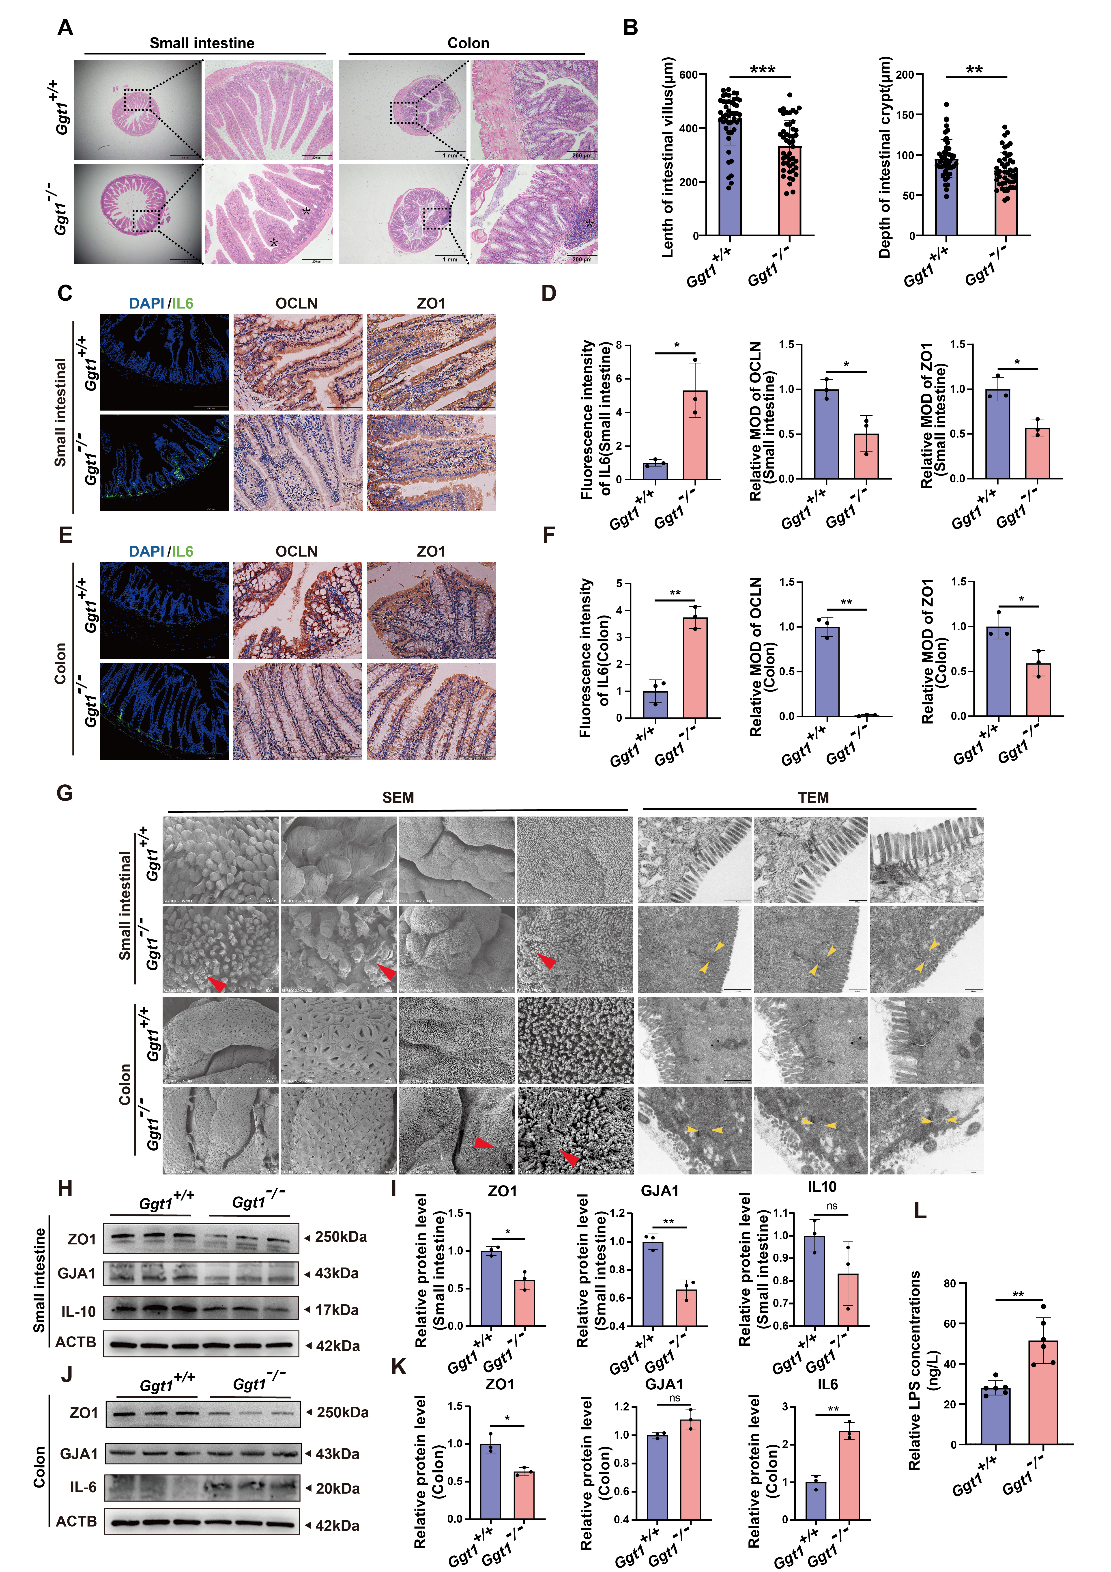
Supplementary Fig. 7 Ggt1 knockout disturbs intestinal barrier function and increases gut inflammation in mice. (A) H&E staining of intestine sections from Ggt1^{+/+} and Ggt1^{-/-} mice. Black asterisks indicate inflammatory cell infiltration. Scale bar = 1 mm. (B) Statistical analysis of small intestinal villus length and crypt depth of Ggt1^{+/+} and Ggt1^{-/-} mice (n = 47). (C – F) Immunofluorescence staining of IL-6 and immunohistochemistry staining of Occludin and ZO1 in small intestine (C, D) and colon (E, F) tissues from Ggt1^{+/+} and Ggt1^{-/-} mice. Fluorescence intensity from immunofluorescence was quantified using ImageJ and mean optical density (MOD) from immunohistochemistry was quantified using Image-Pro Plus. Scale bars = 200 μm, 100 μm, 100 μm. (G) Ultrastructural analysis of the intestines from Ggt1^{+/+} and Ggt1^{-/-} mice by transmission electron microscopy (TEM) and scanning electron microscopy (SEM). The red arrows indicate intestinal damage, and the yellow arrows indicate tight junctions. (H – K) Western blot (H, J) and quantification (I, K) analysis of ZO1, GJA1, IL-10 and IL-6 in the intestines from the Ggt1^{+/+} and Ggt1^{-/-} mice (n = 3). (L) ELISA analysis of serum lipopolysaccharides (LPS) levels in Ggt1^{+/+} and Ggt1^{-/-} mice (n = 6). Data are presented as mean ± SEM. *p < 0.05; **p < 0.01; ns nonsignificant.
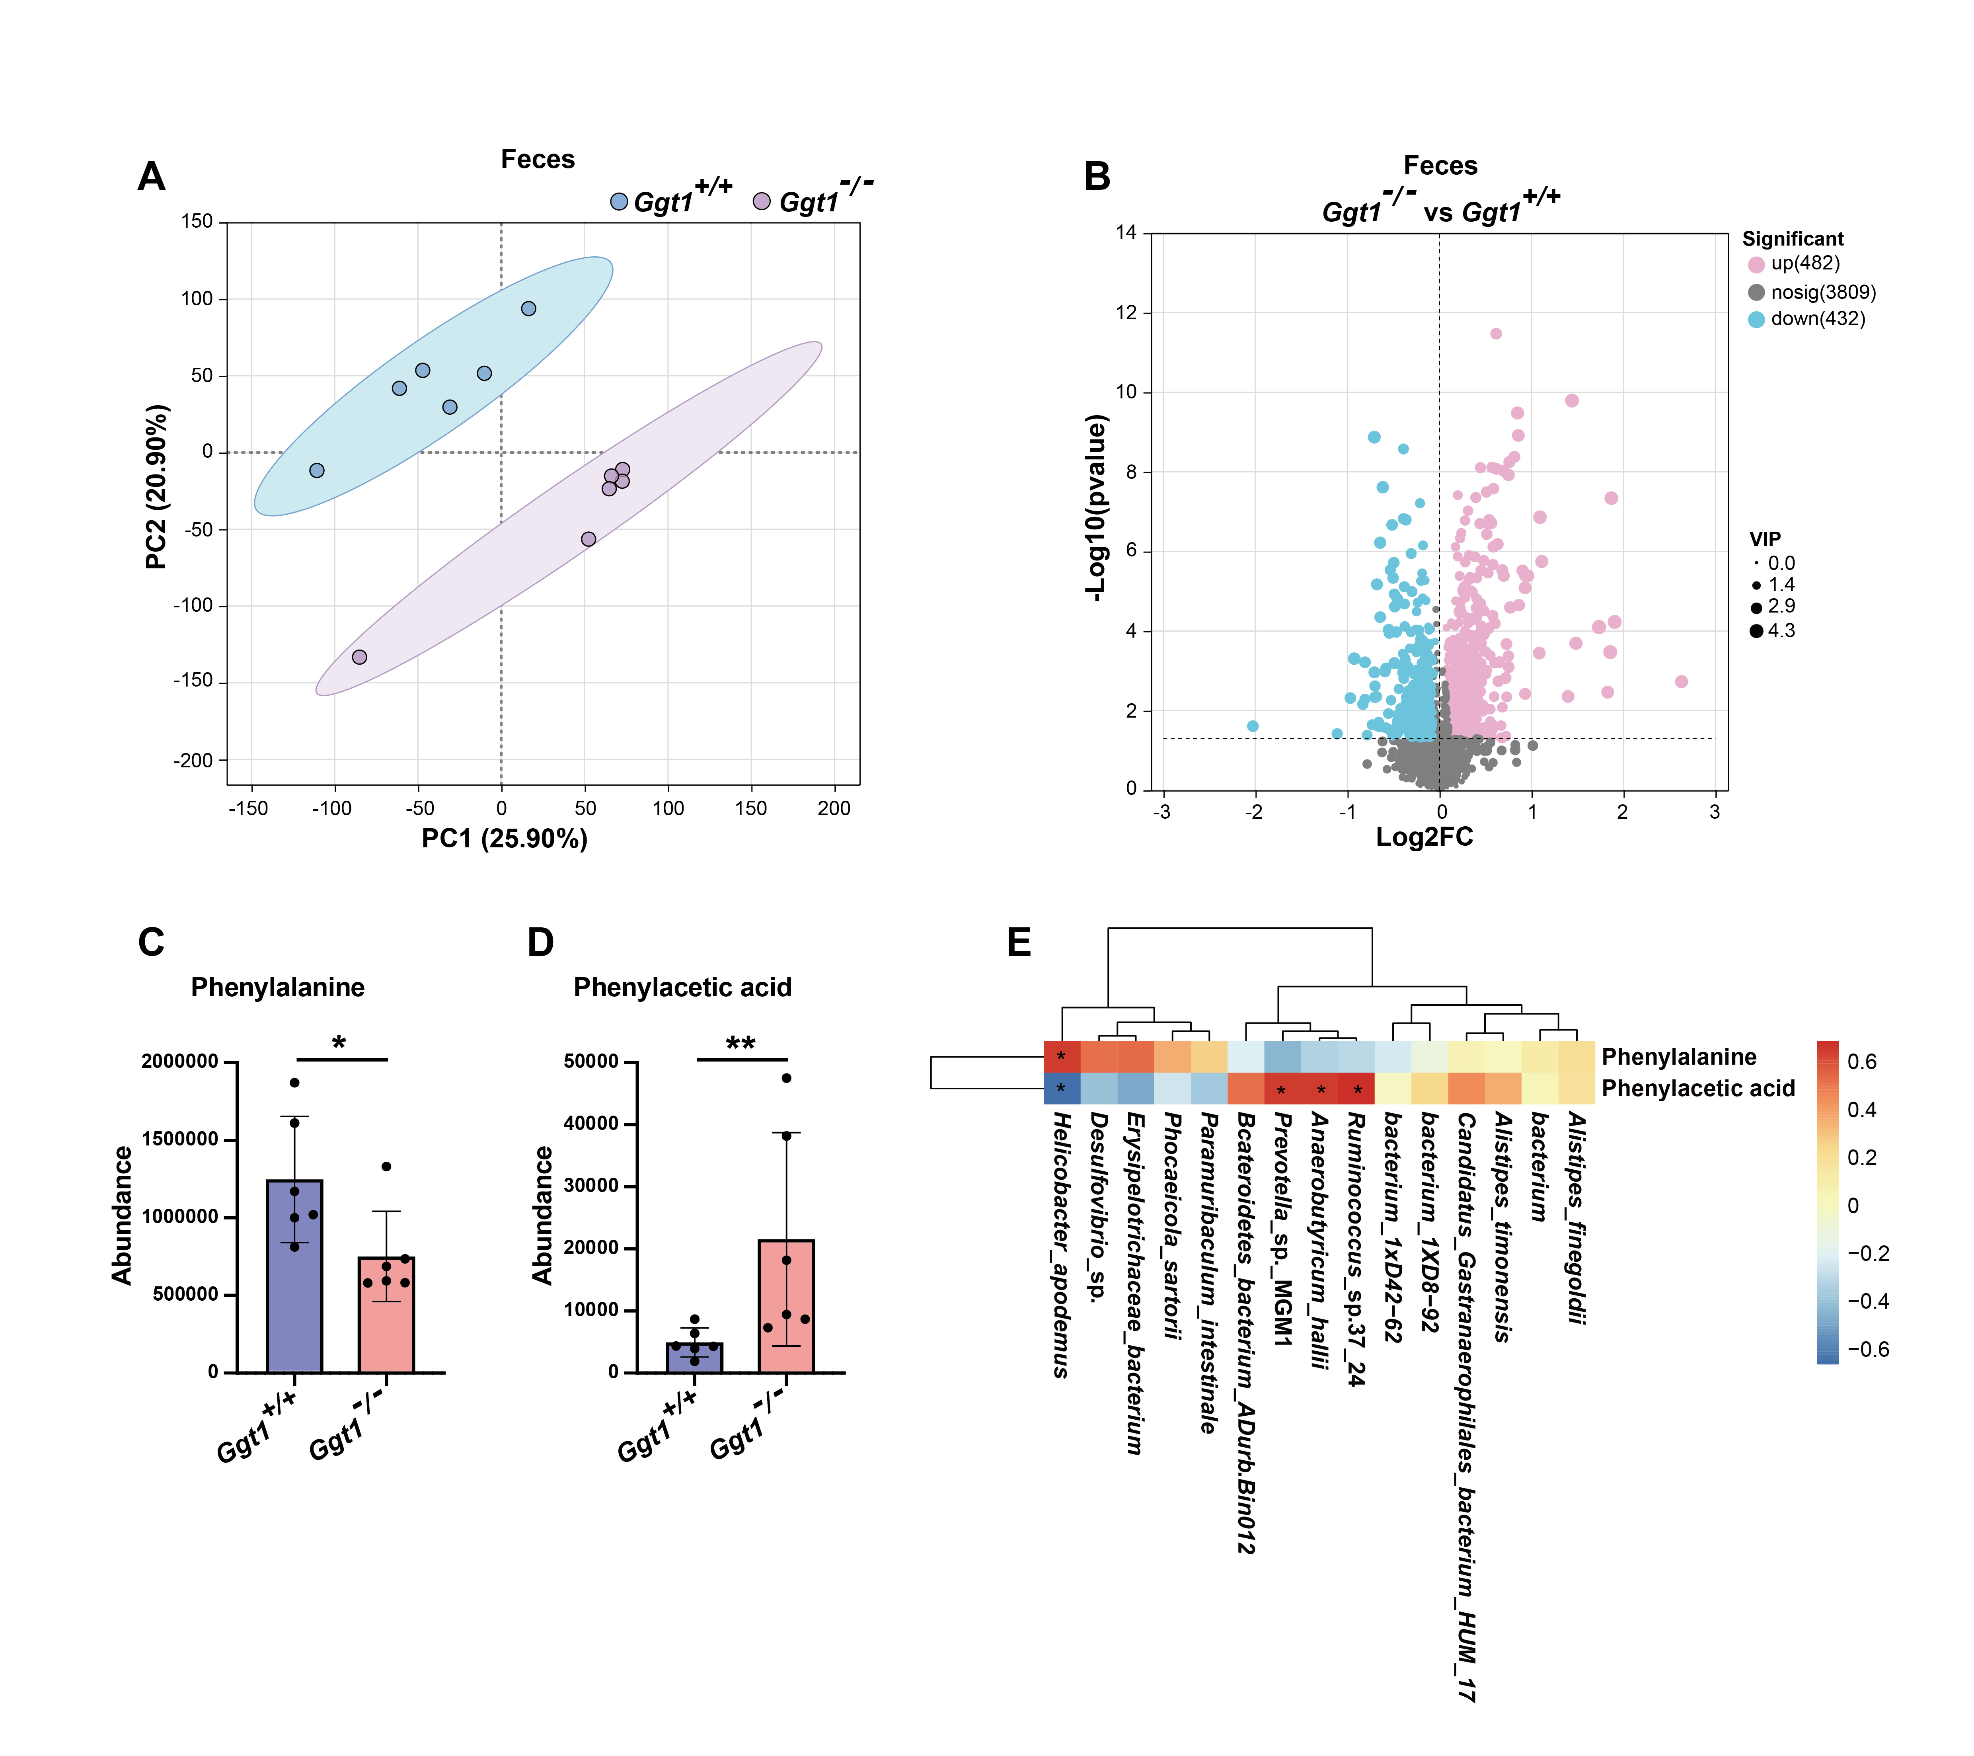
Supplementary Fig. 8 Metabolomics analysis conducted on fecal samples from Ggt1^{+/+} and Ggt1^{-/-} male mice. (A) Unsupervised principal component analysis (PCA) based on metabolic profiles in fecal samples from Ggt1^{+/+} and Ggt1^{-/-} mice (n = 6). (B) The volcano plot (Ggt1^{-/-} vs Ggt1^{+/+}) of fecal metabolites between Ggt1^{+/+} and Ggt1^{-/-} mice (n = 6). (C, D) Phenylalanine (C) and phenylacetic acid (D) level in fecal samples of Ggt1^{+/+} and Ggt1^{-/-} mice (n = 6). (E) Spearman correlation analysis of phenylalanine and phenylacetic acid levels in fecal samples from Ggt1^{+/+} and Ggt1^{-/-} mice with several microbial abundances in fecal samples from Ggt1^{+/+} and Ggt1^{-/-} mice. Red indicates a positive correlation, and blue indicates a negative correlation. Thresholds for significance are set as |r²| > 0.75 and p-value < 0.05. Significantly regulated metabolites between groups were determined by VIP ≥ 1 and p-value < 0.05. Variable importance in the projection (VIP) was obtained by the OPLS-DA model and the p-value was generated by student’s t test. Data are presented as mean ± SEM. *p < 0.05; **p < 0.01.
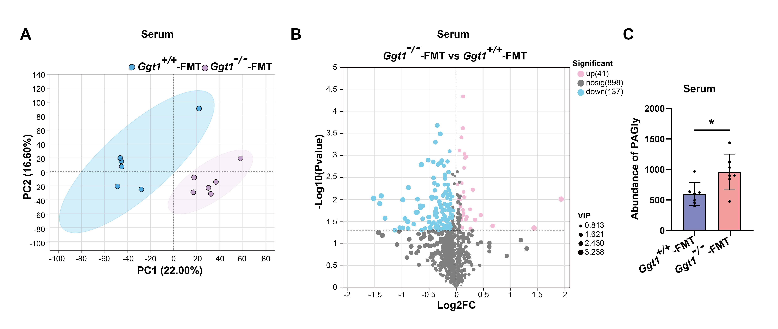
Supplementary Fig. 9 Metabolomics analysis conducted on serum samples from Ggt1^{+/+}-FMT and Ggt1^{-/-}-FMT mice. (A) Unsupervised principal component analysis (PCA) based on metabolic profiles in serum from Ggt1^{+/+}-FMT and Ggt1^{-/-}-FMT mice (n = 6). (B) The volcano plot (Ggt1^{-/-}-FMT vs Ggt1^{+/+}-FMT) of serum metabolites between Ggt1^{+/+}-FMT and Ggt1^{-/-}-FMT mice (n = 6). (C) Phenylacetylglycine (PAGly) level in serum of Ggt1^{+/+}-FMT and Ggt1^{-/-}-FMT mice (n = 6). Data are presented as mean ± SEM. *p < 0.05.
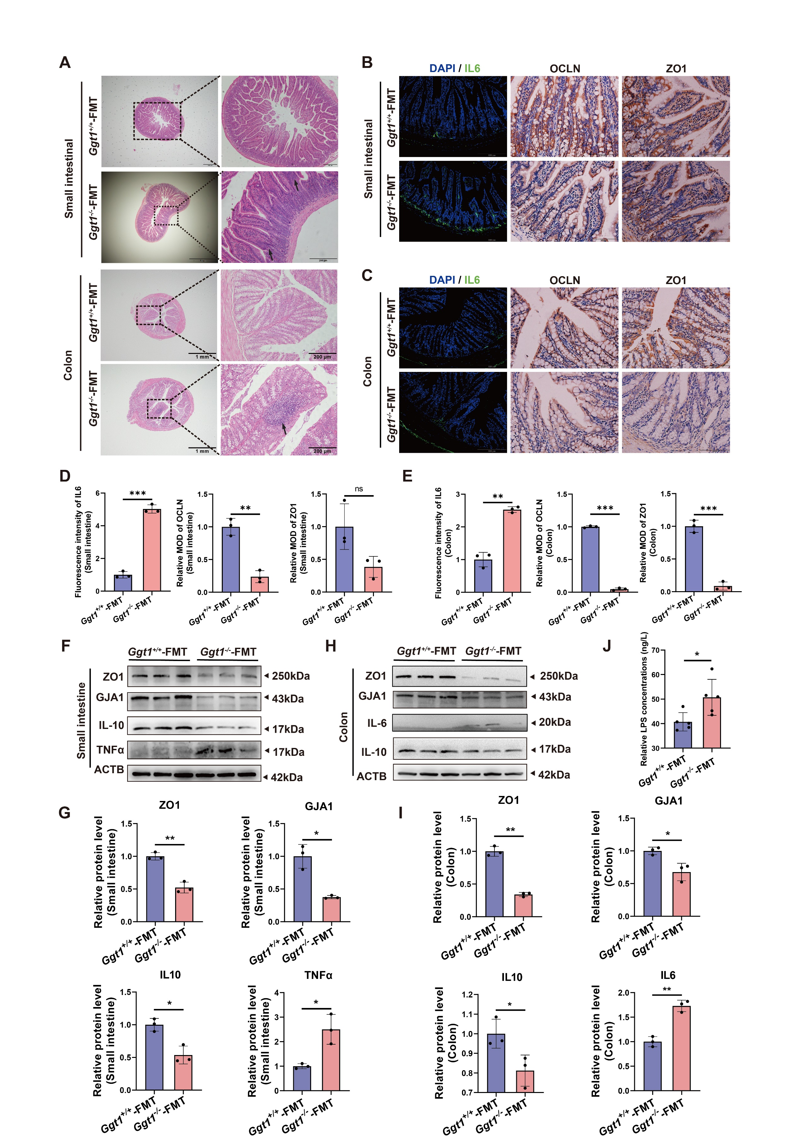
Supplementary Fig. 10 Fecal microbiota transplanted from Ggt1^{-/-} mice impairs intestinal barrier function and increases gut inflammation in recipient mice. (A) H&E staining of intestine sections from Ggt1^{+/+}-FMT and Ggt1^{-/-}-FMT mice. Black arrows indicate inflammatory cell infiltration. Scale bar = 1 mm. (B – E) Immunofluorescence staining of IL-6 and immunohistochemistry staining of Occludin and ZO1 in the small intestine (B, D) and colon (C, E) from Ggt1^{+/+}-FMT and Ggt1^{-/-}-FMT mice. Fluorescence intensity from immunofluorescence was quantified using ImageJ, and mean optical density (MOD) from immunohistochemistry was quantified using Image-Pro Plus. Scale bars = 200 μm, 100 μm, 100 μm. (F – I) Western blot (F, H) and quantification (G, I) analysis of ZO1, GJA1, TNFα, IL-10 and IL-6 in the small intestine and colon from Ggt1^{+/+}-FMT and Ggt1^{-/-}-FMT mice (n = 3). (J) ELISA analysis of serum LPS levels in Ggt1^{+/+}-FMT and Ggt1^{-/-}-FMT mice (n = 5). Data are presented as mean ± SEM. *p < 0.05; **p < 0.01; ***p < 0.001; ns nonsignificant.
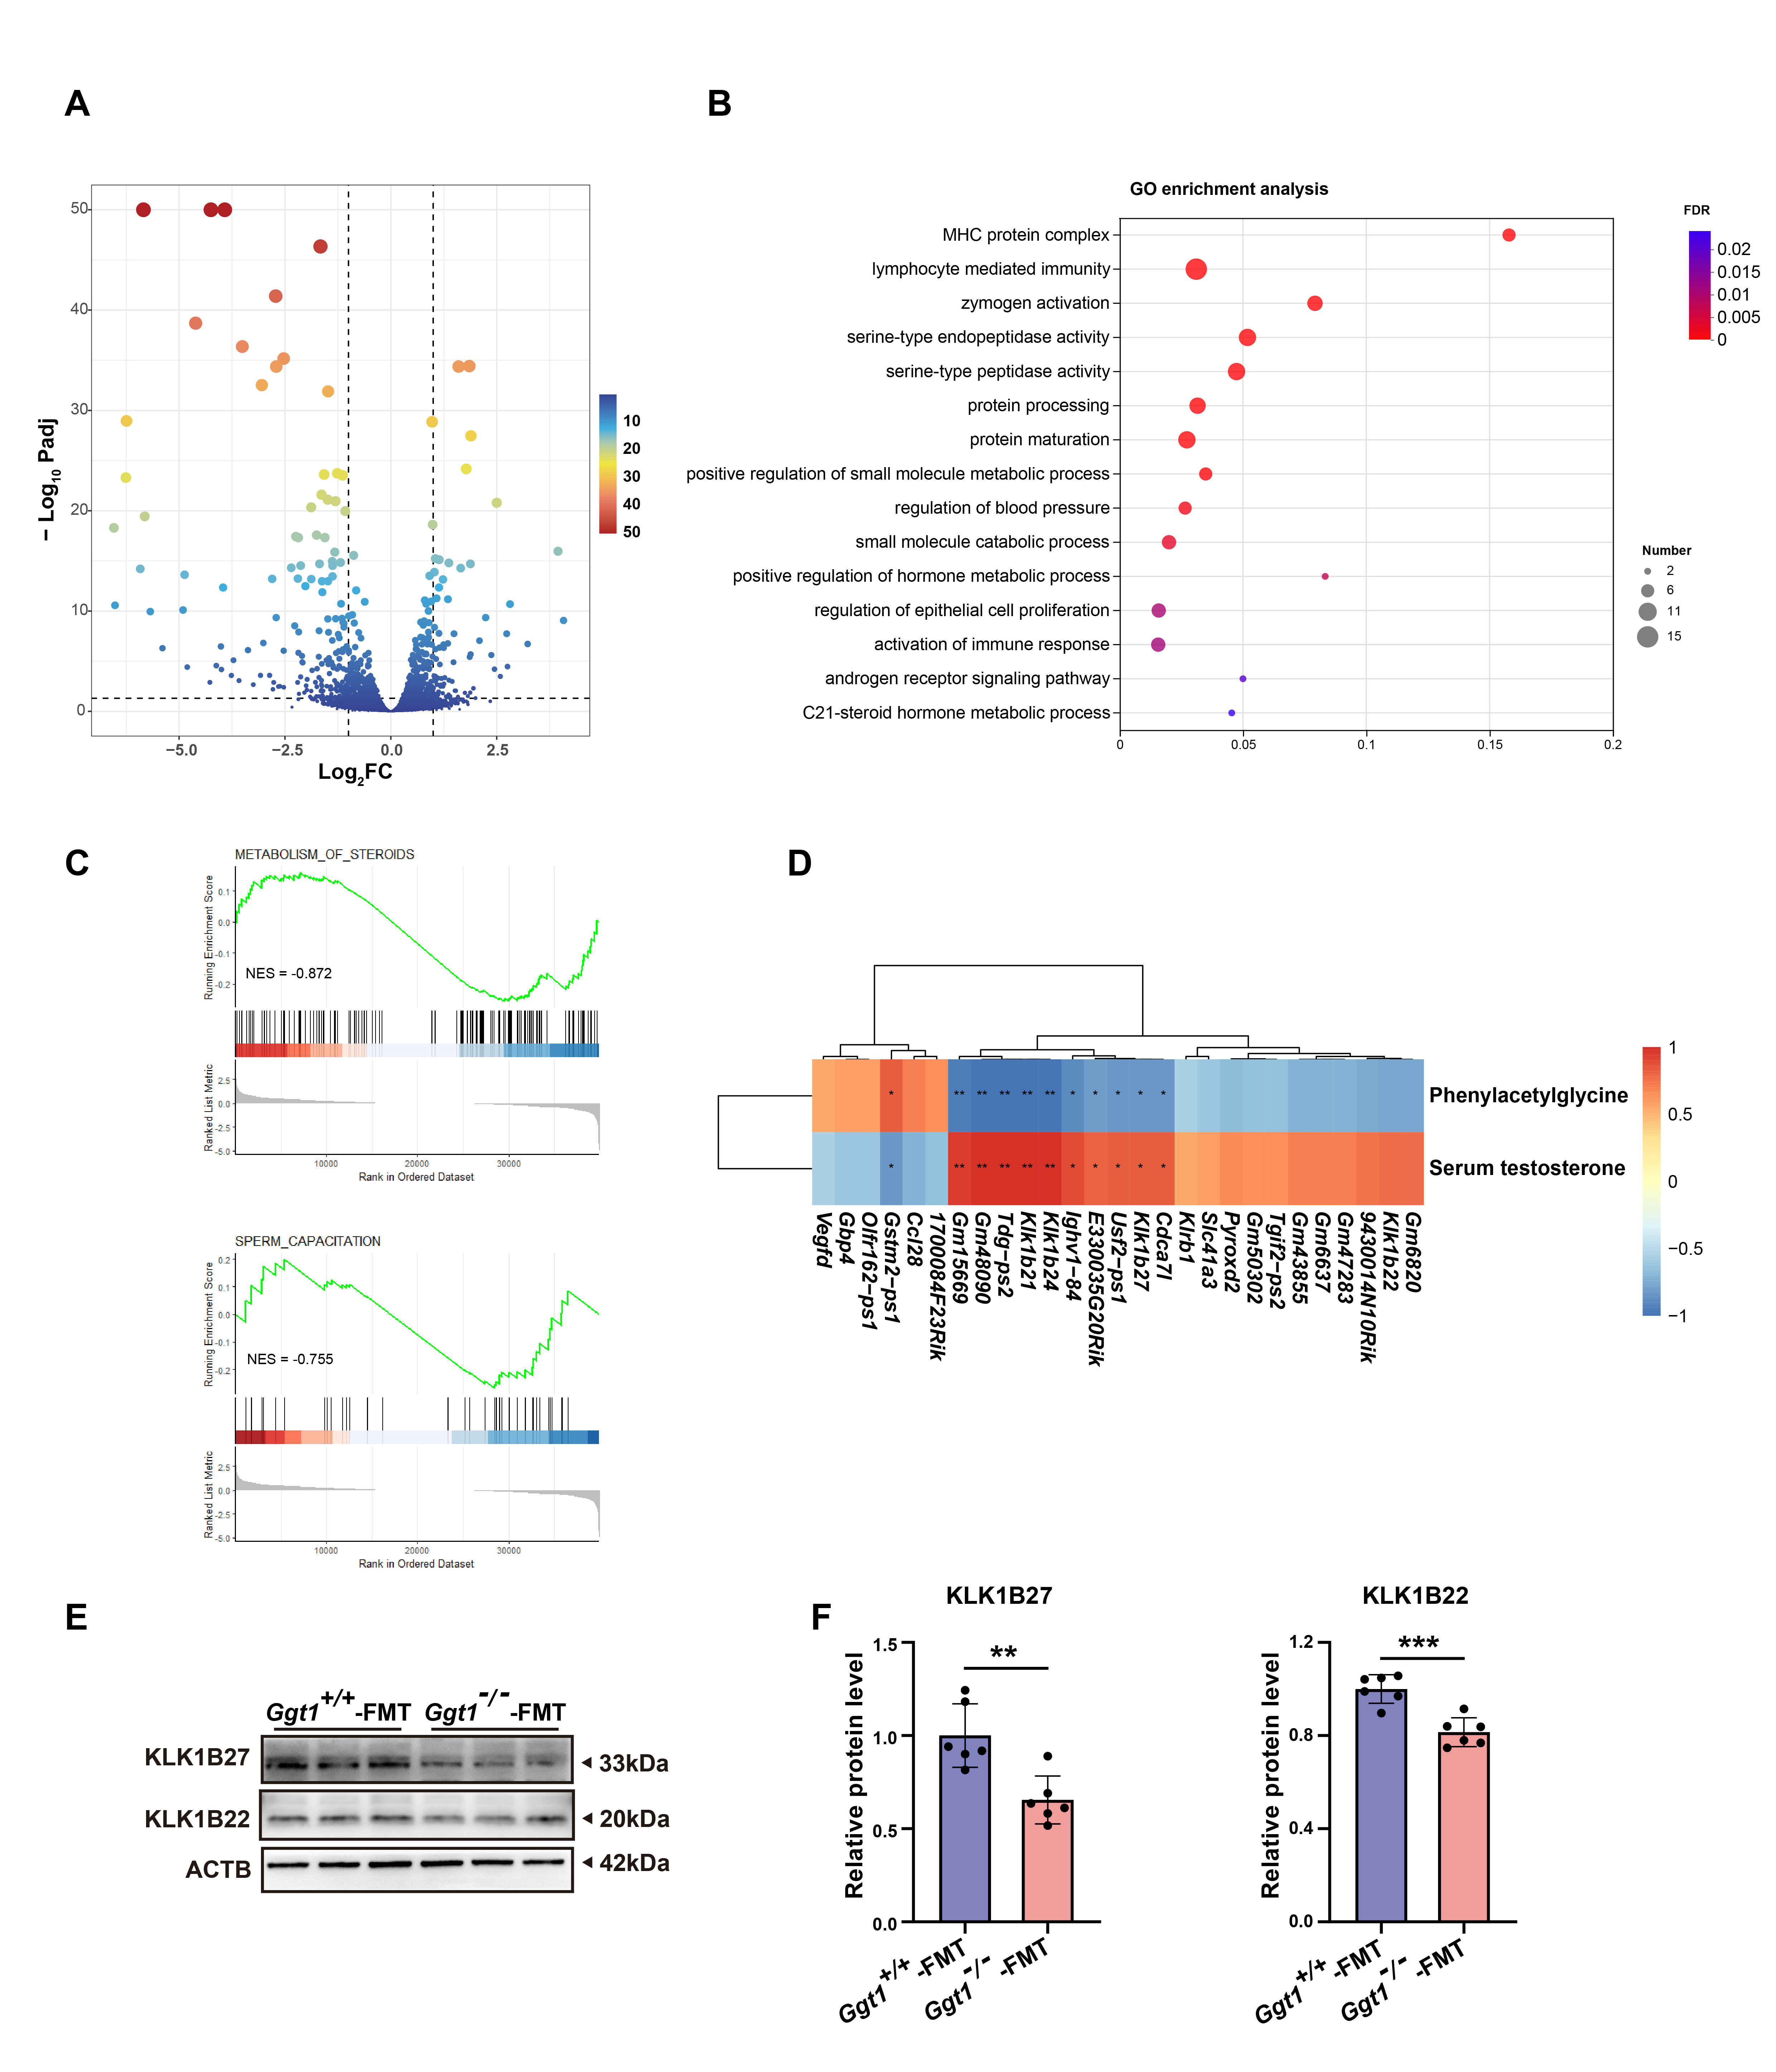
Supplementary Fig. 11 Transcriptomic analysis of the testes from Ggt1^{+/+}-FMT and Ggt1^{-/-}-FMT mice. (A) The volcano plot (Ggt1^{-/-}-FMT vs Ggt1^{+/+}-FMT) of transcriptomic analysis of the testes from Ggt1^{+/+}-FMT and Ggt1^{-/-}-FMT mice (n = 3). DEGs between groups were determined by absolute log₂FC (fold change) > 1 and p-adjust < 0.05. (B) Gene Ontology (GO) enrichment analysis of DEGs in the testes between Ggt1^{+/+}-FMT and Ggt1^{-/-}-FMT mice. (C) GSEA analysis of spermatogenesis-specific gene sets in RNA sequencing data (Ggt1^{-/-}-FMT vs Ggt1^{+/+}-FMT). (D) Spearman correlation analysis of mRNA expression levels in the testes from Ggt1^{+/+}-FMT and Ggt1^{-/-}-FMT mice with testicular phenylacetylglycine and serum total testosterone level of Ggt1^{+/+}-FMT and Ggt1^{-/-}-FMT mice. Red indicates a positive correlation, and blue indicates a negative correlation. Thresholds for significance are set as |r²| > 0.75 and p-value < 0.05. (E, F) Western blot (E) and quantification (F) analysis of KLK1B27 and KLK1B22 in the testis tissues from Ggt1^{+/+}-FMT and Ggt1^{-/-}-FMT mice (n = 6). Data are presented as mean ± SEM. **p < 0.01; ***p < 0.001.
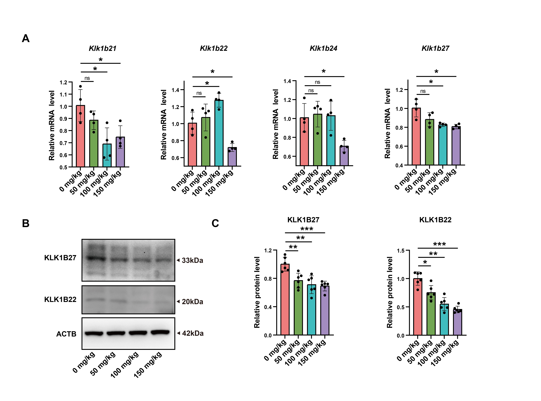
Supplementary Fig. 12 Klk1bs expression analysis in the testis tissues from PAGly treated male mice. (A) qRT-PCR analysis of Klk1b21, Klk1b22, Klk1b24, and Klk1b27 mRNA expression in the testis tissues from male mice treated with PAGly (n = 4). (B, C) Western blot (B) and quantification (C) analysis of KLK1B27 and KLK1B22 in the testis tissues from male mice treated with PAGly (n = 6). The mice were given to intraperitoneal injections of PAGly solution at concentrations of 0 mg/kg, 50 mg/kg, 100 mg/kg, and 150 mg/kg. Data are presented as mean ± SEM. *p < 0.05; **p < 0.01; ***p < 0.001; ns nonsignificant.
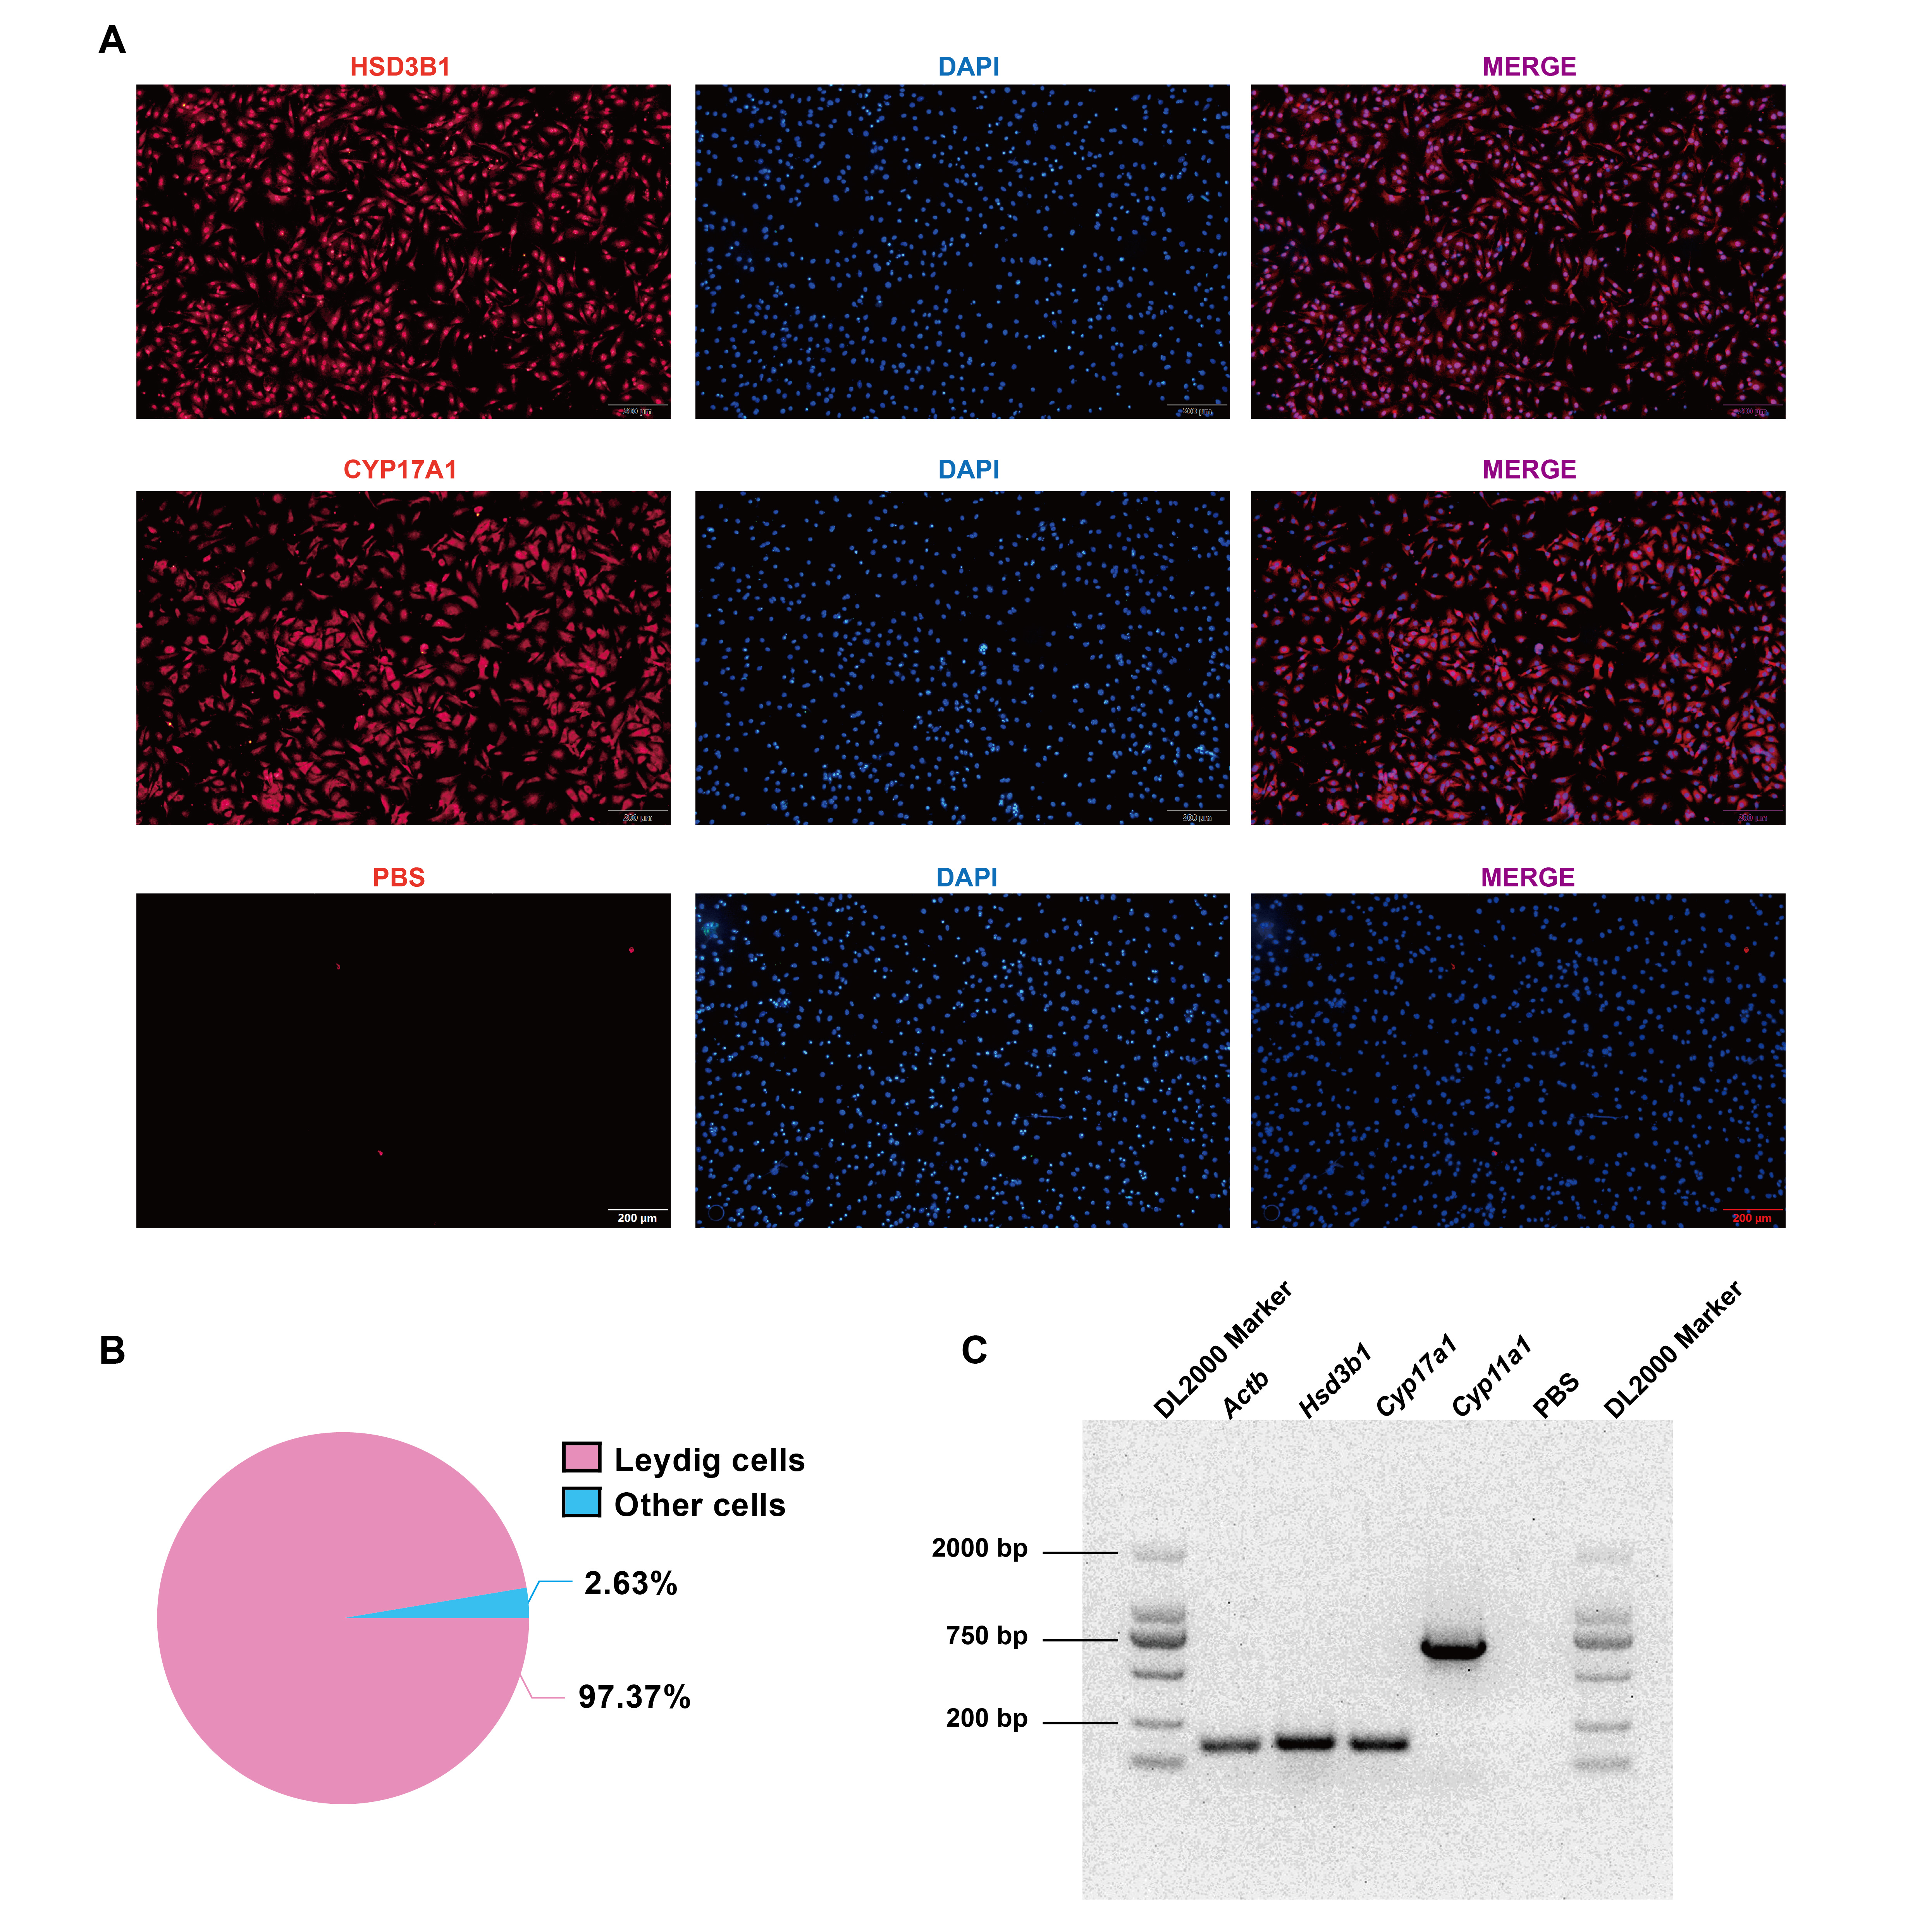
Supplementary Fig. 13 Identification of the primary mouse Leydig cell purity. (A) Immunofluorescence of HDS3B1 and CYP17A1 in isolated primary mouse Leydig cells. DAPI (blue) stains the nucleus (n = 3). Scale bar: 200 μm. (B) The ratio of mouse Leydig cells in (A) (n = 3). (C) Semi-quantitative PCR of Hds3b1, Cyp17a1, and Cyp11a1 genes in isolated mouse primary mouse Leydig cells (n = 3). Actb gene is the internal control and PBS is negative control.
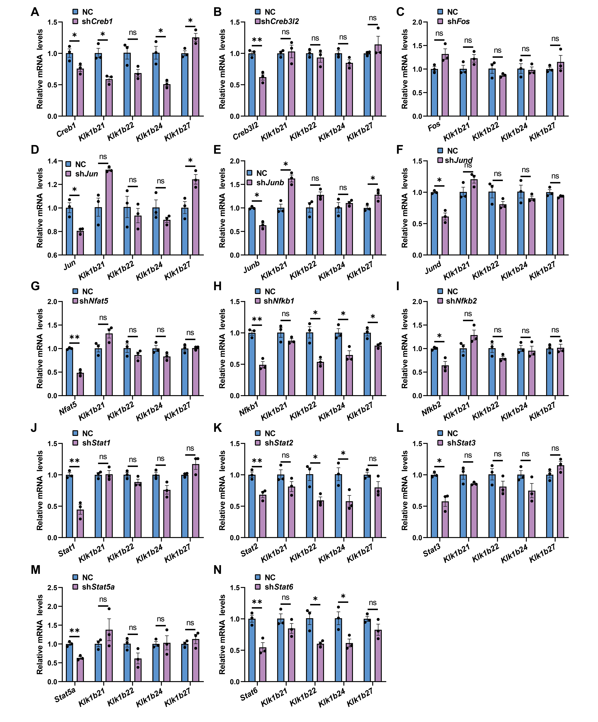
Supplementary Fig. 14 qRT-PCR analysis of transcription factors and Klk1bs expression levels. Quantitative analysis of the knockdown efficiency of transcription factors in the downstream of GPCR signaling and Klk1bs expression levels was performed using qRT-PCR. The primary mouse Leydig cells were infected with lentivirus expressing (A) shRNA-Creb1 (shCreb1), (B) shRNA-Creb3l2 (shCreb3l2), (C) shRNA-Fos (shFos), (D) shRNA-Jun (shJun), (E) shRNA-Junb (shJunb), (F) shRNA-Jund (shJund), (G) shRNA-Nfat5 (shNfat5), (H) shRNA-Nfkb1 (shNfkb1), (I) shRNA-Nfkb2 (shNfkb2), (J) shRNA-Stat1 (shStat1), (K) shRNA-Stat2 (shStat2), (L) shRNA-Stat3 (shStat3), (M) shRNA-Stat5a (shStat5a), (N) shRNA-Stat6 (shStat6), and scrambled shRNA (NC), respectively (n = 3). Data are presented as mean ± SEM. *p < 0.05; **p < 0.01; ns nonsignificant.
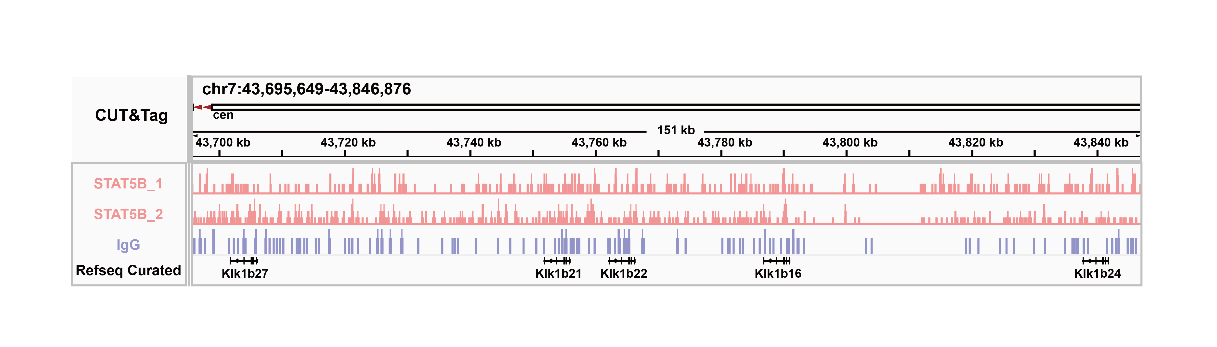
Supplementary Fig. 15 Visualization of CUT&Tag peaks. Visualization of CUT&Tag peaks within ± 3 kb of the TSS for Klk1b21, Klk1b22, Klk1b24, and Klk1b27 using the IGV. IgG was used as a negative control.

