Supplementary Material
Gut microbiota-mediated tryptophan metabolism inhibits pyroptosis via AhR signaling to maintain intestinal epithelial homeostasis in pigs
Mengqi Liu^{1#}, Shouren Li^{1#}, Yalei Cui^{1, 2, 3}, Xiaoyan Zhu^{1, 2, 3}, Zhichang Wang^{1, 2, 3}, Hao Sun^{1, 2, 3}, Defeng Li^{1, 2, 3}, Boshuai Liu^{1, 2, 3}*, Yinghua Shi^{1, 2, 3}*
¹ College of Animal Science and Technology, Henan Agricultural University, Zhengzhou, China
² Henan Key Laboratory of Innovation and Utilization of Grassland Resources, Zhengzhou, China
³ Henan Forage Engineering Technology Research Center, Zhengzhou, Henan, 450002, China
# These authors contributed equally to this work
* Correspondence: Boshuai Liu & Yinghua Shi
Corresponding Author E-mail: boshuailiu@126.com & annysyh@henau.edu.cn
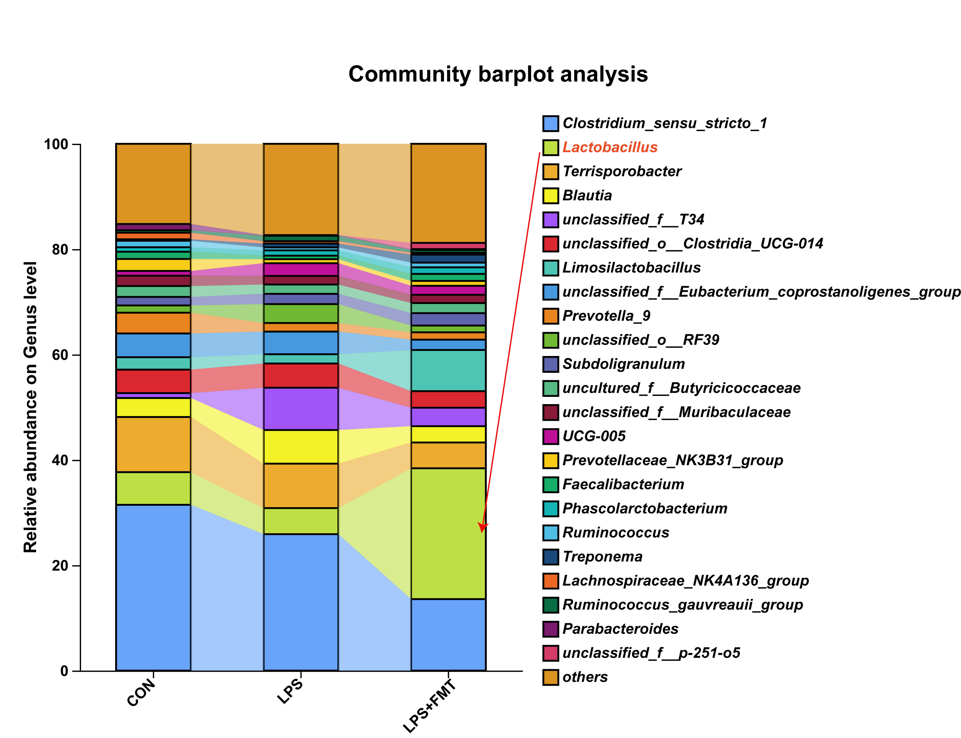
Figure.S1 Stacked bar graph of genus-level relative abundance of gut microbiota among the three groups.
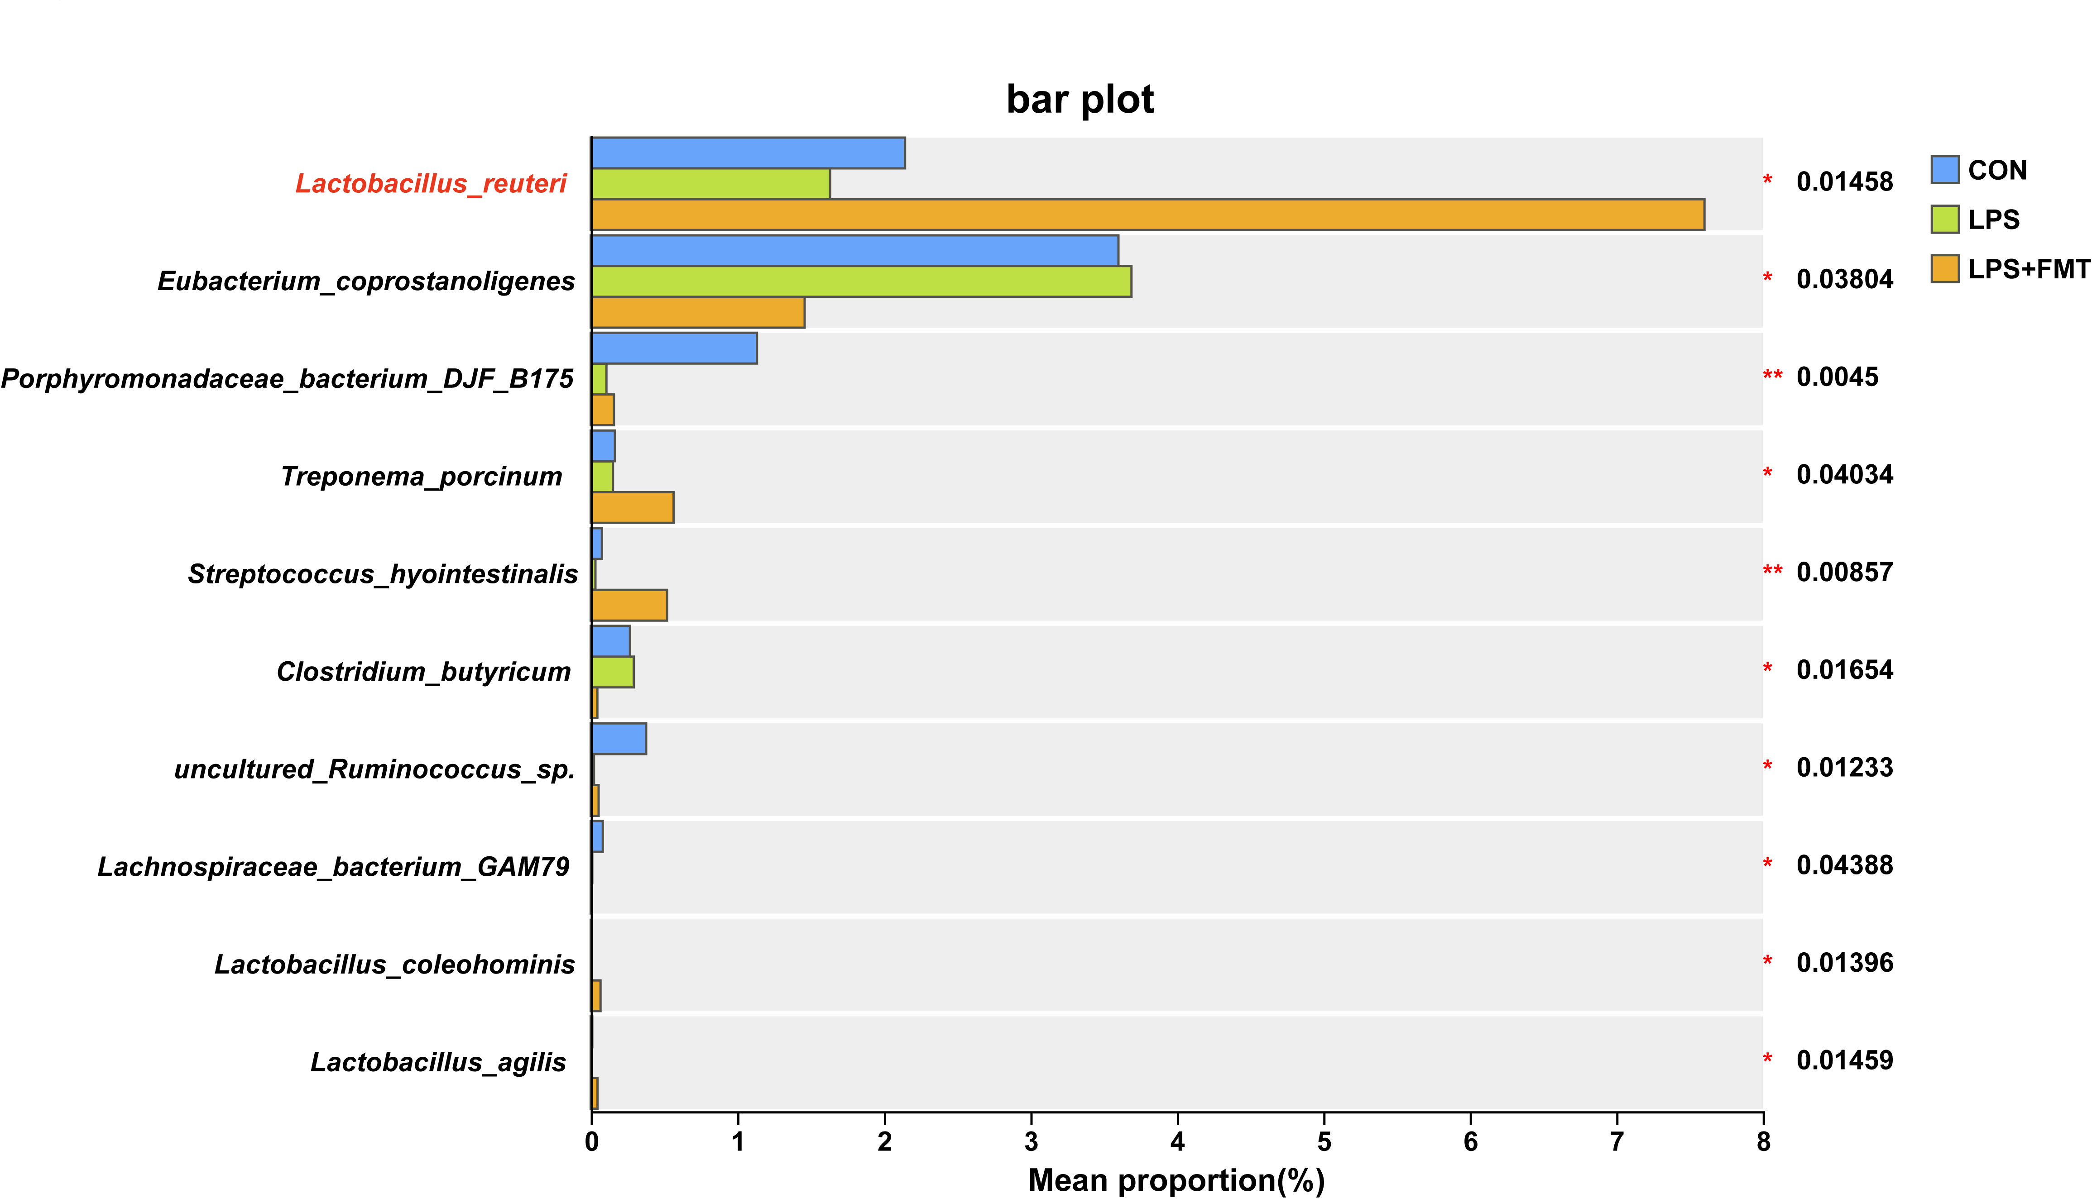
Figure.S2 Analysis of differences in species-level relative abundance of gut microbiota among the three groups. Data are presented as mean ± SEM. **P < 0.01, *P < 0.05.
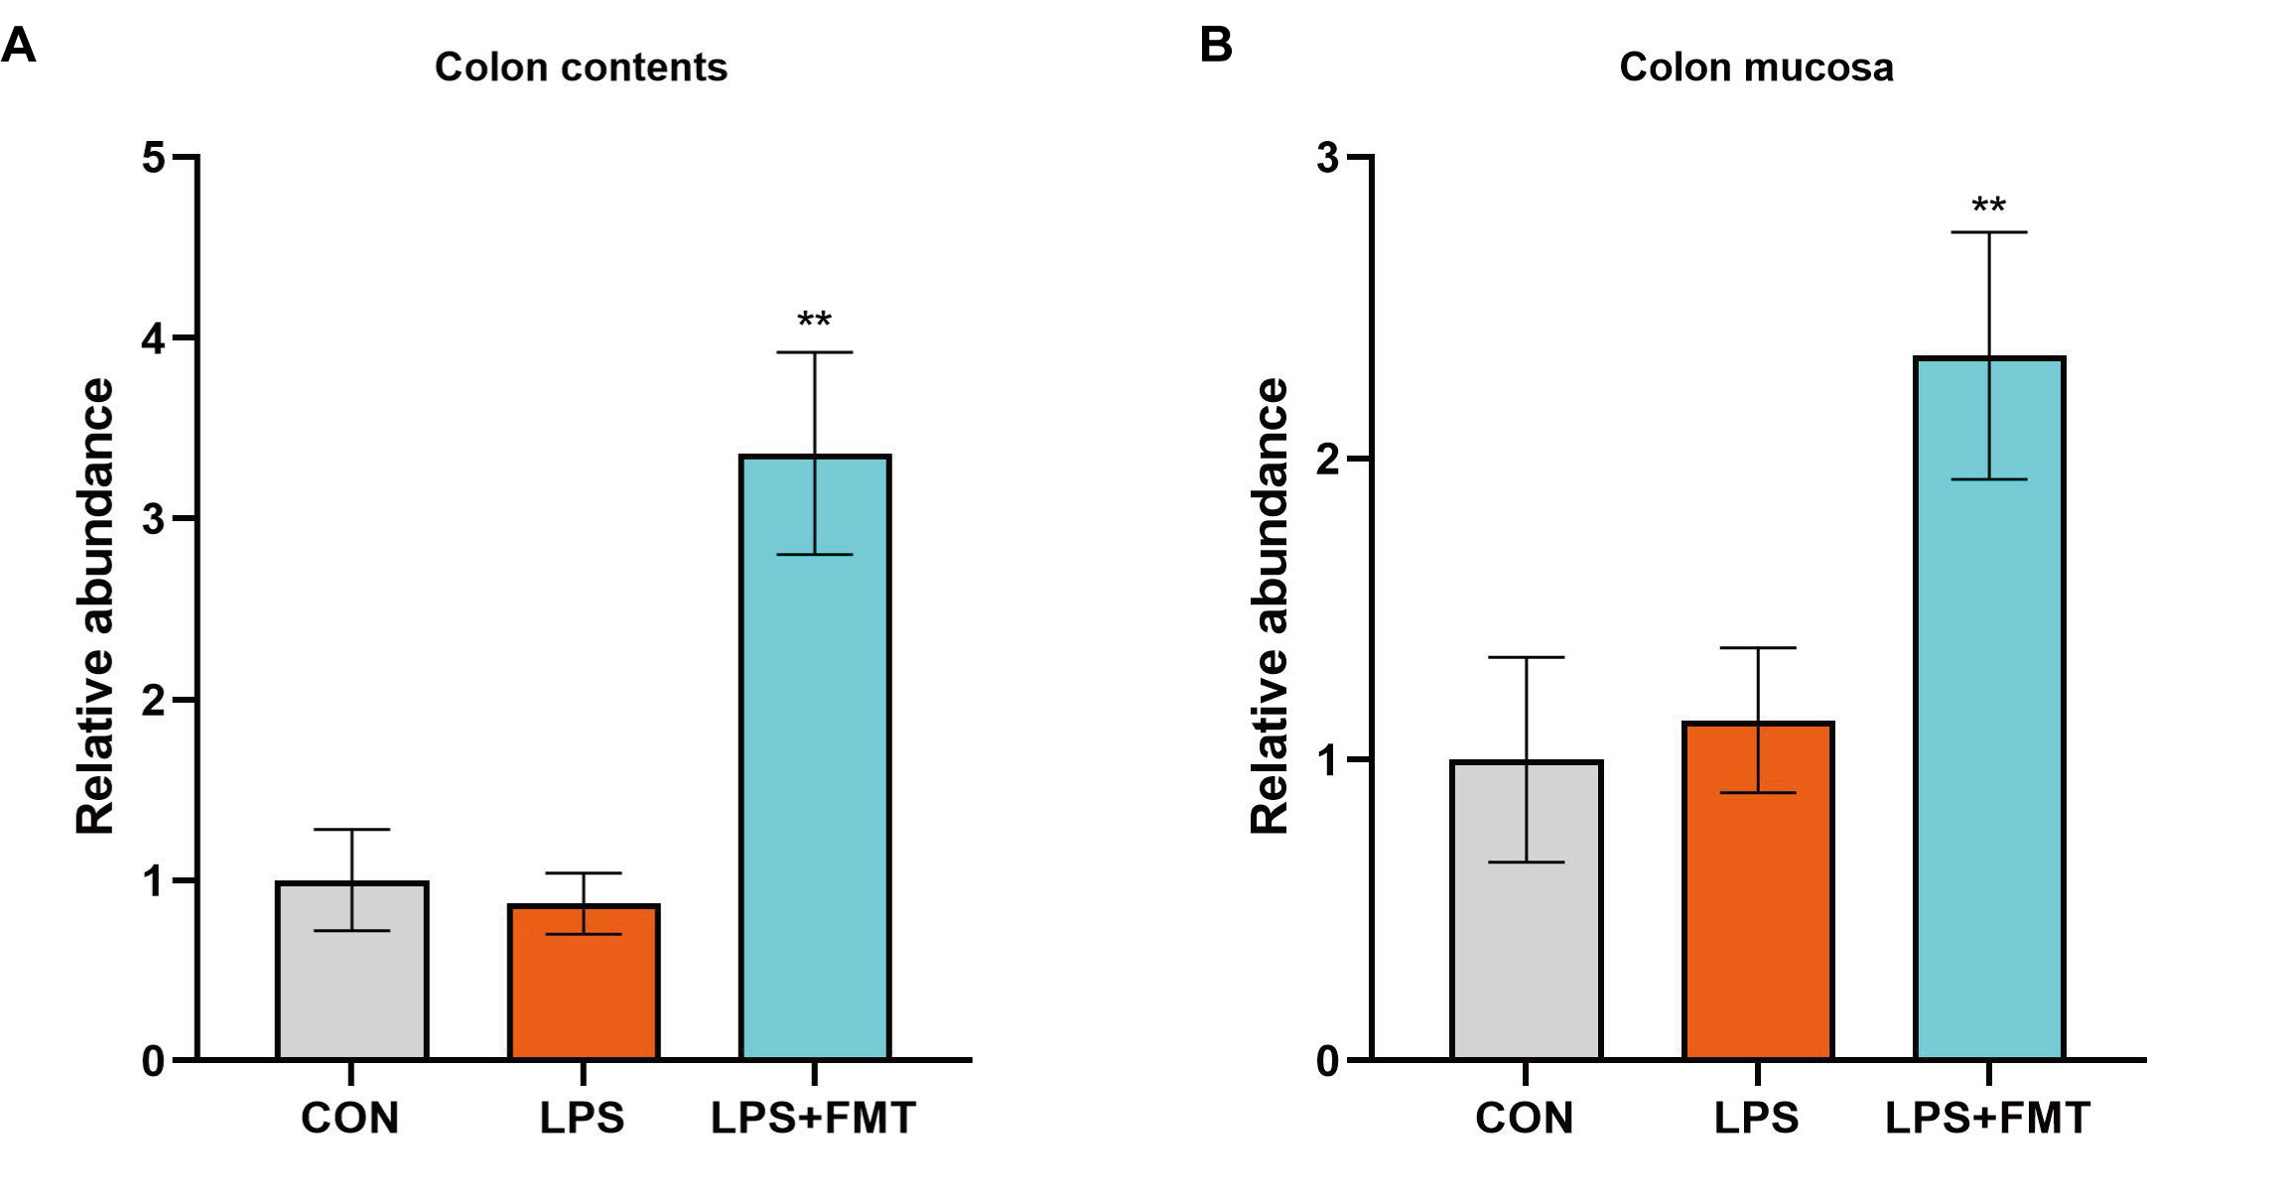
Figure.S3 The relative abundance of Lactobacillus reuteri was measured using RT-qPCR with specific primers. (A) Colon contents. (B) Colon mucosa. Data are presented as mean ± SEM. **P < 0.01, *P < 0.05.
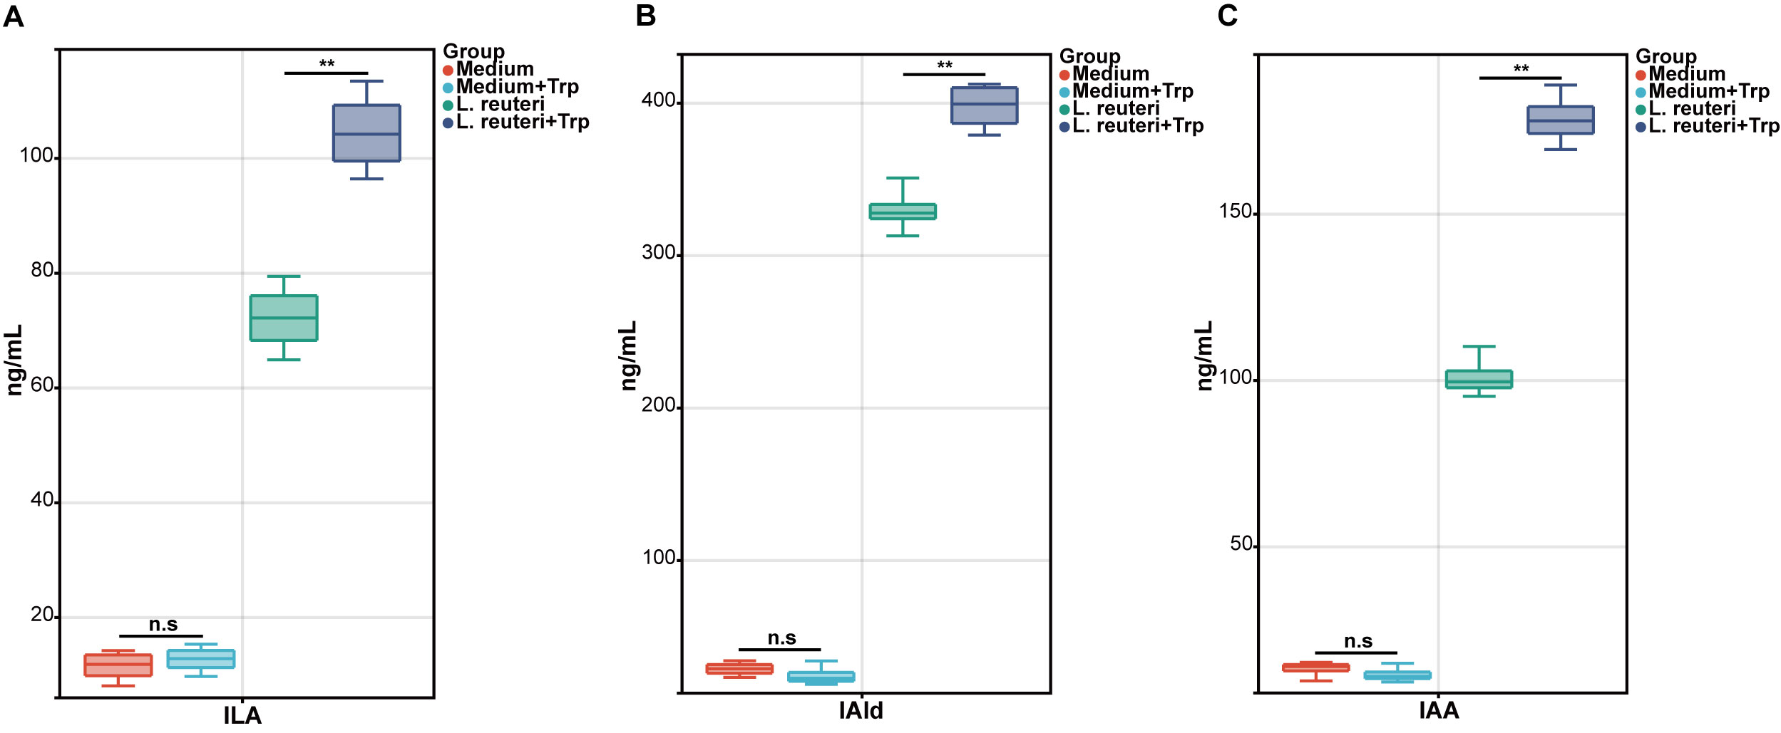Figure S4. In vitro assessment of tryptophan metabolite production by Lactobacillus reuteri.
(A-C) Concentrations of ILA (A), IAld (B), and IAA (C) in culture supernatants. Lactobacillus reuteri was cultured in medium with or without L-tryptophan (Trp) supplementation. Data are presented as mean ± SEM. **P < 0.01, *P < 0.05.
Table S1 The fecal donor information
Donor | Gender | Age/days | Body weight/kg
Donor 1 | male | 60 | 26.31
Donor 2 | male | 60 | 26.14
Donor 3 | male | 60 | 25.97
Donor 4 | female | 60 | 26.27
Donor 5 | female | 60 | 26.08
Donor 6 | female | 60 | 26.27

Table S2 Ingredient composition of basal diets (%, as-fed basis)
Items | Composition, %
Corn | 58.6
Soybean meal | 13
Whey powder | 8
Fish meal | 3
Soy protein concentrate | 5
Extruded full-fat soybean | 5
Glucose | 2
Soybean oil | 2
Dicalcium phosphate | 1
Limestone | 0.8
NaCl | 0.2
L-Lysine-HCl | 0.55
DL-Methionine | 0.1
L-Threonine | 0.2
L-Tryptophan | 0.05
Premix¹ | 0.5
Total | 100
DE, MJ/kg | 14.82
Crude protein | 18.86
Calcium | 0.80
Total Phosphate | 0.65
Lysine | 1.53
Methionine | 0.44
Treonine | 0.95
Tryptophan | 0.26
Note: ¹Premix provided the following per kg of complete diet for piglets: vitamin A, 12,000 IU; vitamin D₃, 2,500 IU; vitamin E, 30 IU; vitamin K₃, 3.0 mg; vitamin B₁₂, 0.012 mg; riboflavin, 4.0 mg; pantothenic acid, 15.0 mg; niacin, 40.0 mg; choline chloride, 400.0 mg; folic acid, 0.7 mg; vitamin B₁, 1.5 mg; vitamin B₆, 3 mg; biotin, 0.1mg; Mn, 40.0 mg; Fe, 90.0 mg; Zn, 100.0 mg; Cu, 8.8 mg; I, 0.35 mg; Se, 0.3 mg.
Table S3. Kit used in this study for biochemical analysis
Biochemical kit name | Company | Product category
DAO | Cusabio Co., Ltd. Wuhan China | CSB-E10137h
DAO | Cusabio Co., Ltd. Wuhan China | CSB-E10090m
DAO | CLOUD-CLONE CORP. Co., Ltd. Wuhan China | SEA656Po
IL-1β | Cusabio Co., Ltd. Wuhan China | CSB-E08053h
IL-1β | Cusabio Co., Ltd. Wuhan China | CSB-E08054m
IL-1β | Enzyme-linked Biotechnology Co., Ltd. Shanghai China | ml022366-J
IL-18 | Cusabio Co., Ltd. Wuhan China | CSB-E07450h
IL-18 | Cusabio Co., Ltd. Wuhan China | CSB-E04609m
IL-18 | CLOUD-CLONE CORP. Co., Ltd. Wuhan China | SEA064Po
LDH | Cusabio Co., Ltd. Wuhan China | CSB-E11720h
LDH | Cusabio Co., Ltd. Wuhan China | CSB-E11723m
LDH | Enzyme Exemption Industry Co., Ltd. Jiangsu China | MM-77964O2

Table S4. Antibodies used in this study for western blot
Antibody name | Company | product category | Dilution ratio
ZO-1 | Proteintech Group, Wuhan, China | Cat No. 21773-1-AP | 1:5000
Occludin | Proteintech Group, Wuhan, China | Cat No. 27260-1-AP | 1:5000
AhR | Proteintech Group, Wuhan, China | Cat No. 67785-1-Ig | 1:2000
CYP1A1 | Proteintech Group, Wuhan, China | Cat No. 13241-1-AP | 1:1000
NLRP3 | Proteintech Group, Wuhan, China | Cat No. 27458-1-AP | 1:500
ASC | Proteintech Group, Wuhan, China | Cat No. 27458-1-AP | 1:1000
GSDMD | Proteintech Group, Wuhan, China | Cat No. 20770-1-AP | 1:2000
GSDMD-N | ABclonal, Wuhan, China | A22523 | 1:1000
Caspase 1 | Proteintech Group, Wuhan, China | Cat No. 22915-1-AP | 1:2000
IL-1β | Proteintech Group, Wuhan, China | Cat No. 16806-1-AP | 1:500
IL-18 | Proteintech Group, Wuhan, China | Cat No. 10663-1-AP | 1:2000
β-Tubulin | Proteintech Group, Wuhan, China | Cat No.10068-1-AP | 1:1000
PCNA | Proteintech Group, Wuhan, China | Cat No. 10205-2-AP | 1:1000
GAPDH | Proteintech Group, Wuhan, China | Cat No. 60004-1-Ig | 1:50000
Lamin B1 | Proteintech Group, Wuhan, China | Cat No. 12987-1-AP | 1:5000
HRP Goat anti-Rabbit IgG | Active Motif, CA, USA | Cat No. 15015 | 1:1000
HRP Goat anti-Mouse IgG | Active Motif, CA, USA | Cat No. 15014 | 1:1000

Table S5. Specific primers of related genes
Gene | Sequence (5’-3’)
L. reuteri-F | GCGTTGATGTTGTTGAAGGAATGAGCTTTG
L. reuteri-R | CATCAGCAATGATTAAGAGAGCACGGCC
universal Eubacteria 16s-F | CGGCAACGAGCGCAACCC
universal Eubacteria 16s-R | CCATTGTAGCACGTGTGTAGCC

