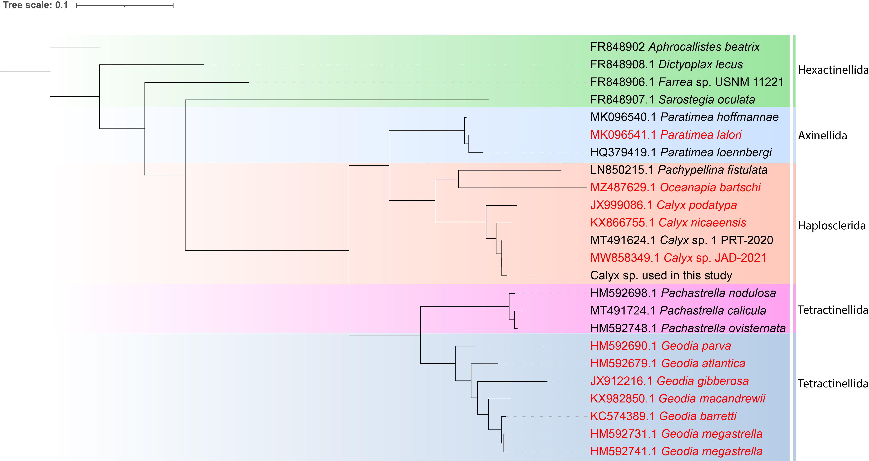

Figure S1 Phylogenetic tree for Calyx sp. samples based on part of the COI gene using primer pairs dgLCO1490 and dgLCO2198. Reference sequences were obtained from the NR database of the National Centre for Biotechnology Information. Organisms in red are voucher specimen. The remaining Calyx sp. samples were amplified using the 28S rRNA primer pairs C2 and D2 and were found to be identical to the sample shown here. Scale bar represents the tree scale.

