Supporting Information
Recombinant LAB vector-based multicomponent vaccine against Campylobacter jejuni potentially promoting a healthier microbial balance in the poultry gut

Prakash Biswasª, Sakil Ahmedª, Samiran Mondal^{b}, Samson Oladokun^{c}, Ozan Gundogdu^{d}*, and Amirul Islam Mallickª*

ªDepartment of Biological Sciences, Indian Institute of Science Education and Research Kolkata, Mohanpur, Nadia, 741246, West Bengal, India.
^{b}Department of Veterinary Pathology, West Bengal University of Animal and Fishery Sciences, Kolkata, West Bengal 700037, India
^{c}Department of Poultry Science, Texas A&M University, College Station, TX 77843, USA
^{d}Department of Infection Biology, Faculty of Infectious & Tropical Diseases, London School of Hygiene and Tropical Medicine, London, WC1E 7HT, United Kingdom

*Corresponding Authors
Dr. Amirul Islam Mallick, DVM, PhD
Professor, Department of Biological Sciences, Indian Institute of Science Education and Research Kolkata, Mohanpur, Nadia, West Bengal, 741246, India. Ph. 91-33-61360022-Ext 1221, E-mail: amallick@iiserkol.ac.in, ORCID ID: 0000-0002-2265-9856
Dr. Ozan Gundogdu, PhD
Associate Professor, Department of Infection Biology, Faculty of Infectious & Tropical Diseases, London School of Hygiene and Tropical Medicine, London, WC1E 7HT, United Kingdom Email: Ozan.Gundogdu@lshtm.ac.uk, ORCID ID: 0000-0002-3550-0545.
Bacterial strains and  Plasmids | Characteristics | Purpose | Source
Strains
E. coli Top 10 | F- mcrAΔ (mrr-hsdRMS-mcrBC)  Φ80lacZΔM15 Δ lacX74 recA1  araD139 Δ (araleu)7697 galUgalKrpsL  (StrR) endA1 nupG | Recombinant plasmid  storage (L. lactis-based  plasmid constructs) | Thermo Fisher  Scientific, USA
E. coli M15 | F-, Φ80ΔlacM15, thi, lac-, mtl-, recA+, KmR | Recombinant protein expression | [1,2]
E. coli BL21 | F- ompT gal dcm lon hsdSB(rB-mB-) | Recombinant protein expression | This work
L. lactis NZ9000 | MG1363 (nisRK genes into  chromosome), Wild type, plasmid-free | Wild-type control | Dr. L. G. Bermúdez  Humarán, INRA, France
L. lactis NZ9000- JlpA | Cm^{r}, NZ9000 harboring pNZ8048-  CWAM6-JlpA | Recombinant protein  expression | [1]
L. lactis NZ9000- Hcp | Cm^{r}, NZ9000 harboring pNZ8048-  CWAM6-Hcp | Recombinant protein  expression | [3]
L. lactis NZ9000- CadF | Cm^{r}, NZ9000 harboring pNZ8048-  CWAM6-CadF | Recombinant protein  expression | This work
C. jejuni TGH9011 | T6SS-positive C. jejuni | In vivo challenge study | BEI Resources
Plasmids
pNZ8048-CWA_{M6} | Cm^{r}, SPUsp45, M6 cell wall anchor  expressed under the PnisA promoter | L. lactis-based recombinant  protein expression vector | Dr. L. G. Bermúdez  Humarán, INRA, France
pNZ8048-CWA_{M6}-JlpA | Cm^{r}, SPUsp45, M6 cell wall anchor  expressed under the PnisA promoter | L. lactis-based JlpA protein  expression vector | [1]
pNZ8048-CWA_{M6}-Hcp | Cm^{r}, SPUsp45, M6 cell wall anchor  expressed under the PnisA promoter | L. lactis-based Hcp protein  expression vector | [3]
pNZ8048-CWA_{M6}-CadF | Cm^{r}, SPUsp45, M6 cell wall anchor  expressed under the PnisA promoter | L. lactis-based CadF protein  expression vector | This work
pQE30-JlpA | Amp^{r}, pQE30 harbouring JlpA | JlpA protein expression vector | [1]
pQE30-Hcp | Amp^{r}, pQE30 harbouring Hcp | Hcp protein expression vector | [2]
pHisTEV-CadF | Amp^{r}, pHisTEV harbouring CadF | CadF protein expression vector | This work
Table S1: The list of bacterial strains and plasmids.

Ingredients | Pre-starter feed (0 to 10 days) | Starter feed (11 to 35 days)
Maise | 550 | 590
Soya Deoiled cake* | 390 | 340
Oil | 16.5 | 27
Dicalcium Phosphate | 12 | 12
Line Stone Powder | 16 | 16
Trace Mineral (Manganese, Zinc, Iron, Iodine, Copper, Cobalt) | 2 | 2
Salt | 2.5 | 2.5
Sodium bicarbonate | 1.5 | 1.5
Choline Chloride | 0.5 | 0.5
Lysine | 2.5 | 2
D.L. Methionine | 2.8 | 2.7
Toxin Binder | 1 | 1
Emulsifier | 0.25 | 0.25
Threonine | 0.15 | 0.15
Phytase 5000 | 0.1 | 0.1
Total | 999.9 | 999.8
Table S2: Composition of poultry feed used in the present study [4].

Antibody name | Fluorophore | Source | Volume utilised
Anti-chicken Bu1 | FITC | Southern Biotech, Canada | 0.5 µL
Anti-chicken IgA | PE | Southern Biotech, Canada | 0.5 µL
Anti-chicken CD3ζ | APC | Southern Biotech, Canada | 0.5 µL
Anti-chicken CD4 | FITC | Southern Biotech, Canada | 0.5 µL
Anti-chicken TCR γδ | PE | Southern Biotech, Canada | 0.5 µL
7-AAD | Far-red | Southern Biotech, Canada | 1 µL
Table S3: Detailed list of the antibodies used for flow cytometry.

Primers | Sequence (5’→3’) | References
β-actin FP | GAGAAATTGTGCGTGACATCA | [5]
β-actin RP | CCTGAACCTCTCATTGCCA | [5]
CXCL8 FP | GGCTTGCTAGGGGAAATGA | [6]
CXCL8 RP | AGCTGACTCTGACTAGGAAACTGT | [6]
IL-17 FP | ATTCCAGGTGCGTGAACTCGGC | [2]
IL-17 RP | GTGCAGCCCACGGTGATCATTTTC | [2]
IFNγ FP | ACACTGACAAGTCAAAGCCGCACA | [7]
IFNγ RP | AGTCGTTCATCGGGAGCTTGGC | [7]
NFκB FP | GAAGGAATCGTACCGGGAACA | [8]
NFκB RP | CTCAGAGGGCCTTGTGACAGTAA | [8]
TNFα FP | TTGCAGGCTGTTTCTGCCTCTGC | This work
TNFα RP | TGAAGGTGGTGCAGATGGGGC | This work
IL-1β FP | AGTGAGGCTCAACATTGCGCTGTA | [9]
IL-1β RP | TAGAAGATGAAGCGGGTCAGCTCG | [9]
iNOS FP | GAACAGCCAGCTCATCCGATA | This work
iNOS RP | CCCAAGCTCAATGCACAACTT | This work
CadF FP | CGGCGCGCATGCGCTGATAACAATGTAAAATTTG | This work
CadF RP | CGCGCGGCTAGCGATCTTAAAATAAATTTAGCATCC | This work
Table S4: Cytokine gene primers used for qRT-PCR and CadF cloning primers.

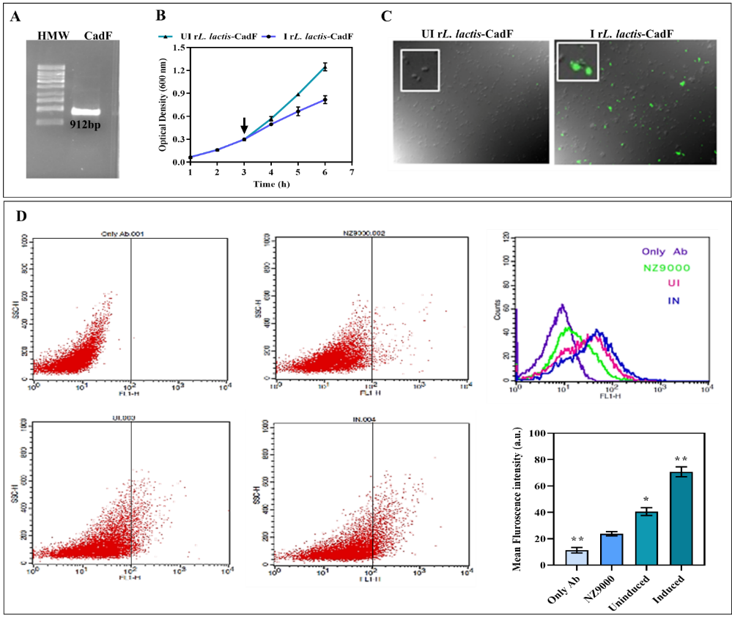
Figure S1: Bioengineering L. lactis surface expressing CadF protein of C. jejuni. The gene encoding the truncated CadF sequence was successfully cloned into the nisin-inducible Lactococcal expression vector pNZ8048-CWA_{M6}, positioned between the N-terminal signal peptide (SP) of USP₄₅ and the C-terminal CWA_{M6} domain. Restriction digestion of recombinant plasmid (pNZ8048-USP₄₅-CadF-CWA_{M6}) with SphI/NheI endonucleases and gene sequencing confirmed the successful cloning of the desired gene. (A) L. lactis NZ9000 cells were electro-transformed with the pNZ-CadF plasmid, and the positive transformants were screened using chloramphenicol as a selection marker and gene amplification (~912 bp) using a specific primer set. (B) In vitro growth kinetics of uninduced and nisin-induced rL. lactis cells. Cells were induced with Nisin (Sigma, USA) (15 ng/mL) when OD₆₀₀ reached ~0.2-0.3. (C) Further indirect immunofluorescent assay and (D) flow cytometric analysis of nisin-induced rL. lactis cells confirm optimal surface expression of CadF protein.

Figure S2: Standard plot for sodium nitrite (NaNO₂) using Griess reagent. This plot was used to quantify NO production (refer to Figure 2D).

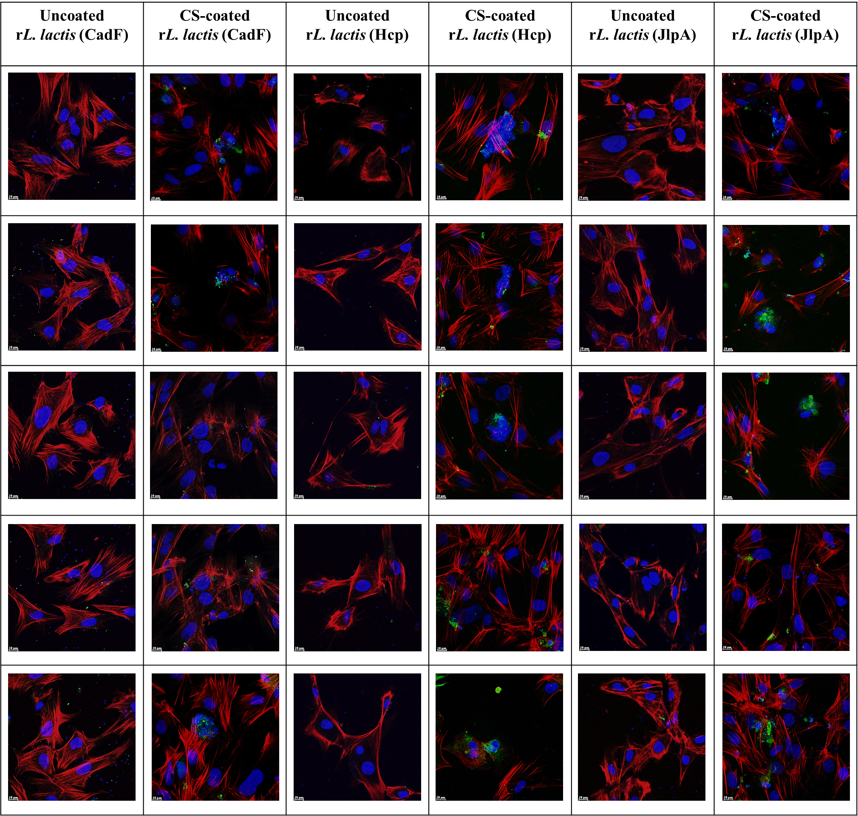
Figure S3: In vitro adhesion assay of uncoated and CS-coated rL. Lactis (CadF, Hcp, JlpA) in CEICs. The cells were incubated with induced uncoated and CS-coated rL. lactis 4 h at 37 °C with 5% CO₂, at a ratio of cell vs bacteria 1:1000. CLSM images of cells incubated with CS-coated rL. lactis cells showed enhanced cell adhesion compared to uncoated bacteria. Scale bar: 10 μm.

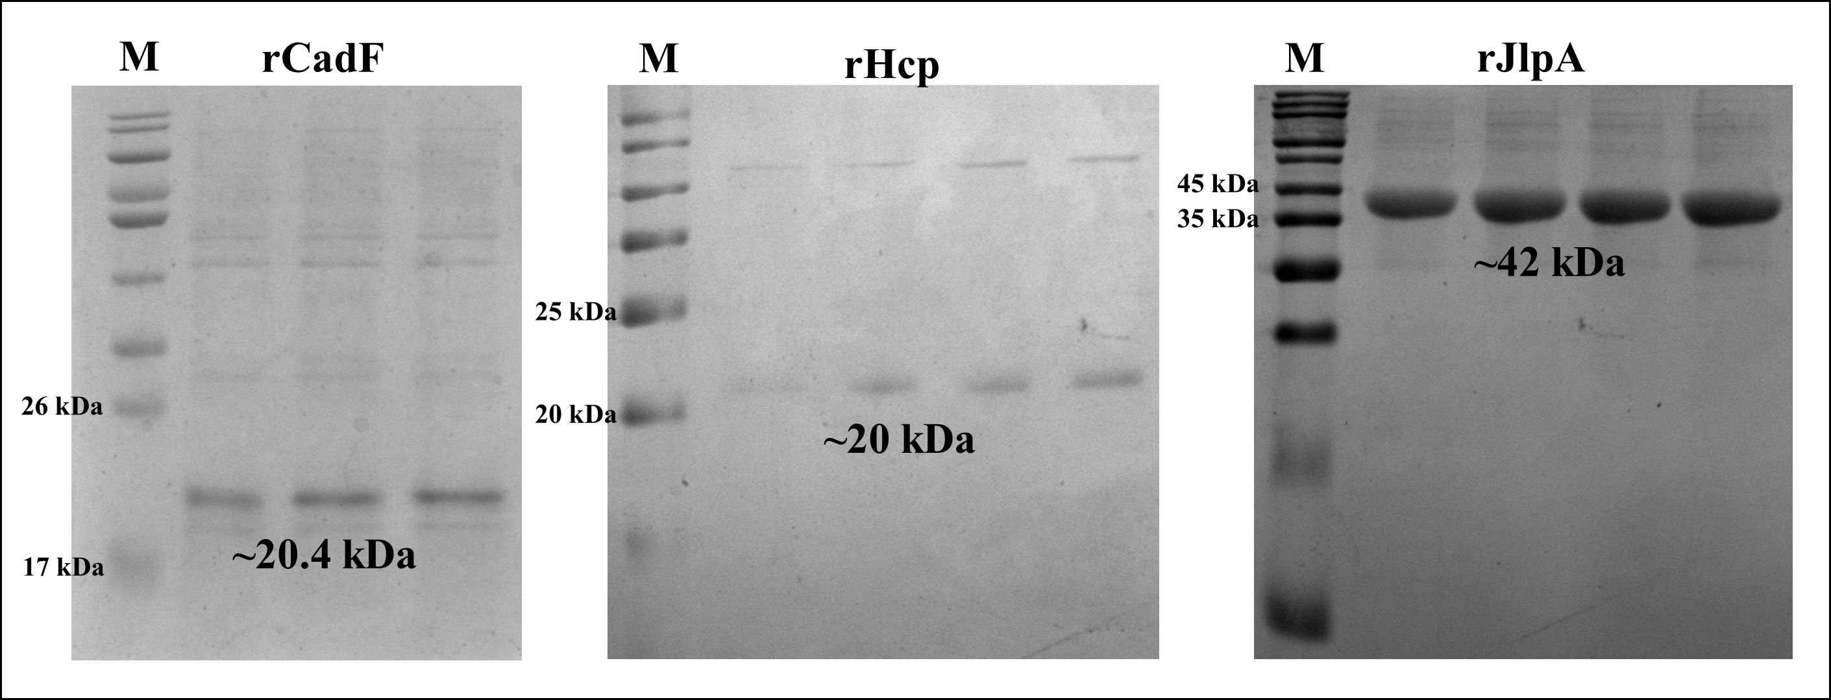
Figure S4: SDS-PAGE analysis of recombinant CadF, Hcp, and JlpA proteins. Representative Coomassie-stained SDS-polyacrylamide gels showing protein bands at the expected molecular weights. Left panel: SDS-PAGE showing a prominent band at ~20.4 kDa for CadF protein. Middle panel: SDS-PAGE indicating protein bands migrating at approximately ~20 kDa for the Hcp protein. Right panel: SDS-PAGE showing a strong band at ~42 kDa for JlpA protein. The positions of the target proteins are indicated with approximate molecular weights.
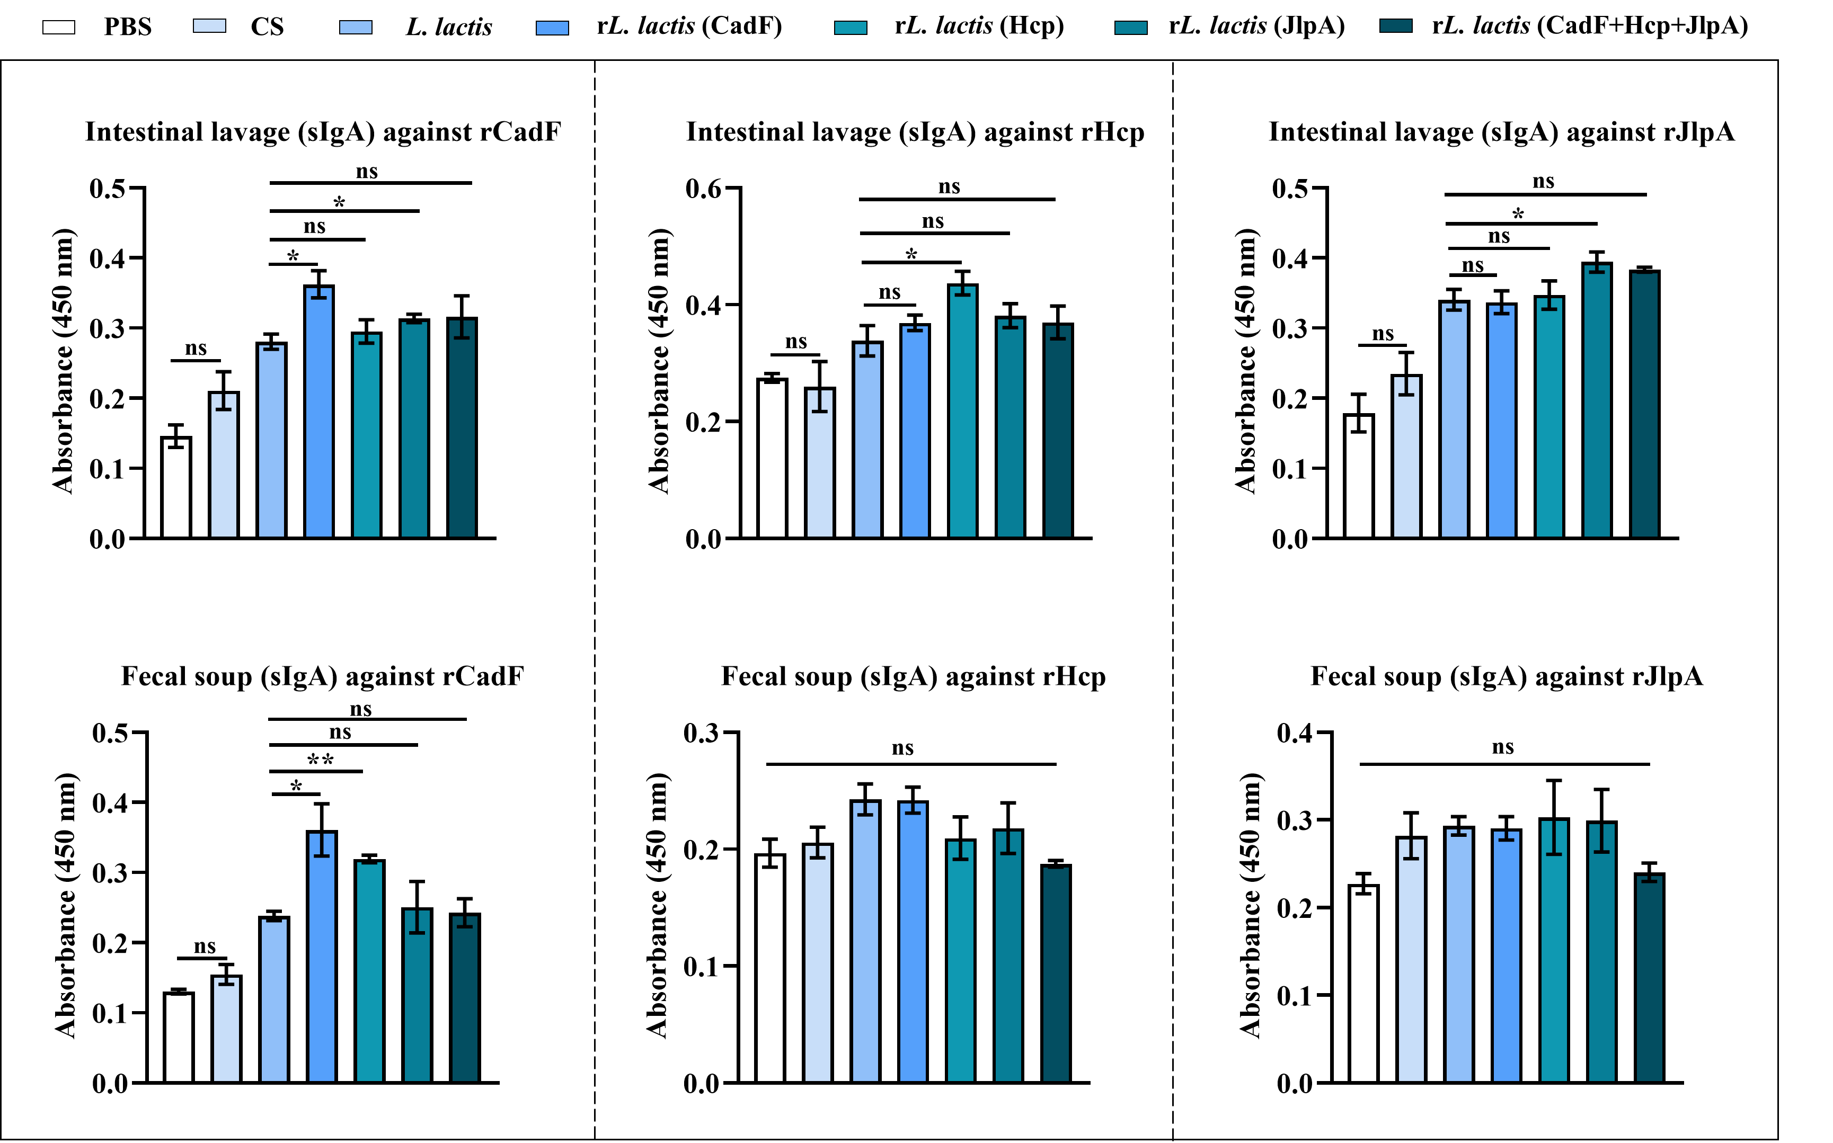
Figure S5: Antigen-specific mucosal sIgA responses in intestinal lavage and fecal soup samples following oral immunization with recombinant L. lactis strains. ELISA plates were coated individually with purified recombinant CadF, Hcp, or JlpA proteins, and sIgA levels were measured in intestinal lavage and fecal soup samples collected from experimental birds. Antibody responses in birds immunized with rL. lactis expressing CadF, Hcp, or JlpA were compared with those in the L. lactis control group. Each bar represents the mean absorbance (A450) ± SE of 12 birds pooled in 4 replicates from two independent experiments. Asterisks indicate a statistically significant difference (*p < 0.05) compared to the control group (PBS).

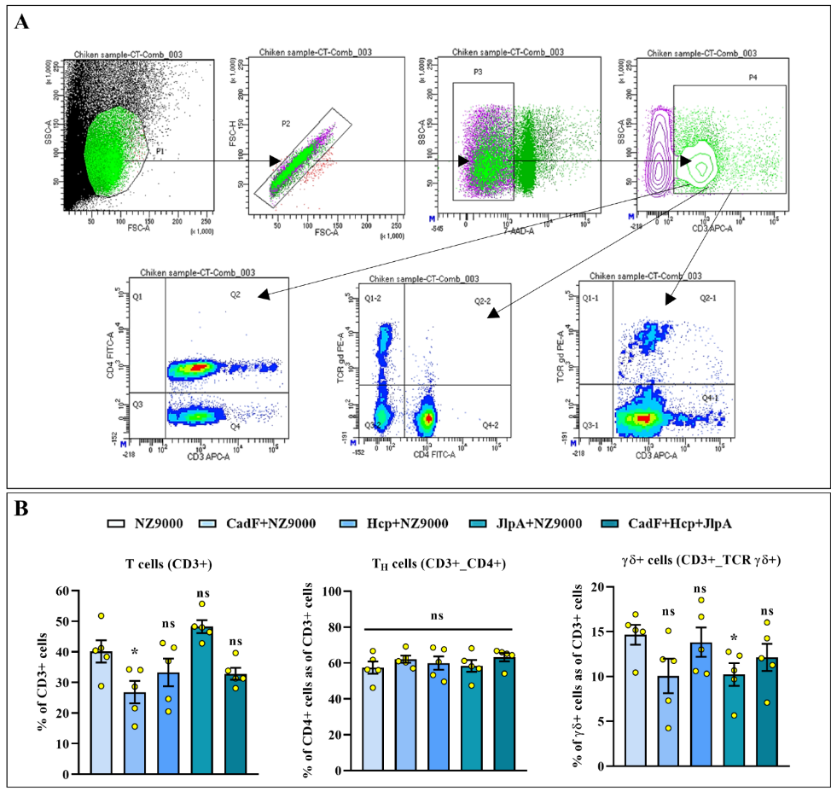
Figure S6: Flow cytometric analysis of T-cell subsets in cecal tonsils of immunized birds. Cecal tonsils were collected from birds at day 28 post-first immunization and processed to isolate mononuclear cells. (A) Panel showing the gating strategy for T cells present in the cecal tonsil (CT) of experimental birds. (B) Flow cytometric analysis of T cells suggests no changes in the CD3⁺, CD4^{+,} and TCRγδ⁺ populations in birds administered with rL. lactis (CadF, JlpA, and Hcp) compared to other experimental groups.

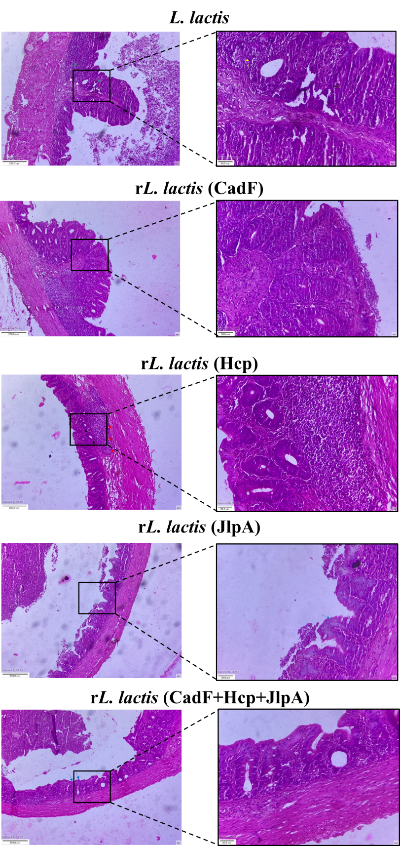
Figure S7: Additional images of tissue sections showing histopathological changes of cecal tissue collected from birds at day 7 post-infection with C. jejuni (TGH 9011). Green arrow: cellular infiltration, yellow arrow: crypt disruption, white arrow: tissue necrosis, red arrow: lymphoid accumulation, black arrow: well-organized crypt, blue arrow: intact epithelia.

PBS vs Baseline
Phylum | Log2FC | St. Error |  |  |  | P-value |  |  |  | FDR
Armatimonadota | 0.909 | 0.312 |  |  |  | 0.00351 |  |  |  | 0.0181
Actinomycetota | 0.935 | 0.477 |  |  |  | 0.0499 |  |  |  | 0.132
Candidatus_Bipolaricaulota | 0.988 | 0.568 |  |  |  | 0.0818 |  |  |  | 0.176
Aquificota | 1.41 | 0.895 |  |  |  | 0.115 |  |  |  | 0.229
Acidobacteriota | -0.584 | 0.395 |  |  |  | 0.139 |  |  |  | 0.26
Fusobacteriota | 0.898 | 0.725 |  |  |  | 0.216 |  |  |  | 0.345
Nitrospirota | -0.802 | 0.658 |  |  |  | 0.223 |  |  |  | 0.345
Thermodesulfobacteriota | 0.872 | 0.838 |  |  |  | 0.298 |  |  |  | 0.437
Bacteroidota | 0.778 | 0.772 |  |  |  | 0.314 |  |  |  | 0.445
Campylobacterota | -0.417 | 0.632 |  |  |  | 0.51 |  |  |  | 0.632
Candidatus_Omnitrophota | 0.0354 | 0.704 |  |  |  | 0.96 |  |  |  | 0.98
PBS vs UU
Phylum | Log₂FC |  | St. Error |  |  |  | P-value |  |  |  | FDR
Armatimonadota | 1.37 |  | 0.316 |  |  |  | 1.45E-5 |  |  |  | 9.83E-5
Candidatus_Bipolaricaulota | 1.49 |  | 0.427 |  |  |  | 4.75E-4 |  |  |  | 0.0019
Fusobacteriota | 1.23 |  | 0.541 |  |  |  | 0.0226 |  |  |  | 0.0552
Actinomycetota | 0.908 |  | 0.477 |  |  |  | 0.0568 |  |  |  | 0.119
Aquificota | 1.23 |  | 0.76 |  |  |  | 0.105 |  |  |  | 0.18
Bacteroidota | 0.885 |  | 0.646 |  |  |  | 0.17 |  |  |  | 0.268
Acidobacteriota | -0.309 |  | 0.397 |  |  |  | 0.436 |  |  |  | 0.582
Campylobacterota | -0.36 |  | 0.516 |  |  |  | 0.486 |  |  |  | 0.602
Thermodesulfobacteriota | 0.428 |  | 0.603 |  |  |  | 0.478 |  |  |  | 0.602
Candidatus_Omnitrophota | 0.15 |  | 0.578 |  |  |  | 0.796 |  |  |  | 0.891
Nitrospirota | -2.22E-7 |  | 0.82 |  |  |  | 1.0 |  |  |  | 1.0
PBS vs CS
Phylum | Log2FC |  |  |  | St. Error |  |  |  | P-value |  |  | FDR
Candidatus_Bipolaricaulota | 0.511 |  |  |  | 0.39 |  |  |  | 0.19 |  |  | 0.315
Armatimonadota | 0.376 |  |  |  | 0.308 |  |  |  | 0.222 |  |  | 0.345
Thermodesulfobacteriota | -0.625 |  |  |  | 0.647 |  |  |  | 0.334 |  |  | 0.459
Fusobacteriota | 0.396 |  |  |  | 0.528 |  |  |  | 0.453 |  |  | 0.595
Actinomycetota | 0.354 |  |  |  | 0.508 |  |  |  | 0.486 |  |  | 0.603
Aquificota | 0.333 |  |  |  | 0.747 |  |  |  | 0.656 |  |  | 0.769
Candidatus_Omnitrophota | 0.279 |  |  |  | 0.719 |  |  |  | 0.698 |  |  | 0.797
Acidobacteriota | -0.114 |  |  |  | 0.399 |  |  |  | 0.775 |  |  | 0.853
Nitrospirota | 0.185 |  |  |  | 0.832 |  |  |  | 0.824 |  |  | 0.873
Bacteroidota | 0.13 |  |  |  | 0.69 |  |  |  | 0.851 |  |  | 0.888
Campylobacterota | 0.00662 |  |  |  | 0.516 |  |  |  | 0.99 |  |  | 0.99
PBS vs L. lactis
Phylum | Log2FC |  |  | St. Error |  |  |  | P-value |  |  |  |  | FDR
Armatimonadota | 2.15 |  |  | 0.361 |  |  |  | 2.44E-9 |  |  |  |  | 7.15E-8
Actinomycetota | -2.35 |  |  | 0.474 |  |  |  | 6.82E-7 |  |  |  |  | 1.17E-5
Acidobacteriota | -1.35 |  |  | 0.392 |  |  |  | 5.52E-4 |  |  |  |  | 0.00343
Candidatus_Omnitrophota | -1.66 |  |  | 0.482 |  |  |  | 5.85E-4 |  |  |  |  | 0.00343
Thermodesulfobacteriota | -1.77 |  |  | 0.559 |  |  |  | 0.00155 |  |  |  |  | 0.00719
Bacteroidota | -1.42 |  |  | 0.645 |  |  |  | 0.0274 |  |  |  |  | 0.0755
Aquificota | -1.46 |  |  | 0.677 |  |  |  | 0.0312 |  |  |  |  | 0.0824
Candidatus_Bipolaricaulota | 0.969 |  |  | 0.459 |  |  |  | 0.0346 |  |  |  |  | 0.0824
Nitrospirota | -1.34 |  |  | 0.636 |  |  |  | 0.0356 |  |  |  |  | 0.0824
Fusobacteriota | -0.962 |  |  | 0.494 |  |  |  | 0.0516 |  |  |  |  | 0.106
Campylobacterota | 0.257 |  |  | 0.517 |  |  |  | 0.619 |  |  |  |  | 0.718
PBS vs rL. lactis (CadF)
Phylum | Log2FC |  |  | St. Error |  |  |  | P-value |  |  |  |  | FDR
Actinomycetota | -2.22 |  |  | 0.474 |  |  |  | 2.74E-6 |  |  |  |  | 3.45E-5
Armatimonadota | 2.13 |  |  | 0.543 |  |  |  | 8.75E-5 |  |  |  |  | 7.0E-4
Thermodesulfobacteriota | -2.25 |  |  | 0.587 |  |  |  | 1.26E-4 |  |  |  |  | 7.94E-4
Bacteroidota | -2.36 |  |  | 0.645 |  |  |  | 2.54E-4 |  |  |  |  | 0.0014
Candidatus_Omnitrophota | -1.73 |  |  | 0.481 |  |  |  | 3.2E-4 |  |  |  |  | 0.00166
Acidobacteriota | -1.32 |  |  | 0.392 |  |  |  | 7.45E-4 |  |  |  |  | 0.00345
Candidatus_Bipolaricaulota | 1.34 |  |  | 0.423 |  |  |  | 0.00155 |  |  |  |  | 0.0062
Nitrospirota | -1.57 |  |  | 0.652 |  |  |  | 0.0159 |  |  |  |  | 0.0423
Aquificota | -1.61 |  |  | 0.676 |  |  |  | 0.0175 |  |  |  |  | 0.0454
Fusobacteriota | -0.399 |  |  | 0.496 |  |  |  | 0.421 |  |  |  |  | 0.562
Campylobacterota | 0.147 |  |  | 0.516 |  |  |  | 0.776 |  |  |  |  | 0.853
PBS vs rL. lactis (Hcp)
Phylum | Log2FC |  |  | St. Error |  |  |  | P-value |  |  |  |  | FDR
Armatimonadota | 2.35 |  |  | 0.559 |  |  |  | 2.53E-5 |  |  |  |  | 5.56E-4
Actinomycetota | -1.84 |  |  | 0.474 |  |  |  | 1.02E-4 |  |  |  |  | 0.0018
Candidatus_Bipolaricaulota | 1.34 |  |  | 0.581 |  |  |  | 0.0212 |  |  |  |  | 0.103
Bacteroidota | -1.35 |  |  | 0.645 |  |  |  | 0.0367 |  |  |  |  | 0.154
Campylobacterota | 1.03 |  |  | 0.518 |  |  |  | 0.0465 |  |  |  |  | 0.173
Candidatus_Omnitrophota | -0.762 |  |  | 0.486 |  |  |  | 0.117 |  |  |  |  | 0.258
Acidobacteriota | -0.594 |  |  | 0.395 |  |  |  | 0.133 |  |  |  |  | 0.276
Aquificota | -0.784 |  |  | 0.677 |  |  |  | 0.247 |  |  |  |  | 0.419
Thermodesulfobacteriota | -0.695 |  |  | 0.646 |  |  |  | 0.282 |  |  |  |  | 0.469
Nitrospirota | -0.717 |  |  | 0.694 |  |  |  | 0.302 |  |  |  |  | 0.483
Fusobacteriota | -0.19 |  |  | 0.497 |  |  |  | 0.702 |  |  |  |  | 0.853
PBS vs rL. lactis (JlpA)
Phylum | Log2FC |  |  | St. Error |  |  |  | P-value |  |  |  |  | FDR
Actinomycetota | -2.08 |  |  | 0.474 |  |  |  | 1.13E-5 |  |  |  |  | 2.5E-4
Armatimonadota | 2.35 |  |  | 0.559 |  |  |  | 2.53E-5 |  |  |  |  | 3.7E-4
Candidatus_Bipolaricaulota | 1.8 |  |  | 0.485 |  |  |  | 2.03E-4 |  |  |  |  | 0.00255
Acidobacteriota | -1.27 |  |  | 0.392 |  |  |  | 0.00123 |  |  |  |  | 0.009
Candidatus_Omnitrophota | -1.27 |  |  | 0.483 |  |  |  | 0.00833 |  |  |  |  | 0.0407
Bacteroidota | -1.13 |  |  | 0.645 |  |  |  | 0.0795 |  |  |  |  | 0.2
Aquificota | -1.07 |  |  | 0.677 |  |  |  | 0.113 |  |  |  |  | 0.256
Nitrospirota | -0.909 |  |  | 0.657 |  |  |  | 0.166 |  |  |  |  | 0.333
Thermodesulfobacteriota | -0.681 |  |  | 0.562 |  |  |  | 0.226 |  |  |  |  | 0.406
Campylobacterota | 0.551 |  |  | 0.517 |  |  |  | 0.287 |  |  |  |  | 0.486
Fusobacteriota | -0.116 |  |  | 0.497 |  |  |  | 0.816 |  |  |  |  | 0.872
PBS vs rL. lactis (CadF+Hcp+JlpA)
Phylum | Log2FC |  |  | St. Error |  |  |  | P-value |  |  |  |  | FDR
Armatimonadota | 1.87 |  |  | 0.404 |  |  |  | 3.77E-6 |  |  |  |  | 8.3E-5
Actinomycetota | -1.75 |  |  | 0.474 |  |  |  | 2.29E-4 |  |  |  |  | 0.00227
Bacteroidota | -2.21 |  |  | 0.645 |  |  |  | 6.07E-4 |  |  |  |  | 0.00486
Candidatus_Bipolaricaulota | 1.51 |  |  | 0.59 |  |  |  | 0.0104 |  |  |  |  | 0.0611
Candidatus_Omnitrophota | -1.14 |  |  | 0.484 |  |  |  | 0.0184 |  |  |  |  | 0.0871
Campylobacterota | 0.828 |  |  | 0.518 |  |  |  | 0.109 |  |  |  |  | 0.254
Nitrospirota | -1.07 |  |  | 0.655 |  |  |  | 0.101 |  |  |  |  | 0.254
Aquificota | -0.937 |  |  | 0.677 |  |  |  | 0.166 |  |  |  |  | 0.341
Thermodesulfobacteriota | -0.838 |  |  | 0.645 |  |  |  | 0.194 |  |  |  |  | 0.363
Acidobacteriota | -0.417 |  |  | 0.427 |  |  |  | 0.329 |  |  |  |  | 0.527
Fusobacteriota | 0.195 |  |  | 0.526 |  |  |  | 0.711 |  |  |  |  | 0.811

Table S5: Multiple linear regression with covariate adjustment of cecal microbiota at the phylum level. The MicrobiomeAnalyst (2.0), a freely available software, was used to perform multiple regression analyses across experimental groups. The tool uses MaAsLin2 to fit general models to identify associations between microbial features and experimental metadata. A Zero-Inflated Negative Binomial Model (ZINB) was fitted to each microbial feature, including the primary metadata and covariates.

Chao1
Pair | Statistic | P-value | FDR
Baseline vs CS | -0.7387 | 0.49235 | 0.68172
Baseline vs L._lactis | -5.626 | 0.00524 | 0.063954
Baseline vs PBS | -0.85651 | 0.42462 | 0.65097
Baseline vs rL._lactis_(CadF) | -4.2464 | 0.016894 | 0.070517
Baseline vs rL._lactis_(CadF+Hcp+JlpA) | -2.1524 | 0.11347 | 0.24029
Baseline vs rL._lactis_(Hcp) | -3.608 | 0.027017 | 0.08105
Baseline vs rL._lactis_(JlpA) | -5.0298 | 0.0078753 | 0.063954
Baseline vs UU | -2.07 | 0.12173 | 0.24346
CS vs L._lactis | -4.7123 | 0.0054202 | 0.063954
CS vs rL._lactis_(CadF) | -3.6419 | 0.019588 | 0.070517
CS vs rL._lactis_(CadF+Hcp+JlpA) | -1.8312 | 0.1492 | 0.26856
CS vs rL._lactis_(Hcp) | -3.0144 | 0.0353 | 0.088312
CS vs rL._lactis_(JlpA) | -4.1756 | 0.0090239 | 0.063954
L._lactis vs rL._lactis_(CadF) | 0.19805 | 0.84994 | 0.89993
L._lactis vs rL._lactis_(CadF+Hcp+JlpA) | 0.8314 | 0.44759 | 0.65097
L._lactis vs rL._lactis_(Hcp) | 0.84185 | 0.43356 | 0.65097
L._lactis vs rL._lactis_(JlpA) | 0.4117 | 0.69486 | 0.78172
PBS vs CS | -0.069136 | 0.94745 | 0.94745
PBS vs L._lactis | -5.1564 | 0.0068991 | 0.063954
PBS vs rL._lactis_(CadF) | -3.8779 | 0.021911 | 0.071709
Shannon
Pair | Statistic | P-value | FDR
Baseline vs CS | -0.94281 | 0.39154 | 0.55982
Baseline vs L._lactis | -5.0328 | 0.0029105 | 0.10478
Baseline vs PBS | -1.2612 | 0.25562 | 0.48432
Baseline vs rL._lactis_(CadF) | -3.9041 | 0.013171 | 0.13368
Baseline vs rL._lactis_(CadF+Hcp+JlpA) | -0.40903 | 0.70591 | 0.79415
Baseline vs rL._lactis_(Hcp) | 0.57017 | 0.59842 | 0.75296
Baseline vs rL._lactis_(JlpA) | -1.8216 | 0.15245 | 0.36589
Baseline vs UU | -2.4617 | 0.053838 | 0.21535
CS vs L._lactis | -2.2615 | 0.085756 | 0.28066
CS vs rL._lactis_(CadF) | -2.4349 | 0.050854 | 0.21535
CS vs rL._lactis_(CadF+Hcp+JlpA) | 0.14355 | 0.89187 | 0.94433
CS vs rL._lactis_(Hcp) | 1.1531 | 0.29532 | 0.48478
CS vs rL._lactis_(JlpA) | -1.1798 | 0.29625 | 0.48478
L._lactis vs rL._lactis_(CadF) | -0.93175 | 0.40431 | 0.55982
L._lactis vs rL._lactis_(CadF+Hcp+JlpA) | 1.4692 | 0.22955 | 0.48432
L._lactis vs rL._lactis_(Hcp) | 3.1932 | 0.037812 | 0.19446
L._lactis vs rL._lactis_(JlpA) | -0.043294 | 0.96796 | 0.96796
PBS vs CS | -0.14865 | 0.88865 | 0.94433
PBS vs L._lactis | -4.171 | 0.0059699 | 0.10746
PBS vs rL._lactis_(CadF) | -3.241 | 0.029819 | 0.17892
Simpson
Pair | Statistic | P-value | FDR
Baseline vs CS | 0.39635 | 0.71173 | 0.83121
Baseline vs L._lactis | 0.15848 | 0.87958 | 0.90472
Baseline vs PBS | -0.30815 | 0.76847 | 0.84763
Baseline vs rL._lactis_(CadF) | -0.83054 | 0.45068 | 0.7736
Baseline vs rL._lactis_(CadF+Hcp+JlpA) | 1.6023 | 0.20249 | 0.50945
Baseline vs rL._lactis_(Hcp) | 2.9041 | 0.056848 | 0.37776
Baseline vs rL._lactis_(JlpA) | 0.44072 | 0.68794 | 0.83121
Baseline vs UU | -1.8139 | 0.12455 | 0.50945
CS vs L._lactis | -0.28009 | 0.79135 | 0.84763
CS vs rL._lactis_(CadF) | -0.93959 | 0.38385 | 0.76771
CS vs rL._lactis_(CadF+Hcp+JlpA) | 1.3536 | 0.2488 | 0.55434
CS vs rL._lactis_(Hcp) | 2.509 | 0.06296 | 0.37776
CS vs rL._lactis_(JlpA) | 0.27097 | 0.80054 | 0.84763
L._lactis vs rL._lactis_(CadF) | -0.88875 | 0.41581 | 0.7736
L._lactis vs rL._lactis_(CadF+Hcp+JlpA) | 1.5448 | 0.21227 | 0.50945
L._lactis vs rL._lactis_(Hcp) | 2.819 | 0.057987 | 0.37776
L._lactis vs rL._lactis_(JlpA) | 0.39742 | 0.71576 | 0.83121
PBS vs CS | 0.56873 | 0.60067 | 0.83121
PBS vs L._lactis | 0.42796 | 0.6852 | 0.83121
PBS vs rL._lactis_(CadF) | -0.666 | 0.54163 | 0.77995
Fisher
Pair | Statistic | P-value | FDR
Baseline vs CS | -1.0486 | 0.33809 | 0.50714
Baseline vs L._lactis | -10.669 | 5.64E-05 | 0.0017278
Baseline vs PBS | -0.88543 | 0.41056 | 0.52787
Baseline vs rL._lactis_(CadF) | -6.904 | 0.0019106 | 0.0085976
Baseline vs rL._lactis_(CadF+Hcp+JlpA) | -3.3324 | 0.037117 | 0.078601
Baseline vs rL._lactis_(Hcp) | -5.5254 | 0.004818 | 0.014454
Baseline vs rL._lactis_(JlpA) | -8.4591 | 3.99E-04 | 0.0035932
Baseline vs UU | -2.6778 | 0.068848 | 0.12232
CS vs L._lactis | -8.3354 | 1.66E-04 | 0.0019866
CS vs rL._lactis_(CadF) | -5.7642 | 0.002185 | 0.00874
CS vs rL._lactis_(CadF+Hcp+JlpA) | -2.8192 | 0.052025 | 0.098575
CS vs rL._lactis_(Hcp) | -4.5203 | 0.0066387 | 0.018273
CS vs rL._lactis_(JlpA) | -6.8158 | 5.71E-04 | 0.0041119
L._lactis vs rL._lactis_(CadF) | 0.26715 | 0.8004 | 0.84748
L._lactis vs rL._lactis_(CadF+Hcp+JlpA) | 0.95317 | 0.39949 | 0.52787
L._lactis vs rL._lactis_(Hcp) | 1.3399 | 0.24143 | 0.37789
L._lactis vs rL._lactis_(JlpA) | 0.44972 | 0.6697 | 0.75341
PBS vs CS | -0.36446 | 0.73003 | 0.7964
PBS vs L._lactis | -10.413 | 9.60E-05 | 0.0017278
PBS vs rL._lactis_(CadF) | -6.5465 | 0.002954 | 0.010634

Table S6: The table summarises the post-hoc pairwise comparison (multi-group) of alpha diversity indexes (Chao1, Shannon, Simpson, and Fisher). Regular Welch t-tests/ANOVA were performed for each pair. The multi-testing adjustment is based on the Benjamini-Hochberg procedure (FDR).

Beta diversity (PERMANOVA)
Pair | F-value | R-squared | P-value | FDR
Baseline vs UU | 6.1114 | 0.5046 | 0.027 | 0.054
Baseline vs PBS | 6.046 | 0.50191 | 0.023 | 0.054
Baseline vs CS | 4.3581 | 0.42074 | 0.028 | 0.054
Baseline vs L._lactis | 13.69 | 0.69528 | 0.027 | 0.054
Baseline vs rL._lactis_(CadF) | 11.493 | 0.65701 | 0.026 | 0.054
Baseline vs rL._lactis_(Hcp) | 24.972 | 0.80628 | 0.04 | 0.054667
Baseline vs rL._lactis_(JlpA) | 8.5266 | 0.58696 | 0.029 | 0.054
Baseline vs rL._lactis_(CadF+Hcp+JlpA) | 14.084 | 0.70126 | 0.028 | 0.054
UU vs PBS | 4.8562 | 0.44732 | 0.024 | 0.054
UU vs CS | 3.329 | 0.35684 | 0.041 | 0.054667
UU vs L._lactis | 20.316 | 0.772 | 0.031 | 0.054
UU vs rL._lactis_(CadF) | 14.459 | 0.70673 | 0.029 | 0.054
UU vs rL._lactis_(Hcp) | 35.516 | 0.85548 | 0.018 | 0.054
UU vs rL._lactis_(JlpA) | 9.6979 | 0.61778 | 0.028 | 0.054
UU vs rL._lactis_(CadF+Hcp+JlpA) | 19.215 | 0.76205 | 0.027 | 0.054
PBS vs CS | 1.632 | 0.21383 | 0.112 | 0.13006
PBS vs L._lactis | 20.215 | 0.77113 | 0.033 | 0.054
PBS vs rL._lactis_(CadF) | 13.709 | 0.69556 | 0.033 | 0.054
PBS vs rL._lactis_(Hcp) | 38.027 | 0.86372 | 0.038 | 0.054667
PBS vs rL._lactis_(JlpA) | 10.165 | 0.62884 | 0.027 | 0.054

Table S7: The table summarises the results of the pairwise PERMANOVA analysis of beta diversity. The multi-testing adjustment is based on the Benjamini-Hochberg procedure (FDR).
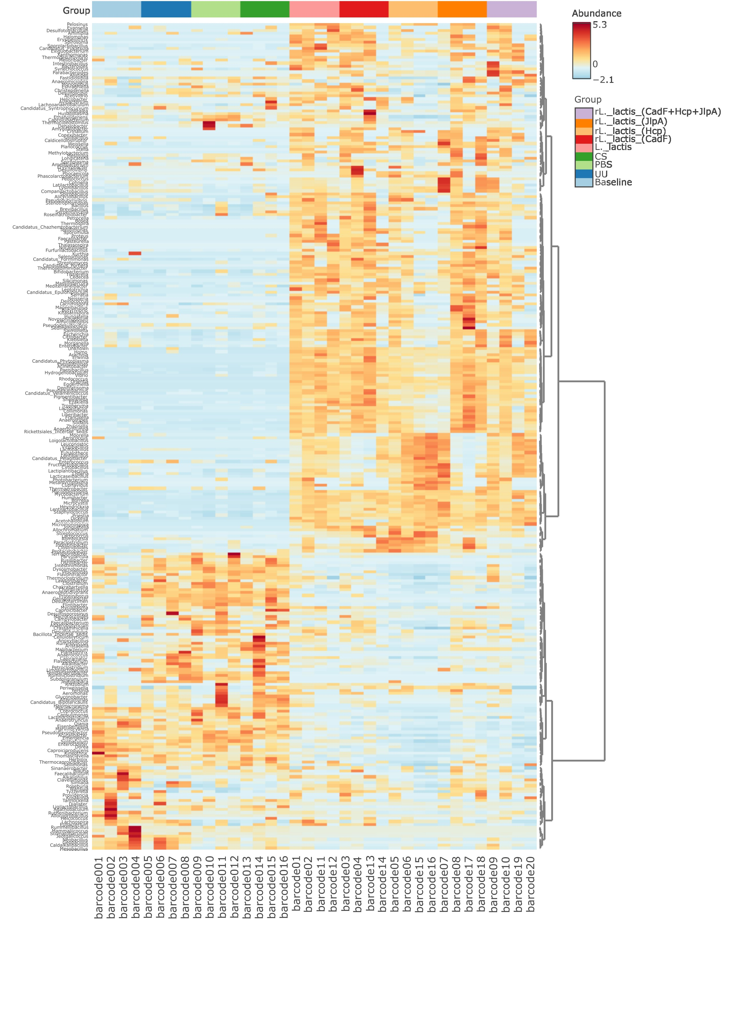Figure S8: The clustering heatmap showed the relative abundance of microbial genera between treatment groups.
References:
1. Gorain C, Singh A, Bhattacharyya S, Kundu A, Lahiri A, Gupta S, et al. Mucosal delivery of live Lactococcus lactis expressing functionally active JlpA antigen induces potent local immune response and prevent enteric colonization of Campylobacter jejuni in chickens. Vaccine. 2020;38:1630–42. https://doi.org/10.1016/j.vaccine.2019.12.064
2. Singh A, Nisaa K, Bhattacharyya S, Mallick AI. Immunogenicity and protective efficacy of mucosal delivery of recombinant hcp of Campylobacter jejuni Type VI secretion system (T6SS) in chickens. Mol Immunol. 2019;111:182–97. https://doi.org/10.1016/j.molimm.2019.04.016
3. Gorain C, Khan A, Singh A, Mondal S, Mallick AI. Bioengineering of LAB vector expressing Haemolysin co-regulated protein (Hcp): a strategic approach to control gut colonization of Campylobacter jejuni in a murine model. Gut Pathogens. 2021;13:48. https://doi.org/10.1186/s13099-021-00444-2
4. Jayaraman S, Das PP, Saini PC, Roy B, Chatterjee PN. Use of Bacillus Subtilis PB6 as a potential antibiotic growth promoter replacement in improving performance of broiler birds. Poultry Science. 2017;96:2614–22. https://doi.org/10.3382/ps/pex079
5. Li Y-P, Ingmer H, Madsen M, Bang DD. Cytokine responses in primary chicken embryo intestinal cells infected with Campylobacter jejuni strains of human and chicken origin and the expression of bacterial virulence-associated genes. BMC Microbiol. 2008;8:107. https://doi.org/10.1186/1471-2180-8-107
6. Hong YH, Lillehoj HS, Lee SH, Dalloul RA, Lillehoj EP. Analysis of chicken cytokine and chemokine gene expression following Eimeria acervulina and Eimeria tenella infections. Vet Immunol Immunopathol. 2006;114:209–23. https://doi.org/10.1016/j.vetimm.2006.07.007
7. Mallick AI, Haq K, Brisbin JT, Mian MF, Kulkarni RR, Sharif S. Assessment of bioactivity of a recombinant chicken interferon-gamma expressed using a baculovirus expression system. J Interferon Cytokine Res. 2011;31:493–500. https://doi.org/10.1089/jir.2010.0130
8. Chiang H-I, Berghman LR, Zhou H. Inhibition of NF-kB 1 (NF-kBp50) by RNA interference in chicken macrophage HD11 cell line challenged with Salmonellaenteritidis. Genet Mol Biol. 2009;32:507–15. https://doi.org/10.1590/S1415-47572009000300013
9. Bhowmick S, Gupta S, Mondal S, Mallick AI. Activation of Antiviral Host Responses against Avian Influenza Virus and Remodeling of Gut Microbiota by rLAB Vector Expressing rIL-17A in Chickens. ACS Infect Dis. American Chemical Society; 2024;10:3026–41. https://doi.org/10.1021/acsinfecdis.4c00377

