Supplementary Figures

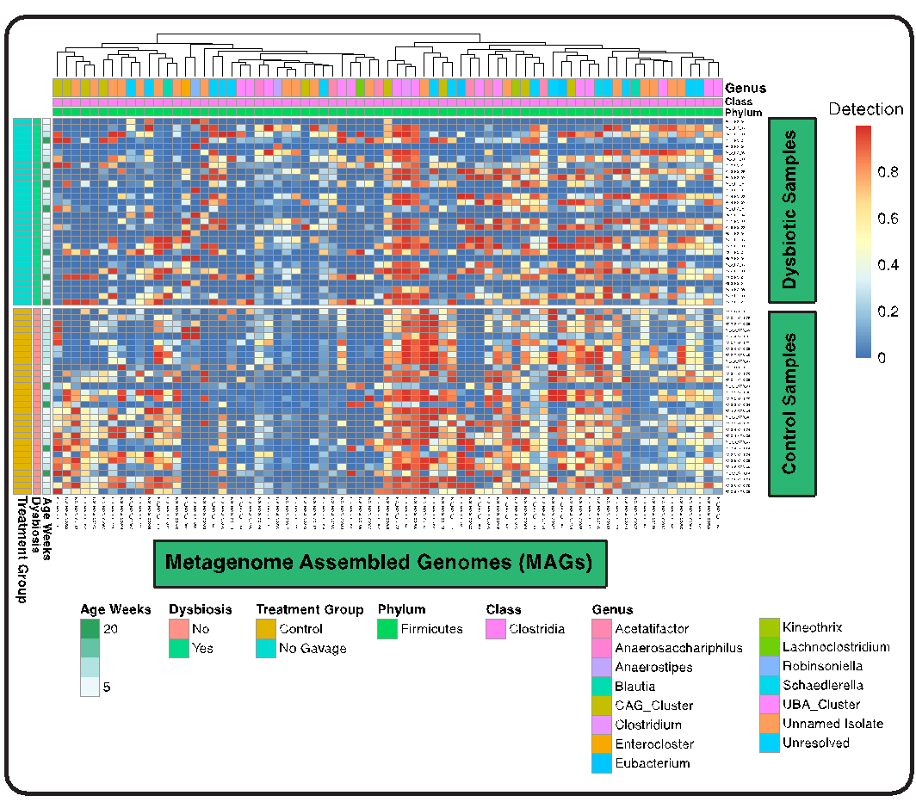
Supplementary Figure S1.

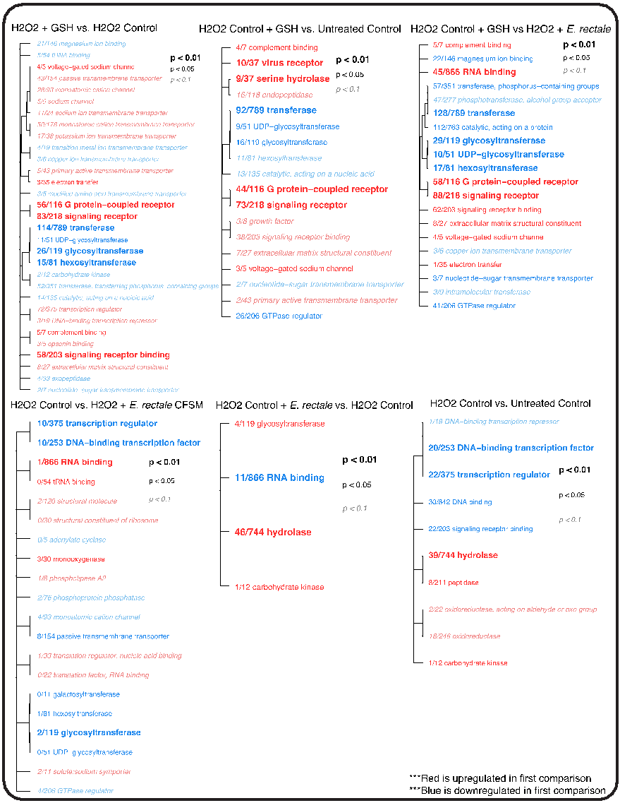
Supplementary Figure S2.

