Supplementary Information for
Invertebrate gut viromes mediate microbial adaptation to pharmaceutical diversity under warming
Ya-Ning Wang^{1,2}, Jin-Ting Zheng^{1,3}, Xue-Peng Chen^{1,4}, Luo-Qin Shen^{1,2}, Ming-Ming Sun⁵, Mao Ye⁶, Yi-Fei Wang^{1,7}*, Roy Neilson⁸, Dong Zhu^{1,7}*
¹ State Key Laboratory of Regional and Urban Ecology, Ningbo Observation and Research Station, Institute of Urban Environment, Chinese Academy of Sciences, Xiamen 361021, China
² University of Chinese Academy of Sciences, 19A Yuquan Road, Beijing, 100049, China
³ College of JunCao Science and Ecology (College of Carbon Neutrality), Fujian Agriculture and Forestry University, Fuzhou 350002, China
⁴ Department of Environmental Science and Engineering, University of Science and Technology of China, Hefei 230026, China
⁵ Soil Ecology Laboratory, College of Resources and Environmental Sciences, Nanjing Agricultural University, Nanjing 210095, China
⁶ National Engineering Research Center for Soil Nutrient Management and Pollution Remediation, Institute of Soil Science, Chinese Academy of Sciences, Nanjing 210008, China
⁷ Zhejiang Key Laboratory of Pollution Control for Port-Petrochemical Industry, CAS Haixi Industrial Technology Innovation Center in Beilun, Ningbo 315830, China
⁸ Ecological Sciences, The James Hutton Institute, Dundee, DD2, 5DA, Scotland, UK

* Corresponding Author: Dong Zhu and Yi-Fei Wang
Email address: dzhu@iue.ac.cn and yfwang@iue.ac.cn

This file includes:
Supplementary Fig. 1 to 9
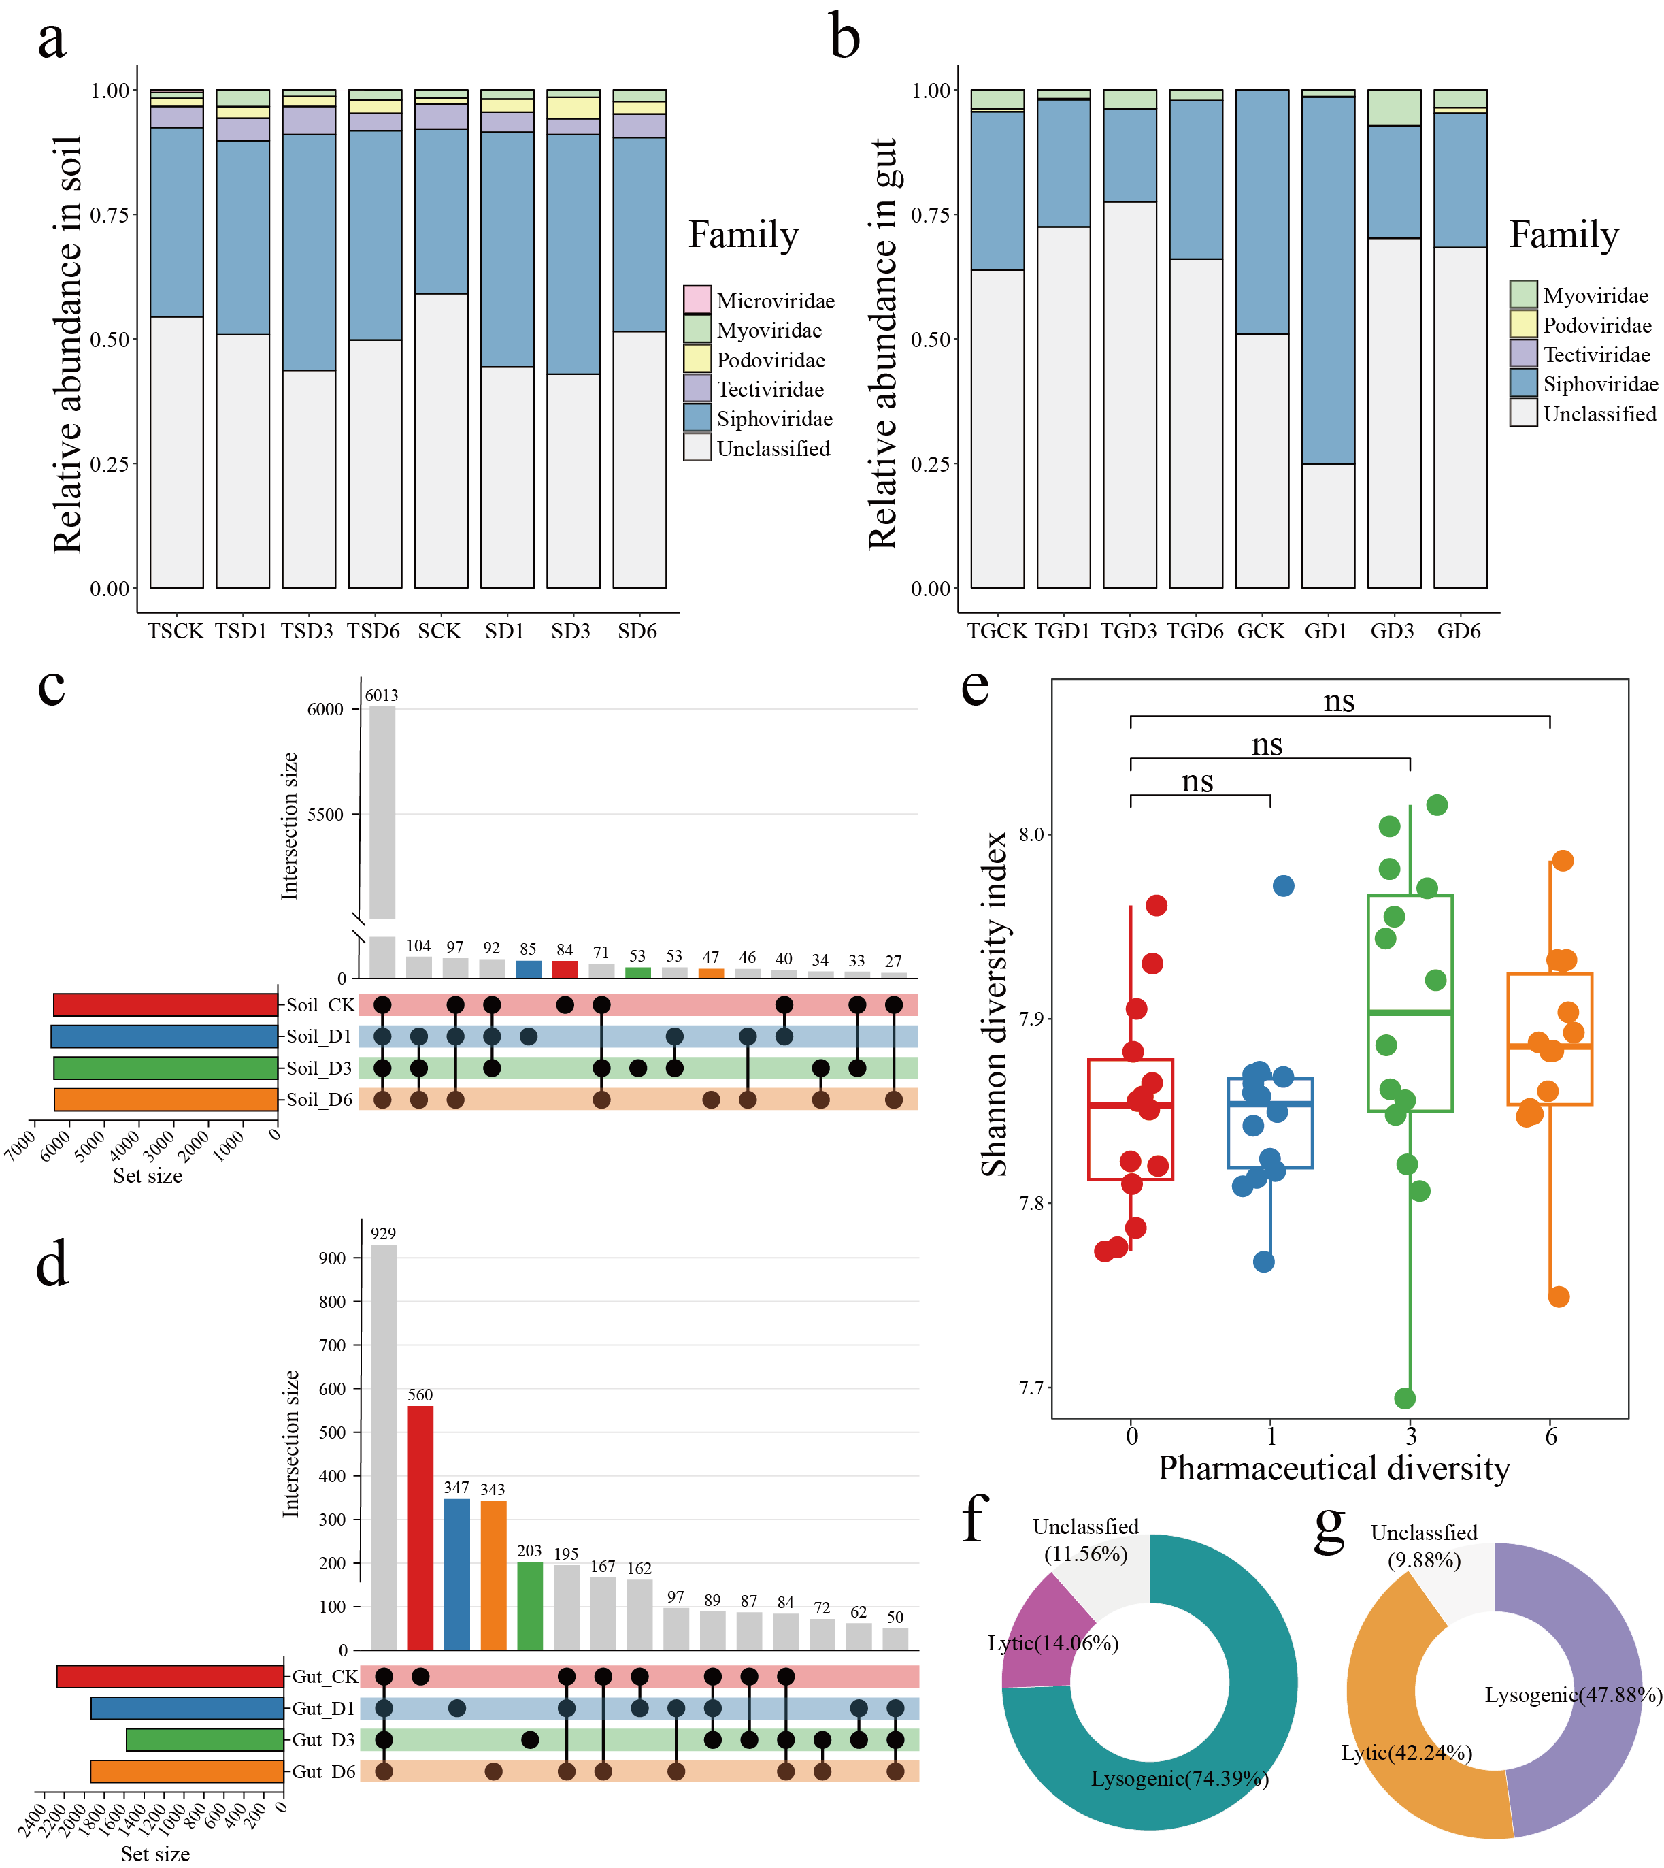
Supplementary Fig. 1 Composition of viral communities in soil and the collembolan gut. a, b, Taxonomic composition of viral communities at the family level in soil (a) and the collembolan gut (b). T represents the warming treatment (23 ℃); S and G represent soil and collembolan gut samples, respectively; CK, D1, D3, and D6 correspond to pharmaceutical diversity levels of 0, 1, 3, and 6 compounds. c, d, Shared vOTUs under increasing pharmaceutical diversity in soil (c) and the collembolan gut (d). e, Alpha diversity (Shannon) of soil viral communities with increasing pharmaceutical diversity (t-test, ns = no significant difference). f, g, Proportions of phage lifestyles in soil (f) and collembolan gut communities (g).
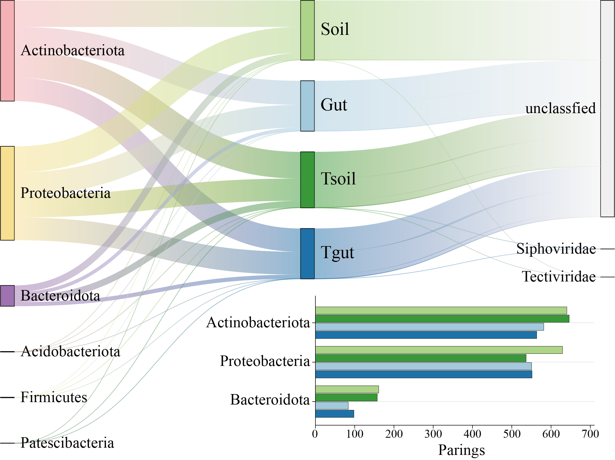
Supplementary Fig. 2 Predicted phage-host associations. Left: Taxonomic distribution of bacterial hosts at the phylum level. Middle: Number of phage–host pairs identified by experimental treatment. Right: Viral contigs matched with a host. Bottom bar plot shows the number of matches to specific bacterial phyla by treatment. Soil and Gut represent soil and collembolan gut samples under ambient conditions, Tsoil and Tgut represent the soil and collembolan gut samples under elevated temperature conditions, respectively.
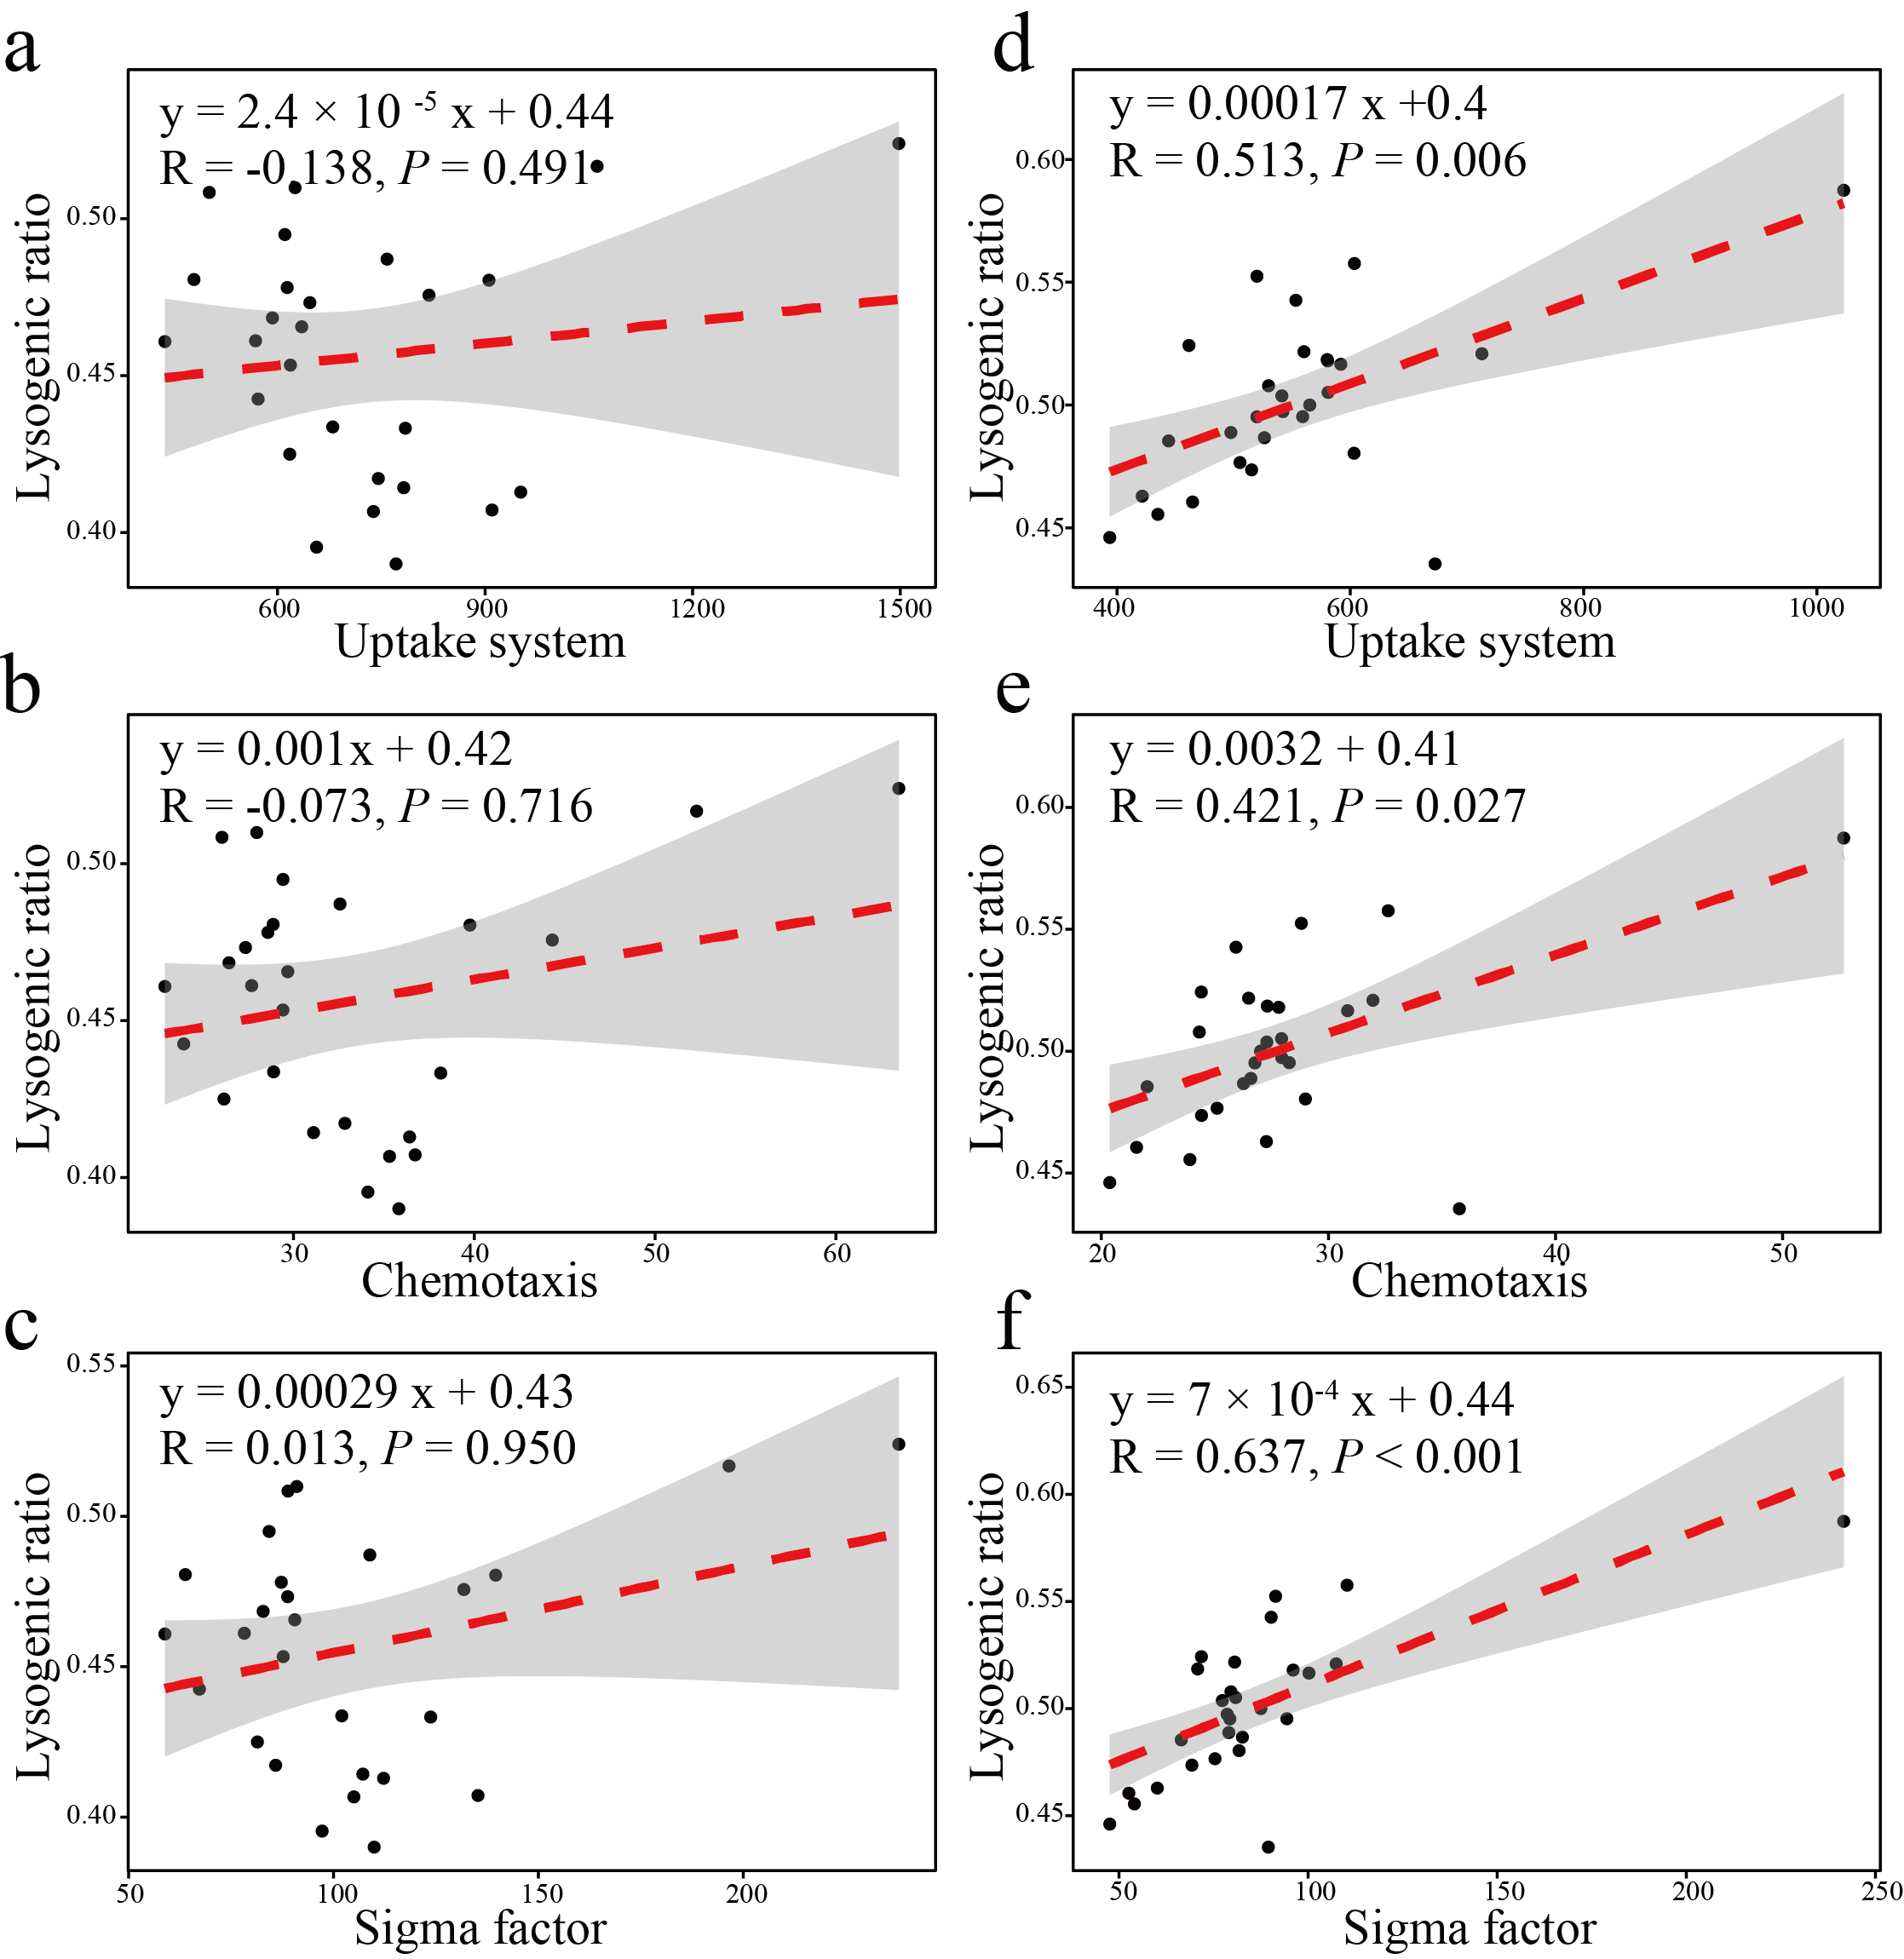
Supplementary Fig. 3 Correlations between bacterial life history strategies and the proportion of lysogenic phages. a–c, Correlation between uptake system (a), chemotaxis (b), and sigma factor (c) and the proportion of lysogenic phages at 20 ℃; and d–f, between uptake system (d), chemotaxis (e), and sigma factor (f) and the proportion of lysogenic phages at 23 ℃. Spearman’s rank correlation was used to determine associations.
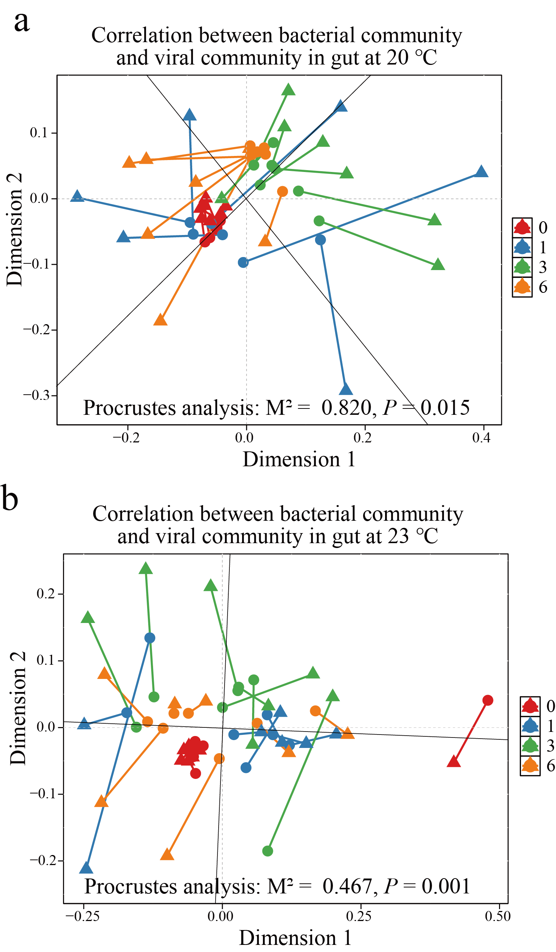
Supplementary Fig. 4 Correlations between gut bacterial and viral communities in collembola. a, b, Procrustes analysis of gut bacterial and viral communities at 20 ℃ (a) and 23 ℃ (b). Colours represent pharmaceutical diversity, red = control (0 pharmaceutical compounds), blue (1 compound), green (3 compounds) and orange (6 compounds).
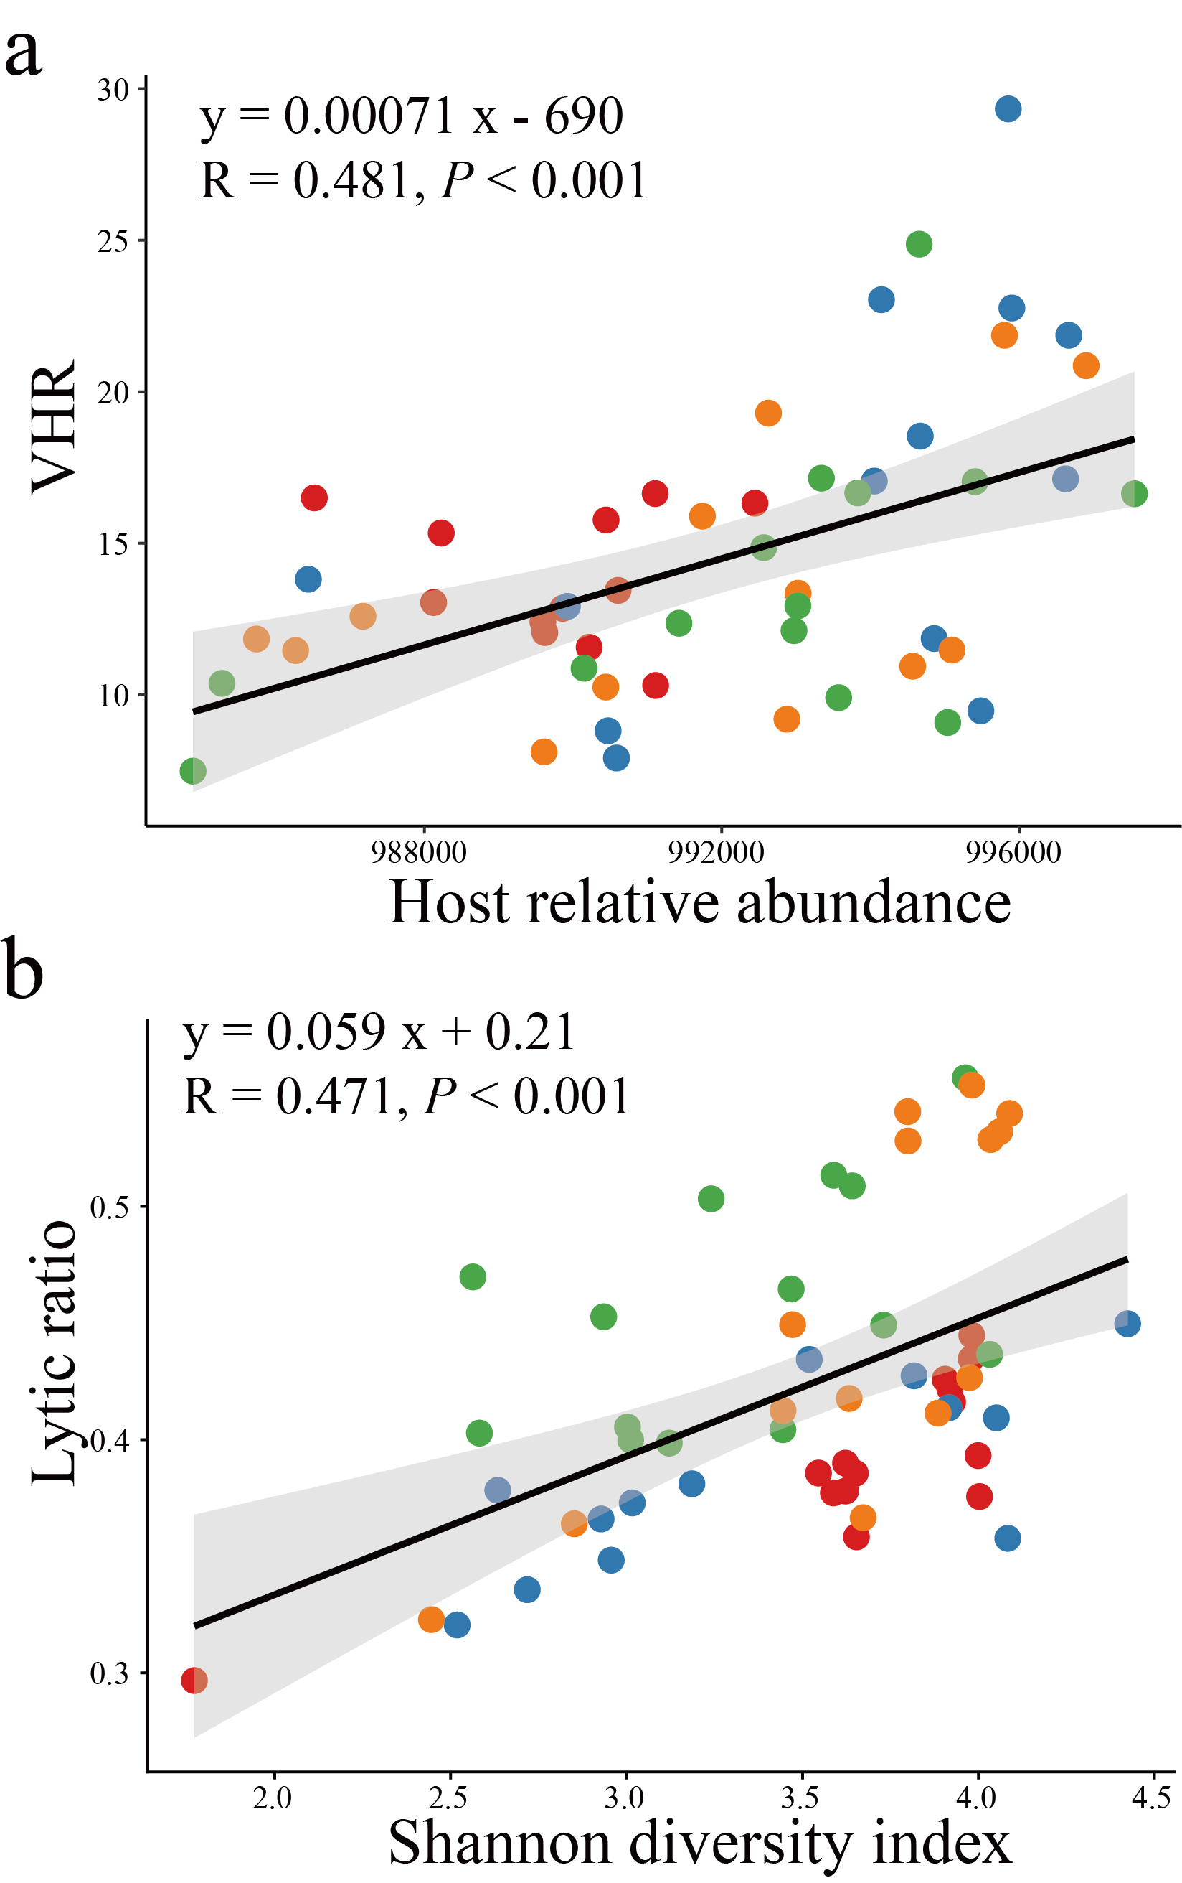
Supplementary Fig. 5 Correlation between phages and bacterial communities in the collembolan gut. a, Host relative abundance and the virus–to–host abundance ratio (VHR). b, Bacterial alpha diversity (Shannon) and the proportion of lytic phages. Spearman’s rank correlation was used to determine associations. Colours represent pharmaceutical diversity as presented in Supplementary Fig. 4.
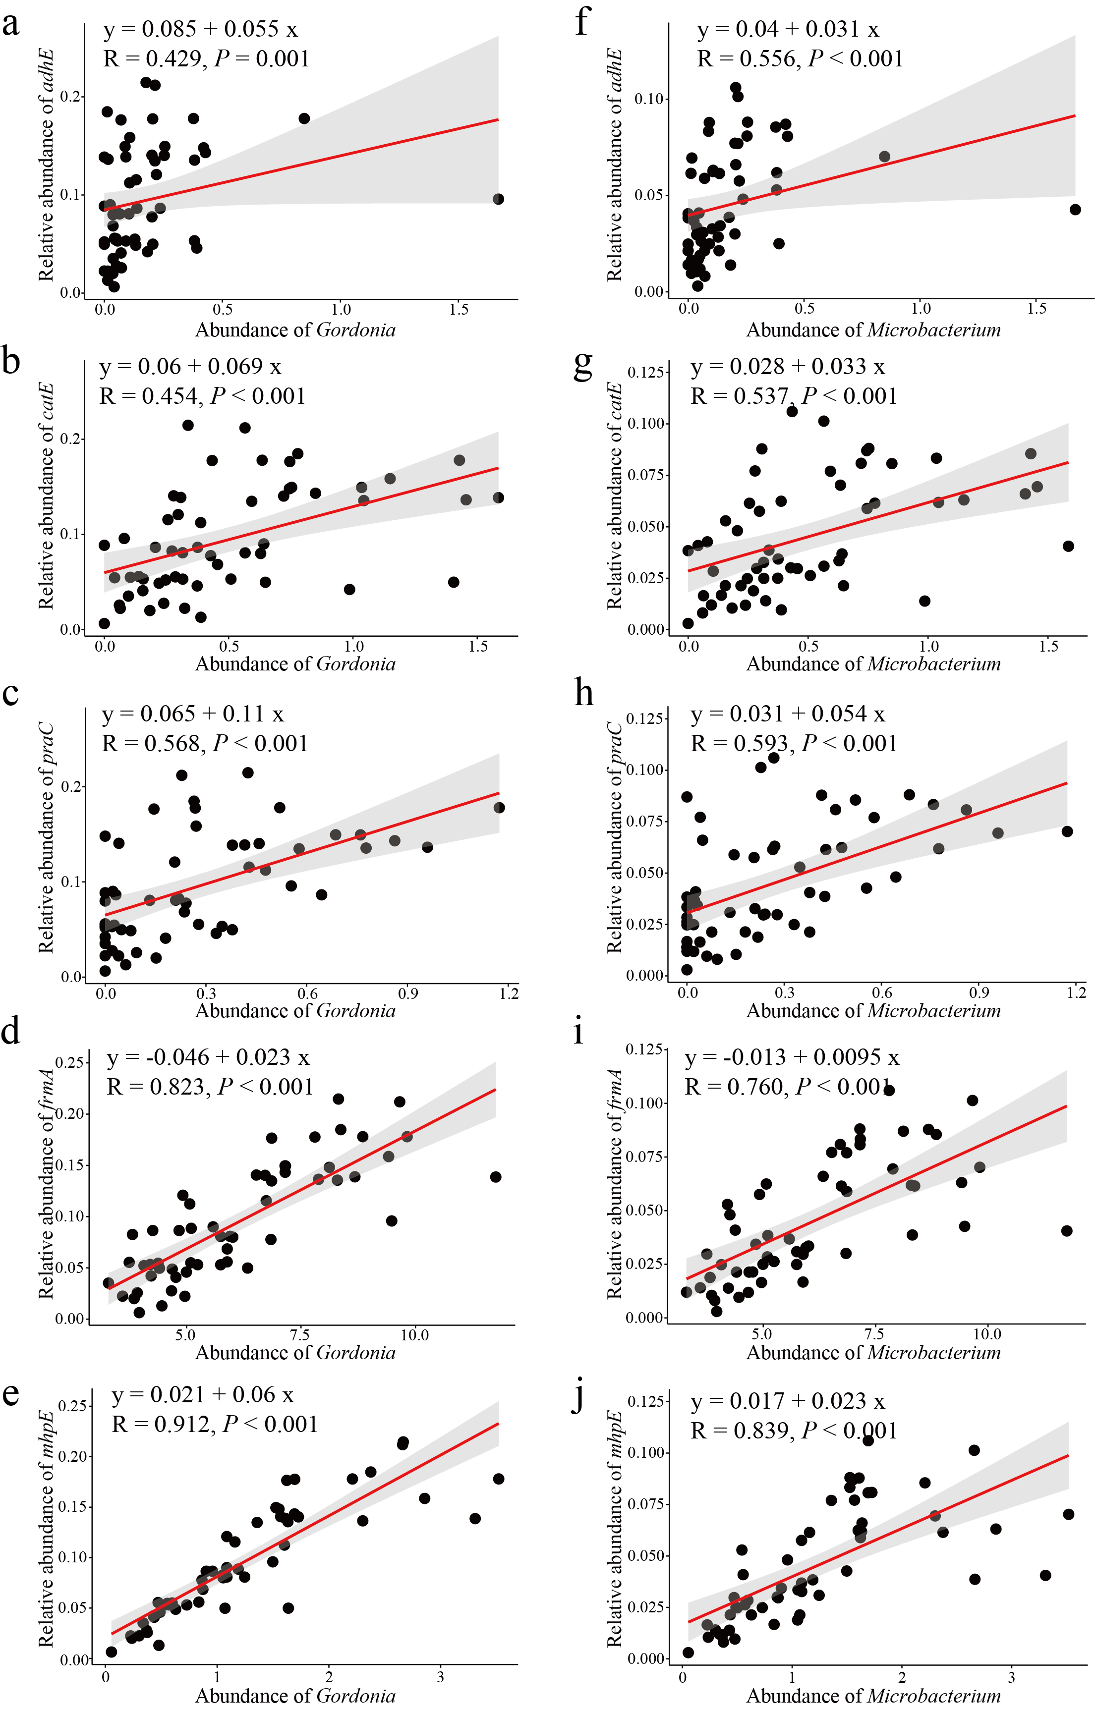
Supplementary Fig. 6 Correlations between relative abundance of KEGG genes and aromatic hydrocarbon degradation and dominant bacterial genera in the collembolan gut. a–e, Relative abundance of Gordonia and adhE (a), catE (b), praC (c), frmA (d), and mhpE (e) genes. f–j, Relative abundance of Microbacterium and adhE (f), catE (g), praC (h), frmA (i), and mhpE (j) genes. Spearman’s rank correlation was used to determine associations.
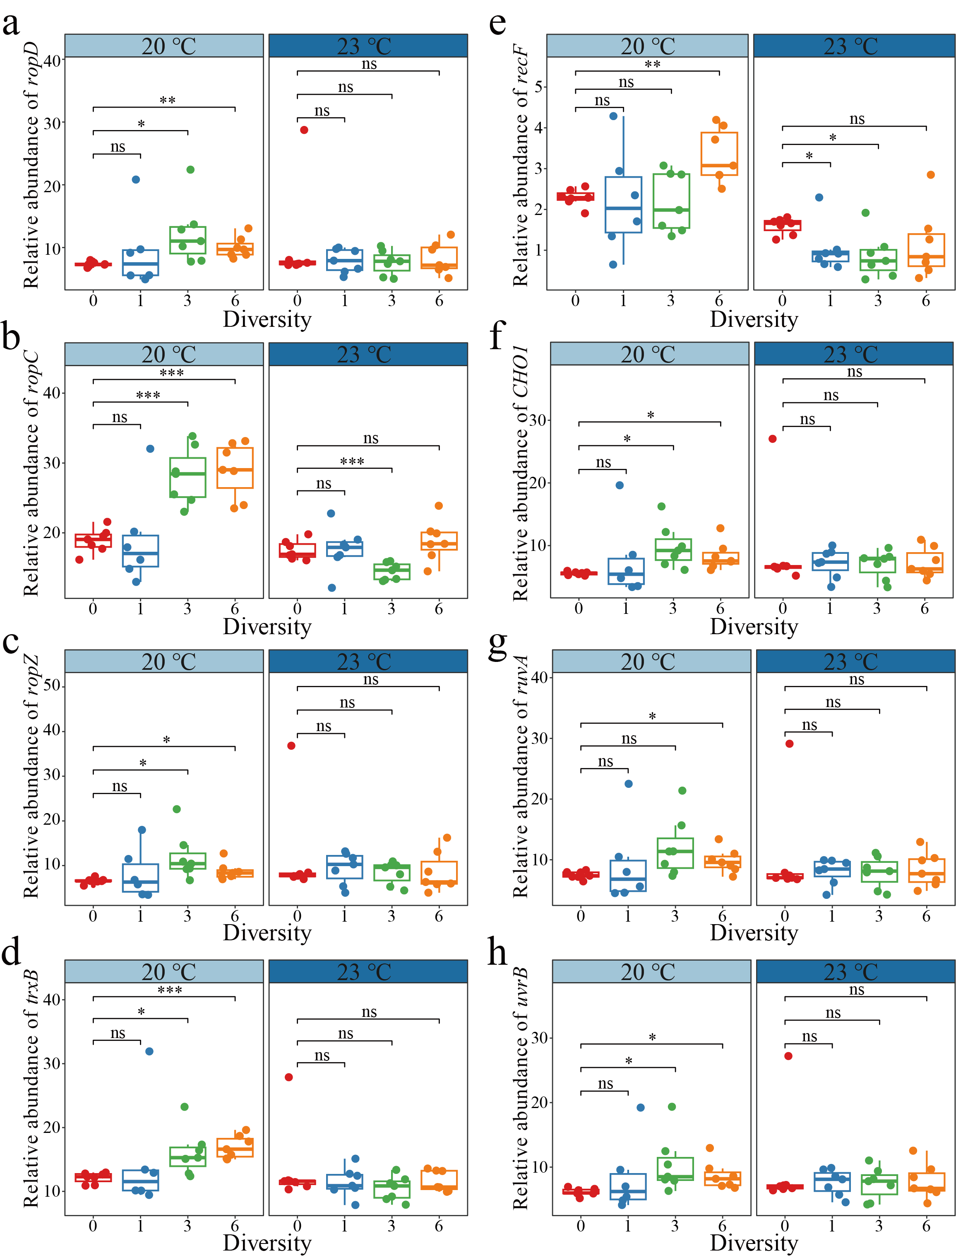
Supplementary Fig. 7 Changes in the relative abundance of ROS- and SOS-related KEGG genes with increasing pharmaceutical diversity levels under different temperatures. a–d, Relative abundance of ROS-related genes ropD (a), ropC (b), ropZ (c), and trxB (d) with increasing pharmaceutical diversity. e–h, Relative abundance of SOS-related genes recF (e), CHO1 (f), ruvA (g), uvrB (h) with increasing pharmaceutical diversity. Significance levels are indicated as follows: * P < 0.05, ** P < 0.01, *** P < 0.001, ns = not significant.
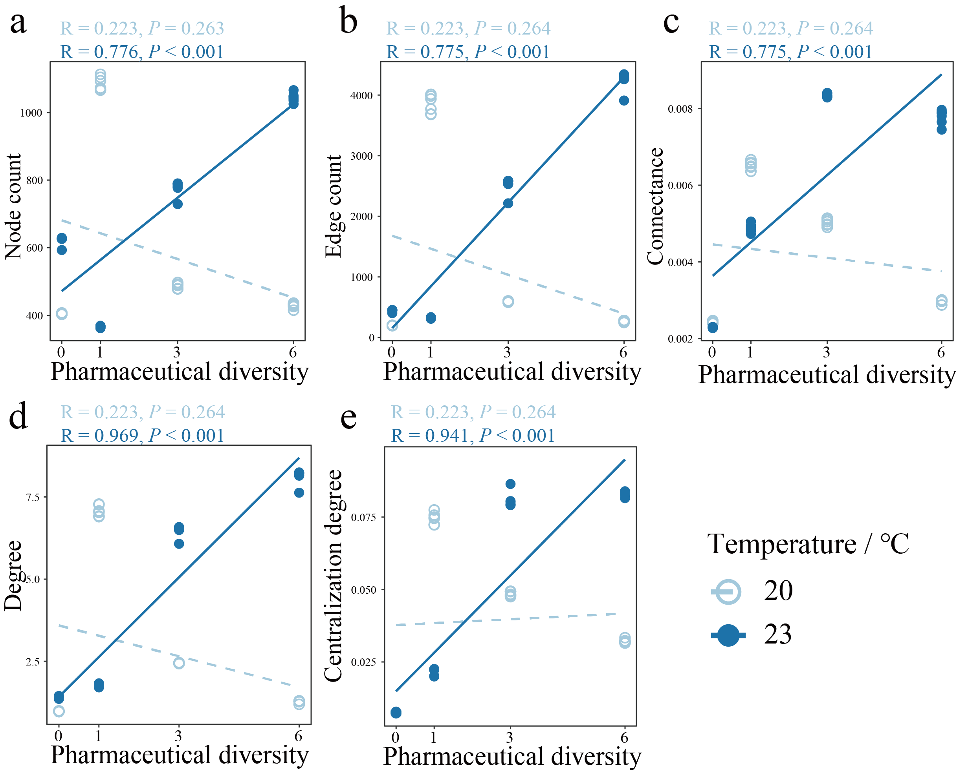
Supplementary Fig. 8 Correlations between network topological features and pharmaceutical diversity. At 20 ℃ and 23 ℃, linear regressions were performed between pharmaceutical diversity and core network features, including node count (a), edge count (b), connectance (c), degree (d), and centralization degree (e). Linear regression models were performed separately for each temperature treatment (20 ℃ and 23 ℃) to assess the relationship between pharmaceutical diversity and network topological features. The R² and P for each model were calculated to evaluate the strength and significance of the associations.
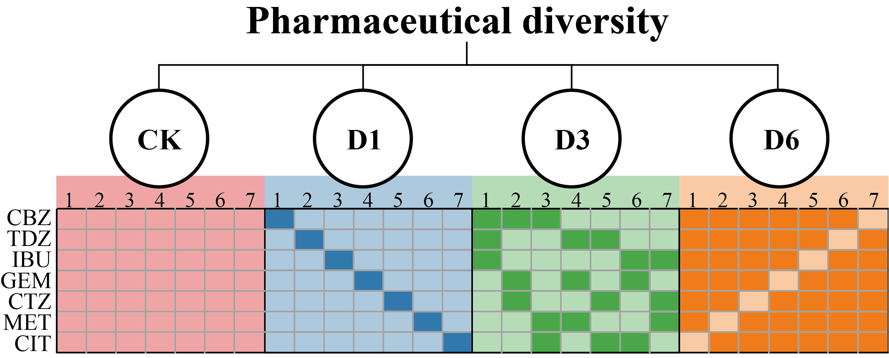
Supplementary Fig. 9 Experimental design. CK, D1, D3, and D6 represent treatments with increasing pharmaceutical diversity levels of 0, 1, 3, and 6 pharmaceutical compounds, respectively. Darker colours indicate the presence of a given pharmaceutical. The seven commonly prescribed pharmaceuticals for human use in this study are: CBZ (Carbamazepine), TDZ (Thioridazine), IBU (Ibuprofen), GEM (Gemfibrozil), CTZ (Cetirizine), MET (Metformin), and CIT (Citalopram).

