Supplementary Figures
Toxic metals differentially affect bacterial and fungal seed endophytes in Arabidopsis arenosa

Agnieszka Domka^{1,2*}, Ayesha Aziz^{1,3}, Roman J. Jędrzejczyk¹, Oleksandra Kutinova^{1,3}, Weronika Kosowicz^{1,3}, Artur Pliszko⁵, Piotr Rozpądek¹, Rafał Ważny^{1*}

¹ Małopolska Centre of Biotechnology, Jagiellonian University in Kraków, Gronostajowa 7a, 30-387 Kraków, Poland
²W. Szafer Institute of Botany Polish Academy of Sciences, Lubicz 46, 31‑512 Krakow, Poland
³Doctoral School of Exact and Natural Sciences, Jagiellonian University in Kraków, Łojasiewicza 11, 30-387 Kraków, Poland
⁴Institute of Botany, Faculty of Biology, Jagiellonian University in Kraków, Gronostajowa 3, 30-387 Kraków, Poland
*Corresponding authors: a.domka@botany.pl rafal.wazny@uj.edu.pl

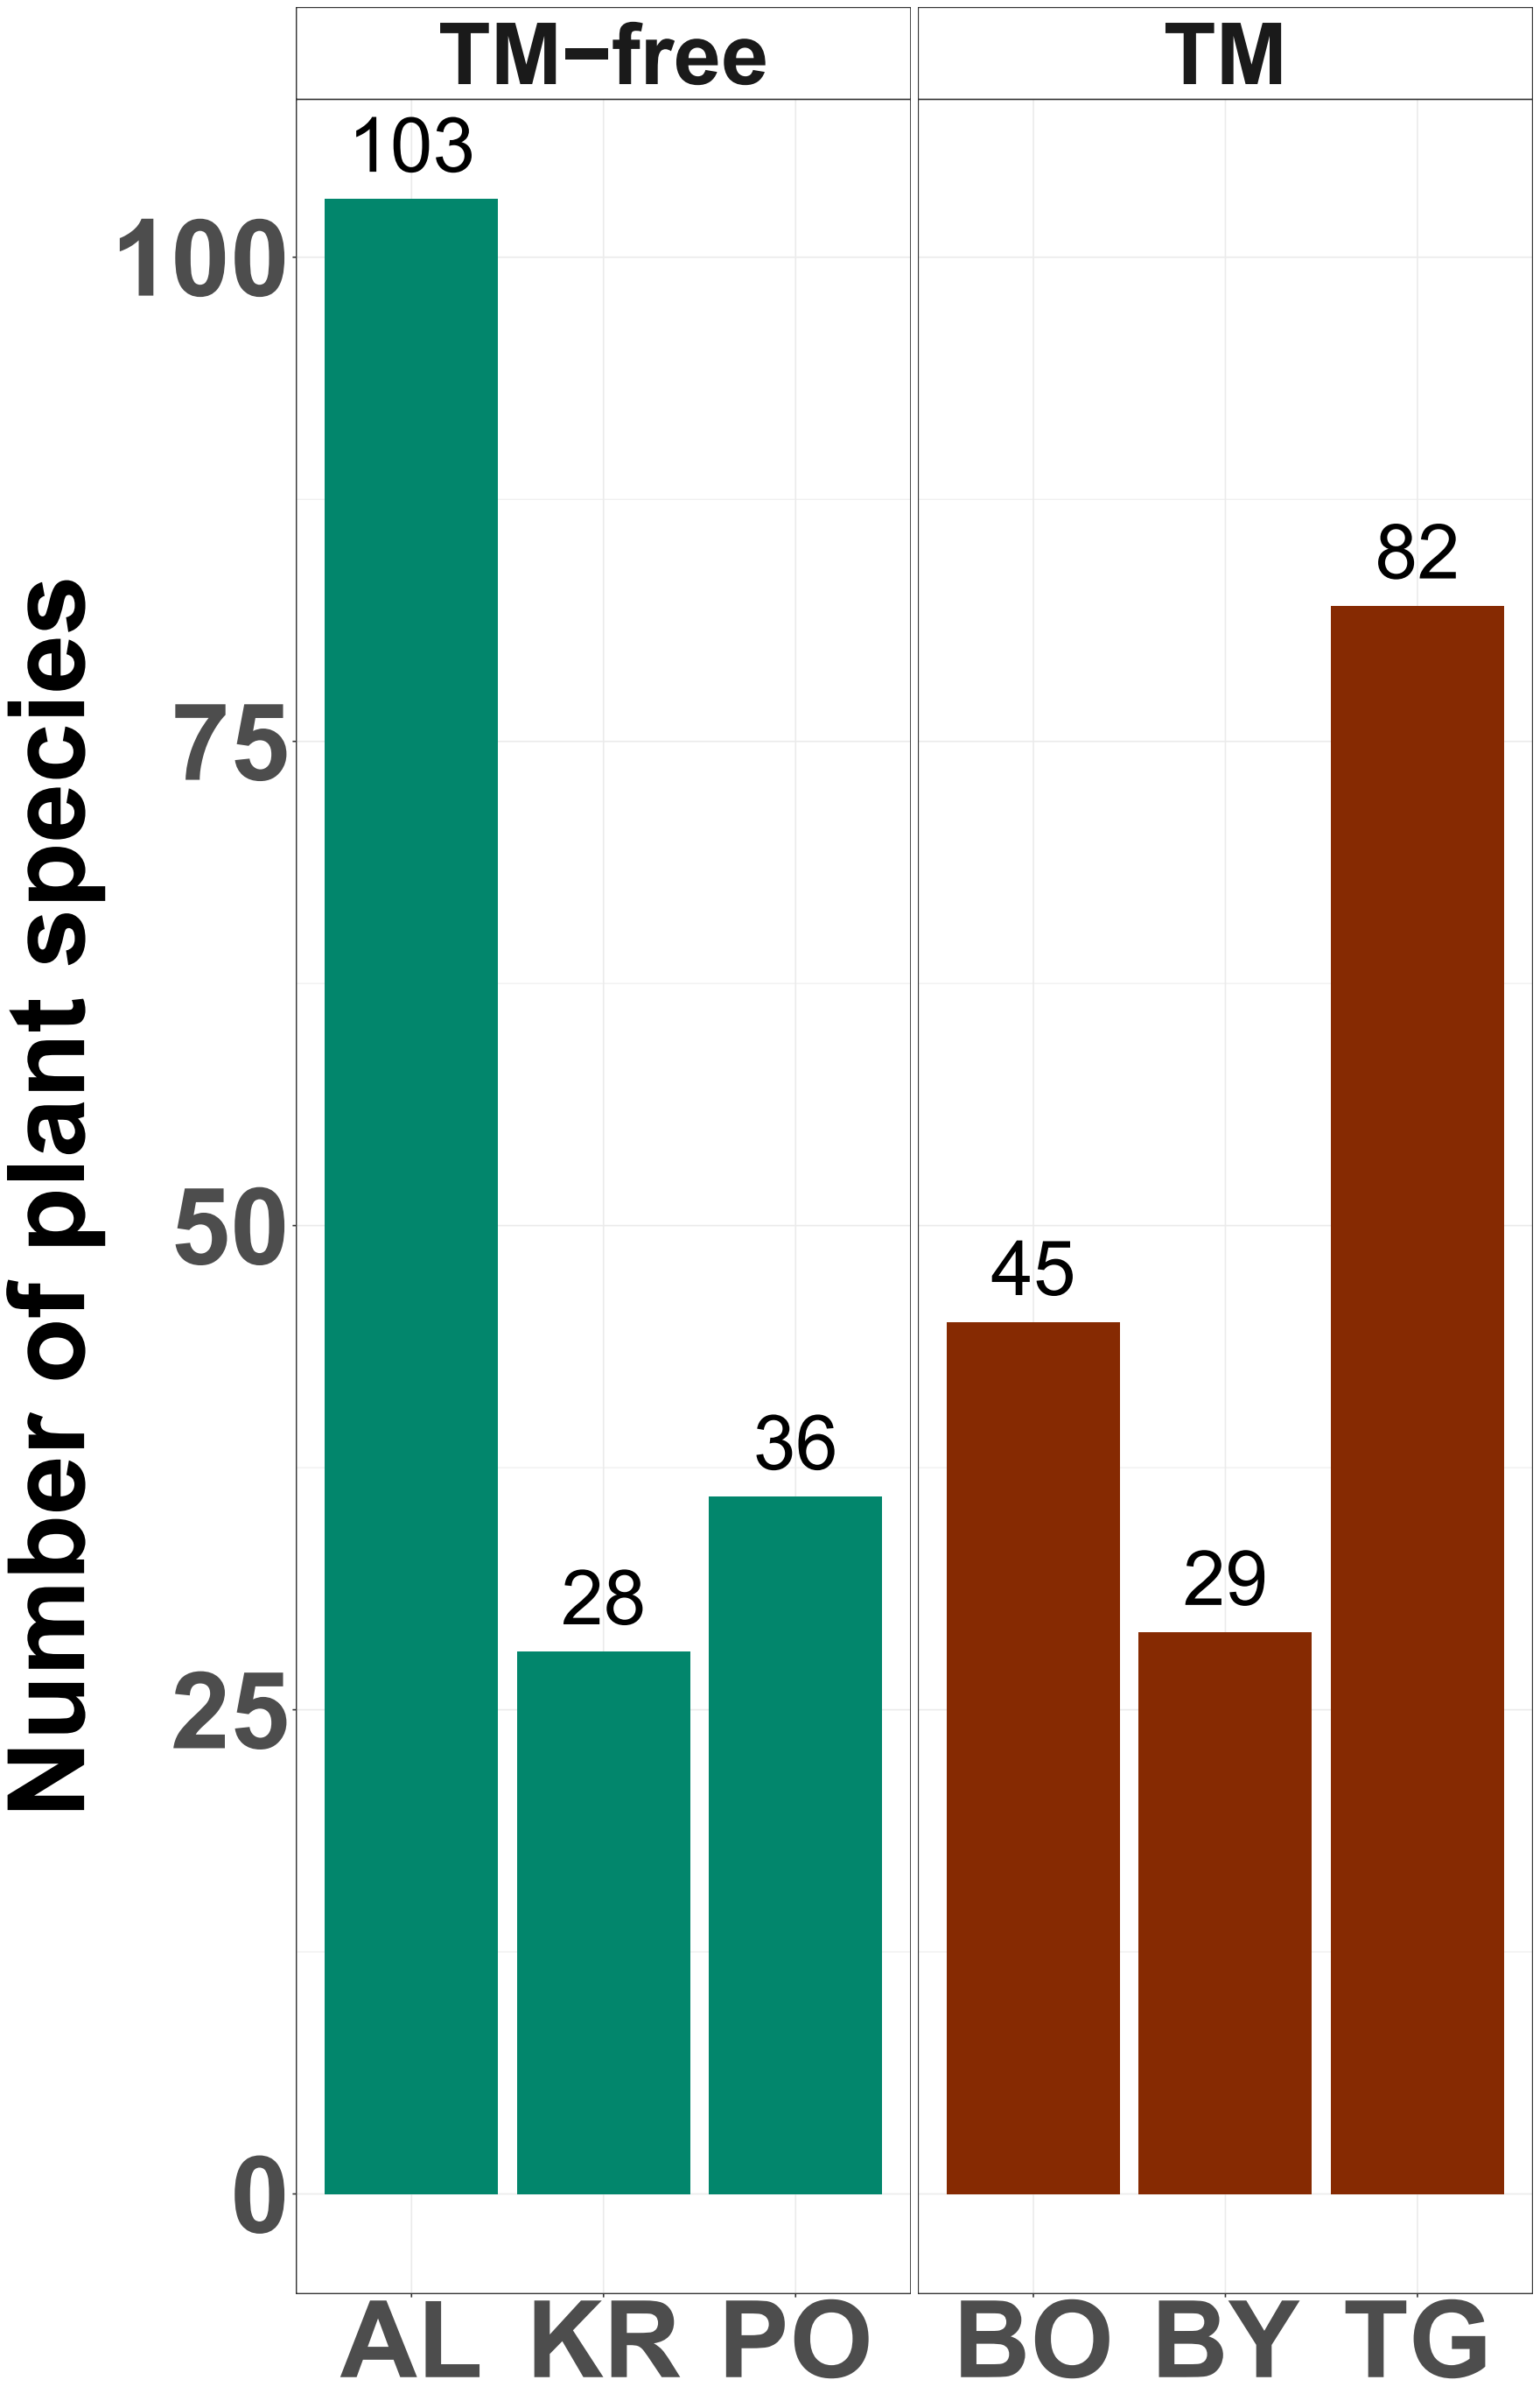
Figure S1. Number of vascular plant species accompanying Arabidopsis arenosa in the study sites
The total number of vascular plant species identified in the study sites is shown in Figure S1. Detailed list of species is shown in Supplementary Table S1.

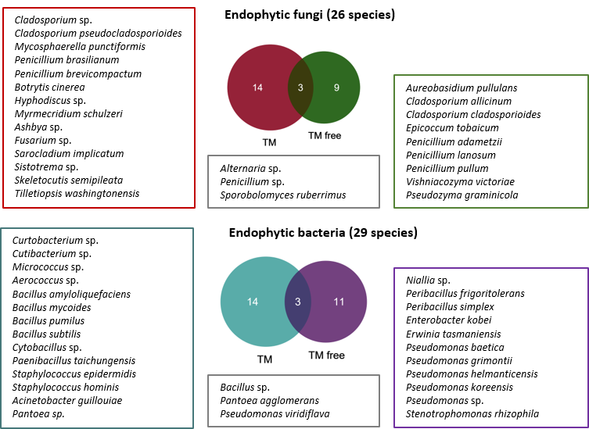
Figure S2. Shared and site-specific endophytes isolated from the seeds
Figure shows endophytic fungi and bacteria isolated from the seeds of Arabidopsis arenosa. Detailed molecular identification of all fungal and bacterial strains with NCBI database accession numbers is presented in Supplementary Tables S2 and S3, respectively.

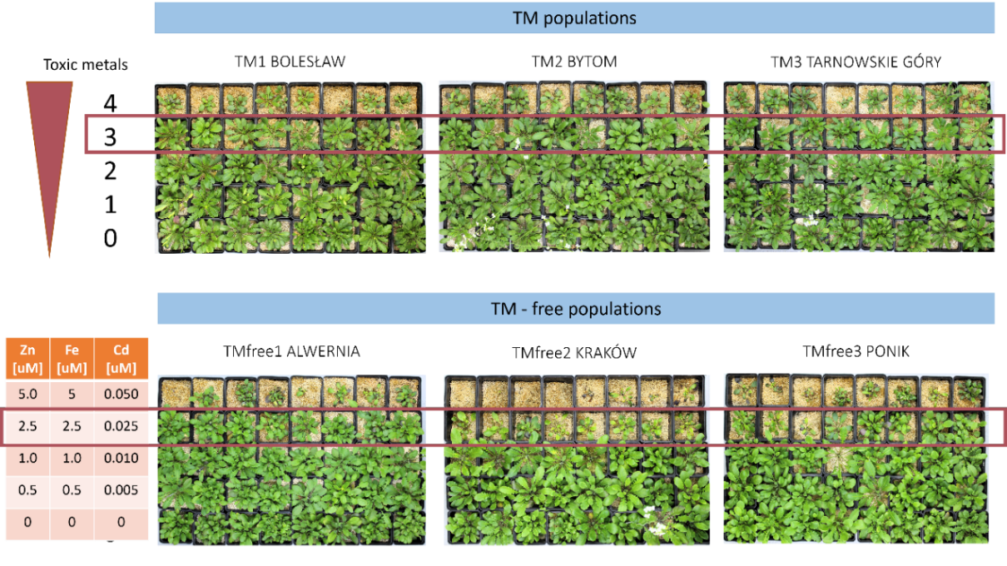
A

B
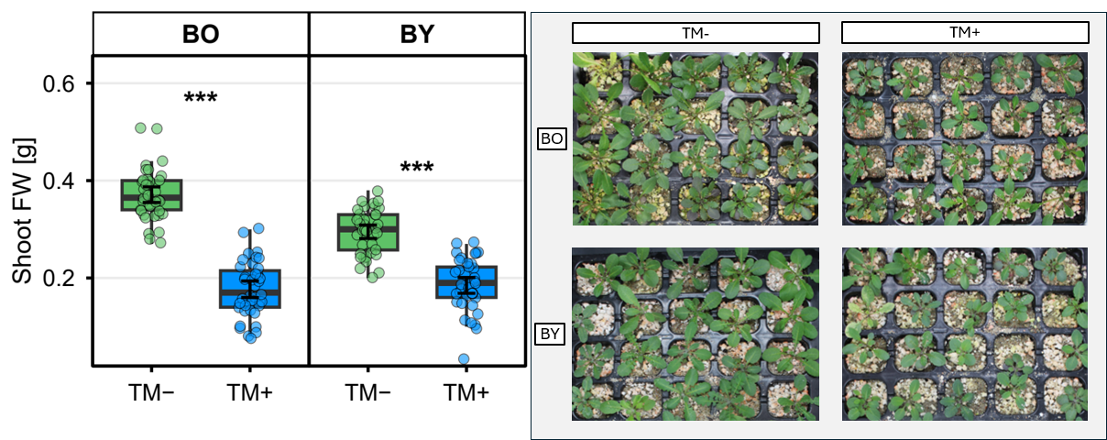
Figure S3. Optimization of toxic metal concentrations in pot experiments
(A) Four different doses of 3 toxic metals (Zn, Fe, Cd) were tested. The ratio between metals was similar to their ratio presented in mine site Boleslaw (ref). Dose number 3 was selected because it limited plant growth on one hand, but on the other hand, allowed the plants to survive; (B) shoot biomass and representative photographs of plants from the BO and BY populations grown with toxic metals at dose 3 or under non-supplemented control conditions.
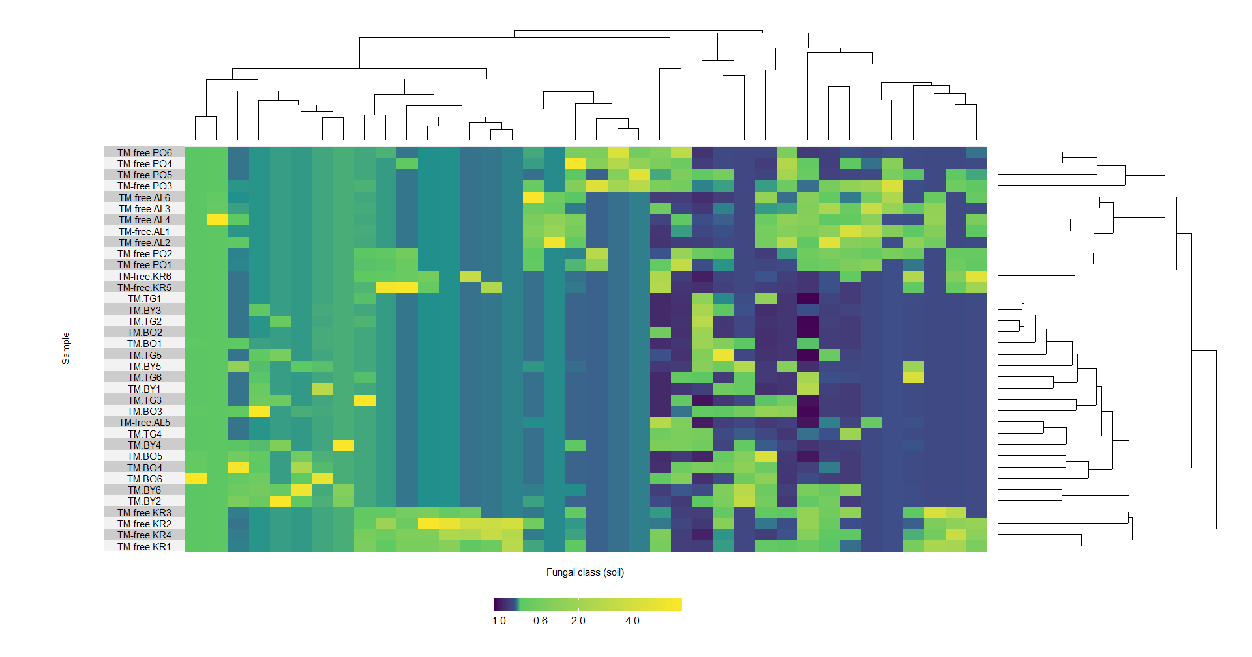
A

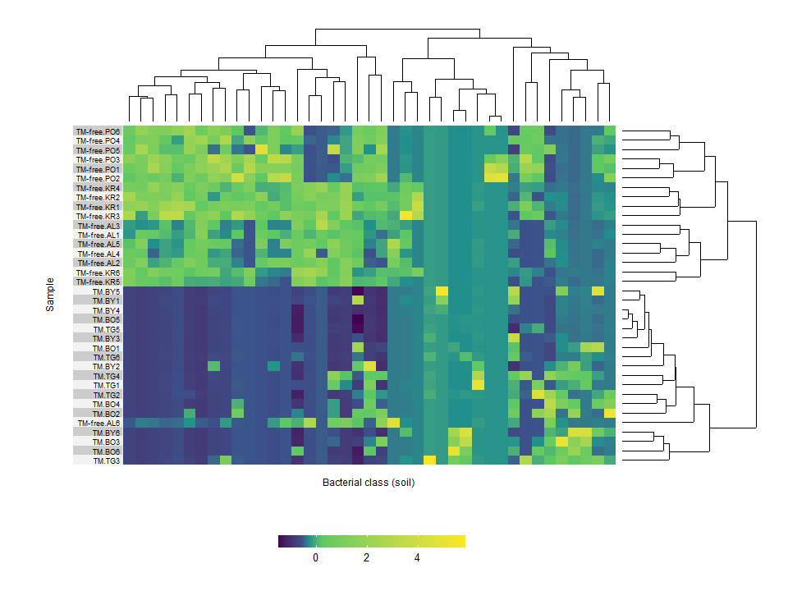
B

Figure S4. Heatmap illustrating the relative abundance of the fungal (A) and bacterial (B) classes in the soil samples with dendrograms calculated based on Manhattan distances between samples

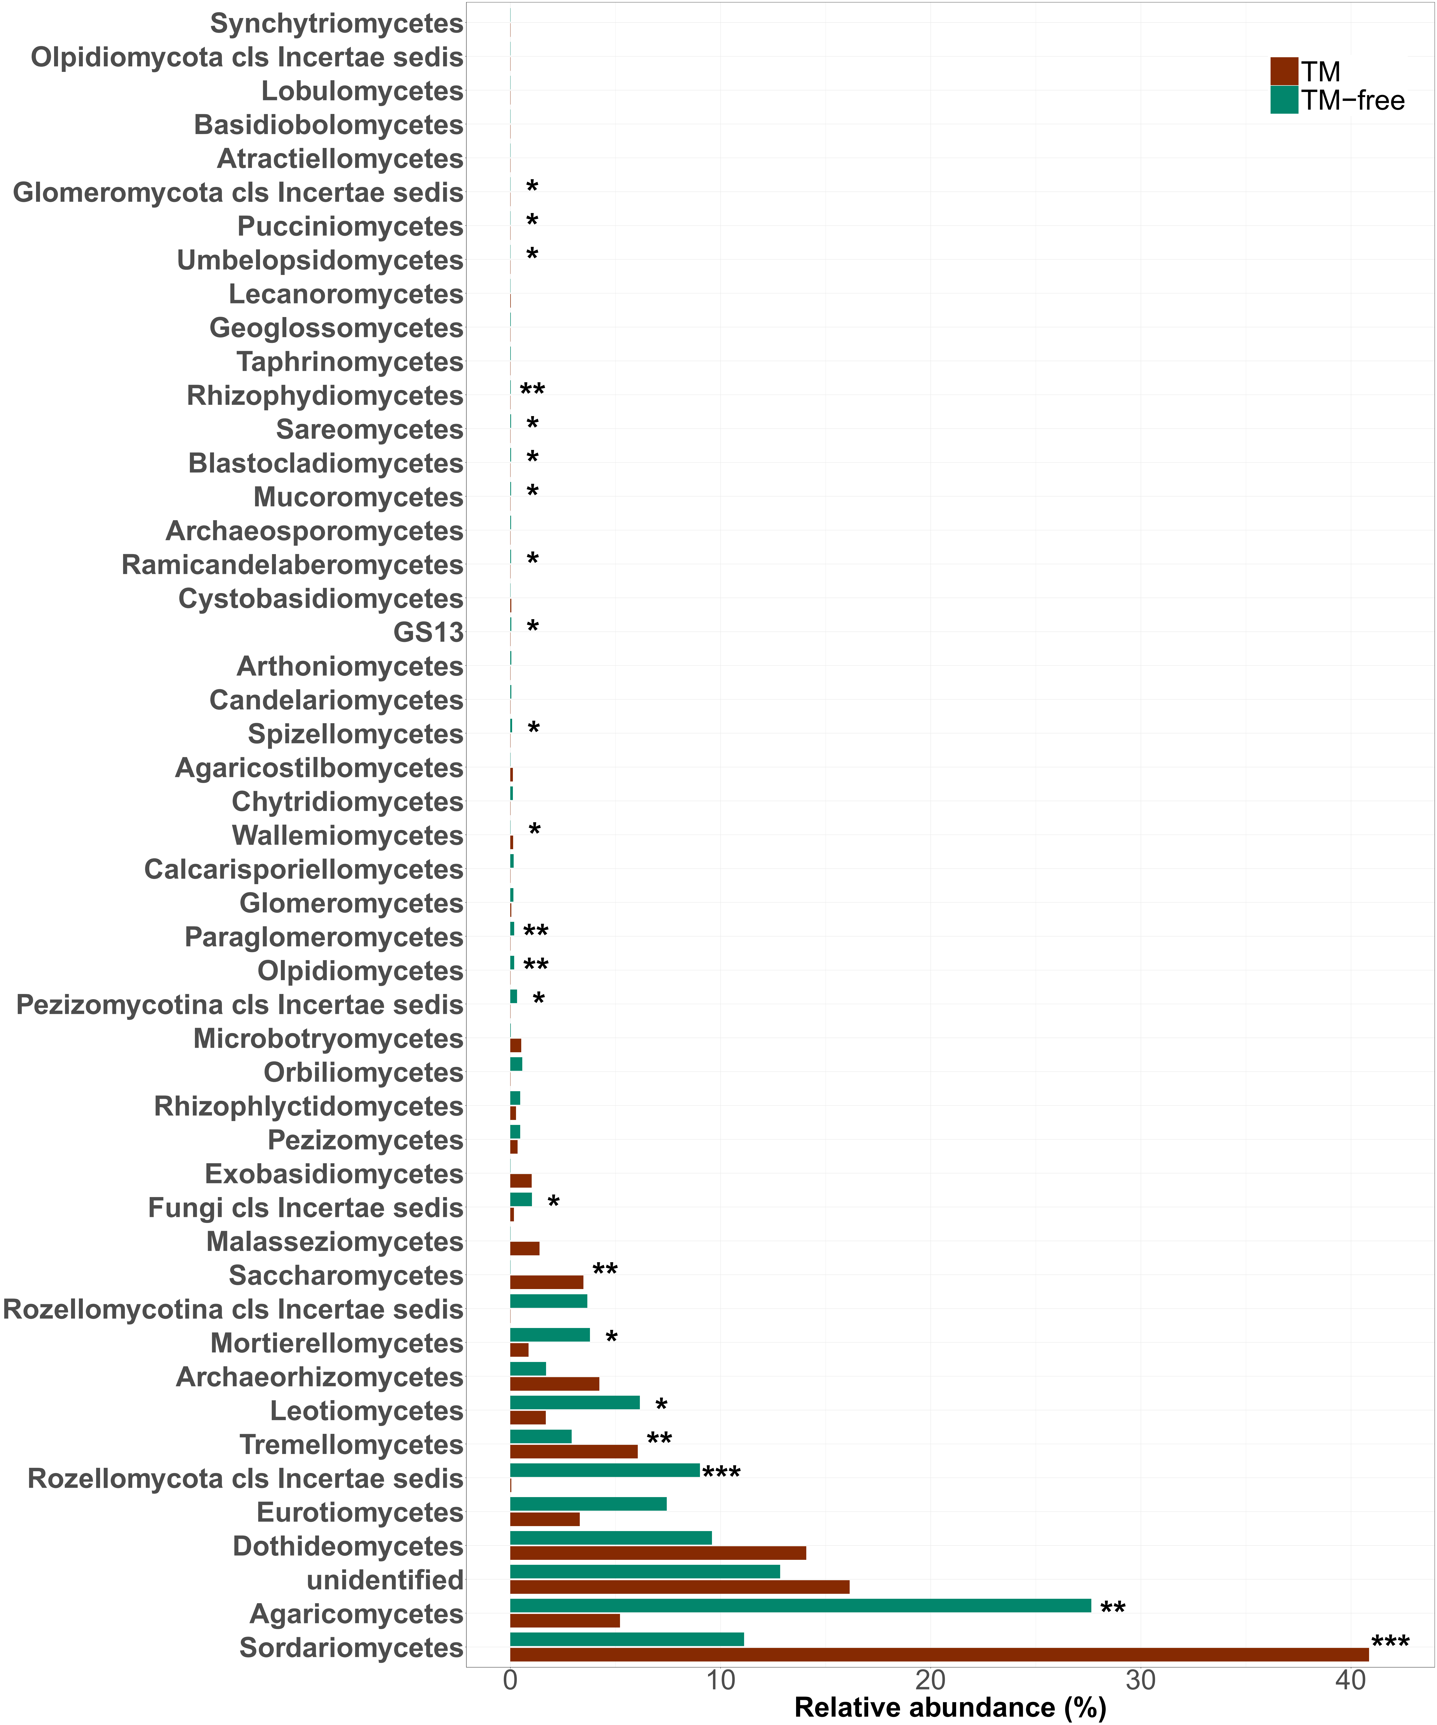

Figure S5. Relative abundance of fungal classes in the soil

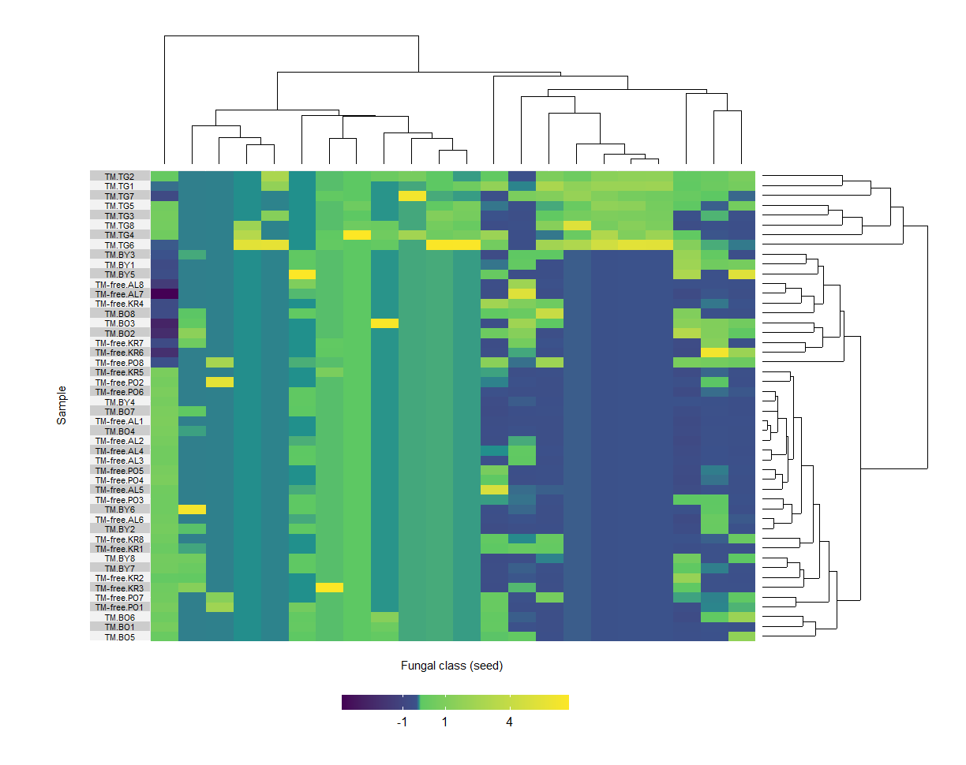
A

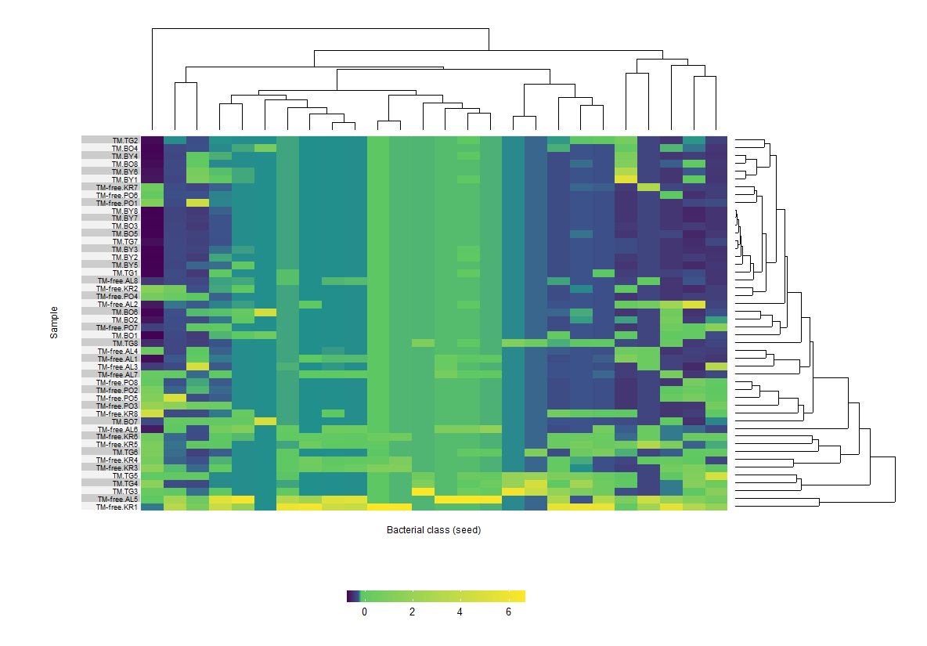
B

Figure S6. Heatmap illustrating the relative abundance of the fungal (A) and bacterial (B) classes in the seed samples with dendrograms calculated based on Manhattan distances between samples
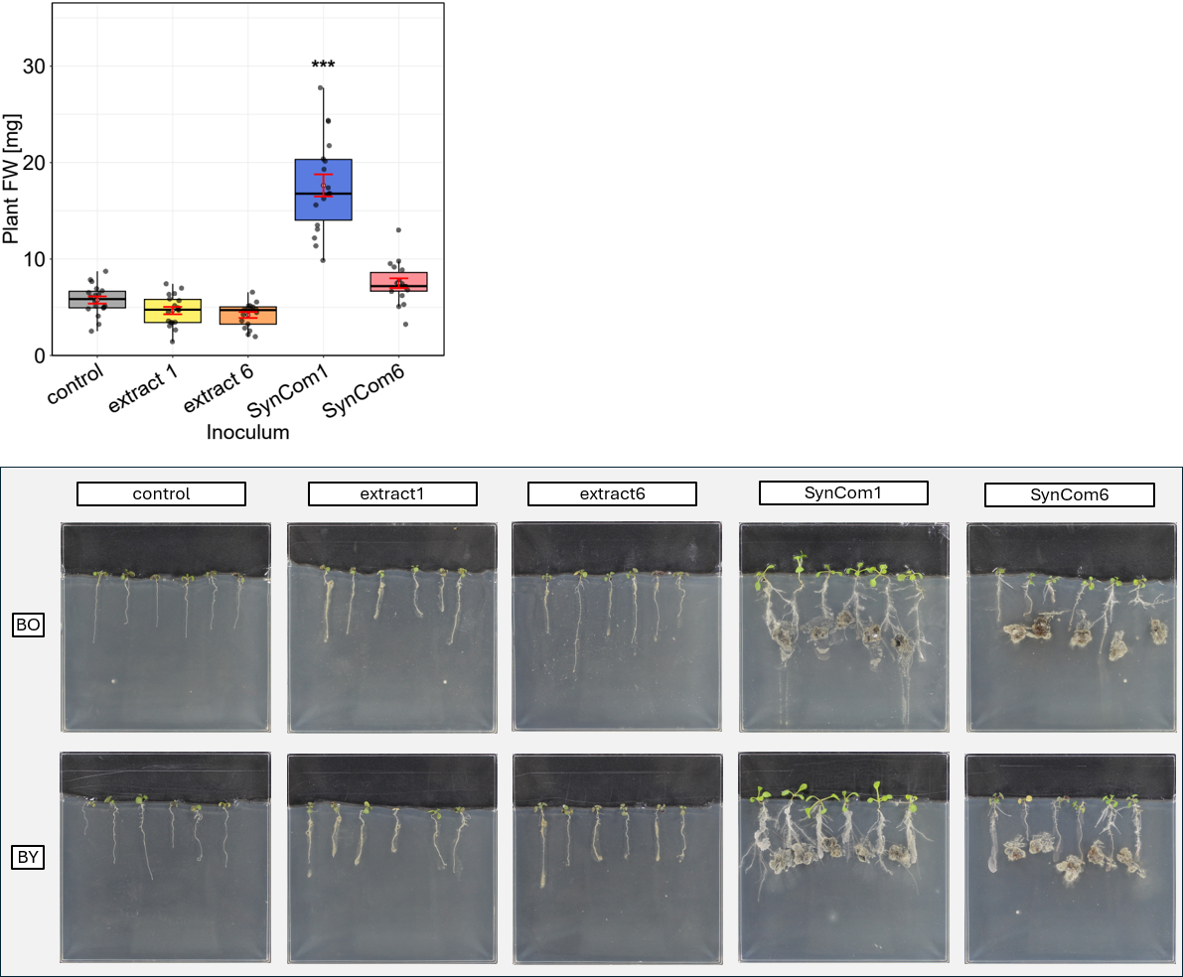

Figure S7 Fresh weight of A. arenosa plants from the BY population and representative photographs of plants from both populations grown in vitro on MSR medium supplemented with toxic metals (TMs; 0.5 µM Zn, 0.5 µM Fe, 0.005 µM Cd). Plants were inoculated with SynCom 1 or SynCom 6, composed of seed endophytes isolated from TM-free and TM-contaminated sites, respectively, or treated with extract 1 or extract 6, prepared from seeds collected from TM-free and TM-contaminated sites, respectively (N = 18). Boxplots represent the median and interquartile range with standard deviation indicated in red. Stars indicate statistically significant differences (Dunnett’s test, * - P≤0.05, ** - P≤0.01, *** - P≤0.001) between control and inoculated plants

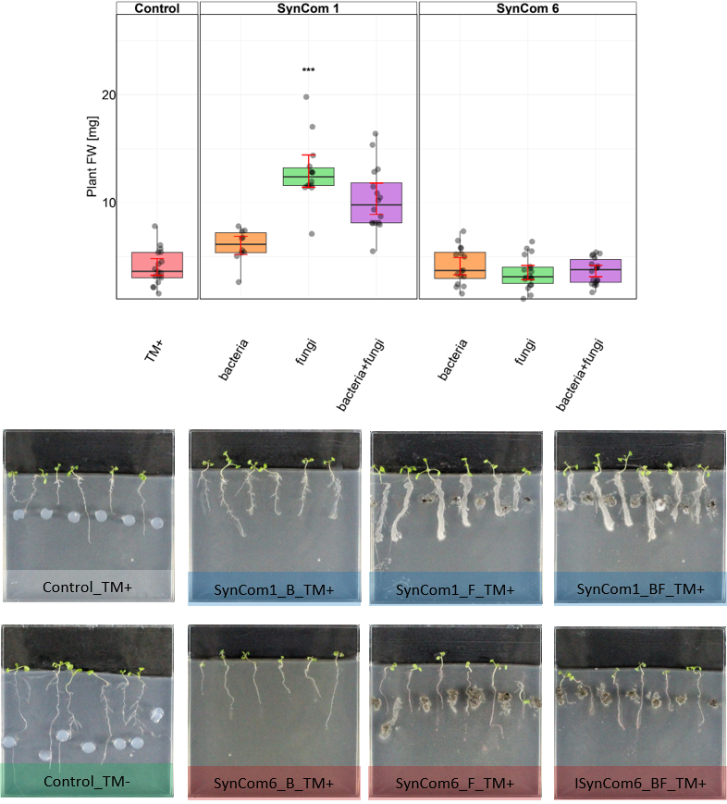
Figure S8. Photographic documentation and fresh weight of A. arenosa (BY population) inoculated with SynCom 1 (seed endophytes isolated from TM free sites) and SynCom 6 (seed endophytes isolated from TM sites) cultured in vitro on MSR with TM supplementation (0.5 µM Zn, 0.5 µM Fe, 0.005 µM Cd) (N = 18). Boxplots represent the median and interquartile range with standard deviation indicated in red.

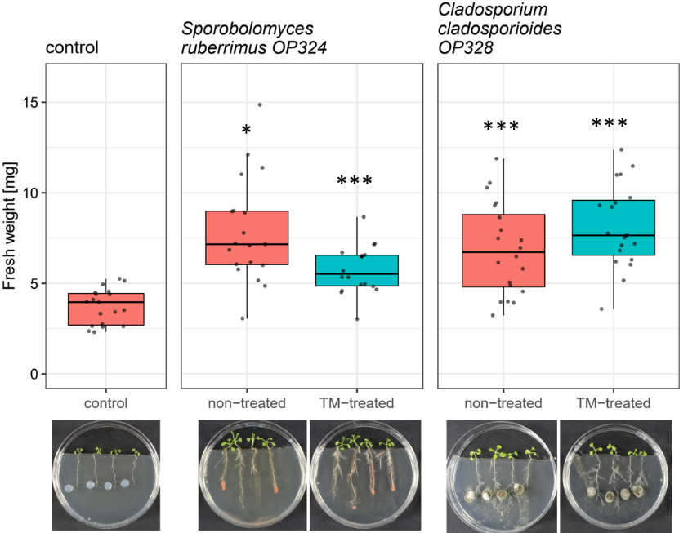
Figure S9. Plant fresh weight and photographic documentation of A. arenosa inoculated with Sporobolomyces ruberrimus (OR324) and Cladosporium cladosporioides (OR328) isolated from reference populations and treated and non-treated with TMs for 2 months before inoculation cultured in vitro on MSR with TM supplementation (0.5 µM Zn, 0.5 µM Fe, 0.005 µM Cd) (N = 12). Boxplots represent the median and interquartile range with standard deviation indicated in red. Stars indicate statistically significant differences (Dunnett’s test, * - P≤0.05, ** - P≤0.01, *** - P≤0.001) between control and inoculated plants

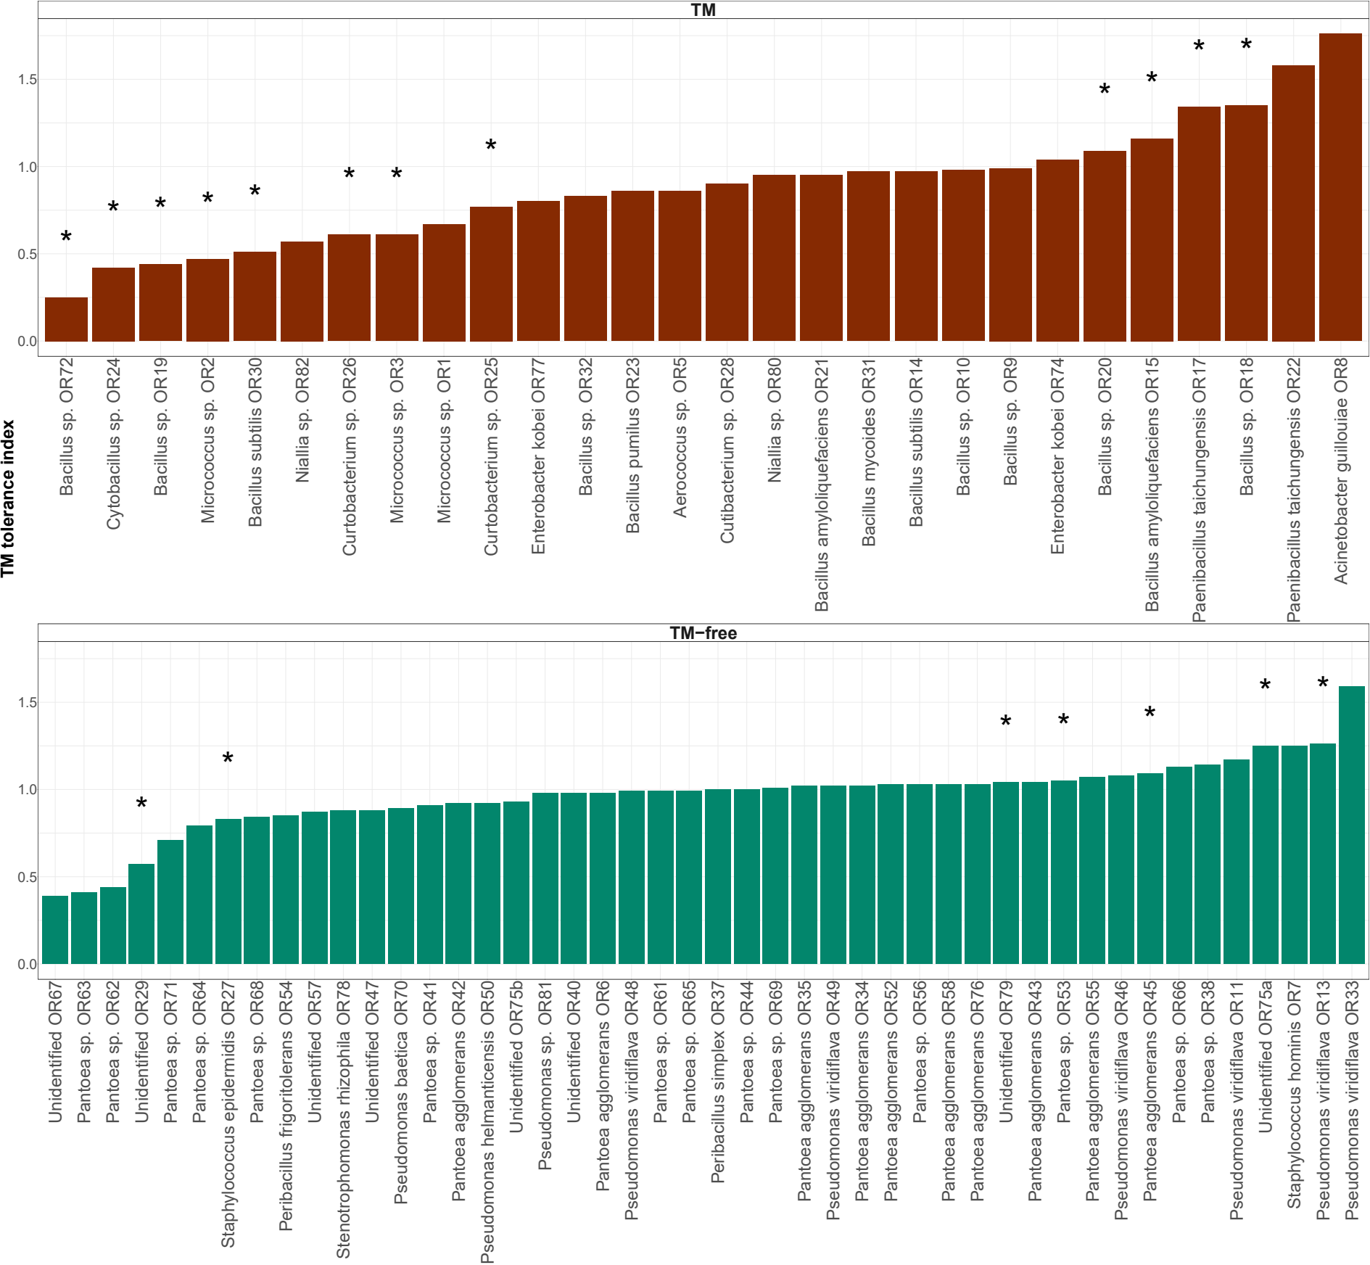
Figure S10. Toxic metal tolerance index of endophytic bacteria

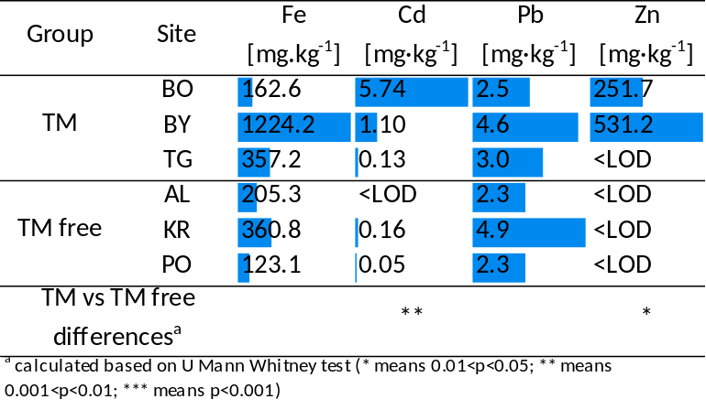
Figure S11. Metal concentration in the seeds

