Supplementary materials：
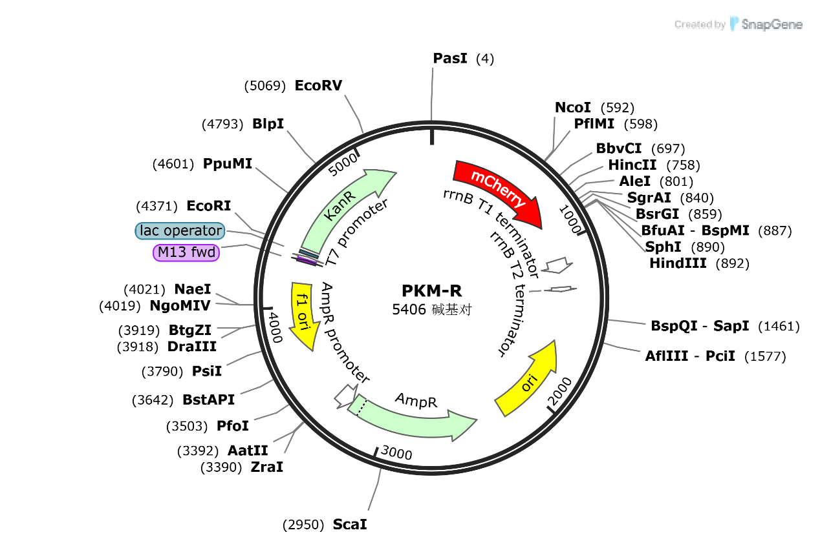
Supplementary Figure 1 PKEN-KanR-mCherry plasmid mapping
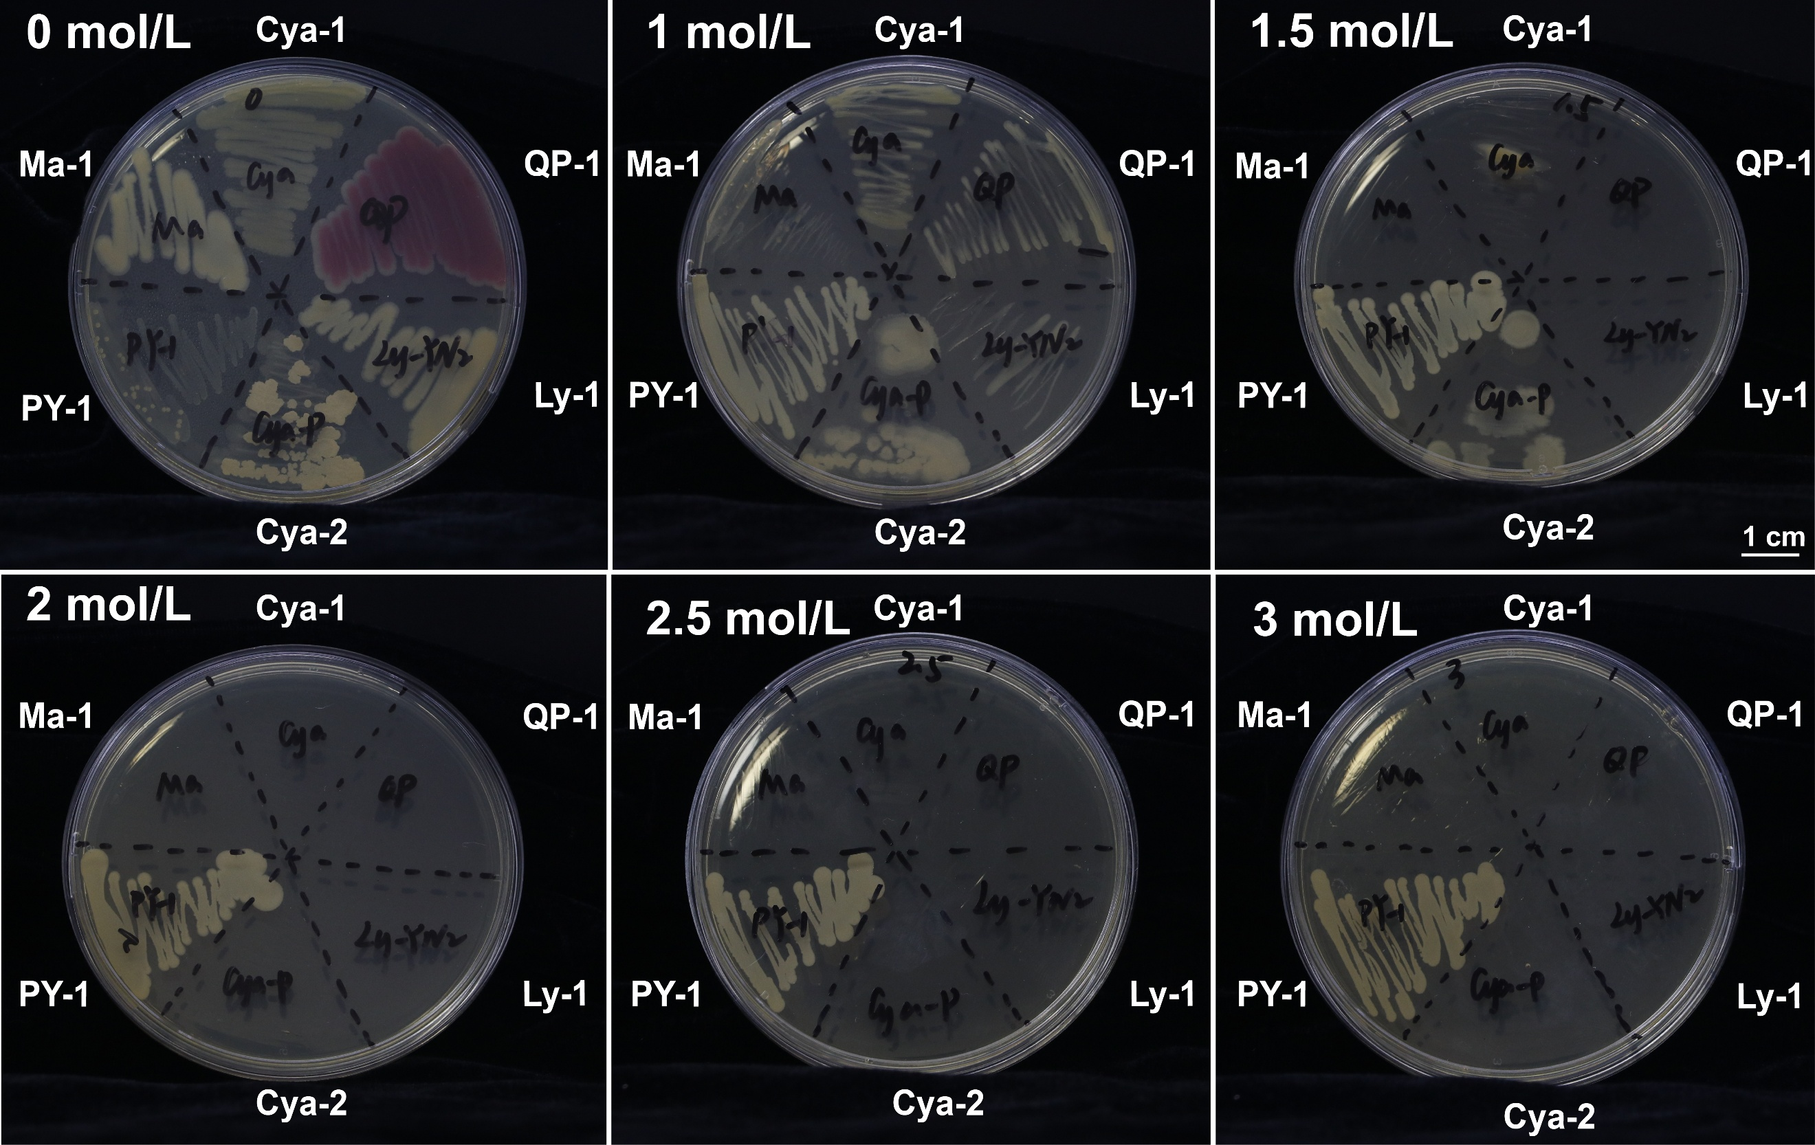
Supplementary Figure 2 Growth of strains on plates subjected to different salt stresses
Note: PY-1 Pseudomonas fulva; Ma-1 Raoultella terrigena; Cya-1 Kosakonia cowanii; Cya-2 Bacillus stercoris; QP-1 Serratia marcescens; Ly-1 Novosphingobium capsulatum.0, 1, 2, 3 indicate the additional NaCl concentrations in mol/L.
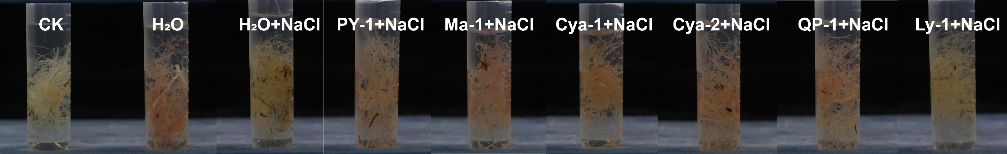
Supplementary Figure 3 Root vigor of each group under high salt 250 mmol/L NaCl stress
Note: The CK group is the control for assessing root vitality after root destruction.
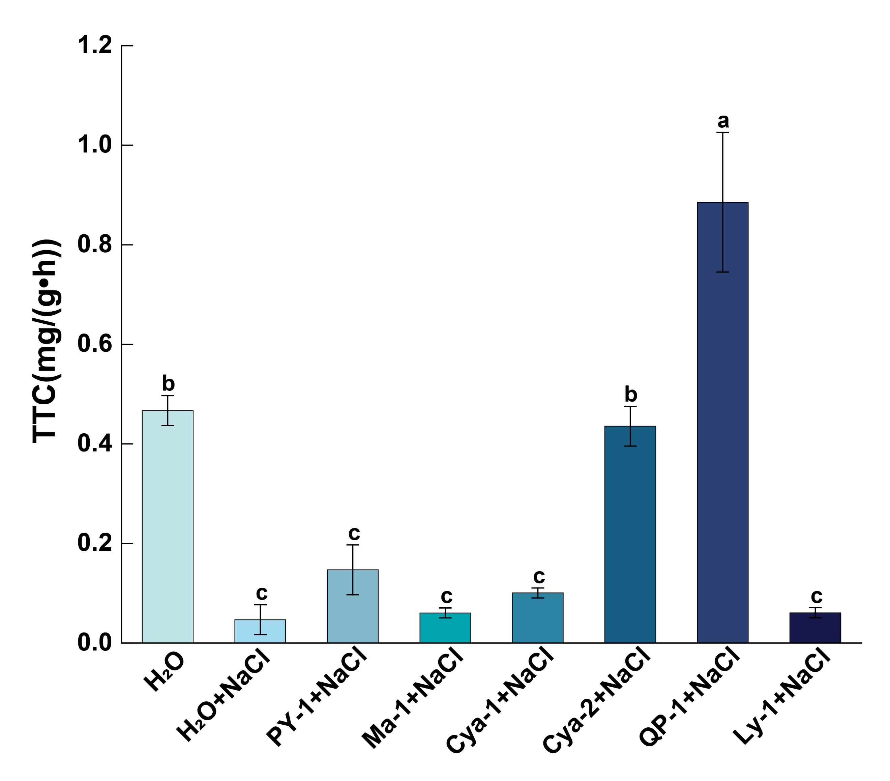
Supplementary Figure 4 Root vigor values of each group under high salt 250 mmol/L NaCl stress
Note: Salt stress was applied at 250 mmol/L NaCl. The H₂O group received water only; The H₂O+NaCl group received NaCl solution without bacterial inoculum. PY-1 Pseudomonas fulva; Ma-1 Raoultella terrigena; Cya-1 Kosakonia cowanii; Cya-2 Bacillus stercoris; QP-1 Serratia marcescens; Ly-1 Novosphingobium capsulatum.
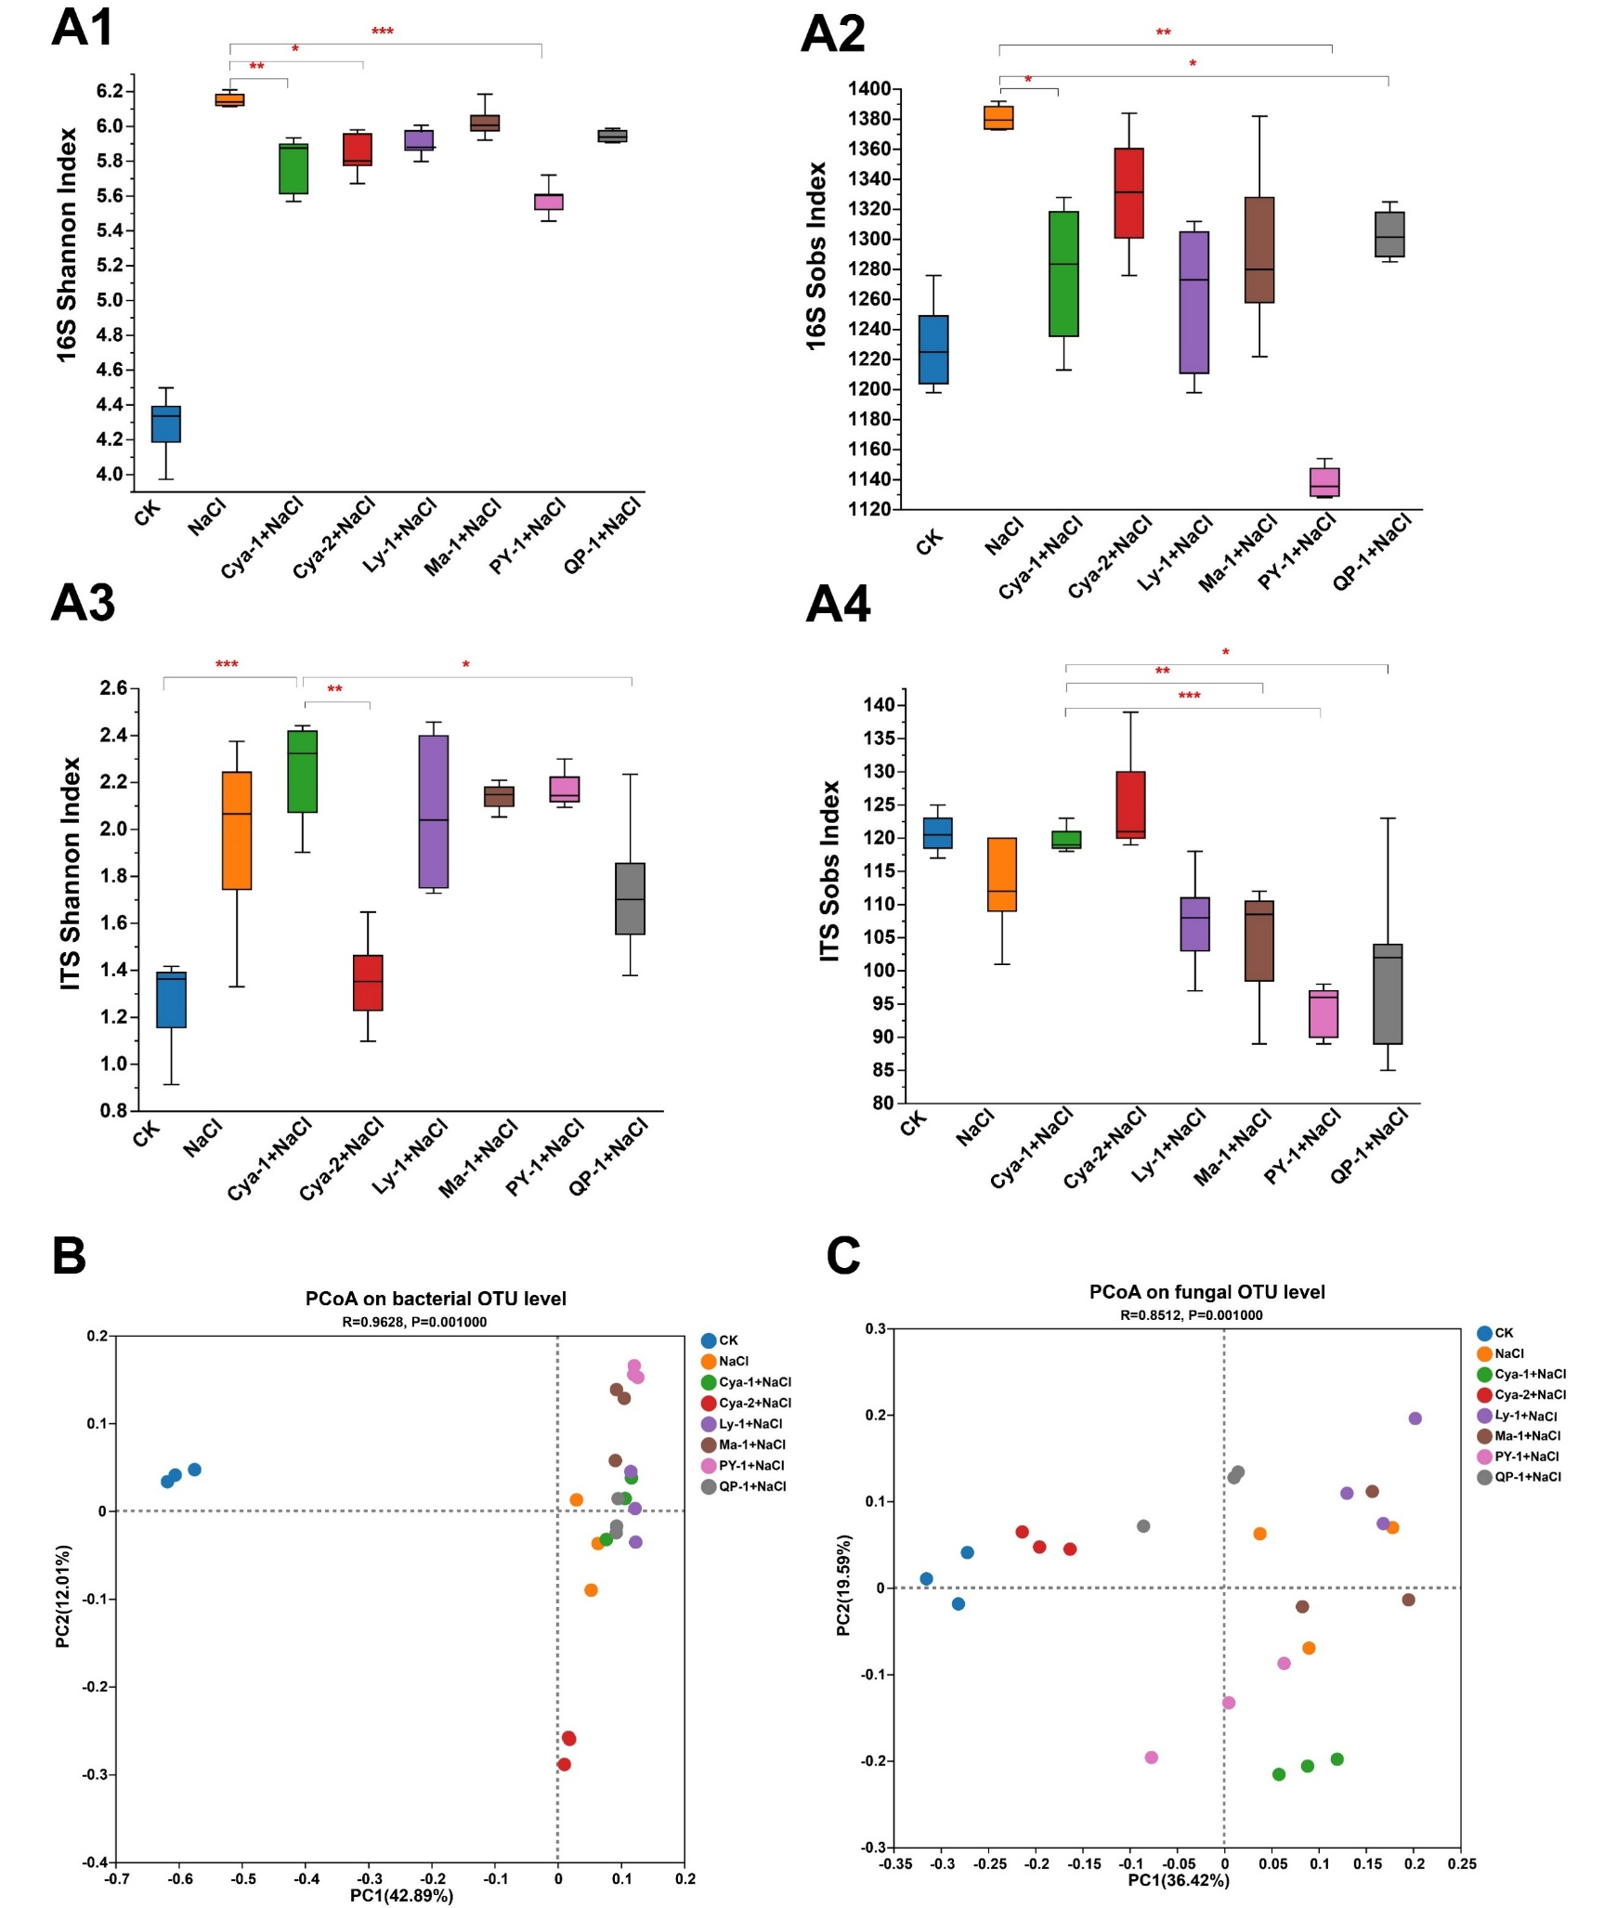
Supplementary Figure 5 Diversity of microbial bacterial and fungal communities in the inter-root of cucumber
Note: A: α-diversity of bacterial (A1, Shannon index; A2, Sobs index) and fungal (A3, Shannon index; A4, Sobs index) communities in the cucumber rhizosphere. B: Principal coordinates analysis (PCoA) of bacterial β-diversity. C: PCoA of fungal β-diversity.
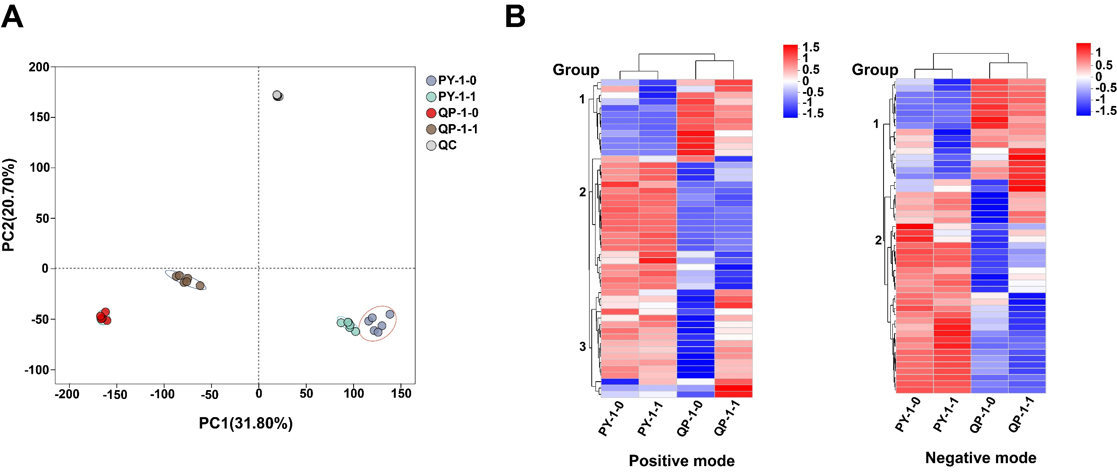
Supplementary Figure 6 Comparative metabolomic analysis of representative strains
Note: A: Principal component analysis (PCA) score plot of metabolite profiles. B: Hierarchical clustering heatmap of differentially metabolites. QC, quality control samples. PY-1-1, strain PY-1 cultured with 1 mol/L NaCl; PY-1-0, PY-1 under non-stress conditions. QP-1-1, strain QP-1 cultured with 1 mol/L NaCl; QP-1-0, QP-1 under non-stress conditions.
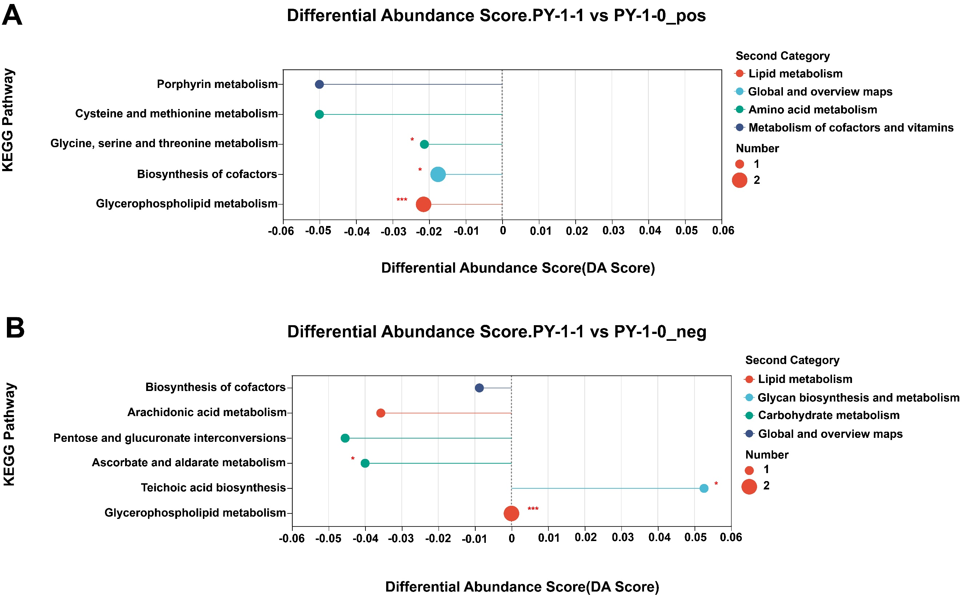
Supplementary Figure 7 Comparative metabolomic analysis of strains PY-1
Note: A, B: Differential abundance score (DA Score) plots for PY-1-1 versus PY-1-0 in positive (pos) and negative (neg) ionization modes. The x-axis reflects integrated metabolite perturbation within each KEGG pathway (y-axis). Line length indicates absolute DA score magnitude, while dot size corresponds to metabolite count per pathway.Rightward dots denote pathway enrichment (upregulation); leftward dots indicate depletion (downregulation).
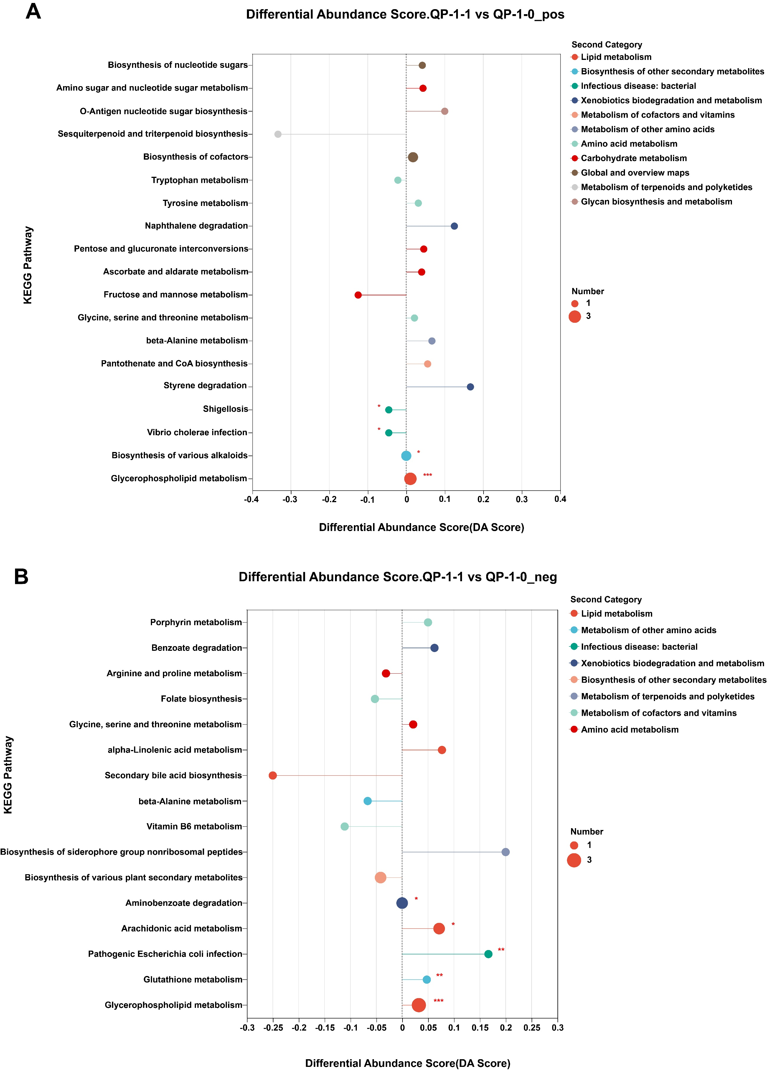
Supplementary Figure 8 Comparative metabolomic analysis of strains QP-1
Note: A, B: QP-1-1 vs QP-1-0 positive ion and negative ion differential abundance score plots.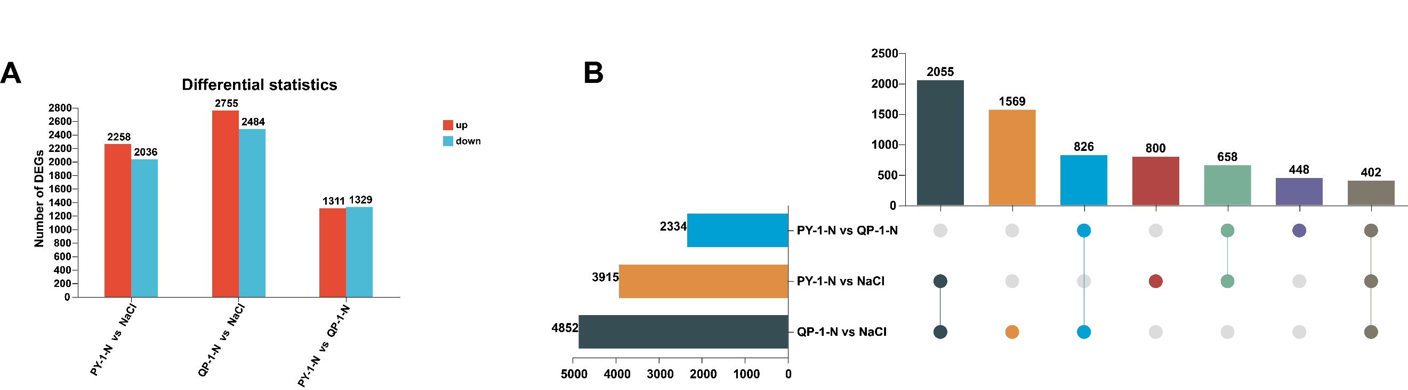
Supplementary Figure 9 Differentially expressed gene analysis
Note: A: Differentially regulated gene counts between treatments. B: Upset analysis of differentially expressed genes. PY-1-N and QP-1-N: bacterial suspension + NaCl; NaCl: salt stress-only.
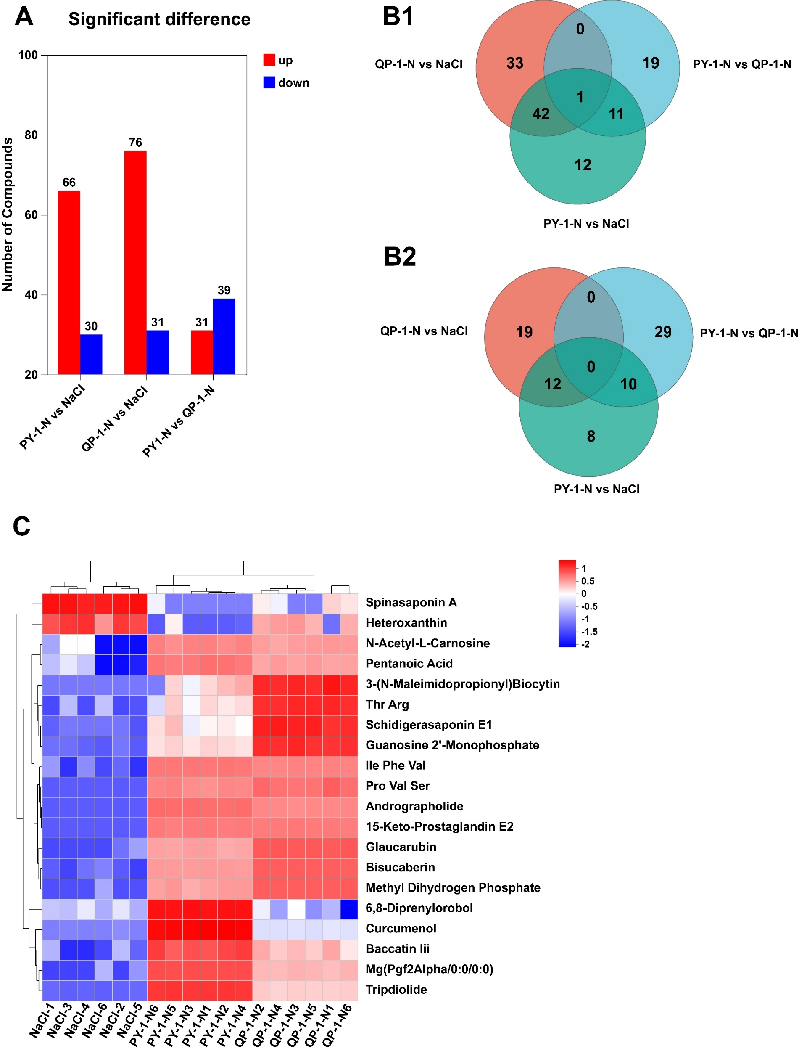
Supplementary Figure 10 Differential metabolite analysis
Note: A: Differential metabolite counts; B1: Upregulated metabolites; B2: Downregulated metabolites; C: Clustering heatmap of the top 20 differential metabolites. PY-1-N and QP-1-N: bacterial culture + NaCl; NaCl: salt-only stress.

