Supplementary figures
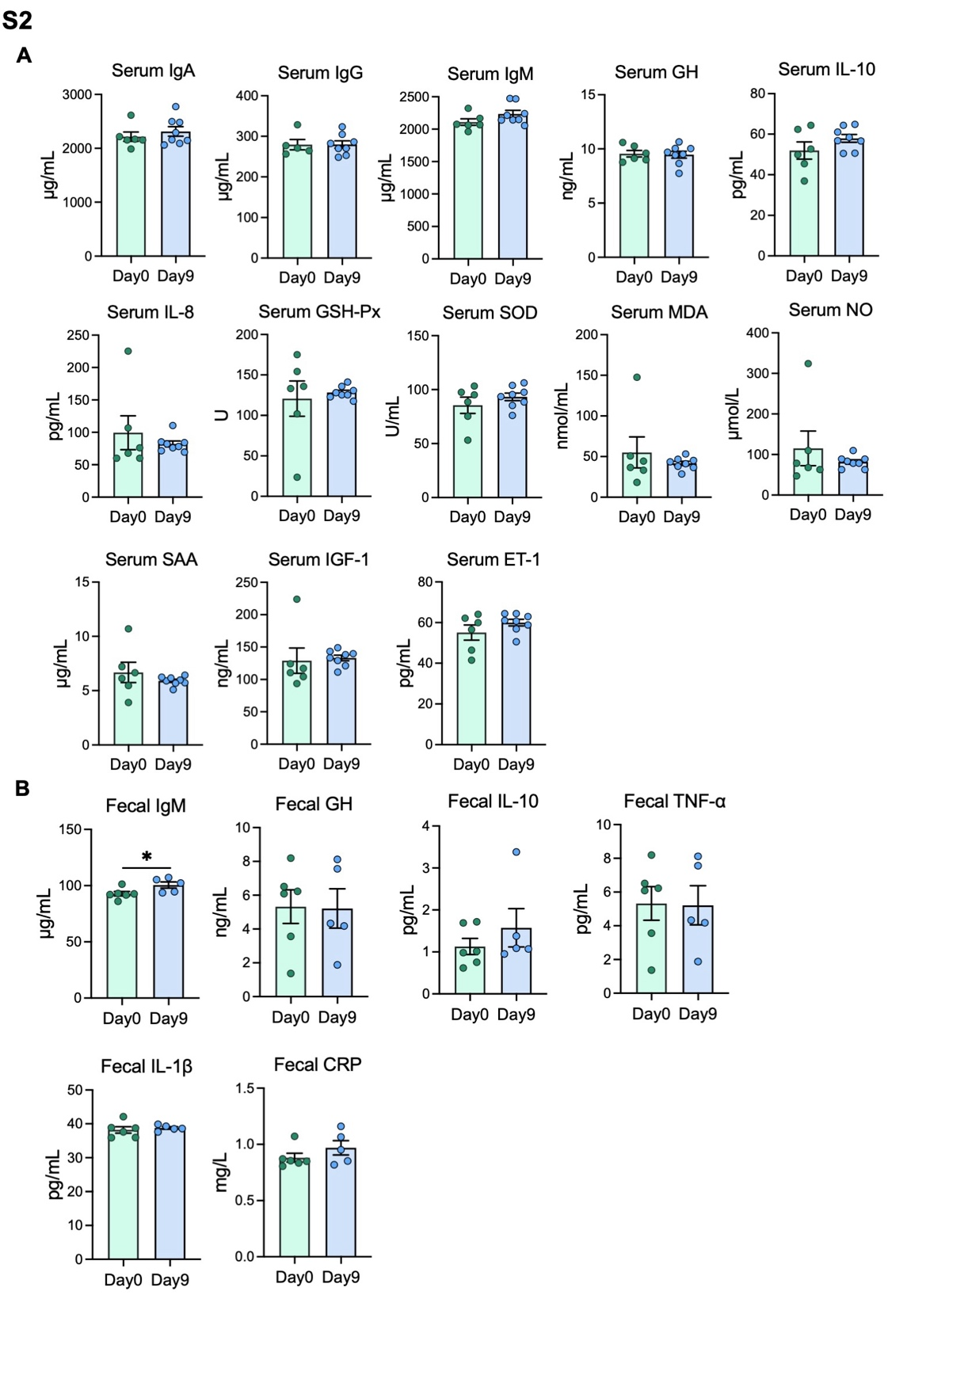 Figure S1. Effect of age on serum and fecal biochemical indices in calves. A The serum levels of IgA, IgG, IgM, GH, IL-10, IL-8, GSH-Px, SOD, MDA, NO, SAA, IGF-1 and ET-1 (n = 5–8 biologically independent samples per group). B The fecal levels of IgM, GH, IL-10, TNF-α, IL-1β and CRP (n = 5–6 biologically independent samples per group). Data are presented as mean ± SEM where applicable. Each point in quantitative plots represents one calf. *P < 0.05.
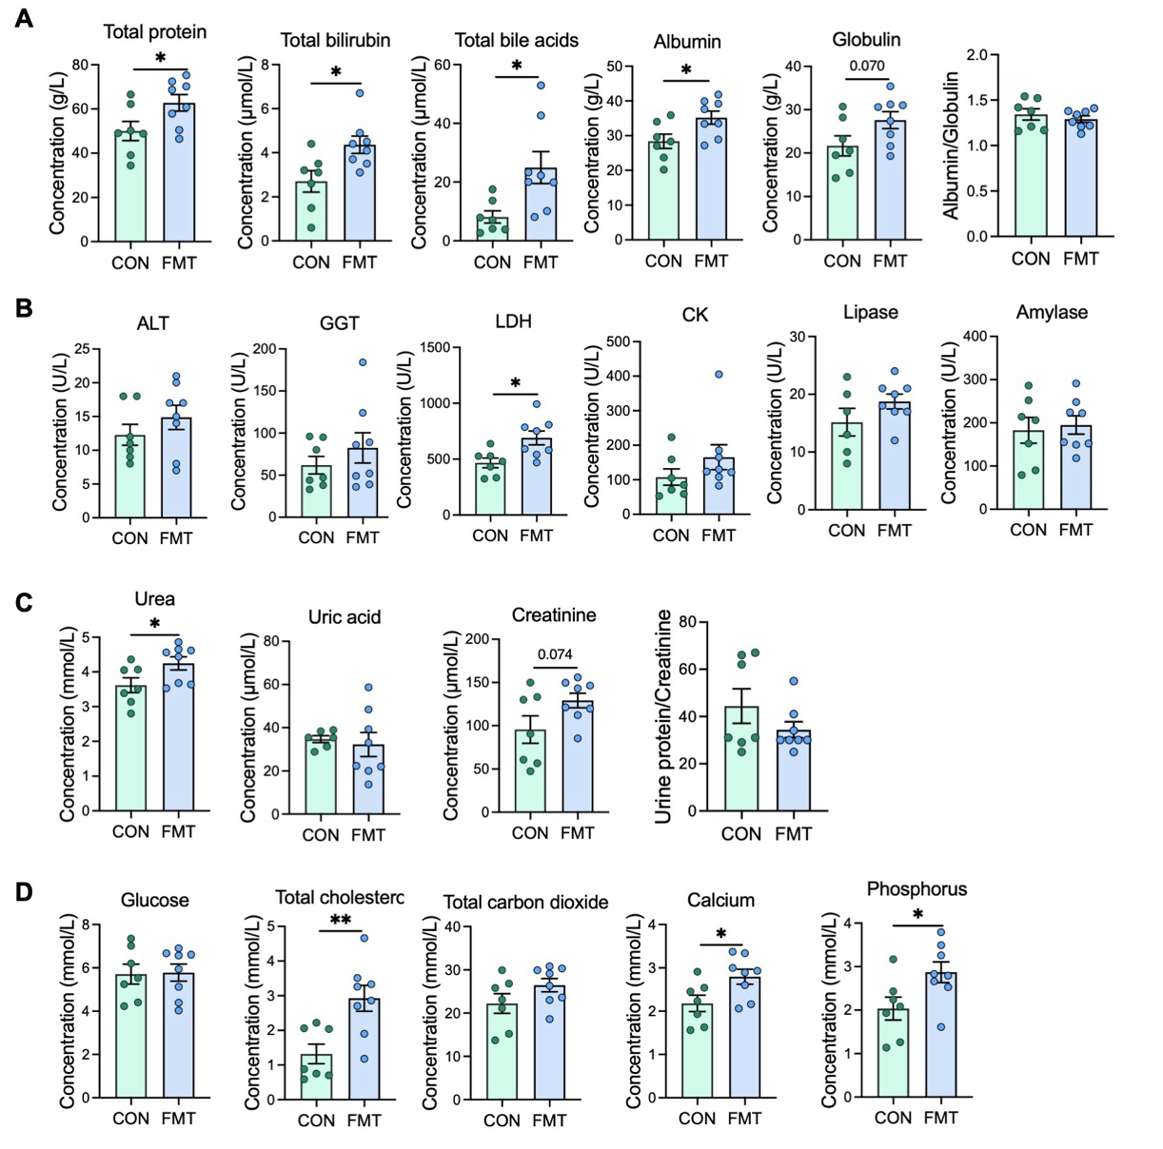
Figure S2. Serum biochemical parameters in CON and FMT calves. A Serum concentrations of total protein, total bilirubin, total bile acids, albumin, globulin, and albumin/globulin ratio in CON and FMT calves. B Serum concentrations or activities of alanine aminotransferase (ALT), γ-glutamyl transferase (GGT), lactate dehydrogenase (LDH), creatine kinase (CK), lipase, and amylase in CON and FMT calves. C Serum concentrations of urea, uric acid, creatinine, and urine protein/creatinine ratio in CON and FMT calves. D Serum concentrations of glucose, total cholesterol, total carbon dioxide, calcium, and phosphorus in CON and FMT calves. CON group, n = 7 biologically independent samples; FMT group, n = 8 biologically independent samples. Data are expressed as mean ± SEM. Each point represents one calf. *P < 0.05, **P < 0.01.

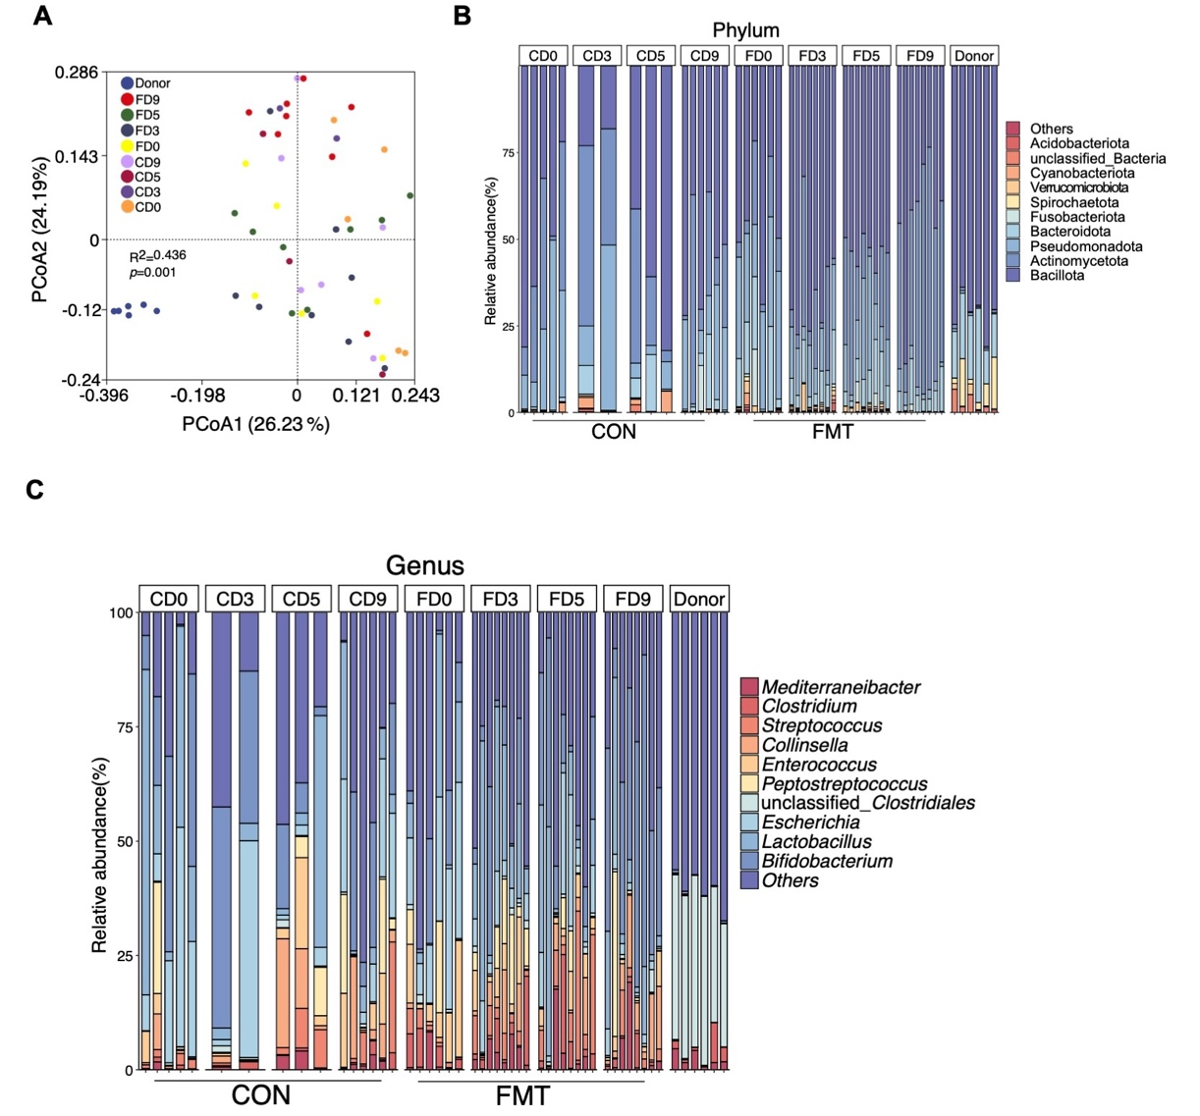 Figure S3. 16S rRNA gene sequencing of gut microbes from donor and recipient's calves. A PCoA analysis of 16S rRNA gene sequencing based on weighted UniFrac distance. P values indicated represent permanova. B and C Histogram analysis of microbial taxonomic composition at phylum (B) and genus (C) levels.
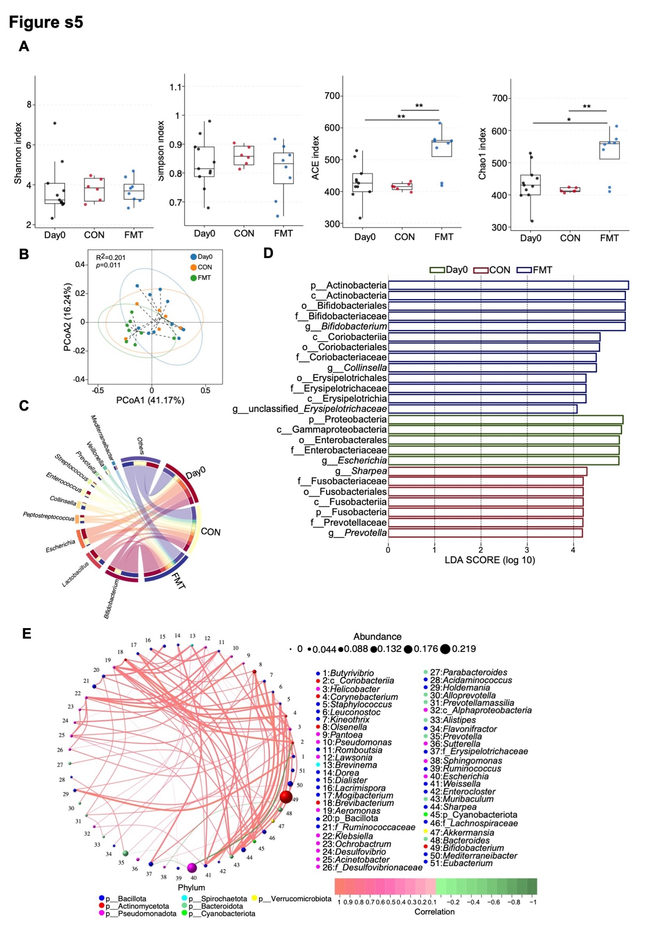 Figure S4. The 16S rRNA gene sequencing of the gut microbes of calves after FMT. A Shannon, Simpson, Ace and Chao1 index. B PCoA analysis of 16S rRNA gene sequencing based on weighted UniFrac distance. C Relative abundance of gut microbiota at the genus level. D The most differentially abundant taxa between groups identified by LDA effect size. Only LDA threshold of ≥ 4 taxa are shown. E The Spearman association analysis network for genus-level species. Data are expressed as mean ± SEM. P values indicated represent permanova (B). *P < 0.05, **P < 0.01.
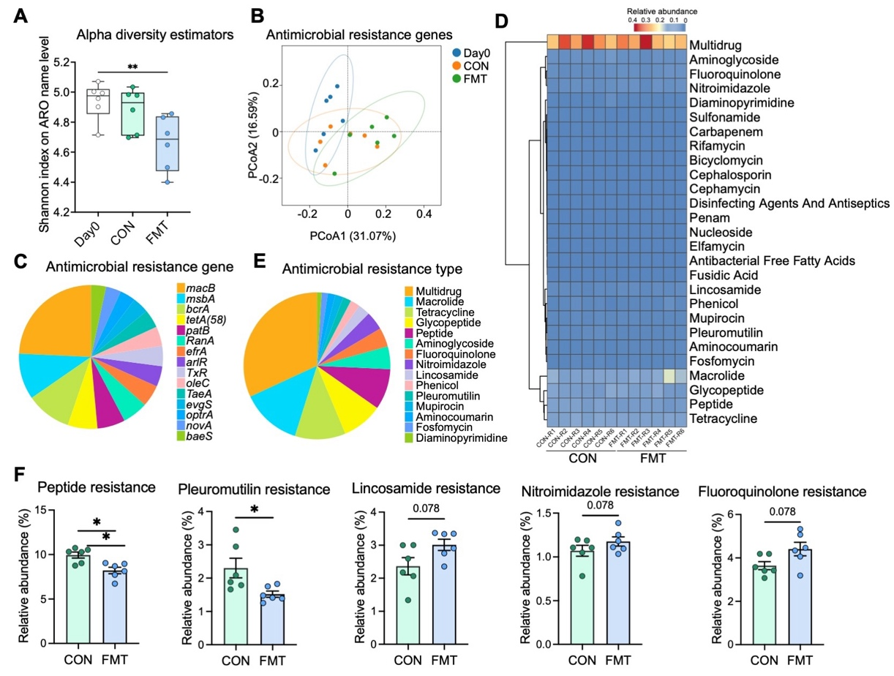
Figure S5. Alterations in antimicrobial resistance genes in the gut microbiota of Day0, CON, and FMT calves. A Alpha diversity of Antibiotic Resistance Ontology (ARO) in feces as measured by Shannon richness. B PCoA of gut microbial ARG compositions in calves. C Average proportions of gut microbial ARGs. D Heatmap analysis of gut microbial antimicrobial resistance types. E Average proportions of gut microbial antimicrobial resistance types. F Comparative analyses of the relative abundances of the antimicrobial resistance types, including peptide, pleuromutilin, lincosamide, nitroimidazole and fluoroquinolone resistances (Day0 group, n = 6 biologically independent samples; CON group, n =6 biologically independent samples; FMT group, n = 6 biologically independent samples). Data are expressed as mean ± SEM. Each point in quantitative plots represents one calf. *P < 0.05, **P < 0.01.

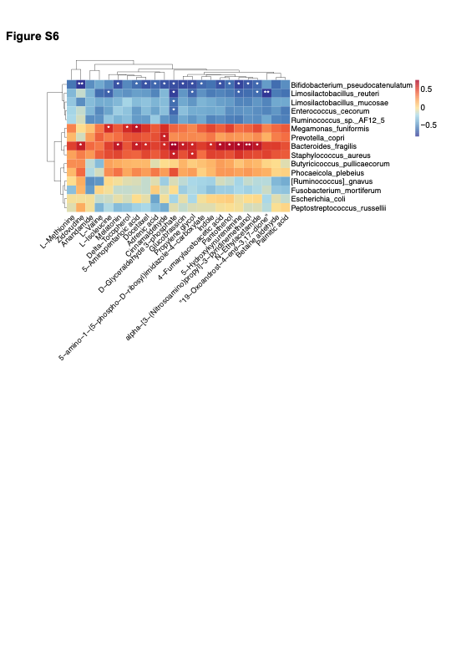 Figure S6. Correlation analysis of gut microbes and plasma metabolites of calves. Heatmap for the Spearman’s correlation analysis of gut microbes and differential metabolites of calves in KEGG pathway. *P < 0.05, **P < 0.01.
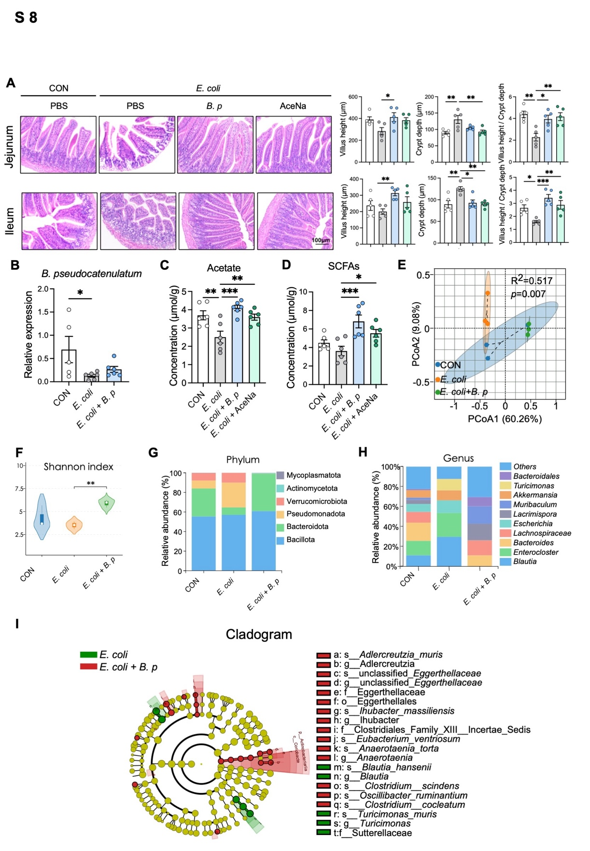
Figure S7. B. pseudocatenulatum restores intestinal morphology, promotes acetate production, and remodels gut microbiota composition in E. coli-challenged mice. A Representative images of jejunum and ileum histological morphology by H&E staining and statistical analysis of villus height, crypt depth, and the ratio of the villus height to crypt depth (n = 5 biologically independent samples per group). B The relative quantification of B. pseudocatenulatum (n = 5–6 biologically independent samples per group). C and D The content of acetate (C) and SCFAs (D) (n = 6 biologically independent samples per group). E Scatter plots depicting the PCoA results of the16S rRNA gene analysis obtained from CON, E. coli and E. coli + B. pseudocatenulatum group (n = 3 biologically independent samples per group). F Shannon index. G and H Histogram analysis of microbial taxonomic composition at phylum (G) and genus (H) levels. I The most differentially abundant taxa between E. coli and E. coli + B. pseudocatenulatum groups identified by LDA effect size. Only LDA threshold of ≥ 4 taxa are shown. Data are presented as mean ± SEM. Each point in quantitative plots represents one mouse. *P < 0.05, **P < 0.01, ***P < 0.001. AceNa, sodium acetate; B. p, B. pseudocatenulatum.

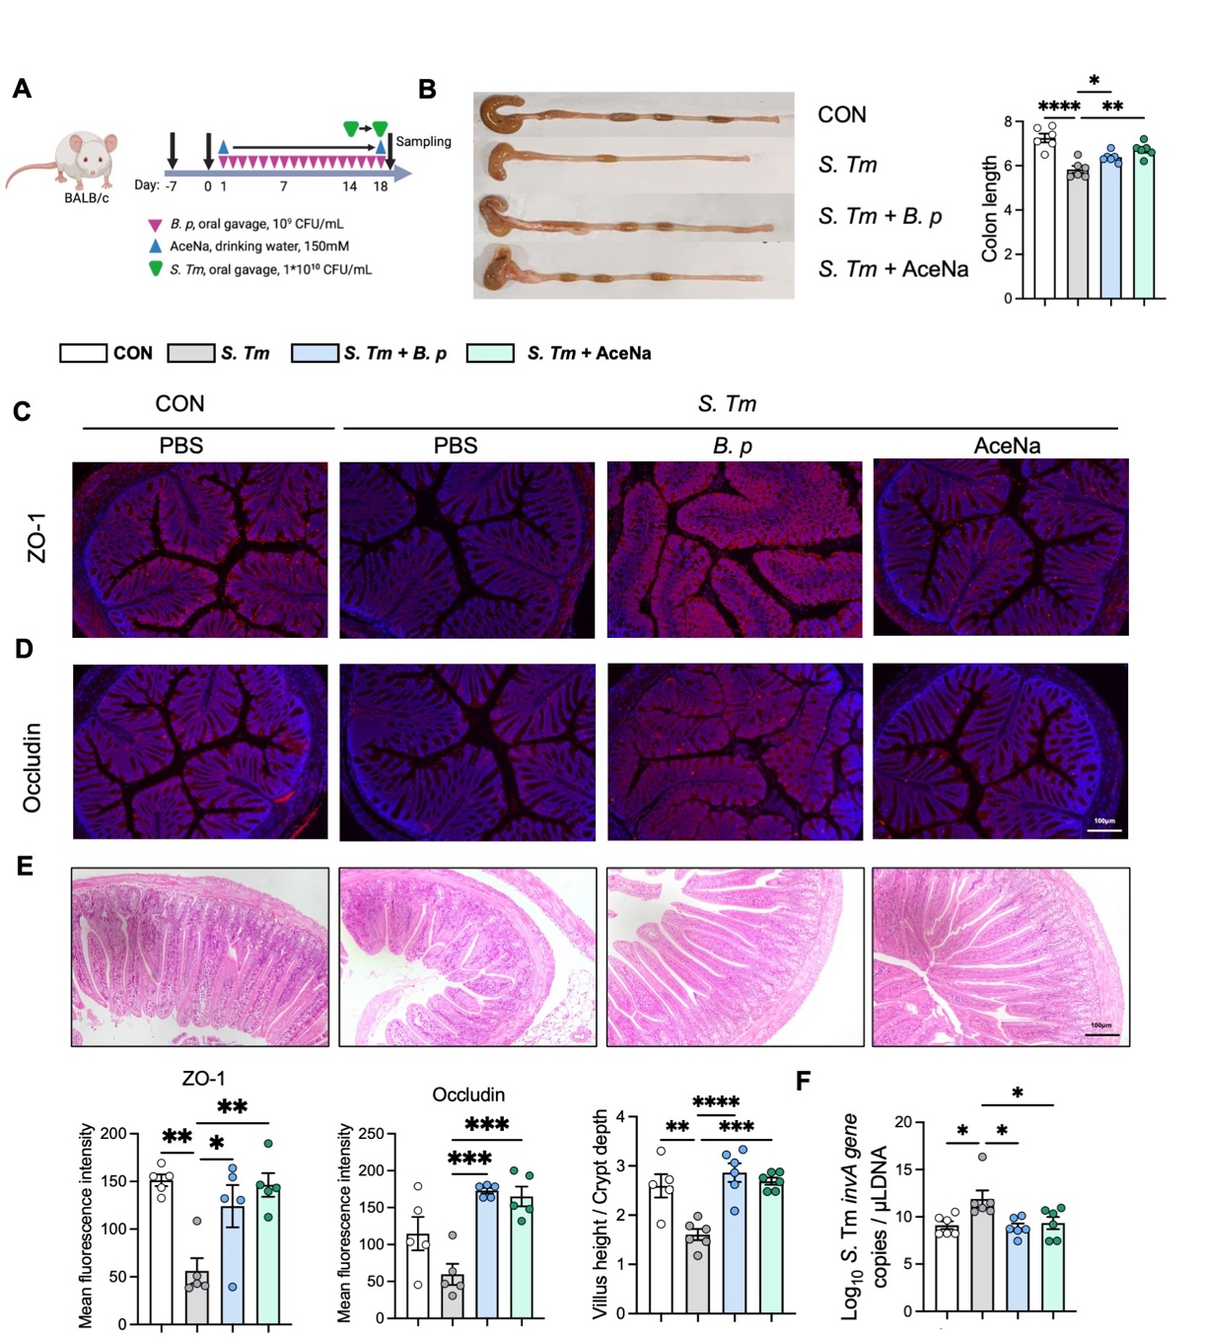Figure S8. Effect of B. pseudocatenulatum and AceNa on S. Typhimurium-induced inflammation in mice. A Experimental design for BALB/c mice: CON group was subjected to PBS for 17 days; Treatment groups were subjected to PBS (S. Typhimurium group), or B. pseudocatenulatum (109 CFU/mL, 300 μL; S. Typhimurium + B. pseudocatenulatum group), or acetate (150 mM; S. Typhimurium + AceNa group) for 14 consecutive days before inoculation with S. Typhimurium (total 17 days). Created with BioRender.com. B Representative colonic images and statistical histogram of colon length (n = 6 biologically independent samples per group). C and D Representative immunofluorescence of ZO-1 and occludin (n = 5 biologically independent samples per group). E Representative images of ileum histological morphology by H&E staining and statistical analysis of the ratio of the villus height to crypt depth (n = 5–6 biologically independent samples per group). Scale bar = 100 μm. F Absolute fecal burden of S. Typhimurium, expressed as log₁₀ gene copies per μL of DNA (n = 6 biologically independent samples per group). Data are presented as mean ± SEM where applicable. Each point in quantitative plots represents one mouse. *P < 0.05, **P < 0.01, ***P < 0.001, ****P < 0.0001. AceNa, sodium acetate; B. p, B. pseudocatenulatum.

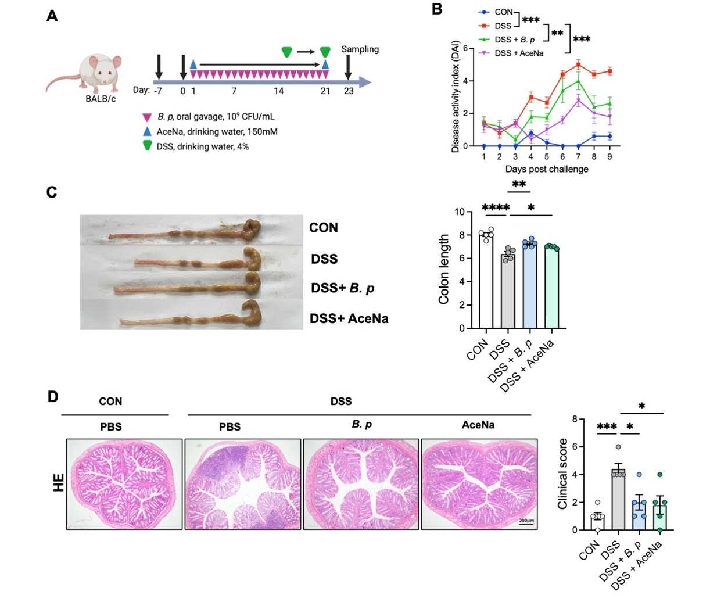
Figure S9. Effect of B. pseudocatenulatum and AceNa on DSS-induced colonic inflammation in mice. A Experimental design for BALB/c mice: CON group was subjected to PBS for 21 days; Treatment groups were subjected to PBS (DSS group), or B. pseudocatenulatum (10⁹ CFU/mL, 300 μL; DSS + B. pseudocatenulatum group), or sodium acetate (150 mM; DSS + AceNa group) for 14 consecutive days before drinking DSS (total 21 days). Created with BioRender.com. B The DAI after DSS drinking. C Representative colonic images and statistical histogram of colon length (n = 5 biologically independent samples per group). D Representative images of colon histological morphology by H&E staining (scale bar = 200 μm) and statistical analysis of histological score (n = 5 biologically independent samples per group). Data are expressed as mean ± SEM. Each point in quantitative plots represents one mouse. *P < 0.05, **P < 0.01, ***P < 0.001. AceNa, sodium acetate; B. p, B. pseudocatenulatum.

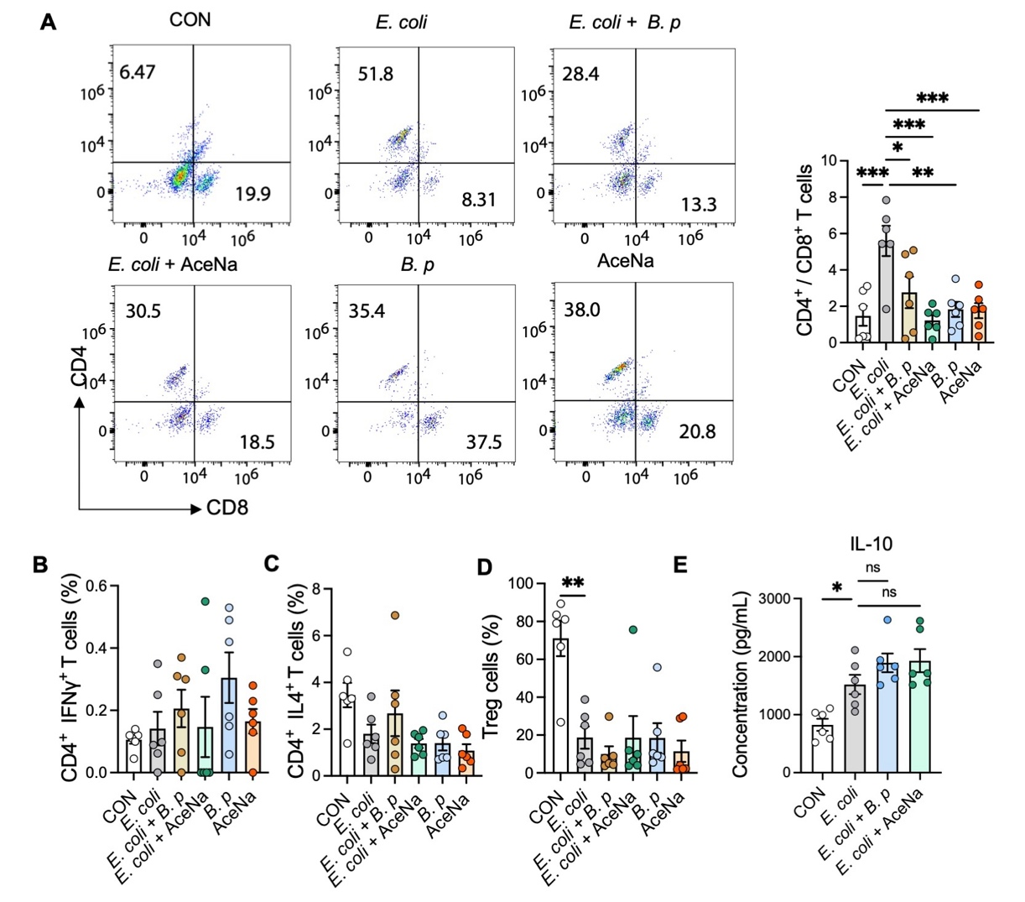Figure S10. Effects of B. pseudocatenulatum and AceNa on T-cell subsets and inflammatory factors in E. coli-challenged mice. A Ratio of CD4⁺/CD8⁺ T cells in the indicated groups (n = 6 biologically independent samples per group). B-D Proportion of CD4⁺IFNγ⁺ T cells (B), CD4⁺IL4⁺ T cells (C), and Treg cells (D) in the indicated groups (n = 6 biologically independent samples per group). E The colon levels of IL-10 (n = 6 biologically independent samples per group). Data are expressed as mean ± SEM. Each point in quantitative plots represents one biologically independent sample. *P < 0.05, **P < 0.01, ***P < 0.001, ****P < 0.0001. AceNa, sodium acetate; B. p, B. pseudocatenulatum.
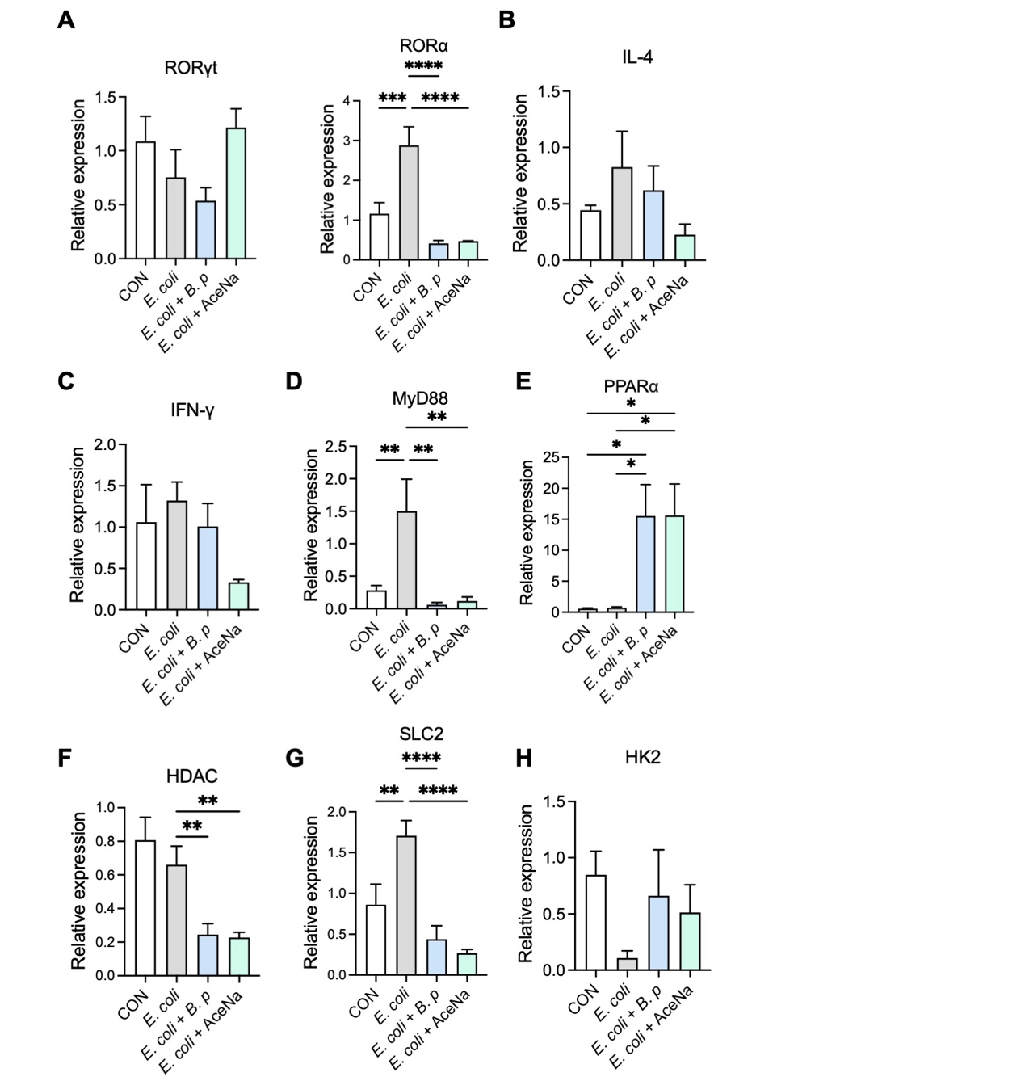Figure S11. Effects of B. pseudocatenulatum and AceNa on the expression of genes related to immune responses and metabolism in intestinal epithelial cells of E. coli-challenged mice. A Relative mRNA expression of RORγt and RORα. B and C The relative expression of IL-4 (B) and IFN-γ (C) (n = 4 biologically independent samples per group). D The relative expression of MyD88 (n = 3 biologically independent samples per group). E and F The relative expression of PPARα (E) and HDAC (F) (n = 4 biologically independent samples per group). G and H The relative expression of SLC2 (G) and HK2 (H) (n = 6 biologically independent samples per group). Data are expressed as mean ± SEM. Each point in quantitative plots represents one biologically independent sample. *P < 0.05, **P < 0.01, ***P < 0.001, ****P < 0.0001. AceNa, sodium acetate; B. p, B. pseudocatenulatum.
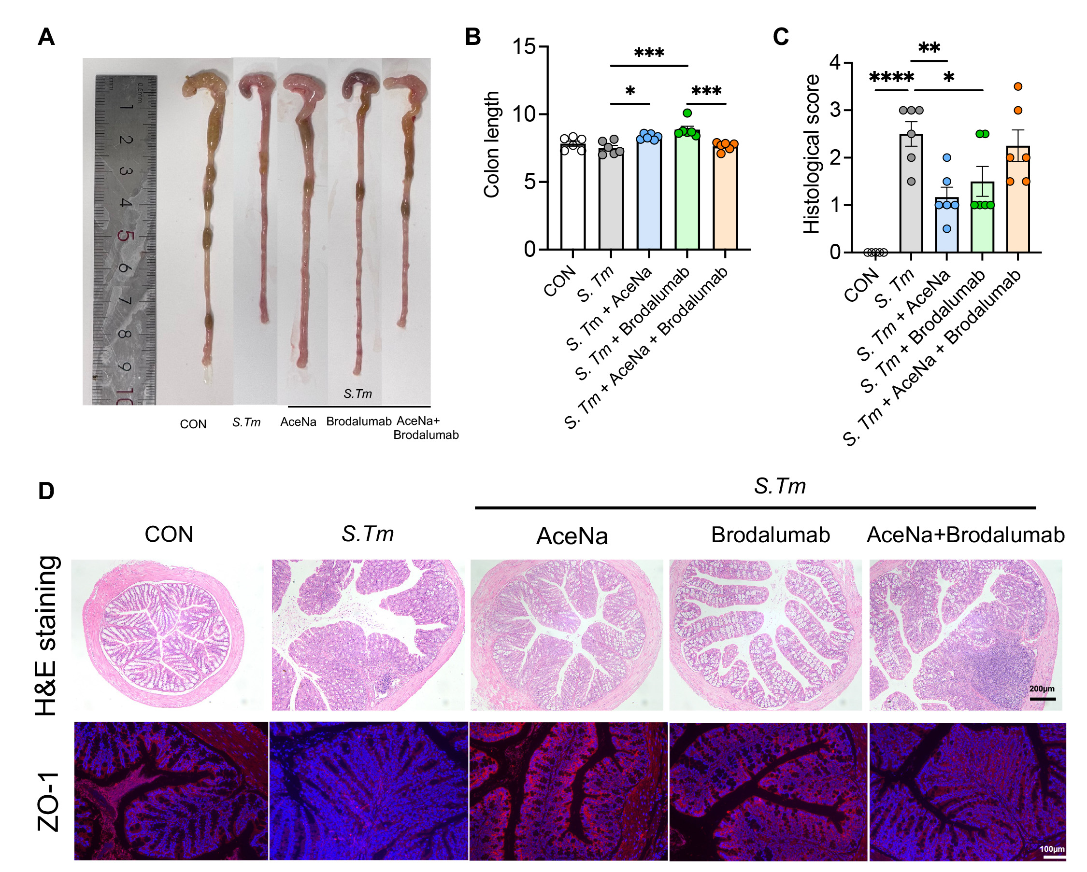 Figure S12. Brodalumab counteracts the effect of acetate on alleviating S. Typhimurium-induced colitis. A Representative images of colon for colitis mice. B Analysis of colon length (n = 6 biologically independent samples per group). C Analysis of histological score (n = 6 biologically independent samples per group). D Representative images of colonic tissues H&E staining and the representative fluorescent images of ZO-1in colonic tissues. Data are expressed as mean ± SEM where applicable. Each point in quantitative plots represents one mouse. *P < 0.05, **P < 0.01, ***P < 0.001, ****P < 0.0001. AceNa, sodium acetate; B. p, B. pseudocatenulatum.

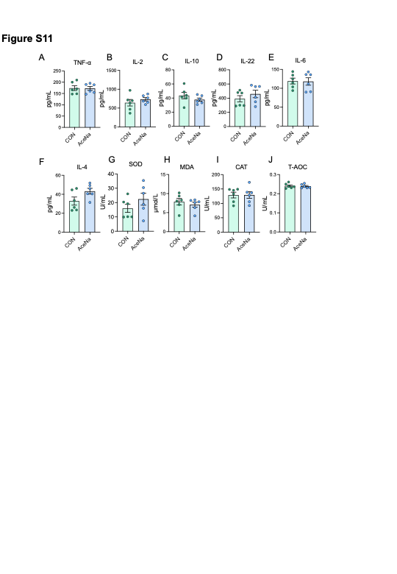 Figure S13. Effect of AceNa on serum biochemical indicators of calves. A-J, The levels of TNF-α (A), IL-2(B), IL-10 (C), IL-22 (D), IL-6 (E), IL-4 (F), SOD (G), MDA (H), CAT (I) and T-AOC (J) in the serum of calves after AceNa treatment (n = 6 biologically independent samples per group). Data are expressed as mean ± SEM. Each point in quantitative plots represents one calf. AceNa, sodium acetate.

