Volatile-mediated microbiome enrichment by Streptomyces albidoflavus G1 enhances suppression of apple ring rot pathogen Botryosphaeria dothidea

Shengzhi Guo^{1†}, Arneeb Tariq^{1†}, Yarong Luo¹, Xianyu Li¹, Zixu Wang¹, Zhinan Du¹, Qi Cheng¹, Jiangbo Qi¹, Junfeng Pan¹, Lingfang Zhu^{1*}, Xihui Shen^{1,2*}

¹ State Key Laboratory for Crop Stress Resistance and High-Efficiency Production, Shaanxi Key Laboratory of Agricultural and Environmental Microbiology, College of Life Sciences, Northwest A&F University, Yangling, Shaanxi 712100, China
² College of Plant Protection, Northwest A&F University, Yangling, Shaanxi 712100, China

* Corresponding authors:
Lingfang Zhu (E-mail: lingfangzhu@nwafu.edu.cn)
Xihui Shen (E-mail: xihuishen@nwafu.edu.cn)

† Shengzhi Guo and Arneeb Tariq contributed equally to this work.

Contents:
Supplementary Materials and Methods;
Supplementary Figures S1–S7;
Supplementary References.

Supplementary Materials and methods

Whole-genome sequencing, assembly, annotation, and genome-based taxonomic analysis of G1 and aNRL1.
A pure culture of G1 was grown in ISP2 broth at 30°C for 96 h in a shaker at 180 rpm. Cells were harvested by centrifugation at 4,500 rpm for 10 min, and genomic DNA was extracted using the TIANamp Bacteria DNA Kit (Tiangen Biotech Co., Beijing, China). DNA library preparation and whole-genome sequencing were performed by Magigene Biotechnology Co., Ltd. (Guangdong, China) using a combination of Illumina short-read and Oxford Nanopore long-read sequencing technologies.
Strain aNRL1 was cultured in LB broth at 30°C for 24 h, and bacterial cells were collected by centrifugation. Genomic DNA was extracted using the PureLink™ Genomic DNA Mini Kit (Invitrogen, Thermo Fisher Scientific, USA). Library preparation and whole-genome sequencing were performed by Shanghai BIOZERON Biotech. Co., Ltd. (Shanghai, China). Short-read sequencing was conducted on an Illumina platform in paired-end 150-bp mode. For long-read sequencing on the MGI Cyclone platform, high-molecular-weight DNA fragments were size-selected using a BluePippin system (Sage Science, USA) with a 0.75% DF Marker S1 High-Pass 6–10 kb v3 cassette.
Quality-filtered short- and long-read sequences were subjected to hybrid de novo assembly using Unicycler v0.4.8 [1], yielding complete genome assemblies. For strain G1, protein-coding genes were predicted using Glimmer 3 [2], and genome annotation was performed using the RAST server [3]. For strain aNRL1, coding sequences were predicted de novo using GeneMark [4]. The predicted aNRL1 proteins were searched against the NR, Swiss-Prot, KEGG, GO, COG, CAZy, ARD, CARD, PHI-base, TCDB, VFDB, and BacMet databases using BLASTp to obtain functional annotations. The identification of secondary metabolite biosynthetic gene clusters was accomplished through antiSMASH 7.0 [5].
The construction of a phylogenomic tree based on complete genomes was reconstructed using Type (Strain) Genome Server (TYGS; https://tygs.dsmz.de) with FastME 2.1.6.1 method [6]. FastANI was employed to determine the average nucleotide identity among selected species [7]. Digital DNA-DNA hybridization values were calculated with the Genome-to-Genome Distance Calculator 3.0 [8].

HS-SPME-GC–MS/MS analysis of G1-derived volatile compounds
Liquid samples were thawed on ice and vortex-mixed thoroughly. An aliquot of 200 μL was transferred into an autosampler headspace vial, followed by the addition of 0.2 g NaCl and 20 μL of an internal-standard solution (10 μg mL⁻¹; 3-Hexanone-2,2,4,4-d4). Volatile compounds were extracted using an automated headspace solid-phase microextraction system equipped with a 120-μm divinylbenzene/carbon wide range/polydimethylsiloxane (DVB/CWR/PDMS) SPME Arrow [9]. Before extraction, samples were agitated at 60°C for 5 min. The SPME Arrow was then exposed to the vial headspace at 60°C for 15 min and desorbed in the GC inlet at 250°C for 5 min. Before each analytical sequence, the Arrow was conditioned in a fibre-conditioning station at 250°C for 5 min. New SPME Arrows were conditioned at 250°C for 2 h before their first use.
Volatile compounds were analyzed using an Agilent 8890 gas chromatograph coupled to an Agilent 7000D triple-quadrupole mass spectrometer. Chromatographic separation was performed on a DB-5MS capillary column (30 m × 0.25 mm × 0.25 μm; Agilent J&W Scientific, Folsom, CA, USA). High-purity helium (≥99.999%) was used as the carrier gas at a constant flow rate of 1.2 mL min. The injector temperature was maintained at 250°C, and the solvent delay was 3.5 min. The oven temperature program was as follows: 40°C for 3.5 min; increased to 100°C at 10°C min; increased to 180°C at 7°C min; and then increased to 280°C at 25°C min and held for 5 min.
The mass spectrometer was operated with an electron-ionization source at 70 eV. The ion-source temperature, quadrupole temperature, and transfer-line temperature were maintained at 230°C, 150°C, and 280°C, respectively. Data were acquired in selected-ion monitoring mode.

Assessment of apple quality parameters
Apple quality parameters were assessed after incubation using standard postharvest-quality procedures [10]. Fresh weight was recorded before and after incubation. Fresh-weight loss was calculated as:
$$\text{Fresh-weight loss (\%)=}\left(\frac{{\text{W}}_{0}\text{-}{\text{W}}_{t}}{{\text{W}}_{0}}\right)\text{×}\text{100}$$
where W₀ is the initial fruit weight and W_{t} is the fruit weight after incubation.
Fruit-skin color was measured using a PCE-CSM 1 colorimeter (PCE Instruments, United Kingdom). CIE L*, a*, and b* values were recorded at 6 positions per fruit. Overall color difference relative to the WM control was calculated as:
$${\text{∆}\text{E}}_{ab}^{*}\text{=}\sqrt{\left[{\left({\text{L}}^{\text{*}}\text{-}L_{WM}^{*}\right)}^{\text{2}}\text{ + }{\left({\text{a}}^{\text{*}}\text{-}a_{WM}^{*}\right)}^{\text{2}}\text{ + }{\left({\text{b}}^{\text{*}}\text{-}b_{WM}^{*}\right)}^{\text{2}}\right]}$$
Titratable acidity was determined by titrating 2 mL of apple juice with standardized NaOH (0.1 mol L⁻¹) to a final pH of 8.1, and was expressed as grams of malic acid per 100 mL of juice. Titratable acidity was calculated as:
$$TA({g 100mL}^{-1})=\frac{V_{NaOH} ×C_{NaOH} × 67.045×100}{1000×V_{juice}}$$
where V_{NaOH} is the volume of NaOH consumed (mL), C_{NaOH} is the molarity of NaOH (mol L⁻¹), 67.045 is the equivalent mass of malic acid, and V_{juice} is the volume of juice titrated (mL).
Fruit firmness, chewiness, springiness, and fracturability were determined using a TA.XTPlusC texture analyser (Stable Micro Systems, United Kingdom). Total soluble solids were measured as Brix using a digital refractometer (BM04-Nohawk, Shenzhen, China) after juice extraction from apple tissues. Aroma-related changes were evaluated using an electronic nose system (PEN3; Airsense Analytics, Schwerin, Germany) following published apple-volatilome procedures. For each sample, 5 mL of apple juice was transferred into a 40-mL sealed sampling vial and equilibrated for 3 min at 30°C. Sensor signals were collected using a sampling flow rate of 300 mL min⁻¹ for 60 s, followed by a sensor-cleaning period of 180 s. Electronic-nose response patterns were analyzed by principal-component analysis.

Supplementary Figures
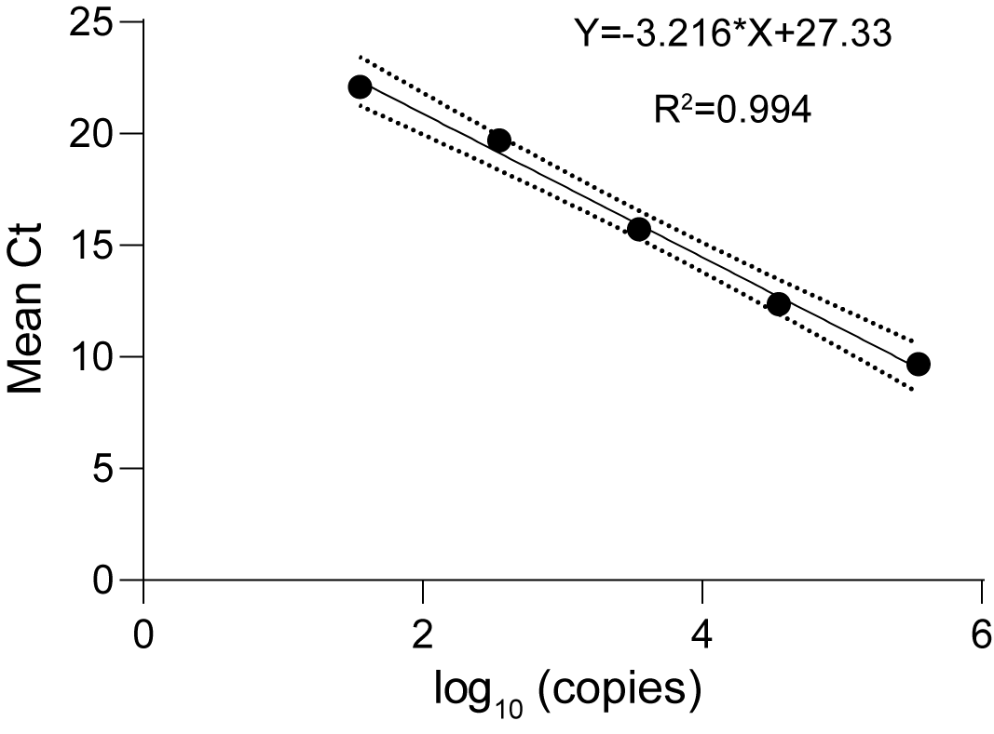

Fig. S1 Plasmid-based standard curve for DNA-based absolute qPCR quantification of Botryosphaeria dothidea in apple lesion-margin tissues. The BdEF1 target fragment was cloned into the pMD19-T vector, and ten-fold serial dilutions of the recombinant plasmid were used to generate the standard curve. Cycle threshold (Ct) values showed a linear relationship with the log₁₀-transformed target copy number. The regression equation was Ct = −3.216 × log₁₀(copies) + 27.33, with R² = 0.994 and amplification efficiency of 104.7%.
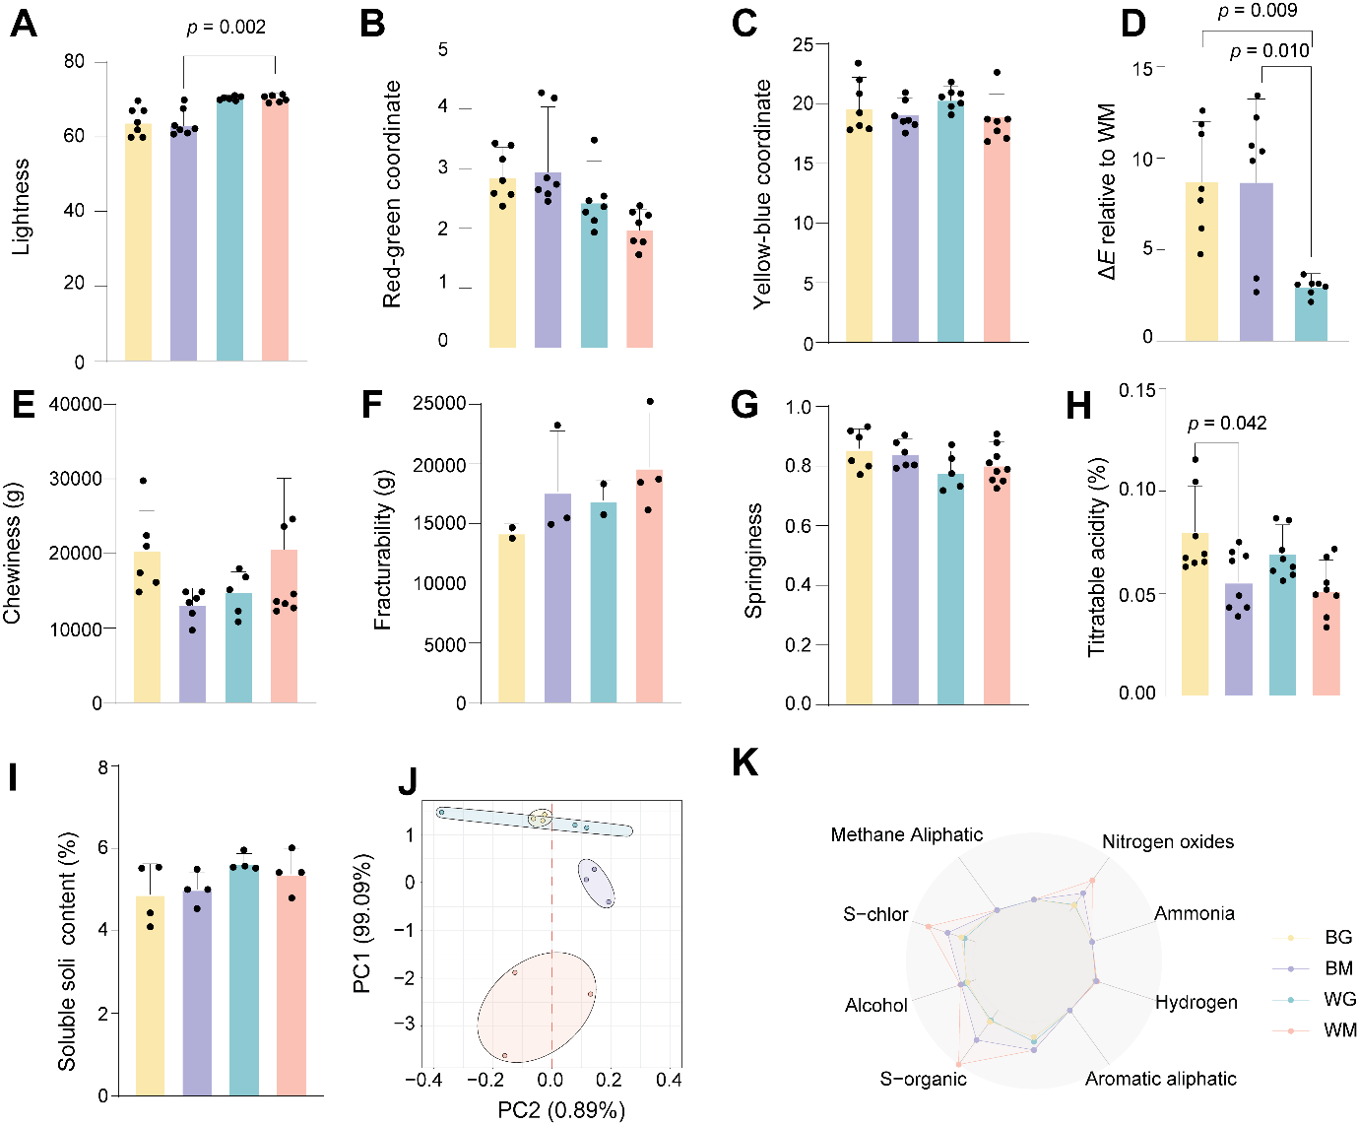

Fig. S2 Comprehensive assessment of apple fruit quality and VOC profiles across treatment groups. BG, B. dothidea inoculation with G1-VOC exposure; BM, B. dothidea inoculation without G1-VOC exposure; WG, mock inoculation with G1-VOC exposure; and WM, mock inoculation without G1-VOC exposure. (A–C) Colorimetric analysis indicating variations in lightness, red-green, and yellow-blue coordinates. (D) Total color difference (ΔE) relative to the WM group, showing significant shifts in BG and BM groups. (E–G) Texture profile analysis measurements including chewiness, fracturability, and springiness. (H, I) Biochemical evaluation of titratable acidity and soluble solid content. (J) Principal Component Analysis (PCA) of VOC profiles, illustrating distinct clustering based on treatment. (K) Radar plot of electronic nose sensor responses, highlighting differences in volatile emission patterns. Data are presented as mean ± SD. p-values indicate statistically significant differences.

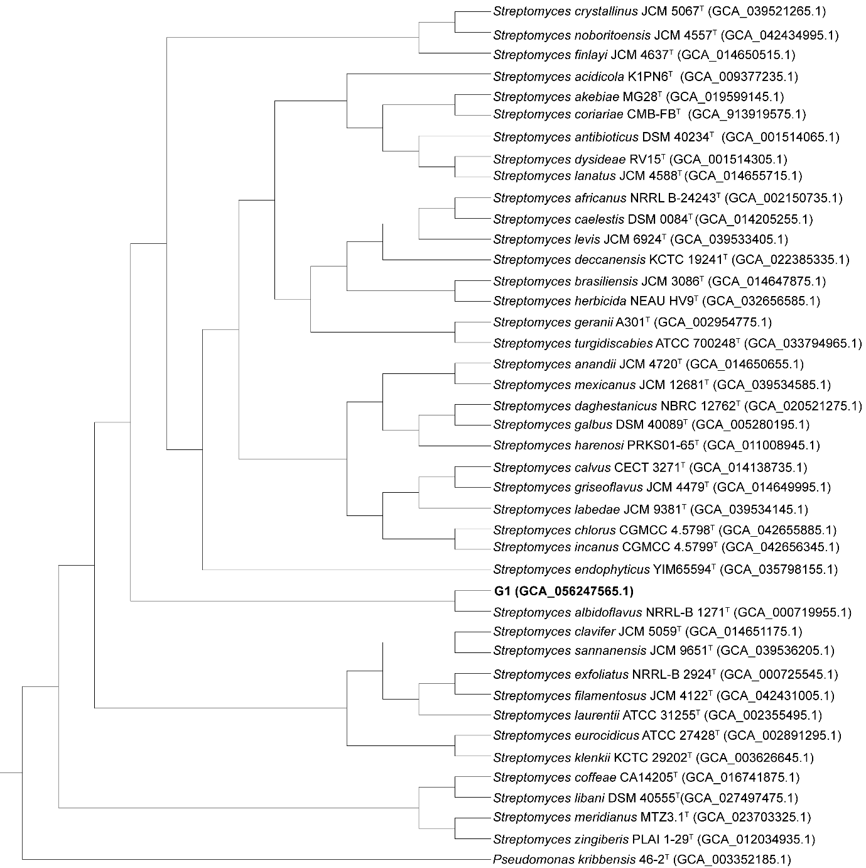

Fig. S3 Whole-genome-based phylogenetic analysis of strain G1. The phylogenetic tree illustrates the taxonomic position of G1 within the genus Streptomyces. G1 clustered closely with Streptomyces albidoflavus NRRL-B-1271ᵀ, supporting its identification as S. albidoflavus together with the ANI analysis. Pseudomonas kribbensis 46-2ᵀ was used as the outgroup. GenBank accession numbers of the genome assemblies are provided in parentheses.

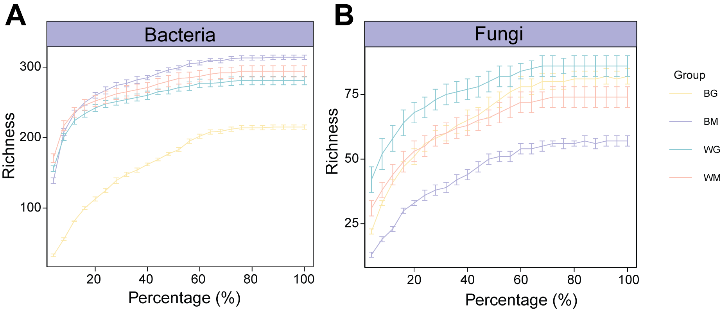

Fig. S4 Rarefaction curves of bacterial and fungal communities in apple lesion-margin tissues under the four treatments. (A) Bacterial and (B) fungal ASV richness plotted against the percentage of sequencing reads retained during subsampling. Lines represent the mean richness, and error bars indicate the standard error across biological replicates. BG, with B. dothidea and with G1; BM, with B. dothidea and without G1; WG, without B. dothidea and with G1; WM, without B. dothidea and without G1. The tendency of the curves to approach saturation indicates that the sequencing depth captured most of the detectable bacterial and fungal diversity.

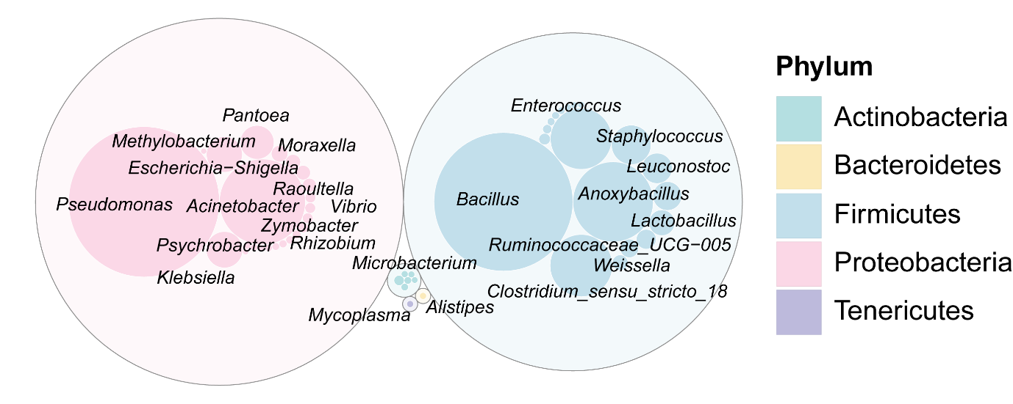

Fig. S5 Taxonomic distribution and abundance of the apple fruit microbiome at the genus level. Bubble plot displaying the relative abundance of dominant bacterial genera. Circle size corresponds to abundance, with taxa color-coded by phylum.
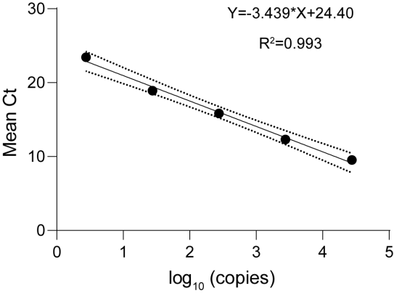

Fig. S6 Plasmid-based standard curve for absolute quantification of Pseudomonas in apple lesion-margin tissues. The target fragment amplified by the Pseudomonas-specific primer pair Pse435F/Pse686R was cloned into pMD19-T and quantified using ten-fold serial dilutions of the recombinant plasmid. Cycle threshold (Ct) values were plotted against the log₁₀-transformed target copy number. The regression equation was Ct =-3.439× log₁₀(copies) + 24.40 (R²= 0.993).

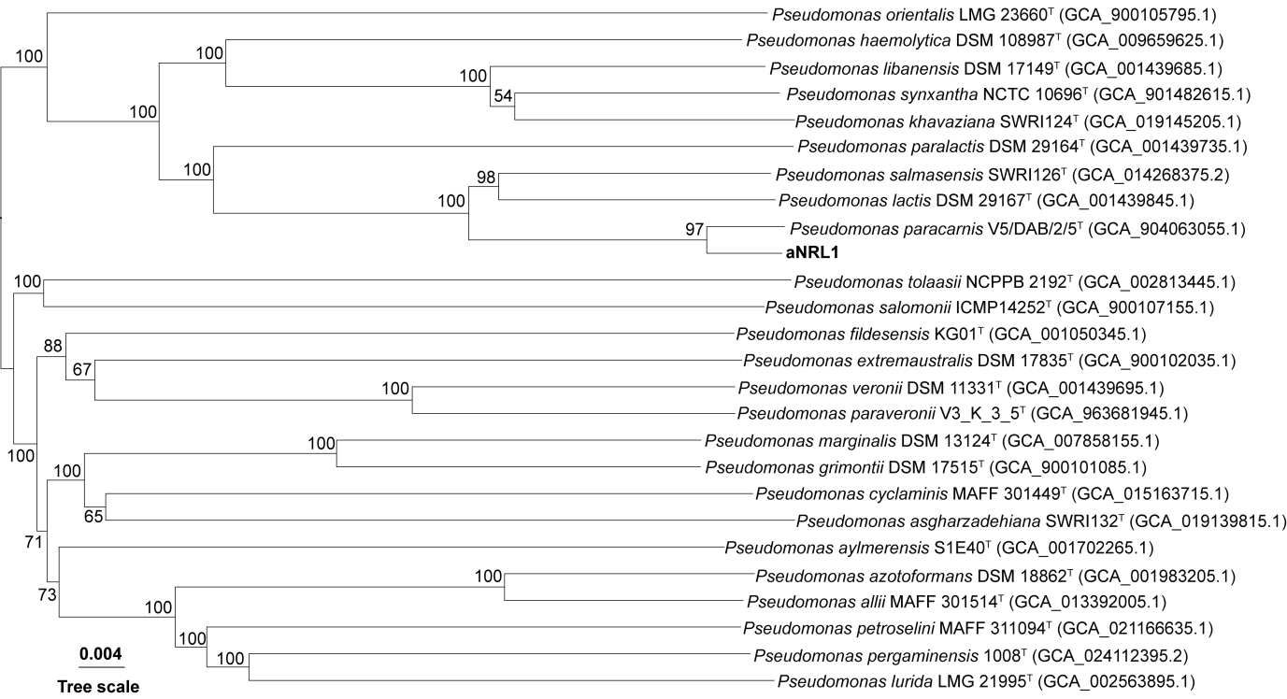

Fig. S7 Core-genome phylogenetic placement of Pseudomonas paracarnis aNRL1 and closely related Pseudomonas type strains. The tree was reconstructed using FastME 2.1.6.1 from GBDP distances calculated from genome sequences. The branch lengths are scaled in terms of GBDP distance formula d5. The numbers above branches are GBDP pseudo-bootstrap support values > 60% from 100 replications, with an average branch support of 65.8%. GenBank accession numbers of the genome assemblies are provided in parentheses.

Supplementary References
1 Wick, R. R., Judd, L. M., Gorrie, C. L. & Holt, K. E. Unicycler: Resolving bacterial genome assemblies from short and long sequencing reads. PLoS Comput Biol 13, e1005595 (2017).
2 Delcher, A. L., Bratke, K. A., Powers, E. C. & Salzberg, S. L. Identifying bacterial genes and endosymbiont DNA with Glimmer. Bioinformatics 23, 673-679 (2007).
3 Aziz, R. K. et al. The RAST Server: rapid annotations using subsystems technology. BMC Genomics 9, 75 (2008).
4 Lukashin, A. V. & Borodovsky, M. GeneMark.hmm: new solutions for gene finding. Nucleic Acids Res 26, 1107-1115 (1998).
5 Blin, K. et al. antiSMASH 7.0: new and improved predictions for detection, regulation, chemical structures and visualisation. Nucleic Acids Res 51, W46-W50 (2023).
6 Lefort, V., Desper, R. & Gascuel, O. FastME 2.0: a comprehensive, accurate, and fast distance-based phylogeny inference program. Mol Biol Evol 32, 2798-2800 (2015).
7 Jain, C., Rodriguez, R. L., Phillippy, A. M., Konstantinidis, K. T. & Aluru, S. High throughput ANI analysis of 90K prokaryotic genomes reveals clear species boundaries. Nat Commun 9, 5114 (2018).
8 Meier-Kolthoff, J. P., Carbasse, J. S., Peinado-Olarte, R. L. & Goker, M. TYGS and LPSN: a database tandem for fast and reliable genome-based classification and nomenclature of prokaryotes. Nucleic Acids Res 50, D801-D807 (2022).
9 Kim, S. J., Lee, J. Y., Choi, Y. S., Sung, J. M. & Jang, H. W. Comparison of different types of SPME Arrow sorbents to analyze volatile compounds in Cirsium setidens Nakai. Foods 9, 785 (2020).
10 Jha, S. N., Rai, D. R. & Shrama, R. Physico-chemical quality parameters and overall quality index of apple during storage. J Food Sci Technol 49, 594-600 (2012).

