Supplementary Figure Legends
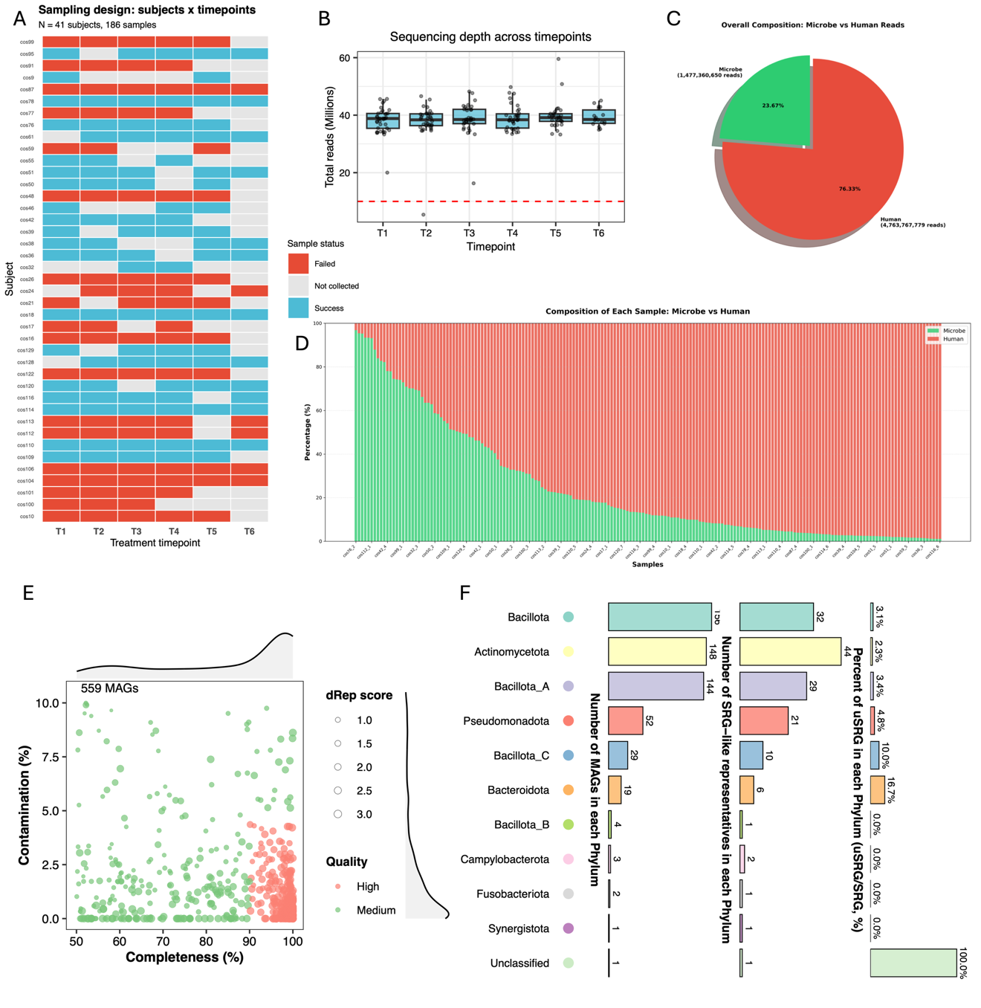
Supplementary Figure S1. Sequencing quality control and host removal overview
(A) Sample collection status heatmap. Binary heatmap showing sample availability for each subject (rows) across timepoints T1–T6 (columns), with pregnancy outcome annotated. (B) Read depth distribution. Boxplots with individual sample points showing total read counts per sample across timepoints. Horizontal dashed line indicates recommended quality threshold (10 million reads). (C) Overall host versus microbial reads composition. Pie chart or ring diagram showing the proportion of microbial versus human (host) reads in the total sequencing dataset. (D) Per-sample host read proportions. Stacked bar chart displaying microbial (blue) versus host (gray) read percentages for each sample, ordered by timepoint. (E) MAG quality scatter density plot. Scatter plot of 559 dereplicated MAGs showing completeness versus contamination, with density distributions along axes. 285 MAGs satisfied high-quality criteria (> 90% completeness, < 5% contamination); 274 satisfied medium-quality criteria (≥ 50% completeness, < 10% contamination). (F) MAG taxonomy distribution. Phylum-level distribution of species-level representative genome (SRG-like) clusters, showing proportion of unknown clusters, number of clusters, and number of MAGs per phylum.
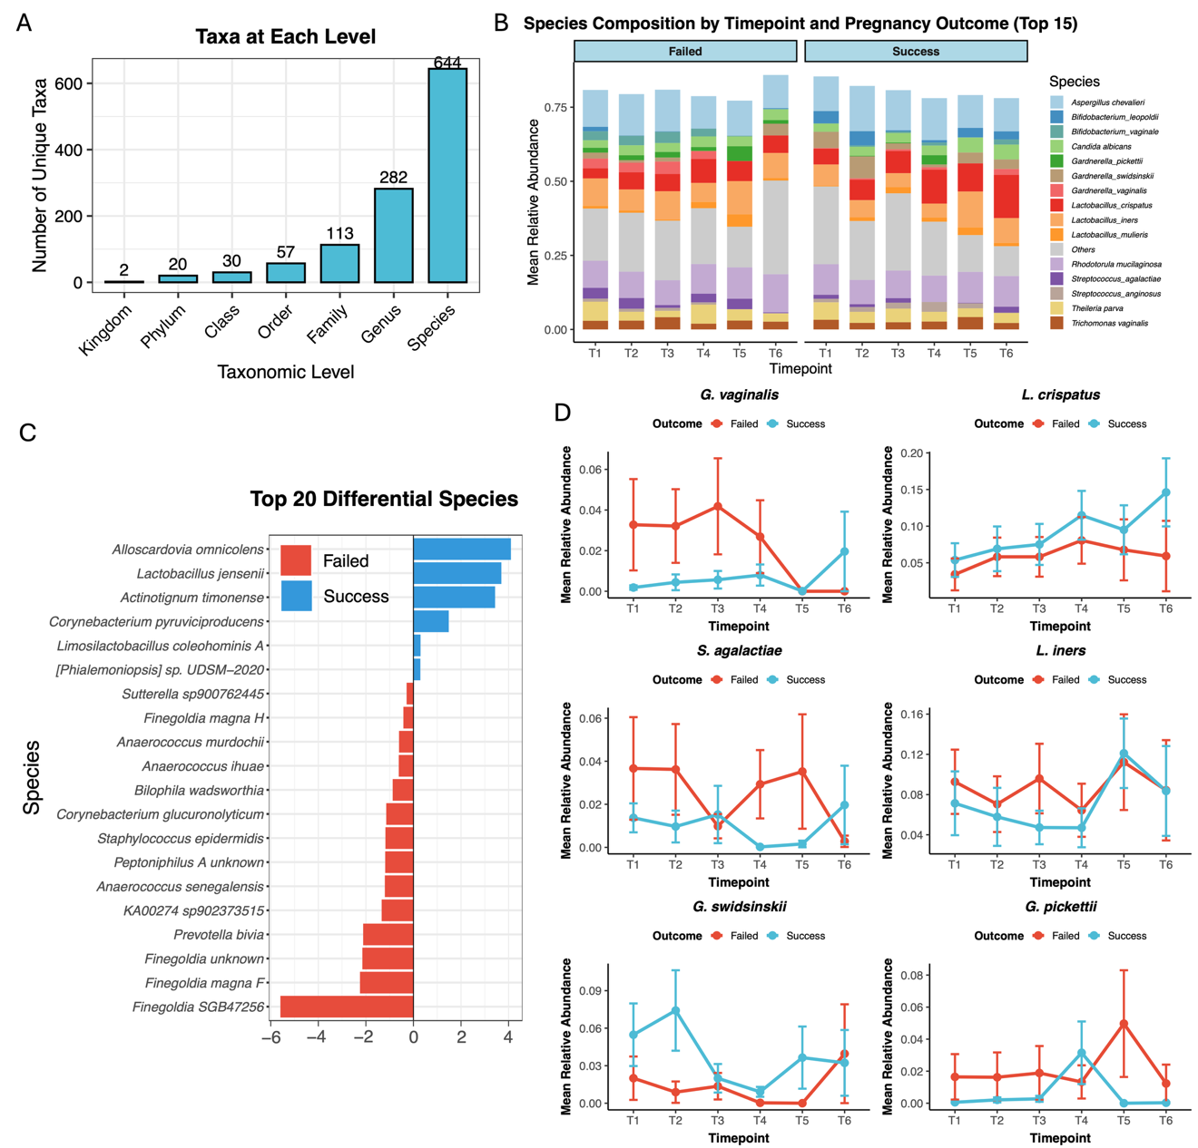
Supplementary Figure S2. Species-level composition and differential abundance analysis
(A) Taxonomic richness by level. Bar chart showing number of taxa at each taxonomic level: Kingdom (2), Phylum (20), Class (30), Order (57), Family (113), Genus (282), Species (644). (B) Species composition by pregnancy outcome. Faceted stacked bar chart showing mean relative abundance of top 15 species across timepoints (T1–T6), separated by pregnancy outcome. (C) Top 20 differential species. Horizontal bar chart of log₂ fold-change for the 20 most significantly different species (all p < 0.05), colored by enrichment direction. Success-enriched: L. crispatus, L. jensenii. Failed-enriched: Gardnerella species, S. agalactiae. (D) Key species temporal trends. Multi-panel line plots (2×3 grid) showing mean relative abundance ± SEM across timepoints for six key species: L. crispatus, L. iners, G. vaginalis, G. pickettii, S. agalactiae, and G. swidsinskii.
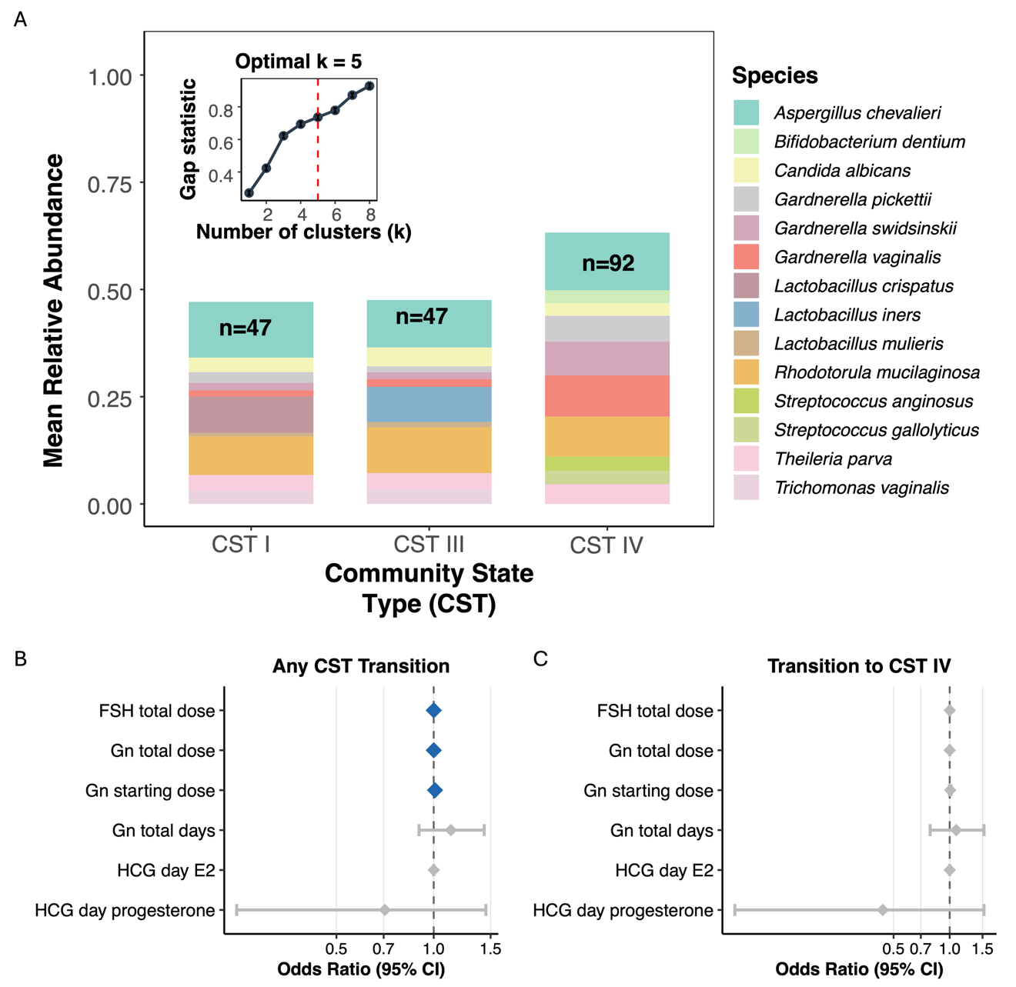
Supplementary Figure S3. CST species composition and medication effects on CST dynamics
(A) CST species composition. Stacked bar chart showing top 10 species composition for each CST (I–V), with sample counts annotated. CST-I: > 80% L. crispatus; CST-II: > 70% L. iners; CST-III: > 60% L. jensenii; CST-IV: polymicrobial (< 40% any single species); CST-V: mixed Lactobacillus. (B) Forest plot: medication effects on any CST transition. Odds ratios (OR) with 95% confidence intervals for FSH total dose, Gn total dose, Gn starting dose, and other medication parameters. Significant associations: FSH total dose OR = 1.0006 (p = 0.023), Gn starting dose OR = 1.009 (p = 0.007). Effect sizes are minimal. (C) Forest plot: medication effects on transition to CST-IV. Same format as Panel B, showing no significant associations between medication dosages and transition to high-risk CST-IV (all p > 0.17).
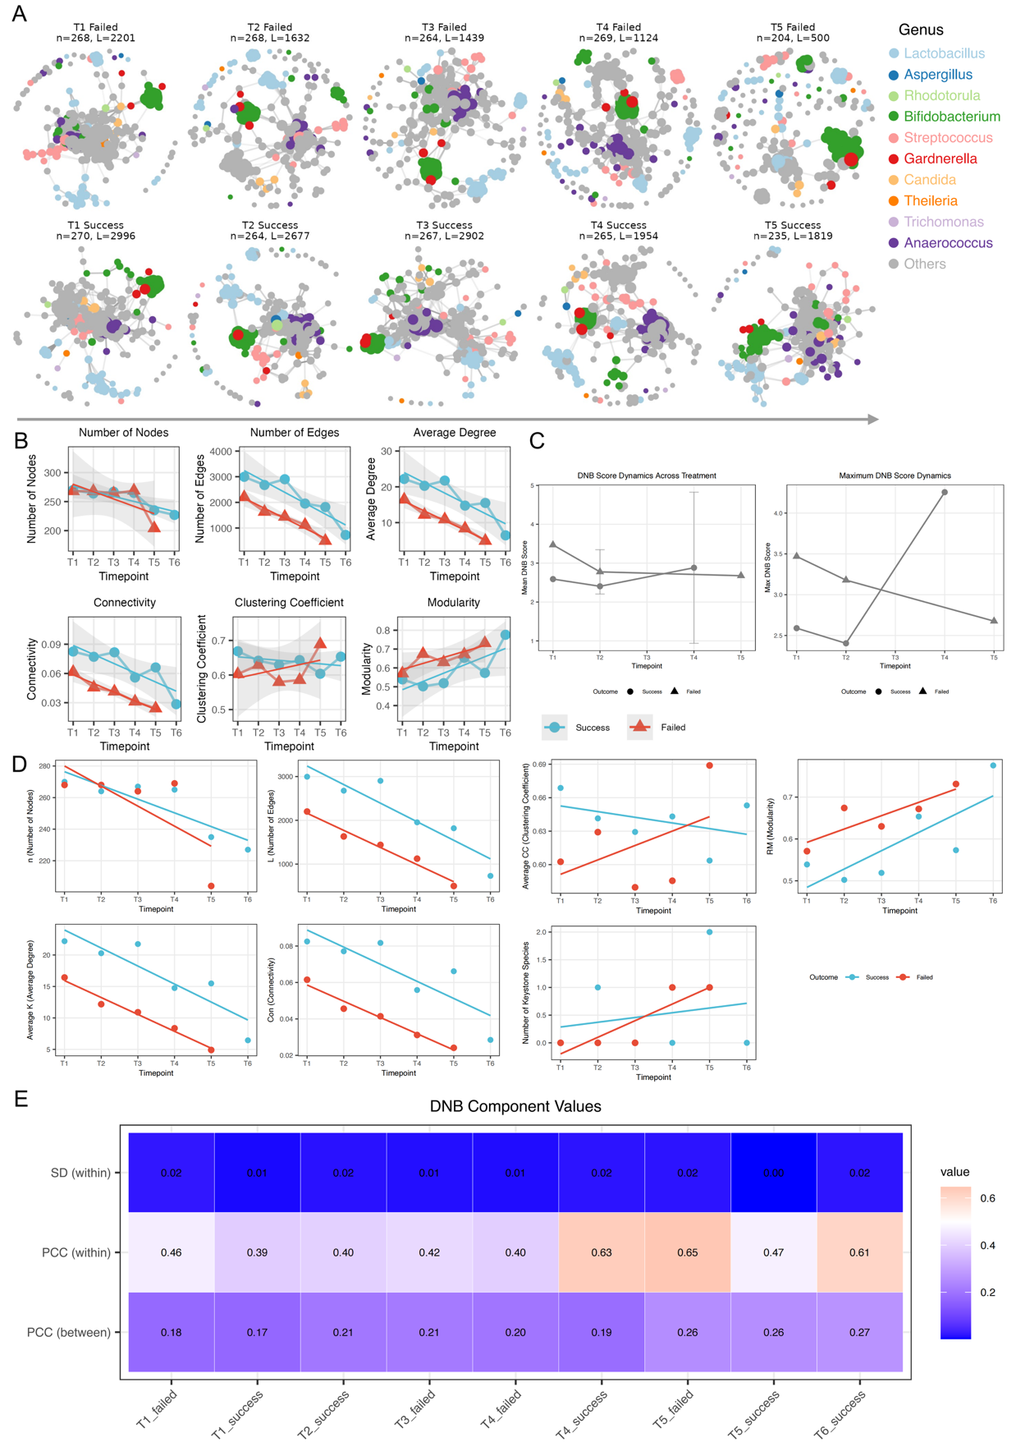
Supplementary Figure S4. Microbial co-occurrence network dynamics and critical transitions
(A) Co-occurrence network structure comparison by genus. Network visualizations constructed using SparCC correlations (|ρ| ≥ 0.3, FDR < 0.05), with nodes representing species and edges representing significant correlations. Node size scales with mean relative abundance, and node colors correspond to bacterial genera. Networks are shown for T4 and T5 timepoints, comparing Success (left) versus Failed (right) groups. Failed group demonstrates network collapse at T4→T5 with 55.5% edge reduction, while Success group maintains network integrity (only 8.0% edge reduction). (B) Network topology metrics across time. Time-series plots showing multiple network topology indicators (node count, edge count, average degree, connectivity, clustering coefficient, modularity, and natural connectivity) from T1 to T5/T6, stratified by pregnancy outcome (Success: blue; Failed: red). Shaded region highlights the T4→T5 critical window where Failed group exhibits precipitous decline across multiple robustness indicators. (C) Dynamic Network Biomarker (DNB) score dynamics. Time-series plot with error bars showing mean DNB scores across timepoints, stratified by pregnancy outcome. DNB score is calculated as (SD\_in × PCC\_in) / PCC\_out. Failed group shows significantly elevated DNB score at T4 (2.87 ± 0.94 vs 1.42 ± 0.56, p = 0.003), representing an early warning signal preceding the T4→T5 network collapse. (D) Full timepoint network topology time series. Multi-faceted line plots showing all network topology indicators (node count, edge count, average degree, connectivity, clustering coefficient, modularity, natural connectivity) from T1–T6, stratified by outcome group. Shaded region marks T4→T5 interval where Failed group shows simultaneous decline across multiple indicators. (E) High-DNB module composition heatmap. Clustered heatmap showing species composition of high-DNB modules (DNB score > 2.0), with rows as species and columns as timepoint × outcome group combinations. BV-associated anaerobes (*Gardnerella, Prevotella, Megasphaera, Sneathia*) highlighted.Statistical significance: * p < 0.05, ** p < 0.01, *** p < 0.001.
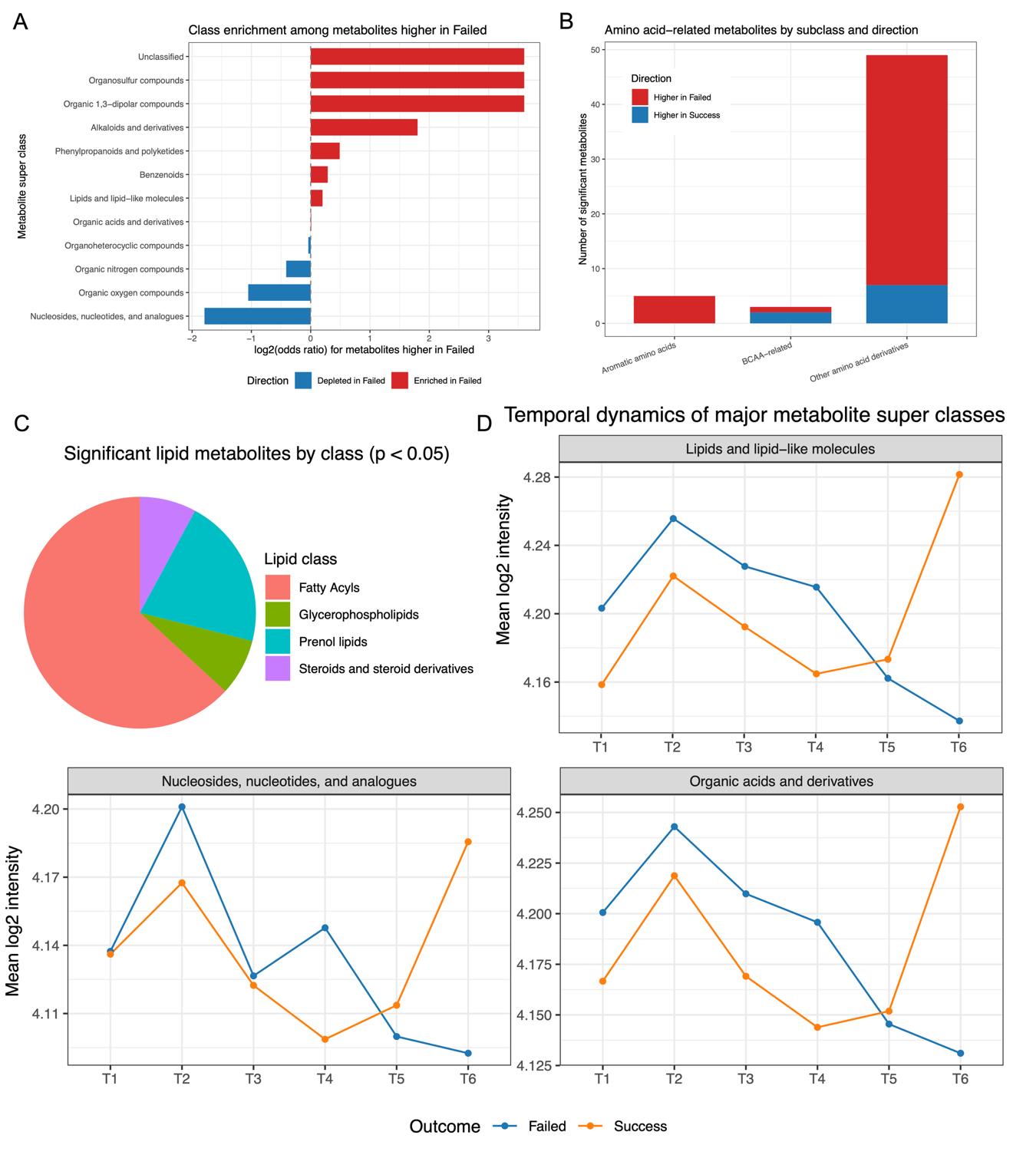
Supplementary Figure S5. Metabolite class enrichment analysis
(A) Metabolite super class enrichment. Horizontal bar chart showing log₂ odds ratio for enrichment of each metabolite super class among nominally significant metabolites (p < 0.05), colored by direction (Higher in Failed vs Higher in Success). (B) Amino acid subclass breakdown. Stacked bar chart showing the count of differential metabolites within amino acid sub-classes (BCAA-related, aromatic amino acids, other derivatives), subdivided by direction of change. (C) Lipid class distribution. Pie chart showing composition of differential lipids by class (glycerophospholipids, sphingolipids, fatty acyls, etc.). (D) Metabolite class temporal dynamics. Multi-panel time series plots for key super classes (organic acids, lipids, organonitrogen compounds, nucleosides) showing mean log₂ intensity across T1–T6 by outcome group.
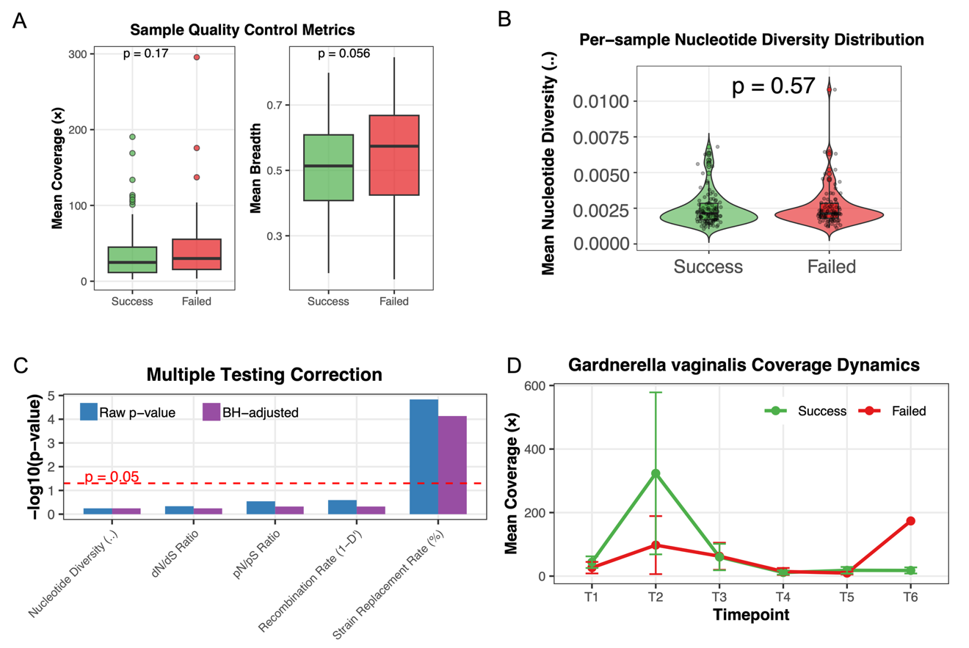
Supplementary Figure S6. Statistical validation and quality control supporting Figure 4
(A) Sample quality control metrics. Boxplots comparing mean coverage and breadth between outcome groups, demonstrating no significant differences (coverage p = 0.62; breadth p = 0.056). (B) Multiple testing correction. Summary of p-values before and after FDR correction for key strain-level metrics, confirming strain replacement rate remains significant after correction. (C) Per-sample nucleotide diversity distribution. Violin plots showing sample-level π distribution by outcome group. (D) Gardnerella vaginalis temporal dynamics. Time series showing coverage/abundance dynamics for G. vaginalis, confirming no significant outcome-associated differences for this secondary species.
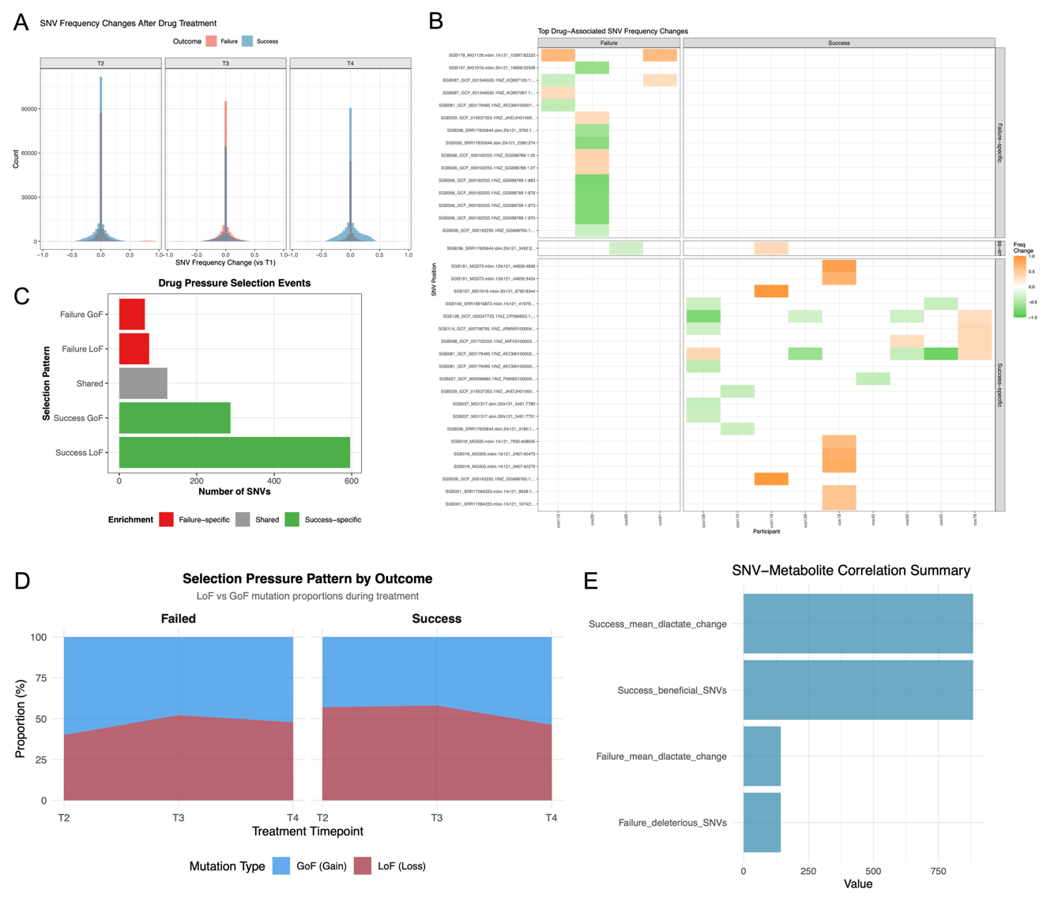
Supplementary Figure S7. Layer 2 temporal dynamics supporting Figure 4 Panels E–H
(A) SNV frequency change distribution. Density plots or histograms showing distribution of SNV frequency changes across timepoints. (B) SNV dynamics heatmap. Heatmap visualization of SNV frequency changes across time. (C) Selection pattern distribution (LoF/GoF). Bar charts showing Loss-of-Function versus Gain-of-Function mutation counts by outcome group. Success group: 67.5% LoF (596 LoF vs 287 GoF). (D) Selection pressure stacked area plot. Temporal visualization of selection pressure components. (E) SNV-metabolite association summary. Correlation analysis between key SNVs and metabolite abundances.
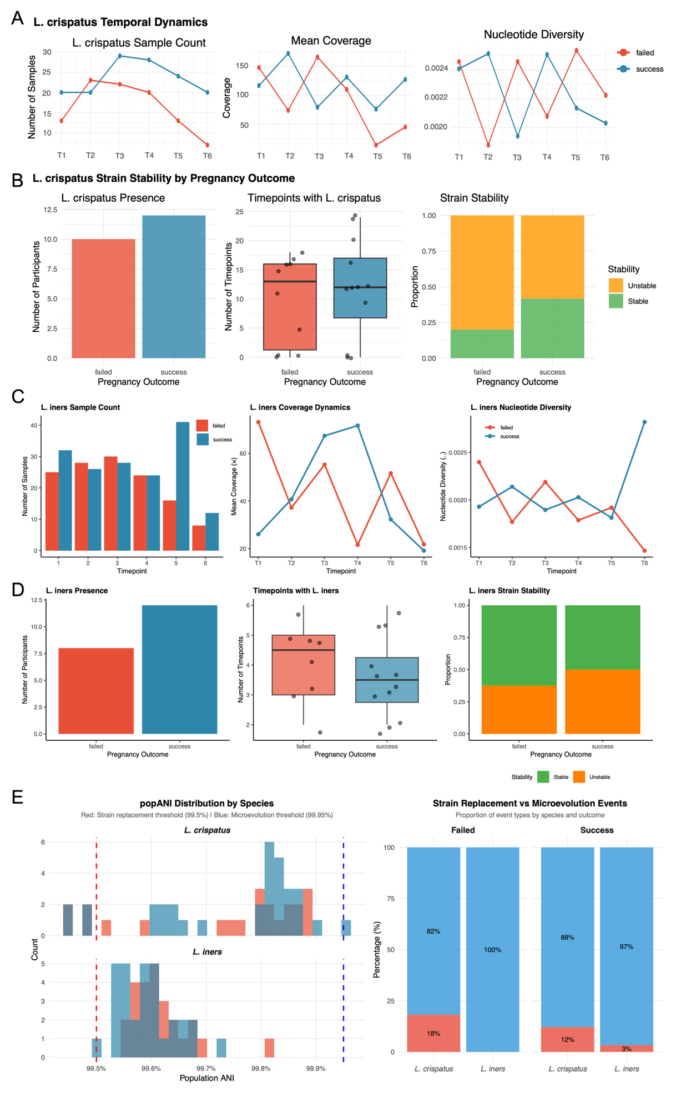
Supplementary Figure S8. Layer 3 dual-species evolution tracking supporting Figure 4 Panels I–L
(A) L. crispatus coverage temporal dynamics by outcome. (B) L. crispatus stability comparison. (C) L. iners coverage temporal dynamics by outcome. (D) L. iners stability comparison. (E) popANI distribution and dynamics. Distribution of population-level average nucleotide identity values. (F) Strain replacement versus microevolution event comparison. Bar chart distinguishing between full strain replacement (popANI < 0.99999) and within-strain microevolution events.
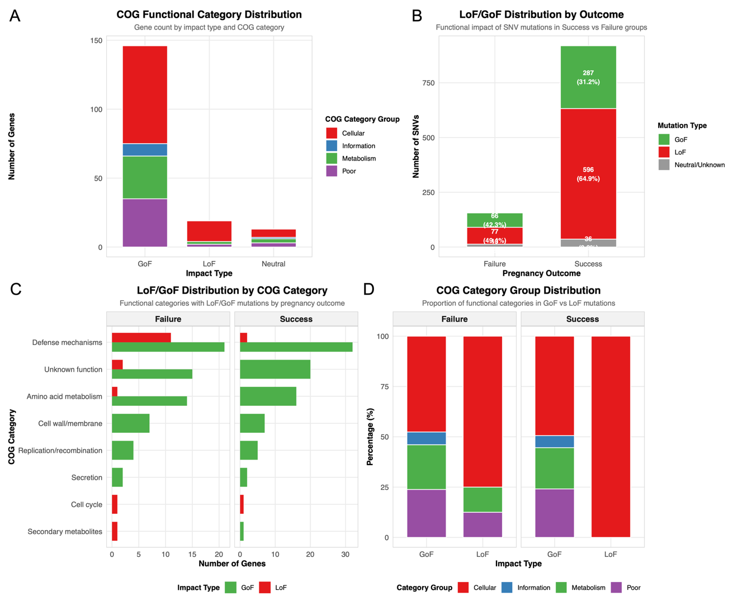
Supplementary Figure S9. Layer 4 functional analysis overview supporting Figure 5
(A) COG functional category distribution. Bar chart showing SNV distribution across COG categories. Major categories: Defense mechanisms (66 genes), Unknown function (37), Amino acid metabolism (31). (B) LoF/GoF distribution by COG category. Stacked bar chart showing LoF versus GoF mutations within each COG category. (C) LoF/GoF distribution by pregnancy outcome. Comparison showing Success group: 596 LoF, 287 GoF; Failed group: 77 LoF, 66 GoF. (D) COG category proportions. Pie chart or proportional bar chart summarizing functional annotation distribution.
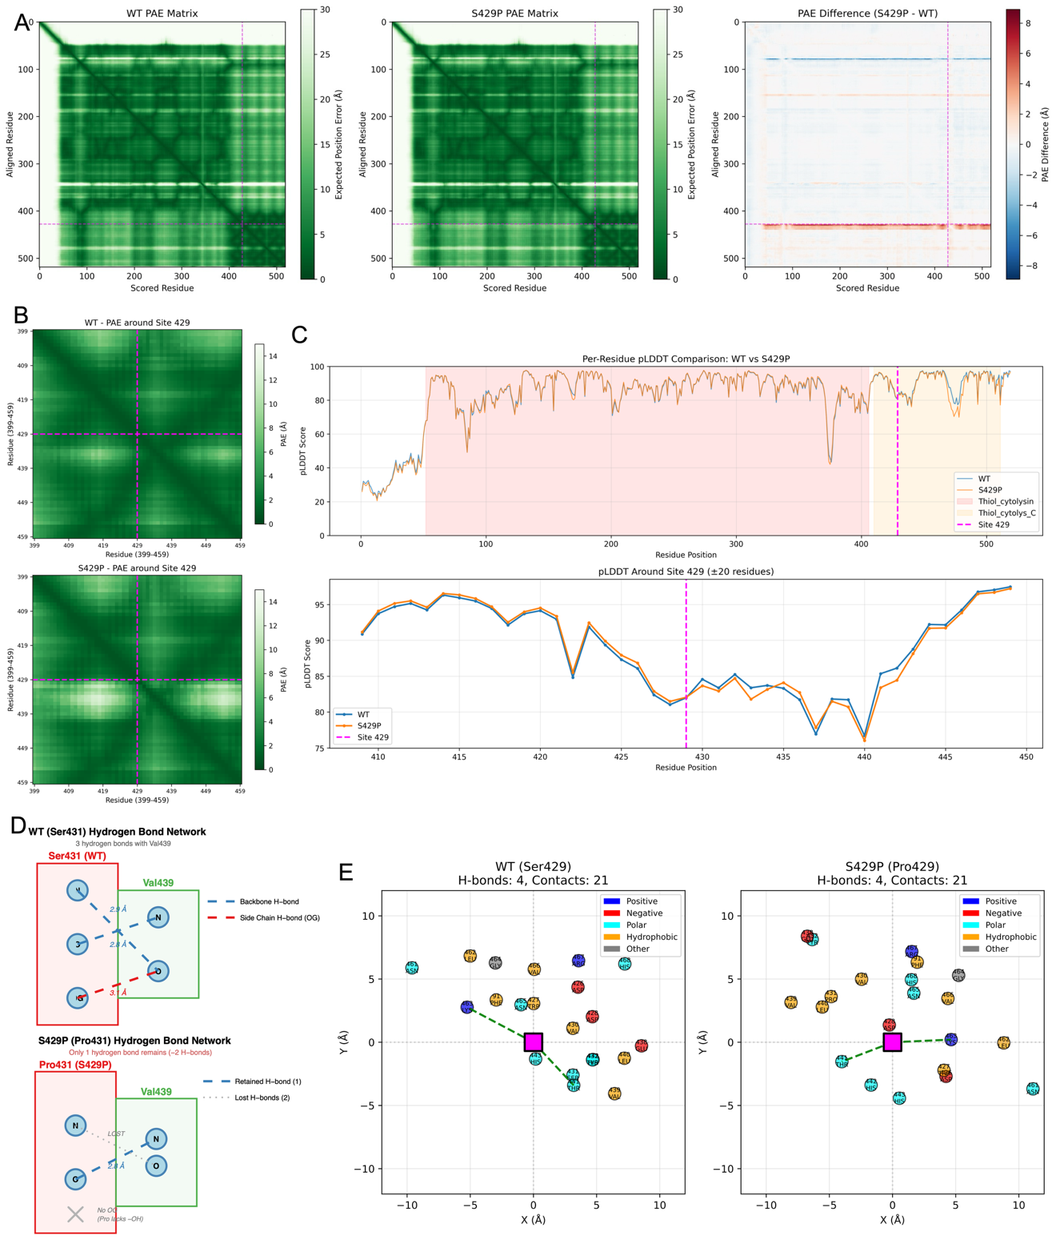
Supplementary Figure S10. Inerolysin structural validation details supporting Figure 5 Panels C–F
(A) Inerolysin Predicted Aligned Error (PAE) heatmaps. Comparison between wild-type and S429P mutant. (B) Local PAE at position 429. Zoomed PAE analysis around the mutation site. (C) pLDDT confidence score comparison. Residue-level pLDDT comparison between WT (83.4 at position 429) and S429P (82.9). (D) Wild-type hydrogen bond network detail at Ser429. (E) S429P mutant hydrogen bond network detail at Pro429. (F) Interaction network comparison. Side-by-side visualization of local interaction changes.
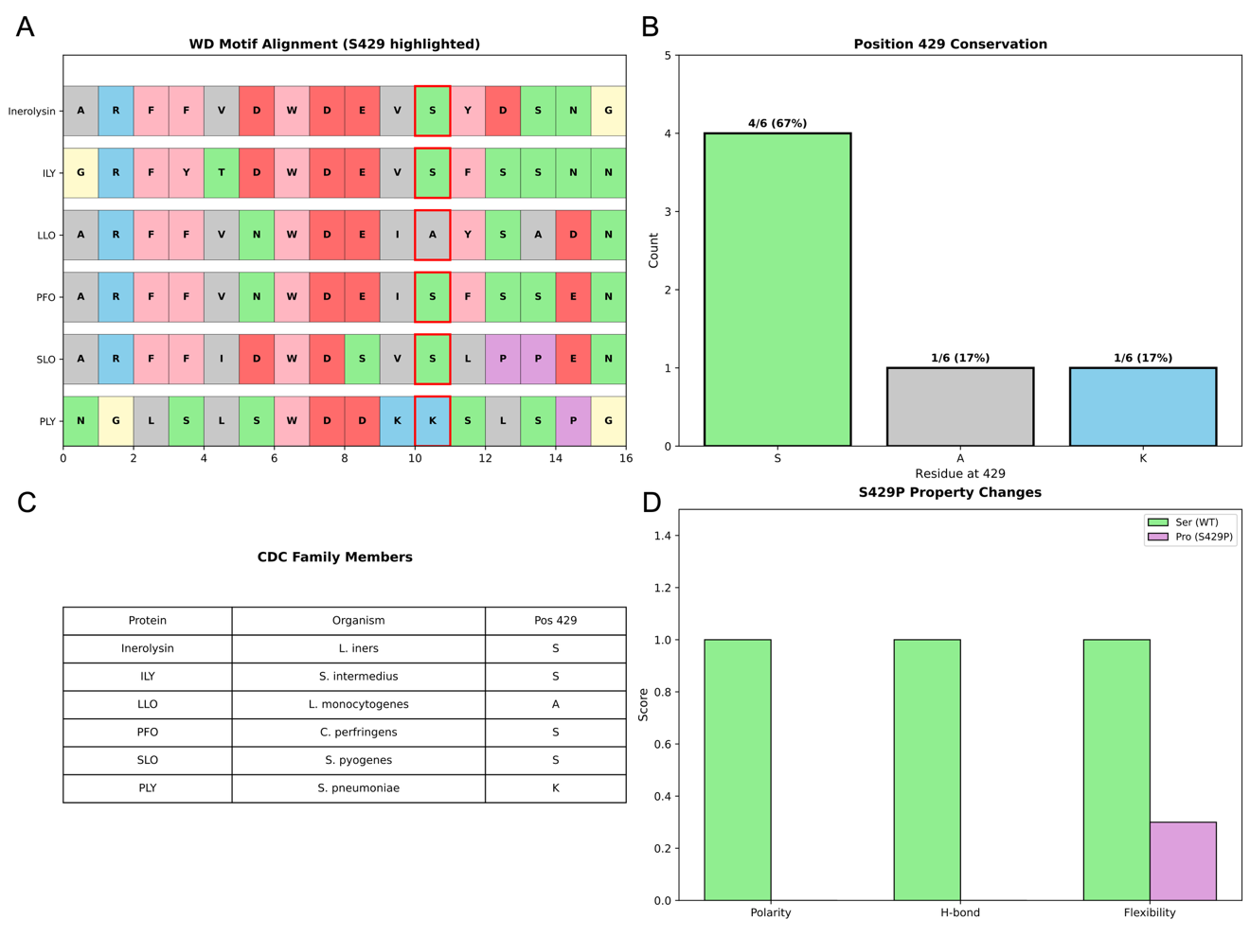
Supplementary Figure S11. CDC family conservation analysis supporting Figure 5 Panel F
(A) WD motif multiple sequence alignment. MAFFT alignment of six CDC family representatives (Inerolysin, ILY, LLO, PFO, SLO, PLY) with S429 position highlighted. (B) Position 429 conservation scores. Bar chart showing amino acid composition: Serine 67% (4/6, high conservation), Alanine 17%, Lysine 17%. (C) CDC family protein information table. Summary of source organisms and position 429 residues for each aligned protein. (D) S429P amino acid property change diagram. Illustration of biochemical changes: loss of polarity, hydrogen bonding capacity, and local flexibility. Conclusion: S429P represents an evolutionarily unfavorable substitution in a highly conserved position.
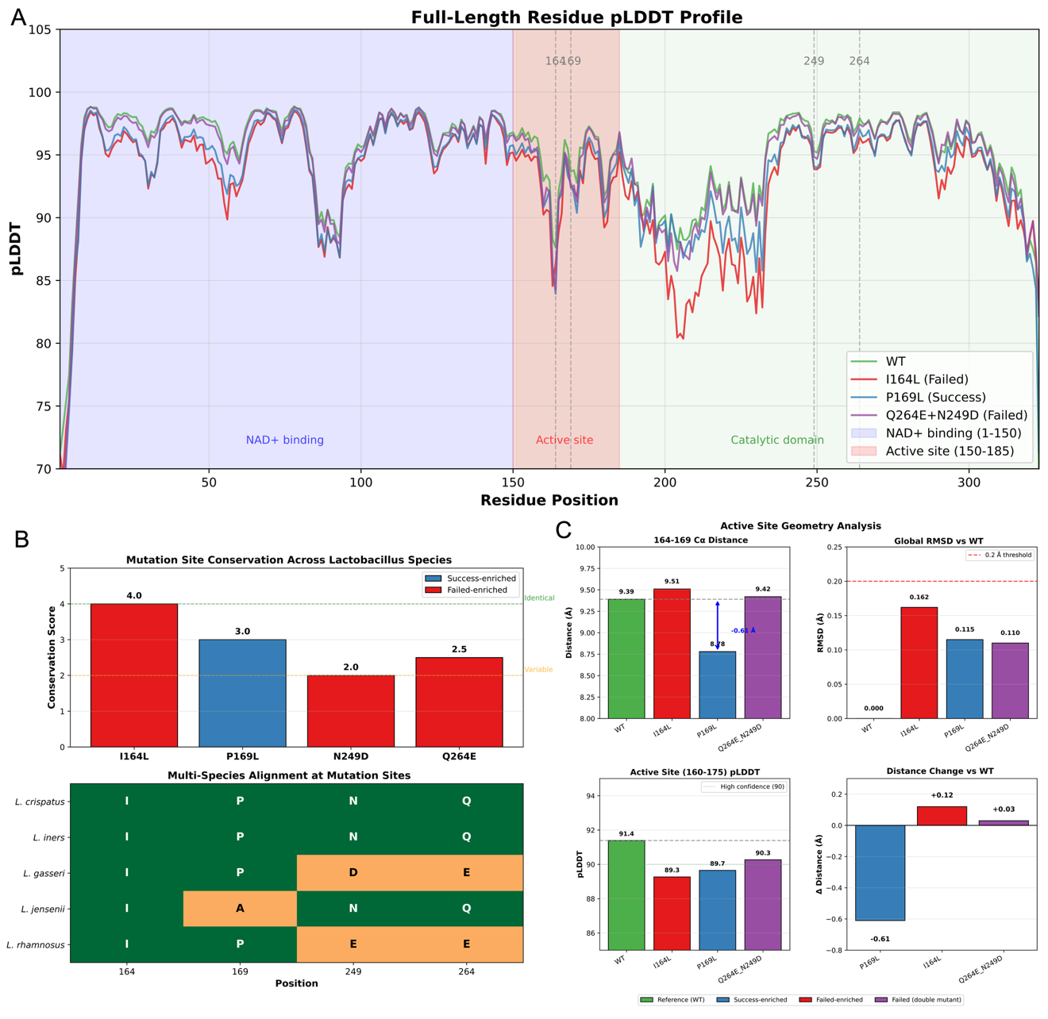
Supplementary Figure S12. L-LDH structural validation details supporting Figure 5 Panels G–N
(A) Full-length residue pLDDT profile. Line plots showing pLDDT values across all 323 residues for WT (green), P169L (blue), I164L (red), and Q264E\_N249D (purple). Active site region (150–185) shows most pronounced differences for P169L and I164L. (B) L-LDH sequence conservation analysis. Multiple sequence alignment with other Lactobacillus species (L. iners, L. gasseri, L. jensenii, L. rhamnosus). Conservation scores: I164 (highly conserved), P169 (moderately conserved), N249 and Q264 (partially conserved). (C) Active site geometry analysis. Four-panel analysis: (i) 164–169 Cα distance showing P169L shortening by 0.61 Å; (ii) Global RMSD versus WT; (iii) Active site pLDDT values; (iv) Distance changes relative to WT.
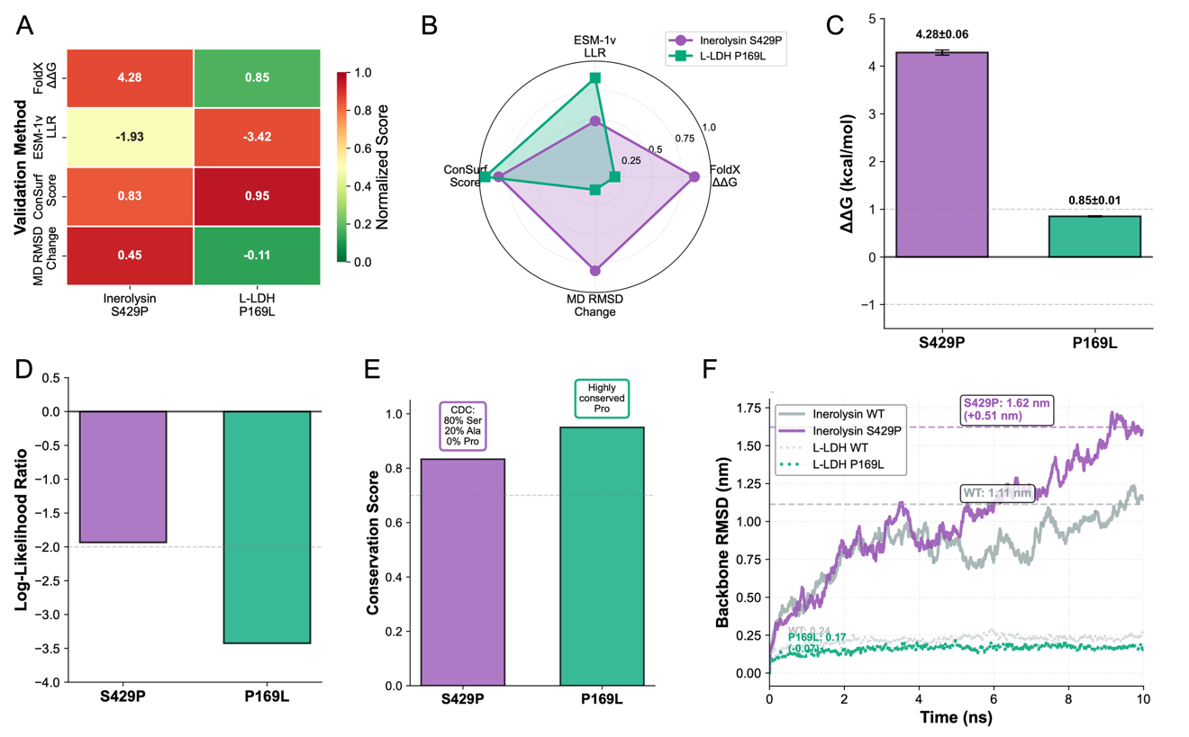
Supplementary Figure S13. Computational triangulation analysis of structural predictions
Enhanced six-panel visualization integrating four orthogonal computational methods for Inerolysin S429P and L-LDH P169L mutations. (A) Heatmap summary. Color-coded matrix showing normalized scores across all four validation methods (FoldX ΔΔG, ESM-1v LLR, ConSurf conservation, MD RMSD change) for both mutations. Red indicates destabilizing/deleterious effects; green indicates stabilizing/beneficial effects. Annotations show raw values. (B) Radar chart comparison. Multi-dimensional profile comparing mutation signatures across all four methods. Inerolysin S429P (purple) shows convergent high scores across all axes, indicating consistent destabilization. L-LDH P169L (teal) shows divergent profile with high evolutionary constraint but low MD RMSD, revealing gain-of-function mechanism. (C) FoldX ΔΔG stability prediction. Bar chart with error bars (5 independent runs): Inerolysin S429P (+4.28 ± 0.06 kcal/mol, strongly destabilizing) vs L-LDH P169L (+0.85 ± 0.01 kcal/mol, mildly destabilizing). Horizontal dashed lines mark ±1.0 kcal/mol thresholds. (D) ESM-1v evolutionary constraint scoring. Bar chart showing log-likelihood ratios: Inerolysin S429P (LLR = −1.93, deleterious) vs L-LDH P169L (LLR = −3.42, strongly deleterious). Dashed line at LLR = −2.0 marks deleterious threshold. (E) ConSurf sequence conservation. Bar chart showing conservation scores: Inerolysin S429 (0.833; CDC family: 80% Ser, 20% Ala, 0% Pro) vs L-LDH P169 (0.95, highly conserved Pro). Annotation boxes highlight key residue composition. (F) Molecular dynamics RMSD trajectories. Line plots showing backbone RMSD over 10 ns (GROMACS 2023.3 [NOTE: verify exact version used in analysis], CHARMM36m). Inerolysin: WT (gray, 1.15 nm) vs S429P (purple, 1.60 nm, +39% increase). L-LDH: WT (light gray, 0.27 nm) vs P169L (teal, 0.16 nm, −41% decrease). Dashed lines indicate mean values. Legend shows protein-specific colors and thresholds.
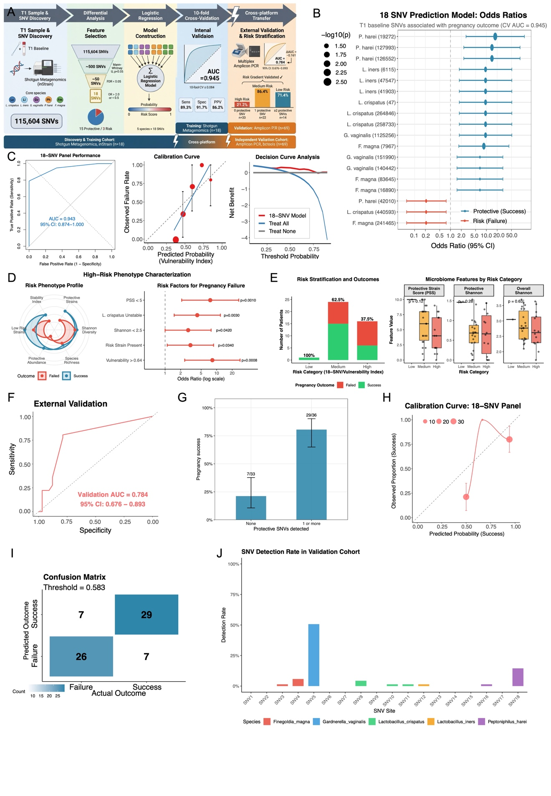
Supplementary Figure S14. Prediction model construction and high-risk phenotype validation
(A) Model construction pipeline. Three-stage flowchart: Feature Selection (115,604 → 18 SNVs via differential analysis and FDR correction) → Model Building (logistic regression, OR calculation) → Validation (10-fold CV, ROC-AUC, calibration). (B) Variable selection rationale and importance. Forest plot displaying odds ratios with 95% CIs for 18 SNVs. Model covers 5 core species: L. crispatus (4 SNVs), L. iners (3), G. vaginalis (3), P. harei (4), F. magna (4). 15/18 (83.3%) are Success-enriched. (C) Model technical validation. (C1) ROC curves comparing 18-SNV model, Vulnerability Index, and clinical-only model. 10-fold CV AUC = 0.945 ± 0.084. (C2) Calibration curve. (C3) Decision curve analysis (net benefit). Performance metrics: Sensitivity 89.3%, Specificity 91.7%, PPV 86.2%, NPV 93.5%. (D) High-risk phenotype characterization. (D1) Radar plot of multi-dimensional comparison (PSS, Shannon, richness, protective abundance). (D2) Forest plot of risk factor odds ratios: PSS < 5 (OR = 7.50, p = 0.001), Vulnerability > 0.64 (OR = 8.25, p = 0.0008), L. crispatus unstable (OR = 4.20, p = 0.003). (D3) Vulnerability Index distribution histogram by outcome.

