7Hepatocellular carcinoma associated hypercholesterolemia: Involvement of proprotein-convertase-subtilisin-kexin type-9 (PCSK9)
Authors: Dipti Athavale¹, Surbhi Chouhan¹, Vimal Pandey ^{1, #} Shyamananda Singh Mayengbam¹, Snahlata Singh¹, Manoj Kumar Bhat^{1,*}
Authors’ affiliations:
¹National Centre for Cell Science, Savitribai Phule Pune University Campus, Ganeshkhind, Pune 411 007, India
#Laboratory of Neuroscience, Department of Biotechnology & Bioinformatics, School of Life Sciences, University of Hyderabad, Hyderabad- 500046, Telangana, India

Additional File 2: Figure S1
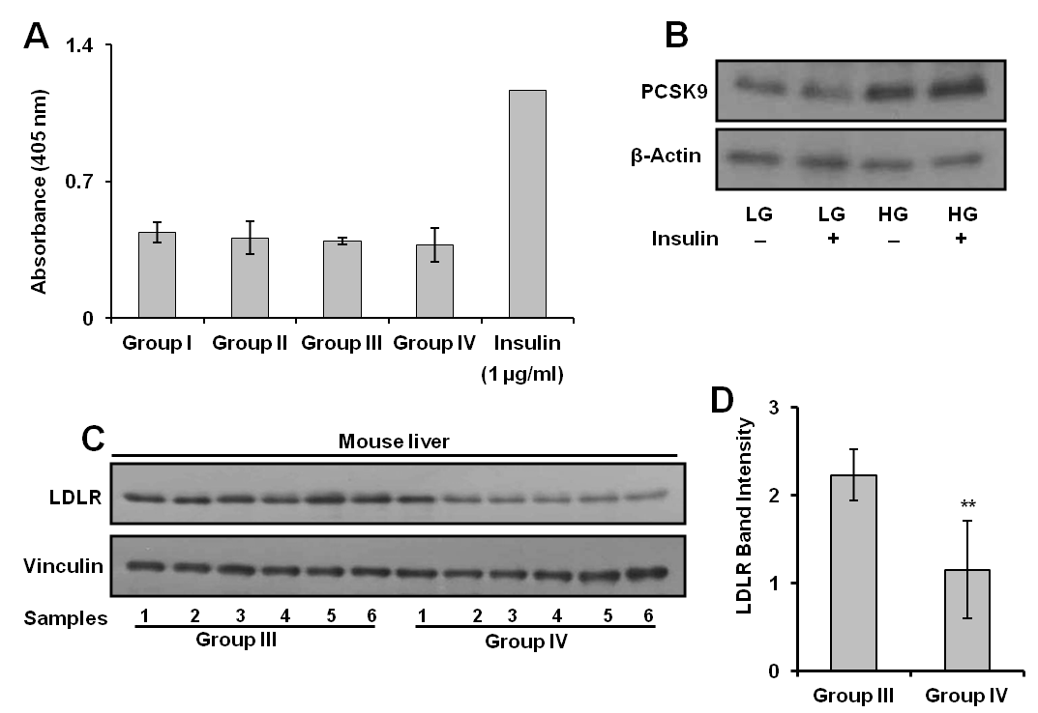
Figure S1: Insulin induced changes in PCSK9. a Individual serum samples collected from Group I, Group II, Group III and Group IV were subjected to ELISA to quantify Insulin levels. The results are given as means ± standard deviation. b HepG2 cells were cultured in LG and HG in presence or absence of insulin (100 nM) for 12 h. Expression of PCSK9 was analysed by Western blot. c, d Liver tissue lysates from Group III and Group IV (n=6) were resolved by SDS-PAGE and LDLR protein levels were analyzed by Western Blot. LDLR band intensities were measured by densitometry and normalized with vinculin. The results are given as means ± standard deviation; **p < 0.01, denote significant differences between the groups.

