Additional File 3: Figure S2
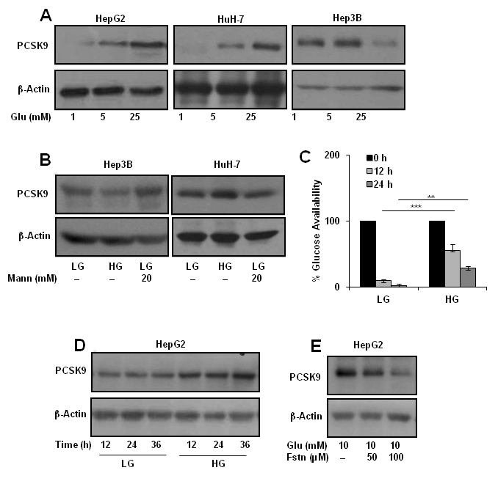
Figure S2: Glucose specificity of PCSK9 regulation. a HepG2 (12 h) and Hep3B, HuH-7 cells (24 h) were cultured in indicated concentrations of glucose (Glu) and expression of PCSK9 protein was analyzed by Western blot. b Hep3B and HuH-7 cells were cultured in LG, HG and LG + mannitol (Mann) for 24 h and expression of PCSK9 was examined by immunobltting. c HepG2 cells were cultured in LG and HG for 12 h and 24 h. Glucose remaining in the spent medium was estimated by kit. d HepG2 cells were cultured in LG and HG medium for indicated time period. Respective media were replenished after every 12 h. Expression of PCSK9 was analysed by immunoblot. e HepG2 cells were treated with indicated concentrations of Glu and fasentin (ftsn) and expression of PCSK9 was analyzed by Western blot. Bar graph represents mean ± SEM; n=3; **p<0.01, ***p<0.001 denote significant differences in the groups.

