Additional File 4: Figure S3
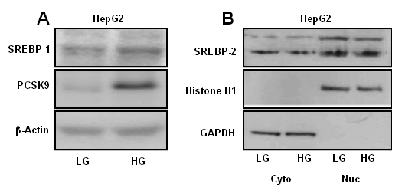
Figure S3: Effect of glucose on SREBP-1 and SREBP-2. HepG2 cells were seeded and treated with LG and HG for 12 h and processed as follows a Whole cell lysates were resolved on SDS-PAGE and expression of SREBP-1 and PCSK9 were analyzed by Western blot. b Cytosolic and nuclear fractions were prepared and expression of SREBP-2 was analysed. Histone H1 and GAPDH were included in the Western blot as loading controls for nuclear and cytosolic fractions respectively.

